# 

# Hydrofoil Development and Test Plan

Aquantis, Inc.

101 E. Victoria Street, Suite F

Santa Barbara, CA 93101  
Tel. +1 805 845 7575

Fax +1 805 845 7266   
aquantistech.com

Authors

Henry Swales, Aquantis Inc.

Case Van Damn, Senta Engineering

Henry Shiu, Senta Engineering

Wesley Goodman, NASA Langley Research Center

|  |  |  |  |  |
| --- | --- | --- | --- | --- |
| Rev # | Description of changes | Rev Date | Revised By | Pages |
| 1.0 | Original manuscript | 3/20/2014 | Swales | All |
| 1.1 | AoA sweep adjusted for tunnel capability | 3/28/2014 | Swales |  |
| 1.2 | Updates: Schedule, Budget, Pre-Test | 5/8/2014 | Swales |  |
|  |  |  |  |  |
|  |  |  |  |  |

Table of Contents

1 Introduction 6

1.1 Nomenclature 6

2 Hydrofoil Development 7

2.1 Design Objectives 7

2.1.1 Summary of Updates to MHKF1 Hydrofoil Family 7

2.1.2 Design Requirements 7

2.2 Design Methodology 7

2.3 Development and Test Schedule 8

3 Test Set-Up 8

3.1 Wind tunnel 8

3.2 Airfoil Models 9

3.3 Aerodynamic Devices 9

3.4 Instrumentation 9

3.4.1 Airfoil Models 10

3.4.2 Wake Rake 10

3.4.3 Wall Pressure 10

4 Test Procedure 10

4.1 Angle of Attack 10

4.2 Test Conditions 12

4.2.1 Mach Number 12

4.2.2 Reynolds Number 12

4.3 Test Configurations 13

5 Data Collection and Reduction 13

5.1 Wall Interference Correction 14

5.2 Measurement Uncertainty 14

6 References 14

# Table of Figures

Figure 1: Airfoil Model in 0.3m TCT 9

Figure 2: Example Operating Conditions 12

# Table of Tables

Table 1: Test Summary 6

Table 2: Preliminary Schedule 8

Table 3: 0.3m TCT Operating Capabilities 9

Table 4: 0.3m TCT Instrumentation Capabilities 9

Table 5: Test Procedure for Varying Angle of Attack 11

Table 6: Example Positive AoA Test Matrix 11

Table 7: Example Negative AoA Test Matrix 12

Table 8: Approximate Test Conditions 13

Table 9: 0.3m TCT Data Acquisition Capabilities 14

**Test To Be Conducted For:**

Aquantis Inc.

101 E. Victoria St.

Santa Barbara, CA  
93101

**Test To Be Conducted By:**

0.3m Transonic Cryogenic Tunnel, NASA Langley

**Internal Test Readiness Review Committee**

|  |
| --- |
| Henry Swales, Aquantis Inc.  Ole Kils, Aquantis Inc.  Ken Gluck, Aquantis Inc.  Alex Fleming Aquantis Inc.  Nobuyasu Sakata, MHI  Kei Sato, MHI |
|  |
|  |

**External Test Readiness Review Committee**

|  |
| --- |
| Case Van Damn, Senta Engineering  Henry Shiu, Senta Engineering  Wesley Goodman, NASA Langley Research Center |

# Introduction

Aquantis Inc. will work with Senta Engineering and others to develop a structurally optimized family of 4 hydrofoils for large fixed-pitch MHK turbines such as the C-Plane.

The following test will characterize the performance of this family of 2D hydrofoil sections. Test data will be used to design and certify turbines for generating electrical power from ocean current, river, and tidal flows. Testing will include 'clean' conditions as well as 'soiled' conditions to replicate marine growth and/or standard manufacturing surface roughness.

Table 1: Test Summary

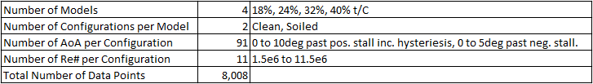

## Nomenclature

α angle of attack

CFD computational fluid dynamics

C chord length

Cd sectional drag coefficient

Cl sectional lift coefficient

Cl0 sectional lift coefficient at zero degrees angle of attack

Cpmin minimum pressure coefficient

l/d lift to drag ratio

l/dmax maximum lift to drag ratio

M∞ freestream Mach number

MHK marine and hydrokinetic

m meters

m/s meters per second

ncrit transition prediction parameter

p pressure

pv vapor pressure

p∞ freestream pressure

ρ density

ρ∞ freestream density

R rotor radius

RaNS Reynolds-averaged Navier Stokes

Re Reynolds number

σ cavitation number

# Hydrofoil Development

## Design Objectives

### Summary of Updates to MHKF1 Hydrofoil Family

1. 4th foil at 32% t/C
2. Fixed-pitch Operation
3. Limited rotational stall delay
4. Increased design Re#

### Design Requirements

1. Family of 4 hydrofoils intended for MHK turbine applications in ocean currents with the following t/C ratios:
   1. 18%
   2. 24%
   3. 32%
   4. 40%
2. Design Re#: 5-10 million.
3. Good hydrodynamic performance with high lift to drag ratio (l/d) as the primary goal. Extended favorable pressure gradient, ramp and recovery to promote laminar flow on suction surface.
4. Limited rotational stall delay. Relatively high Cl to limit chord lengths.
5. Linear transitions of the following hydrodynamic and geometric design parameters between hydrofoilsto enable cohesive blade design and smooth lofting.
   1. Cl0, camber
   2. Clmax
   3. Stall Angle
   4. Trailing Edge Thickness
   5. Max Thickness Chord Location
6. Benign stall characteristics and restrained Clmax for fixed-pitch operation (variable speed stall regulation).
   1. l/d max relatively close to stall for operation in low turbulence environment (deep water ocean current resource).
7. Limited sensitivity to soiling due to bio-fouling. Low susceptibility to boundary layer tripping.
8. Low susceptibility to cavitation. Reduced suction peak.
9. Low susceptibility to singing. Trailing edge thickness.

## Design Methodology

The first phase will focus on calibration of our computational tools, comparing 3-D Navier-Stokes CFD (Fig. 2) with lower order methods such as those employed by AirfoilPrep and RFOIL. Ideally, we would analyze coupled high Reynolds number, roughness sensitivity, and rotational effects simultaneously, performing 3-D CFD as needed for the expected operational configurations and conditions. However, to accelerate this initial stage, we will mine the existing 3-D CFD datasets that we have generated previously. These include results for the NREL 5-MW rotor and two cases for an MHK rotor. While new 3-D CFD cases will not be run, the post-processing and analysis of the existing cases will still be a significant process which will inform the next phase.

In the second phase, we will design a new hydrofoil family using the calibrated toolset developed in the first phase. These hydrofoils will be developed from the MHKF1 family, a reference MHK hydrofoil set. The focuses will be on (1) the mid-outboard region and high Reynolds number effects and (2) the mid-inboard region, where there will be large thickness and significant rotational and roughness effects. If possible, the most inboard stations will also be considered.

## Development and Test Schedule

Table 2: Preliminary Schedule

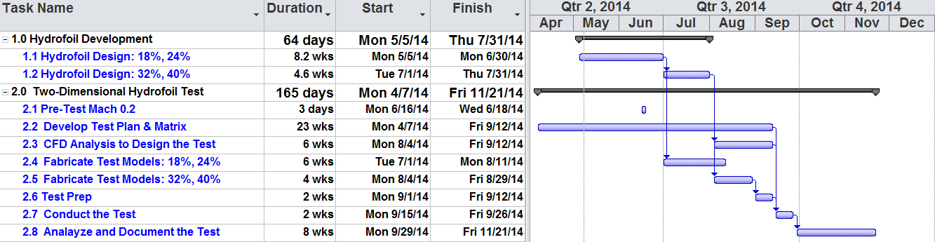

# Test Set-Up

## Wind tunnel

The 0.3-Meter Transonic Cryogenic Tunnel (0.3-m TCT) is a high-pressure, cryogenic, closed-circuit, wind tunnel used to test two-dimensional airfoil sections and proof-of-concept configurations, develop advanced test techniques, and validate computation fluid dynamics codes at high Reynolds numbers. The flexible floor and ceiling in the 0.3-m square test section can be adjusted to approximate free-stream shapes to eliminate or reduce wall effects.

The 0.3-m TCT is capable of running with air or gaseous nitrogen as the test medium. With the ability to control temperature and pressure as well, a very large range of Reynolds and Mach number combinations can be achieved.

The test section has computer-controlled angle-of-attack and traversing-wake-survey rake systems. Two inches of honeycomb and five anti-turbulence screens in the settling chamber provide flow quality suitable for natural laminar flow testing.

High-pressure (350 psi) and low-pressure (100 psi) air sources are available. These sources are located near the test section and can be used for boundary-layer blowing or calibration of auxiliary devices.



Figure 1: Airfoil Model in 0.3m TCT

Table 3: 0.3m TCT Operating Capabilities

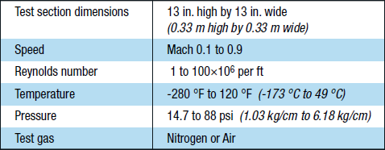

## Airfoil Models

Each hydrofoil section shall have a 2D model constructed of 6061 Aluminum TBD.

Span: 0.33m

Chord: 0.11m TBD Check blockage effects and degree of mitigation through wall deflection.

## Aerodynamic Devices

Boundary layer trips located at 5% chord on high pressure and low pressure surfaces.

## Instrumentation

The following instrumentation shall be implemented on the hydrofoil models and tunnel.

Table 4: 0.3m TCT Instrumentation Capabilities



### Airfoil Models

Number and location of pressure ports TBD.

### Wake Rake

Number and location of pressure ports TBD. Traverse range TBD.

### Wall Pressure

Number and location of pressure ports TBD.

# Test Procedure

The test objectives are to determine lift, drag, and pitching moment polars for each foil well past positive and negative stall (>20deg AoA) to characterize stall hysteriesis. Reynolds number range from 1.5M to over 10M. Airofil pressure distributions and wake momentum loss will be measured.

Test Protocol for each model:

1. Install model, check pressure taps, close up tunnel
2. Set pressure and temperature in tunnel
3. Put model at initial condition (zero degrees AoA)
4. Bring tunnel on-line to desired Mach#, adjust pressure and temperature to get desired Re#.
5. Adjust walls for pressure gradient. Check wall pressures for correct geometry.
6. Take data point.
7. Adjust AoA to next point.
8. Repeat steps 5, 6, 7, until we get last AoA.
9. Repeat step 3, 4, 5, 6, 7 for next Mach# & Re#.
10. Bring temperature up and vent tunnel.
11. Remove model form tunnel.

## Angle of Attack

-9 to 20deg

Each configuration test shall commence at 0 degrees angle of attack and proceed as follows. Measurements shall be recorded at each positive 1 degree angle of attack increment until the start of positive stall is observed. Measurements shall then be recorded at 0.5 degree increments up to 10 degrees above positive stall (or as far as possible considering tunnel blockage limitations). Measurements shall then be recorded at 0.5 degree increments as the angle of attack is decreased to 5 degrees below positive stall to capture. Measurements shall then be recorded at 0.5 degree increments as the angle of attack is increased again to the point of positive stall to fully document any hysteresis in performance. The model shall then be returned to 0 degrees and the angle of attack incremented -1deg to 5deg past negative stall. Less fidelity is required of the negative angles as this is an off-design condition. Angle of attack increments may be adjusted in real time to increase or reduce fidelity of measurements as necessary. This procedure is summarized in the table below.

Table 5: Test Procedure for Varying Angle of Attack

|  |  |  |  |
| --- | --- | --- | --- |
| **Test Step**  **(#)** | **Starting Angle of Attack**  **(deg)** | **Finishing Angle of Attack**  **(deg)** | **Change Increment**  **(deg)** |
| **1** | 0 | Positive Stall | +1.0 |
| **2** | Positive Stall | Positive Stall + 10.0 | +0.5 |
| **3** | Positive Stall + 10.0 | Positive Stall - 10.0 | -0.5 |
| **4** | Positive Stall - 10.0 | Positive Stall | +0.5 |
| **5** | 0 | Negative Stall | -1.0 |
| **6** | Negative Stall | Negative Stall - 5.0 | -1.0 |

A data point shall be recorded at each of the following positive angles of attack for each Model Configuration and Test Condition (assumes 12deg stall angle).

Table 6: Example Positive AoA Test Matrix

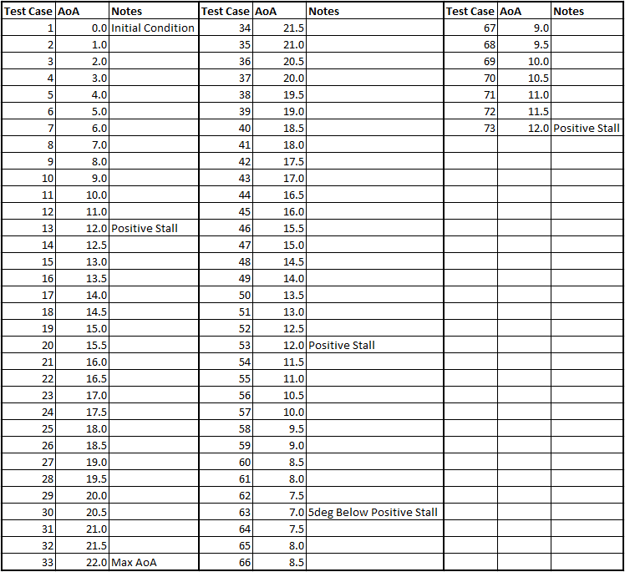

A data point shall be recorded at each of the following negative angles of attack for each Model Configuration and Test Condition (assumes 12deg stall angle).

Table 7: Example Negative AoA Test Matrix

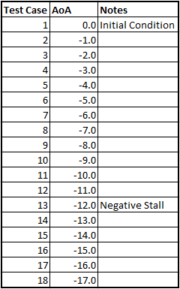

## Test Conditions

Tunnel operating conditions shall be determined by NASA Langley Research Center.

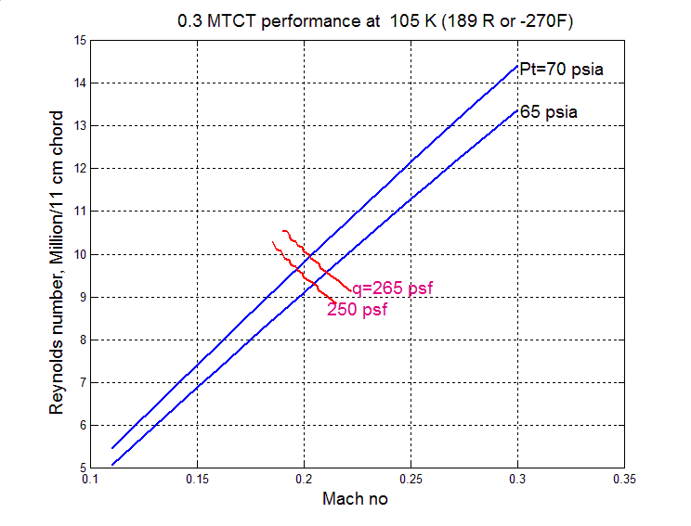

Figure 2: Example Operating Conditions

### Mach Number

All tests shall be conducted at Mach 0.2.

### Reynolds Number

Each model shall be tested over a range of Re# from 1.5e6 to 11.5e6 in increments of 1.0e6.

Table 8: Approximate Test Conditions

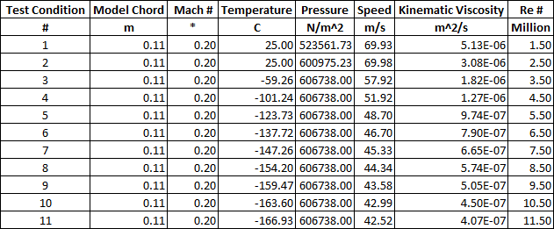

Note that the lowest two Re# may be conducted at room temperature. Higher Re# shall be conducted at max tunnel pressure and progressively lower temperatures to minimize LN2 costs. If tunnel capabilities, blockage limitations, model structural constraints, and budgetary restrictions allow, higher Re# may be explored.

## Test Configurations

Each test condition identified in Tables 5 and 6 shall be executed for both ‘clean’ and ‘soiled’ model configurations. Soiled model configurations shall implement boundary layer trips at 5% chord on the high pressure and low pressure surfaces.

# Data Collection and Reduction

Except for instances where pressure ports are obstructed, the following data shall be provided for all of the aforementioned test conditions and configurations. Data shall be provided for each angle of attack specified in section 4.1.

1. Free stream pressure and velocity, Reynolds number, Mach number, Angle of attack.
2. Static pressure and pressure coefficient for all airfoil pressure ports. Calculated lift, drag, and moment coefficients from airfoil pressure data.
3. Static pressure and pressure coefficient for all wall pressure ports. Calculated lift coefficient from wall pressure data.
4. Static and total pressure and pressure coefficient for all wake rake pressure ports. Calculated drag coefficient from wake pressure data.

Table 9: 0.3m TCT Data Acquisition Capabilities

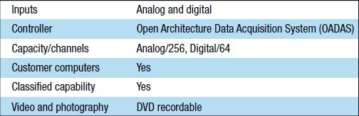

## Wall Interference Correction

Wall geometry will be determined a priori through CFD analysis to minimize or eliminate wall effects. If the variable wall geometry is unable to adequately mitigate wall effects, the wall correction method of Allen and Vincenti [10] shall be used to correct the measured data for the effects of wall interference and tunnel blockage. Compressibility should not be a factor since the highest test Mach number is 0.2, below the widely accepted compressibility threshold of 0.3 Mach.

## Measurement Uncertainty

NASA Langley Research Center shall provide an uncertainty analysis of all measurement systems with the final results of this test.

# References

1. McGhee, R.J., Viken, J.K., and Pfenninger, W.D., “Experimental Results for a Flapped Natural-Laminar Flow Airfoil With High Lift/Drag Ratio,” NASA TM-85788, 1984.
2. Tangler, J.L., and Somers, D.M., “NREL Airfoil Series for HAWTs,” NREL/TP-442-7109, Jan. 1995.
3. Ehrmann, R.S., White, E.B., Rumsey, M., Chow, R., Langel, C.M., van Dam, C.P., “Realistic Leading-Edge Roughness Effects on Airfoil Performance,” AIAA conference, San Diego, CA, June 2013.
4. Flack, K.A., Schultz, M.P., “Review of Hydraulic Roughness Scales in the Full Rough Regime,” Journal of Fluids Engineering, Vol. 132, Article 041203, Apr. 2010.
5. S. Schreck, L. Fingersh, K. Siegel, M. Singh, and P. Medina, “Rotational Augmentation on a 2.3 MW Rotor Blade with Thick Flatback Airfoil Cross-Sections: Preprint,” National Renewable Energy Laboratory (NREL), Golden, CO., NREL/CP-5000-57372, Jan. 2013.
6. “NWTC Computer-Aided Engineering Tools (AirfoilPrep by Dr. Craig Hansen).” Available: http://wind.nrel.gov/designcodes/preprocessors/airfoilprep/. Accessed: 20-May-2013.
7. R. P. J. O. M. Van Rooij and W. A. Timmer, “Roughness sensitivity considerations for thick rotor blade airfoils,” Journal of Solar Energy Engineering, Transactions of the ASME, vol. 125, no. 4, pp. 468–478, 2003.
8. Drela, M., “XFOIL: An Analysis and Design System for Low Reynolds Number Airfoils,” Conference on Low Reynolds Number Airfoil Aerodynamics, University of Notre Dame, June 1989.
9. H. Shiu, C.P. van Dam, M. Barone, E. Johnson, R. Phillips, W. Straka, A. Fontaine, M. Jonson, “A Design of a Hydrofoil Family for Current-Driven Marine Hydrokinetic Turbines,” ICONE20POWER2012-55224, 20th International Conference on Nuclear Engineering and the ASME 2012 Power Conference, Anaheim, CA, 2012.
10. Allen, H. J. and Vincenti, W. G., ‘Wall Interference in a Two-Dimensional Wind Tunnel, with Consideration of the Effect of Compressibility’, NACA report no. 782, 1947.