Background on Feed-forward control of RME Surge WEC

Authors: Anantha Karthikeyan, Mirko Previsic
Company: Re-Vision Consulting
Date: 7/28/2016
Re-Vision Consulting has developed a Model Predictive Control (MPC) Code Framework for implementing feedforward controls on the RME Surge WEC. This controls strategy has two aspects (see Figure 1), (1) forecasting the wave force on the WEC using up-wave sensor measurements and (2) Non-causal optimization using MPC for implementing active controls on the PTO mechanism.
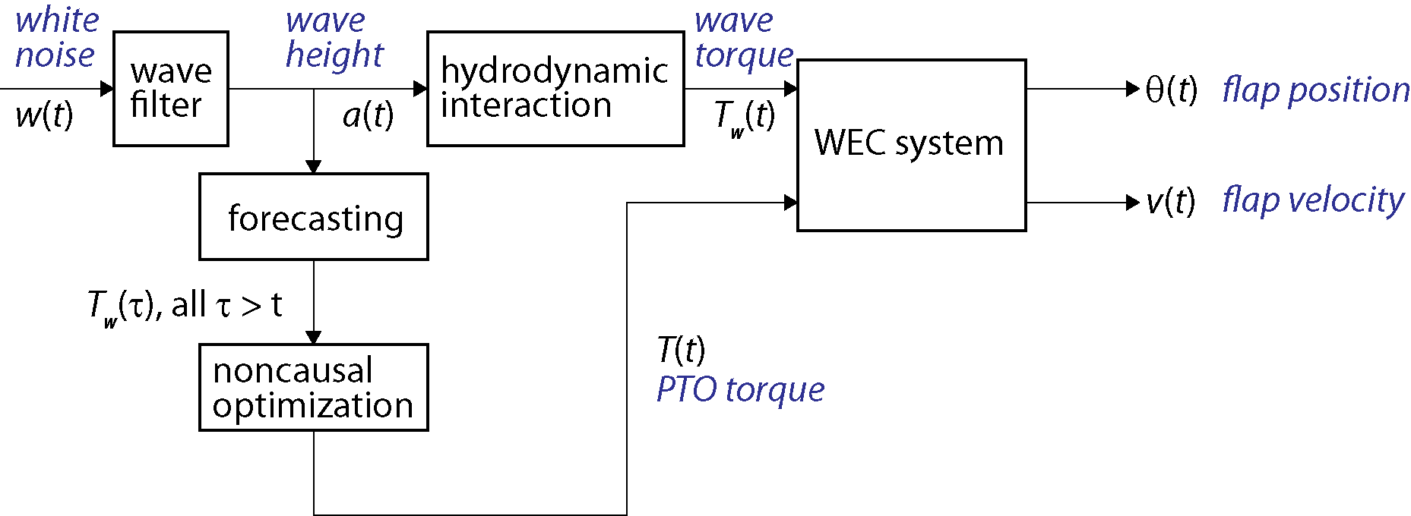
Figure 1: Feedforward control of RME Surge WEC

Forecasting using up-wave sensor measurements
The forecasting algorithm shown in Figure 2, uses a shallow water model to propagate up-wave measurements to the WEC location. This model is capable of utilizing a variable number of inputs from wave probes located at the boundary of the prediction domain. For a realistic wave field simulation we have tested this algorithm using a truth model developed using WWIII and SWAN spectra (Figure 3). A sensitivity study was also conducted to estimate the minimum number of probes required to achieve suitable performance with MPC (see Figure 4). It was observed that with 8 sensors the normalized performance of MPC is at 97.8%. Note that this model can be just as easily adapted to work with measurements obtained from a wave radar.
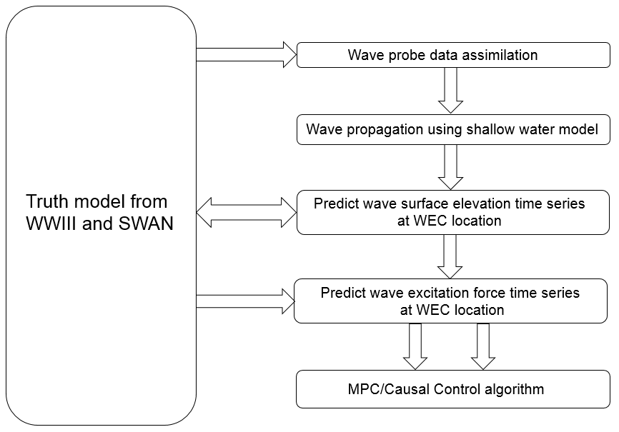
Figure 2: Wave forecasting algorithm

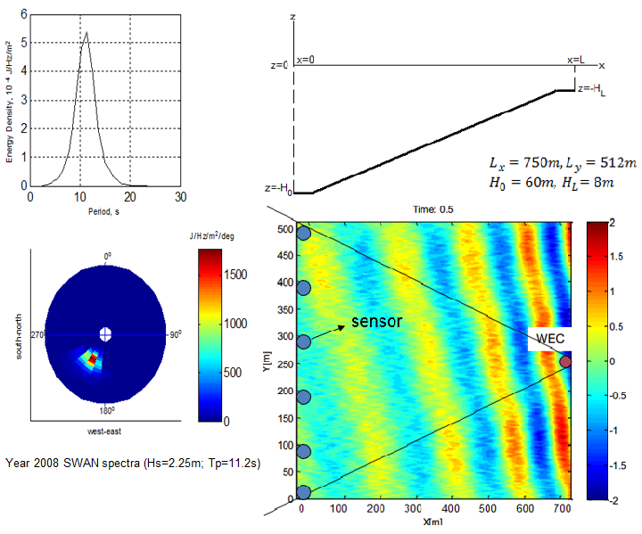
Figure 3: Wave field truth model and sensor placement

Figure 4: Performance of MPC vs number of probes

MPC optimization for active PTO control

Inputs to the algorithm
The MPC code framework uses a system dynamics model of the flap which was developed by RME. This model is in state space form and accounts for the mass, added mass, hydrostatic spring stiffness and radiation damping terms. To this model non-linear drag forces are added based on the relative velocity of the flap and surrounding wave particle velocity.

MPC Controls Framework
Maximizing the power output of a Surge WEC device can be recast as an optimization problem subject to both control and state constraints. Such constraints are related to the system dynamics, and include machinery constraints related both to the saturation of the actuators, and to limits in the displacement and velocity of the device. Model Predictive Control (MPC) represents the best framework available today for such constrained optimization problems. Moreover, the results for the Surge WEC show that the MPC outperforms all the other control strategies in all sea conditions. Furthermore, the powerful MPC formulation can easily be extended to any configuration of WEC, which is generally not possible for other control algorithms.

Receding-Horizon Model Predictive Control involves successive gradient-based optimizations, performed significantly faster than real time, in which both the constraints and the cost function to be optimized are specified. The cost function considered in the present work includes the wave energy captured and the actuator energy consumed over the finite horizon of time in the near future being considered; this time horizon is gradually receded as the actual time advances. Iterative optimization of the cost function is performed while adjusting the free parameters in the system (that is, the “control variables”), in a manner which minimizes the cost function, over the gradually-receding horizon being considered, while respecting the various control and state constraints specified on the problem.

To illustrate our methodology, let us consider the simpler case of linear MPC. This formulation considers a discrete-time state-space model of the Surge WEC:
(13)

Where, x_{k} is the discrete state vector at time t_{k} , u_{k} is the control input, A_{d} is the state-space matrix, B_{d} is the control matrix, and E is the exogenous force matrix. f_{e k} is the excitation force due to the interaction of the wave field with the wave energy converter. Then, maximizing the power take-off over a finite horizon T_{h} means maximizing at each instant t_{k} the absorbed energy:
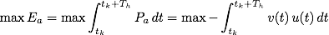
(14)

Where, v is the WEC velocity contained in the state vector x. By discretizing the time integral and introducing the extraction matrix S_{v}, we can rewrite the optimization as a minimization problem:
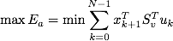
(15)

Now, by defining the following vectors
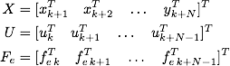

the cost function can be written as:
(16)

Where, S_{v} a matrix which has S_{v} on the main block diagonal. In this way, it is possible to express X as a function of U and F_{e}
(17)

Where,
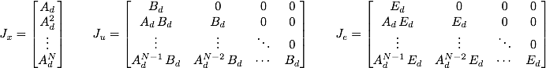
(18)
By replacing (17) into the cost function (16), we get:

(19)

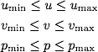
As for the inequality constraints, we consider saturation on the actuators and motion constraints, such as limits on the maximum velocity v and displacement p allowed, i.e.

Combining the cost function with the inequalities that must be satisfied, the MPC algorithm reduces to the solution of a quadratic programming problem. The solution of such a problem is the optimal control input U* over the time horizon considered in the optimization. The first element of this vector then represents the optimal control at the instant t._{k}. At the next time step, the same procedure is repeated, after redefining the vectors X, U and F_{e} and using x_{k+1} as initial condition.

Adaptation of the above methodology to the different control options simply requires a suitable modification to the cost function. The idea is to maximize at each instant the generated power (which accounts for the transmission losses and conversion efficiencies), instead of the absorbed power. The absorbed power (P) and generated power (P_{gen}) are related to each other as follows:

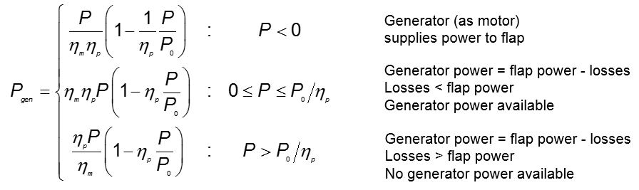
The uni-direction power flow constraint for Option2 (continuous torque control) and Option1 (discrete torque control) can be handled by imposing constraints on the product of instantaneous velocity and control torque over a given prediction horizon.
Finally, the non-linear drag force is introduced in all the gradient calculations and time evolution of the system dynamics. From our simulations it is seen that drag has a significant impact on the generated power. This motivates the need for a rounded geometry which would keep the drag forces at a minimum.

References
[1] M.Richter, Different Model Predictive Control Approached for Controlling Point Absorber Wave Energy Converters. Institute of System dynamics, University of Stuttgart, Stuttgart, 2011.
[2] Kung, S.Y., A New Identification and Model Reduction Algorithm via Singular Value Decompositions, Proc.Twelth Asilomar Conf. on Circuits, Systems and Computers, November 6-8, 1978, p. 705-714
[3] Z.Yu and J.Falnes, State-space modelling of a vertical cylinder in heave, Applied Ocean Research, 17: 265-275, December 4, 1995
[4] J.M. Maciejowski, Predictive Control with Constraints, Prentice Hall, 2002
[5] M.Previsic, K.Shoele, J.Epler, A.Karthieyan. Validation of Theoretical Performance Results using Wave Tank Testing of Heaving Point Absorber Wave Energy Conversion Device working against a Subsea Reaction Plate, Global Marine Renewable Energy Conference, 2014
[6] J.Hals, J. Falnes, and T. Moan, “Constrained optimal control of a heaving buiy wave-energy converter”,Journal of Offshore Mechanics and Arctic Engineering, vol. 133, no. 1, pp. 1-15, 2011

