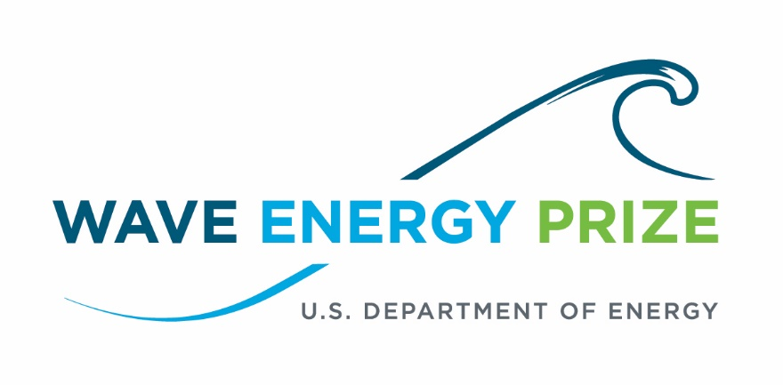

Coverage of the Wave Energy Prize
October 1, 2014-November 30, 2016

Prepared by Polaris Strategic Communications and Ricardo, Inc.

Contents

World Maritime News
WEC Prize Competition registration date set (Jan. 27, 2015)
http://tidalenergytoday.com/2015/01/27/wec-prize-competition-registration-set-for-april-15/

Solar Thermal Magazine

Official Registration for the DOE Sponsored Wave Energy Prize Opens April 2015 (Jan. 28, 2015)
https://solarthermalmagazine.com/2015/01/28/official-registration-doe-sponsored-wave-energy-prize-opens-april-2015/

Ecopreneurist

Wave Energy Prize Challenge Seeks to Halve the Cost (Feb. 4, 2015)
http://ecopreneurist.com/2015/02/03/wave-energy-prize-challenge-seeks-to-halve-the-cost/

Clean Technica

Wave Energy Prize Aims To Cut Costs Of Wave Energy Production In Half (Feb. 10, 2015)
http://cleantechnica.com/2015/02/10/wave-energy-prize-aims-cut-costs-wave-energy-production-half/

AltEnergyMag

What is the Wave Energy Prize? (Feb. 16, 2015)

http://www.altenergymag.com/emagazine/2015/02/us-department-of-energys-wave-energy-prize/2406

ClimateSpectator

Surf’s up – can wave energy rise to the challenge in Australia? (Feb. 19, 2015)
https://www.businessspectator.com.au/article/2015/2/20/renewable-energy/surfs-%E2%80%93-can-wave-energy-rise-challenge-australia

Renewable Energy World

Wave and Tidal Energy in 2015: Finally Emerging from the Labs (Feb. 25, 2015)

http://www.renewableenergyworld.com/rea/news/article/2015/02/wave-and-tidal-energy-in-2015-finally-emerging-from-the-labs

Green Living Ideas

The Future of Wave Power (March 2, 2015)
http://greenlivingideas.com/2015/02/03/future-of-wave-power/

World Maritime News

Public comments open for Wave Energy Prize Rules Draft (March 17, 2015)

http://tidalenergytoday.com/2015/03/17/public-comments-open-for-wave-energy-prize-rules-draft/

Hydro World

Energy Department prize challenge incentivizes wave energy conversion next generation ideas (April 2, 2015)

http://www.hydroworld.com/articles/2015/04/energy-department-prize-challenge-incentivizes-wave-energy-conversion-next-generation-ideas.html

Ocean News and Technology
U.S. Department of Energy Looks to Revolutionary Innovation for Harnessing Wave Energy (April 22, 2015)
https://www.oceannews.com/feature-story/2015/04/22/april-editorial-focus-doe

Hydro World
DOE looking for tech boom with new Wave Energy Prize (April 27, 2015)
http://www.hydroworld.com/articles/2015/04/doe-looking-for-tech-boom-with-new-wave-energy-prize.html

EIN News
Energy Department Launches Competition to Drive Innovations in Wave Energy (April 27, 2015)
http://www.einnews.com/pr_news/262296974/energy-department-launches-competition-to-drive-innovations-in-wave-energy

Solar Thermal Magazine
U.S. DOE Launches Competition to Drive Innovations in Wave Energy (April 27, 2015)
https://solarthermalmagazine.com/2015/04/27/u-s-doe-launches-competition-to-drive-innovations-in-wave-energy/

Domestic Fuel
DOE Announces Wave Energy Prize (April 28, 2015)
http://domesticfuel.com/2015/04/28/doe-announces-wave-energy-prize/

reNews
US floats wave prize (April 28, 2015)
http://renews.biz/87739/doe-floats-wave-price/

Tidal Energy Today
US DoE launches Wave Energy Prize competition (April 28, 2015)
http://tidalenergytoday.com/2015/04/28/us-doe-launches-wave-energy-prize-competition/

Power Systems Design
Energy Department launches competition to drive innovation in wave energy (April 28, 2015)
http://www.powersystemsdesign.com/energy-department-launches-competition-to-drive-innovation-in-wave-energy

The Maritime Executive
Energy Department Launches Wave Energy Prize Competition (April 28, 2015)
http://www.maritime-executive.com/pressrelease/energy-department-launches-wave-energy-prize-competition

ECO Magazine
Funding: Over $2 Million in Wave Energy Prizes (April 29, 2015)
http://www.ecomagazine.com/news-briefs/funding-over-2-million-in-wave-energy-prizes.html

International Water Power & Dam Construction
Registration open for US DOE’s Wave Energy Prize (April 29, 2015)
http://www.waterpowermagazine.com/news/newsregistration-open-for-us-does-wave-energy-prize-4565344

AltEnergyMag
Department of Energy Wave Energy Prize Kicks Off Annual NHA/IMREC Conference (April 29, 2015)
http://www.altenergymag.com/news/2015/04/28/department-of-energy-wave-energy-prize-kicks-off-annual-nhaimrec-conference-/19757/

HydroWorld
NHA 2015 Annual Conference Special Edition Newscast (May 2, 2015)
http://www.hydroworld.com/topics/m/video/104661581/nha-2015-annual-conference-special-edition-newscast.htm​

Targeted News Service
DOE Establishes $2 Million in Prizes for Wave Energy Concepts (May 3, 2015)
http://targetednews.com/display_story.php?s_id=1203666

Southeast Green
Energy Department Launches Competition to Drive Innovations in Wave Energy (May 4, 2015)
http://www.southeastgreen.com/index.php/news/washington-dc/13347-energy-department-launches-competition-to-drive-innovations-in-wave-energy

Voice of America
US Energy Agency Announces Wave Energy Prize Competition (May 4, 2015)
http://www.voanews.com/content/department-of-energy-wave-energy-prize-competition/2748293.html

Big News Network
US Energy Agency Announces Wave Energy Prize Competition (May 4, 2015)
http://www.bignewsnetwork.com/index.php/sid/232546711

CleanTechnica
Registration Open For The New Wave Energy Prize Competition (May 9, 2015)
http://cleantechnica.com/2015/05/09/registration-open-new-wave-energy-prize-competition/

Hydro World
DOE offers prize challenge for wave energy conversion ideas (May 20, 2015)
http://www.hydroworld.com/articles/hr/print/volume-34/issue-4/departments/marine-hydrokinetics.html

Tidal Energy Today
Wave Energy Prize extends registration deadline (June 15, 2015)
http://tidalenergytoday.com/2015/06/15/wave-energy-prize-extends-registration-deadline/

Hydro World
DOE looks for tech boom with new Wave Energy Prize announcement
(June 29, 2015)
http://www.hydroworld.com/articles/hr/print/volume-34/issue-5/departments/marine-hydrokinetics.html

Tidewater Current
Virginia Joins Wave Energy Competition (July 6, 2015)
http://www.tidewatercurrent.com/2015_summer/energy.html

Domestic Fuel
Wave Energy Prize Entrants Move Forward (July 7, 2015)
http://energy.agwired.com/2015/07/07/wave-energy-prize-entrants-move-forward/

Popular Science
For The First Time, Waves Are Adding Power To The U.S. Grid (July 7, 2015)
http://www.popsci.com/waves-are-adding-power-grid-hawaii

Business Insider
The US just tapped into a surprising source of renewable energy for the first time (July 8, 2015)
http://www.businessinsider.com/hawaii-is-using-waves-to-power-homes-for-the-first-time-2015-7

Fierce Energy
Water water everywhere, but is it too soon for wave energy? (July 8, 2015)
http://www.fierceenergy.com/story/water-water-everywhere-it-too-soon-wave-energy/2015-07-08

Hydro World
More than 90 teams enter U.S. DOE's Wave Energy Prize program (July 8, 2015)
http://www.hydroworld.com/articles/2015/07/more-than-90-teams-enter-u-s-doe-s-wave-energy-prize-program.html

Phys.org
Wave energy device is watched for clean power in Hawaii (July 9, 2015)
http://phys.org/news/2015-07-energy-device-power-hawaii.html

Tidal Energy Today
US Wave Energy Prize: Race-on for 92 teams (July 13, 2015)
http://tidalenergytoday.com/2015/07/13/us-wave-energy-prize-race-on-for-92-teams/

OffshoreWIND.biz
USD 2 Mln Wave Energy Prize Attracts 92 Teams (July 13, 2015)
http://www.offshorewind.biz/2015/07/13/usd-2-mln-wave-energy-prize-attracts-92-teams/

HydroWorld
COER competition could help marine hydrokinetic development (July 27, 2015)
http://www.hydroworld.com/articles/2015/07/coer-competition-could-help-marine-hydrokinetic-development.html

energybiz
Wave energy test rolling forward in Hawaii (July 28, 2015)
http://www.energybiz.com/article/15/07/wave-energy-test-rolling-forward-hawaii

E&E News (ClimateWire)
Infant U.S. wave-to-energy industry looks to build more testing facilities (Aug. 7, 2015)
http://www.eenews.net/stories/1060023142

Virginia Public Radio

West Coast Waves Promise Clean Power (Aug. 12, 2015)

http://wvtf.org/post/west-coast-waves-promise-clean-power#stream/0

HydroWorld
DOE selects 20 teams to advance in Wave Energy Prize program (Aug. 14, 2015)
http://www.hydroworld.com/articles/2015/08/doe-selects-20-teams-to-advance-in-wave-energy-prize-program.html

HydroWorld
Hydro Headlines Weekly Newscast (Aug. 14, 2015)
http://www.hydroworld.com/index.html

Virginia Public Radio
Virginia Company A Leader in Marine Energy (Aug. 14, 2015)
http://wvtf.org/post/virginia-company-leader-marine-energy#stream/0

Marine Technology News
Twenty Teams Vie for Wave Energy Prize (Aug. 14, 2015)
http://www.marinetechnologynews.com/news/twenty-teams-energy-prize-519330

Tidal Energy Today
US Wave Energy Prize advances 20 teams to next stage (Aug. 17, 2015)
http://tidalenergytoday.com/2015/08/17/us-wave-energy-prize-advances-20-teams-to-next-stage/

renews
DoE picks top wave devices (Aug. 17, 2015)
http://renews.biz/93779/doe-picks-top-wave-devices/

AltEnergyMag
Twenty Teams Advancing to Next Phase of the Wave Energy Prize (Aug. 17, 2015)
http://www.altenergymag.com/news/2015/08/17/twenty-teams-advancing-to-next-phase-of-the-wave-energy-prize-/21037/

MIT Sea Grant Program
MIT Sea Grant led team advances to next phase of the Wave Energy Prize Contest (Aug. 17, 2015)
http://seagrant.mit.edu/press_releases.php?nwsID=509

Oregon Wave Energy Trust
Twenty Teams Advancing to Next Phase of the Wave Energy Prize (Aug. 17, 2015)
http://oregonwave.org/news/twenty-teams-advancing-to-next-phase-of-the-wave-energy-prize/

offshoreWIND.biz
20 Teams Qualify for DOE Wave Energy Prize (Aug. 17, 2015)
http://www.offshorewind.biz/2015/08/17/20-teams-qualify-for-doe-wave-energy-prize/

Renewable Energy Focus
Twenty teams advancing to next phase of the Wave Energy Prize (Aug. 20, 2015)
http://www.renewableenergyfocus.com/view/42782/twenty-teams-advancing-to-next-phase-of-the-wave-energy-prize/

Popular Science
A New Energy Plant In Hawaii Generates Power From Ocean Temperature Extremes (Aug. 24, 2015)
http://www.popsci.com/new-energy-plant-hawaii-uses-ocean-temperatures

renews
M3 Wave eyes energy prize (Aug. 25, 2015)
http://renews.biz/94338/m3-wave-eyes-energy-prize/

Tidal Energy Today
M3 Wave to unveil NEXUS wave energy device (Aug. 25, 2015)
http://tidalenergytoday.com/2015/08/26/m3-wave-to-unveil-nexus-wave-energy-device/

Sea Technology
92 Teams Submit Technical Description of WECs to DOE (August 2015)
http://www.sea-technology.com/news/mar_resources.php

Hydro Review
DOE's Wave Energy Prize narrowed to 20 teams (Sept. 17, 2015)
http://www.hydroworld.com/articles/hr/print/volume-34/issue-7/departments/marine-hydrokinetics.html

Hydro World
Lignum Vitae North America donates bearings to teams in the Wave Energy Prize Challenge (Sept. 23, 2015)
http://www.hydroworld.com/articles/2015/09/lignum-vitae-donates-bearings-to-teams-in-the-wave-energy-prize-challengeb.html
AltEnergyMag
Technical Summaries of Wave Energy Prize Qualified Teams (Oct. 1, 2015)
http://www.altenergymag.com/article/2015/09/technical-summaries-of-wave-energy-prize-official-qualified-teams/21560

EnergyBiz Magazine
Wave Energy Test Rolling Forward in Hawaii (Fall 2015)
http://www.energybiz.com/magazine/article/433323/wave-energy-test-rolling-forward-hawaii

Tidal Energy Today
Sea Potential prepares DUO wave energy converter for testing (Nov. 3, 2015)
http://tidalenergytoday.com/2015/11/03/sea-potential-prepares-duo-wave-energy-converter-for-testing/

Tidal Energy Today
AWP backs out of Wave Energy Prize (Nov. 5, 2015)
http://tidalenergytoday.com/2015/11/05/awp-backs-out-of-wave-energy-prize/

renews
Atlantic quits DoE competition (Nov. 5, 2015)
http://renews.biz/100364/atlantic-quits-doe-competition/

Tidal Energy Today
Another company withdraws from Wave Energy Prize (Nov. 11, 2015)
http://tidalenergytoday.com/2015/11/11/another-company-withdraws-from-wave-energy-prize/

Tidal Energy Today
Sea Potential performs wet tests on DUO WEC (Nov. 26, 2015)
http://tidalenergytoday.com/2015/11/26/sea-potential-performs-wet-tests-on-duo-wec/

The Weather Channel
Harnessing Wave Energy for Power (Dec. 11, 2015)
http://www.weather.com/tv/shows/amhq/video/harnessing-wave-energy-for-power

Tidal Energy Today
Atlas Ocean concludes scaled WEC testing (Dec. 15, 2015)
http://tidalenergytoday.com/2015/12/15/atlas-ocean-concludes-scaled-wec-testing/

Tidal Energy Today
USA: UMaine wave energy testing underway (Dec. 18, 2015)
http://tidalenergytoday.com/2015/12/18/usa-umaine-wave-energy-testing-underway/

National Geographic
8 Tech Breakthroughs of 2015 That Could Help Power the World (Dec. 29, 2015)
http://news.nationalgeographic.com/energy/2015/12/151228-eight-tech-breakthroughs-that-could-help-power-the-world/

Tidal Energy Today
Wave Energy Prize: Teams to finish scaled testing end of January (Jan. 4, 2016)
http://tidalenergytoday.com/2016/01/04/wave-energy-prize-teams-to-finish-scaled-testing-end-of-january/

The Straits Times
8 Tech Breakthroughs of 2015 That Could Help Power the World (Jan. 10, 2016)
http://www.straitstimes.com/opinion/8-tech-breakthroughs-in-2015-that-could-help-power-the-world

NYU ScienceLine

A new paradigm for renewable energy (Jan. 17, 2016)

http://scienceline.org/2016/01/a-new-paradigm-for-renewable-energy/

Tidal Energy Today
VIDEO: AquaHarmonics’ scaled WEC testing (Jan. 25, 2016)
http://tidalenergytoday.com/2016/01/25/video-aquaharmonics-scaled-wec-testing/

Tidal Energy Today
VIDEO: Oscilla Power’s Triton WEC (Jan. 27, 2016)
http://tidalenergytoday.com/2016/01/27/video-oscilla-powers-triton-wec/

Engineering News Record
Three Firms Test Wave-Power Models at UMaine's 'W2' Lab (Jan. 28, 2016)
http://www.enr.com/articles/38716-three-firms-test-wave-power-models-at-umaines-w2-lab

Virginia Tech News
Squid-inspired wave energy converter turns ocean's power into electricity (Feb. 12, 2016)
http://www.vtnews.vt.edu/articles/2016/02/021216-ictas-waveenergyprize.html

AltEnergyMag
U.S. Department of Energy’s Wave Energy Prize Announces Finalist Teams (March 1, 2016)
http://www.altenergymag.com/news/2016/03/01/us-department-of-energy%E2%80%99s-wave-energy-prize-announces-finalist-teams/22995

Hydro World
DOE announces Wave Energy Prize finalists (March 1, 2016)
http://www.hydroworld.com/articles/2016/03/doe-wave-energy-prize-announces-finalists.html

MarineLink
Finalists Complete for $2 Mln Wave Energy Prize (March 1, 2016)
http://www.marinelink.com/news/finalists-complete-energy405952.aspx

Pete Danko Clean Energy News & Commentary
Two Oregon Teams Reach Wave Energy Prize Finals (March 1, 2016)
http://petedanko.net/two-oregon-teams-reach-wave-energy-prize-finals/

Maritime Global News
Finalists Complete for $2 Mln Wave Energy Prize (March 1, 2016)
http://maritimeglobalnews.com/news/finalists-complete-energy-prize-c34nrs

Oregon Wave Energy Trust
Energy Department Announces Finalists Vying for $2.25 Million Wave Energy Prize (March 1, 2016)
http://oregonwave.org/news/energy-department-announces-finalists-vying-for-2-25-million-wave-energy-prize/

Tidal Energy Today
Wave Energy Prize unveils finalist teams (March 2, 2016)
http://tidalenergytoday.com/2016/03/02/wave-energy-prize-unveils-finalist-teams/

Renews
Finalists eye Wave Energy Prize (March 2, 2016)
http://renews.biz/101765/finalists-eye-doe-wave-energy-prize/

Network World
Energy Dept. sets 9 finalists for $2.25M wave energy prize (March 2, 2016)
http://www.networkworld.com/article/3040323/data-center/energy-dept-sets-9-finalists-for-2-25m-wave-energy-prize.html

Inside Climate News
Not Just Riding the Waves, These Competitors Seek to Harness Their Energy (March 7, 2016)
http://insideclimatenews.org/news/06032016/wave-energy-power-department-energy-contest-renewable-climate-change

Belfast News Letter
Pure Marine on the crest of a US wave (March 8, 2016)
http://www.newsletter.co.uk/news/ni-business-news/pure-marine-on-the-crest-of-a-us-wave-1-7259575#ixzz42KDbbuE0

News Channel 10 (CA – CBS affiliate)
SEWEC Named Finalist in U.S. Department of Energy's Wave Energy Prize (March 8, 2016)
http://www.newschannel10.com/story/31414156/sewec-named-finalist-in-us-department-of-energys-wave-energy-prize

Renewable Energy World
DOE Announces Wave Energy Prize Finalists (March 9, 2016)
http://www.renewableenergyworld.com/articles/hydro/2016/03/doe-wave-energy-prize-announces-finalists.html

EERE Network News
Energy Department Announces Finalists Vying for Wave Energy Prize (March 9, 2016)
http://apps1.eere.energy.gov/news/news_detail.cfm/news_id=22185

International Water Power and Dam Construction
Nine teams get to final of US Govt’s Wave Energy Prize (March 11, 2016)
http://www.waterpowermagazine.com/news/newsnine-teams-get-to-final-of-us-govts-wave-energy-prize-4836614?utm_source=twitterfeed&utm_medium=twitter

Seacoastonline.com

York business a finalist in National Wave Energy Contest (March 15, 2016)
http://www.seacoastonline.com/article/20160315/NEWS/160319536

IHS Engineering 360
Wave Energy: Chasing the Big One (March 17, 2016)
http://insights.globalspec.com/article/2312/wave-energy-chasing-the-big-one

Tidal Energy Today
Waveswing America gears up for June WEC testing (March 25, 2016)
http://tidalenergytoday.com/2016/03/25/waveswing-america-gears-up-for-june-wec-testing/

Tidal Energy Today
Oscilla Power to test wave device in July (April 1, 2016)
http://tidalenergytoday.com/2016/04/01/oscilla-power-to-test-wave-device-in-july/

Fosters.com
Harnessing the ocean (April 3, 2016)
http://www.fosters.com/article/20160403/NEWS/160409904

Energy Harvesting Journal
Finalist in wave energy prize competition (April 13, 2016)
http://www.energyharvestingjournal.com/articles/9325/finalist-in-wave-energy-prize-competition

Tidal Energy Today
Who’s judging technology competing for Wave Energy Prize? (April 15, 2016)
http://tidalenergytoday.com/2016/04/15/whos-judging-technology-competing-for-wave-energy-prize/

Hydro Review
Update on DOE’s Wave Energy Prize (April 2016)
http://www.hydroworld.com/articles/hr/print/volume-35/issue-3/articles/update-on-doe-s-wave-energy-prize.html

Sea Technology Magazine
Catalyzing Advancements in Ocean Energy (April 2016)
http://www.sea-technology.com/news/archives/2016/soapbox/soapbox0416.php

Marine Technology Reporter
The Chase for $2m Prize (April 2016)
http://www.marinetechnologynews.com/magazine

Amped Up!
Wave Energy Prize Inspires Innovation (March/April 2016)
http://energy.gov/sites/prod/files/2016/04/f30/amped_up_vol_2_number_2.pdf

Tidal Energy Today
Sea Potential works on DUO WEC optimization (May 5, 2016)
http://tidalenergytoday.com/2016/05/05/sea-potential-works-on-duo-wec-optimization/

GTown Radio
Planet Philadelphia Podcast (May 6, 2016)
http://planetphila.weebly.com/podcasts

Tidal Energy Today
Waveswing America starts WEC construction (May 10, 2016)
http://tidalenergytoday.com/2016/05/10/waveswing-america-starts-wec-construction/

Hydro World
Hydro Headlines Weekly Newscast (May 12, 2016)
http://www.hydroworld.com/topics/m/video/115149031/www-2016-m3-wave-llc.htm?eid=326856542&bid=1404872

Tidal Energy Today
Introducing Mocean Energy’s hinged raft WEC (May 13, 2016)
http://tidalenergytoday.com/2016/05/13/introducing-mocean-energys-hinged-raft-wec/

Utility Dive
Making waves: DOE reboots marine hydrokinetic energy program to push commercialization (May 18, 2016)
http://www.utilitydive.com/news/making-waves-doe-reboots-marine-hydrokinetic-energy-program-to-push-commer/419200/

Tidal Energy Today
Wave Energy Prize Teams presented at Waterpower Week (May 20, 2016)
http://tidalenergytoday.com/2016/05/20/wave-energy-prize-teams-presented-at-waterpower-week/

Clean Technica
Waves & Tides Star As DOE Rekindles Marine Hydrokinetic Energy Program, Targeting Commercialization (May 20, 2016)
http://cleantechnica.com/2016/05/20/waves-tides-star-as-doe-rekindles-marine-hydrokinetic-energy-program/

Tidal Energy Today
SEWEC starts WEC assembly process (May 23, 2016)
http://tidalenergytoday.com/2016/05/23/sewec-starts-wec-assembly-process/

Renewable Energy World
Award-winning Wave Energy (June 1, 2016)
http://www.renewableenergyworld.com/articles/print/volume-19/issue-6/departments-columns/hydro-here-and-now/award-winning-wave-energy.html

The Energy Times
West Coast Ocean Power Surge (June 3, 2016)
http://tdworld.com/news/west-coast-ocean-power-surge-0

Tidal Energy Today
Wave Energy Prize recap ahead of TG3 review (June 17, 2016)
http://tidalenergytoday.com/2016/06/17/wave-energy-prize-recap-ahead-of-tg3-review/

Tidal Energy Today
Video: Harvest Wave Energy scale WEC testing (June 20, 2016)
http://tidalenergytoday.com/2016/06/20/video-harvest-wave-energy-scale-wec-testing/

University of California News

From the test tank to the open ocean: Wave energy’s make-or-break moment (June 20, 2016)
http://universityofcalifornia.edu/news/calwave

Tidal Energy Today
Waveswing America makes waves in Iowa (June 23, 2016)
http://tidalenergytoday.com/2016/06/23/waveswing-america-makes-waves-in-iowa/

Materials Science Research Bulletin
Challenge prize offer unique opportunities for materials innovation (July 2016)
(no link)

Tidal Energy Today
Finalists move ahead in Wave Energy Prize (July 4, 2016)
http://tidalenergytoday.com/2016/07/04/finalists-move-ahead-in-wave-energy-prize/

Portland Business Journal

Portland startup's wave invention lands on national stage (July 21, 2016)

http://www.bizjournals.com/portland/blog/sbo/2016/07/portland-startups-wave-invention-lands-on-national.html

Tidal Energy Today
Triton WEC heads to Carderock (July 22, 2016)
http://tidalenergytoday.com/2016/07/22/triton-wec-heads-to-carderock/

Solar Thermal Magazine
Wave Energy Prize Team Updates (July 25, 2016)
https://solarthermalmagazine.com/2016/07/25/wave-energy-prize-team-updates/

Tidal Energy Today
Video: AquaHarmonics to test at Carderock end of August (July 28, 2016)
http://tidalenergytoday.com/2016/07/28/video-aquaharmonics-to-test-at-carderock-end-of-august/

HydroWorld
DOE to fund test facility for U.S. waters as Wave Energy Prize competition continues (August 2, 2016)
http://www.hydroworld.com/articles/2016/08/doe-to-fund-test-facility-for-u-s-waters-as-wave-energy-prize-competition-continues.html

Oregon Best
M3 Wave to be First in the Water as Part of DOE Wave Prize Competition (Aug. 2, 2016)
http://oregonbest.org/news-events/news/item/news/News/action/detail/story/m3-wave-to-be-first-in-the-water-as-part-of-doe-wave-prize-competition/

Tidal Energy Today
M3 Wave to Test NEXUS Next Week (Aug. 3, 2016)
http://tidalenergytoday.com/2016/08/03/m3-wave-to-test-nexus-next-week/

Tidal Energy Today
Video: Test tank for Wave Energy Prize finalists (Aug. 9, 2016)
http://tidalenergytoday.com/2016/08/09/video-test-tank-for-wave-energy-prize-finalists/

Tidal Energy Today
Video: M3 Wave tests wave energy device in MASK Basin (Aug. 16, 2016)
http://tidalenergytoday.com/2016/08/16/video-m3-wave-tests-wave-energy-device-in-mask-basin/

Salon.com
Is blue the new green? Wave power could revolutionize the renewable-energy game (Aug. 27, 2016)
http://www.salon.com/2016/08/27/is-blue-the-new-green-wave-power-could-revolutionize-the-renewable-energy-game/

Navy News Service
Carderock Supports Energy Innovation with Wave Energy Prize Tests (Aug. 29, 2016)
http://www.navy.mil/submit/display.asp?story_id=96431

OSTP Blog
Prizes Creating “Waves” in the Energy Sector (Aug. 31, 2016)
https://www.whitehouse.gov/blog/2016/08/31/prizes-creating-waves-energy-sector
Belfast Telegraph
Scheme gives Northern Ireland tech companies the chance to pitch directly to Prince Andrew (Sept. 6, 2016)
http://www.belfasttelegraph.co.uk/business/news/scheme-gives-northern-ireland-tech-companies-the-chance-to-pitch-directly-to-prince-andrew-35022835.html

Tidal Energy Today
Video: Ongoing Wave Energy Prize WECs testing (Sept. 9, 2016)
http://tidalenergytoday.com/2016/09/09/video-ongoing-wave-energy-prize-wecs-testing/

WUSA-9 (CBS affiliate)
Teams compete to find clean energy using the ocean's waves (Sept. 15, 2016)
http://www.wusa9.com/news/local/maryland/teams-compete-to-find-clean-energy-using-the-oceans-waves/319286887

Providence Journal
Providence energy developer’s DUO device is a finalist for $1.5M award (Sept. 18, 2016)
http://www.providencejournal.com/news/20160918/providence-energy-developers-duo-device-is-finalist-for-15m-award

Tidal Energy Today
Wave energy testing at Carderock nears conclusion (Sept. 28, 2016)
http://tidalenergytoday.com/2016/09/28/wave-energy-testing-at-carderock-nears-conclusion/

PDQ@RWU

Architecture Student Collaborates on Wave Energy Project Competing for $1.5 Million (Oct. 5, 2016)

http://pdq.rwu.edu/news/architecture-student-collaborates-wave-energy-project-competing-15-million

Product Design & Development

Can Department of Energy Prize Encourage the Proliferation of Wave Energy Projects? (Oct. 12, 2016)
https://www.pddnet.com/news/2016/10/can-department-energy-prize-encourage-proliferation-wave-energy-projects

White House Blog

Advancing the Frontiers of Clean Energy Innovation (Oct. 13, 2016)

https://www.whitehouse.gov/blog/2016/10/12/advancing-frontiers-clean-energy-innovation

Eureka Alert!

Wave energy researchers dive deep to advance clean energy source (Oct. 13, 2016)

https://www.eurekalert.org/pub_releases/2016-10/ddoe-wer101316.php

AZO Cleantech

Sandia Engineers Try to Optimize Performance of Wave-Energy Converters (Oct. 14, 2016)

http://www.azocleantech.com/news.aspx?newsID=23758

Tidal Energy Today

White House Frontiers Conference welcomes wave energy (Oct. 20, 2016)

http://tidalenergytoday.com/2016/10/20/white-house-frontiers-conference-welcomes-wave-energy/

WRAL TechWire

Triangle startup Harvest Wave Energy draws White House attention (+ video) (Oct. 28, 2016)

http://wraltechwire.com/triangle-startup-harvest-wave-energy-draws-white-house-attention-video-/16170724/
Tidal Energy Today
Wave Energy Prize winner to be unveiled mid-November (Nov. 1, 2016)
http://tidalenergytoday.com/2016/11/01/wave-energy-prize-winner-to-be-unveiled-mid-november/

Portland Business Journal

Portland wave energy team snags a coveted $1.5M prize (Nov. 16, 2016)

http://www.bizjournals.com/portland/news/2016/11/16/portland-wave-energy-team-snags-a-coveted-1-5m.html

renews

AquaHarmonics wins wave prize (Nov. 16, 2016)

http://renews.biz/104946/aquaharmonics-scoops-us-wave-prize/

Voice of America
Team Wins $1.5 Million for Wave Energy Device (Nov. 17, 2016)
https://www.youtube.com/watch?v=mvFe1RXWKgU

Tidal Energy Today
AquaHarmonics scoops $1.5M US wave prize (Nov. 17, 2016)
http://tidalenergytoday.com/2016/11/17/aquaharmonics-scoops-1-5m-us-wave-prize/

Navy News Service
Carderock Division Hosts Wave Energy Prize Innovation Showcase (Nov. 17, 2016)

http://www.navy.mil/submit/display.asp?story_id=97733

UC Newsroom

CalWave rides Wave Energy Prize (Nov. 17, 2016)

https://www.universityofcalifornia.edu/news/uc-startup-rides-coveted-wave-energy-prize

HydroWorld

DOE names AquaHarmonics winner of US$1.5 million in Wave Energy Prize competition (Nov. 17, 2016)

http://www.hydroworld.com/articles/2016/11/doe-names-aquaharmonics-winner-of-us-1-5-million-in-wave-energy-prize-competition.html

Utility Dive

Wave energy developer AquaHarmonics wins DOE $1.5M prize (Nov. 17, 2016)

http://www.utilitydive.com/news/wave-energy-developer-aquaharmonics-wins-doe-15m-prize/430633/

Marine Technology News

Wave Energy Prize's $1.5 Million Winner Announced (Nov. 17, 2016)

http://www.marinetechnologynews.com/news/energy-prize-million-winner-541493

KATU-2 (Portland, OR)

Portland wave-energy company wins grand prize in USDOE competition (Nov. 17, 2016)

http://katu.com/news/local/portland-wave-energy-company-wins-1st-place-in-usdoe-prize
SeeNews Renewables

AquaHarmonics wins USD-1.5m wave energy grant from US DOE (Nov. 17, 2016)

https://renewables.seenews.com/news/aquaharmonics-wins-usd-1-5m-wave-energy-grant-from-us-doe-547346

Kallanish Energy

AquaHarmonics wins $1.5 million Wave Energy Prize (Nov. 18, 2016)

https://www.kallanishenergy.com/2016/11/18/aquaharmonics-wins-1-5-million-wave-energy-prize/

Clean Technica
Giant Floating Frisbee Wins $1.5 Million Wave Energy Grant From DOE (Nov. 18, 2016)
https://cleantechnica.com/2016/11/18/giant-floating-frisbee-wins-1-5-million-wave-energy-grant-doe/

The Maritime Executive
Over $2 Million for Wave Energy Winners (Nov. 18, 2016)
http://www.maritime-executive.com/article/over-2-million-for-wave-energy-winners

Tolerance.ca
Team Wins $1.5 Million for Wave Energy Device (Nov. 18, 2016)
http://www.tolerance.ca/ArticleExt.aspx?ID=332086&L=en

KBND (radio)
Portland Company Wins Wave Energy Tech Grant (Nov. 18, 2016)
http://kbnd.com/kbnd-news/regional-news/280552

Portland Business Journal
The breakthrough that won the $1.5M Wave Energy Prize for Portland's AquaHarmonics (Nov. 22, 2016)
http://www.bizjournals.com/portland/news/2016/11/22/the-breakthrough-that-won-the-1-5m-wave-energy.html

ExecutiveBiz

AquaHarmonics Wins DOE Wave Energy Converter Devt Competition (Nov. 21, 2016)
http://blog.executivebiz.com/2016/11/aquaharmonics-wins-doe-wave-energy-converter-devt-competition/

Daily Energy Insider
Energy Department awards AquaHarmonics Wave Energy Prize (Nov. 22, 2016)
https://dailyenergyinsider.com/industry/2339-energy-department-awards-aquaharmonics-wave-energy-prize/

Planetsave
Wave Energy Converter Prize is Awarded to AquaHarmonics (Nov. 23, 2016)
http://planetsave.com/2016/11/23/wave-energy-converter-technology-development-prize-awarded-aquahamonics/

ENGINEERING.com
Two Guys in a Garage Win $1.5M Wave Energy Prize (Nov. 27, 2016)
http://www.engineering.com/ElectronicsDesign/ElectronicsDesignArticles/ArticleID/13782/Two-Guys-in-a-Garage-Win-15M-Wave-Energy-Prize.aspx

E&E News

2016 — the end or beginning of an era for marine energy? (Nov. 28, 2016)

http://www.eenews.net/stories/1060046254

Interesting Engineering

Garage Project Garners $1.5 Million Energy Award (Nov. 29, 2016)

http://interestingengineering.com/garage-project-garners-1-5-million-award/

Energy Harvesting Journal
AquaHarmonics wins wave energy prize (Nov. 30, 2016)
http://www.energyharvestingjournal.com/articles/10286/aquaharmonics-wins-wave-energy-prize

World Maritime News

WEC Prize Competition registration date set

Jan. 27, 2015
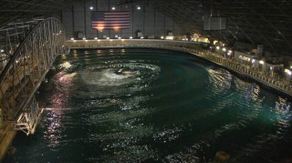
The Wave Energy Prize is a public prize challenge sponsored by the U.S. Department of Energy’s Water Power Program that aims to encourage the development of more efficient wave energy conversion (WEC) devices.
Registration for the Wave Energy Prize opens online on April 1, 2015, with access to the Wave Energy Prize Rules, and closes on June 15.
The Water Power Program awarded USD 6.5 million to Prize Administration Team led by Ricardo Inc. for the execution of the competition.
The WEC Prize aims to attract innovative ideas from developers by offering a monetary prize to participants and by providing an opportunity for tank testing and evaluation of scaled WEC prototypes.
The Carderock Division in West Bethesda, Maryland will allow WEC Prize participants to put their WEC devices to the test to see how much energy they can extract from waves in real-life wave scenarios. It houses several basins, including the Maneuvering and Seakeeping basin which is 110 m long, 73 m wide, and 6 m deep, and has 216 individually-controlled paddles, the DoE’s press release reads.
U.S. entities are able to participate in the Wave Energy Prize. This includes U.S. persons and companies as well as foreign companies that are incorporated in and maintain a primary place of business in the United States.

Solar Thermal Magazine

Official Registration for the DOE Sponsored Wave Energy Prize Opens April 2015

By U.S. DOE Renewable Energy; Jan. 28, 2015
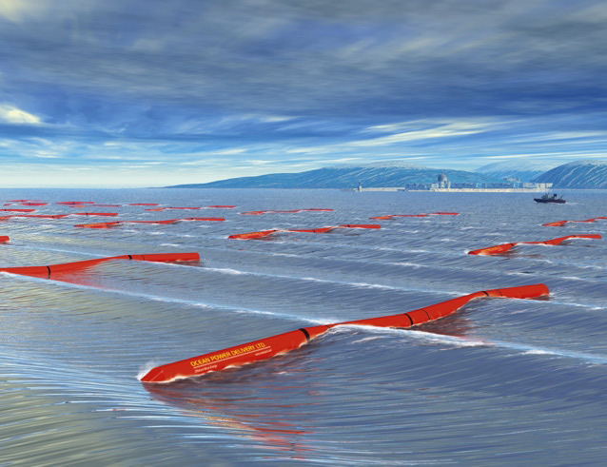Pelamis wave energy convertor
The Wave Energy Prize is a public prize challenge sponsored by the U.S. Department of Energy (DOE)’s Water Power Program. The prize is designed to increase the diversity of organizations involved in Wave Energy Converter (WEC) technology development, while motivating and inspiring existing stakeholders. DOE envisions this competition will achieve game-changing performance enhancements to WEC devices, establishing a pathway to sweeping cost reductions on a commercial scale.
The wave energy industry is young and is experiencing many new innovations as evidenced by a sustained growth in patent activity. While the private industry is developing these early-concept WEC devices through design and benchtop prototype testing, funding is hard to secure for performance testing and evaluation of WEC devices in wave tanks at a meaningful scale. This is a problem for the industry since scaled WEC prototype tank testing, validation, and evaluation are key steps in the advancement of WEC technologies through the technical readiness levels to reach commercialization.

The Goal
The Wave Energy Prize will encourage the development of more efficient WEC devices that double the energy captured from ocean waves, which in turn will reduce the cost of wave energy, making it competitive with other traditional energy solutions.

Economic Impact
A successful Wave Energy Prize could jump-start private sector innovation critical to the country’s long-term economic growth, energy security, and international competitiveness in the wave energy conversion sector.

Why Participate?
The Wave Energy Prize seeks to attract innovative ideas from developers new to the industry and next-generation ideas from existing developers by offering a monetary prize purse and providing an opportunity for tank testing and evaluation of scaled WEC device prototypes at the U.S. Navy’s Maneuvering and Seakeeping Basin (MASK) facility in Carderock, MD.

Ecopreneurist

Wave Energy Prize Challenge Seeks to Halve the Cost

Feb. 4, 2015
Compared to some of the other renewable energy technologies, such as solar and wind, wave energy is still in its infancy (OK, maybe its early adolescence), and so far, wave energy advances haven’t yet come close to producing a cost-effective solution for electricity production.
And yet because some 50% of the US population lives within 50 miles of the coast, if it were more feasible, both in terms of efficiency and cost, wave energy could eventually prove to be a big contributor to the country’s renewable energy mix.
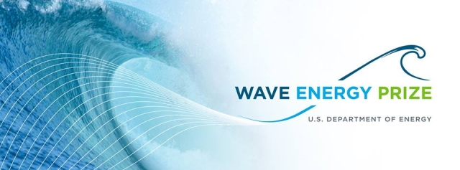An initiative from the US Department of Energy (DOE), sponsored by the Water Power Program, could give wave energy technology a big boost over the next year and a half.
“What if in the next two years the wave energy industry achieved a technology leap so revolutionary that it would make the cost of wave energy competitive with traditional sources of energy? This could be the result of the U.S. Department of Energy’s Wave Energy Prize.” – Wave Energy Prize
The Wave Energy Prize is looking for applicants who can design better wave energy conversion devices, with the goal being to produce a device with the potential to cut the cost of producing electricity from ocean waves by half. The 18-month competition will have participants design and build their wave energy device and then test and evaluate them at the US Navy’s Maneuvering and Seakeeping (MASK) Basin at Carderock, MD, with the overall winner taking in more than $1 million in cash prizes.
The Wave Energy Prize opens up to registration in April 2015, and the information on the site isn’t yet complete, but if you want to stay in the loop until then, sign up for the newsletter on the home page of the website.

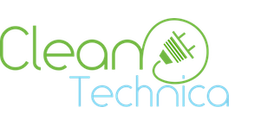

CleanTechnica

Wave Energy Prize Aims To Cut Costs Of Wave Energy Production In Half
By Derek Markham; Feb. 10, 2015
Originally published on Ecopreneurist.
Compared to some of the other renewable energy technologies, such as solar and wind, wave energy is still in its infancy (OK, maybe its early adolescence), and so far, wave energy advances haven’t yet come close to producing a cost-effective solution for electricity production.
And yet because some 50% of the US population lives within 50 miles of the coast, if it were more feasible, both in terms of efficiency and cost, wave energy could eventually prove to be a big contributor to the country’s renewable energy mix.
An initiative from the US Department of Energy (DOE), sponsored by the Water Power Program, could give wave energy technology a big boost over the next year and a half.
“What if in the next two years the wave energy industry achieved a technology leap so revolutionary that it would make the cost of wave energy competitive with traditional sources of energy? This could be the result of the U.S. Department of Energy’s Wave Energy Prize.” – Wave Energy Prize
The Wave Energy Prize is looking for applicants who can design better wave energy conversion devices, with the goal being to produce a device with the potential to cut the cost of producing electricity from ocean waves by half. The 18-month competition will have participants design and build their wave energy device and then test and evaluate them at the US Navy’s Maneuvering and Seakeeping (MASK) Basin at Carderock, MD, with the overall winner taking in more than $1 million in cash prizes.
The Wave Energy Prize opens up to registration in April 2015, and the information on the site isn’t yet complete, but if you want to stay in the loop until then, sign up for the newsletter on the home page of the website.
Reprinted with permission.

AltEnergyMag
What is the Wave Energy Prize?
By Alison LaBonte, U.S. Department of Energy; Feb. 16, 2015
The Department of Energy is investing in renewable energy through the Wave Energy Prize and is offering an opportunity for both seed funding and prize purses totaling more than $1 million for qualified prize participants.
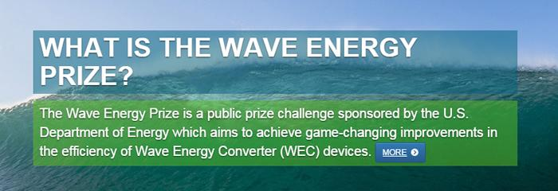

What is wave energy?
Wave energy is one form of marine renewable energy. Wave energy converts the energy in highly predictable ocean waves into electricity using a range of different technologies. Wave energy conversion (WEC) devices are in the early stages of technological development, and there are currently hundreds of potentially viable technologies in this emerging industry as researchers and developers seek to prove their technologies’ viability.

How much potential does wave energy have as a viable alternative energy source in the United States?
With more than 50 percent of the U.S. population living within 50 miles of coastlines, there is vast potential to provide clean, renewable electricity to communities and cities across the United States using wave energy. It is estimated that the technically recoverable wave energy resource is approximately 1,170 terawatt hours (TWh) per year, distributed across Alaska, the West Coast, the East Coast, the Gulf of Mexico, Hawaii, and Puerto Rico. Developing just a small fraction of the available wave energy resource could allow for millions of American homes to be powered with this clean, reliable form of energy. For context, approximately 85,000 homes could be powered by 1 TWh per year.

Are there examples of wave energy systems in use in other parts of the world?
The Open Energy Information (OpenEI) website houses critical public datasets and reports, maps and visualization tools, links to organizations working to advance the water power industries, and more. The Marine and Hydrokinetic Technology Database on OpenEI provides information on wave energy projects, both in the United States and around the world. You can also find information on wave energy systems in other parts of the world in the International Energy Agency’s Ocean Energy Systems annual report. Each year, the U.S. Department of Energy (DOE), along with several other countries, contributes to the report, which provides an overview of worldwide ocean energy developments.

What are the challenges to developing wave energy resources, and how will the Wave Energy Prize help solve some of the problems?
One challenge is that current WEC concepts are not yet cost competitive with other means of generating electricity. Thus, the Department sees an important opportunity in reducing the cost of wave energy so it can contribute to the nation’s clean energy supply. The Wave Energy Prize is one way to encourage the development of more efficient WEC devices, which in turn will reduce the cost of wave energy, making it competitive with traditional energy solutions.

Why did the Energy Department decide to do a prize challenge focused on wave energy?
The Energy Department sought to use a prize challenge to help dramatically improve the performance of WEC devices, providing a pathway to game-changing reductions in the cost of wave energy. Prize competitions set a high technical bar for participants to be eligible for a prize, facilitating rapid advancements in technical innovations at a relatively low cost to the sponsoring agency. The Wave Energy Prize aims to attract next generation ideas by offering a prize purse and providing an opportunity for testing at the nation’s most advanced wave-making facility, the Naval Surface Warfare Center’s Maneuvering and Seakeeping (MASK) Basin in Maryland.

What will participants have to do?
WEC devices can be greatly improved upon in terms of efficiency. Participants in the Wave Energy Prize will design and build a prototype of a WEC device that can capture at least twice as much wave energy as today’s technology.

What types of participants do you anticipate being drawn to the prize?
The Energy Department envisions a diverse group of Wave Energy Prize competitors, including corporations, small businesses, professional engineers, students, and entrepreneurs. It is open to all U.S. entities, which include U.S. persons and companies as well as foreign companies that are incorporated in and maintain a primary place of business in the United States.

What is the prize, is it a cash prize? How much?
The Department of Energy is investing in renewable energy through the Wave Energy Prize and is offering an opportunity for both seed funding and prize purses totaling more than $1 million for qualified prize participants.

What is the prize timeline– how long will it last, when does it kick off, etc?
Registration for the Wave Energy Prize is scheduled to open in April 2015. It is a year-and-a-half design-build-test competition. There are a number of milestones that teams will have to reach, including a technical submission and small-scale testing, before finalists are identified to participate in testing at the MASK basin in the summer of 2016. Winner(s) will be announced in September 2016. You can find a complete list of prize phases on the Wave Energy Prize website.
To learn more about the Wave Energy Prize, please visit the website: waveenergyprize.org.

Alison LaBonte
Alison LaBonte is the Marine and Hydrokinetic Technology Program Manager in the U.S. Department of Energy’s (DOE) Wind and Water Power Technologies Office. As the Program Manager, Alison is responsible for the development and execution of the nation's strategy for advancing marine renewable technologies to be viable, cost-competitive contributors to the clean energy economy. Alison came to Washington, D.C. in 2009 as an American Association for the Advancement of Science
(AAAS) fellow, and spent her fellowship term at the White House Office of Science and Technology Policy and the DOE Geothermal Technologies Program. Before her AAAS fellowship, Alison applied her technical expertise integrating scientific instrumentation with Canada’s NEPTUNE offshore cabled observatory (Postdoctoral Fellowship: University of Victoria), and designing, prototyping, and deploying new seafloor sensors (Engineering internship: Monterey Bay Aquarium Research Institute). Alison’s degrees are in Oceanography, (PhD: Scripps Institution of Oceanography), and Mathematics (BS: University of California, Los Angeles).

ClimateSpectator

Surf’s up – can wave energy rise to the challenge in Australia?
By Hugh Wolgamot; Feb. 19, 2015
The Conversation
Wednesday’s announcement that a pioneering wave farm off Perth has started generating electricity is an exciting and welcome development. The project, developed by Fremantle-based Carnegie Wave Energy, features two buoys, 11m in diameter, below the sea surface (with a third to follow).
The buoys are now generating electricity and supplying it to the nearby HMAS Stirling naval base. With this full scale plant now working, is an explosion in wave power imminent?
Australia is undoubtedly blessed with abundant wave energy. But as well as the size of the resource, it is important to consider how wave energy “adds up” in the context of Australia’s total power demand. Here Australia does extremely well – it is difficult to nominate another country which has so much wave energy relative to its population size. In comparison to other renewables, wave energy is attractive as it is a relatively dense energy source, and easy to predict.
However, there are also substantial challenges. Some estimates put wave energy 15 to 20 years behind wind energy on the development curve – and as yet there has been no convergence on which type of wave energy device(s) is best.
This is indicated by the fact that a recent study identified 147 different devices under development worldwide (including several in Australia) – although only a couple have reached a similar stage of development to Carnegie’s.
This proliferation of devices seems unlikely to be whittled down just yet – the US government is conducting a prize competition this year to encourage the development of new prototypes. Set against this is the difficulty of reaching the stage of full-scale testing and commercialisation. This has been dramatically indicated by the struggles of leading players in the UK wave energy industry, such as Pelamis (bankrupt) and Aquamarine Power (downsized) over the past year.
Challenging seas
What are the challenges that these technologies seek to overcome? Like other renewables, the presence or absence of a carbon price or other measures to level the playing field for cost of power are relevant. However, there are also some problems that are unique to wave energy.
First, wave energy, while predictable, is tricky to convert into electricity. The frequency at which the waves oscillate is critical, and a device must be able to be tuned to operate efficiently at different frequencies. However, at any one time waves with a range of frequencies are present, and this distribution changes over periods of hours or days.
Second, extreme loads in the ocean (due to large waves) are much larger than the loads in normal operating conditions. The energy in stormy seas may easily be 100 times greater than in average conditions. Therefore, the costs may be driven by the need for a device that can withstand extremes, but the revenue is dictated only by the average conditions.
Third, converting the absorbed energy to electricity entails the relatively low-frequency wave oscillations being converted into much higher-frequency oscillations for electricity generation. Each step of the power conversion chain (if there are many) must be as efficient as possible. This is further complicated by the fact that the size of the wave oscillations change from wave to wave and over hours and days.
Finally, maintenance of devices offshore is more difficult and costly than for devices onshore, and is therefore generally minimised to the extent possible.
What progress has been made towards overcoming these challenges? Plenty - the earliest interest in wave energy was in the UK, Norway and Japan, and since the oil crisis of the 1970s great progress has been made in the fundamental understanding of the behaviour of wave energy devices. The first prototype devices appeared in these countries in the 1970s and 1980s.
The interaction of neighbouring devices in arrays is also complex. In wave energy, these interactions happen both “backwards” and “forwards”, unlike in a wind farm where each turbine has a (negative) effect on downwind turbines only. Carnegie’s full-scale array deployment will provide a good opportunity to learn more. It is encouraging that there are relationships between the company and academic institutions, including Swinburne and the Australian Maritime College, the University of Adelaide and the University of Western Australia. Other wave energy companies in Australia are also involved in such exchanges of ideas.
It is too early to say what a future Australian grid including wave energy would look like. If renewables become a large part of the national power supply, it will undoubtedly be best to have a mix, and wave energy can certainly be part of that. In the meantime, progress depends on more projects like Carnegie’s getting off the ground, or more accurately out to sea.
Hugh Wolgamot is a research fellow in offshore hydrodynamics at the Centre for Offshore Foundation Systems at the University of Western Australia.
This article was originally published on The Conversation. Read the original article here.
Renewable Energy World

Wave and Tidal Energy in 2015: Finally Emerging from the Labs

Ongoing research and development in the wave and tidal sector has brought the industry into the beginnings of commercial development. However, it will be years before we start seeing a device to harness the power of the tides and waves off every coast.
By Andrew Williams, International Correspondent; February 25, 2015
LONDON -- Technologies to harness wave and tidal power have been under development for over 40 years, but up until quite recently the center of technology development has been in Europe, where the resource intensity is greater than the United States’ coasts. However, in an effort to nurture the country’s sector, the U.S. Department of Energy’s Water Power Program has invested in a broad portfolio of technologies and Alison Labonte, DOE Marine and Hydrokinetic Technology Manager, revealed that it has recently increased its focus on “innovative, game changing technologies that utilize the most abundant marine resources and that have the greatest potential for achieving economic viability.”
This article is part of our Renewable Energy World January/February Annual Outlook Issue for 2015. The issue includes our Global Directory of Suppliers. If you are not already a subscriber, CLICK HERE to subscribe!
“The sector has come a long way since the origin of the Program in 2008,” she explained. “Today, there are fully permitted projects which, once installed, will deliver 1365 kW (wave) and 1350 kW (tidal) of electricity to coastal populations,” she added.
Although growth in 2015 “will be seen in the form of technology advancement for prototypes and early production models that are deployed in demonstration projects,” Labonte said that substantial growth in the form of commercial deployments of technologies in the U.S. “will occur when technology costs become competitive with local cost of energy.”
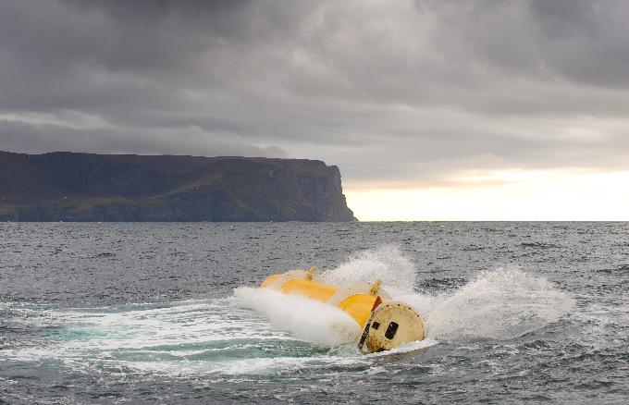
Aquamarine Power’s Oyster wave power device in action. Credit: Aquamarine Power.
“The DOE”s investment portfolio recognizes that high-risk research and development activities have the potential to more than double the energy capture efficiency of today’s wave energy technologies, and are needed to tap into the greatest marine energy markets in California, Oregon, and Washington,” she said.
According to new analysis, published recently in the journal Renewable Energy, large-scale wave energy systems developed in the Pacific Northwest should be “comparatively steady, dependable and able to be integrated into the overall energy grid at lower costs than some other forms of alternative energy, including wind power.”
“Ocean wave energy tends to have low short term variability when aggregated over a large area, which results in a calculated integration cost, in terms of impact to reserve generation requirements, that is relatively low, and much lower than wind,” said report co-author Ted Brekken, Associate Professor of Energy Systems at Oregon State University.
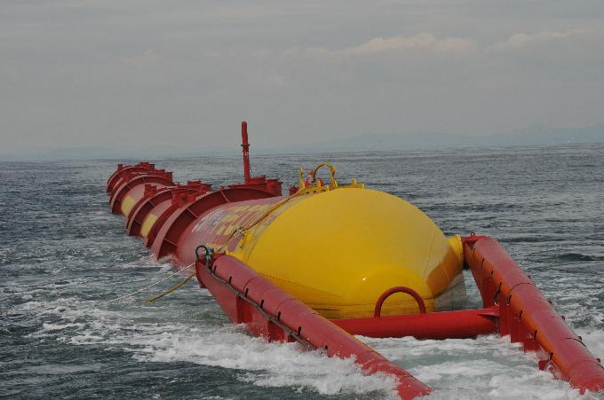
E.ON Pelamis P2 in Orkney. Credit: Pelamis Wave Power.
Looking ahead, Labonte said that developers now recognize the greatest market potential for current technologies exists in “remote and other niche applications,” but that opportunities lie in “taking advantage of these markets for demonstrating existing technologies while making fundamental improvements to systems to ready them for larger, utility-scale markets in the longer-term.”
“The DOE is confident that the successful development and deployment of marine energy devices and technologies will continue throughout 2015,” she concluded.
Mixed Picture for UK
For Nick Medic, Director of Offshore Renewables at RenewableUK, 2014 was a notable year for the UK wave and tidal sectors, both “in terms of progress made and setbacks suffered.” On the plus side, the first tidal energy array reached financial close and is under construction, the country’s first tidal lagoon project has gone into planning and has attracted preliminary funding commitments, devices continue to be tested and R&D is “continuing apace, more so than anywhere else in the world.”
However, Medic also believes that “chronic underfunding” and a lack of firmer messaging on the role marine energy should play have brought matters to a head with “a number of developers both on the wave and tidal side either winding up or exiting the sector.” In November 2014, Pelamis Wave Power announced financial difficulties such that the company has been put into administration and Aquamarine Power cut back to a skeleton staff.
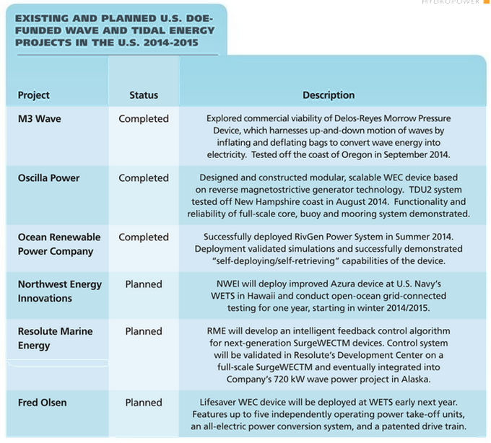
“This is a worrying situation, yet one that can and should be remedied. Bodies such as Wave Energy Scotland are awake to the danger of gains made in the sector being reversed, but we need a coordinated UK approach to stabilize the sector,”
he added.
Dr Stephanie Merry, Head of Marine at the UK Renewable Energy Association, agreed the outlook for the UK sector is “not encouraging.” That said, when it comes to developing tidal energy technology, the UK is still further ahead than many countries and Merry pointed out that the Marine Current Turbines (MCT) Seagen device, which remains installed at Strangford Lough, where it has delivered more than 9 GWh to the national grid, is “arguably the most successful tidal stream generator to date in the world.”
“In 2015, the tidal energy sector will watch the progress of MeyGen with keen interest. We also hope the second tidal array project, Scottish Power Renewables in the Sound of Islay, will continue to move forward. Welsh company Tidal Energy is also in the process of deploying its DeltaStream machine in Ramsey Sound and the Swedish Minesto device has been tested at Strangford Lough,” said Merry.
“One UK wave energy project to watch is WaveSub, which has been successful in raising funds for development and is well-placed in Wales to access EU funds for the future,” she added.
Promising Markets
Elsewhere, although the January 2015 demise of leading Australian technology developer Oceanlinx was an undeniable setback, Merry revealed that some foreign wave energy developers remain “buoyant.”
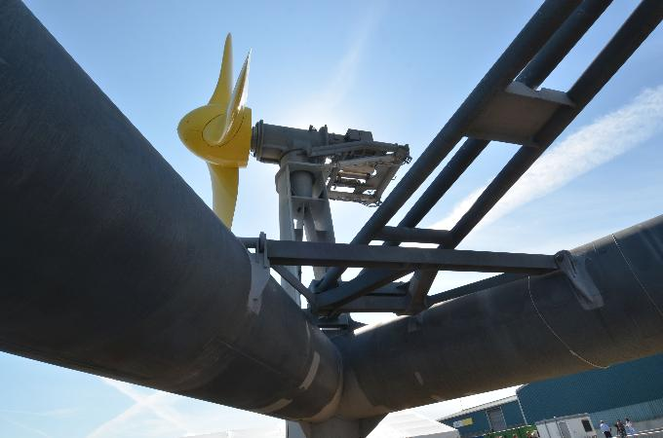
The Deltastream that is currently being deployed in the UK. Credit: Deltastream.
“Internationally, I like the technology of Fred Olsen’s BOLT machine. Being privately funded, it is in a comfortable position financially, as long as it continues to prove its potential,” she added.
Merry believes that France is “poised to take over the global lead” for tidal stream energy, while a number of European maritime countries, as well as Australia, are “moving ahead more successfully than the UK with wave power.”
“Growth of the tidal sector in France will be strong, because the French government has provided excellent support with high levels of capital grant and guaranteed grid access, although the market mechanisms are not as good as in the UK. Leases in the Raz Blanchard, the French side of the Alderney Race, have been let. Growth in Canada is also good with Atlantis securing a feed-in tariff of about £292/MWh for up to 4.5 MW capacity at the Fundy Ocean Research Centre,” she said.

Green Living Ideas

The Future of Wave Power
March 2, 2015
There is good news for the future of wave power. Not only does the technology for tidal energy continue to get better and more cost competitive, there is a growing interest in this wide-open field of study.
As reported on Ecopreneurist, an initiative from the US Department of Energy (DOE), sponsored by the Water Power Program, could give wave energy technology a big boost over the next year and a half.
“What if in the next two years the wave energy industry achieved a technology leap so revolutionary that it would make the cost of wave energy competitive with traditional sources of energy? This could be the result of the U.S. Department of Energy’s Wave Energy Prize.” – Wave Energy Prize
The Wave Energy Prize is looking for applicants who can design better wave energy conversion devices, with the goal being to produce a device with the potential to cut the cost of producing electricity from ocean waves by half. The 18-month competition will have participants design and build their wave energy device and then test and evaluate them at the US Navy’s Maneuvering and Seakeeping (MASK) Basin at Carderock, MD, with the overall winner taking in more than $1 million in cash prizes.
And there’s more good news. As reported by Oregon State University, findings from a recent article in the journal Renewable Energy, confirm what scientists have expected – that wave energy will be more consistent than other renewable energy sources, and that larger scale projects are the key to reducing variability. There are so many sources of wave and tidal power available, it seems like there unlimited potential for this blue resource!
Here’s more from the Oregon State University press release:
The variability of alternative energy sources is one factor that holds back their wider use – if wind or solar energy decreases and varies widely, then some other energy production has to back it up, and that adds to the overall cost of energy supply.
Ted Brekken, an associate professor and renewable energy expert in the College of Engineering at Oregon State University, says, “By producing wave energy from a range of different sites, possibly with different types of technology, and taking advantage of the comparative consistency of the wave resource itself, it appears that wave energy integration should be easier than that of wind energy,” he said. “The reserve, or backup generation, necessary for wave energy integration should be minimal.”
This estimate of the cost of integrating wind energy indicated that it would be 10 percent or less than the actual charges being made for the integration of wind energy. Energy integration, however, is just one component of the overall cost of the power generated. Wave energy, still in the infancy of its development, is not yet cost competitive on an overall basis.
Wave energy is not now being commercially produced in the Pacific Northwest, but experts say its future potential is significant, and costs should come down as technologies improve and more systems are developed. This study examined the hypothetical addition of 500 megawatts of generating capacity in this region by 2025, which would be comparable to approximately five large wind farms.
Another strength of wave energy, the study suggested, is that its short-term generation capacity can be predicted with a high degree of accuracy over a time scale ranging from minutes to hours, and with some accuracy even seasonally or annually.
The Pacific Northwest has some of the nation’s best wave energy resources, and as a result is home to the Northwest National Marine Renewable Energy Center, supported by the U.S. Department of Energy.
Wave energy in the region is expected to spur economic growth, help diversify the energy portfolio, reduce greenhouse gas emissions and reduce transmission losses, the study noted.
Wave image from Shutterstock

World Maritime News

Public comments open for Wave Energy Prize Rules Draft

March 17, 2015
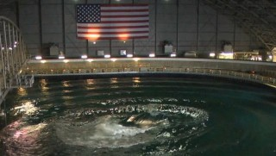
U.S. Department of Energy (DoE) is sponsoring Wave Energy Prize competition in order to encourage the development of WEC devices that reduce the cost of wave energy production.
Through the Wave Energy Prize, the DoE is trying to identify new technologies that can help reduce the Levelized Cost of Energy (LCOE) over current leading WEC device designs.
Registration for the Wave Energy Prize is set for April 1, 2015, and the Prize Administration Team has published a draft version of the Wave Energy Prize Rules that is now open for public comments.
The public comment period ends on March 20, 2015.
The official version of the Wave Energy Prize Rules will be published once the registration for the competition opens.
The team that ranks the higher after testing the 1/20th scale WEC device model will be awarded USD 1.5 mln. The second team will win an award in the amount of USD 500.000, and the third-placed tam will be awarded USD 250.000.

Hydro World

Energy Department prize challenge incentivizes wave energy conversion next generation ideas
By Gregory B. Poindexter, Associate Editor; April 2, 2015
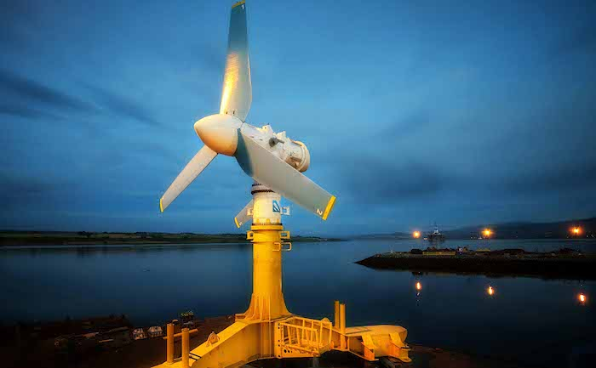
Courtesy Lockheed-Martin
In April, the U.S. Department of Energy announced its launch of the Wave Energy Prize competition “as a means to use a prize challenge to help dramatically improve the performance of wave energy conversion (WEC) devices, providing a pathway to game-changing reductions in the cost of wave energy.”
The competition is a multi-tiered, open entry program meant to spur development of marine hydrokinetic technology for use in the U.S.
According to the agency, the Wave Energy Prize aims to attract next generation ideas by offering a prize purse and providing an opportunity for testing at the Naval Surface Warfare Center Carderock’s Maneuvering and Seakeeping (MASK) Basin in Maryland.
During the year-and-a-half design-build-test competition, teams must reach a number of milestones that include a technical submission, numerical modeling, and small-scale testing. Beginning in August 2016, selected projects from the initial milestone phases will be invited to participate in further testing at the MASK basin. Winners from projects tested at the MASK basin will be announced in November 2016.
For more information on the competition, log onto WaveEnergyPrize.org.

Ocean News and Technology
U.S. Department of Energy Looks to Revolutionary Innovation for Harnessing Wave Energy
By Jose Zayas; April 22, 2015

Wave Energy Prize ﬁnalists will have the opportunity to test their designs at the nation’s most advanced wave-making facility, the Naval Surface Warfare Center’s Maneuvering and Seakeeping (MASK) Basin at Carderock, Maryland in the summer of 2016. Credit: Naval Surface Warfare Center.
Within its varied topographies and climates, the United States offers an abundant and diverse set of renewable energy sources for innovative technology developers to harness. One such emerging renewable energy industry is marine and hydrokinetics (MHK)—energy generated by waves, tides, currents, and ocean thermal resources. While researchers are only beginning to learn how to efficiently and cost effectively harvest MHK energy sources at a commercial scale, a recent assessment indicated that the United States has vast wave resources that, if harnessed, could provide significant energy generation.

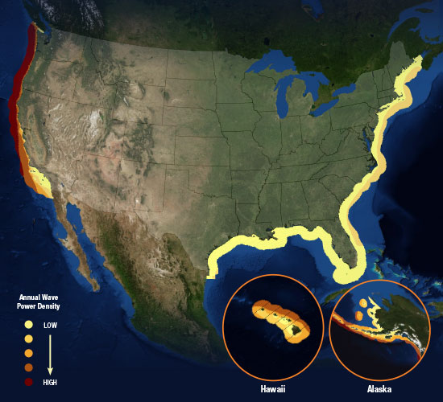
Annual wave power density potential across the United States. Credit: U.S. Department of Energy.

Wave Energy has the Potential to Power 5 Million American Homes
The 2013 resource assessment by the Electric Power Research Institute, created with support from the U.S. Department of Energy’s (DOE’s) Water Power Program, analyzed ocean wave energy potential along U.S. coasts. The report found that the technically recoverable resource for electric generation from waves is approximately 1,170 terawatt-hours per year (TWh/year), which is almost one third of the 4,000 TWh/year of electricity used in the United States.
Although the assessment’s technical resource potential does not factor in “practical constraints” such as economic, environmental, and regulatory considerations, developing just a small fraction of this resource could allow for millions of American homes to be powered with this clean, reliable form of energy. For context, approximately 90,000 homes can be powered by 1 TWh/year. Extracting just 5% of the approximate 1,170 TWh/year of gross resource potential could result in wave energy powering for 5 million American homes.
This enormous wave energy resource has characteristics that will help it become a price-competitive, low-carbon energy supplier in the United States. For example, with more than 50% of the U.S. population living within 50 miles of the nation’s coastlines, wave energy’s close proximity to coastal load centers reduces transmission costs and challenges. And these coastlines’ higher-than-average electricity prices bring the levelized cost of wave energy generation closer to the costs of conventional energy generation, which will help wave energy become price competitive.
With all of these considerations, DOE sees wave energy as an opportunity for the United States to engage directly in an emerging area of energy science while developing a new suite of renewable energy technologies that will stimulate a new industry, help reduce emissions, and meet energy and climate objectives. DOE is pursuing this opportunity by cost-sharing some of the initial financial risk for targeted wave energy technology research, development, demonstration, and deployment projects as well as environmental impact and siting research. By accelerating project deployment, evaluating early stage technologies’ viability, and addressing market barriers, DOE is working to drive down wave energy technology costs and attract private-sector financing for future commercialization.
How Does Wave Energy Generation Work?
Not unlike wind energy’s status 20 to 30 years ago, wave energy is in the early stages of commercial technology development, and wave energy devices today are diverse in form and function. As such, DOE funds a wide range of emerging wave energy technologies so that researchers and developers have space to make dramatic and radical innovations that will revolutionize marine energy production. A comprehensive list of marine and hydrokinetic device configurations, current projects, and development companies is provided by the Marine and Hydrokinetic Technology Database on OpenEI.org.
DOE’s Wave Energy Technology Research, Development, and Demonstrations
Over the past 6 years, DOE has awarded over $110 million to fund technology R&D projects related to MHK energy systems, infrastructure, and instrumentation, many of which have directly benefited wave energy development. In 2014 alone, DOE supported $29.5 million in competitive awards to industry and university R&D efforts, including the several notable examples below.
Augmenting R&D Capabilities: The nation’s universities contain a wealth of R&D expertise and intellectual capital that can help advance MHK technologies. With $4 million in DOE funding, a new university consortium was formed in 2014 that will support the advancement of wave and tidal energy technologies by leveraging existing resources at the Northwest National Marine Renewable Energy Center. Oregon State University, the University of Washington, and the University of Alaska Fairbanks will combine their field-focused R&D capabilities to develop autonomous robotic devices for MHK operations, design arrays with improved performance, and standardize approaches for wildlife monitoring at MHK projects.
Department of Defense (DoD) Partnership: DOE is partnering with DoD to leverage the Navy’s Wave Energy Test Site (WETS) off the waters of Marine Corps Base Hawaii—the nation’s only grid-connected open-water test site—for testing of wave energy conversion (WEC) devices. Northwest Energy Innovations’ Azura™ device (previously WET-NZ), which was first awarded funding from DOE in 2010, is now at an advanced stage of development; a full-scale, pre-commercial prototype device was deployed at WETS in March 2015. Additionally, in 2014, DOE selected funding recipients to design, build, and test advanced WEC systems in the ocean environment at WETS berths located at depths of 60 m and 80 m in Kaneohe, Hawaii.
Addressing Environmental Concerns: To support the development of cost-effective environmental monitoring technologies, in 2014, DOE provided a total of $2.75 million to five new technology development projects that address a variety of environmental concerns, including noise produced by devices and the behaviors of fish and marine mammals near devices.
The Wave Energy Prize
The DOE is kicking off a new MHK technology initiative called the Wave Energy Prize. This public prize challenge will encourage the development of new WEC devices that demonstrate an ability to convert twice as much energy from ocean waves into electricity as current WEC technologies.
By implementing a public prize, DOE aims to attract newcomers to wave energy technology development in addition to meeting the Prize’s objective of developing revolutionary WEC devices. The nature of a prize challenge levels the playing field significantly, allowing new participants to bring forward ideas that may not otherwise have made it. For example, the compressed timetable of a prize challenge, in this case just over a year and a half, favors lean and agile entities, which is characteristic of many newcomers. Thus, the Prize will create opportunities for all developers—new and experienced—who can step outside the box and depart from traditional R&D methods to showcase novel approaches.
By attracting new participants while also encouraging new technologies from existing companies, DOE is engaging a broad range of viewpoints with very little risk. The investment on the part of the government is based on performance; those participants whose technologies perform well will receive seed money, and the winner will receive a prize purse. This approach enables R&D to accelerate the speed of innovation.
Catching the Wave
Teams participating in the Wave Energy Prize have an opportunity to benefit on many levels. Qualified teams will have a chance to take part in two rounds of testing. In the second round of testing, finalists will test their scaled WEC prototypes at the nation’s most advanced wave-making facility, the Naval Surface Warfare Center’s Maneuvering and Seakeeping (MASK) Basin in Carderock, Maryland, beginning in the summer of 2016. Additionally, DOE will give seed money to finalist teams to lower the barriers to entry encountered by many innovators and provide an additional prize for the winning team(s).

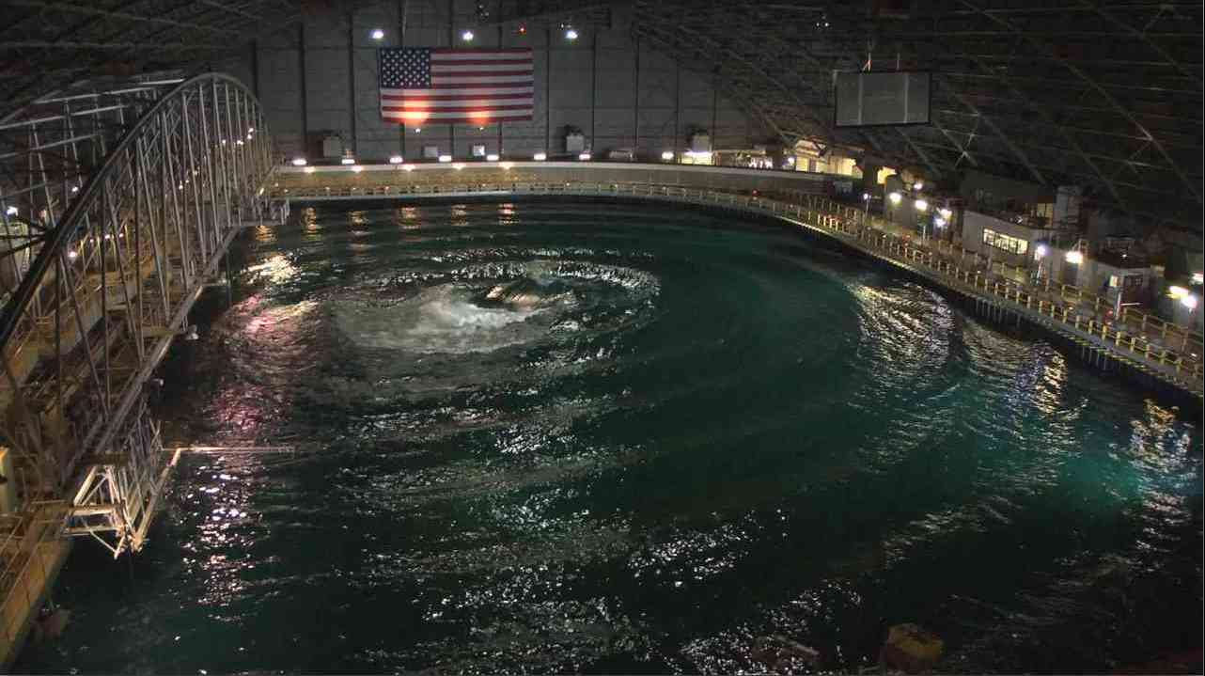
Wave Energy Prize ﬁnalists will have the opportunity to test their designs at the nation's most advanced wave-making facility, the Naval Surface Warfare Center's Maneuvering and Seakeeping (MASK) Basin at Carderock, Maryland in the summer of 2016. Credit: Naval Surface Warfare Center.

The Wave Energy Prize is open to U.S. entities, including U.S. persons and companies as well as foreign companies that are incorporated in and maintain a primary place of business in the United States. To learn more or to register your team, visit www.waveenergyprize.org. Registration is scheduled to close on June 15, 2015.
DOE and its partners will continue to make key investments to ensure that a cutting-edge research portfolio will produce the next generation of wave energy technologies and jump-start private sector innovation, providing clean energy sources that can contribute to our nation’s energy independence. More information on DOE’s current wave energy activities is available at http://water.energy.gov.

Hydro World
DOE looking for tech boom with new Wave Energy Prize
By Michael Harris; April 27, 2015
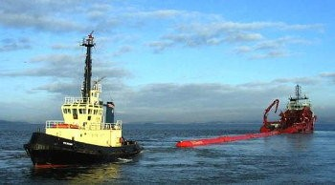
A new prize purse announced by the U.S. Department of Energy could feed more than $2 million into wave energy technology research and development.
Introduced today by DOE Office of Energy Efficiency and Renewable Energy Assistant Secretary Dave Danielson during the keynote session of the National Hydropower Association's Annual Conference in Washington, D.C., the program -- called the Wave Energy Prize -- is intended to "reduce the cost of wave energy, making it more competitive with traditional energy solutions."
The announcement is of particular interest to those attending the International Marine Renewable Energy Conference (IMREC) and Marine Energy Technology Symposium (METS), which are, for the first time, co-located with NHA's annual meeting.
"For this exciting new prize competition, we're challenging you -- our key stakeholders in the industry -- to double the energy captured from ocean waves by developing new ocean wave energy converter technology" Danielson said. "[The Wave Energy Prize] will not only result in some fascinating new concepts, but will also open up new technology for the industry as it moves forward more and more rapidly."
The program includes a 20-month design-build-test competition that offers seed money and an opportunity to participate in two rounds of testing, with those selected for the second round of competition given a chance to test scaled wave energy conversion (WEC) devices at the Naval Surface Warfare Center's Maneuvering and Seakeeping (MASK) Basin at Carderock, Md., beginning Summer 2016.
"The winning devices will help create new possibilities to reduce costs and move wave energy even closer to widespread commercialization," Danielson said.
Programs like the Wave Energy Prize are becoming increasingly popular, White House Office of Science and Technology Policy Chief of Staff Cristin Dorgelo said, as federal agencies look for innovative ways of engaging private sector developers.
"By reaching beyond existing communities of interest, prize challenges source out-of-discipline perspectives that can yield outstanding and novel solutions," Dorgelo said. "This effort brings new perspectives to the table with minimal risk."
Registration for the Wave Energy Prize is scheduled to remain open until June 15. For more information, visit WaveEnergyPrize.org.

EIN News
Energy Department Launches Competition to Drive Innovations in Wave Energy
April 27, 2015

The Energy Department today announced the opening of the registration period for the Wave Energy Prize competition that aims to double the state-of-the-art performance of wave energy conversion (WEC) devices over the next two years. By accelerating the development of WEC devices that capture more energy from ocean waves, the winning devices will help reduce costs and move wave energy closer to widespread commercial deployment. The Energy Department announced the Wave Energy Prize today at the International Marine Renewable Energy Conference co-located at the National Hydropower Association Annual Conference.
Marine and hydrokinetic energy technologies convert the energy of waves, tides, and river and ocean currents into electricity. With more than 50% of the population living within 50 miles of coastlines, these technologies have vast potential to provide clean, renewable electricity to communities and cities across the United States.
The Wave Energy Prize provides an opportunity for participants to:
- Win a monetary prize.
- Receive seed funding to build a 1/20th scale model WEC device for testing.
- Participate in two rounds of WEC testing--including the final round at the U.S. Navy's Maneuvering and Seakeeping Basin in Carderock, Maryland, the nation's premier wave testing facility.
- Contribute to the development of innovative clean energy technologies that boost U.S. energy security.
The judging panel will include technical experts from: Sandia National Laboratories, Albuquerque, New Mexico; National Renewable Energy Laboratory, Golden, Colorado; Naval Surface Warfare Center—Carderock Division, Bethesda, Maryland; and Ricardo, Inc., Van Buren Township, Michigan. The Department expects to select finalists and alternates in early 2016. Participants can register through June 15, 2015.
This prize competition builds on the Energy Department's ongoing efforts to demonstrate and reduce the costs of these emerging technologies by supporting the design, manufacture, testing, and evaluation of marine and hydrokinetic energy devices. To learn more about the Wave Energy Prize rules, eligibility and timeline, see the Wave Energy Prize web page.
The Department's Office of Energy Efficiency and Renewable Energy accelerates development and deployment of energy efficiency and renewable energy technologies and market-based solutions that strengthen U.S. energy security, environmental quality, and economic vitality. For more information about wave and tidal energy research and development, see the EERE Water Power Program's Research and Development web page.

Solar Thermal Magazine
U.S. DOE Launches Competition to Drive Innovations in Wave Energy
By Tracey Smith; April 27, 2015

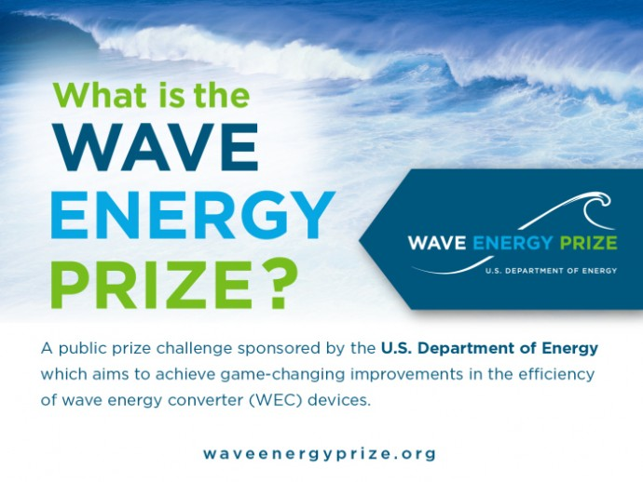
The U.S. Energy Department today announced the opening of the registration period for the Wave Energy Prize, a competition that aims to double the state-of-the-art performance of wave energy conversion (WEC) devices over the next two years. The U.S. has been much slower to embrace the potential of wave energy than countries such as Scotland, and hopes that accelerating the development of WEC devices will help reduce costs and move wave energy closer to widespread commercial deployment.
Marine and hydrokinetic energy technologies convert the energy of waves, tides, and river and ocean currents into electricity. It is estimated that the technically recoverable wave energy resource in the U.S. is approximately 1,170 terawatt hours (TWh) per year, distributed across Alaska, the West Coast, the East Coast, the Gulf of Mexico, Hawaii, and Puerto Rico. With more than 50% of the population living within 50 miles of coastlines, wave energy has vast potential to provide clean, renewable energy to cities and communities in the U.S.
The Wave Energy Prize provides an opportunity for participants to:
- Win a monetary prize.
- Receive seed funding to build a 1/20th scale model WEC device for testing.
- Participate in two rounds of WEC testing–including the final round at the U.S. Navy’s Maneuvering and Seakeeping Basin in Carderock, Maryland, the nation’s premier wave testing facility.
- Contribute to the development of innovative clean energy technologies that boost U.S. energy security.
The judging panel will include technical experts from: Sandia National Laboratories, Albuquerque, New Mexico; National Renewable Energy Laboratory, Golden, Colorado; Naval Surface Warfare Center—Carderock Division, Bethesda, Maryland; and Ricardo, Inc., Van Buren Township, Michigan.
The DOE expects to select finalists and alternates in early 2016. Participants can register through June 15, 2015.
This prize competition builds on the U.S. Energy Department’s ongoing efforts to demonstrate and reduce the costs of these emerging technologies by supporting the design, manufacture, testing, and evaluation of marine and hydrokinetic energy devices. To learn more about the Wave Energy Prize rules, eligibility and timeline, see the Wave Energy Prize web page.

Domestic Fuel
DOE Announces Wave Energy Prize
By Joanna Schroeder; April 28, 2015

During the annual National Hydropower Association and International Marine Renewable Energy Conferences, the Department Of Energy (DOE) Office of Energy Efficiency and Renewable Energy Assistant Secretary Dr. Dave Danielson announced the Wave Energy Prize. The prize, totaling more than $2 million, is designed to encourage the development of wave energy conversion (WEC) devices that double the energy captured from ocean waves, which in turn will reduce the cost of wave energy, making it more competitive with traditional energy solutions.
White House Office of Science and Technology Policy Chief of Staff Cristin Dorgelo addressed the audience about the role public prize challenges can play in sparking innovation.
“Prize challenges are an effective way to spur innovation and solve tough problems by 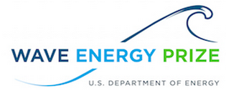attracting, untapped talent,” said Dorgelo. “By reaching beyond existing communities of interest, prize challenges source out-of-discipline perspectives that can yield outstanding and novel solutions. This effort brings new perspectives to the table with minimal risk.”
“DOE recognized that the complex technology challenges associated with WEC concepts made this a great candidate for the challenge mechanism, particularly since one of the goals of the Wave Energy Prize is to attract new developers to the industry as well as next-generation concepts from those developers already working in clean energy,” said Wes Scharmen, Wave Energy Prize principal investigator at Ricardo, Inc. “There is so much opportunity to achieve real gains in the field of wave energy, and by solving the energy capture efficiency challenge of WEC concepts we expect to see significant impact in terms of energy cost. There is a vast, untapped resource potential along our coasts; this prize focuses on innovative approaches that get the nation closer to realizing its potential.”
The 20-month design-build-test competition will offer participants seed money and a chance to take part in two rounds of testing, the second being an opportunity for finalists to test their scaled WEC prototypes at the nation’s most advanced wave-making facility, the Naval Surface Warfare Center’s Maneuvering and Seakeeping (MASK) Basin at Carderock, Md., beginning in the summer of 2016.
Registration for the Wave Energy Prize is scheduled to remain open until June 15. For more information or to register, go to waveenergyprize.org. Additional information can also be found in the DOE Progress Alert.

reNews
US floats wave prize
April 28, 2015

The US Department of Energy has opened the registration period for its Wave Energy Prize competition, which aims to double the performance of wave energy conversion devices over the next two years.
The prize will provide an opportunity for participants to:
- win money;
- receive seed funding to build a 1/20th scale model WEC device for testing;
- participate in two rounds of WEC testing, which will include the final round at the US Navy's Maneuvering and Seakeeping Basin in Carderock in Maryland; and
- contribute to the development of clean energy technologies to boost US energy security.
The DoE said: “By accelerating the development of WEC devices that capture more energy from ocean waves, the winning devices will help reduce costs and move wave energy closer to widespread commercial deployment.”
The judging panel will include technical experts from: Sandia National Laboratories, Albuquerque, New Mexico; National Renewable Energy Laboratory, Golden, Colorado; Naval Surface Warfare Center – Carderock Division, Bethesda, Maryland; and Ricardo Inc, Van Buren Township, Michigan.
The DoE expects to select finalists and alternates in early 2016. Participants can register through 15 June, 2015.
Image: finalists will be selected in early 2016 (sxc)

Tidal Energy Today
US DoE launches Wave Energy Prize competition
April 28, 2015

US Navy's Maneuvering and Seakeeping Basin in Carderock
US Department of Energy (DoE) has opened the registration period for the Wave Energy Prize competition that aims to double the performance of wave energy conversion (WEC) devices over the next two years.
This prize competition builds on the Energy Department’s efforts to demonstrate and reduce the costs of the emerging technologies by supporting the design, manufacture, testing, and evaluation of marine and hydrokinetic energy devices.
By accelerating the development of WEC devices that capture more energy from ocean waves, the winning devices will help reduce costs and move wave energy closer to widespread commercial deployment, DoE’s press release reads.
The Wave Energy Prize provides an opportunity for participants to:
- Win a monetary prize,
- Receive seed funding to build a 1/20th scale model WEC device for testing,
- Participate in two rounds of WEC testing – including the final round at the US Navy’s Maneuvering and Seakeeping Basin in Carderock, Maryland,
- Contribute to the development of innovative clean energy technologies that boost US energy security.
The deadline for registration is set for June 15, 2015.
U.S. entities are eligible to participate in the Wave Energy Prize. This includes US persons and companies as well as foreign companies that are incorporated in and maintain a primary place of business in the United States.
The team that ranks the higher after testing the 1/20th scale WEC device model will be awarded USD 1.5 mln. The second team will win an award in the amount of USD 500.000, and the third-placed tam will be awarded USD 250.000.
DoE expects to select finalists and alternates in early 2016.
The judging panel will include technical experts from Sandia National Laboratories, National Renewable Energy Laboratory, Naval Surface Warfare Center – Carderock Division, and Ricardo Inc.

Power Systems Design
Energy Department launches competition to drive innovation in wave energy
April 28, 2015
The Wave Energy Prize is a public prize challenge sponsored by the U.S. Department of Energy (DOE)‘s Water Power Program. The prize is designed to increase the diversity of organizations involved in Wave Energy Converter (WEC) technology development, while motivating and inspiring existing stakeholders. DOE envisions this competition will achieve game-changing performance enhancements to WEC devices, establishing a pathway to sweeping cost reductions on a commercial scale.
The wave energy industry is young and is experiencing many new innovations as evidenced by a sustained growth in patent activity. While the private industry is developing these early-concept WEC devices through design and benchtop prototype testing, funding is hard to secure for performance testing and evaluation of WEC devices in wave tanks at a meaningful scale. This is a problem for the industry since scaled WEC prototype tank testing, validation, and evaluation are key steps in the advancement of WEC technologies through the technical readiness levels to reach commercialization.
The Goal
The Wave Energy Prize will encourage the development of more efficient WEC devices that double the energy captured from ocean waves, which in turn will reduce the cost of wave energy, making it more competitive with traditional energy solutions.
Economic Impact
A successful Wave Energy Prize could jump-start private sector innovation critical to the country’s long-term economic growth, energy security, and international competitiveness in the wave energy conversion sector.
Why Participate?
The Wave Energy Prize seeks to attract innovative ideas from developers new to the industry and next-generation ideas from existing developers by offering a monetary prize purse and providing an opportunity for tank testing and evaluation of scaled WEC device prototypes at the nation’s most advanced wave-making facility, the U.S. Navy’s Maneuvering and Seakeeping Basin (MASK) facility in Carderock, MD.

The Maritime Executive
Energy Department Launches Wave Energy Prize Competition
April 28, 2015
The Energy Department today announced the opening of the registration period for the Wave Energy Prize competition that aims to double the state-of-the-art performance of wave energy conversion (WEC) devices over the next two years. By accelerating the development of WEC devices that capture more energy from ocean waves, the winning devices will help reduce costs and move wave energy closer to widespread commercial deployment. The Energy Department announced the Wave Energy Prize today at the International Marine Renewable Energy Conference co-located at the National Hydropower Association Annual Conference.
Marine and hydrokinetic energy technologies convert the energy of waves, tides, and river and ocean currents into electricity. With more than 50% of the population living within 50 miles of coastlines, these technologies have vast potential to provide clean, renewable electricity to communities and cities across the United States.
The Wave Energy Prize provides an opportunity for participants to:
- -Win a monetary prize.
- -Receive seed funding to build a 1/20th scale model WEC device for testing.
- -Participate in two rounds of WEC testing--including the final round at the U.S. Navy's Maneuvering and Seakeeping Basin in Carderock, Maryland, the nation's premier wave testing facility.
- -Contribute to the development of innovative clean energy technologies that boost U.S. energy security.
The judging panel will include technical experts from: Sandia National Laboratories, Albuquerque, New Mexico; National Renewable Energy Laboratory, Golden, Colorado; Naval Surface Warfare Center—Carderock Division, Bethesda, Maryland; and Ricardo, Inc., Van Buren Township, Michigan. The Department expects to select finalists and alternates in early 2016. Participants can register through June 15, 2015.
This prize competition builds on the Energy Department's ongoing efforts to demonstrate and reduce the costs of these emerging technologies by supporting the design, manufacture, testing, and evaluation of marine and hydrokinetic energy devices. To learn more about the Wave Energy Prize rules, eligibility and timeline, see the Wave Energy Prize web page.

ECO Magazine
Funding: Over $2 Million in Wave Energy Prizes
April 29, 2015
The U.S. Department of Energy (DOE) announced that its latest prize competition is now underway, with a prize purse totaling more than $2 million available for top ranking teams.
In a keynote presentation during the joint opening session of the annual National Hydropower Association and International Marine Renewable Energy Conferences, DOE Office of Energy Efficiency and Renewable Energy Assistant Secretary Dr. Dave Danielson announced the Wave Energy Prize. The prize will encourage the development of game-changing wave energy conversion (WEC) devices that double the energy captured from ocean waves, which in turn will reduce the cost of wave energy, making it more competitive with traditional energy solutions.
Danielson was introduced by White House Office of Science and Technology Policy Chief of Staff Cristin Dorgelo, who addressed the audience about the role public prize challenges can play in sparking innovation.
“Prize challenges are an effective way to spur innovation and solve tough problems by attracting, untapped talent,” said Dorgelo. “By reaching beyond existing communities of interest, prize challenges source out-of-discipline perspectives that can yield outstanding and novel solutions. This effort brings new perspectives to the table with minimal risk.” “DOE recognized that the complex technology challenges associated with WEC concepts made this a great candidate for the challenge mechanism, particularly since one of the goals of the Wave Energy Prize is to attract new developers to the industry as well as next-generation concepts from those developers already working in clean energy,” said Wes Scharmen, Wave Energy Prize principal investigator at Ricardo, Inc. “There is so much opportunity to achieve real gains in the field of wave energy, and by solving the energy capture efficiency challenge of WEC concepts we expect to see significant impact in terms of energy cost. There is a vast, untapped resource potential along our coasts; this prize focuses on innovative approaches that get the nation closer to realizing its potential.”
The 20-month design-build-test competition will offer participants seed money and a chance to take part in two rounds of testing, the second being an opportunity for finalists to test their scaled WEC prototypes at the nation's most advanced wave-making facility, the Naval Surface Warfare Center's Maneuvering and Seakeeping (MASK) Basin at Carderock, Md., beginning in the summer of 2016.
Registration for the Wave Energy Prize is scheduled to remain open until June 15. For more information or to register, go to waveenergyprize.org. Additional information can also be found in DOE Progress Alert.
International Water Power & Dam Construction
Registration open for US DOE’s Wave Energy Prize
April 29, 2015

The US Department of Energy (DOE) has announced that its Wave Energy Prize competition is now underway, with a prize purse totalling more than $2 million available for top ranking teams.
Details of the competition were announced by Dr Dave Danielson, DOE Office of Energy Efficiency and Renewable Energy Assistant, during the joint opening session of the annual National Hydropower Association and International Marine Renewable Energy Conferences. The prize has been introduced to encourage the development of game-changing wave energy conversion (WEC) devices that double the energy captured from ocean waves, which in turn will reduce the cost of wave energy, making it more competitive with traditional energy solutions.
Danielson was introduced by White House Office of Science and Technology Policy Chief of Staff Cristin Dorgelo, who addressed the audience about the role public prize challenges can play in sparking innovation.
"Prize challenges are an effective way to spur innovation and solve tough problems by attracting, untapped talent," said Dorgelo. "By reaching beyond existing communities of interest, prize challenges source out-of-discipline perspectives that can yield outstanding and novel solutions. This effort brings new perspectives to the table with minimal risk."
"DOE recognized that the complex technology challenges associated with WEC concepts made this a great candidate for the challenge mechanism, particularly since one of the goals of the Wave Energy Prize is to attract new developers to the industry as well as next-generation concepts from those developers already working in clean energy," added Wes Scharmen, Wave Energy Prize principal investigator at Ricardo, Inc. "There is so much opportunity to achieve real gains in the field of wave energy, and by solving the energy capture efficiency challenge of WEC concepts we expect to see significant impact in terms of energy cost. There is a vast, untapped resource potential along our coasts; this prize focuses on innovative approaches that get the nation closer to realizing its potential."
The 20-month design-build-test competition will offer participants seed money and a chance to take part in two rounds of testing, the second being an opportunity for finalists to test their scaled WEC prototypes at the nation's most advanced wave-making facility, the Naval Surface Warfare Center's Maneuvering and Seakeeping (MASK) Basin at Carderock, Md., beginning in the summer of 2016.
Registration for the Wave Energy Prize is scheduled to remain open until June 15. For more information or to register, go to waveenergyprize.org.

AltEnergyMag
Department of Energy Wave Energy Prize Kicks Off Annual NHA/IMREC Conference
April 29, 2015

The U.S. Department of Energy (DOE) announced today that its latest prize competition is now underway, with a prize purse totaling more than $2 million available for top ranking teams.
In a keynote presentation today during the joint opening session of the annual National Hydropower Association and International Marine Renewable Energy Conferences, DOE Office of Energy Efficiency and Renewable Energy Assistant Secretary Dr. Dave Danielson announced the Wave Energy Prize. The prize will encourage the development of game-changing wave energy conversion (WEC) devices that double the energy captured from ocean waves, which in turn will reduce the cost of wave energy, making it more competitive with traditional energy solutions.
Danielson was introduced by White House Office of Science and Technology Policy Chief of Staff Cristin Dorgelo, who addressed the audience about the role public prize challenges can play in sparking innovation.
"Prize challenges are an effective way to spur innovation and solve tough problems by attracting, untapped talent," said Dorgelo. "By reaching beyond existing communities of interest, prize challenges source out-of-discipline perspectives that can yield outstanding and novel solutions. This effort brings new perspectives to the table with minimal risk."
"DOE recognized that the complex technology challenges associated with WEC concepts made this a great candidate for the challenge mechanism, particularly since one of the goals of the Wave Energy Prize is to attract new developers to the industry as well as next-generation concepts from those developers already working in clean energy," said Wes Scharmen, Wave Energy Prize principal investigator at Ricardo, Inc. "There is so much opportunity to achieve real gains in the field of wave energy, and by solving the energy capture efficiency challenge of WEC concepts we expect to see significant impact in terms of energy cost. There is a vast, untapped resource potential along our coasts; this prize focuses on innovative approaches that get the nation closer to realizing its potential."
The 20-month design-build-test competition will offer participants seed money and a chance to take part in two rounds of testing, the second being an opportunity for finalists to test their scaled WEC prototypes at the nation's most advanced wave-making facility, the Naval Surface Warfare Center's Maneuvering and Seakeeping (MASK) Basin at Carderock, Md., beginning in the summer of 2016.
Registration for the Wave Energy Prize is scheduled to remain open until June 15. For more information or to register, go to waveenergyprize.org. Additional information can also be found in today's DOE Progress Alert.

HydroWorld
NHA 2015 Annual Conference Special Edition Newscast
May 2, 2015

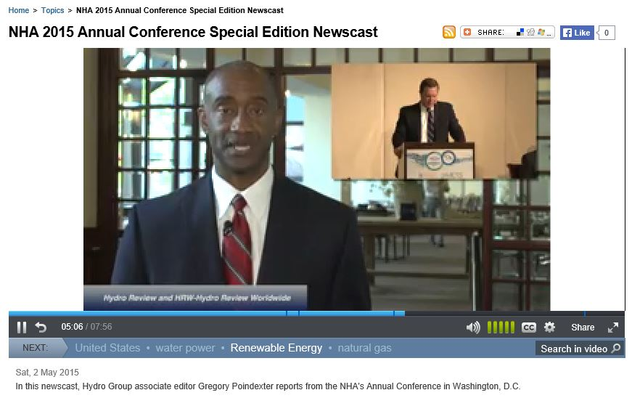
[TRANSCRIPT OF 4:45 TO 6:40] The Wave Energy Prize is the public prize challenge sponsored by the US Department of Energy's Water Power Program. In the keynote presentation during the opening session of the annual National Hydro Power Association and the International Marine Renewable Energy Conference and Marine Energy Technology Symposium both of which were co-located with the NHA's annual conference The deal is Dr. Dave Danielson announced the wave energy prize. The first announcement I'd like to make. I'd like to start by following up on Kristen's remarks, about the power of prizes. By formally announcing here today, the Department of Energy's brand new wave energy prize competition. Through this exciting new prize competition. We're challenging you, our key stakeholders and industry partners, to double the energy captured from ocean waves by developing new wave energy converter, or WEC, technologies. That we believe will not only result in the development of some fascinating new concepts But will also open up new technology horizons for the industry as it moves forward more and more rapidly. Here's how the wave energy prize works. This is a design build test competition in which teams will get two rounds Of free testing, and more than $2 million in prize money to try out their revolutionary new WEC concepts. D.O.E. has partnered with the Navy to open up the Maneuvering and Seakeeping Basin at Carderock, Maryland, the nation's premier wave-making facility, for the final round of the competition. By accelerating the development of WEC devices to capture more energy from ocean waves The winning devices will help create new possibilities, to reduce costs, and move wove energy even closer to widespread commercial deployment. The prize's design is to increase the diversity of organizations involving with energy converter technology and development, while motivating and inspiring existing stakeholders.

Targeted News Service
DOE Establishes $2 Million in Prizes for Wave Energy Concepts
May 3, 2015

WASHINGTON, May 3 -- The Department of Energy published the following notice in the Federal Register from the Office of Energy Efficiency and Renewable Energy:
Wave Energy Prize

Targeted News Service Information Request Form
Top of Form
Name:
What's your  Affiliation | Government Newspaper / Media Business  Public Policy Individual / Student Educators
Organization Name:
Email:
Phone:
State:
I'd like to have a copy of fulltext of the article above mailed to me.

Request a free sample
Check any of the products below to receive a free sample via email.
1 - State Newsletters
2 - Federal Contract Awards
3 - Federal Solicitations (by product/service) **
4 - Federal Grant Opportunities (by eligible recipient/topic category) **

Check the products below that interest you and a representative will call you within 24 hours
5 - U.S. Patent Awards
6 - Congressional Votes (by state delegation)
7 - NewsFocus Newsletter (by YOUR subject topic) **
8 - Congressional Bill Introductions
9 - Customized services (we'll be in touch by phone) **
Golf Tracking site (FairwayFiles.com)
Products marked with ** can be customized by keywords or areas of interest.
If you select them please specify your keywords in the box below:
Additonal questions or comments:
Bottom of Form

Myron Struck, editor, Targeted News Service, Springfield, Va., 703/304-1897; editor@targetednews.com; http://www.targetednews.com
Federal Register Notices Scraping
Copyright © Targeted News Service, 2015

Southeast Green
Energy Department Launches Competition to Drive Innovations in Wave Energy
May 4, 2015
The Energy Department announced the opening of the registration period for the Wave Energy Prize competition that aims to double the state-of-the-art performance of wave energy conversion (WEC) devices over the next two years. By accelerating the development of WEC devices that capture more energy from ocean waves, the winning devices will help reduce costs and move wave energy closer to widespread commercial deployment. The Energy Department announced the Wave Energy Prize today at the International Marine Renewable Energy Conference co-located at the National Hydropower Association Annual Conference.
Marine and hydrokinetic energy technologies convert the energy of waves, tides, and river and ocean currents into electricity. With more than 50% of the population living within 50 miles of coastlines, these technologies have vast potential to provide clean, renewable electricity to communities and cities across the United States.
The Wave Energy Prize provides an opportunity for participants to:
- Win a monetary prize.
- Receive seed funding to build a 1/20th scale model WEC device for testing.
- Participate in two rounds of WEC testing--including the final round at the U.S. Navy's Maneuvering and Seakeeping Basin in Carderock, Maryland, the nation's premier wave testing facility.
- Contribute to the development of innovative clean energy technologies that boost U.S. energy security.
The judging panel will include technical experts from: Sandia National Laboratories, Albuquerque, New Mexico; National Renewable Energy Laboratory, Golden, Colorado; Naval Surface Warfare Center—Carderock Division, Bethesda, Maryland; and Ricardo, Inc., Van Buren Township, Michigan. The Department expects to select finalists and alternates in early 2016. Participants can register through June 15, 2015.
This prize competition builds on the Energy Department's ongoing efforts to demonstrate and reduce the costs of these emerging technologies by supporting the design, manufacture, testing, and evaluation of marine and hydrokinetic energy devices. To learn more about the Wave Energy Prize rules, eligibility and timeline, see the Wave Energy Prize web page.
The Department's Office of Energy Efficiency and Renewable Energy accelerates development and deployment of energy efficiency and renewable energy technologies and market-based solutions that strengthen U.S. energy security, environmental quality, and economic vitality. For more information about wave and tidal energy research and development, see the EERE Water Power Program's Research and Development web page.

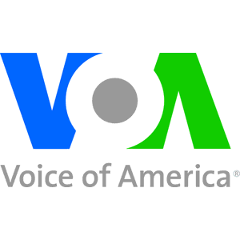
Voice of America
US Energy Agency Announces Wave Energy Prize Competition
By George Putic, May 4, 2015

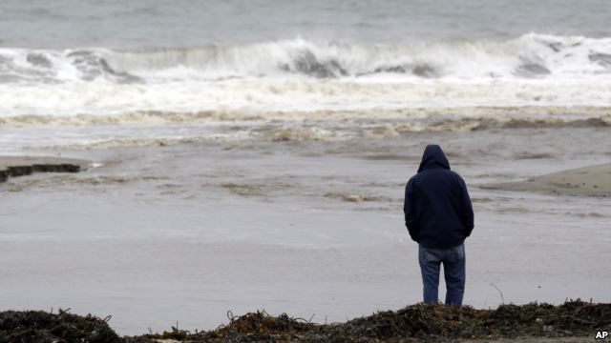
FILE - A man watches ocean waves crash at Seacliff State Beach in Aptos, California.

Sun and wind are seen as the most abundant sources of clean, renewable energy, but as many 'ocean-hugging' countries know, the energy of ocean waves is also both powerful and endless. Looking for the most efficient ways to capture that energy, the U.S. Department of Energy has announced a $1.5 million-prize competition for new ideas.
The department estimates that waves and tides along the U.S. coasts generate 1,420 terawatt-hours of energy annually. That is equal to the output of more than 330 nuclear power plants.
Unfortunately, the efficiency of today’s technologies for capturing that energy is only about 20 percent, too low for the investment to be economical, says Jose Zayas, director of the Wind and Water Power Technologies Office at the Department of Energy.
“We’re really looking to step-change that into the high 30s-40s [percent] and I think… once you achieve that, then the economic competiveness of this industry really comes to life and that’s really the target that we are shooting for,” says Zayas.
To encourage development of new technologies, the Department of Energy has launched a nationwide competition, called the Wave Energy Prize.
Developing new devices to capture wave energy can be a challenge. The environment in which wave capture machines must operate can be very harsh and unforgiving, with crushing blows of notoriously corrosive salty medium.
Competition organizers expect that most of the new ideas will be coming from existing energy companies, but also from the academic sector and research institutions.
Zayas says testing of the proposed technologies will be done in several phases.
“We would have 1/50th scale testing where we would do the first fundamental evaluation of their performance, as well as making sure that they are in a pathway that can assure them success towards a prize. We will then down-select again, and near the end we will have about 10 teams… it’s our hope to be competing at 1/20th scale,” says Zayas.
Testing of the scaled models will be done at the U.S. Navy’s huge indoor testing pool, with machines capable of generating ocean-size waves.
Zayas says the models will not be required to produce electrical power. Instead they will have to prove how much of the wave energy they can capture.
“We are looking at how the companies, architectures, have the ability to capture that energy and, of course, through high degrees of data analysis, acquisition sensing, actually quite easy to convert that mechanical kinetic energy into electrical energy, giving us confidence that at least the attributes of the machine are in line with the objectives of the prize,” says he.
Zayas says the ultimate goal of the Wave Energy Prize is to inspire a new set of power-generating technologies for the 21st century. Developers of the three best performing devices will be awarded prizes ranging from $250,000 to $1.5 million.

Big News Network
US Energy Agency Announces Wave Energy Prize Competition
By VoA News, May 4, 2015

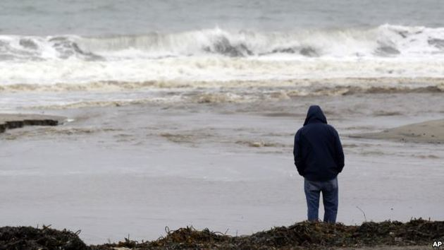
Sun and wind are seen as the most abundant sources of clean, renewable energy, but as many 'ocean-hugging' countries know, the energy of ocean waves is also both powerful and endless. Looking for the most efficient ways to capture that energy, the U.S. Department of Energy has announced a $1.5 million-prize competition for new ideas.
The department estimates that waves and tides along the U.S. coasts generate 1,420 terawatt-hours of energy annually. That is equal to the output of more than 330 nuclear power plants.
Unfortunately, the efficiency of today's technologies for capturing that energy is only about 20 percent, too low for the investment to be economical, says Jose Zayas, director of the Wind and Water Power Technologies Office at the Department of Energy.
"We're really looking to step-change that into the high 30s-40s [percent] and I thinkhellip; once you achieve that, then the economic competiveness of this industry really comes to life and that's really the target that we are shooting for," says Zayas.
To encourage development of new technologies, the Department of Energy has launched a nationwide competition, called the Wave Energy Prize.
Developing new devices to capture wave energy can be a challenge. The environment in which wave capture machines must operate can be very harsh and unforgiving, with crushing blows of notoriously corrosive salty medium.
Competition organizers expect that most of the new ideas will be coming from existing energy companies, but also from the academic sector and research institutions.
Zayas says testing of the proposed technologies will be done in several phases.
"We would have 1/50th scale testing where we would do the first fundamental evaluation of their performance, as well as making sure that they are in a pathway that can assure them success towards a prize. We will then down-select again, and near the end we will have about 10 teamshellip; it's our hope to be competing at 1/20th scale," says Zayas.
Testing of the scaled models will be done at the U.S. Navy's huge indoor testing pool, with machines capable of generating ocean-size waves.
Zayas says the models will not be required to produce electrical power. Instead they will have to prove how much of the wave energy they can capture.
"We are looking at how the companies, architectures, have the ability to capture that energy and, of course, through high degrees of data analysis, acquisition sensing, actually quite easy to convert that mechanical kinetic energy into electrical energy, giving us confidence that at least the attributes of the machine are in line with the objectives of the prize," says he.
Zayas says the ultimate goal of the Wave Energy Prize is to inspire a new set of power-generating technologies for the 21st century. Developers of the three best performing devices will be awarded prizes ranging from $250,000 to $1.5 million.

CleanTechnica
Registration Open For The New Wave Energy Prize Competition
May 9, 2015

While solar and wind sweep ahead, leading the game-changers of the renewable energy market, one fresh but valuable resource is building up momentum as well — wave energy. The US Department of Energy’s Water Power Program is looking to help grow that momentum, and registration is now open for the new Wave Energy Prize competition.
Sponsored by the US Department of Energy (DOE), the competition’s purpose is none less than doubling the state-of-the-art performance of wave energy conversion (WEC) devices over the next two years. The DOE announced the Wave Energy Prize at the International Marine Renewable Energy Conference co-located at the National Hydropower Association Annual Conference.
According to Energy.gov, “Marine and hydrokinetic energy technologies convert the energy of waves, tides, and river and ocean currents into electricity.” The DOE’s intention for the competition is to advance developments of WEC devices. The focus is mainly to accelerate invention of WEC devices capturing increased energy from ocean waves.
The population of the United States loves to live near water. More than 50% of Americans are residing within 50 miles of coastlines. Thus, such technologies offer boundless communities a chance to restore clean air and water via renewable electricity in their regions. Successful entries will diminish costs and affect the commercial deployment of wave energy in expanding areas.
As a public prize challenge sponsored by the US Department of Energy (DOE)‘s Water Power Program, expectations are for this competition to broaden the diversity of organizations involved in Wave Energy Converter (WEC) technology development — at the same time energizing and motivating present stakeholders.
With more than $2 million freed up for the most inspired and creatively effective teams, the Wave Energy Prize bestows an occasion for participants to:
Win a monetary prize.
Receive seed funding to build a 1/20th scale model WEC device for testing.
Participate in two rounds of WEC testing, including the final round at the US Navy’s Maneuvering and Seakeeping Basin in Carderock, Maryland, the nation’s premier wave testing facility.
Contribute to the development of innovative clean energy technologies that boost US energy security.
The Wave Energy Prize news release quotes White House Office of Science and Technology Policy Chief of Staff Cristin Dorgelo: “Prize challenges are an effective way to spur innovation and solve tough problems by attracting untapped talent…. By reaching beyond existing communities of interest, prize challenges source out-of-discipline perspectives that can yield outstanding and novel solutions. This effort brings new perspectives to the table with minimal risk.”
The panel of judges is composed of technical experts from Sandia National Laboratories (in Albuquerque, New Mexico), the National Renewable Energy Laboratory (in Golden, Colorado), the Naval Surface Warfare Center—Carderock Division (in Bethesda, Maryland), and Ricardo, Inc. (in Van Buren Township, Michigan). The DOE expects to select finalists and alternates in early 2016.
Registration for the Wave Energy Prize is scheduled to remain open until June 15. For more information or to register, go to waveenergyprize.org.
The Water Power Program:
“What if in the next two years the wave energy industry achieved a technology leap so revolutionary that it would make the cost of wave energy competitive with traditional sources of energy? This could be the result of the U.S. Department of Energy’s Wave Energy Prize.” –Wave Energy Prize
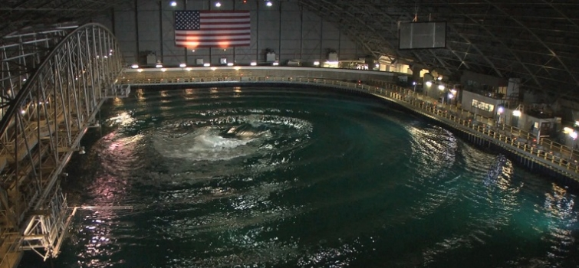
Ecopreneurist reports the 18-month competition will have participants design and build their wave energy devices and then test and evaluate them at the US Navy’s Maneuvering and Seakeeping (MASK) Basin at Carderock, MD.
Images via the DOE

Hydro World
DOE offers prize challenge for wave energy conversion ideas
May 20, 2015
In April, the U.S. Department of Energy announced its launch of the Wave Energy Prize competition "as a means to use a prize challenge to help dramatically improve the performance of wave energy conversion devices, providing a pathway to game-changing reductions in the cost of wave energy."
The competition is a multi-tiered, open entry program meant to spur development of marine hydrokinetic (MHK) technology for use in the U.S.
According to the agency, the Wave Energy Prize aims to attract next-generation ideas by offering a prize purse and providing an opportunity for testing at the Naval Surface Warfare Center Carderock's Maneuvering and Seakeeping (MASK) Basin in Maryland.
During the year-and-a-half design-build-test competition, teams must reach a number of milestones that include a technical submission, numerical modeling, and small-scale testing.
Beginning in August 2016, developers of selected projects from the initial milestone phases will be invited to participate in further testing at the MASK basin. Winners from among the projects tested at the MASK basin will be announced in November 2016.
For more information on the competition, log onto WaveEnergyPrize.org.

Tidal Energy Today
Wave Energy Prize extends registration deadline
June 15, 2015

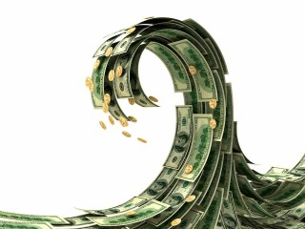
The registration deadline for the Wave Energy Prize has been extended for additional two weeks.
Wave Energy Prize, a competition launched by US Department of Energy (US DoE), aims to accelerate the development of WEC devices that capture energy from ocean waves.
The original deadline for the team registration was set for June 15, but Wave Energy Prize administration team has extended the deadline to June 30, 2015.
The number of teams registered for the Wave Energy Prize so far amounts to 45, including the teams from 40SouthEnergy, Oscilla Power, and Protean Wave Technology.
The team that ranks the highest after testing the 1:20 scaled WEC device model will be awarded $1.5 mln. The second team will win an award in the amount of $500.000, and the third-placed tam will be awarded $250.000.
US DoE expects to select finalists and alternates in early 2016.
The judging panel will include technical experts from Sandia National Laboratories, National Renewable Energy Laboratory, Naval Surface Warfare Center – Carderock Division, and Ricardo Inc.

Hydro World
DOE looks for tech boom with new Wave Energy Prize announcement
June 29, 2015

A new prize purse announced by the U.S. Department of Energy could feed more than $2 million into wave energy technology research and development.
Introduced by DOE Office of Energy Efficiency and Renewable Energy Assistant Secretary Dave Danielson on April 27, during the National Hydropower Association's Annual Conference in Washington, D.C., the program -- called the Wave Energy Prize -- is intended to "reduce the cost of wave energy, making it more competitive with traditional energy solutions."
The announcement was of particular interest to those people attending the International Marine Renewable Energy Conference (IMREC) and Marine Energy Technology Symposium (METS), which were, for the first time, co-located with NHA's annual meeting.
"For this exciting new prize competition, we're challenging you -- our key stakeholders in the industry -- to double the energy captured from ocean waves by developing new ocean wave energy converter technology" Danielson said. "[The Wave Energy Prize] will not only result in some fascinating new concepts, but will also open up new technology for the industry as it moves forward more and more rapidly."
The program includes a 20-month design-build-test competition that offers seed money and an opportunity to participate in two rounds of testing. Those companies selected for the second round of competition will be given a chance to test scaled wave energy conversion (WEC) devices at the Naval Surface Warfare Center's Maneuvering and Seakeeping (MASK) Basin at Carderock, Md., beginning Summer 2016.
"The winning devices will help create new possibilities to reduce costs and move wave energy even closer to widespread commercialization," Danielson said.
Interested participants can register for the Wave Energy Prize until June 15 at WaveEnergyPrize.org.

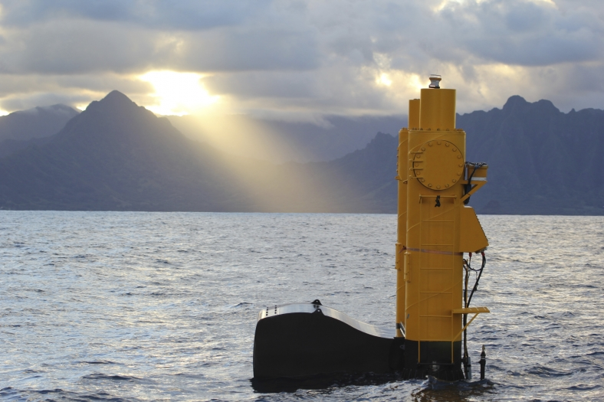Azura designd by Northwest Energy Innovations is currently connected to the grid and undergoing testing at the Navy's Wave Energy Test Site (WETS) in Kaneohe Bay on Oahu | Virginia Joins Wave Energy Competition  7.6.15 - With a purse of $2 million, three teams from Virginia have entered the Department of Energy’s Wave Energy Prize Challenge. The teams, all with ties to Virginia Tech, are competing in a pool of 92 applicants for up to 20 spots that will be announced in August.  The design-build-test competition was organized to spark innovation and pave the way to commercial development of wave energy conversion (WEC) devices. To reduce the costs associated with the nascent technology, teams are striving to build machines that double energy extraction.  The potential for wave energy along US coasts, where half the country’s population resides is tremendous. According to the DOE, 5% of the available resource could provide power to 5 million homes. Updates on the process will be posted.

Domestic Fuel
Wave Energy Prize Entrants Move Forward
By Joanna Schroeder, July 7, 2015
The U.S. Department of Energy’s (DOE) wave energy competition is moving toward the next phase with 92 teams. The Wave Energy Prize is a design-build-test competition encouraging the development of better innovations for wave energy conversion (WEC) devices that will double energy capture. When this is achieved, costs will be reduced making wave energy more competitive with established energy technologies.
The 91 American teams and one team from Denmark official will now begin working to double the energy captured from ocean waves and win a prize purse totaling more than $2 million.
“We’re extremely pleased with both the quantity of teams and the diversity of participants reflecting broad expertise from so many established companies in the ocean energy space, universities, and newcomers to the industry,” said Julie Zona, Wave Energy Prize administrator. “The composition of the participating teams truly demonstrates one of the benefits of a prize challenge, which is to encourage the inclusion of new perspectives. We’re very hopeful that the diverse backgrounds of these teams will help lead to the Prize’s goal of achieving game-changing performance enhancements to wave energy technologies.”
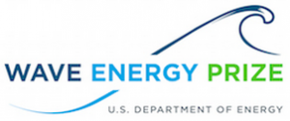Team names and background information on the official registered teams can be found on the Wave Energy Prize website.

Popular Science
For The First Time, Waves Are Adding Power To The U.S. Grid
By Mary Beth Griggs, July 7, 2015
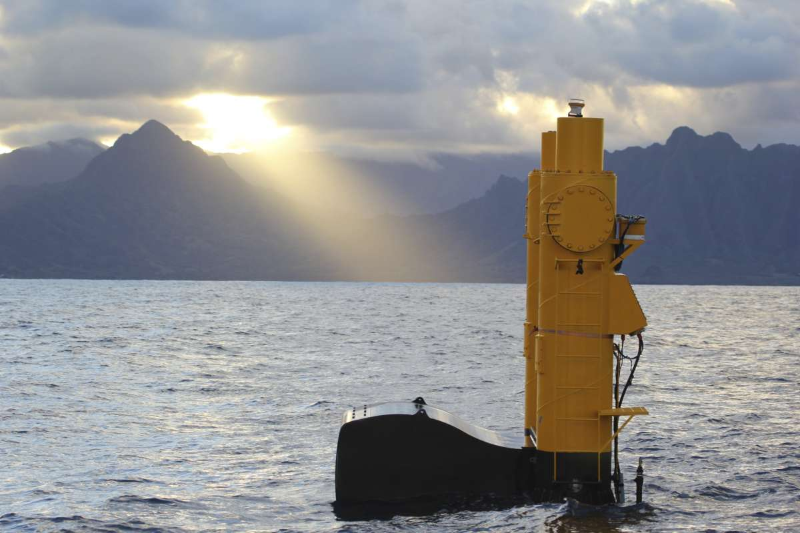
Azura, Northwest Energy Innovations. Azura, a machine that turns the mothion of waves into electricity, off the coast of Hawaii
The waves of Hawaii are a big draw for tourists and surfers, but now they're also a source of electricity. For the first time in the United States, energy collected from waves is being turned into electricity that is heading onto the grid, and powering homes in Hawaii.

The project involves the Azura prototype, built by Northwest Energy Innovations. Azura is a 45 ton machine that moves with the swells of the waves capturing their complex motion in 360 degrees, making it more efficient than other wave generators that only capture a particular movement in the waves (like up and down, or side to side).
Video of NWEI Animation
Azura was deployed last month, and will run for a full year, monitored by many different research groups, including the University of Hawaii, who independently verified that the generators were working and supplying power to the grid. If all goes well, an even larger version of the device will go into the ocean in 2017.
Though this is the first, there are a lot more wave energy projects in the works. The Department of Energy (DOE) notes that over 50 percent of the population in the United States lives within 50 miles of the coast, making waves (and their energy) an easily accessible renewable energy option.

The DOE is currently sponsoring the Wave Energy Prize, a competition open to the public where teams attempt to build the best wave energy device. Registration for the competition just closed this week, and 92 teams have submitted proposals, hoping to reach the grand prize of $1.5 million. Twenty finalists will be announced in August, and will then start building their designs.

Business Insider

The US just tapped into a surprising source of renewable energy for the first time

By Mary Beth Grigg, Popular Science, July 8, 2015

The waves of Hawaii are a big draw for tourists and surfers, but now they're also a source of electricity. For the first time in the United States, energy collected from waves is being turned into electricity that is heading onto the grid, and powering homes in Hawaii.
The project involves the Azura prototype, built by Northwest Energy Innovations. Azura is a 45 ton machine that moves with the swells of the waves capturing their complex motion in 360 degrees, making it more efficient than other wave generators that only capture a particular movement in the waves (like up and down, or side to side).
Azura was deployed last month, and will run for a full year, monitored by many different research groups, including the University of Hawaii, who independently verified that the generators were working and supplying power to the grid. If all goes well, an even larger version of the device will go into the ocean in 2017.
Though this is the first, there are a lot more wave energy projects in the works. The Department of Energy (DOE) notes that over 50 percent of the population in the United States lives within 50 miles of the coast, making waves (and their energy) an easily accessible renewable energy option.
The DOE is currently sponsoring the Wave Energy Prize, a competition open to the public where teams attempt to build the best wave energy device. Registration for the competition just closed this week, and 92 teams have submitted proposals, hoping to reach the grand prize of $1.5 million. Twenty finalists will be announced in August, and will then start building their designs.
This article originally appeared on Popular Science

Fierce Energy
Water water everywhere, but is it too soon for wave energy?
By Jaclyn Brandt, July 8, 2015
Although wave energy development in the European Union (EU) is going full-steam ahead, the technology still has a ways to go in the United States. However, a new development is giving researchers in the U.S. a chance to look at the long-term effects of wave energy.
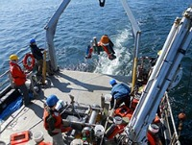
Credit: Department of Energy
The test device, called Azura, was launched in a 30-meter test berth at the United States Navy's Wave Energy Test Site (WETS) in Kaneohe Bay, on the island of Oahu, Hawaii. It was supported by the Department of Energy (DOE) and the U.S. Navy.
Azura is a grid-connected wave energy converter (WEC), and is being independently tested by the University of Hawaii in open ocean.
"The project supports the Energy Department's mission to research, test, and develop innovative technologies capable of generating renewable, environmentally responsible, and cost-effective electricity from clean energy resources, including water," DOE said in a statement. "Marine and hydrokinetic (MHK) technologies, which generate power from waves, tides, or currents, are at an early but promising stage of development."
The researchers first tested a smaller prototype of Azura in a wave tank, before launching the full prototype, which was done in open sea off the cost of Oregon in 2014. Azura's developer, Northwest Energy Innovations (NWEI) of Portland, Oregon, tested the functionality of the device, while also testing other aspects and collecting data during the experiment.
According to DOE, more than 50 percent of the population of the United States lives within 50 miles of a coastline, and many coastlines in the country have strong wave and tidal resources.
"The technically recoverable resource for electric generation from waves is approximately 1,170 terawatt-hours per year (TWh/year), which is almost one third of the 4,000 TWh of electricity uses in the United States each year," Katie Arberg, spokesperson for the U.S. Department of Energy's Office of Energy Efficiency and Renewable Energy, told FierceEnergy. "Developing just a small fraction of the available wave energy resource could allow for millions of American homes to be powered with this clean, reliable form of energy. For context, approximately 85,000 homes can be powered by 1 TWh/year."
Because of this, transmission from wave energy could become economically viable. But there have been numerous investments in wave energy across the world, and very few in the United States. Arberg explained that the US has been an active member of International Energy Agency's Ocean Energy Systems (OES) Technology Initiative since 2005 -- an intergovernmental collaboration of 22 countries to advance MHK.
"The current state of the wave energy industry is much like the early stages of the wind energy industry in the 1980s," she explained. "Many concepts for MHK devices have been proposed with a wide variety of methods for energy capture and conversion, but there has been little technology convergence to date."
Arberg told FierceEnergy that short-term growth will be seen in the form of technology advancement -- in both prototypes and early-production models. However, wave energy devices are not yet cost-competitive with other forms of energy.
"Thus, DOE sees an important opportunity in reducing the cost of wave energy so it can contribute to the nation's clean energy supply," she explained. "Over the past six years, DOE has awarded over $110 million in funding in technology research and development (R&D) projects related to marine and hydrokinetic (MHK) energy systems, infrastructure, and instrumentation, many of which have directly benefited wave energy development. In 2014 alone, DOE supported $29.5 million in competitive awards to industry and university R&D efforts."
NWEI has also launched a 20-kilowatt (kW) demonstration project connected to the grid at WETS.
"The current phase of in-water testing at the WETS's 30-meter test berth has already proven valuable in gathering performance and reliability data from the device in deepwater, open-ocean conditions," DOE said. "The data will be used to further optimize Azura's performance and refine existing wave energy computer simulations, ultimately supporting commercialization of this technology."
NWEI received $5 million from DOE for the project, and is helping with the current deployment. The researchers are looking to learn from the first test, and improve the efficiency and reliability of the technology. They plan to launch a full-scale device, from 500 kW and 1 megawatt (MW) at WETS in water between 60 meters and 80 meteres deep.
The projects are supported by the Energy Department's Office of Energy Efficiency and Renewable Energy (EERE), whose goal is to develop renewable energy technologies, while also creating energy security, environmental quality, and economic vitality.
In April 2015 DOE also launched the Wave Energy Prize competition, the first opportunity for wave energy conversion devices to test their innovative designs at the nation's most advanced wave-making facility in the Naval Surface Warfare Center Carderock's Maneuvering and Seakeeping (MASK) Basin in Maryland.
"With further progress towards commercialization, MHK technologies could make substantial contributions to our nation's electricity needs," DOE said. "To accelerate commercialization of wave energy devices, the Energy Department funds research and development -- from laboratory and field-testing of individual components, up to demonstration and deployment of complete utility-scale systems."
For more:
- visit this website
- watch this video

Hydro World
More than 90 teams enter U.S. DOE's Wave Energy Prize program
By Michael Harris, Associate Editor, July 8, 2015
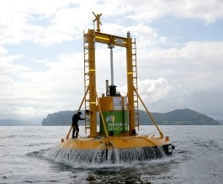
The U.S. Department of Energy has accepted 92 teams from industry and academia to compete in its Wave Energy Prize program that seeks to encourage the development of wave energy conversion devices.
The program, which was introduced in April by the DOE Office of Energy Efficiency and Renewable Energy during the National Hydropower Association's Annual Conference in Washington, D.C., is a design-build-test competition that supports the department's goal of making marine hydrokinetic generation more competitive with traditional forms of production.
Teams will be competing for a total prize purse that totals more than $2 million.
"We’re extremely pleased with both the quantity of teams and the diversity of participants reflecting broad expertise from so many established companies in the ocean energy space, universities, and newcomers to the industry," said Julie Zona, Wave Energy Prize administrator.
Since registration for the program closed June 30, teams are working on the first requirement for the prize -- a technical submission describing their concepts, which is due later this month. A panel will then select up to 20 of the top teams by mid-August, with those groups invited to build a 1/50th scale model for small-tank testing.
The pool will be further culled by next March, and the remaining teams will receive seed money to build a 1/20th scale prototype that will undergo stank testing at the Naval Surface Warfare Center's Maneuvering and Seakeeping (MASK) Basin in Carderock, Md., beginning that summer.
"The composition of the participating teams truly demonstrates one of the benefits of a prize challenge, which is to encourage the inclusion of new perspectives," Zona said. "We're very hopeful that the diverse backgrounds of these teams will help lead to the prize's goal of achieving game-changing performance enhancements to wave energy technologies."
Programs like the Wave Energy Prize are becoming increasingly popular, White House Office of Science and Technology Policy Chief of Staff Cristin Dorgelo said, as federal agencies look for innovative ways of engaging private sector developers.
"By reaching beyond existing communities of interest, prize challenges source out-of-discipline perspectives that can yield outstanding and novel solutions," Dorgelo said. "This effort brings new perspectives to the table with minimal risk."
Teams participating in the opening round of the Wave Energy Prize competition include:
- 40South Energy (Palo Alto, Calif.)
- AdapWave (Baltimore, Md.)
- Advanced Ocean Energy @ Virginia Tech (Hampton Roads, Va.)
- AIMMER Marine Energy (Oakland, Calif.)
- Alternative Energy Engineering Associates (Port Orchard, Wash.)
- Aqua-Shift (Encinitas, Calif).
- AquaHarmonics (Oakland, Calif.)
- ATA Engineering (San Diego, Calif.)
- Atargis Energy Corporation (Pueblo, Colo.)
- Atlantic Wavepower Partnership (Newport, R.I.)
- Atlas Ocean Systems (Houston, Texas)
- AWECS Attenuator (Glen Burnie, Md.)
- Brimes Energy (Holbrook, N.Y.)
- Buoyant Energy (Cambridge, Mass.)
- Cal Poly – Protean Wave Energy, Inc. (San Luis Obispo, Calif.)
- CalWave (Berkeley, Calif.)
- Centipod (Santa Barbara, Calif.)
- Crestwing (Denmark)
- Earth By Design (Bend, Ore.)
- eBuoy (Ayer, Mass.)
- Energystics (Stony Brook, N.Y.)
- Enorasy Labs (Bedford, Mass.)
- EnSea, Inc. (San Francisco, Calif.)
- ESI – Perpetuwave (Doral, Fla.)
- Etymol Ocean Power (Winter Springs, Fla.)
- Fetzer Wave (Palm Harbor, Fla.)
- Float Inc. – BergerABAM (San Diego, Calif.)
- GlobalOne Sciences (Dayton, Ohio)
- Greenfield Technologies LLC (Addison, Ala.)
- GyroGenTM (Bloomfield Hills, Mich.)
- Healy’s Wave Energy Converter (Hollis, N.H.)
- Hui Nalu (Honolulu, Hawaii)
- Hydrokinetic Energy Solutions (Sunnyvale, Calif.)
- Iowec (Cambridge, Mass.)
- James F. Marino (San Diego, Calif.)
- Jetty Joule (Colusa, Calif.)
- KNSwing (Denmark)
- Kozoriz-Franklin California Maglev, Inc. (Long Beach, Calif.)
- KymoGen (Bristol, Conn.)
- Leviathan Energy Waves (Stony Brook, N.Y.)
- M3 Wave (Salem, Ore.)
- MARUTHI POWER (Cleveland, Ohio)
- Mighty Waves Energy Team (Vienna, Va.)
- Mocean Energy (Annapolis, Md.)
- Neptune Wave Power, LLC (Dallas, Texas)
- Next Gen (Sacramento, Calif.)
- NM-AGGIE Waves (Las Cruces, N.M.)
- Ocean Energy USA (Sacramento, Calif.)
- Ocean Kinetics (Homer, Alaska)
- Ocean Lab (Glendale, Calif.)
- Ocean Motion International (Denver, Colo.)
- Oscilla Power (Seattle, Wash.)
- Ovsiankin Energy Group (Chicago, Ill.)
- Poseidon’s Kite (Gambrills, Md.)
- Principle Power (Berkeley, Calif.)
- Protean Wave Technology Inc. (San Juan, Puerto Rico)
- ReWEB Technology (Narragansett, R.I.)
- Rohan Patel (Bensalem, Pa.)
- Royal Wave (Paonia, Colo.)
- RPPC (Denver, Colo.)
- RTI-MIT Wave Power (York, Maine)
- Rutgers Wave Power (Piscataway, N.J.)
- SAi Orbit Wave Power (Daphne, Ala.)
- Sea Potential (Bristol, R.I.)
- SeaFoil (Redwood City, Calif.)
- SeaGreen Technologies (Annapolis, Md.)
- SeaStar Ocean (Los Angeles, Calif.)
- SEWEC (Redwood City, Calif).
- Spindrift Energy (Simi Valley, Calif.)
- Super Watt Wave Catcher Barge Team (Houston, Texas)
- TAMU-OSSL (College Station, Texas)
- Team FLAPPER (Research Triangle Park, N.C.)
- Team Treadwater (Houston, Texas)
- Thrustcycle Enterprises (Wilsonville, Ore.)
- Undulational Harvester (Albany, Calif.)
- Uniturbine Corporation (Lewes, Del.)
- Vortex (Lenox, Mass.)
- Wave Energy at Virginia Tech (Blacksburg, Va.)
- Wave Energy Conversion Corporation of America (WECCA) (North Bethesda, Md.)
- Wave Forest Power (Benton, Ky.)
- Wave Water Works (Northville, Mich.)
- Wave Wheel (Gray, Maine)
- Waveberg Development (San Diego, Calif.)
- WaveFlex 1 (Baltimore, Md.)
- WaveFlex 2 (Baltimore, Md.)
- WaveFlo (Newburyport, Mass.)
- Waves2Energy (Union, N.J.)
- Waveswing America (Sacramento, Calif.)
- Wavewatts (Aliso Viejo, Calif.)
- Wavy Turbine (La Jolla, Calif.)
- Wizards of Energy (Dania Beach, Fla.)
- Worldwide Windfinder (Dallas, Texas)
Full profiles for each of the teams can be found on DOE's Wave Energy Prize website.

For more marine and hydrokinetic news, visit here.

Phys.org
Wave energy device is watched for clean power in Hawaii
By Nancy Owano, July 9, 2015

The U.S. government continues its interest in wave energy, saying it is "committed to supporting the growth of this emerging technology." Supporters of wave energy hope that it will one day be an important source of clean energy, providing low-carbon electricity to places.
Marine and hydrokinetic (MHK) technologies, which generate power from waves, tides, or currents, said the Department of Energy, are at an early but promising stage of development.
Why is wave energy still at an early stage? A key factor, among any other challenge, is cost. Wind and solar have grabbed most of the renewable energy headlines in recent years as they got cheaper but, said Matt Dozier, Office of Public Affairs, that didn't happen overnight.
"Decades of research, testing and investment—much of it supported by Energy Department initiatives—have given us more reliable, cost-effective hardware, encouraging more installations and driving down energy prices. The same needs to happen for wave power."
The question has been how to generate electricity from the sea on a scale that makes economic sense, he wrote. And that is what makes a Hawaii-based project interesting. This is the Wave Energy Pilot Project from Oregon-based Northwest Energy Innovations (NWEI). The project is now at the stage of being grid-connected and is undergoing open-sea pilot testing.
Last month a prototype of their bright-yellow wave energy converter was deployed at a U.S. Navy testing site, on Oahu. It's in a 30-meter test berth.
The Azura device gets support from the Energy Department and the U.S. Navy. It weighs 45 tons but weight is not its outstanding feature. The interesting part is that it can harness movement in 360 degrees. This is special because it represents a shift in how such wave-energy devices operate.
"Waves have both side-to-side and up-and-down motion, but up to this point, almost all designs have been limited to one direction or the other," said Dozier.
Testing of the Azura device will continue for a year, and in 2017 there is potential for a full-scale demo. The Azura is connected to Hawaii's electric grid.
What are observers watching out for during this pilot test? They will monitor and evaluate long-term performance; this is the nation's first grid-connected wave energy converter (WEC) device to be independently tested by a third party (University of Hawaii) in the open ocean.
NWEI said on Wednesday that in addition to evaluating performance, data collected will enable the team to develop a more accurate assessment of the technology's Levelized Cost of Energy (LCOE), which accounts for capital cost, project development cost, life cycle costs and annual energy production.
What's next: NWEI, with $5 million in additional funding from the Energy Department, will apply lessons learned from this phase to modify design in to improve on efficiency and reliability. NWEI said on Wednesday that the device "will be deployed for 12 months of grid-connected testing as part of a rigorous program to commercialize the Azura technology."
With the improved design, according to the DOE report, NWEI plans on testing with a full-scale device rated between 500 kilowatts and one megawatt at WETS at deeper test berths of 60 meters to 80 meters over the next several years.
In related DOE wave-energy news, Mary Beth Griggs in Popular Science reported earlier this week that the DOE is sponsoring the Wave Energy Prize; registration is now closed and one can expect more interesting ideas to come. The contest is inviting teams to try to build the best wave energy device. The top prize is $1.5 million.
Again, this relates to the challenge of cost in advancing wave energy. "The wave energy industry is young and is experiencing many new innovations as evidenced by a sustained growth in patent activity," said the contest notes. "While the private industry is developing these early-concept WEC devices through design and benchtop prototype testing, funding is hard to secure for performance testing and evaluation of WEC devices in wave tanks at a meaningful scale. This is a problem for the industry since scaled WEC prototype tank testing, validation, and evaluation are key steps in the advancement of WEC technologies through the technical readiness levels to reach commercialization. "
It is a 20-month design-build-test competition. There are numerous milestones that teams will need to reach before finalists are identified, said the contest site.
Participants in the contest will design, build, numerically model, and test prototypes of a WEC device at the 1/50th and 1/20th scales.
The Wave Energy Prize has been designed to focus on deep-water devices; it chose wave conditions on the U.S. West Coast due to the large energy resource in this region

Tidal Energy Today
US Wave Energy Prize: Race-on for 92 teams
July 13, 2015
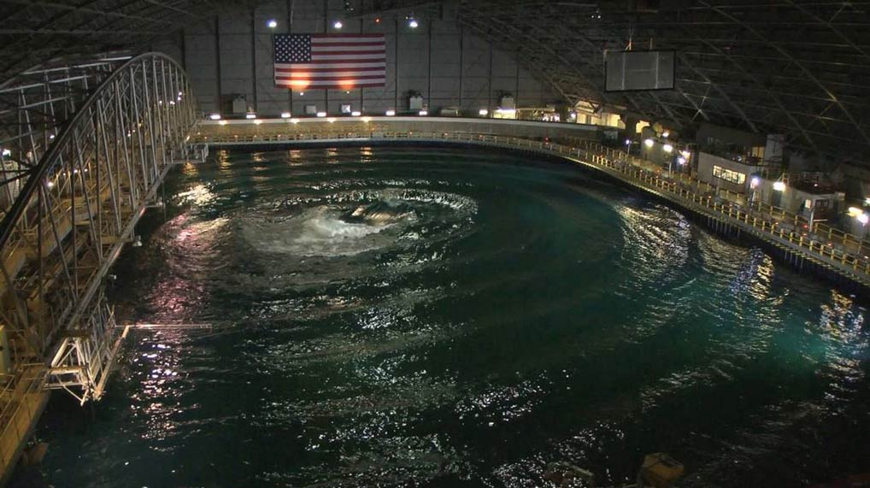US Navy’s Maneuvering and Seakeeping Basin in Carderock
Wave Energy Prize, a competition launched by the US Department of Energy (US DoE), has announced that 92 teams have officially been registered for the WEC device development competition.
This design-build-test competition is encouraging the development of game-changing wave energy conversion (WEC) devices that will achieve the DOE’s goal of doubling energy capture, thus reducing the cost of wave energy and making it more competitive with traditional energy solutions.
The official registered teams will now begin working to double the energy captured from ocean waves and win a prize purse totaling more than $2 million, according to Wave Energy Prize.
Some of the official registered teams include those from: 40South Energy, Perpetuwave, Oscilla Power, and Protean Wave Technology.
Julie Zona, Wave Energy Prize Administrator, said: “The composition of the participating teams truly demonstrates one of the benefits of a prize challenge, which is to encourage the inclusion of new perspectives. We’re very hopeful that the diverse backgrounds of these teams will help lead to the Prize’s goal of achieving game-changing performance enhancements to wave energy technologies.”
Registration for the Wave Energy Prize opened on April 27 and closed on June 30, 2015.
Since registering, the teams have begun work on the first requirement for the Prize, a technical submission describing their concepts, due July 15, which will be reviewed by a panel of expert judges.
According to Wave Energy Prize, up to 20 of the top teams will be named qualified teams based on their technical submissions in an announcement scheduled for mid-August.
Qualified teams will build a 1/50th scale model and will participate in small-scale tank testing for validation of their design concepts.
Finalist teams, which will be announced in March 2016, will have the opportunity to receive seed money to build 1/20th scale WEC prototypes that will undergo tank testing at the Naval Surface Warfare Center’s Maneuvering and Seakeeping (MASK) Basin at Carderock, Maryland, beginning in the summer of 2016.
The team that ranks the highest after testing the 1:20 scaled WEC device model will be awarded $1.5 mln. The second team will win an award in the amount of $500.000, and the third-placed tam will be awarded $250.000.
The judging panel will include technical experts from Sandia National Laboratories, National Renewable Energy Laboratory, Naval Surface Warfare Center – Carderock Division, and Ricardo Inc.
A complete list of the registered teams is available on Wave Energy Prize website.
Image: Wave Energy Prize

OffshoreWIND.biz
USD 2 Mln Wave Energy Prize Attracts 92 Teams July 13, 2015
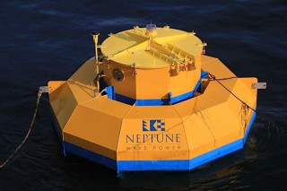

Wave energy enthusiasts from industry and academia have formed 92 teams to move toward the first milestone of the U.S. Department of Energy’s (DOE) Wave Energy Prize.
The design-build-test competition is encouraging the development of wave energy conversion (WEC) devices that will achieve the DOE’s goal of doubling energy capture, thus reducing the cost of wave energy and making it more competitive with traditional energy solutions.
These official registered teams will now begin working to double the energy captured from ocean waves and win a prize purse totaling more than $2 million.
A list of the official registered teams and background information can be found on the Wave Energy Prize website.
Image: Neptune Wave Power (Illustration)

HydroWorld
COER competition could help marine hydrokinetic development
By Gregory Poindexter; July 27, 2015
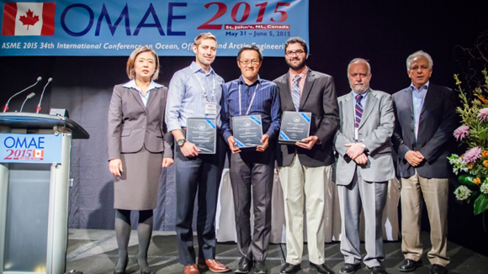
A combination multi-agency team may have an effect on marine hydrokinetic energy development after winning a recent international competition for the Center for Ocean Energy Research (COER) Hydrodynamic Modeling Competition.
The U.S. Energy Department (DOE) funded the wave energy converter (WEC) modeling team whose members are from the National Renewable Energy Laboratory (NREL) and Sandia National Laboratories (SNL).
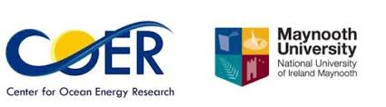
Using national lab-developed design tools, the modeling team bested five different teams including entrants from the Massachusetts Institute of Technology, Canada-based Dynamic Systems Analysis and three additional international universities.
Organized by Maynooth University in Ireland, COER competition was held in conjunction with this year’s International Conference on Ocean, Offshore and Arctic Engineering (OMAE) in Newfoundland, Canada from May 31–June 5.
In a press release, DOE said the researchers it funded were challenged to predict the dynamic motion of a floating body in an irregular wave field measuring results using the open-source platform, WEC-Sim system. This allowed researchers to customize its code to suit their specific needs through computer-based modeling software.
Teams had three months to compile and submit their final simulation results; these submissions were then compared with data from an experimental scenario outlined by COER. The DOE-funded team simulated the experimental scenario with the smallest variance from the experimental results.
WECs have the potential to produce electricity from America’s vast domestic wave energy resources. This spurs opportunities for device design optimization, while driving down the cost of this as-yet untapped source of energy.
DOE said, “Ongoing projects, like our Wave Energy Prize, provide additional opportunities to further the advancements being made in this industry.
“Many new technological developments could result from the prize as 92 eligible teams recently registered to compete to become one of 10 finalists that will test their WEC devices at the maneuvering and seakeeping basin in Carderock, Maryland.”

energybiz
Wave energy test rolling forward in Hawaii
By Amy Gahran, July 28, 2015
Just off the coast of Oahu, Hawaii, last month a wave energy generator began contributing small ripples of electricity to the local utility's grid. In this one-year test of new technology, the U.S. Department of Energy and the University of Hawaii are collaborating to gather data which could help shape the future of wave energy technology.
This test also will help show how well wave energy might help utilities address crucial, growing challenges with maintaining grid stability while relying more heavily on renewables.
The 20 kW wave energy converter from Oregon-based Northwest Energy Innovations, called Azura, doesn't quite produce enough electricity to power even a single home. But it represents a significant technological advancement.
Azura is one of the first devices developed that will demonstrate conversion of ocean energy to electricity by absorbing energy through both up-and-down and back-and-forth wave motions, enabling its converter to generate more electricity than previous such devices.
In addition, the energy-harvesting "float" at the top of Azura can rotate 360 degrees, reducing mechanical stress and helping prevent failures - a problem with earlier technologies.
Azura sits in 30 meters of water in a berth at a U.S. Navy testing facility, where undersea cables and a supportive stakeholder made it easy to site the test. (As with ocean wind power projects, finding a home for wave energy projects can prove complex or controversial.)
Steven Kopf, CEO of Northwest Energy Innovations, said the university's independent validation and analysis of data from this test is a critical step in moving wave energy technology forward.
"Utilities and power project developers won't even consider buying wave power technology unless they can see what an independent third party says it can really do," said Kopf. "So we're consciously running this test in all sorts of conditions, even when wave conditions are suboptimal for power production, just to get a complete picture of performance."
DOE agrees. "This pilot testing is now giving U.S. researchers the opportunity to monitor and evaluate the long-term performance of a grid-connected WEC device in the open ocean," said a spokesperson. "So far, this project has already proven valuable in identifying deployment efficiencies, gathering performance data, and developing operations and maintenance procedures. The learnings from the Azura deployment will accelerate the ultimate technology commercialization."
Northwest Energy Innovations designed Azura using standard components, in order to help keep production costs down - another challenge with earlier technologies.
Cost is one of the most critical issues with wave power. As with all new renewables, the initial cost of wave power is relatively high. According to the Ocean Energy Council, recent experience in the U.K. (which is more advanced in wave power testing and deployment) is about 7.5 cents per kWh at best. The industry goal is to get this down to about 4.5 cents per kwh - comparable with the cost of wind power, although still much higher than the cost of fossil-fuel generation.
However, wave power offers some notable potential advantages to compensate for that cost.
In addition to helping states meet renewable energy targets, proximity to demand often reduces the cost and complexity of power transmission - and about 50% of the U.S. population live within 50 miles of a coastline. A 2011 Electric Power Research Institute report found that available wave energy resources offer the potential to meet about one-third of current U.S. electricity demand.
Addressing environmental concerns, laying undersea cables and gaining stakeholder cooperation does take work.
One reason utilities and power network operators might be especially interested in wave power is that it tends to be far more predictable than wind or solar power. According to the DOE, this advantage might help compensate for the complications associated with deploying wave power, which include "locating an undersea cable for bringing the power to shore, while avoiding conflicts with shipping lanes, fishing grounds, military exercises or any of the myriad other ways we use our bustling coastal waters."
Still, predictability saves money. "Generally you can see four days out, with a high level of certainty, what the wave conditions will be," Knopf observed. "This allows power planners to know what they can count on from wave power, which makes it easier to control overall costs for electricity."
Hawaii may prove to be a promising initial U.S. market for wave energy. In June, Hawaii passed legislation requiring an even more aggressive increase in renewable energy production: 30% by the end of 2020, 40% by 2030, and 70% by 2040.
The state also has, by far, the highest cost for electricity: 34 cents per kWh, according the U.S. Energy Information Administration. Also, Hawaii is reaching the limit of the amount of solar energy its grids can handle.
Kopf acknowledged that cultivating investors for wave energy is challenging. "Early technologies didn't pan out, and a lot of investors got burned," he said. "But we've been quietly chipping away at this problem, and gradually investors are starting to get re-interested in it, now that they see the technology didn't completely bomb."
Last October, DOE awarded Northwest Energy $5 million to apply the lessons learned from the Azura test in Oahu to develop a full-scale unit - which Kopf says will provide up to 1 MW of power. Also, DOE is holding a Wave Energy Prize contest, to spur development of WECs with double the energy-capture potential of current technologies.

E&E News

RENEWABLE ENERGY: Infant U.S. wave-to-energy industry looks to build more testing facilities

By Camille von Kaenel, E&E reporter, via ClimateWire, Aug. 7, 2015

In the wave energy world, progress means having "steel in the water." Now that gadgets are graduating from mere prototypes to pre-commercial machines, their engineers must find the best places to try them out in the open ocean.
"You can learn a lot in the lab, but in order to prove commercial viability, you need to prove ocean viability," said Justin Klure, a partner at Portland, Ore.-based Pacific Energy Ventures who consults on the Azura wave energy device.
The 45-ton "Azura" went into the water in early June at the U.S. Navy's wave energy test site, near Kaneohe Bay off the coast of Oahu, Hawaii.
Pre-existing test facilities like that allow developers to skip some steps and deploy their machines so they can see what works and what doesn't. They don't have to find a site or get all the permits themselves.
During a yearlong trial run, Azura's parts will move up and down and side to side with the waves. The relative motion feeds a generator, which sends electricity back to the grid through an undersea cable.
Seeing the device start swaying with the waves was a "eureka moment" for Steve Kopf, the CEO of Northwest Energy Innovations, which is developing Azura. It is the first time a third party, the University of Hawaii, is validating the data coming from a wave energy device.
The country's waves are a huge, untapped energy source. On the coasts, including Alaska, waves could provide enough recoverable energy, around 1,170 terawatt-hours per year, to power almost 100 million homes, according to estimates from the Department of Energy.
The West Coast offers a quarter of that potential. With its energetic waves and populated shores, it's a promising market for wave energy dreamers. But for now, the dream is still far off.

Next step: standardization
For Azura, surviving the Hawaiian waters will be a first step, allowing engineers to tweak and update it for better performance. To make sure it is ready to sell electricity to utilities, it will have to run in a wave energy farm.
That setup doesn't exist anywhere in the United States -- for now. Two groups, in Oregon and California, are preparing plans for utility-scale, grid-connected test facilities. They are larger than the Hawaii facility, which already has four devices lined up for prototype tests in the upcoming years.
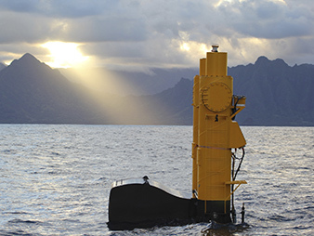
"Steel in the water": Azure, which makes electricity from the motion of the sea, settles into her Pacific home in Hawaii. Photo by Steve Kopf, courtesy of Northwest Energy Innovations.
The Department of Energy will choose one of the project sites at which to fund construction, as per its 2016 budget request, according to an emailed statement.
Europe, generally ahead on marine renewables, already has a few test sites, notably the European Marine Energy Center off the coast of Scotland. Now, the United States is trying to catch up.
No one is really sure what the technology will look like in 10 or 20 years.
"We haven't settled yet on a standardized technology, which is why we need to have several in the water and build our familiarity in the technology," said Jason Busch, director of the nonprofit Oregon Wave Energy Trust, which supports the wave industry in the state. "We don't have our three-bladed wind turbine yet."

Many groups offer ideas, but few are chosen
There are point-absorber devices, like Azura. They have generators that turn the relative motion of their parts into electricity. Some focus on the heave, or up and down, of the waves; some on the surge, or back and forth. The other main type is called an oscillating water column. The movement of the waves pushes air back and forth in an inner chamber, spinning turbines to produce electricity.
Engineers overflow with ideas. In late May, the Department of Energy launched a $2 million competition called the Wave Energy Prize. Ninety-two teams have applied. The top designs will be announced in mid-August.
Few companies are in it for the long haul. Only around a dozen companies are "throwing serious money" at wave energy, said Busch. The recession, the limited funding and the difficulty of ocean engineering dried up many enthusiastic early developers.
"It's what happens in every industry: Smaller companies or more ineffective companies are just not making it," Busch said. "It's a natural process."
Specialization, he thinks, could be the way for the industry to grow. "You could talk about deep-water technology, shallow-water technology, different levels of energy in the ocean," Busch said. "Technology that would be appropriate off the coast of Oregon would look different than technology powering communities off Alaska or Caribbean or Hawaii."
Small, remote coastal towns or Navy bases who already pay expensive utility bills and would require only one or two devices could be the best place to launch wave energy, some experts have said (ClimateWire, May 9, 2014).

Drip-by-drip federal funding
For now, the main force behind the new marine technology has been the Energy Department. It has poured $47 million into wave energy projects since 2008, according to an emailed statement.
The industry at large has not weaned itself off the drip-by-drip federal funding yet. That means both test-site developers and device engineers are sputtering ahead in uncertain starts and stops.
"There's not really enough funding to get everything going at the pace that people would like it to get going," said Belinda Batten, who leads the Northwest National Marine Renewable Energy Center (NNMREC) at Oregon State University. "It's this big bundling conundrum right now."
Oregon has led the rest of the country on wave energy development. Since 2012, NNMREC already operates a small non-grid-connected testing station off Newport, Ore. Multiple devices, including a previous version of Azura, have already been tested there.
A second facility, called the Pacific Marine Energy Center's South Energy Test Site, is one of the candidates for full funding by the Energy Department. The site could have four individually grid-connected berths, at which developers could test single devices or an array of devices.
If she had all the money she needed today, the site could be online in 2017, Batten estimated. That more or less syncs up with when developers could be ready to test an array of devices. Azura could be there in 2018 or 2019, according to Kopf.
The other potential test site, in California, is just starting out. The state offers a more pricey and larger electricity market.
The CalWave project, led by California Polytechnic State University, would be located off the coast of Vandenberg Air Force Base near the town of Lompoc in Southern California. For now, Bill Toman, the project's leader, is using an initial $750,000 Energy Department grant to figure out how a test site could work. The full feasibility study could be out later this month, he said.
The facility could include four testing berths, including potential connections for floating offshore wind turbines. There's a pre-existing undersea water cable nearby that already connects an offshore building platform to the grid, which could avoid additional construction costs.
Being able to plug in to existing infrastructure could make a difference for wave energy developers, he said. Installing cables and moorings in ocean conditions can be tough and expensive (Greenwire, Nov. 11, 2014).

Getting the permits
Another obstacle to establishing the open-water facilities is the lengthy permitting process. Dozens of local, regional and federal agencies must give their stamp of approval.
A promising grid-connected project by Ocean Power Technologies Inc., a Pennington, N.J.-based wave energy company, had to fold last year in part because of the costs accrued during permitting (ClimateWire, May 8, 2014).

Ask Dan Hellin, who's in charge of testing at the NNMREC in Oregon, about slogging through the permits there, and he chuckles. But he's optimistic that the process will get easier with time as more deployments carve an increasingly familiar path.

That's also why Azura is important. The University of Hawaii's Hawaii Natural Energy Institute is studying Azura's environmental impacts, like those on wildlife or sediments, on a federal grant.

"Given how few deployments there have been in the world, it's at least scratching the surface," said Patrick Cross, one of scientists doing the research in Hawaii. "It's giving the regulators who have to sign the license more information to make them more comfortable."

Twitter: @cvonka Email: cvonkaenel@eenews.net

Virginia Public Radio

West Coast Waves Promise Clean Power

By Sandy Hausman, Aug. 12, 2015

This month, the U.S. Department of Energy will award the first round of prizes for devices designed to harvest the power of ocean waves. Ninety-two teams of inventors have applied for more than $6 million, and four of them are from Virginia.

Listen
Listening...
/
3:31
Sandy Hausman reports on who’s in the marine energy game and why.
When it comes to wave power, Oregon’s coast is a hot spot. Belinda Batten directs the Northwest National Marine Renewables Center in Corvallis.
“The waves are always bigger on the west coast of continents, because the waves are created by the wind, and they’re flowing from the west to the east.”
That’s one reason Oregon State University is action central for testing of marine energy technologies. Another reason – it’s built the nation’s largest indoor flume – a canal designed for 3-D study of waves.
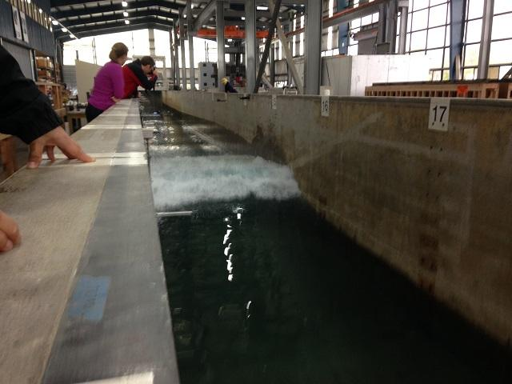
Oregon State has the nation's largest flume -- a facility designed to study waves.
Today, lab director Pedro Lamonica says they’re looking at the big daddy – a tsunami, scaled down to five feet for expert analysis.
“We have video cameras, we have pressure gauges, load cells, we have accelerometers and a picture of the wave as it is approaching, so we are talking about maybe 150 different instruments.”
Studies here will help scientists and engineers to design structures that can withstand tsunamis and still generate power from waves, currents and tides. OSU grad Mike Morrow and two friends formed a company called M3 Wave to develop and market one of those technologies.
“M3 Wave was a company formed by three guys named Mike. 3M was already taken, and + fundamentally what we’re doing is we’re developing a technology that sits on the ocean floor and turns waves into electricity. We’re really harnessing the wave’s swell more so than the chop at the top.”
Studies in the lab show there’s a lot more power on the surface, but Morrow says there’s a lot more risk too. Storms and boat traffic could damage floating hardware, but his device sits safely on the ocean floor. It’s tested. It works, but M3 can’t get funding to push its technology to market.
“It’s impossible. We’re in the R&D phase in this industry, and they’re not interested in funding R& D. They’re interested in funding what’s going to show a return on investment.”
That’s where government funding comes in. Belinda Batten says it’s essential to making marine energy happen.
“We have had a steady stream of federal investment, and that’s what will get us through to the proven technologies so then commercialization can happen. We have benefited from bi-partisan support at the federal level, and so that has really gotten us to where we are today.”
And this month, the U.S. Department of Energy will hand out some of that cash. It’s offering $6.5 million in prize money to the top 20 wave power generating designs. Ninety-two teams have applied – two from Blacksburg, one from Hampton Roads and a fourth from Vienna. Professor Eric Paterson leads one of Virginia Tech’s teams. He figures this country could meet all of its electric needs with energy from the ocean.
“It’s a large amount of energy. It would require about 450 nuclear power plants to generate all the electricity demanded in the U.S.”
But Virginia has a problem when it comes to generating power from waves.
"The Virginia wave energy resource, anywhere on the East Coast, is actually not very good. Ask any surfer. They’re pretty small.”
That’s George Hagerman, another Virginia Tech professor who’s entered the Wave Energy competition.
“California, Oregon, southeast Alaska, Washington State, the west coast of Mexico and Central America, Western Europe, the British Isles, Scandinavia, that’s where the big government investment is.”
Still there might be a place for marine energy in Virginia, and experts think it could be installed at minimal risk to fish, marine mammals and sea birds. Details in our next report.

HydroWorld
DOE selects 20 teams to advance in Wave Energy Prize program
By Michael Harris, Aug. 14, 2015
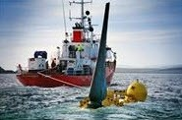
The U.S. Department of Energy has pared a list of 92 entrants to just 20 in the first round of its Wave Energy Prize program.
The 20 qualified teams now enter the design-build-test portion of the competition with the goal of developing wave energy conversion (WEC) devices that will achieve the DOE"s goal of doubling energy captured.
The program, which was introduced in April by the DOE Office of Energy Efficiency and Renewable Energy during the National Hydropower Association's Annual Conference in Washington, D.C., is a design-build-test competition that supports the department's goal of making marine hydrokinetic generation more competitive with traditional forms of production.
Teams that made the first round of cut were selected based on the technical quality of their submissions.
The teams will now build 1/50th scale models and participate in small-scale tank testing before the pool is further culled by next March.
Entrants that make it through the second round of selections will then receive seed money to build a 1/20th scale prototype that will undergo stank testing at the Naval Surface Warfare Center's Maneuvering and Seakeeping (MASK) Basin in Carderock, Md., beginning Summer 2016.
Official qualified teams include:
- Advanced Ocean Energy @ Virginia Tech (Hampton Roads, Va.)
- AquaHarmonics (Oakland, Calif.)
- Atlantic Wavepower Partnership (Newport, R.I.)
- Atlas Ocean Systems (Houston, Texas)
- CalWave (Berkeley, Calif.)
- Enorasy Labs (Bedford, Mass.)
- Float Inc. – BergerABAM (San Diego, Calif.)
- IOwec (MIT Sea Grant College Program) (Cambridge, Mass.)
- M3 Wave (Salem, Ore.)
- Mocean Energy (Annapolis, Md.)
- OceanEnergy USA (Sacramento, Calif.)
- Oscilla Power (Seattle, Wash.)
- Principle Power (Berkeley, Calif.)
- RTI Wave Power (York, Maine)
- Sea Potential (Bristol, R.I.)
- SEWEC (Redwood City, Calif.)
- Super Watt Wave Catcher Barge Team (Houston, Texas)
- Team FLAPPER (Floating Lever and Piston Power ExtractoR) (Research Triangle Park, N.C.)
- Wave Energy Conversion Corporation of America (WECCA) (North Bethesda, Md.)
- Waveswing America (Sacramento, Calif.)

HydroWorld
Hydro Headlines Weekly Newscast
By Greg Poindexter, Aug. 14, 2015
(Coverage Starts at 1:44)

Virginia Public Radio
Virginia Company A Leader in Marine Energy
By Sandy Hausman, Aug. 14, 2015
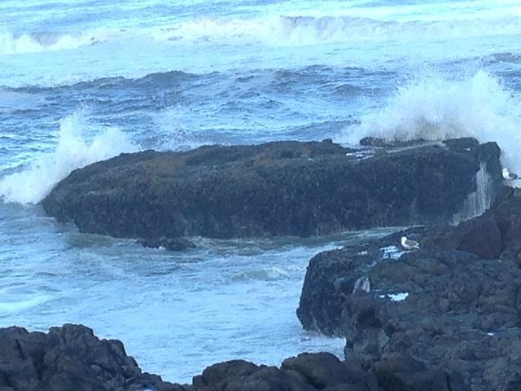
Four engineers from Virginia Tech have beat 72 other teams to win a place in the federal government’s Wave Energy competition. Eric Paterson, George Hagerman, Mike Philen and Heng Xiao now have the chance to win $2 million to build their design which would turn wave power into electricity.
Another Virginia team chose not to enter the contest. Instead, they’re hoping to leapfrog the competition by installing a successful commercial wave farm in Europe.

Listen
Listening...
/
3:30
Sandy Hausman reports.
Sandy Riesky and Matt Hansman are a couple of entrepreneurs from Charlottesville who found a promising wave power technology in Oregon about 15 years ago. They licensed it, hired a group of west coast engineers, and began making modifications, but their company, Columbia Power Technologies, didn’t spend a fortune building one prototype after the next for tests in the ocean. Instead, CEO Reenst Lesemann says they took advantage of new computer modeling technologies.
“Our view is that it’s better to fail quickly and to fail on paper so to speak or in a computer model rather than going through the time and expense to build a prototype, go out and test it, and then see that you’ve got a failure.”
Once they had a success on paper, they proceeded to test their prototype for a full year in Puget Sound.
“And that’s one of the longest sea trials of anybody on record in the industry worldwide.”
They used a simple mooring technology, and designed their device, called the StingRAY, to withstand storms that occur every 50-100 years.
The StingRAY is different from other floating wave devices. It looks like a giant yellow step ladder, and it’s made of fiberglass instead of steel.
“If you look at the coast guard, when they have a buoy out in the water, every three or four years that buoy has to come in to be stripped and repainted and reconditioned, and that’s really expensive when you talk about a large piece of equipment or a whole farm of wave energy devices.”
Each StingRAY will weigh a thousand tons, Lesemann says it will be fairly cheap and easy to install them.
“We’re designing them so that they can be towed and deployed very quickly and recovered very quickly, but it’s a large piece of equipment. To make utility scale electricity, it’s not something you can do with a smaller device.”
And so far, he notes, investors are on board – among them, the U.S. Department of Energy and the Navy.
“We’ve one 8 competitive grants since 2008 to develop and test the system.”
In January, they’ll begin the last round of testing off a military base in Hawaii. If all goes well, Lesemann says that state could be an early adopter of wave power.
“Hawaii is still 70% diesel. It’s really hard to believe, but they’re still burning that much diesel, but they are. Southeast Alaska is very similar. Those communities are spending 50-60 cents per kilowatt hour for electricity, which is four to five times what we pay here on the east coast.”
But the bigger opportunity is in Europe, where prices for power are high and governments are anxious to be energy independent.
“It’s got to be a very scary place to wake up depending on Russian natural gas every morning. They have made the conscious decision throughout most of Europe to move away from nuclear energy, and so that leaves a gap.”
Columbia is already talking with European utilities, and if they should sign on, the cost of this technology will likely come down.
“We’ve seen the cost of energy for wind and solar really fall through the floor in the last five years, and that is really because of economies of scale and production volumes.”
When that happens, Lesemann says wave technology could finally be right for Virginia, and if climate change is as dangerous as scientists say it will be, Neil Kermode at the European Marine Energy Center, says we may all be turning sooner to the sea for salvation.
“We are pressing on very hard, because we absolutely know there is energy in the water out there, and we know we’re going to need this stuff. When will it happen? I just don’t know, but the thing is, we have done that piece of alchemy – of turning sea water into electricity. We can make this work.”
Sandy Hausman reported from Europe with the support of an Energy and Climate Media Fellowship from the Heinrich Böll Foundation.

Marine Technology News
Twenty Teams Vie for Wave Energy Prize
By Eric Haun, Aug. 14, 2015

Qualified teams to continue pursuit to win U.S. Department of Energy’s prize challenge

Twenty teams have successfully navigated the first technology gate of the U.S. Department of Energy’s (DOE) Wave Energy Prize to become official qualified teams.

The 20 qualified teams, selected from the field of 92 official registered teams announced on July 6, will continue their quest to double the energy captured from ocean waves and win a prize purse totaling more than $2 million. The design-build-test competition is encouraging the development of game-changing wave energy conversion (WEC) devices that will achieve the DOE’s goal of doubling energy captured, which will in turn reduce the cost of wave energy, making it more competitive with traditional energy solutions.

Official qualified teams are:
•Advanced Ocean Energy @ Virginia Tech (Hampton Roads, Va.)
•AquaHarmonics (Oakland, Calif.)
•Atlantic Wavepower Partnership (Newport, R.I.)
•Atlas Ocean Systems (Houston, Texas)
•CalWave (Berkeley, Calif.)
•Enorasy Labs (Bedford, Mass.)
•Float Inc. – BergerABAM (San Diego, Calif.)
•IOwec (MIT Sea Grant College Program) (Cambridge, Mass.)
•M3 Wave (Salem, Ore.)
•Mocean Energy (Annapolis, Md.)
•OceanEnergy USA (Sacramento, Calif.)
•Oscilla Power (Seattle, Wash.)
•Principle Power (Berkeley, Calif.)
•RTI Wave Power (York, Maine)
•Sea Potential (Bristol, R.I.)
•SEWEC (Redwood City, Calif.)
•Super Watt Wave Catcher Barge Team (Houston, Texas)
•Team FLAPPER (Floating Lever and Piston Power ExtractoR) (Research Triangle Park, N.C.)
•Wave Energy Conversion Corporation of America (WECCA) (North Bethesda, Md.)
•Waveswing America (Sacramento, Calif.)

“We’re extremely pleased with the quality of the technical submissions and the diversity of ideas brought forth by all the teams,” said Phil Michael, technical expert at Ricardo, Inc. “We’re excited to see how these 20 devices perform during the small-scale testing, and we’re hopeful many will demonstrate a capability to achieve the DOE’s goal of doubling the cost effectiveness of energy capture from ocean waves. The field of registered teams was very strong, and there are many teams that had great ideas but were not able to advance to the next round. Many of these teams were previously unknown to DOE, and it’s our hope that they continue to stay engaged and contribute their good ideas in response to future funding opportunities the government may offer.”

A panel of expert judges identified the qualified teams based upon the quality of their technical submissions, which described their concepts in detail. Among other requirements, qualified teams will now build a 1/50th scale model and will participate in small-scale tank testing as a means of validating their concepts.

Finalist teams, which are scheduled to be announced in March 2016, will be selected based upon the requirements of Prize’s second technology gate. These teams will have the opportunity to receive seed money to build their 1/20th scale WEC prototypes, which are scheduled to undergo tank testing at the nation's most advanced wave-making facility, the Naval Surface Warfare Center's Maneuvering and Seakeeping (MASK) Basin at Carderock, Md., beginning in the summer of 2016.

Tidal Energy Today
US Wave Energy Prize advances 20 teams to next stage
Aug. 17, 2015
US Department of Energy (DoE) has selected 20 teams as official qualified teams for the Wave Energy Prize.
The 20 qualified teams, selected out of 92 official registered teams, have passed the first technology gate and will continue their quest to double the energy captured from ocean waves and win a prize purse totaling more than $2 million, Wave Energy Prize’s press release reads.
The design-build-test competition is encouraging the development of game-changing wave energy conversion (WEC) devices.
The aim is the development of a device that will achieve the DOE’s goal of doubling energy captured, which will in turn reduce the cost of wave energy, making it more competitive with traditional energy solutions.
A panel of expert judges identified the qualified teams based upon the quality of their technical submissions, which described their concepts in detail. Among other requirements, qualified teams will now build a 1:50 scale model and will participate in small-scale tank testing as a means of validating their concepts, according to Wave Energy Prize.
Official qualified teams are:
- Advanced Ocean Energy at Virginia Tech,
- AquaHarmonics,
- Atlantic Wavepower Partnership,
- Atlas Ocean Systems,
- CalWave,
- Enorasy Labs,
- Float Inc. – BergerABAM,
- IOwec (MIT Sea Grant College Program),
- M3 Wave,
- Mocean Energy,
- OceanEnergy USA,
- Oscilla Power,
- Principle Power,
- RTI Wave Power,
- Sea Potential,
- SEWEC,
- Super Watt Wave Catcher Barge Team,
- Team FLAPPER (Floating Lever and Piston Power ExtractoR),
- Wave Energy Conversion Corporation of America (WECCA),
- Waveswing America.
Phil Michael, Technical Expert at Ricardo, said: “We’re excited to see how these 20 devices perform during the small-scale testing, and we’re hopeful many will demonstrate a capability to achieve the DOE’s goal of doubling the cost effectiveness of energy capture from ocean waves.”
Finalist teams, which are scheduled to be announced in March 2016, will be selected based upon the requirements of Prize’s second technology gate.
These teams will have the opportunity to receive funds to build their 1:20 scale WEC prototypes, which are scheduled to undergo tank testing at the Naval Surface Warfare Center’s Maneuvering and Seakeeping (MASK) Basin at Carderock, Maryland, beginning in the summer of 2016.

renews
DoE picks top wave devices
Aug. 17, 2015

HomeWave and Tidal DoE picks top wave devices
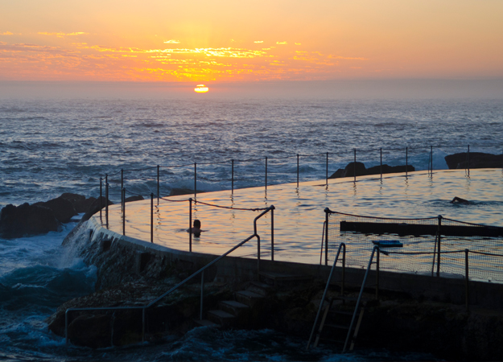
The US Department of Energy has selected 20 devices to be entered into the second phase of its $2.25m Wave Energy Prize fund.
The 20 qualified teams, selected from the field of 92 official registered teams announced on 6 July, will now build a 1:50 scale model and will participate in small-scale tank testing as a means of validating their concepts.
Finalist teams, which are scheduled to be announced in March 2016, will have the opportunity to receive seed money to build 1:20 scale prototypes.
These are scheduled to undergo tank testing at the US Naval Surface Warfare Center’s Maneuvering and Seakeeping (MASK) Basin at Carderock, Maryland next summer.
The official qualified teams are as follows:
•Advanced Ocean Energy at Virginia Tech
•AquaHarmonics
•Atlantic Wavepower Partnership
•Atlas Ocean Systems
•CalWave
•Enorasy Labs
•Float Inc. – BergerABAM
•IOwec (MIT Sea Grant College Program)
•M3 Wave
•Mocean Energy
•OceanEnergy USA
•Oscilla Power
•Principle Power
•RTI Wave Power
•Sea Potential
•SEWEC
•Super Watt Wave Catcher Barge Team
•Team FLAPPER (Floating Lever and Piston Power ExtractoR)
•Wave Energy Conversion Corporation of America (WECCA)
•Waveswing America
“We’re extremely pleased with the quality of the technical submissions and the diversity of ideas brought forth by all the teams,” said Ricardo technical expert Phil Michael.
“We’re excited to see how these 20 devices perform during the small-scale testing, and we’re hopeful many will demonstrate a capability to achieve the DOE’s goal of doubling the cost effectiveness of energy capture from ocean waves.”

AltEnergyMag
Twenty Teams Advancing to Next Phase of the Wave Energy Prize
Aug. 17, 2015

Qualified Teams to Continue Pursuit to Win U.S. Department of Energy’s Prize Challenge
WASHINGTON (August 14, 2015) - Twenty teams have successfully navigated the first technology gate of the U.S. Department of Energy's (DOE) Wave Energy Prize to become official qualified teams.
The 20 qualified teams, selected from the field of 92 official registered teams announced on July 6, will continue their quest to double the energy captured from ocean waves and win a prize purse totaling more than $2 million. The design-build-test competition is encouraging the development of game-changing wave energy conversion (WEC) devices that will achieve the DOE's goal of doubling energy captured, which will in turn reduce the cost of wave energy, making it more competitive with traditional energy solutions.
Official qualified teams are:
· Advanced Ocean Energy @ Virginia Tech (Hampton Roads, Va.)
· AquaHarmonics (Oakland, Calif.)
· Atlantic Wavepower Partnership (Newport, R.I.)
· Atlas Ocean Systems (Houston, Texas)
· CalWave (Berkeley, Calif.)
· Enorasy Labs (Bedford, Mass.)
· Float Inc. - BergerABAM (San Diego, Calif.)
· IOwec (MIT Sea Grant College Program) (Cambridge, Mass.)
· M3 Wave (Salem, Ore.)
· Mocean Energy (Annapolis, Md.)
· OceanEnergy USA (Sacramento, Calif.)
· Oscilla Power (Seattle, Wash.)
· Principle Power (Berkeley, Calif.)
· RTI Wave Power (York, Maine)
· Sea Potential (Bristol, R.I.)
· SEWEC (Redwood City, Calif.)
· Super Watt Wave Catcher Barge Team (Houston, Texas)
· Team FLAPPER (Floating Lever and Piston Power ExtractoR) (Research Triangle Park, N.C.)
· Wave Energy Conversion Corporation of America (WECCA) (North Bethesda, Md.)
· Waveswing America (Sacramento, Calif.)
"We're extremely pleased with the quality of the technical submissions and the diversity of ideas brought forth by all the teams," said Phil Michael, technical expert at Ricardo, Inc. "We're excited to see how these 20 devices perform during the small-scale testing, and we're hopeful many will demonstrate a capability to achieve the DOE's goal of doubling the cost effectiveness of energy capture from ocean waves. The field of registered teams was very strong, and there are many teams that had great ideas but were not able to advance to the next round. Many of these teams were previously unknown to DOE, and it's our hope that they continue to stay engaged and contribute their good ideas in response to future funding opportunities the government may offer."
A panel of expert judges identified the qualified teams based upon the quality of their technical submissions, which described their concepts in detail. Among other requirements, qualified teams will now build a 1/50th scale model and will participate in small-scale tank testing as a means of validating their concepts.
Finalist teams, which are scheduled to be announced in March 2016, will be selected based upon the requirements of Prize's second technology gate. These teams will have the opportunity to receive seed money to build their 1/20th scale WEC prototypes, which are scheduled to undergo tank testing at the nation's most advanced wave-making facility, the Naval Surface Warfare Center's Maneuvering and Seakeeping (MASK) Basin at Carderock, Md., beginning in the summer of 2016.
To follow the progress of the Wave Energy Prize or for more information, go to waveenergyprize.org.

MIT Sea Grant Program
MIT Sea Grant led team advances to next phase of the Wave Energy Prize Contest
Aug. 17, 2015
Team IOwec, led by MIT Sea Grant's Dr. Stefano Brizzolara, will advance to the next level in the highly competitive Wave Energy Prize Contest put on by the U. S. Department of Energy.
The team designed an Inertial Ocean Wave Energy Converter, or IOWEC, which is an all enclosed, monolithic floating Wave Energy Converter. Team IOwec was one of 20 selected to move on to the next phase out of 92 teams. The teams that have advanced will now build a 1/50th scale model of their proposed design and will participate in small-scale tank testing as a means of validating their concepts. Three finalist will be announced March of 2016. The top prize for the competition is a purse of $1.5 million dollars.
The IOwec team is a collaboration between the MIT Sea Grant, the Politecnico di Torino, Florida Atlantic University, and private company Wave4Energy. Dr. Stefano Brizzolara is joined by Dr. Guiliana Mattiazzo, and Dr. Manhar Dhanak. The team has extensive experience in ocean engineering and renewable energy.
See full press release at http://waveenergyprize.org.
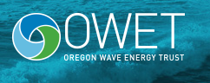
Oregon Wave Energy Trust
Twenty Teams Advancing to Next Phase of the Wave Energy Prize
Aug. 17, 2015

View Original at Wave Energy Prize
Qualified Teams to Continue Pursuit to Win U.S. Department of Energy’s Prize Challenge
​WASHINGTON (August 14, 2015) – Twenty teams have successfully navigated the first technology gate of the U.S. Department of Energy’s (DOE) Wave Energy Prize to become official qualified teams.
The 20 qualified teams, selected from the field of 92 official registered teams announced on July 6, will continue their quest to double the energy captured from ocean waves and win a prize purse totaling more than $2 million. The design-build-test competition is encouraging the development of game-changing wave energy conversion (WEC) devices that will achieve the DOE’s goal of doubling energy captured, which will in turn reduce the cost of wave energy, making it more competitive with traditional energy solutions.
Official qualified teams are:
· Advanced Ocean Energy @ Virginia Tech (Hampton Roads, Va.)
· AquaHarmonics (Oakland, Calif.)
· Atlantic Wavepower Partnership (Newport, R.I.)
· Atlas Ocean Systems (Houston, Texas)
· CalWave (Berkeley, Calif.)
· Enorasy Labs (Bedford, Mass.)
· Float Inc. – BergerABAM (San Diego, Calif.)
· IOwec (MIT Sea Grant College Program) (Cambridge, Mass.)
· M3 Wave (Salem, Ore.)
· Mocean Energy (Annapolis, Md.)
· OceanEnergy USA (Sacramento, Calif.)
· Oscilla Power (Seattle, Wash.)
· Principle Power (Berkeley, Calif.)
· RTI Wave Power (York, Maine)
· Sea Potential (Bristol, R.I.)
· SEWEC (Redwood City, Calif.)
· Super Watt Wave Catcher Barge Team (Houston, Texas)
· Team FLAPPER (Floating Lever and Piston Power ExtractoR) (Research Triangle Park, N.C.)
· Wave Energy Conversion Corporation of America (WECCA) (North Bethesda, Md.)
· Waveswing America (Sacramento, Calif.)
“We’re extremely pleased with the quality of the technical submissions and the diversity of ideas brought forth by all the teams,” said Phil Michael, technical expert at Ricardo, Inc. “We’re excited to see how these 20 devices perform during the small-scale testing, and we’re hopeful many will demonstrate a capability to achieve the DOE’s goal ofdoubling the cost effectiveness of energy capture from ocean waves. The field of registered teams was very strong, and there are many teams that had great ideas but were not able to advance to the next round. Many of these teams were previously unknown to DOE, and it’s our hope that they continue to stay engaged and contribute their good ideas in response to future funding opportunities the government may offer.”
A panel of expert judges identified the qualified teams based upon the quality of their technical submissions, which described their concepts in detail. Among other requirements, qualified teams will now build a 1/50th scale model and will participate in small-scale tank testing as a means of validating their concepts.
Finalist teams, which are scheduled to be announced in March 2016, will be selected based upon the requirements of Prize’s second technology gate. These teams will have the opportunity to receive seed money to build their 1/20thscale WEC prototypes, which are scheduled to undergo tank testing at the nation’s most advanced wave-making facility, the Naval Surface Warfare Center’s Maneuvering and Seakeeping (MASK) Basin at Carderock, Md., beginning in the summer of 2016.
To follow the progress of the Wave Energy Prize or for more information, go to waveenergyprize.org.

offshoreWIND.biz
20 Teams Qualify for DOE Wave Energy Prize
Aug. 17, 2015
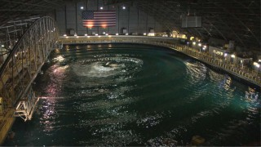
Twenty teams have successfully navigated the first technology gate of the U.S. Department of Energy’s (DOE) Wave Energy Prize to become official qualified teams.
The 20 qualified teams, selected from the field of 92 official registered teams announced on July 6, will continue their quest to double the energy captured from ocean waves and win a prize purse totaling more than $2 million. The design-build-test competition is encouraging the development of game-changing wave energy conversion (WEC) devices that will achieve the DOE’s goal of doubling energy captured, which will in turn reduce the cost of wave energy, making it more competitive with traditional energy solutions.
Official qualified teams are:
- Advanced Ocean Energy at Virginia Tech,
- AquaHarmonics,
- Atlantic Wavepower Partnership,
- Atlas Ocean Systems,
- CalWave,
- Enorasy Labs,
- Float Inc. – BergerABAM,
- IOwec (MIT Sea Grant College Program),
- M3 Wave,
- Mocean Energy,
- OceanEnergy USA,
- Oscilla Power,
- Principle Power,
- RTI Wave Power,
- Sea Potential,
- SEWEC,
- Super Watt Wave Catcher Barge Team,
- Team FLAPPER (Floating Lever and Piston Power ExtractoR),
- Wave Energy Conversion Corporation of America (WECCA),
- Waveswing America.
Phil Michael, technical expert at Ricardo, Inc., said: “We’re excited to see how these 20 devices perform during the small-scale testing, and we’re hopeful many will demonstrate a capability to achieve the DOE’s goal ofdoubling the cost effectiveness of energy capture from ocean waves.”
Finalist teams, which are scheduled to be announced in March 2016, will be selected based upon the requirements of Prize’s second technology gate.
These teams will have the opportunity to receive seed money to build their 1/20thscale WEC prototypes, which are scheduled to undergo tank testing at the nation’s most advanced wave-making facility, the Naval Surface Warfare Center’s Maneuvering and Seakeeping (MASK) Basin at Carderock, Md., beginning in the summer of 2016.
Image: waveenergyprize

Renewable Energy Focus
Twenty teams advancing to next phase of the Wave Energy Prize
Aug. 20, 2015

Qualified Teams to Continue Pursuit to Win U.S. Department of Energy’s Prize Challenge
Twenty teams have successfully navigated the first technology gate of the U.S. Department of Energy’s (DOE) Wave Energy Prize to become official qualified teams.
The 20 qualified teams, selected from the field of 92 official registered teams announced on July 6, will continue their quest to double the energy captured from ocean waves and win a prize purse totaling more than $2 million. The design-build-test competition is encouraging the development of game-changing wave energy conversion (WEC) devices that will achieve the DOE’s goal of doubling energy captured, which will in turn reduce the cost of wave energy, making it more competitive with traditional energy solutions.
“We’re extremely pleased with the quality of the technical submissions and the diversity of ideas brought forth by all the teams,” said Phil Michael, technical expert at Ricardo, Inc. “We’re excited to see how these 20 devices perform during the small-scale testing, and we’re hopeful many will demonstrate a capability to achieve the DOE’s goal of doubling the cost effectiveness of energy capture from ocean waves. The field of registered teams was very strong, and there are many teams that had great ideas but were not able to advance to the next round. Many of these teams were previously unknown to DOE, and it’s our hope that they continue to stay engaged and contribute their good ideas in response to future funding opportunities the government may offer.”
A panel of expert judges identified the qualified teams based upon the quality of their technical submissions, which described their concepts in detail. Among other requirements, qualified teams will now build a 1/50th scale model and will participate in small-scale tank testing as a means of validating their concepts.
Finalist teams, which are scheduled to be announced in March 2016, will be selected based upon the requirements of Prize’s second technology gate. These teams will have the opportunity to receive seed money to build their 1/20th scale WEC prototypes, which are scheduled to undergo tank testing at the nation's most advanced wave-making facility, the Naval Surface Warfare Center's Maneuvering and Seakeeping (MASK) Basin at Carderock, Md., beginning in the summer of 2016.

FURTHER READING
To follow the progress of the Wave Energy Prize or for more information, go to waveenergyprize.org.

Popular Science
A New Energy Plant In Hawaii Generates Power From Ocean Temperature Extremes
By Mary Beth Griggs, Aug. 24, 2015

It's hot then it's cold
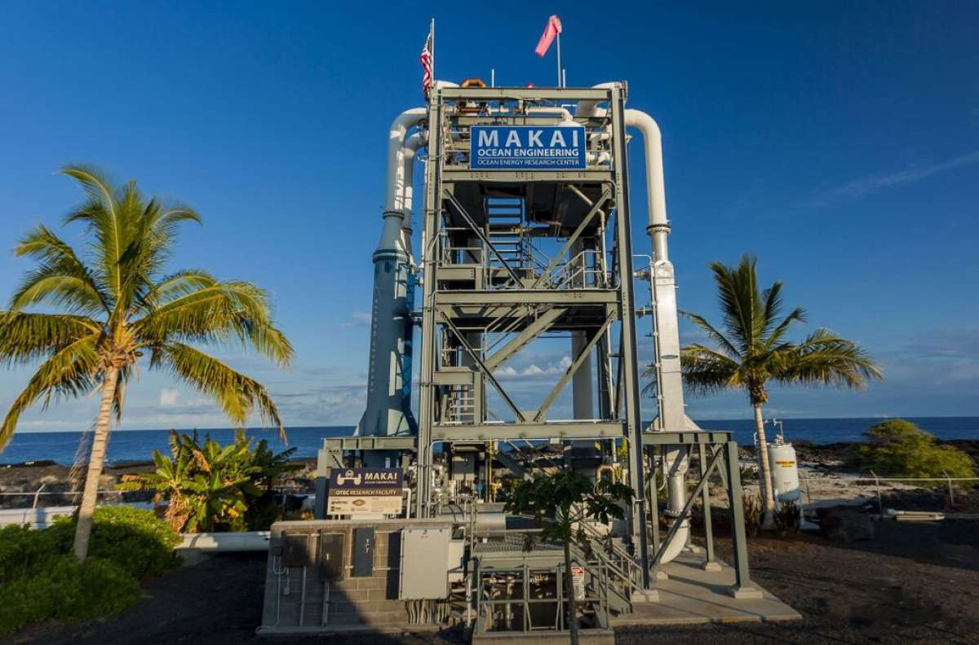
Thermal Plant
Makai Ocean Engineering
There's a big difference between the warm, shallow seawater lapping up against a beach and the icy depths of the ocean. Now, researchers are turning that temperature difference into energy at energy plants all over the world. The newest one opened up in Hawaii last Friday, where it expects to generate enough energy to power 120 homes per year.
The plant, built by Maki Ocean Engineering and situated at the Natural Energy Laboratory of Hawaii Authority (NELHA) is the largest plant of its kind in the world.

The plant uses a concept called Ocean Thermal Energy Conversion (OTEC). Inside the system is a liquid that has a very low boiling point (meaning that it requires less energy to evaporate), like ammonia. As ammonia passes through the closed system of pipes, it goes through a section of pipes that have been warmed by seawater taken from the warm (77 degrees Fahrenheit), shallow waters. The ammonia vaporizes into a gas, which pushes a turbine, and generates power. Then, that ammonia gas passes through a section of pipes that are cooled by frigid (41 degrees Fahrenheit) seawater pumped up from depths of around 3,000 feet. The gas condenses in the cold temperatures, turning back into a liquid, and repeats the process all over again. The warm and cold waters are combined, and pumped back into the ocean.
The idea of harnessing the temperature gradient to generate power has been around for a while. The Department of Energy says the OTEC concept originated in 1881 with a French physicist named Jacques Arsene d'Arsonval. In 1930, his student, Georges Claude, built the first plant in Cuba, but it was destroyed by storms soon after it was built. Other plants followed but they were small, and didn't generate much energy. The idea came back into vogue in the 1970's and 1980's, but went out of fashion again when oil prices dropped.
Now, with renewable, environmentally-friendly energy sources in demand, OTEC is edging back into the spotlight. A similar technology was used in 2010 to create a thermal engine that could power an unmanned submarine indefinitely.

In addition to this new thermal plant, there are also plenty of other energy options in the sea. Hawaii is also the home of the first wave energy project connected to the electrical grid, and the Department of Energy is sponsoring a Wave Energy Prize looking for the best ways to derive energy from waves. The final competition for the Wave Energy Prize should take place next year.

Eventually, Maki Ocean Engineering hopes to move their operations offshore, to head directly to the source of the deep, cold water needed to power the OTEC plant. They hope that this planned expansion will generate enough energy to power 120,000 homes every year.

renews
M3 Wave eyes energy prize
Aug. 25, 2015

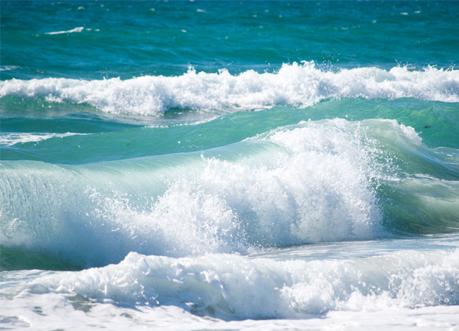
M3 Wave has been selected as one of 20 semi-finalists in the US Department of Energy’s Wave Energy Prize competition.
The design-build-test competition is intended to encourage the development of wave energy conversion technology.
M3 Wave said it will unveil its competition entry, codenamed Nexus, in the months to come.
It is a deep-water, high power variant of their venerable DMP/Apex technology and has been developed in secret over the last two years using private funds.
M3 Wave chief technology officer Mike Delos-Reyes said: “The beauty of Nexus is we enjoy an exponential increase in wave energy input to the device as we move closer to the ocean surface.
“This means we can get significantly more power output from the same Apex or DMP if we integrate it into a Nexus system.”
Dynamics modeling support will come from Oregon State University’s Northwest National Marine Renewable Energy Center, while materials and fabrication engineering will be done in collaboration with Ershigs in Ridgefield, Washington.
M3 will also work with FTI to adapt the prognostic and health monitoring system into Nexus system architecture to improve uptime and reduce maintenance costs.
More team members will be announced in September.

Tidal Energy Today
M3 Wave to unveil NEXUS wave energy device
Aug. 25, 2015
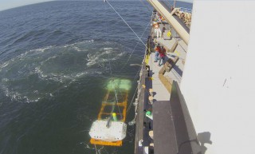
M3 Wave, an Oregon-based wave energy developer, plans to unveil the design of their NEXUS wave energy device in the following months, in an effort to win US Department of Energy’s Wave Energy Prize.
As reported earlier, the company has been selected among 20 semi-finalist teams for the Wave Energy Prize Competition, intended to encourage the development of game-changing wave energy conversion technology.
M3 Wave plans to unveil their competition entry, codenamed NEXUS, in the months to come, according to the company’s press release. The device is a variant of the M3 Wave’s deep-water, high power DMP/APEX technology, and has been under development over the last 2 years.
NEXUS wave energy device doesn’t have exposed mechanical or electrical components, and as the company stated, it is very similar to the APEX device that M3 Wave deployed in the Pacific Ocean off Astoria.
Mike Morrow, M3 Wave’s President and CEO, said: “The beauty of NEXUS is we enjoy an exponential increase in wave energy input to the device as we move closer to the ocean surface. This means we can get significantly more power output from the same APEX or DMP if we integrate it into a NEXUS system.
“We are honored to be among only 20 teams in the world who have been selected and we look forward to pushing the envelope toward the breakthrough performance that has been so elusive for earlier generations of marine renewable technologies.”
M3 Wave announced that the dynamics modeling support for their NEXUS device will come from Oregon State University’s Northwest National Renewable Energy Center while materials and fabrication engineering will be done in collaboration with Ershigs in Ridgefield, Washington.
Image: M3 Wave/Illustration

Sea Technology
92 Teams Submit Technical Description of WECs to DOE
August 2015
Wave energy enthusiasts from industry and academia have formed 92 teams to move toward the first milestone of the U.S. Department of Energy’s (DOE) Wave Energy Prize.
This design-build-test competition is encouraging the development of game-changing wave energy conversion (WEC) devices that will achieve the DOE’s goal of doubling energy capture, thus reducing the cost of wave energy and making it more competitive with traditional energy solutions.
The prize purse totals more than $2 million.
The teams had to submit a technical description of their concepts in July, which will be reviewed by a panel of expert judges. Based on this, up to 20 of the top teams will be named qualified teams in an announcement scheduled for mid-August.
Qualified teams will build a 1/50th-scale model and will participate in small-scale tank testing for validation of their design concepts. Finalist teams, which will be announced in March 2016, will have the opportunity to receive seed money to build 1/20th-scale WEC prototypes that will undergo tank testing at the Naval Surface Warfare Center’s Maneuvering and Seakeeping Basin at Carderock, Maryland, beginning summer 2016.

Hydro Review
DOE's Wave Energy Prize narrowed to 20 teams
Sept. 17, 2015
The U.S. Department of Energy originally accepted 92 teams from industry and academia to compete in its Wave Energy Prize program that seeks to encourage the development of wave energy conversion devices.
The DOE Office of Energy Efficiency and Renewable Energy introduced the program in April during the National Hydropower Association's Annual Conference in Washington, D.C. The program is a design-build-test competition that supports the department's goal of making marine hydrokinetic generation more competitive with traditional forms of production.
Program registration closed June 30, and teams worked on the first requirement for the prize -- a technical submission describing their concepts that was due in July. Inmid-August, a panel selected the top 20 teams, with those groups invited to build a 1/50th scale model for small-tank testing.
Teams will compete for a prize purse that totals more than US$2 million.
"We're extremely pleased with both the quantity of teams and the diversity of participants reflecting broad expertise from so many established companies in the ocean energy space, universities, and newcomers to the industry," said Julie Zona, Wave Energy Prize administrator.
The pool will be further culled through committee selection by March 2016, and the remaining two teams will receive seed money to build a 1/20th scale prototype. Prototypes will undergo tank testing at the Naval Surface Warfare Center's Maneuvering and Seakeeping (MASK) Basin in Carderock, Md., beginning summer 2016.
The judging panel will include technical experts from Sandia National Laboratories, National Renewable Energy Laboratory, Naval Surface Warfare Center – Carderock Division, and Ricardo Inc.
"The composition of the participating teams truly demonstrates one of the benefits of a prize challenge, which is to encourage the inclusion of new perspectives," Zona said. "We're very hopeful that the diverse backgrounds of these teams will help lead to the prize's goal of achieving game-changing performance enhancements to wave energy technologies."
Full profiles for the teams can be found at http://waveenergyprize.org/teams.

Hydro World
Lignum Vitae North America donates bearings to teams in the Wave Energy Prize Challenge
By Gregory Poindexter, Sept. 23, 2015
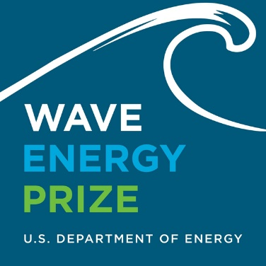
Lignum Vitae North America LLC will donate bearings to any of the 20 teams advancing to the next phase in the Wave Energy Prize Challenge sponsored by the U.S. Department of Energy’s Water Power Program.
"We look forward to seeing each team’s innovative and forward-thinking contributions to the growth of commercial wave energy technology, and the clean energy sector as a whole,” said Bob Shortridge, Lignum Vitae president.
Against a backdrop of recent lawsuits and new regulations restricting the use of oil in proximity to water, teams will benefit both structurally and environmentally by using Lignum Vitae as the bearing component, the company says.
In the past five years, more than 200 hydropower plants in North America have converted to Lignum Vitae bearings, according to a press release.
After verifying requests and addressing any questions, Lignum Vitae will provide bearing stock to the individual teams so they can custom mill their bearing designs.

AltEnergyMag
Technical Summaries of Wave Energy Prize Qualified Teams
Oct. 1, 2015
The Wave Energy Prize is a public prize challenge sponsored by the U.S. Department of Energy (DOE)‘s Water Power Program. The prize is designed to increase the diversity of organizations involved in Wave Energy Converter (WEC) technology development, while motivating and inspiring existing stakeholders. DOE envisions this competition will achieve game-changing performance enhancements to WEC devices, establishing a pathway to sweeping cost reductions on a commercial scale.
The wave energy industry is young and is experiencing many new innovations as evidenced by a sustained growth in patent activity. While the private industry is developing these early-concept WEC devices through design and benchtop prototype testing, funding is hard to secure for performance testing and evaluation of WEC devices in wave tanks at a meaningful scale. This is a problem for the industry since scaled WEC prototype tank testing, validation, and evaluation are key steps in the advancement of WEC technologies through the technical readiness levels to reach commercialization.
The Wave Energy Prize will encourage the development of more efficient WEC devices that double the energy captured from ocean waves, which in turn will reduce the cost of wave energy, making it more competitive with traditional energy solutions.
Judges have completed reviewing the technical submissions and a total of 20 Qualified Teams are advancing to next phase of the Wave Energy Prize!

Advanced Ocean Energy @ Virginia Tech
Hampton Roads, Va.
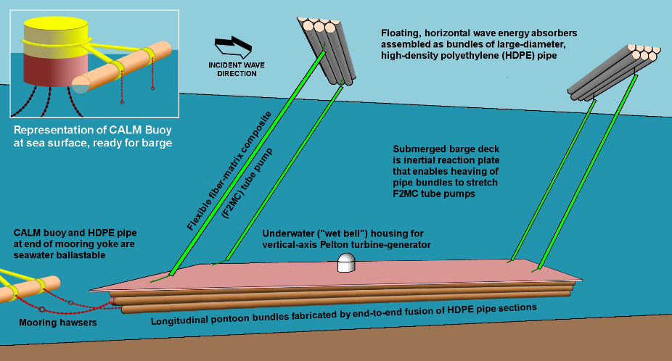
Virginia Tech’s MULti-body LinEar Terminator (MULLET) is a self-contained array of Bundled pIpe Terminator Wave Energy Converters (BITWECs). Each BITWEC is a floating bundle of large-diameter, high-density polyethylene (HDPE) pipes. The basic MULLET building block is a “tandem BITWEC” whereby two pipe bundles are arrayed one behind the other in the down-wave direction.
Each bundle is tethered by a pair of flexible fiber matrix composite tube pumps to the deeply submerged deck of a pontoon barge, which also is fabricated from large-diameter HDPE pipe sections, as shown in the conceptual diagram, below. Seawater output from the tube pumps is piped to an underwater habitat housing an accumulator and Pelton turbine-generator.
The MULLET barge is assembled while floating in calm water at dockside and then towed to its offshore installation site. Once on site, the barge is connected to a pre-set catenary anchor-leg mooring (CALM) buoy. The barge pontoons and CALM buoy are then flooded with seawater, submerging the barge to its mid-water operating position, where the barge deck acts as an inertial reaction plate for the floating bundles to work against, stretching the tube pumps. For inspection and maintenance, the barge and CALM buoy are re-floated to the surface by reversing the installation procedure.

AquaHarmonics
Portland, Ore.
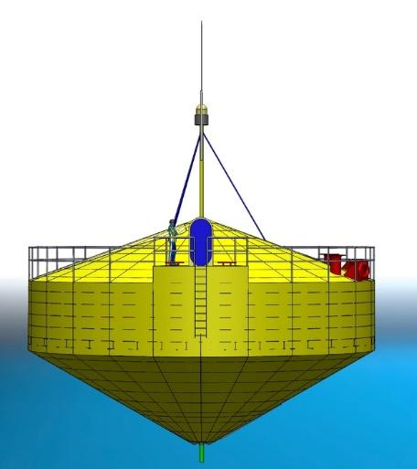
AquaHarmonics' Wave Energy Device is a point absorber device consisting of a simple Power Take Off (PTO) system mounted in a cone/cylinder shaped hull with a single mooring line that has a power cable at its core.
The PTO System consists of a sheave fixed to a shaft mounted in bearings within a sealed compartment and directly coupled to a pair of axial flux generators. The device only generates power on the rise of the wave, and during the fall of the wave the generators are operated as motors to reel in the mooring line for the next wave cycle.
During reel in, the control system of the device can provide additional energy input to achieve phase locking with any wave frequency. This control method is known as "de-clutching," which has been shown to effectively increase the operational bandwidth of a wave energy device.
The generated power is far greater than that consumed during the wave cycle with some energy stored on board for periods of low wave activity. The power is conditioned on board and sent to shore via a slipring on the shaft connected to the power cable located at the core of the mooring line.
AquaHarmonics. Clean.Simple.Energy.

Atlantic Wavepower Partnership
Newport, R.I.
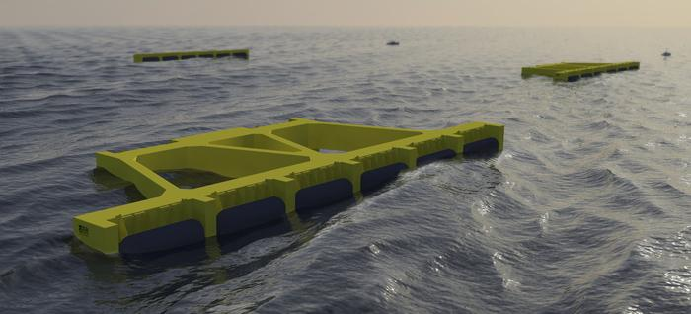
The AWS-III is a large-scale surface floating multi-absorber wave energy converter. Each absorber cell comprises a partially submerged air-filled chamber, one face of which is covered with a rubber diaphragm which flexes in response to the incoming wave actions. The movement of the diaphragm pumps air to and from the cell via an air turbine-generator set where the energy is converted to electricity. The cells are inter-connected via a ring-main such that air is exchanged between cells rather than with the outside environment.
All mechanical moving parts are isolated from the sea and contained within the device, whilst the turbine technology is tried-and-tested and available on the commercial market. The device is moored using traditional systems for offshore structures, either catenary systems and drag-embedment anchors or tension tethers and suction anchors. Accordingly, the device is utility-scale and has low technical risk and is capable of on-board maintenance of all parts with the exception of the diaphragms. Initial systems are expected to be rated at 2.0MW.

Atlas Ocean Systems
Houston, Texas
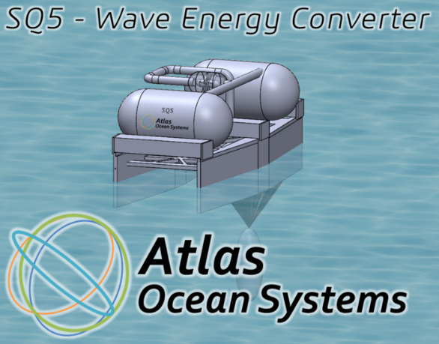
The Atlas Ocean Systems SQ5 Wave Energy Converter is a completely new device that captures energy primarily from pitch using two independent coupled oscillators. The SQ5 consists of three primary elements: 1) a float, 2) a new innovative submerged bag filled with air under pressure, and 3) a large submerged ballast. The bag and submerged ballast are essentially in static buoyant equilibrium. The catamaran float provides roll stability and resonates in pitch with the waves and transfers vertical motion to the bag system which then excites a vertical oscillation of the submerged ballast. The oscillation of the ballast drives shape changes within the bag to pump air through a reversible flow turbine to generate useful energy. Pitch response of the float is adjustable in real-time using a ballasting system and coupling between the float and ballast is adjusted during design. Coupling between the two oscillating systems provides a wide dual-peak absorption spectrum providing good power output over a variety of sea states. There are no mechanical moving parts, seals, hinges, or pistons requiring lubrication or maintenance. The turbine system is protected within the pressurized pneumatic system and is suspended in a transverse mounting minimizing gyroscopic forces. The nominal system is designed for a 500kW-1MW rating.

CalWave
Berkeley, Calif.
CalWave provides a solution to harness the renewable power of ocean waves to produce electricity and freshwater. Our device is a novel Wave Energy Converter (WEC) called the WaveCarpet that is simple and scalable. Our innovative approach was inspired by the ability of a muddy seafloor to effectively absorb overpassing ocean waves within only a few wavelengths. The unique converter design uses a synthetic-seabed-carpet that has the ability to extract wave energy the same way.
The technology is based on research conducted at the Massachusetts Institute of Technology (MIT) and the University of California, Berkeley.
The Wave Carpet operates submerged, allowing it to survive stormy seas while causing no visual pollution or posing any collision danger. The WaveCarpet has the advantage of being:
1) Survivable
Due to the fact that the carpet is fully submerged, it is able to survive the strong momentum of stormy seas.
2) Passive
The device poses no visual pollution to the ocean surface and no collision danger to boats and sea life.
3) Simple
High, broadband and omnidirectional absorption efficiency of ocean waves.
4) Scalable
The modular design allows the device to scale in width for setting a desired output power capacity.

Enorasy Labs
Bedford, Mass.
Enorasy Labs designed a control system characterized by the Department of Energy as "unique." This control system enables the implementation of a unique turbine, which can generate MegaWatts of electricity with efficiencies that have not been reached before, both in ocean and in land. The control system, called D.A.R.L.E.M., dynamically adjusts the rotational platform of an eccentric mass in multiple degrees of freedom. This real-time "smart" adjustment causes a heavy eccentric mass to rotate at the desired RPM, while it is directly coupled with an electromagnetic generator. The power input for the adjustment is extremely small, as it is provided when the rotating mass, being eccentric, is in a position that requires minimal effort to incline. This is why this unique turbine, which we call Gravity Control Turbine, is extremely efficient.
The ocean wave version of this turbine gyroscopically keeps track of the platform level, which is altered by ocean waves, and in real-time "smartly" adjusts it for optimized results. This frees up the device from the need to predict the upcoming wave characteristics. The mechanism, totally enclosed in a substantially submerged simply moored circular buoy, is also independent from wave directions. DOE: "it has the potential to absorb a significant amount of wave power."

Float Inc. – BergerABAM
San Diego, Calif.
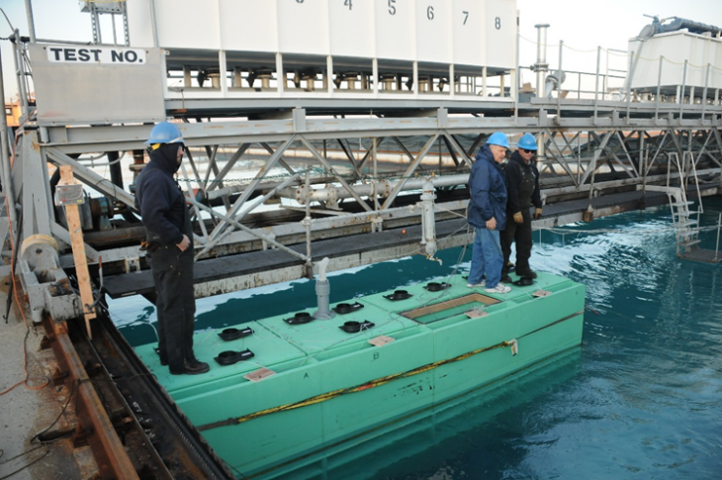
Wave energy absorption is maximized by matching the input impedance of the WEC to the characteristic impedance of the targeted water waves. (The term “Rho-Cee” (ρC) is the formulation of that impedance: water mass density X wave propagation velocity.) The Rho-Cee is the only WEC system that does that – as a matter of explicit design and operational principle. In the ρC, three nested L-shaped oscillating water columns are tuned to resonate over a band of energetic wave frequencies – fitted with float-driven linear electric generators. In an effective “terminator” linear array configuration, no leeward replication, as in a “farm”, is required. Limited model testing (supported by MMS in ‘09-‘10) has shown unprecedented absorption, validating the application of the impedance matching principle to WEC design.
The Rho-Cee WEC structure is made entirely in reinforced concrete, as is its deploying moored Pneumatically Stabilized Platform (PSP). Literally, only concrete is in contact with sea-water in both the Rho-Cee WEC and its PSP, so that with proper formulation and application in construction, neither need suffer corrosion in a 50 year (or more) lifetime. All maintenance-requiring equipment in the ρC WEC is located well above the water line, under cover, fully accessible to personnel on foot.

IOwec (MIT Sea Grant College Program)
Cambridge, Mass.
The IOWEC (Inertial Ocean Wave Energy Converter) is an all enclosed, monolithic floating WEC secured to the sea floor by a slack mooring line. The kinetic energy of the hull resonant wave induced pitch motion is converted into mechanical energy at the axis of the PTO by a gyroscopic system. All mechanical components are enclosed into internal watertight compartments and protected from sea water. The hull pitch motion induces a variation of the angular momentum of the flywheel thus generating a gyroscopic torque. In its turn, due to precession speed, the gyroscope imparts a damping torque to the hull and extracts the corresponding kinetic energy. The PTO is connected to the precession axis, so it is actuated by the gyroscopic torque and produces electrical energy by means of a permanent magnet electrical generator. The use of Pitch Resonance Tuning Tanks (PRTT) allows tune the resonance frequency of the device, thus increasing the overall efficiency of the system in different over a wide range of sea states. The main advantage of the IOWEC are the long operational life, high reliability and low OPEX: these are achieved by designing the IOWEC hull according low-tech shipbuilding standard and with no submerged moving parts.

M3 Wave
Salem, Ore.
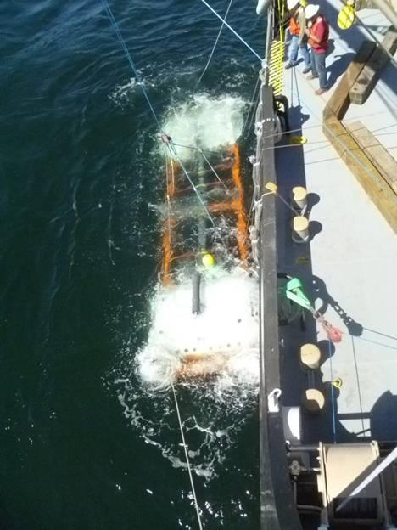
M3 Wave's entry into the Wave Energy Prize competition is NEXUS, a mid-column variant of their venerable DMP/APEX submerged pressure differential technology. The system harnesses the pressure wave under ocean swell while stationed above the ocean floor but still safely under the surface, protected from surface hazards. All power, electrical, and mechanical systems are inside protected dry chambers- there are no exposed mechanical joints or sliding seals.
NEXUS turns the pressure fluctuations under ocean waves into alternating expansion and compression cycles of air inside an enclosed pipe. Power is harnessed with a bi-directional air turbine. M3 Wave proved the viability of the underlying conversion technology during pilot testing of their APEX variant in 2014 off the coast of Oregon. NEXUS is positioned higher up the water column, dramatically increasing device power output while preserving the robustness and deployability aspects of APEX.

Mocean Energy
Annapolis, Md.
The Mocean wave energy converter (WEC) is a hinged raft. Wave forcing and the bodies' dynamic responses leads to a motion about the hinge (called flex), which drives a power take-off mechanism that converts the kinetic energy into electricity. It has seven degrees of freedom.
The innovation of the Mocean WEC is in the design of the shapes of the bodies, which dramatically improves its dynamics and thus power absorption. The configurations are based around varying the ratio and position of the water-plane area to the submerged volume, where the water-plane area affects the hydrostatic restoring force and the volume affects the mass and added mass. By changing these values one can induce coupling between the modes and tune the resonant response to improve performance in wavelengths that are significantly longer than the overall length of the machine.
Consequently, although the power take-off is solely in flex around the hinge, there is extensive cross-coupling with other degrees of freedom, and when excited by wave action the device responds not only in flex but substantially in heave and also pitch and surge. This results in greater cancellation of the incoming wave and a broader bandwidth response than a standard hinged raft.

OceanEnergy USA
Sacramento, Calif.
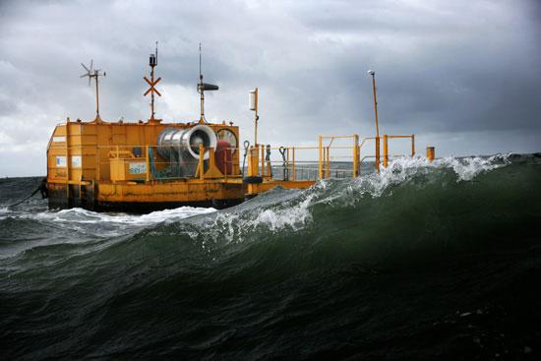
The OE buoy is a deep-water, self-referenced oscillating water column device. The device consists of a long submersed backward-facing duct connected to an air-chamber. Wave forces induce a differential air-pressure in the air-chamber, which gets converted to electricity using a bi-directional air turbine.
The key advantages of this device include: (1) there is only one moving part – the turbine runner – which is out of the water and easily accessible, (2) the air turbine generator combination runs at generation speeds and there are no gearboxes involved making the drive train simple, and (3) being a floating platform it is able to easily shed excessive loads during storm conditions.
The OE Buoy is the result of over 10 years of research and development and has just completed over three years of rigorous testing in Atlantic waters.
Extreme storms and Atlantic waves have confirmed the survivability of the OE Buoy as a power generation platform in the most extreme conditions. This is a testament to the design of the buoy and the simplicity of the functional design as well as the strength of the mooring technology.

Oscilla Power
Seattle, Wash.
Oscilla Power’s Triton™ wave energy converter is a two-body point absorber, consisting of a large surface float connected by flexible tethers to a submerged heave plate. As ocean waves excite the surface float, it reacts against the heave plate, generating tension changes in the tethers. These tension changes are applied to a linear drivetrain, consisting of a hydrostatic load amplification system and a variable reluctance generator that translates the low displacement, high force mechanical energy input into electrical energy in a simple, highly reliable manner that is unachievable in the ocean environment with conventional generators. Triton’s advantages over conventional point absorbers include greater energy production, lower capital costs and lower maintenance costs.

Principle Power
Berkeley, Calif.
Principle Power is humbled and excited to be a part of the DOE's Wave Energy Prize to develop affordable, clean energy technologies.

RTI Wave Power
York, Maine
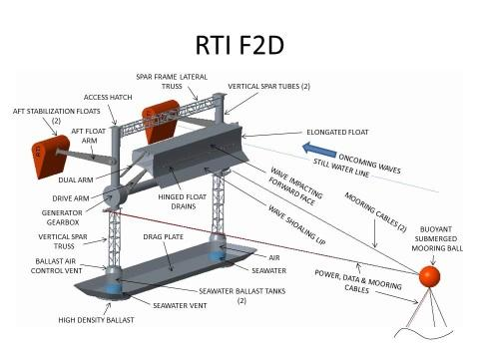
The RTI F2/F2D Wave Energy Converter (WEC) development objective is the lowest Capital Cost per Megawatt of output combined with secure survivability in severe seas. WECs must weigh less to cost less. Intercepting maximum energy containing wave front per unit WEC vessel volume, which like ship volume, determines WEC weight and cost. This is only realizable with WECs utilizing single or adjacent multiple Elongated Wave Front Parallel (EWFP) floats.
To concurrently capture a majority of both heave and surge energy the RTI F2/F2D utilizes elongated swing arms to attach its EWFP float directly to a generator in its motion stabilized floating twin vertical spar frame which constrains the float to move concurrently upward (for heave capture) and rearward (for surge capture) on wave crests and return forward and downward on subsequent wave troughs. The F2/F2D WEC utilizes RTI’s floodable and submergible floats and seawater ballasted frame to place its EWFP float safely below severe sea wave troughs.
The RTI F2/F2D is covered under US Patents 9,127,640, 8,614,520, U.S. Published Application 2015/0082785 and pending U.S. and International Applications.

Sea Potential
Bristol, R.I.
The DUO wave energy converter is a new design concept that simultaneously captures power from both the heave and the pitch/surge motions induced by wave action.
The additional modes of power capture have the potential for increased efficiency in terms of energy capture per unit cost compared to devices operating in a single mode or single direction.
The DUO’s patented configuration, which connects oscillating bodies with angled pre-tensioned cable linkages and a Power Take Off system, enables power capture from pitch motions to be exploited simultaneously with heave motions. The DUO’s primary power absorption is achieved by damping the relative heave and rotational motions of the oscillating structures.
This produces a significant increase in power capture (and energy production) compared to devices that capture power from a single mode of motion.
The increased power capture and the associated engineering innovations can produce major reductions to the costs of generating electricity from wave energy resources.

SEWEC
Redwood City, Calif.
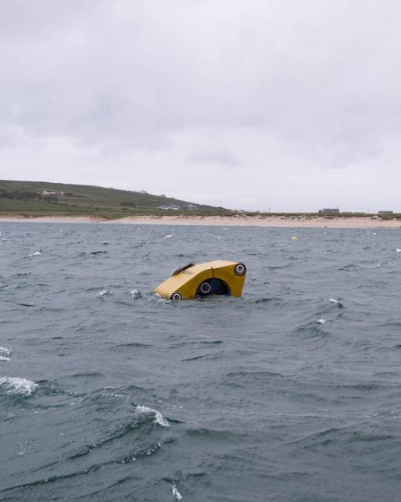
SEWEC is an oscillating water column (OWC) wave energy converter -- a device that operates in a similar fashion to the most successful shore based wave energy convertors, such as the Limpet (https://en.wikipedia.org/wiki/Islay_LIMPET).
The difference is that SEWEC is free-floating and specially adapted to withstand the more challenging offshore, deep water environment where available energy levels are higher and more widespread than those available nearshore.
The SEWEC device extends the proven OWC concept, enabling devices to be moored offshore in a much wider range of locations than conventional shore-based devices. Unlike shore-based OWC’s, only minimal site work is required to set up a SEWEC wave energy farm – the devices are simply towed out to their moorings.
The Wave Energy Prize targets offshore wave energy capture and uses conversion efficiency and capital cost as key metrics to compare the competing entries. SEWEC scores well on both counts – its simplicity and robustness result in low capital costs and the highly efficient OWC principle delivers great conversion efficiency.
Only large-scale deployment of low-cost, robust and efficient devices can fully exploit the huge and as yet largely untapped renewable energy resource surging in the world’s oceans. So Team SEWEC is eagerly participating in the WEP competition -- a great way to identify the really serious contenders.

Super Watt Wave Catcher Barge Team
Houston, Texas
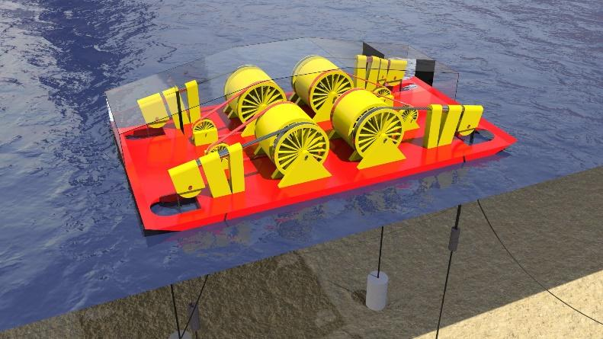
Super Watt Wave Catcher Barges take full advantage of economies of scale and use proven low-cost components. They use an ocean going barge to catch as much vertical wave pressure as possible with one structure, one mooring system and one export power cable. They are moored vertically and horizontally. Their vertical mooring legs turn large diameter uni-directional pulleys that "store torque" in large recoil springs located inside large diameter flywheels. These flywheel / recoil spring combinations uniformly unload their "stored torque" to four low torque, low RPM, high output direct drive wind turbine generators located onboard. The generators take advantage of sea water cooling for further cost, space and weight reduction. The power can be converted onboard or delivered directly to a Lazy S export power cable connected to a local power hub for further power farm conversion. The vertical mooring system loads are reduced automatically to a maintenance top tension during storms and the barge rides out the storms on its horizontal mooring system. After the storms pass, the vertical mooring system is reengaged and the power generation, of up to 4 x 6 megawatts of power, is resumed. CAPEX an OPEX are similar to onshore wind power.

Team FLAPPER (Floating Lever and Piston Power ExtractoR)
Research Triangle Park, N.C.
Wavefront Power's Very Large Flapper Array (VLFA) is being developed for utility-scale power production from deepwater ocean swell waves. The design will introduce a number of innovative, patent-pending technologies that will enable for the first time the economic capture of deepwater wave power. Operating at depths up to 100 meters, the device is expected to be rated at approximately 5 MW with a capacity factor of 48% based on an annualized average wave density of 30 kilowatts per meter.
The VLFA generally falls into the oscillating wave surge converter category of wave energy collection devices. While intellectual property concerns prevent us from disclosing many of the VLFA's internal mechanisms, general operation is characterized by a conversion of the kinetic energy of wave swells into electrical energy through a power conversion chain including a hydraulic power take-off, hydraulic motor and electrical alternator.

Wave Energy Conversion Corporation of America (WECCA)
North Bethesda, Md.
Wave Energy Conversion Corporation of America (WECCA) has developed its patent-pending Advanced Wave Energy Conversion System (AWECS), which physically presents as three articulating barges, securely anchored off shore, which survived nine years of WEC platform concept testing off the west coast of Ireland. The fore and aft barges are propelled by continuous, undulating, emission free, ocean waves surrounding the world's continents. Power Take Off devices are connected at leveraged hinge points to the center barge via robust hinges. The relative motions of the fore and aft barges, compared to the "weight dampened center barge", provide opportunity to cost effectively capture and transform ocean wave energy into electricity. AWECS electricity is then "conditioned" for local grid requirements.
The AWECS is constructed from lightweight, durable composite material providing strength, maintenance advantages and long term environmental cost benefits to operators and consumers. Designed to constantly sense and dynamically tune its physical characteristics, the system is able to extract the maximum energy through resonance relative to changing wave climates. When hazardous storm conditions are sensed, the AWECS is designed to submerge and hover at safe depths, until storm conditions subside, then surface again to generate electricity.

Waveswing America
Sacramento, Calif.
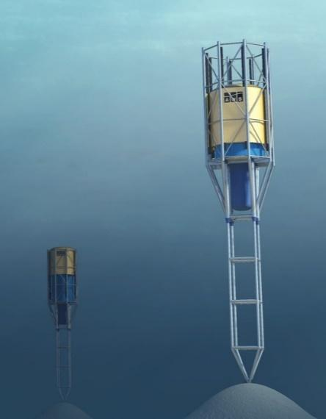
The Archimedes Waveswing™ is a submerged point-absorber wave energy converter which uses the change in pressure caused by passing waves to expand and contract a large piston. The piston houses a linear generator which converts the relative motion of the two parts directly into electricity. The unique operating principle of the device provides a gearing effect resulting in amplification of the effective wave height, thus producing a highly effective point absorber. The device is tension-tethered to the sea bed anchor via a structural leg which also carries a flexible power cable for export of electricity ashore.
The device was originally invented by Fred Gardner in Holland in 1994 and a previous variant was tested offshore Portugal at large scale. The recent innovations have enabled down-scaling of the device, thus improving the energy yield per unit volume and hence reducing the cost of power produced. Initial systems will be rated at 50kW and designed to meet power needs in isolated situations and island communities where the cost of alternatives is high. The technology is expected to progress to utility scale as learning is gathered through early deployments. The current design although novel, is based on many years of experience.

For more information about the Wave Energy Prize visit http://waveenergyprize.org/

EnergyBiz Magazine
Wave Energy Test Rolling Forward in Hawaii
By Amy Gahran, Fall 2015

JUST OFF THE COAST of Oahu, Hawaii, last month a wave energy generator began contributing small ripples of electricity to the local utility's grid. In this one-year test of new technology, the U.S. Department of Energy and the University of Hawaii are collaborating to gather data that could help shape the future of wave energy technology.
This test also will help show how well wave energy might help utilities address crucial, growing challenges with maintaining grid stability while relying more heavily on renewables.
The 20-kw wave energy converter from Oregonbased Northwest Energy Innovations, called Azura, doesn't quite produce enough electricity to power even a single home. But it represents a significant technological advancement.
Azura is one of the first devices developed that will demonstrate conversion of ocean energy to electricity by absorbing energy through both up-and-down and back-and-forth wave motions, enabling its converter to generate more electricity than previous such devices.
In addition, the energy-harvesting "float" at the top of Azura can rotate 360 degrees, reducing mechanical stress and helping prevent failures -- a problem with earlier technologies.
Azura sits in 30 meters of water in a berth at a U.S. Navy testing facility, where undersea cables and a supportive stakeholder made it easy to site the test. (As with ocean wind power projects, finding a home for wave energy projects can prove complex or controversial.) Steven Kopf, CEO of Northwest Energy Innovations, said the university's independent validation and analysis of data from this test is a critical step in moving wave energy technology forward.
"Utilities and power project developers won't even consider buying wave power technology unless they can see what an independent third party says it can really do," said Kopf. "So we're consciously running this test in all sorts of conditions, even when wave conditions are suboptimal for power production, just to get a complete picture of performance."
DOE agrees. "This pilot testing is now giving U.S. researchers the opportunity to monitor and evaluate the long-term performance of a gridconnected WEC device in the open ocean," said a spokesperson. "So far, this project has already proven valuable in identifying deployment efficiencies, gathering performance data, and developing operations and maintenance procedures. The learnings from the Azura deployment will accelerate the ultimate technology commercialization."
Northwest Energy Innovations designed Azura using standard components in order to help keep production costs down -- another challenge with earlier technologies.
Cost is one of the most critical issues with wave power. As with all new renewables, the initial cost of wave power is relatively high. According to the Ocean Energy Council, recent experience in the U.K. (which is more advanced in wave power testing and deployment) is about 7.5 cents per kWh at best. The industry goal is to get this down to about 4.5 cents per kwh -- comparable with the cost of wind power, although still much higher than the cost of fossil-fuel generation.
However, wave power offers some notable potential advantages to compensate for that cost.
In addition to helping states meet renewable energy targets, proximity to demand often reduces the cost and complexity of power transmission -- and about 50% of the U.S. population live within 50 miles of a coastline. A 2011 Electric Power Research Institute report found that available wave energy resources offer the potential to meet about one-third of current U.S. electricity demand.
Addressing environmental concerns, laying undersea cables and gaining stakeholder cooperation does take work.
One reason utilities and power network operators might be especially interested in wave power is that it tends to be far more predictable than wind or solar power.
According to the DOE, this advantage might help compensate for the complications associated with deploying wave power, which include "locating an undersea cable for bringing the power to shore, while avoiding conflicts with shipping lanes, fishing grounds, military exercises or any of the myriad other ways we use our bustling coastal waters."
Still, predictability saves money. "Generally you can see four days out, with a high level of certainty, what the wave conditions will be," Kopf observed. "This allows power planners to know what they can count on from wave power, which makes it easier to control overall costs for electricity."
Hawaii may prove to be a promising initial U.S. market for wave energy. In June, Hawaii passed legislation requiring an even more aggressive increase in renewable energy production: 30% by the end of 2020, 40% by 2030, and 70% by 2040.
The state also has, by far, the highest cost for electricity: 34 cents per kWh, according the U.S.
Energy Information Administration. Also, Hawaii is reaching the limit of the amount of solar energy its grids can handle.
Kopf acknowledged that cultivating investors for wave energy is challenging. "Early technologies didn't pan out, and a lot of investors got burned," he said. "But we've been quietly chipping away at this problem, and gradually investors are starting to get re-interested in it, now that they see the technology didn't completely bomb."
Last October, DOE awarded Northwest Energy $5 million to apply the lessons learned from the Azura test in Oahu to develop a full-scale unit-- which Kopf says will provide up to 1 MW of power. Also, DOE is holding a Wave Energy Prize contest, to spur development of WECs with double the energy-capture potential of current technologies.

Tidal Energy Today
Sea Potential prepares DUO wave energy converter for testing
Nov. 3, 2015
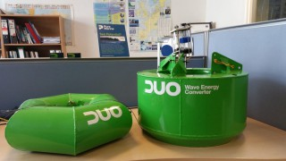 DUO wave energy converter
The Sea Potential team has been working closely with Fred Stern and the team at Iowa University in preparation for the 1:50 scale tank testing of its DUO WEC planned for December, 2015.
The hull structures for the scaled model are complete and preparations for the integration of the PTO, sensors and data acquisition systems are underway, according to Wave Energy Prize, for which Sea Potential is competing.
Sea Potential is working with Applied Renewables Research on the PTO and instrumentation systems for a multi-mode power capture point absorber device called DUO.
The company is also working with Wood Group Kenny on the numerical modeling, using Wood Group’s Flexom coupled analysis software.
Sea Potential is a development initiative by RCV Bradenten, whose primary place of business is in Cincinnati, Ohio, in partnership with Pure Marine Gen out of Belfast, Northern Ireland.
Pure Marine Gen has developed the technical knowledge, engineering and patented designs for DUO wave energy converter, and the team aims to use the Wave Energy Prize competition as a step towards deployment of DUO demonstration projects and wave farms off the coasts of North America, where RCV Brandenton contributes with US financing and development capabilities.
As reported earlier, 20 finalist teams for Wave Energy Prize are preparing for the construction of scaled models of their wave energy devices ahead of small-scale tank testing.
Small-scale devices will be tested in wave tanks at Oregon State University, Stevens Institute of Technology, the University of Iowa, the University of Maine, and the University of Michigan.
Following the review of the results of small-scale testing, up to 10 finalists and alternates are expected to be announced on March 1, 2016, after which the seed funding distribution for the finalists will begin.
Wave Energy Prize competition was launched by the US Department of Energy to encourage the development of game-changing wave energy conversion (WEC) devices that will achieve the DOE’s goal of doubling energy capture, thus reducing the cost of wave energy and making it more competitive with traditional energy solutions.
Image: Wave Energy Prize

Tidal Energy Today
AWP backs out of Wave Energy Prize
Nov. 5, 2015
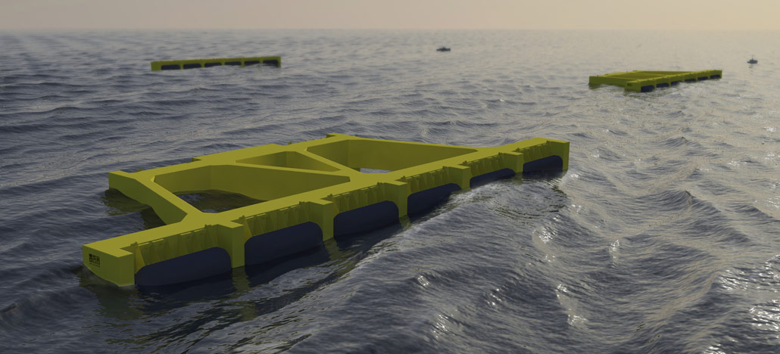
The Atlantic Wavepower Partnership (AWP) has withdrawn from the Wave Energy Prize competition.
AWP, a partnership formed between Renewable Ocean Energy and AWS Ocean Energy, has been selected by the Wave Energy Prize administration as one of the 20 qualified teams out of 92 official registered teams.
However, the AWP team announced that it’s pulling out of Wave Enegy Prize competition earlier this week, stating: “The Atlantic Wavepower Partnership is disappointed to announce that it is withdrawing from the Wave Energy Prize competition. We would like to thank the DoE for sponsoring the WEP as a means to advance the ocean wave renewable energy technologies.”
Prior to the announcement, AWP team was working on the construction of 1:50 scaled multi-absorber floating terminator array AWS-III.
The AWS-III is a multi-cell array of flexible membrane absorbers which covert wave power to pneumatic power through compression of air within each cell. The cells are inter-connected, thus allowing interchange of air between cells in anti-phase.
Turbine-generator sets are provided to convert the pneumatic power to electricity.
Wave Energy Prize competition was launched by the US Department of Energy to encourage the development of wave energy conversion (WEC) devices that will achieve the DOE’s goal of doubling energy capture, thus reducing the cost of wave energy and making it more competitive with traditional energy solutions.
Image: AWS Ocean Energy/AWS-III

renews
Atlantic quits DoE competition
Nov. 5, 2015

The Atlantic Wavepower Partnership has withdrawn from the Wave Energy Prize competition.

The prize is a competition sponsored by the US Department of Energy’s water power program and is designed to increase the diversification of wave energy converter platforms.
AWS was shortlisted for the prize in July, but gave no reason for the withdrawal

It said: “We would like to thank the DoE for sponsoring the WEP as a means to advance the ocean wave renewable energy technologies.

“We are grateful to the prize administration team and the staff of our testing facility for supporting us in the competition. We wish all the remaining teams the best of luck.”

Tidal Energy Today
Another company withdraws from Wave Energy Prize
Nov. 11, 2015
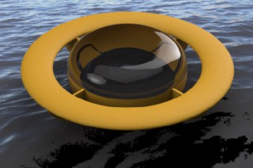 Enorasy Labs Robotic Juggler
Enorasy Labs has pulled out of US Department of Energy’s Wave Energy Prize challenge and shifted its focus on developing turbine technology.
The company has announced that it has decided to focus its efforts on developing its Gravity Control Turbine, based on DARLEM control, and on energy storage system.
Ahead of quitting the Wave Energy Prize challenge, the company was working on developing 1:50 scale model of its Eccentrically Rotating Mass in a Buoy wave energy converter, as well as conducting numerical analysis for the full scale device.
Enorasy Labs stated: “Enorasy Labs was selected to showcase its technologies during the Defense Innovation Summit in Austin, Texas, on December 2, 2015. Unfortunately, our small startup does not yet have all the resources required to keep up with all innovation demonstration opportunities, simultaneously. We would like to express our sincere gratitude to the judges and all people in the organizations that the DoE has assigned to run this unique competition.”
Earlier this month, another wave energy developer, The Atlantic Wavepower Partnership, quit the Wave Energy Prize.
The wave energy challenge was launched by the US Department of Energy to encourage the development of wave energy conversion (WEC) devices that will achieve the DOE’s goal of doubling energy capture, while reducing the cost of wave energy.
Image: Wave Energy Prize

Tidal Energy Today
Sea Potential performs wet tests on DUO WEC
Nov. 26, 2015

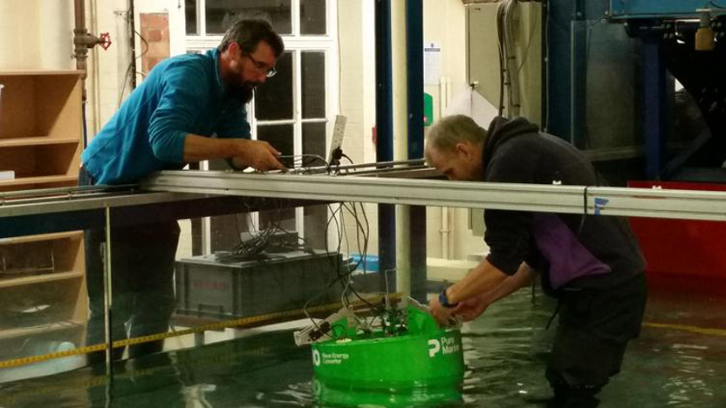
The power take-off (PTO) system and sensors on the 1:50 DUO wave energy device scaled model have been wet tested at the wave tank in Queens University in Belfast.
Sea Potential’s scaled model is nearly ready for shipment to Iowa where it will be tested as part of the Wave Energy Prize challenge.
According to Wave Energy Prize, a multi-mode power capture point absorber device called DUO comprises several mechanical and hydrodynamic features that can be changed to reduce the responsiveness of the device in larger waves, which means the DUO behaves more like a large buoy structure that has well proven survivability characteristics.
Sea Potential stated that the animation features of the structural analysis software Flexcom from Wood Group Kenny have been an important visualization tool to develop the design for the PTO system.
The coupled analysis module of Flexcom includes the full range of finite element capabilities that allow for accurate modelling of angled cables, hinge joints, mechanical connections and damping components of the PTO system.
Following the review of the results of small-scale device testing from 20 Wave Energy Prize finalist teams, up to 10 finalists and alternates are expected to be announced on March 1, 2016, after which the seed funding distribution for the finalists will begin.
Sea Potential is a development initiative by RCV Bradenten, whose primary place of business is in Cincinnati, Ohio, in partnership with Pure Marine Gen out of Belfast, Northern Ireland.
Image: Wave Energy Prize/DUO WEC wet testing

The Weather Channel
Harnessing Wave Energy for Power
Dec. 11, 2015

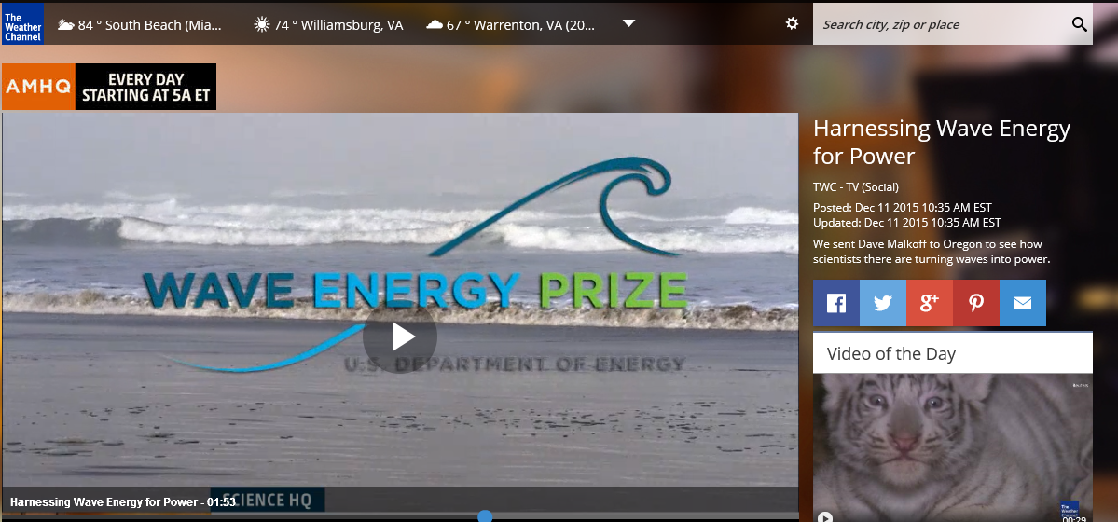

Tidal Energy Today
Atlas Ocean concludes scaled WEC testing
Dec. 15, 2015

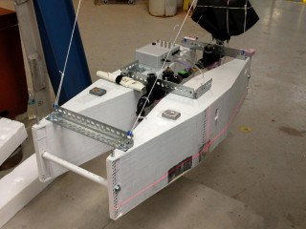
Atlas Ocean System's scaled WEC (Photo: Wave Energy Prize)
Atlas Ocean Systems, a US-based wave energy developer, has completed the trials of its scaled SQ5 wave energy device running for the US Department of Energy’s (DoE) Wave Energy Prize.
The 1:50 scaled wave energy converter model was tested at the Marine Hydrodynamics Laboratory at the University of Michigan.
Atlas Ocean is developing a point absorber with suspended oscillating ballast driving pneumatic bladder WEC type.
Following the completion of the tests, the company stated: “We had some very pleasant surprises watching our model interact with the dynamics of the wave tank and the mooring. Coming into the testing we were pretty sure the ‘roughness’ of the pneumatic system on our ‘hand-built-in-the-garage’ model wouldn’t be as responsive or stable as we wanted, but it came through with flying colors. Our unique ‘compressibility compensation’ system seemed to be working very well and as a result we were getting what appear to be truly scaled pneumatic system responses (volumetric flow rates and pressures).”
The testing was conducted from November 29 to December 4, 2015.
Upon the 1:50 scaled testing results review, up to 10 finalists and alternates, out of 17 total, are expected to be announced on March 1, 2016, after which the seed funding distribution for the finalists will begin.
These finalist teams will have the opportunity to receive funds to build their 1:20 scale WEC prototypes, which are scheduled to undergo tank testing at the Naval Surface Warfare Center’s Maneuvering and Seakeeping (MASK) Basin at Carderock, Maryland, beginning in the summer of 2016.
Initially, there were 20 finalist teams selected by the DoE, but 3 companies dropped out of Wave Energy Prize competition for various reasons.
Wave Energy Prize competition was launched by the US Department of Energy to encourage the development of game-changing wave energy conversion (WEC) devices that will achieve the DOE’s goal of doubling energy capture, thus reducing the cost of wave energy and making it more competitive with traditional energy solutions.

Tidal Energy Today
USA: UMaine wave energy testing underway
Dec. 18, 2015

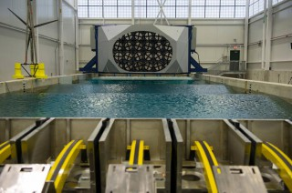
The Harold Alfond W2 Ocean Engineering Lab (Photo: UMaine)
The University of Maine (UMaine) Composites Center is currently testing US Wave Energy Prize challenge finalists’ scaled wave energy devices to generate performance data that will allow a panel of judges selected by the US Department of Energy (DoE) to evaluate the teams.
The Harold Alfond W2 Ocean Engineering Lab at the University of Maine Advanced Structures and Composites Center is one of five US facilities competitively selected to conduct 1:50 scale testing as part of the US DoE Wave Energy Prize.
UMaine will test three wave energy devices as part of this program: RTI Wave Power’s F2 QD device, Oscilla Power’s Triton WEC, and Float Inc.-BERGER/ABAM’s Rho-Cee device.
RTI F2 QD is a wave terminator-type WEC that utilizes an elongated wave front parallel float and a semi-submerged twin spar vertical spar frame. At full scale, the RTI design would be 28 meters wide, weigh about 200 tons, with a peak output of 1.5 MW per unit, which is, according to UMaine’s press release, enough to power 1,000 homes.
Oscilla Power’s Triton WEC is a two-body, multi-mode point absorber consisting of a catenary moored surface float and a suspended asymmetric heave plate.
Float Inc.-BERGER/ABAM’s Rho-Cee is an impedance-matched, optimizable, multi-band oscillating water column terminator that will be constructed in reinforced concrete.
Photos by UMaine
Anthony Viselli, Manager of the UMaine facility, said: “We look forward to working with these private companies and entrepreneurs to help them test and potentially optimize their devices. We will be helping these companies test the new devices, particularly determining their ability to convert wave energy to power.”
The Harold Alfond W2 Ocean Engineering Lab is equipped with a high-performance rotating wind machine over a multidirectional wave basin. The facility simulates scaled wind and wave conditions, and it is also capable of conducting towing tests and testing at variable water depths.
The facility is designed for prototyping coastal and offshore structures, including ships, aquaculture facilities, oil and gas structures, and ocean energy devices.
Wave Energy Prize competition was launched by the US Department of Energy to encourage the development of game-changing wave energy conversion (WEC) devices that will achieve the DOE’s goal of doubling energy capture, thus reducing the cost of wave energy and making it more competitive with traditional energy solutions.
The winning team of the DoE Wave Energy Prize will receive a $1.5 million award, the second-place team will get $500,000, and third placed team will be awarded $250,000.

National Geographic
8 Tech Breakthroughs of 2015 That Could Help Power the World

By Wendy Koch, Dec. 29, 2015

Self-driving cars like Google's prototype, above, could help save fuel by operating at maximum efficiency with the best routes. Photograph by Tony Avelar, AP
A car that drives itself. A watch that remotely turns lights on or off. A home that produces power for neighbors during a blackout.
These three don’t belong to a Jetsons-like future. They’ve already arrived. They're part of a new tech era in which scientists and entrepreneurs are rapidly trying bold ideas to save energy or provide cleaner alternatives.
Their discoveries could help countries meet the goals of this month’s historic UN climate accord, aimed at slashing greenhouse gas emissions. Yet they still need public acceptance, lawmakers’ approval, and enough funding to avoid innovation’s often-cited “valleys of death.”
“We’re problem solvers here, so there’s nothing like a great challenge,” says Robert Armstrong, director of the Massachusetts Institute of Technology’s Energy Initiative. He says MIT has taken on climate change as a “priority,” involving thousands of students, a third of the faculty, and more than 40 startups.
Other universities and national laboratories are also stepping up. They’ll get help from a new billionaires’ club, the Breakthrough Energy Coalition, that Microsoft founder Bill Gates created to get ideas out of the lab and into the marketplace. The investors will work with 20 countries, including the United States and China, to double spending on clean energy’s research and development.

4. Wave/Tidal Power
This year marks the launch of the world’s first multi-machine, grid-connected wave energy project, by Carnegie Wave Energy off the coast of Australia. Its technology, under development for a decade, is unique because it operates underwater where it’s safe from large storms. Buoys, tethered to seabed pumps, move with the motion of the waves and drive turbines that produce power for up to 2,000 homes.
National Geographic Channel’s Breakthrough series showed how the project works in its finale, Water Apocalypse, which aired December 13.
This month, another wave power project completed its deployment off the coast of Australia. The $21 million bioWAVE pilot unit, developed by BioPower Systems, has a 26-meter tall oscillating structure that sways back and forth beneath the ocean swell, capturing and converting the wave’s energy into electricity that‘s fed into the grid via an undersea cable.
The U.S. Department of Energy says the marine and hydrokinetic industry is still in early development but could produce enough power to meet nearly half of U.S. electricity usage. Between 2008 and 2014, DOE spent $133 million to develop 97 projects. In August, it selected 20 teams to advance to the next phase of its $2 million Wave Energy Prize. Their devices will be tested to see which meets DOE’s goal of doubling the amount of energy that’s captured.

Tidal Energy Today
Wave Energy Prize: Teams to finish scaled testing end of January
Jan. 4, 2016
Semi-finalist teams running for the Wave Energy Prize, set up by the US Department of Energy, are scheduled to complete the small-scale testing of their wave energy devices by the end of January, 2016.
With seven qualified teams that have completed the 1:50 scaled testing of their wave energy devices, the competition is approaching Technology Gate 2 stage.
Seven teams that have completed the small-scale testing include Atlas Ocean Systems, Super Watt Wave Catcher Barge Team, Sea Potential, SEWEC, Team FLAPPER, IOwec and RTI Wave Power.
Ten teams, scheduled to complete small-scale testing from January 4 through 29, 2016, include: M3 Wave, Mocean Energy, Oscilla Power, Principle Power, AquaHarmonics, WECCA, CalWave, Float Inc. – BergerABAM, Advanced Ocean Energy @ VA Tech and WaveSwing America.
The remaining three qualified teams, Atlantic Wave Power Partnership, Enorasy Labs and OceanEnergy USA, announced their withdrawal from the competition in November.
Additionally, the teams will submit the model design and construction plans for their 1:20 scale models by January 29, 2016. This plan, along with the results of small-scale testing, numerical modeling and revisions to their technical submissions, will be evaluated by the Wave Energy Prize judges at Technology Gate 2 to determine which teams will advance as official finalist teams, according to the Wave Energy Prize.
The Wave Energy Prize expects to announce the finalist teams and alternates at the beginning of March this year.
The selected teams will have the opportunity to receive funds to build their 1:20 scale WEC prototypes, which are scheduled to undergo tank testing at the Naval Surface Warfare Center’s Maneuvering and Seakeeping (MASK) Basin at Carderock, Maryland, beginning in the summer of 2016.
The winner(s) of Wave Energy Prize challenge are expected to be announced in November.
Wave Energy Prize competition was launched by the US Department of Energy to encourage the development of game-changing wave energy conversion (WEC) devices that will achieve the DOE’s goal of doubling energy capture, thus reducing the cost of wave energy and making it more competitive with traditional energy solutions.
The team that ranks the highest after testing the 1:20 scaled WEC device model will be awarded $1.5 mln. The second team will win an award in the amount of $500.000, and the third-placed tam will be awarded $250.000.

The Straits Times
8 Tech Breakthroughs of 2015 That Could Help Power the World

By Wendy Koch, Jan. 10, 2016

Companies worldwide are racing to be the first to put new technologies for cleaner, more efficient energy on the market
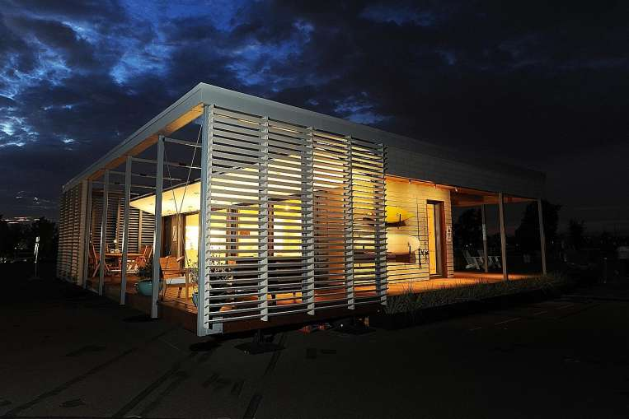

A car that drives itself. A watch that remotely turns lights on or off. A home that produces power for neighbors during a blackout.
These three don’t belong to a Jetsons-like future. They’ve already arrived. They're part of a new tech era in which scientists and entrepreneurs are rapidly trying bold ideas to save energy or provide cleaner alternatives.
Their discoveries could help countries meet the goals of this month’s historic UN climate accord, aimed at slashing greenhouse gas emissions. Yet they still need public acceptance, lawmakers’ approval, and enough funding to avoid innovation’s often-cited “valleys of death.”
“We’re problem solvers here, so there’s nothing like a great challenge,” says Robert Armstrong, director of the Massachusetts Institute of Technology’s Energy Initiative. He says MIT has taken on climate change as a “priority,” involving thousands of students, a third of the faculty, and more than 40 startups.
Other universities and national laboratories are also stepping up. They’ll get help from a new billionaires’ club, the Breakthrough Energy Coalition, that Microsoft founder Bill Gates created to get ideas out of the lab and into the marketplace. The investors will work with 20 countries, including the United States and China, to double spending on clean energy’s research and development.

4. Wave/Tidal Power
This year marks the launch of the world’s first multi-machine, grid-connected wave energy project, by Carnegie Wave Energy off the coast of Australia. Its technology, under development for a decade, is unique because it operates underwater where it’s safe from large storms. Buoys, tethered to seabed pumps, move with the motion of the waves and drive turbines that produce power for up to 2,000 homes.
National Geographic Channel’s Breakthrough series showed how the project works in its finale, Water Apocalypse, which aired December 13.
This month, another wave power project completed its deployment off the coast of Australia. The $21 million bioWAVE pilot unit, developed by BioPower Systems, has a 26-meter tall oscillating structure that sways back and forth beneath the ocean swell, capturing and converting the wave’s energy into electricity that‘s fed into the grid via an undersea cable.
The U.S. Department of Energy says the marine and hydrokinetic industry is still in early development but could produce enough power to meet nearly half of U.S. electricity usage. Between 2008 and 2014, DOE spent $133 million to develop 97 projects. In August, it selected 20 teams to advance to the next phase of its $2 million Wave Energy Prize. Their devices will be tested to see which meets DOE’s goal of doubling the amount of energy that’s captured.

NYU ScienceLine

A new paradigm for renewable energy

By Sara Chodosh; Jan. 17, 2016

Scotland and Ireland commit to a clean energy future together
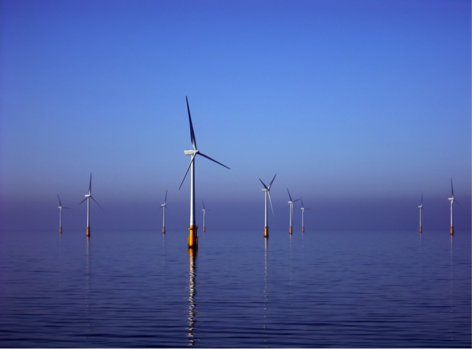
Offshore wind turbines may be the most visible of the marine renewables, but tidal and wave systems play an important role under the surface. [Image credit: Wikimedia Commons]

Scotland, with its long shorelines and brisk coastal winds, is a well of potential tidal and wind energy. Now it is teaming up with its island neighbors, Ireland and Northern Ireland, to build one of the world’s first large-scale marine renewable energy systems.
The Irish Scottish Links on Energy Study project is set to produce 6.2 gigawatts of power annually by 2020 — that’s enough to power about 1.8 million homes. It will be part of the European Union’s goal of using 27 percent renewable energy by 2030. The project, known as ISLES, will use all three of the major marine renewable energy sources — offshore wind, wave and tidal — and will provide much-needed data on the technology and its effects on the environment.
“The main advantage of marine renewable energy is that the input is much more constant,” says Sarah Henkel, a researcher at the Hatfield Marine Science Center at Oregon State University. The amount of energy produced by onshore wind turbines and solar power varies with the weather and time of day, so the consistency of marine renewables makes them valuable both to utility companies and consumers. “Efficiency is also an advantage,” Henkel says. Water is denser than air, so less motion produces the same amount of force as it would on land.
But the potential environmental effects may hinder widespread implementation of marine renewables. All three marine energy production devices make noise, which can be problematic for ocean life. Not only do many sea creatures communicate via sound waves, loud sound waves can actually injure marine animals. We still don’t have enough research to know the effects this sound will have, says Henkel, and it’s hard to design a device that prevents problems that haven’t been identified yet. But she says there is sufficient data on underwater sound waves to address issues if and when they arise.
There is far less data about other environmental issues. Artificial reefs, which form around new objects in the ocean — like wind turbines or wave energy devices — “could attract invasive species or drag fish away from their natural habitats,” says Brian Polagye, co-director of the Northwest National Marine Renewable Energy Center at the University of Washington. Providing more habitat for fish isn’t necessarily a bad thing, but if the artificial reefs cause too much change in the ecosystem they could be ultimately harmful. That’s why some of his research investigates how to design a foundation that encourages certain types of marine life to take hold. If scientists can control the local artificial reef environment, they might be able to promote marine life, but they might also unintentionally harm it. Without large-scale research, it’s difficult to know what effects the reefs will have and how much scientists will be able to control those outcomes.
Studies that would actually investigate these issues are slow to progress, however. Polagye says he can sometimes work directly with companies that produce prototypes of renewable technology or get funded through federal agencies to do testing, but there just aren’t very many prototypes being deployed in the United States.
Scotland, on the other hand, has been testing prototypes at its European Marine Energy Centre for the past 10 years. “Europe takes the approach of putting them in the ocean and seeing what happens,” says Henkel, whereas American scientists try to assess every possible outcome before deploying anything.
Europe also has geographical advantages. Offshore wind and tidal arrays are already a reality there because Europe has relatively shallow waters, says Polagye. That makes marine renewables easier to implement because building structures — especially offshore wind turbines — in deep water is expensive and challenging.
Technology to solve these problems can be repurposed across all marine renewables, but it’s still expensive to develop these solutions in the first place. Much of the technology in the U.S. has actually come from the needs of oil companies, Polagye says, who want to drill increasingly in deeper waters. But despite advances, he says the cost of energy from wave and tidal energy producers is still an order of magnitude higher than current prices.
High energy prices in Europe drive the desire for cheap renewable energy, says Henkel. Investments in marine renewables here in the U.S. dropped off when oil prices fell in 2014. Without investments, Henkel says we need national test facilities so that research isn’t reliant on individual companies pushing prototypes one by one.
The U.S. Department of Energy has already invested $300 million in offshore wind developments and sponsors the Wave Energy Prize to help make wave energy devices more affordable. But Polagye says renewable energy advances come with popular support. “The idea of marine energy is wrapped up in the idea of Scottish identity,” he says, “it’s a national issue in a way that it probably never will be in the U.S.”
American scientists should be trying to involve the public in the quest for marine renewables, says Polagye, but we as a country need to push forward in the meantime. Perhaps the U.S. should follow the ISLES project’s lead, says Henkel. “We’re at a tipping point now where we really just have to get something in the water.”

Corrections, January 18, 2015. The following errors have been corrected from the originally published version of this story: 6.2 GW would power about 1.8 million homes, not 6200.

Tidal Energy Today

VIDEO: AquaHarmonics’ scaled WEC testing
January 25, 2016
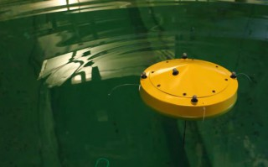
AquaHarmonics’ 1:50 scaled WEC (Photo: AquaHarmonics)
AquaHarmonics, one of the teams competing for the Wave Energy Prize challenge, is developing a point absorber wave energy device consisting of power take-off (PTO) system mounted in a cylinder shaped hull with a single mooring line that has a power cable at its core.
The PTO system consists of a sheave fixed to a shaft mounted in bearings within a sealed compartment and directly coupled to a pair of axial flux generators.
The device only generates power on the rise of the wave, and during the fall of the wave the generators are operated as motors to reel in the mooring line for the next wave cycle.
During reel in, the control system of the device can provide additional energy input to achieve phase locking with any wave frequency, and according to Wave Energy Prize, this control method known as ‘de-clutching’, has been shown to effectively increase the operational bandwidth of a wave energy device.
The generated power is greater than that consumed during the wave cycle with some energy stored on board for periods of low wave activity.
The power is conditioned onboard and sent to shore via a slipring on the shaft connected to the power cable located at the core of the mooring line.
Take a look at the video of AquaHarmonics’ 1:50 scaled wave energy device under tests at the University of Michigan’s Marine Hydrodynamic Laboratory.

Tidal Energy Today

VIDEO: Oscilla Power’s Triton WEC
January 27, 2016
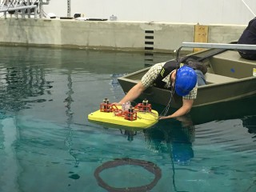m
Oscilla Power's scaled Triton WEC during tests (Photo: Wave Energy Prize)
Oscilla Power, a Seattle-based wave energy developer, has completed the testing of their 1:50 scaled wave energy converter as part of the Wave Energy Prize challenge.
Oscilla Power is developing a wave energy converter called Triton. It is a two-body point absorber, consisting of a large surface float connected by flexible tethers to a submerged heave plate.
As ocean waves excite the surface float, it reacts against the heave plate, generating tension changes in the tethers.
These tension changes are applied to a linear drivetrain, consisting of a hydrostatic load amplification system and a variable reluctance generator that translates the low displacement, high force mechanical energy input into electrical energy.
Oscilla Power states that Triton’s advantages over conventional point absorbers include greater energy production, lower capital costs and lower maintenance costs.
In January, Oscilla Power completed 1:50 model testing at the University of Maine. The team competing for the Wave Energy Prize is now focused on completing the 1:20 model build plan for submission at the end of January.

Engineering News Record

Three Firms Test Wave-Power Models at UMaine's 'W2' Lab

By Johanna Knapschaefer; January 28, 2016
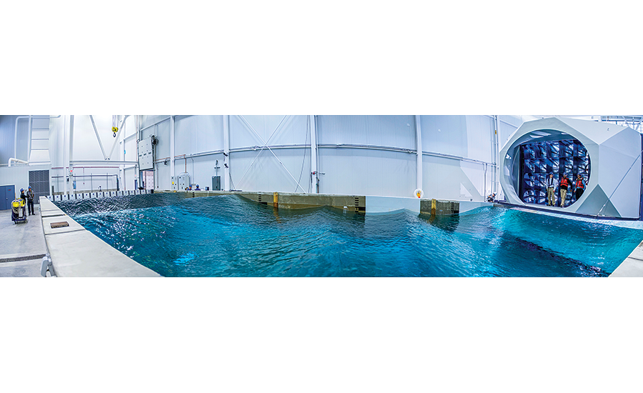
UMaine’s new Harold Alfond W2 Ocean Engineering Lab can whip up 200-plus-mph winds and waves equivalent to 100 ft high.
Three ocean engineering firms in January completed testing of wave energy converters in a unique wind-wave test basin at the University of Maine, gauging how they will respond to severe offshore storms.
The Harold Alfond W2 Ocean Engineering Lab, which opened on Nov. 23, houses the world’s first offshore wind-wave test basin with a rotating open-jet wind tunnel over a multidirectional wave basin that mimics severe storms at sea, says Habib Dagher, director of the university’s
Advanced Structures and Composites Center (ASCC) in Orono. The 98-ft x 30-ft test basin uses 32 fans and 16 paddles to generate 100-plus-ft-equivalent waves and winds of more than 200 mph.
The 8,940-sq-ft W2 lab is one of five U.S. facilities selected to conduct 1:50-scale testing as part of the U.S. Dept. of Energy’s $2.25-million Wave Energy Prize competition. The 20-month design-build-test competition seeks to drive innovation in wave-energy devices through a rigorous testing program.
“Helping to identify the best ideas in the U.S. to convert wave energy into electricity is yet another way that UMaine participates in developing clean, low-cost, domestic renewable energy,” Dagher says.
In mid-December, RTI Wave Power, York, Maine, tested its sixth-generation 1:50-scale RTI F2 wave energy converter (WEC) at the lab. “The university’s wave-energy-prize test team ran 31 tests over two days to determine the capture efficiency of our device under varying wave conditions having up to 20 watts per meter of wave energy,” says John Rohrer, founder of RTI. “We’re comfortable our device performed as expected.” A DOE panel of judges will evaluate the 10 competition finalists in February and announce the results in March.
“We tested to see if our computational fluid-dynamics model was simulating what was actually happening with the device in the wave tank,” Rohrer adds. “It tested well, confirming our model.”
Oscilla Power, Seattle, and Float Inc.-BergerABAM, San Diego, also are testing WEC devices as part of the program led by Krish Thiagarajan, the university’s principal investigator on the project. “Additional projects are lined up, and inquiries are coming in daily,” says Josh Plourde, spokesman for ASCC.
The ocean engineering lab accurately simulates towing tests, accommodating water depths from zero to 16.4 ft, as well as scaled wind and wave conditions that represent some of the worst storms possible anywhere on earth, Plourde explains.
These capabilities will assist businesses worldwide in developing vessel hulls, wind and tidal energy generators, and deepwater aqua-culture technology, such as offshore fish holding pens with moorings. Other research areas comprise oil-and-gas structures, including those for seafloor extracting, and waterfront infrastructure— bridges, causeways, piers, docks and port facilities—that can withstand waves and scour. Scientists and engineers also will examine systems to protect coastal cities from the effects of erosion and extreme storms.
The lab will test bridge models for state departments of transportation, Dagher says. “This [lab] can assist engineering firms and city planning boards with future infrastructure plans,” he adds.
The attached, 3,725-sq-ft Advanced Manufacturing Lab for Structural Thermoplastics Composites, which Pittsfield, Maine-based Cianbro is constructing, is scheduled to open this summer. It will feature robotics and other equipment to study and develop thermoplastic composites. Crews have begun installing equipment, including the Stratysys Fortus 900 3D production system for printing accurate, repeatable parts as large as 914 x 610 x 914 millimeters (36 x 24 x 36 in.), Plourde says.
The W2 lab and the integrated Advanced Manufacturing Lab—both a part of the existing ASCC—were funded by a $5-million voter-approved bond and a $3.9-million grant from the Harold Alfond Foundation, along with nearly $10 million the university received from the U.S. Economic Development Administration, the National Science Foundation and the Maine Technology Institute, among others.

Virginia Tech News
Squid-inspired wave energy converter turns ocean's power into electricity
Feb. 12, 2016
BLACKSBURG, Va., Feb. 12, 2016 – Engineers at Virginia Tech recently tested a wave energy converter inspired by the way squid propel themselves through water during the second round of competition for the U.S. Department of Energy’s Wave Energy Prize, which will eventually award more than $2 million in funding.
The Virginia Tech team is one of 20 which had qualified for the second round and the most recent tests, at a wave basin at the Stevens Institute of Technology, went well, according to Michael Philen, an associate professor of aerospace and ocean engineering in the College of Engineering and a member of the team.
George Hagerman, a senior research associate at the Virginia Tech Advanced Research Institute in Hampton, Virginia, leads Virginia Tech’s effort. Philen, Heng Xiao, an assistant professor of aerospace and ocean engineering; research associate Philip Balitsky, and research administrator Susan Sorlie of the Advanced Research Institute make up the rest of the team.
The competition is part of an effort by the Department of Energy to find an effective way to turn the mechanical energy of the ocean’s waves — an immense, but virtually untapped, resource — into clean electricity.
More than half of the U.S. population lives within 50 miles of the coast, in easy reach of the 1,170 terawatt hours per year that the Department of Energy estimates could be harvested from the ocean. Recovering even 5 percent of this amount could power 5 million American homes.
Nevertheless, wave energy development lags behind other renewables. Eric Paterson, the head of the Department of Aerospace and Ocean Engineering, explained that’s partly because wave energy is currently very expensive. “And the reason is because the ocean environment is so harsh,” he said.
Storms, corrosion, and marine life all make wave-energy systems difficult to maintain, increasing costs.
“In the long term, whatever is successful will have to be simple,” Paterson said. “It will have to be corrosion-resistant, it will have to be robust, it will have to be resistant to storms. Where innovation is really going to occur is in coming up with a creative design that’s also inexpensive.”
The Institute for Critical Technology and Applied Science has provided much of the seed funding for Virginia Tech’s team. It’s an investment that could yield dividends in the form of affordable sustainable energy.
“That’s what the goal is here, is to try to get the cost of energy down by doing something cheap and innovative. And if you do that, then things could really change,” Paterson said.
The team’s energy-harvesting system consists of two bundles of pipes made from polyethylene, connected to either end of an underwater barge deck by flexible tubes that contract when waves jostle the pipes.
The tubes are made from a material called a flexible matrix composite: a stretchy silicone coating surrounds braided fibers that resemble the cellulose fibers in a squid’s mantle.
In the squid, the contracting fibers expel seawater to push the squid forward; in the wave energy converter, they force the water into a high-pressure tank in the barge deck that drives a turbine to generate electricity.
By using inexpensive, durable, and off-the-shelf materials like polyethylene pipe, and flexible matrix composites instead of rigid mechanical components with moving parts, the researchers hope to create a system that will be cost-effective to build and maintain.
“That’s one of the selling points of the concept,” said Xiao. “It’s very robust.”
Philen, whose work focuses on smart structures and materials, has worked extensively with flexible matrix composites, which are also useful in applications like airplane wing design and robotics.
Xiao, an expert in computational fluid dynamics, has been working with Rui Sun, a third-year doctoral student from Anshan, China, on computer simulations to model design questions including the most efficient way to bundle the pipes and how far apart the two bundles should be.
Undergraduate aerospace engineering students in Philen’s lab have done most of the prototype assembly, including Carson Squibb, a junior from Eggleston, Virginia.; Adrian Bialy, a junior from Leesburg, Virginia; and Lorianne Groo, a senior from Taylorsville, Utah. “I call them rock stars,” Philen said.
The current prototype is a 1:50 scale model of the proposed commercial system, which would use PVC pipes a meter in diameter and flexible tubes 40 meters long.
After analysis of last month's testing, up to ten finalists will receive $125,000 each to develop a larger prototype for testing next summer and fall at a U.S. Navy facility in Carderock, Maryland.
The team whose prototype generates the most power will win the $1.5 million first prize to develop their system further; second- and third-place teams will also receive funding.
The Wave Energy Prize deviates from a traditional funding model that allows researchers to use grant money for early-stage work like prototype development. Instead, the competing teams must independently raise the funds to build and test their prototypes to be eligible to win the prize.
A premier Research Institute of Virginia Tech, the Institute for Critical Technology and Applied Science ensures a sustainable future by advancing transformative, interdisciplinary research at the intersections of engineering, the humanities, and the physical, life, and social sciences.

AltEnergyMag
U.S. Department of Energy’s Wave Energy Prize Announces Finalist Teams
March 1, 2016
WASHINGTON (March 1, 2016) - The U.S. Department of Energy (DOE) announced today that nine teams have been named finalists in the Wave Energy Prize—a 20-month design-build-test competition—and will proceed to the next phase of the competition.
The nine finalists and two alternates, identified from the 17 remaining official qualified teams, will continue their quest to double the energy captured from ocean waves and win a prize purse totaling more than $2 million. Each of the finalists and alternates will now receive seed funding from DOE to develop 1/20th scale models of their wave energy converter (WEC) technologies. These models will be tested at the nation's most advanced wave-making facility, the Naval Surface Warfare Center's Maneuvering and Seakeeping (MASK) Basin at Carderock, Md., beginning in the summer of 2016.
Official finalist teams are:
• AquaHarmonics (Portland, Ore.)
• CalWave (Berkeley, Calif.)
• M3 Wave (Salem, Ore.)
• Oscilla Power (Seattle, Wash.)
• RTI Wave Power (York, Maine)
• Sea Potential (Bristol, R.I.)
• SEWEC (Redwood City, Calif.)
• Wavefront Power (Team FLAPPER) (Research Triangle Park, N.C.)
• Waveswing America (Sacramento, Calif.)
Alternate teams are:
• McNatt Ocean Energy (Annapolis, Md.)
• Wave Energy Conversion Corporation of America (WECCA) (North Bethesda, Md.)
"The qualified teams' efforts resulted in some very promising technologies for the judges to evaluate," said Wes Scharmen, principal investigator at Ricardo, Inc. and chief judge of the Wave Energy Prize. "Based on our preliminary evaluation, the data indicates that many of the teams identified as finalists have the potential to achieve the ACE threshold, and thus the potential to exceed DOE's program goal. We're looking forward to further verifying their designs performance at 1/20th scale in the MASK Basin at Carderock this summer."
ACE—a benefit-to-cost ratio—was selected by the Wave Energy Prize as a metric appropriate for comparing low Technology Readiness Level WEC concepts when there is not enough data to calculate the levelized cost of energy—itself a cost-to-benefit ratio—from a device. ACE is determined by dividing, in essence, the wave energy extraction efficiency of a WEC by its structural cost. Finalists were determined based on their potential to achieve the doubling of the current state-of-the-art ACE value of 1.5 meters per million dollars (m/$M) to 3 m/$M during 1/20th scale tank testing at the MASK Basin, making them eligible to win the grand prize.
A panel of expert judges evaluated each qualified team based on their revised technical submissions, numerical modeling results, Model Design and Construction Plans, and the results of small-scale tank testing of their 1/50th scale models, and determined aggregate scores to identify the finalist pool.
The Wave Energy Prize is encouraging the development of game-changing WECs that will reduce the cost of wave energy, making it more competitive with traditional energy solutions.
To follow the progress of the Wave Energy Prize or for more information, go to waveenergyprize.org.
Hydro World
DOE announces Wave Energy Prize finalists
By Gregory B. Poindexter, Associate Editor; March 1, 2016
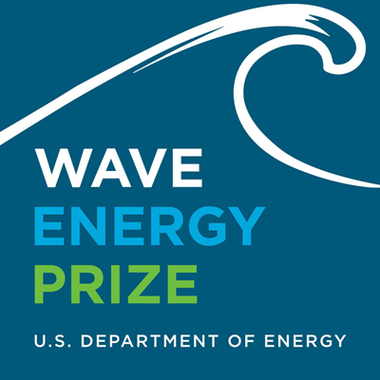
The U.S. Department of Energy (DOE) announced today that nine teams have been named finalists in the Wave Energy Prize -- a 20-month design-build-test competition -- and will proceed to the next phase of the competition.
The finalist teams and the 1/50th scale models of their wave energy converter technologies will be featured in the Wave Energy Prize Showcase on display April 25-26 during Waterpower Week in Washington.
The nine finalists and two alternates, identified from the 17 remaining official qualified teams, will continue their quest to double the energy captured from ocean waves and win a prize purse totaling more than US$2 million. Each of the finalists and alternates will now receive seed funding from DOE to develop 1/20th scale models of their wave energy converter (WEC) technologies. These models will be tested at the nation's most advanced wave-making facility, the Naval Surface Warfare Center's Maneuvering and Seakeeping (MASK) Basin at Carderock, Md., beginning in the summer of 2016.
^{Official finalist teams are:}
- AquaHarmonics (Portland, Ore.);
- CalWave (Berkeley, Calif.);
- M3 Wave (Salem, Ore.);
- Oscilla Power (Seattle, Wash.);
- RTI Wave Power (York, Maine);
- Sea Potential (Bristol, R.I.);
- SEWEC (Redwood City, Calif.);
- Wavefront Power (Team FLAPPER) (Research Triangle Park, N.C.); and
- Waveswing America (Sacramento, Calif.).
Alternate teams are:
- McNatt Ocean Energy (Annapolis, Md.); and
- Wave Energy Conversion Corporation of America (WECCA) (North Bethesda, Md.).
“The qualified teams’ efforts resulted in some very promising technologies for the judges to evaluate,” said Wes Scharmen, principal investigator at Ricardo Inc. and chief judge of the Wave Energy Prize.
“Based on our preliminary evaluation, the data indicates that many of the teams identified as finalists have the potential to achieve the ACE threshold, and thus the potential to exceed DOE’s program goal. We’re looking forward to further verifying their designs performance at 1/20th scale in the MASK Basin at Carderock this summer.”
ACE -- a benefit-to-cost ratio -- was selected by the Wave Energy Prize as a metric appropriate for comparing low Technology Readiness Level WEC concepts when there is not enough data to calculate the levelized cost of energy—itself a cost-to-benefit ratio -- from a device. ACE is determined by dividing, in essence, the wave energy extraction efficiency of a WEC by its structural cost. Finalists were determined based on their potential to achieve the doubling of the current state-of-the-art ACE value of 1.5 meters per million dollars (m/$M) to 3 m/$M during 1/20th scale tank testing at the MASK Basin, making them eligible to win the grand prize.
A panel of expert judges evaluated each qualified team based on their revised technical submissions, numerical modeling results, Model Design and Construction Plans, and the results of small-scale tank testing of their 1/50th scale models, and determined aggregate scores to identify the finalist pool.
The Wave Energy Prize is encouraging the development of game-changing WECs that will reduce the cost of wave energy, making it more competitive with traditional energy solutions.
To follow the progress of the Wave Energy Prize or for more information, go to waveenergyprize.org.

MarineLink
Finalists Complete for $2 Mln Wave Energy Prize
March 1, 2016
U.S. Department of Energy’s Wave Energy Prize announces nine finalist teams to continue in quest to win more than $2 million prize purse

The U.S. Department of Energy (DOE) announced that nine teams have been named finalists in the Wave Energy Prize—a 20-month design-build-test competition—and will proceed to the next phase of the competition.

The nine finalists and two alternates, identified from the 17 remaining official qualified teams, will continue their quest to double the energy captured from ocean waves and win a prize purse totaling more than $2 million. Each of the finalists and alternates will now receive seed funding from DOE to develop 1/20th scale models of their wave energy converter (WEC) technologies. These models will be tested at the nation's most advanced wave-making facility, the Naval Surface Warfare Center's Maneuvering and Seakeeping (MASK) Basin at Carderock, Md., beginning in the summer of 2016.

Official finalist teams are:
- AquaHarmonics (Portland, Ore.)
- CalWave (Berkeley, Calif.)
- M3 Wave (Salem, Ore.)
- Oscilla Power (Seattle, Wash.)
- RTI Wave Power (York, Maine)
- Sea Potential (Bristol, R.I.)
- SEWEC (Redwood City, Calif.)
- Wavefront Power (Team FLAPPER) (Research Triangle Park, N.C.)
- Waveswing America (Sacramento, Calif.)

Alternate teams are:
- McNatt Ocean Energy (Annapolis, Md.)
- Wave Energy Conversion Corporation of America (WECCA) (North Bethesda, Md.)

“The qualified teams’ efforts resulted in some very promising technologies for the judges to evaluate,” said Wes Scharmen, principal investigator at Ricardo, Inc. and chief judge of the Wave Energy Prize. “Based on our preliminary evaluation, the data indicates that many of the teams identified as finalists have the potential to achieve the ACE threshold, and thus the potential to exceed DOE’s program goal. We’re looking forward to further verifying their designs performance at 1/20th scale in the MASK Basin at Carderock this summer.”

ACE—a benefit-to-cost ratio—was selected by the Wave Energy Prize as a metric appropriate for comparing low Technology Readiness Level WEC concepts when there is not enough data to calculate the levelized cost of energy—itself a cost-to-benefit ratio—from a device. ACE is determined by dividing, in essence, the wave energy extraction efficiency of a WEC by its structural cost. Finalists were determined based on their potential to achieve the doubling of the current state-of-the-art ACE value of 1.5 meters per million dollars (m/$M) to 3 m/$M during 1/20th scale tank testing at the MASK Basin, making them eligible to win the grand prize.

A panel of expert judges evaluated each qualified team based on their revised technical submissions, numerical modeling results, Model Design and Construction Plans, and the results of small-scale tank testing of their 1/50th scale models, and determined aggregate scores to identify the finalist pool.

The Wave Energy Prize is encouraging the development of game-changing WECs that will reduce the cost of wave energy, making it more competitive with traditional energy solutions.

Pete Danko Clean Energy News & Commentary
Two Oregon Teams Reach Wave Energy Prize Finals
March 1, 2016
Two Oregon teams are among the finalists selected today in the Wave Energy Prize, a U.S. Department of Energy competition to double the energy captured from ocean waves. One is the familiar Salem-based M3 and the other is a new name in the wave game, Portland-based AquaHarmonics.
The teams, both with Oregon State ties, were selected along with seven other teams to construct 1/20th-scale models of their wave energy converters. As finalists, they’ll receive up to $125,000 to ready their devices for testing this summer at the Navy’s giant Carderock MASK Basin wave tank in Maryland. Assuming they meet a cost-efficiency threshold set for the competition, the first-place winner could receive $1.5 million, second place $500,000 and third place $250,000.
The competition began with 92 entries, then was trimmed to 66 teams that submitted technical documents. Twenty teams were next selected as semifinalists and required to perform wave-tank tests of 1/50th-scale models.
Although Oregon State has a wave tank, in order not to confer a “home-field” advantage, AquaHarmonics and M3 were sent off to the University of Michigan to test their devices.
AquaHarmonics consists of Alex Hagmuller and Max Ginsburg, both engineering graduates from Oregon State, according to their Facebook page. Their device is described as a “point absorber with latching/de-clutching control.” Point absorbers bob at the surface to absorb the vertical motion of passing waves.
M3’s design is an adaptation of the APEX device that was tested off Camp Rilea in September 2014 – submerged but not on the ocean floor like APEX. Called NEXUS, it uses the change in pressure caused by passing waves to send air back and forth through a column, spinning a turbine.
M3 is led by Mike Morrow and Mike Delos-Reyes, both Oregon State grads as well. The pair recently won a $600,000 U.S. DOE contract to advance the APEX concept.
The Pacific Northwest, home to much of the wave energy development in the United States, also has a third team among the finalists, Oscilla Power of Seattle. Their floating device is completely different from anything else, taking advantage of an effect called magnetostriction, caused by the constantly changing tension in the device’s tethers, to produce an electrical current.

Maritime Global News
Finalists Complete for $2 Mln Wave Energy Prize
March 1, 2016
U.S. Department of Energy's Wave Energy Prize announces nine finalist teams to continue in quest to win more than $2 million prize purse
The U.S. Department of Energy (DOE) announced that nine teams have been named finalists in the Wave Energy Prize-a 20-month design-build-test competition-and will proceed to the next phase of the competition.

The nine finalists and two alternates, identified from the 17 remaining official qualified teams, will continue their quest to double the energy captured from ocean waves and win a prize purse totaling more than $2 million. Each of the finalists and alternates will now receive seed funding from DOE to develop 1/20th scale models of their wave energy converter (WEC) technologies. These models will be tested at the nation's most advanced wave-making facility, the Naval Surface Warfare Center's Maneuvering and Seakeeping (MASK) Basin at Carderock, Md., beginning in the summer of 2016.
Official finalist teams are:
- AquaHarmonics (Portland, Ore.)
- CalWave (Berkeley, Calif.)
- M3 Wave (Salem, Ore.)
- Oscilla Power (Seattle, Wash.)
- RTI Wave Power (York, Maine)
- Sea Potential (Bristol, R.I.)
- SEWEC (Redwood City, Calif.)
- Wavefront Power (Team FLAPPER) (Research Triangle Park, N.C.)
- Waveswing America (Sacramento, Calif.)
Alternate teams are:
- McNatt Ocean Energy (Annapolis, Md.)
- Wave Energy Conversion Corporation of America (WECCA) (North Bethesda, Md.)

"The qualified teams' efforts resulted in some very promising technologies for the judges to evaluate," said Wes Scharmen, principal investigator at Ricardo, Inc. and chief judge of the Wave Energy Prize.
"Based on our preliminary evaluation, the data indicates that many of the teams identified as finalists have the potential to achieve the ACE threshold, and thus the potential to exceed DOE's program goal. We're looking forward to further verifying their designs performance at 1/20th scale in the MASK Basin at Carderock this summer."

ACE-a benefit-to-cost ratio-was selected by the Wave Energy Prize as a metric appropriate for comparing low Technology Readiness Level WEC concepts when there is not enough data to calculate the levelized cost of energy-itself a cost-to-benefit ratio-from a device. ACE is determined by dividing, in essence, the wave energy extraction efficiency of a WEC by its structural cost. Finalists were determined based on their potential to achieve the doubling of the current state-of-the-art ACE value of 1.5 meters per million dollars (m/$M) to 3 m/$M during 1/20th scale tank testing at the MASK Basin, making them eligible to win the grand prize.

A panel of expert judges evaluated each qualified team based on their revised technical submissions, numerical modeling results, Model Design and Construction Plans, and the results of small-scale tank testing of their 1/50th scale models, and determined aggregate scores to identify the finalist pool.
The Wave Energy Prize is encouraging the development of game-changing WECs that will reduce the cost of wave energy, making it more competitive with traditional energy solutions.

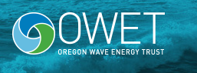
Oregon Wave Energy Trust
Energy Department Announces Finalists Vying for $2.25 Million Wave Energy Prize
March 1, 2016
The U.S. Department of Energy (DOE) announced today the nine teams chosen as finalists in the Wave Energy Prize, which hail from California, Maine, North Carolina, Oregon, Rhode Island, and Washington. The Prize is a 20-month design-build-test competition that aims to double the energy captured from ocean waves. Increasing the energy harnessed by wave energy converter devices will reduce costs and make this renewable energy source more competitive with traditional energy solutions.
Waves provide a continual source of energy whether it’s sunny or cloudy, windy or calm. Recent studies found that America’s technically recoverable wave energy resource is estimated to range between 898-1,229 terawatt hours (TWh) per year, distributed across the coast of Alaska, the West Coast, the East Coast, the Gulf of Mexico, Hawaii, and Puerto Rico. For context, approximately 90,000 homes can be powered by 1 TWh per year. This means that even if only 5 percent of the potential is recovered, millions of homes could be powered by wave energy as the technology progresses.
Of the 92 teams that qualified to compete in the competition, 20 teams advanced to the second technology gate. In this round, teams designed and built 1/50th scale models of their next-generation wave energy devices, which were rigorously tested and evaluated at five small-scale, wave-generating tanks across the United States. Finalists were selected based on their results and potential to achieve the Wave Energy Prize goals.
The nine finalist teams are (listed alphabetically):
- AquaHarmonics of Portland, Oregon
- CalWave of Berkeley, California
- M3 Wave of Salem, Oregon
- Oscilla Power of Seattle, Washington
- RTI Wave Power of York, Maine
- Sea Potential of Bristol, Rhode Island
- SEWEC of Redwood City, California
- Wavefront Power (Team FLAPPER) of Research Triangle Park, North Carolina
- Waveswing America of Sacramento, California
Two alternate teams were also selected (listed alphabetically):
- McNatt Ocean Energy of Annapolis, Maryland
- Wave Energy Conversion Corporation of America of North Bethesda, Maryland
Each of the finalists and alternates will now receive seed funding from DOE to develop a larger, 1/20th-scale model of their wave energy devices. The final round of testing will take place this summer at the nation’s most advanced wave-making facility—the Naval Surface Warfare Center’s Maneuvering and Seakeeping Basin—located at Carderock, Maryland.
In the spring of 2015, an astonishing 92 teams registered for the Wave Energy Prize, 66 of which provided technical submissions that were judged over the summer. In August, DOE announced the selection of 20 teams that would continue as official qualified teams. During the fall and winter, these teams designed and built their 1/50th scale models, which were evaluated, through small-scale testing and on a number of other criteria, for their potential to achieve the program’s goal.
Stay updated with each team’s progress and media coverage on the Team Updates page.

Tidal Energy Today
Wave Energy Prize unveils finalist teams
March 2, 2016
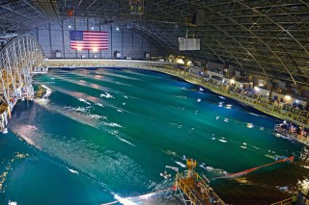
MASK basin at Carderock (Photo: EERE)
The nine finalists and two alternates, identified from the 17 remaining official qualified teams, will continue their quest to double the energy captured from ocean waves and win a prize purse totaling more than $2 million as part of Wave Energy Prize challenge.
Each of the finalists and alternates will now receive seed funding from the US Department of Energy (DoE) to develop 1:20 scale models of their wave energy converter (WEC) technologies.
These models will be tested at the Naval Surface Warfare Center’s Maneuvering and Seakeeping (MASK) wave-making facility at Carderock, Maryland, beginning in the summer of 2016.
Official finalist teams are:
- AquaHarmonics
- CalWave
- M3 Wave
- Oscilla Power
- RTI Wave Power
- Sea Potential
- SEWEC
- Wavefront Power
- Waveswing America
Alternate teams are McNatt Ocean Energy, and Wave Energy Conversion Corporation of America (WECCA).
Wes Scharmen, Chief Judge of the Wave Energy Prize, said: “The qualified teams’ efforts resulted in some very promising technologies for the judges to evaluate. Based on our preliminary evaluation, the data indicates that many of the teams identified as finalists have the potential to achieve the ACE threshold, and thus the potential to exceed DOE’s program goal. We’re looking forward to further verifying their designs performance at 1:20 scale in the MASK Basin at Carderock this summer.”
ACE – a benefit-to-cost ratio – was selected by the Wave Energy Prize as a metric appropriate for comparing low Technology Readiness Level WEC concepts when there is not enough data to calculate the levelized cost of energy – itself a cost-to-benefit ratio – from a device, according to the Wave Energy Prize administration.
ACE is determined by dividing the wave energy extraction efficiency of a WEC by its structural cost.
Finalists were determined based on their potential to achieve the doubling of the current state-of-the-art ACE value of 1.5 meters per million dollars (m/$M) to 3 m/$M during 1:20 scale tank testing at the MASK Basin, making them eligible to win the grand prize.
A panel of expert judges evaluated each qualified team based on their revised technical submissions, numerical modeling results, model design and construction plans, and the results of small-scale tank testing of their 1:50 scale models, and determined aggregate scores to identify the finalist pool, Wave Energy Prize administration informed.

Renews
Finalists eye Wave Energy Prize
March 2, 2016
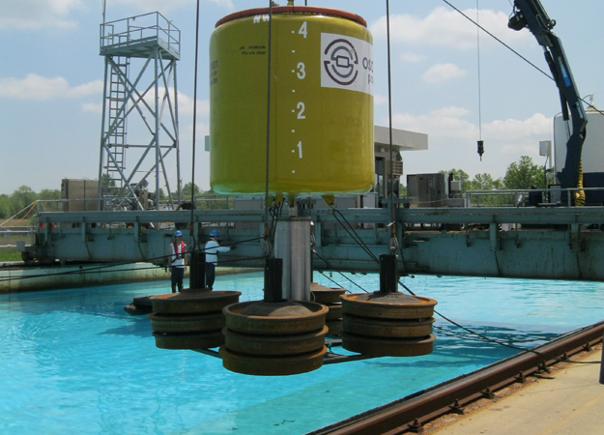02/03/2016
The US Department of Energy has selected nine consortia and two reserve teams to contest the third and final stage of its $2.25m Wave Energy Prize.
The finalists are:
• AquaHarmonics of Portland, Oregon
• CalWave of Berkeley, California
• M3 Wave of Salem, Oregon
• Oscilla Power of Seattle, Washington
• RTI Wave Power of York, Maine
• Sea Potential of Bristol, Rhode Island
• SEWEC of Redwood City, California
• Wavefront Power (Team FLAPPER) of Research Triangle Park, North Carolina
• Waveswing America of Sacramento, California
The two alternate teams are McNatt Ocean Energy of Annapolis, Maryland and Wave Energy Conversion Corporation of America of North Bethesda, Maryland.
Each of the finalists and alternates will now receive seed funding from DOE to develop a larger, 1:20 scale model of their wave energy devices.
Testing will take place this summer the Naval Surface Warfare Centre's Manoeuvring and Seakeeping Basin at Carderock, Maryland.
The prize is a 20-month design-build-test competition that aims to double the energy captured from ocean waves. The second round last August saw the initial 92 teams entered in Spring 2015 whittled down to 20.
Image: Gen 1 wave energy generator (Oscilla Power)

Network World
Energy Dept. sets 9 finalists for $2.25M wave energy prize
March 2, 2016
The US Department of Energy said it has whittled 92 teams down to 9 finalists for its competition that aims to double the current amount of energy captured from ocean waves.
Each of the finalists in the Wave Energy Prize and two alternates will now receive seed DOE funding to develop a 1/20th-scale model of their deep water wave energy converter (WEC) devices. The final round of testing will take place this summer at the nation's most advanced wave-making facility—the Naval Surface Warfare Center's Maneuvering and Seakeeping Basin in Carderock, Maryland.
+More on Network World: 10 hot energy projects that could electrify the world and more Cool Energy projects+
“Recent studies found that America’s technically recoverable wave energy resource is estimated to range between 898-1,229 terawatt hours (TWh) per year, distributed across the coast of Alaska, the West Coast, the East Coast, the Gulf of Mexico, Hawaii, and Puerto Rico. For context, approximately 90,000 homes can be powered by 1 TWh per year. This means that even if only 5% of the potential is recovered, millions of homes could be powered by wave energy as the technology progresses,” the DOE stated.
According to the DOE the broader goal for the WEC competition is to spur innovations for new and next generation technologies to be cost-competitive at 15 cents per kilowatt hour (¢/kWh), down from the current range of 61-77 ¢/kWh3.
The nine finalist teams are:
- AquaHarmonics of Portland, Oregon
- CalWave of Berkeley, California
- M3 Wave of Salem, Oregon
- Oscilla Power of Seattle, Washington
- RTI Wave Power of York, Maine
- Sea Potential of Bristol, Rhode Island
- SEWEC of Redwood City, California
- Wavefront Power (Team FLAPPER) of Research Triangle Park, North Carolina
- Waveswing America of Sacramento, California
The two alternate teams include:
- McNatt Ocean Energy of Annapolis, Maryland
- Wave Energy Conversion Corporation of America of North Bethesda, Maryland

Inside Climate News
Not Just Riding the Waves, These Competitors Seek to Harness Their Energy
By Jesse Emspak; March 7, 2016
Finalists emerge in a Department of Energy competition spawns technologies to finally make a commercial reality out of wave energy.
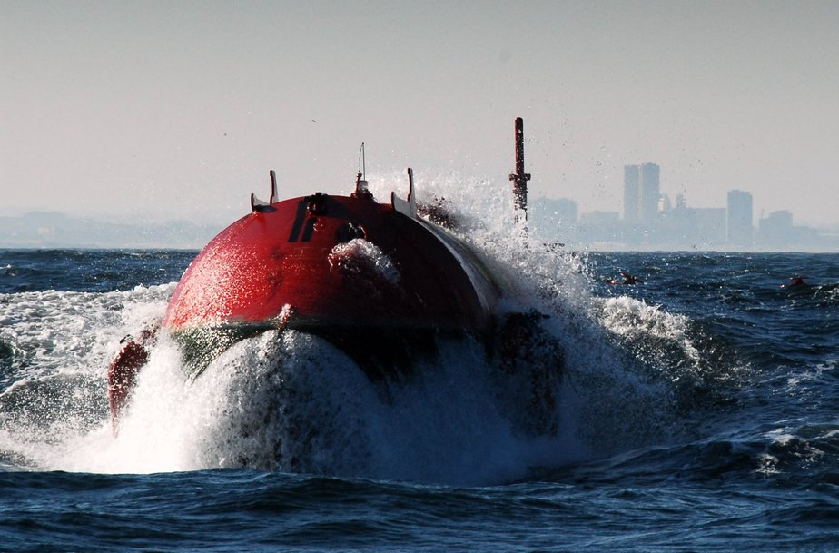
The Aguçadoura Wave Farm in Portugal was the world’s first commercial wave power project, but it closed in 2009 because of difficulty maintaining it. Credit: Wikimedia
The energy created by giant ocean swells that pound America's coastlines could theoretically provide almost all the electricity the nation needs. But financial and technology troubles have thwarted any commercial project from tapping the clean energy source.
A Department of Energy competition is trying to change that. Nine finalists for its Wave Energy Prize were named last week, ranging from startups and university labs to established companies. Proposed projects include barges on the ocean surface and bobbing buoy-like devices to air bags tethered to the sea floor.
The submerged series of air bags in one team's entry are compressed by waves. As the wave squeezes one bag, it sends air to another and cranks a turbine, harnessing the energy.
The goal is to push at least one of these ideas from experiment to commercialization.
"The prize targets the development of small scale prototypes that can be tested under apples-to-apples conditions," said a Department of Energy spokesperson. "The goal of the prize is to halve the current [levelized cost of electricity] of wave energy by doubling the state-of-the-art performance of devices, to put wave energy on a quicker path to commercialization."
The finalists get $125,000 each in seed funding to build a 1:20 scale model of their installations. Whether and how well their systems perform over the next several months will determine which teams get to test their devices at the U.S. Navy's Maneuvering and Seakeeping Basin in Carderock, Md. in July.
Three winners, to be announced November, will receive grants of $1.5 million for first place, $500,000 for second and $250,000 for third. The money will be used as seed capital to build demonstration projects, which could attract private investment. The technologies will be judged on "average climate capture width per capital expenditure"—or simply, how much it costs per meter to build relative to how much power it generates.
This is the first year the DOE has offered a prize for wave energy. The contest continues a long tradition of using prize money to solve the world's vexing problems. In 1714, the British government offered up to £20,000 to anyone who could design and build a clock that could be used to measure longitudes at sea within a half a degree. The winner was John Harrison, who invented the marine chronometer. In 1927, the Ortieg Prize of $25,000 spawned the race to cross the Atlantic in nonstop flight. It was won by Charles Lindbergh.
More recently, the $10 million Ansari X prize, for any private organization to launch a reusable rocket into space twice in two weeks, was given to a team from Mojave Aerospace Ventures in 2004. The U.S. government offers 675 prizes for various fields.
The DOE has held 28 energy innovation contests since 2010, the most famous of which is the Solar Decathlon, in which university engineering and architecture students compete to design the most efficient and affordable solar-powered home.
Bob Thresher, a research fellow at the National Renewable Energy Laboratory, a federal research center in Colorado, said contests like the wave prize can be important for exposing what doesn't work, as well as what does work, and for spurring interest from investors. It provides the crucial trial-and-error process needed to allow winning technologies to emerge.
When it comes to ocean energy, Thresher said, "we're about where wind technology was in the 80s." While wind settled on one technology, the now-familiar three-bladed windmills, decades ago, "that hasn't happened with wave power yet," he said.
While ocean energy technologies are numerous and complex, the basic concept is simple: Transform the vertical motion of ocean swells into rotational energy that powers turbines. If successful, the power potential is immense; a 2011 report by the Intergovernmental Panel on Climate Change (IPCC), citing a 2010 study by Fugro Oceanor, a Norwegian builder of ocean monitoring systems, said the waves off North America and Greenland could generate 4,000 terawatt-hours per year, or about 85 percent of what the United States used in 2013. Thresher said that in reality the generation wouldn't be that much, since wave energy resources tend to be local, but in areas such as the Pacific Coast it could still be significant.
"Once you get your arms around this [potential energy source], the question becomes why can't we get a hold of it?" said Brian Cunningham, the chief executive of Wave Energy Conversion Corporation of America, one of the two alternates in the DOE contest. His team's technology involves linking three barges with a flexible, water-filled joint. As the passing waves stretch and relax the joints, they shoot jets of water that powers a wheel and drives a wave-power generator.
The hurdles to commercializing wave energy are still high. The ocean environment isn't friendly to steel or concrete, and anything at sea has to be durable enough to withstand treacherous conditions. Waves are also spread out over a large area, so any device has to be built on a large scale. There's also the challenge of channeling the power to where people live and work. While many people live near coasts, there is minimal grid infrastructure to transport electricity from offshore.
That hasn't stopped entrepreneurs from trying. In Spain, a wave energy plant in Mutriku has operated at a small scale, sending about 300 kilowatts to 250 households since 2011. In the United Kingdom, Islay LIMPET, the first wave power station connected to the grid, operated from 2000 until 2013, when the German company that owned it, Voith, shut it down, citing a poor return on investment.
In Portugal, the Aguçadoura Wave Farm was the world's first commercial wave power project, but it closed in 2009, largely because it was difficult to maintain. In Australia, Victorian Wave partners, a project of Ocean Power Technologies, was shelved after the company said it was not commercially viable. Ocean Power Technologies tried to build a large-scale wave power project in Oregon in 2014, but the company couldn't raise enough money and it was never built. The U.S. has only one operating wave power station, the Azura, a 20-kilowatt system being tested in Hawaii.
What all this means is that commercialization is many years off. However clever the technologies are in the DOE contest, they all face enormous challenges.
One is scalability. A finalist team from Salem, Oregon, called M3 Wave, for instance, has developed an energy converter that cranks out power from deep under the surface. It uses a system of air-filled bags on the sea floor in bunker-like structures. As waves pass overhead they compress one bag, sending air to another, turning a turbine. But M3 Wave's device generates only 1.5 megawatts per unit, says chief executive Mike Morrow, which is small for power plants. Coal plants average 500 megawatts.
Another technology, from team SEWEC, led by Nick Wynn, a mechanical engineer, has a similar problem. It uses a football-shaped chamber rocking on the surface, half filled with fluid. A vertical flap floats inside and rocks with the waves, and air passing through the flap turns a turbine inside. Wynn said that SEWEC's device would probably generate less than a megawatt, even at full size.
One unifying theme of the entries is avoiding exotic technologies or materials. If something is to be commercialized, it has to be easy to build, can't require specialized equipment to maintain, and of course, be relatively cheap.
"If you're going to deal with the sea it'd better be simple, and it'd better be robust or it will take you down every time," Cunningham said. WECCA is making the barges out of material similar to that used in ships, while SEWEC is using structural polyethylene like that used for pipes.
Even with those challenges, though, Cunningham says he is confident that if the industry can get various ideas funded then wave power can work. "I've raised a lot of [venture capital] over the years," he said, noting that he has run an electronics company, and learned to solve problems during a stint as a physicist at NASA. "I've got a builder that would love to test this."

Belfast News Letter
Pure Marine on the crest of a US wave
March 8, 2016

Technology developed by a Northern Ireland firm has shown it is among the best in the world of wave energy.
Pure Marine, based at the NI Science Park, has been selected as one of only nine finalists for the US Department of Energy’s (DoE) Wave Energy Prize competition.
The global competition is seeking to identify the emerging technology best placed to create a step change in the cost of energy generated from waves.
After an initial assessment of 94 proposals, followed by the detailed assessment of 20 technologies, the DoE has selected the firms they believe have the most potential to cut the cost of generating electricity from wave power by half.
It will now contribute $125k to each of the final firms for the construction and testing of a larger scale device at the US Navy’s MASK test facility in Carderock, Maryland.
The selection process involved assessment of numerical modeling data followed by tank testing of 1/50th-scale models of the 20 devices taken through the initial assessment. The 1/50th-scale DUO device, designed and built by Pure Marine at the science park, was tested across the full-range of sea-states at the University of Iowa’s recently installed test facility.
The Pure Marine team, will now focus on delivering and successfully testing a larger 1/20th-scale device with the aim of capturing the $1.5m prize available for the winning technology.
“It is really encouraging that following a rigorous, independent technical assessment the DUO technology has been demonstrated to perform so well and has been selected for the final of the competition”, said Paul Brewster, Pure Marine’s chief technology officer.
“This is exactly the type of thorough, independent analysis that investors have been seeking to give them the confidence to invest in the DUO technology.”
Science Park CEO Norman Apsley added: “It is wonderful to see a technology developed in Belfast, and the determination, skill and ingenuity of Pure Marine’s team, be rewarded in this way.
“Such competitions in the US are a big deal, a precursor to significant interest and a commensurate investment.
“Paul has been based at the Science Park since its formation working on various marine energy projects and was noticed by our patron HRH Duke of York who introduced him to some of the biggest players in global energy through the Pitch@Palace initiative to support Entrepreneurs.

News Channel 10 (CA – CBS affiliate)
SEWEC Named Finalist in U.S. Department of Energy's Wave Energy Prize
March 8, 2016

Team is among 9 to Continue in Quest to Win More Than $2 Million Prize Purse
Redwood City, CA - March 8, 2016 - (Newswire.com)
The U.S. Department of Energy (DOE) announced today that SEWEC is among the nine teams that have been named finalists in the Wave Energy Prize a 20-month design-build-test competition and will proceed to the next phase of the competition.
The nine finalists and two alternates, identified from the 17 remaining official qualified teams, will continue their quest to double the energy captured from ocean waves and win a prize purse totaling more than $2 million. Each of the finalists and alternates will now receive seed funding from DOE to develop 1/20th scale models of their wave energy converter (WEC). These models will be tested at the nation's most advanced wave-making facility, the Naval Surface Warfare Center's Maneuvering and Seakeeping (MASK) Basin at Carderock, Md., beginning in the summer of 2016.
“We are thrilled to be selected as a finalist in the Wave Energy Prize competition and look forward to going head to head with the eight other worthy contenders,” says Nick Wynn, leader of the SEWEC team. “We’re lucky to be based in California, a world hotspot for innovation in renewable energy as well as big reliable waves - even when the sun shines.”
“The qualified teams’ efforts resulted in some very promising technologies for the judges to evaluate,” said Wes Scharmen, principal investigator at Ricardo, Inc. and chief judge of the Wave Energy Prize. “Based on our preliminary evaluation, the data indicates that many of the teams identified as finalists have the potential to achieve the ACE threshold, and thus the potential to exceed DOE’s program goal. We’re looking forward to further verifying their designs performance at 1/20th scale in the MASK Basin at Carderock this summer.”
ACE a benefit-to-cost ratio was selected by the Wave Energy Prize as a metric appropriate for comparing low Technology Readiness Level WEC concepts when there is not enough data to calculate the levelized cost of energy itself a cost-to-benefit ratio from a device. ACE is determined by dividing, in essence, the wave energy extraction efficiency of a WEC by its structural cost. Finalists were determined based on their potential to achieve the doubling of the current state-of-the-art ACE value of 1.5 meters per million dollars (m/$M) to 3 m/$M during 1/20th scale tank testing at the MASK Basin, making them eligible to win the grand prize.
A panel of expert judges evaluated each qualified team based on their revised technical submissions, numerical modeling results, Model Design and Construction Plans, and the results of small-scale tank testing of their 1/50th scale models, and determined aggregate scores to identify the finalist pool.
The Wave Energy Prize is encouraging the development of game-changing WECs that will reduce the cost of wave energy, making it more competitive with traditional energy solutions.
To follow the progress of the Wave Energy Prize or for more information, go towaveenergyprize.org.
About SEWEC
The SEWEC device pitches in harmony with ocean waves and uses an internal oscillating water column (OWC) to drive an air turbine and generate renewable energy. Unique to SEWEC, the OWC and all moving parts are totally sealed-off from the harsh ocean environment, maximizing survivability, reliability and durability.

Renewable Energy World
DOE Announces Wave Energy Prize Finalists
By Gregory B. Poindexter; March 9, 2016
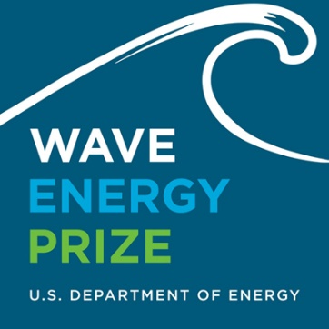
The U.S. Department of Energy (DOE) announced today that nine teams have been named finalists in the Wave Energy Prize -- a 20-month design-build-test competition -- and will proceed to the next phase of the competition.
The winners will be announced at Waterpower Week in Washington on Monday afternoon, April 25.
The nine finalists and two alternates, identified from the 17 remaining official qualified teams, will continue their quest to double the energy captured from ocean waves and win a prize purse totaling more than US$2 million.Each of the finalists and alternates will now receive seed funding from DOE to develop 1/20th scale models of their wave energy converter (WEC) technologies. These models will be tested at the nation's most advanced wave-making facility, the Naval Surface Warfare Center's Maneuvering and Seakeeping (MASK) Basin at Carderock, Md., beginning in the summer of 2016.
^{Official finalist teams are:}
- AquaHarmonics (Portland, Ore.);
- CalWave (Berkeley, Calif.);
- M3 Wave (Salem, Ore.);
- Oscilla Power (Seattle, Wash.);
- RTI Wave Power (York, Maine);
- Sea Potential (Bristol, R.I.);
- SEWEC (Redwood City, Calif.);
- Wavefront Power (Team FLAPPER) (Research Triangle Park, N.C.); and
- Waveswing America (Sacramento, Calif.).
Alternate teams are:
- McNatt Ocean Energy (Annapolis, Md.); and
- Wave Energy Conversion Corporation of America (WECCA) (North Bethesda, Md.).
“The qualified teams’ efforts resulted in some very promising technologies for the judges to evaluate,” said Wes Scharmen, principal investigator at Ricardo Inc. and chief judge of the Wave Energy Prize.
“Based on our preliminary evaluation, the data indicates that many of the teams identified as finalists have the potential to achieve the ACE threshold, and thus the potential to exceed DOE’s program goal. We’re looking forward to further verifying their designs performance at 1/20th scale in the MASK Basin at Carderock this summer.”
ACE -- a benefit-to-cost ratio -- was selected by the Wave Energy Prize as a metric appropriate for comparing low Technology Readiness Level WEC concepts when there is not enough data to calculate the levelized cost of energy—itself a cost-to-benefit ratio -- from a device. ACE is determined by dividing, in essence, the wave energy extraction efficiency of a WEC by its structural cost. Finalists were determined based on their potential to achieve the doubling of the current state-of-the-art ACE value of 1.5 meters per million dollars (m/$M) to 3 m/$M during 1/20th scale tank testing at the MASK Basin, making them eligible to win the grand prize.
A panel of expert judges evaluated each qualified team based on their revised technical submissions, numerical modeling results, Model Design and Construction Plans, and the results of small-scale tank testing of their 1/50th scale models, and determined aggregate scores to identify the finalist pool.
The Wave Energy Prize is encouraging the development of game-changing WECs that will reduce the cost of wave energy, making it more competitive with traditional energy solutions.
To follow the progress of the Wave Energy Prize or for more information, go to waveenergyprize.org.

EERE Network News
Energy Department Announces Finalists Vying for Wave Energy Prize
March 9, 2016
The Energy Department on March 1 announced the nine teams chosen as finalists in the Wave Energy Prize, a 20-month design-build-test competition that aims to double the energy captured from ocean waves. The teams vying for the $2.25 million prize come from California, Maine, North Carolina, Oregon, Rhode Island, and Washington.
Of the 92 teams that qualified to kick off the competition in the spring of 2015, 20 teams advanced to the second technology gate. In this round, teams designed and built 1/50th scale models of their next-generation wave energy devices, which were rigorously tested and evaluated at five small-scale, wave-generating tanks across the United States. Finalists were selected based on their results and potential to achieve the Wave Energy Prize goals.
Each of the finalists and alternates will now receive seed funding from DOE to develop a larger, 1/20th-scale model of their wave energy devices. The final round of testing will take place this summer at the nation's most advanced wave-making facility, the Naval Surface Warfare Center's Maneuvering and Seakeeping Basin, located at Carderock, Maryland.
See the Energy Department news release.

International Water Power and Dam Construction
Nine teams get to final of US Govt’s Wave Energy Prize
March 11, 2016
Nine teams will continue in a bid to win more than £2 million in funding for their wave energy converter (WEC) technologies in the US Department of Energy's (DOE) Wave Energy Prize.
The teams named as finalists in the 20-month design-build-test competition are:
- AquaHarmonics (Portland, Ore.)
- CalWave (Berkeley, Calif.)
- M3 Wave (Salem, Ore.)
- Oscilla Power (Seattle, Wash.)
- RTI Wave Power (York, Maine)
- Sea Potential (Bristol, R.I.)
- SEWEC (Redwood City, Calif.)
- Wavefront Power (Team FLAPPER) (Research Triangle Park, N.C.)
- Waveswing America (Sacramento, Calif.)
In addition, two alternate teams were selected:
- McNatt Ocean Energy (Annapolis, Md.)
- Wave Energy Conversion Corporation of America (WECCA) (North Bethesda, Md.)
The nine finalists and two alternates, identified from the 17 remaining official qualified teams, will continue their quest to double the energy captured from ocean waves and win the prize purse totaling more than $2 million. Each of the finalists and alternates will now receive seed funding from DOE to develop 1/20th scale models of their WEC technologies. These models will be tested at the Naval Surface Warfare Center's Maneuvering and Seakeeping (MASK) Basin at Carderock, Md., beginning in the summer of 2016.
"The qualified teams' efforts resulted in some very promising technologies for the judges to evaluate," said Wes Scharmen, principal investigator at Ricardo, Inc. and chief judge of the Wave Energy Prize. "Based on our preliminary evaluation, the data indicates that many of the teams identified as finalists have the potential to achieve the ACE threshold, and thus the potential to exceed DOE's program goal. We're looking forward to further verifying their designs performance at 1/20th scale in the MASK Basin at Carderock this summer."
ACE - a benefit-to-cost ratio - was selected by the Wave Energy Prize as a metric appropriate for comparing low Technology Readiness Level WEC concepts when there is not enough data to calculate the levelized cost of energy - itself a cost-to-benefit ratio - from a device. ACE is determined by dividing, in essence, the wave energy extraction efficiency of a WEC by its structural cost. Finalists were determined based on their potential to achieve the doubling of the current state-of-the-art ACE value of 1.5 meters per million dollars (m/$M) to 3 m/$M during 1/20th scale tank testing at the MASK Basin, making them eligible to win the grand prize.
A panel of expert judges evaluated each qualified team based on their revised technical submissions, numerical modeling results, Model Design and Construction Plans, and the results of small-scale tank testing of their 1/50th scale models, and determined aggregate scores to identify the finalist pool.
The Wave Energy Prize is encouraging the development of game-changing WECs that will reduce the cost of wave energy, making it more competitive with traditional energy solutions.
To follow the progress of the Wave Energy Prize or for more information, go to waveenergyprize.org.

Seacoastonline.com

York business a finalist in National Wave Energy Contest

March 15, 2016

WASHINGTON, D.C. — U.S. Sens. Susan Collins and Angus King applauded York-based company RTI Wave Power for being selected as one of nine finalists in a national wave energy competition held by the U.S. Department of Energy (DOE). The Wave Energy Prize is a 20-month design-build-test competition that aims to double the energy harnessed by ocean waves.
“Tidal energy is an important part of Maine’s energy future, and with innovative efforts like those at RTI Wave Power and the University of Maine, our state is at the forefront of this promising industry,” Collins and King said in a joint statement. “We are proud of the hardworking team at RTI Wave Power and wish them best of luck as they move forward in the Wave Energy Prize competition.”
For the past seven years, RTI Wave Power has been developing and testing wave energy technologies and holds several U.S. wave energy patents. It is a unit of Rohrer Technology, Inc., a Maine Corporation founded by John W. Rohrer.
The RTI Wave Power team completed its testing at the new Harold Alfond Ocean Engineering and Advanced Manufacturing Laboratories at the University of Maine. Collins and King helped officially unveil the new ocean engineering facility in November of last year.
The Wave Energy Prize is a public prize challenge sponsored by the U.S. Department of Energy’s Water Power Program. The prize is designed to increase the diversity of organizations involved in Wave Energy Converter (WEC) technology development, while motivating and inspiring existing stakeholders. The winner of the Wave Energy Prize will be awarded $2.25 million.

IHS Engineering 360
Wave Energy: Chasing the Big One
March 17, 2016; By Larry Maloney
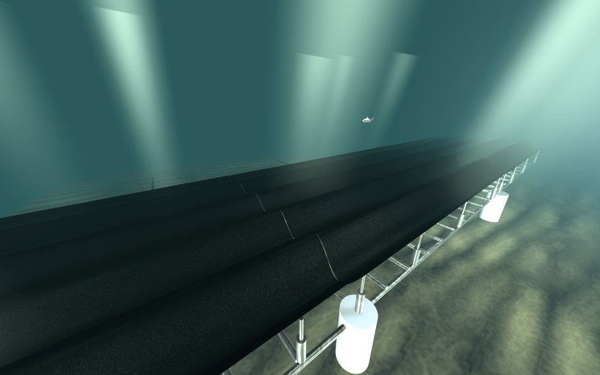
Cal-Berkeley’s “wave carpet” concept links a composite wave absorber to reciprocating pumps. Illustration by Marcus Lehmann, CalWave.
For years, energy experts have heralded the power-generating potential of the waves that relentlessly pound the world’s coastlines. An average 4-foot, 10-second wave puts out more than 35,000 hp per mile of coastline. Waves also produce far more kinetic energy than wind from much smaller devices. And, unlike solar and wind, waves can deliver a constant, predictable energy source.
The Electric Power Research Institute (EPRI) estimates that the technically recoverable wave energy resource in the U.S. alone is about 1.1 trillion kWh/yr, or about one quarter of the country’s electricity consumption. On a global scale, the World Energy Council estimates that about 2 million megawatts – roughly double current world electricity production -- could be generated from wave power.
Despite such estimates, wave energy remains an unfulfilled dream. A 2015 report in Yale University’s Environment360 says that ocean power worldwide is expected to produce 1 gigawatt of electricity by 2020, a fraction of the 370 gigawatts generated by wind. Global investments in marine power – $400 million in 2014 – were miniscule compared with solar energy’s $150 billion. Meanwhile, two prominent Scottish wave energy companies that received government support – Pelamis and Aquamarine Power – reportedly have hit the financial skids.
Behind the sluggish start for wave energy, say energy experts, are the steep costs of producing energy in harsh ocean environments, uncertainty over which designs are most viable, and an economic climate that includes a worldwide oil glut and competition from proven renewable performers like solar and wind.
EPRI’s Paul Jacobson: Wave energy must converge on a cost-effective design.“The high costs of wave energy are directly related to the technical challenges of designing power systems that are efficient, reliable and durable,” says Paul Jacobson, a senior technical leader at EPRI. “But remember that wind energy also had a long gestation period before it took off.”
Eyes on the Prize
Jacobson is among many experts who see the need for the fledgling wave energy field to converge on a proven design, much like the wind turbine industry gravitated to the now-standard three-blade configuration. “Right now, there are too many designs out there,” says Jacobson.
The U.S. Department of Energy is trying to nudge wave energy toward just such a design convergence with its Wave Energy Prize program. The program includes $2.25 million in prize money for three teams that can design devices capable of capturing twice as much wave energy as today’s current technology while also keeping structural and material costs in check.
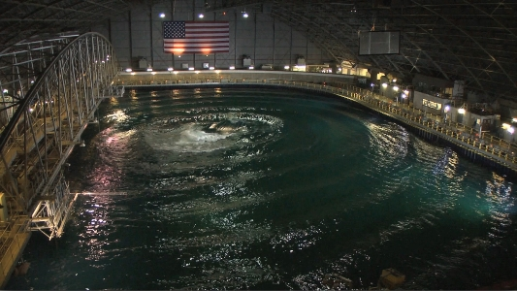
Teams competing in DOE’s Wave Energy Prize competition will test their devices at the Navy’s Maneuvering and Seakeeping Basin. Image source: DOE. In early March 2016, DOE named nine finalists in the competition. They were selected from a field of 92 who entered in July 2015. The finalists, whose 1/50th scale wave energy converters (WECs) were evaluated in wave tank tests, are now building 1/20th scale models that will square off in the summer of 2016 at the Navy’s wave-making facility in Carderock, Maryland.
DOE views the prize competition as a tool for jump-starting private sector interest in the marine power field. “Wave energy is a newcomer in renewable field, so costs are still higher than other sources,” says Alison LaBonte, a program manager in DOE’s Wind & Water Technologies Office. “That opens up a clear role for DOE to invest in this high-risk, high-potential-payoff field.”
Design Grab-Bag
It remains to be seen if the competition will clarify the type of wave energy devices most suitable for commercial scale-up, as DOE officials hope. Consider the different WEC concepts from the four teams that received the highest ratings from program judges following testing of the 1/50th scale models:
· The University of California-Berkeley’s CalWave team designed a totally submerged system, which features an elongated “wave carpet” made of non-corrosive composite materials. The energy from overtopping waves is absorbed by the carpet and converted to hydraulic energy using double-reacting reciprocating pumps connected to the carpet. Among the team’s backers is the Lawrence Berkeley National Laboratory.
· Oscilla Power’s Triton point absorber features a moored surface float connected by flexible tethers to a submerged heave plate. As ocean waves excite the surface float, it reacts against the heave plate, causing tension changes in the tethers. These tension changes are applied to a linear drive train, consisting of a hydrostatic load amplification system and a variable reluctance generator that translates the mechanical energy into electrical energy.
· The Sea Potential team of Bristol, Rhode Island, is competing with its DUO device. This point absorber connects oscillating bodies with angled pre-tensioned cable linkages and a power takeoff (PTO) system. This configuration enables power capture from pitch motions to be exploited simultaneously with heave motions. The DUO’s primary power absorption comes from damping the relative heave and rotational motions of the oscillating structures.
· RTI Wave Power of York, Maine, has designed a WEC called the RTI F2 QD, a simpler, less costly descendent of the “Salter’s Duck,” a wave terminator device developed in the 1970s by Scottish wave energy pioneer Stephen Salter. The RTI team eliminated Salter’s massive central cylinder and complex hydraulic power takeoff. Instead, the design places a smaller cylinder inside the WEC’s elongated wave-front-parallel float, which connects to a semi-submerged twin spar vertical frame. The F2 QD moves both upward and rearward on wave crests and forward and downward on wave troughs, allowing concurrent heave and surge energy capture. For enhanced survivability, a control system floods the float during heavy seas.
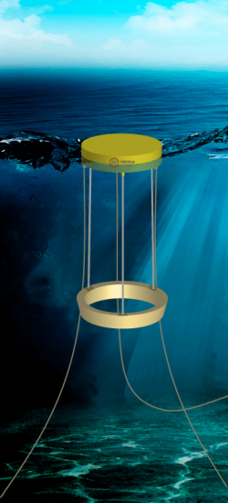
Oscilla Power’s Triton WEC is one of the top-rated devices in DOE’s Wave Energy Prize competition. While the DOE competition seeks to accelerate wave energy technology, the participating teams – most of them small startup ventures – have no illusions about the investments that will be needed to commercialize their concepts. John Rohrer, team leader for RTI Wave Power and a former energy development manager at multiple large companies, says it will take heavy involvement by firms like Siemens, Hitachi, ABB and GE to make wave energy a significant part of the power generation portfolio.
“We have to go beyond today’s pilot projects where a startup installs one or two WEC devices,” says Rohrer. He estimates that it would cost about $3 million to install one full-scale version of the F2 QD, which weigh 200 tons and measures 28 meters wide. “In a commercial wave energy farm connected to the grid, you would be talking about an array of 50 to 100 units and a cost of a quarter billion dollars.” Still, Rohrer believes that the wave energy industry will “take off in 5 to 10 years,” as the field converges on cost-effective designs.
Tapping Government Support
The Wave Energy Prize is not the only government effort to accelerate wave energy development. DOE has earmarked $10 million for evaluation of full-scale wave energy devices at the U.S. Navy’s grid-connected test site near Hawaii’s Kaneohe Bay. Participating companies include Northwest Energy Innovations (NWEI) of Portland, Ore.; Ocean Energy of Sacramento, Calif.; Sweden’s Fred. Olsen & Co.; and Oregon’s Columbia Power Technologies, which received a $3 million Navy contract for its testing.
First in the water was NWEI’s Azura WEC, developed initially by Wave Energy Technology-New Zealand and deployed at the Navy test site in June 2015. The 45-ton device features a 360-degree rotating float mechanism that can extract power from both vertical and horizontal wave motions. The University of Hawaii is gathering cost and reliability data on Azura, which is being billed as the first wave energy device connected to a U.S. power grid. An earlier prototype of Azura was evaluated at a site off the Oregon coast maintained by the Northwest National Marine Renewable Energy Center (NNMREC).
Beyond full-scale testing, DOE earlier in 2016 awarded $10.5 million to six companies for development of technologies that improve the durability and survivability of WECs. Among the projects, M3 Wave, Salem, Ore, will focus on modeling tools to assess environmental threats to WECs and reduce maintenance costs. Oscilla Power will explore ways to optimize the design of its WEC to prevent damage during severe weather.
To spur innovation in the components that make up WECs, DOE also is investing $7.5 million for such projects as:
· Advanced WEC control systems that can predict ocean conditions and adjust a WEC to optimize power production.
· Better power takeoff systems that will improve the efficiency of converting alternating current to direct power current.
· Development of composite components that include built-in diagnostics to prevent system failures.
From Software to Seals
Meanwhile, government labs, such as Sandia and Pacific Northwest National Laboratory (PNNL), are leading ocean energy activities ranging from new software programs and high performance computing to studies on the impact of WECs on the ocean environment.
Vincent Neary of Sandia National Labs: Surviving harsh ocean environments remains a major challenge for wave energy systems. At Sandia Labs, water power technology lead Vince Neary says that many of the teams participating in the Wave Energy Prize are using Sandia’s open-source WEC-Sim modeling and simulation software for design of their devices. The software can model WECs comprised of rigid bodies, take-off systems and mooring structures, while simulating performance in 6 degrees of freedom and under varying weather conditions. Another open-source tool, SNL-SWAN, lets engineers analyze the performance of multiple WECs installed in arrays, as well as their interaction with the ocean environment.
In addition, Sandia harnesses its high-performance computing to help companies improve both the performance and siting of water power technology systems. One key example is a joint effort with the National Renewable Energy Laboratory (NREL) to analyze turbine technology from Maine-based Ocean Renewable Power Corp., a pioneer in tidal power systems.
As Neary sees it, one of the biggest challenges facing wave energy is designing systems that can survive 20 years or more in punishing ocean environments where system maintenance is often difficult, dangerous and expensive. Still, he says he remains optimistic. “Wave energy is where wind and solar were in the ‘70s and ‘80s,” says Neary. “The installed base of those renewables is now far beyond what many people were predicting even ten years ago.”
When it comes to the impact of ocean energy on the marine environment, including fish, seal mammals, and ocean bed vegetation, government studies so far reveal no major showstoppers. For example, one Sandia-PNNL study of possible tidal energy risks to sea mammals concluded that it is unlikely that whales and seals will collide with or be killed by turbine blades. A 2015 DOE-funded study by the H.T. Harvey ecology firm found that underwater WEC structures and mooring lines may actually serve as artificial reefs for some fish species.
With private investors still skeptical, government needs to back wave energy R&D, says DOE program manager Alison LaBonte. As with other major construction projects, large-scale wave energy farms are sure to face a gauntlet of government permits and environmental approvals. To ease that burden and provide a roadmap for wave energy planning, PNNL has produced a model showing the environmental and permitting costs that can be expected for installing both pilot and commercial wave energy systems. DOE also has set up a new Marine and Hydrokinetic Data Repository, where companies and technology developers can access research on water power technology.
Will these efforts lead to a hoped-for surge in wave energy development? With a worldwide oil glut and large-scale investors still watching from the sidelines, the answer is likely to be “not yet.”
The field is largely populated by small companies that are pushing pilot projects, which suggests that wave energy is still moving through the “valley of death” in terms of commercial viability, says Professor Ted Brecken, an energy systems expert at Oregon State University. “The root of the problem is still cost per kilowatt hour, which is around 30 cents for these pilot projects, far more than commercial wind systems.”
Even so, government support and an active base of engineer-entrepreneurs are keeping the dream of wave energy alive. Says DOE’s LaBonte: “Wave energy is a very predictable renewable energy source, and with 50 percent of our nation’s population living within 50 miles of a coast, wave energy still holds promise.”
For More Information
DOE Wave Energy Prize: http://waveenergyprize.org/about
Finalist Teams for the Wave Energy Prize: http://waveenergyprize.org/teams
Video on “wave carpet” energy system from CalWave: http://tidalenergytoday.com/2015/07/21/video-calwaves-wave-carpet-device/
Video on Northwest Energy Innovations’ Azura WEC: https://www.youtube.com/watch?v=Ankdy1yhQLw
Ocean Council video on wave energy basics: http://www.oceanenergycouncil.com/ocean-energy/wave-energy/
Sandia’s WEC-Sim software for design of wave energy systems: http://energy.sandia.gov/energy/renewable-energy/water-power/technology-development/wec-sim-wave-energy-converter-simulator/
Marine and Hydrokinetic Data Repository: https://mhkdr.openei.org/

Tidal Energy Today
Waveswing America gears up for June WEC testing
March 25, 2016
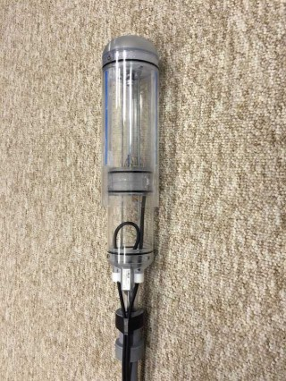
Waveswing America's 1:50 scaled WEC (Photo: Wave Energy Prize)
The Waveswing America team, one of the finalists in the Wave Energy Prize challenge, is preparing its 1:20 scale wave energy device model ahead of June testing at Carderock MASK basin.
The team is developing subsea pressure-differential point-absorber wave energy device, and at the moment, they’re busy designing the 1:20 scale model and the associated control system.
In parallel with this, Waveswing America team is further validating the computational models of the device and advancing the controls strategies to maximize production.
The work is being complemented by parallel work on hydrodynamics and computational modelling of the device being carried out for Wave Energy Scotland.
“Because our device is relatively small at full-scale, design at model scale is challenging, particularly due to the scaling effects with regards to mass.
“We have however found off-the-shelf components which will meet the required specifications and we are now integrating these into the model design. The team recognizes the importance of pre-testing ahead of the prize runs at Carderock and so we are busy planning for this activity during June,” Waveswing America stated.
Waveswing America seeks to demonstrate the benefits of subsea pressure-differential point absorber wave power generators for the production of utility scale power from offshore ocean sites.
The technology the team is developing takes a highly efficient point-absorber concept and combines it with efficient linear generator technology and advanced control algorithms to maximise yield, with the potential ratings of 500 kW and above, according to Waveswing America.
The team, along with 8 others, was selected a finalist for the Wave Energy Prize following the review conducted by a panel of expert judges who evaluated each qualified team based on their revised technical submissions, numerical modeling results, model design and construction plans, and the results of small-scale tank testing of their 1:50 scale models.
The team that ranks the highest after testing the 1:20 scaled WEC device model at the Naval Surface Warfare Center’s Maneuvering and Seakeeping (MASK) wave-making facility at Carderock, Maryland, will be awarded $1.5 million. The second team will win an award in the amount of $500,000, and the third-placed tam will be awarded $250,000.
Take a look at the video showing 1:50 scale testing of Waveswing America’s WEC conducted at the Hydrodynamics Research facility at the University of Iowa in January this year.

Tidal Energy Today
Oscilla Power to test wave device in July
April 1, 2016
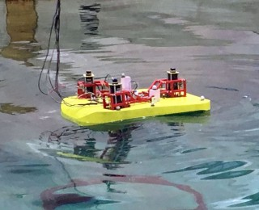
1:50 scale Triton WEC (Photo: Oscilla Power)
Seattle-based wave energy developer, Oscilla Power, is working on the optimization of its scaled wave energy device ahead of July testing.
The company is developing a two-body multi-mode point absorber consisting of a catenary moored surface float and a suspended asymmetric heave plate as part of the Wave Energy Prize challenge.
The team running for the Prize is currently working on the optimization of the surface float and heave plate of the 1:20 scaled WEC.
“The first purchase orders have been placed for components that will allow us to characterize the much larger representative PTO’s on the 1:20 scale model,” the team said.
Also, Oscilla Power team signed a contract to perform pre-testing of the 1:20 device at the the University of Maine (UMaine) Harold Alfond W2 Ocean Engineering Lab, scheduled to take place in July.
Triton converter works when ocean waves excite the surface float, and cause it to react against the heave plate, generating tension changes in the tethers.
These tension changes are applied to a linear drivetrain, consisting of a hydrostatic load amplification system and a variable reluctance generator that translates the low displacement, high force mechanical energy input into electrical energy.
Last month, Oscilla Power, along with 8 others, was selected a finalist for the Wave Energy Prize securing the chance to win a prize purse totaling more than $2 million.

Fosters.com
Harnessing the ocean
April 3, 2016; By Deborah McDermott
- 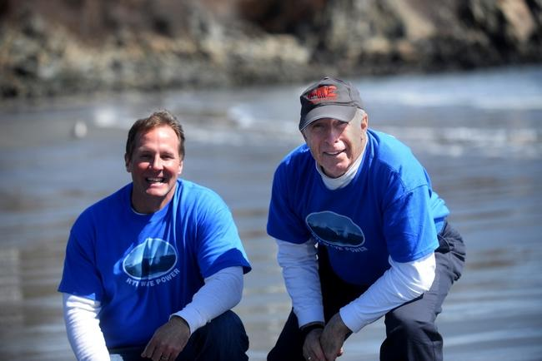John Rohrer, president of Rohrer Technologies, right, and his partner Sean Lewis have developed a wave energy prototype that is one of nine finalists in the country for a $1.5 million wave energy grant from the federal Department of Energy. Photo by Deb Cram/Seacoastonline

YORK, Maine — John Rohrer and Sean Lewis both know the ocean well. Engineers by profession, both also have lobster licenses and they respect and understand the awesome power of water.
Today, the two men are leading a team of private industry and university volunteers to create a scale-model prototype to extract energy from those ocean waves. And their model is being recognized by the U.S. Department of Energy as among the best in the country.
RTI Wave Power, the research and development company formed to create the prototype, is a finalist in the DOE Wave Energy Prize. RTI started in a field of 92 applicants to become one of nine finalists vying for a $1.5 million prize to continue research.
“I didn’t focus on wave energy until about seven years ago, when I started seeing a lot of wind farms in Maine,” said Rohrer, a longtime York resident and former vice president of engineering and project development at Wheelabrator Technologies. RTI Wave Power is a subsidiary of Rohrer’s R&D company, Rohrer Technologies, Inc. Rohrer himself holds 14 patents.
“I’m an offshore fisherman," he said, "and it seemed to me that there was a lot more energy in offshore waves than in wind and sun.”
Lewis, a 1990 York High School graduate, worked in the defense industry for years “but in the back of my mind, I knew I was interested in long-term renewables.” He has a cabin off the grid in Woodstock, Maine, the site of the Spruce Mountain Wind Farm, and said he’s been “fascinated” at the idea of large-scale project.
As anyone who has been on the ocean during rough seas can attest, the power of waves is enormous.
“It’s a much more concentrated resource,” Rohrer said. “Water is 800 times more dense than air, and the ocean waves hold a lot more energy density than solar or wind.”
The energy coming to Earth from the sun is “quite low,” Rohrer said. “Wind is more energy dense than sun, which is why wind is a more cost effective renewable than solar. But ocean waves are even more concentrated.”
The DOE launched the prize on the proviso that a deep ocean farm of “wave energy converters” could be a substantial benefit to many Americans. The 2010 census estimates that 39 percent of all Americans live directly on the coast and more than half the population lives within 50 miles.
According to the DOE, if just 5 percent of gross wave potential could be captured, it could result in wave energy powering 5 million American homes. Ultimately, DOE officials believe wave energy could provide 10 to 30 percent of all U.S. power requirements in the next 20 to 30 years.
The challenge, however, is to produce a wave energy converter that will be able to efficiently handle the heaves and troughs of deep ocean waves at a price that is not cost-prohibitive. Those two factors are the guiding principles behind the Wave Energy Prize.
And, according to a recent blog posted by the Wave Energy Prize team, that is a significant challenge. The ferocity of a severe winter storm “provides significant challenges to the structural design and consequent capital cost, or requires survival strategies, such as diving, submersion or perhaps even removal to shore. And these typical winter storms are not as strong as the survival conditions to be met for the ‘100-year wave’ or rogue waves, which will be even more demanding.”
Whatever solution emerges from the Wave Energy Prize and other U.S.-based and global development activities, “to be successful we need to see large increases in the absorbed power, with high bandwidth and adaptability to different sea states, and maybe even wave-to-wave control, with greatly reduced capital expenditure, reliability, survivability and maintainability,” the DOE team wrote in its blog.
Given these parameters, said Rohrer, “there’s literally hundreds of ways to capture energy from waves and turn it into electricity. But there’s really only one best way. If we can build the best prototype, we can create the best solution.”
The RTI Wave Power converter looks not unlike a football goal post, with two tall vertical trusses topped by a lateral truss. At full scale, it will be 91.8 feet wide, will cost $2 million to $3 million per unit, is intended for off-shore installation at least 150 feet deep and is expected to power up to 1,500 homes. The units would be deployed in “wave farms” of 10 to 100.
The magic occurs in a float that spans the two vertical columns and is below the water line. The float is designed to capture both heave (the up and down component) and surge (the lateral, or front and back motion) of each wave.
“It turns out that about 50 percent of the energy of each wave is surge and 50 percent is heave,” said Lewis. Add to this the different velocity of the wave and the distance it has traveled to get there. “Some could be from a storm 500 miles away and some from a storm 200 miles away,” he said.
The float they’ve devised self-orients (weather-vanes) parallel to the oncoming waves to intercept maximum energy-containing wave front in all sea conditions. Severe sea survival “is assured by automatically flooding the float to negative buoyancy with seawater, allowing it to rotate to a fully submerged 6 o’clock position, well below the troughs of even 50-foot waves,” the team wrote in a summary of the RTI converter.
Lewis and Rohrer assembled a team of volunteers that have been working in the scaled prototype, from Maine Marine Composites in Portland, the University of New Hampshire and Portsmouth Naval Shipyard. Early, small-scale prototypes were tested at the UNH.
When 20 teams were selected as semifinalists, they had to build 1/50th scale models that participated in small-scale tank testing. Luckily for the RTI team, one of the five DOE sites chosen nationwide to conduct the tests was in Maine. The new Harold Alfond W2 Ocean Engineering Lab at the University of Maine is equipped with a high-performance rotating wind machine over a multidirectional wave basin.
“We were very fortunate,” Rohrer said to have the lab in their back yard. “Maine now has the best wave tank in the country.”
As one of the nine finalists, the team is busy working on a 1/20th scale model, which must be completed by mid-July for testing at the Naval Surface Warfare Center’s Maneuvering and Seakeeping Basin in Carderock, Maryland, where the Navy tests its warships. The award winner will be announced in November

Energy Harvesting Journal
Finalist in wave energy prize competition
April 13, 2016
Founded in 2009, Oscilla Power has developed mechanical and electromagnetic systems that allow cost-effective, highly scalable magnetostrictive alloys to produce significant quantities of energy in specific environments. Their patented iMEC technology platform converts mechanical energy into electrical energy in manner that is low-cost, scalable, flexible, predictable, robust and efficient.
Oscilla Power's Triton Wave Energy Converter(WEC) is a two-body point absorber with five key advantages over other WECs. Triton is a highly efficient two-body, multi-mode point absorber that consists of a catenary moored surface float connected to an optimally shaped, vertically asymmetric heave plate by three taut, flexible tethers. Unlike most conventional solutions, Triton's surface float is excited by ocean waves in multiple modes - heave, pitch, surge and roll - allowing for increased energy capture across a wide range of ocean conditions enabling a substantially lower levelized cost of electricity.
Multi-mode energy capture/wide-band response
Enabled by the use of flexible tethers, themselves enabled by an asymmetric heave plate, Triton uniquely captures energy from heave, pitch, sway and roll motions.
High efficiency energy capture & conversion
Enabled by decoupling of the prime mover and generators, Triton's low-displacement drivetrain converts mechanical energy into electrical energy at an average efficiency >75%.
Low cost "tow and drop" installation
Triton is towed to the deployment site with the surface float and heave plates hard-mated to each other, for towing to and from deployment sites. After mooring the surface float, the system is de-latched so that the heave plate can be lowered to the target depth using on-board winches. Winches are employed in reverse for heave plate recovery. This self-deployment and self-recovery function removes the need for specialized vessels or heavy lift equipment for operations, as regular vessels are sufficient to tow the system and supply hydraulic power for winch operations. The use of a transport configuration also allows towing and installation in higher sea states, increasing the duration of acceptable weather windows and thus reducing vessel standby costs.
High survivability and reliability
The Triton WEC's tuning approach (aligning device response with the dominant incident wave conditions to maximize energy capture under smaller waves) can also be used to perform load shedding in larger waves. Adjusting drivetrain parameters and dynamic ballasting of the surface float can both be used to alter the mass properties and reduce the devices' response to the incident wave. With funding from the Department of Energy, Oscilla Power is investigating use of the hard-mated configuration for survival situations, This will enable a reduction in the required over-design for extreme conditions, and thus a reduction in capital cost.
Low reliability and availability, driven largely by drivetrain and generator complexity, has historically been one of the principal drivers of high maintenance cost and low annual energy production faced by wave energy converters. Generator technologies optimized for low cost in a fixed foundation, non-salt water context are simply not going to be the low cost solution for wave energy conversion. Enabled by its linear drivetrain's flexibility, Triton will use low-displacement solutions, such as magnetostrictive generators optimized by Oscilla Power for use in wave energy conversion, to deliver high efficiency energy conversion with unparalleled reliability. Triton's initial deployments are anticipated to use proven, high-power density linear generators, with significantly lower mass and volume than conventional direct drive generators due to the speed increase enabled by the linear drivetrain.
A low-displacement drivetrain
Triton systems will deliver an average power of > 600kW each and will be arrayed together to form utility-scale power plants. Validation of Triton's feasibility has included extensive wave tank testing and hydrodynamic modeling, accelerated reliability testing for key subcomponents and two ocean deployments. Triton is protected by 14 granted and 40+ pending patents in key geographic regions.
The U.S. Department of Energy (DOE) recently announced that Oscillate Power has been named a finalist in the Wave Energy Prize—a 20-month design-build-test competition—and will proceed to the next phase of the competition.
The nine finalists and two alternates, identified from the 17 remaining official qualified teams, will continue their quest to double the energy captured from ocean waves and win a prize purse totaling more than $2 million. Each of the finalists and alternates will now receive seed funding from DOE to develop 1/20th scale models of their wave energy converter (WEC) technologies. These models will be tested at the nation's most advanced wave-making facility, the Naval Surface Warfare Center's Maneuvering and Seakeeping (MASK) Basin at Carderock beginning in the summer of 2016.
Read more at: http://www.energyharvestingjournal.com/articles/9325/finalist-in-wave-energy-prize-competition

Tidal Energy Today
Who’s judging technology competing for Wave Energy Prize?
April 15, 2016
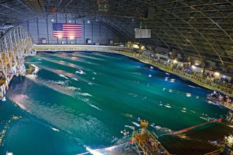zoomMASK basin at Carderock (Photo: EERE)
With the technology gate (TG) 3 review for the Wave Energy Prize just ahead, Tidal Energy Today is introducing you to the judges who evaluated the competing teams’ technologies in two previous TG reviews.
Wave Energy Prize, a challenge launched by the US Department of Energy (DoE) to encourage the development of game-changing wave energy conversion (WEC) devices, has revealed 9 finalist teams earlier this year.
The teams are now working to procure parts and construct their 1:20 scale wave energy converter prototypes in preparation for tank testing at Carderock this summer.
The finalists have been selected by the following panel of expert judges, bringing together years of engineering expertise in the design and construction of marine and hydrokinetic technologies, who have judged either or both of the first two technology gates of the Wave Energy Prize.

Scott Beatty (TG1 and TG2)
Scott Beatty of Cascadia Coast has over a decade of experimental and numerical marine systems research and development experience in both academia and industry, along with deep expertise in wave energy converter model testing. Beatty currently serves as a convener and subject matter expert for two International Electrotechnical Commission international project teams developing and maintaining technical specifications for wave energy converter performance assessment.

Frederick Driscoll (TG1)
Rick Driscoll joined the National Renewable Energy Laboratory in March 2010 and works as a senior engineer on the Offshore Wind and Ocean Power Systems Team. Driscoll works in the areas of offshore wind and marine hydrokinetics on computer modeling, design, testing, instrumentation, and data analysis. Before joining NREL, he was an associate professor of Ocean and Mechanical Engineering at Florida Atlantic University (FAU), where he focused on ocean energy and navy projects for more than 10 years.

Phil Michael (TG 1 and TG2)
Phil Michael is Ricardo Inc.’s wave energy technical expert. While working for Ricardo-AEA in the UK, Michael was closely involved with wave power R&D since the re-opening of the UK’s wave power program and its inclusion in the UK’s New and Renewable Energy Program in 1999. In 2004, he developed the UK’s Marine Renewables Deployment Fund (MRDF), a £50 million scheme aimed at supporting small arrays of commercial-scale wave and tidal stream devices, which he managed until its closure in 2011.

Vincent Neary (TG1 and TG2)
Vincent Neary is the MHK Technology Lead at Sandia National Laboratories, where he manages a diverse portfolio of marine renewable energy R&D projects. Neary’s research contributions include hydrodynamic and wave modeling for tidal current, ocean current and wave resource assessments, turbulent inflow characterization to estimate power performance and dynamic loads on hydrokinetic turbines, and development of best practices for hydrokinetic energy resource assessment and environmental monitoring, amongst others.

David Newborn (TG1 and TG2)
David Newborn is an ocean engineer at the Naval Surface Warfare Center Carderock Division (NSWCCD), Naval Architecture and Engineering Department, Maritime Systems Hydromechanics branch. He has served at NSWCCD for eight years, primarily in the areas of surface and underwater towed systems, unmanned systems, and marine hydrokinetic technologies. Newborn holds a Bachelor of Science degree in Ocean Engineering from FAU.

Dylan Temple (TG1)
Temple works at NSWCCD in the Department of Naval Architecture on hydrodynamic simulation and model testing for amphibious vehicles focusing on seakeeping and maneuvering. He earned his B.E. in Naval Architecture and Marine Engineering from the State University of New York Maritime College and his Ph.D. in Naval Architecture from the University of Michigan. Temple’s graduate research focused on early stage multi-disciplinary design optimization.

Robert Thresher (TG1 and TG2)
Thresher, with more than 40 years of research and management experience, worked for DoE as a principal researcher to conceive and create the National Wind Technology Center, and then served as its first director. In 2008, Thresher was appointed to the position of NREL research fellow. At NREL since 1984, he serves as a strategist and spokesperson for the national research programs to develop offshore renewables, such as wind, wave, tidal and ocean current.

The winner(s) of Wave Energy Prize challenge are expected to be announced in November. The team that ranks the highest after testing the 1:20 scaled WEC device model will be awarded $1.5 million.
The second team will win an award in the amount of $500.000, and the third-placed tam will be awarded $250.000.
Source/Images: Wave Energy Prize

Hydro Review

Update on DOE’s Wave Energy Prize

April 2016; By Alison LaBonte
A new initiative, called the Wave Energy Prize, was announced in 2015 during the keynote address at the annual National Hydropower Association conference, International Marine Renewable Energy Conference, and Marine Energy Technology Symposium. This announcement represented a milestone for the U.S. Department of Energy’s (DOE) Wind and Water Power Technologies Office - the commencement of its first public prize challenge, with a total prize purse of US$2.25 million, stemmed from realizing that a technology leap in the efficiency of wave energy converter (WEC) devices was needed to jolt wave energy onto a pathway toward sweeping cost reductions. This pathway could ultimately make wave energy, which is still in the early stages of technology development, competitive with more traditional forms of energy, paving the way to large-scale implementation within a generation.

Fast-forward just one year - 92 teams registered for the Wave Energy Prize, with 66 of these submitting technical data for review by the prize’s judging panel. In August, 20 teams were named official qualified teams and began developing 1/50th scale models of their WEC devices. Between August 2015 and January 2016, they submitted revised technical submissions, numerical modeling results, model design and construction plans, and the results from their 1/50th scale model tank testing as requirements to be considered for the next round of evaluation.
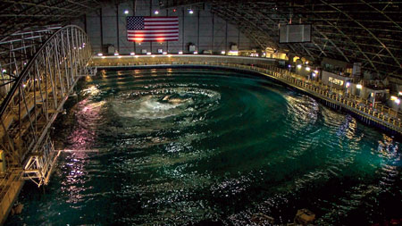
On March 1, DOE announced nine teams as finalists and two as alternates, all of which will continue their quest to double the energy captured from ocean waves and win a prize purse totaling more than US$2 million. Each of the finalists will now receive up to $125,000 of seed funding from DOE, with alternates receiving up to $25,000 to develop 1/20th scale models of their WEC technologies. These models will be tested at the Naval Surface Warfare Center’s Maneuvering and Seakeeping (MASK) Basin at Carderock, Md., beginning in the summer of 2016.

ACE - a benefit-to-cost ratio - was selected by Wave Energy Prize personnel as a metric appropriate for comparing low technology readiness level WEC concepts when there is not enough data to calculate the levelized cost of energy - itself a cost-to-benefit ratio - from a device. ACE is determined by dividing, in essence, the wave energy extraction of a WEC by its structural cost.
“The qualified teams’ efforts resulted in some very promising technologies for the judges to evaluate,” said Wes Scharmen, principal investigator at Ricardo Inc. and chief judge of the Wave Energy Prize. “Based on our preliminary evaluation, the data indicates that many of the teams identified as finalists have the potential to achieve the ACE threshold, and thus the potential to exceed DOE’s program goal.”

Finalists were determined based on their potential to achieve doubling of the current state-of-the-art ACE value of 1.5 meters per million dollars (m/$M) to 3 m/$M during 1/20th scale tank testing at the MASK Basin, making them eligible to win the grand prize of $1.5 million.
Below is information about the technologies vying to win the Wave Energy Prize, listed both in alphabetical order (and in the teams’ own words, provided before completion of 1/50th scale tank testing):
- AquaHarmonics (Portland, Ore.) - AquaHarmonics’ wave energy device is a point absorber consisting of a simple power take off (PTO) system mounted in a cone/cylinder shaped hull with a single mooring line that has a power cable at its core;
- CalWave (Berkeley, Calif.) - CalWave’s device is called the WaveCarpet. This approach was inspired by the ability of a muddy seafloor to effectively absorb overpassing ocean waves within only a few wavelengths. The unique converter design uses a synthetic-seabed carpet that has the ability to extract wave energy the same way;
- m³ Wave (Salem, Ore.) - m³ Wave’s NEXUS is a mid-column variant of its DMP/APEX submerged pressure differential technology. The system harnesses the pressure wave under ocean swells while stationed above the ocean floor, but still safely under the surface, protected from surface hazards;
- Oscilla Power (Seattle, Wash.) - Oscilla Power’s Triton™ is a two-body point absorber, consisting of a large surface float connected by flexible tethers to a submerged heave plate. As ocean waves excite the surface float, it reacts against the heave plate, generating tension changes in the tethers. These tension changes are applied to a linear drivetrain, consisting of a hydrostatic load amplification system and a variable reluctance generator that translates the low displacement, high force mechanical energy input into electrical energy;
- RTI Wave Power (York, Maine) - The RTI F2/F2D development objective is to achieve the lowest capital cost per megawatt of output combined with secure survivability in severe seas. To concurrently capture a majority of both heave and surge energy, the RTI F2/F2D utilizes elongated swing arms to attach its EWFP float directly to a generator in its motion-stabilized floating twin vertical spar frame, which constrains the float to move concurrently upward (for heave capture) and rearward (for surge capture) on wave crests and return forward and downward on wave troughs;
- Sea Potential(Bristol, R.I.) - The DUO is a new design concept that simultaneously captures power from both the heave and pitch/surge motions induced by wave action. DUO’s patented configuration, which connects oscillating bodies with angled pre-tensioned cable linkages and a PTO system, enables power capture from pitch motions to be exploited simultaneously with heave motions. DUO’s primary power absorption is achieved by damping the relative heave and rotational motions of the oscillating structures;
- SEWEC (Redwood City, Calif.) - SEWEC is an oscillating water column (OWC) WEC - a device that operates in a similar fashion to the most successful shore-based wave energy convertors. The SEWEC device extends the proven OWC concept, enabling devices to be moored offshore in a much wider range of locations than conventional shore-based devices.
- Wavefront Power (Research Triangle Park, N.C.) - Wavefront Power’s Very Large Flapper Array (VLFA) is being developed for utility-scale power production from deep water ocean swell waves. The VLFA generally falls into the oscillating wave surge converter category of WEC devices; and
- Waveswing America (Sacramento, Calif.) - The Archimedes Waveswing™ is a submerged point absorber that uses the change in pressure caused by passing waves to expand and contract a large piston. The piston houses a linear generator that converts the relative motion of the two parts directly into electricity.

The two alternate teams are:
- McNatt Ocean Energy (MOE) (Annapolis, Md.) - The MOE WEC is a hinged raft. Wave forcing and the bodies’ dynamic responses leads to a motion about the hinge (called flex), which drives a PTO mechanism that converts the kinetic energy into electricity. It has seven degrees of freedom; and
- Wave Energy Conversion Corporation of America (WECCA) (North Bethesda, Md.) - WECCA’s patent-pending Advanced Wave Energy Conversion System (AWECS) physically presents as three articulating barges, securely anchored offshore, which survived nine years of WEC platform concept testing off the west coast of Ireland.
Testing is scheduled to begin in August and run through mid-October. DOE anticipates announcing the prize winner(s) in November. For more information about the teams, please visit

Alison LaBonte, PhD, is the marine and hydrokinetic technology program manager for the U.S. Department of Energy’s Wind and Water Power Technologies Office.

Sea Technology Magazine
Catalyzing Advancements in Ocean Energy
April 2016; By Dr. Alison LaBonte
Marine and hydrokinetic energy represents a promising, low-carbon form of energy that can help meet future electricity demand in the United States. With more than 50 percent of the nation’s population living within 50 mi. of the coastline, the potential to provide clean, renewable electricity to communities close to the source of ocean power is very appealing.
Waves provide a continual source of energy, whether it’s sunny or cloudy, whether it’s windy or calm. Recent studies (http://energy.gov/eere/water/downloads/mapping-and-assessment-united-states-ocean-wave-energy-resource) found that the technically recoverable wave energy resource is estimated to range between 898 to 1,229 terawatt-hours (TWh) per year, distributed across the coast of Alaska, the West Coast, the East Coast, the Gulf of Mexico, Hawaii and Puerto Rico. For context, approximately 90,000 homes can be powered by 1 TWh per year. This means that even if only 5 percent of the potential is recovered, millions of homes could be powered by wave energy as the technology progresses.
With such great potential, why isn’t wave energy already a significant source of electricity, particularly in wave-rich areas such as the West Coast of the U.S.? One of the most significant barriers to large-scale implementation today is cost—until costs fall significantly and prices are competitive with more traditional forms of energy, the potential wave energy represents will remain just that—potential.
The U.S. Department of Energy (DOE) believes it’s possible to harness this potential if a technology leap in wave energy converter (WEC) devices can be achieved. If increased efficiency in WECs can be realized in the short term, wave energy can get on the pathway to achieve sweeping cost reductions that could ultimately make it competitive with more traditional forms of energy.
To spur the necessary leap in technology, the DOE is sponsoring a 20-month design-build-test competition called the Wave Energy Prize. This public prize challenge aims to achieve game-changing improvements in the efficiency of WEC devices more quickly than would occur by implementing a traditional research and development program. Prize competitions such as this one can spur the development of revolutionary technologies because their open-access structure welcomes newcomers. Their fresh perspectives sometimes bring forth outside-the-box solutions that would otherwise not make it through a traditional research and development process. By leveling the playing field, both existing and new developers have a chance to achieve what may initially appear to be an audacious goal. In the Wave Energy Prize, our specific goal is to develop new technologies capable of doubling the energy captured from ocean waves compared with today’s state-of-the-art devices. WEC devices are in the early stages of technological development, and there are currently several dozen potentially viable technologies in this emerging industry.
The emerging wave energy industry is perfectly poised for a prize challenge, such as the Wave Energy Prize, as researchers and developers seek to prove the viability of their unique technologies. Many of the competitors for the prize will benefit from participating, not only getting their chance at the prize purse totaling more than $2 million, but also having the opportunity to validate their technologies through testing at the Naval Surface Warfare Center’s Maneuvering and Seakeeping (MASK) Basin. The MASK Basin, located in Carderock, Maryland, is the nation’s premier wave-making facility.
In the spring of 2015, an astonishing 92 teams registered for the Wave Energy Prize, 66 of which provided technical submissions that were judged over the summer. In August, DOE announced the selection of 20 teams that would continue as official qualified teams. During the fall and winter, these teams designed and built 1/50th-scale models, which were evaluated, through small-scale testing and on a number of other criteria for their potential to achieve the program’s goal.
Is the audacious goal we’ve set achievable? We believe so. A number of Wave Energy Prize competitors’ technologies have demonstrated the potential to double the energy captured from ocean waves, and as a result will continue into the final stages of the Wave Energy Prize. On March 1, DOE announced that nine official finalist teams, as well as two alternates, would receive seed funding to build a 1/20th-scale prototype of their WEC technologies in preparation for testing at the MASK Basin this summer. Upon completion of testing, DOE plans to announce the winner(s) of the Wave Energy Prize in November.
Within our lifetimes, it’s possible that clean, reliable power captured from ocean waves could be brought to millions of American homes. With DOE’s investment in groundbreaking technologies, more efficient WEC devices are on the horizon. To date, our Wave Energy Prize finalist teams have shown great promise, and several have demonstrated a potential to more than meet the program’s goal of doubling the energy captured from ocean waves, compared with today’s state of the art.
By capturing energy more efficiently, we can drive down the cost, making wave energy more competitive with more conventional forms of energy and eliminating what is arguably the biggest barrier to large-scale implementation.
To learn more about the official Wave Energy Prize teams and their technologies, or to follow the latest developments in the prize, visit www.waveenergyprize.org.

Dr. Alison LaBonte is the marine and hydrokinetic technology program manager in the U.S.
Department of Energy’s Wind and Water Power Technologies Office, responsible for the development and execution of the nation’s strategy for advancing marine renewable technologies as viable, cost-competitive energy contributors. She has a Ph.D. in oceanography and B.S. in mathematics.

Marine Technology Reporter
The Chase for $2m Prize
April 2016

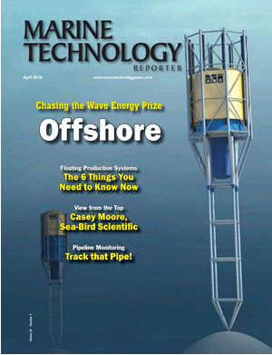

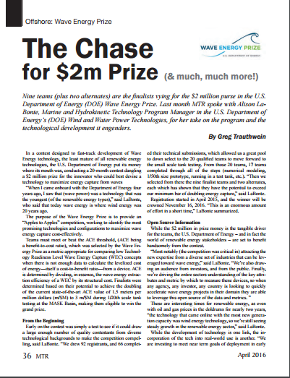

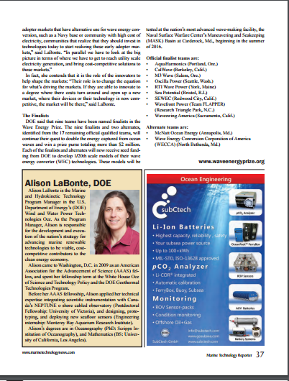

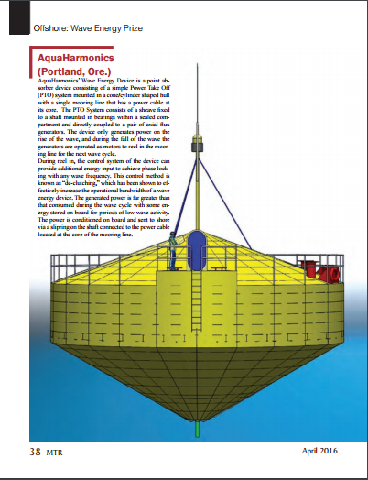

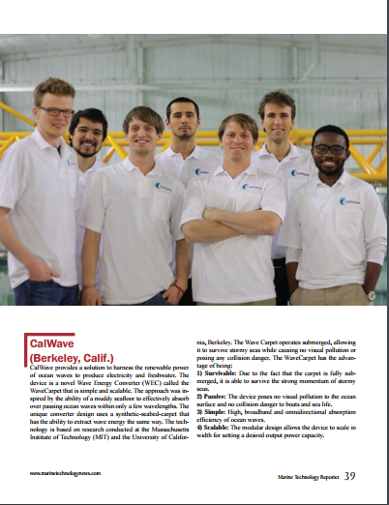

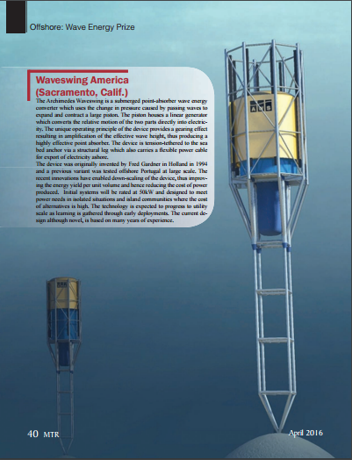

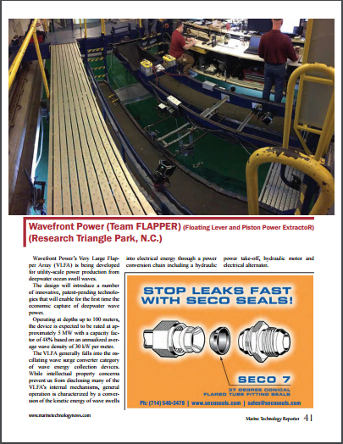

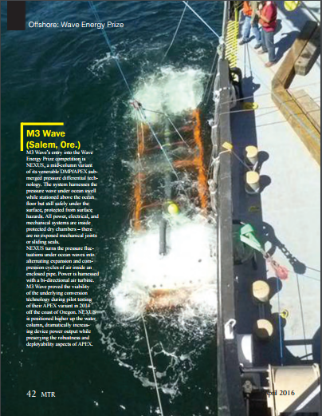

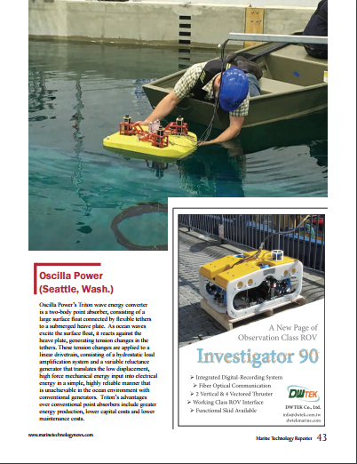

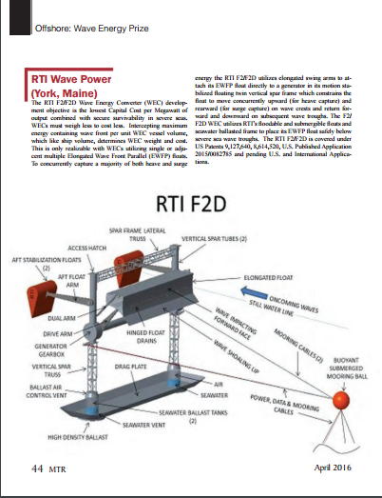

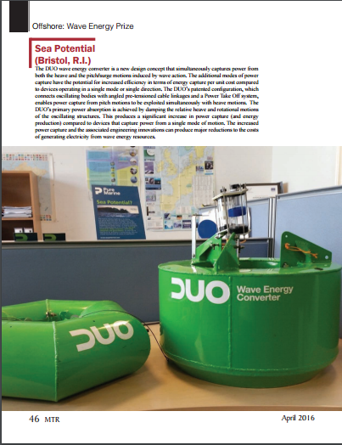

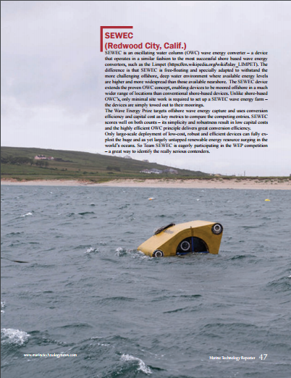

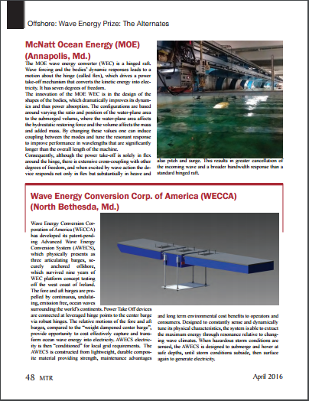

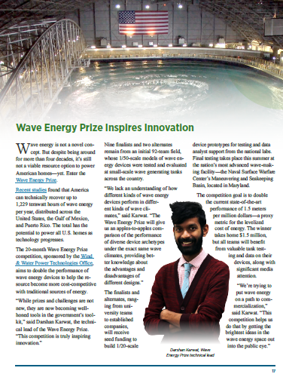
Tidal Energy Today
Sea Potential works on DUO WEC optimization
May 5, 2016

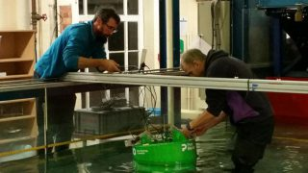
Illustration/DUO WEC 1:50 testing (Photo: Wave Energy Prize)
Sea Potential, one of the finalist teams competing in Wave Energy Prize challenge, is focusing on the optimization of their 1:20 scale DUO wave energy converter ahead of summer tank testing at MASK basin in Maryland.
Sea Potential is developing a multi-mode power capture point absorber wave energy converter called DUO.
The DUO wave energy converter is a new design concept that simultaneously captures power from both the heave and the pitch/surge motions induced by wave action.
The DUO’s patented configuration, which connects oscillating bodies with angled pre-tensioned cable linkages and a power take-off system, enables power capture from pitch motions to be exploited simultaneously with heave motions.
The DUO’s primary power absorption is achieved by damping the relative heave and rotational motions of the oscillating structures.
The additional modes of power capture have the potential for increased efficiency in terms of energy capture per unit cost compared to devices operating in a single mode or single direction.
The increased power capture and the associated engineering innovations can produce major reductions to the costs of generating electricity from wave energy resources, according to Sea Potential.
The team is working on the optimization of the 1:20 scale model, by analyzing the data from 1:50 tests conducted at University of Iowa, and numerical modelling using the advanced coupled analysis features of Wood Group Kenny’s Flexcom, and according to the team, the data has helped in identifying some small structural improvements that will increase the ACE (benefit-to-cost) metric for the 1:20 model.
Flexcom coupled analysis capabilities also present key to optimizing the mooring design for the Naval Surface Warfare Center’s Maneuvering and Seakeeping (MASK) basin, which will be important for the HPQ score that will determine prize winners from the teams that can exceed the 3.0 m/$m threshold, Sea Potential team informed.
The other software Sea Potential are employing for the optimization work is the new techno-economic software from Exceedence. The Sea Potential team states that the ‘Goal Seek’ and ‘Sensitivity’ modules of Exceedence software have enabled them to identify where specific improvements can be made for the range incident wave conditions for the upcoming 1:20 scale testing.
The winner(s) of Wave Energy Prize challenge are expected to be announced in November. The team that ranks the highest after testing the 1:20 scaled WEC device model will be awarded $1.5 million.
The second team will win an award in the amount of $500.000, and the third-placed tam will be awarded $250.000.

Gtown Radio
Planet Philadelphia Podcast
May 6, 2016

Planet Philadelphia Podcast – radio show streamed on Gtown Radio May 6, 2016
5/7/2016
0 Comments

Listen to the podcast of the Planet Philadelphia that was streamed on G-town Radio May 6, 2016 with host Kay Wood’s interviews with Karen Melton, a local climate change activist who talked about her experiences with the Citizens' Climate Lobby and their proposal for a carbon fee and dividend system that’s getting a lot of support across the political spectrum. The second interview is with Dr. Alison LaBonte about Department of Energy’s (DOE) Wave Energy Prize competition. According to some estimates wave energy could meet much of US energy needs if we can solve the technical hurdles. The DOE’s Wave Energy Prize is designed to help work out the best technological innovations to do just that.
Please do tune back in to G-town Radio at 4:00 Friday May 20th for a dynamic interview about sea level rise with Professor Benjamin Horton of Rutgers University who tells us about the absolute urgency about acting on climate change now on another great Planet Philadelphia.
Podcasts of the shows become available a day or two after they broadcast. Call the Listener Comment Line any time: (484) 278-1846. It would be great to hear what you have to say. To find out more about Planet Philadelphia go to http://www.planetphila.com or http://www.gtownradio.com/ | @planetphila | @gtownradio | Facebook
#climatechange #carbon #radio #podcast #waveenergy #carbonfee+dividend

Tidal Energy Today
Waveswing America starts WEC construction
May 10, 2016

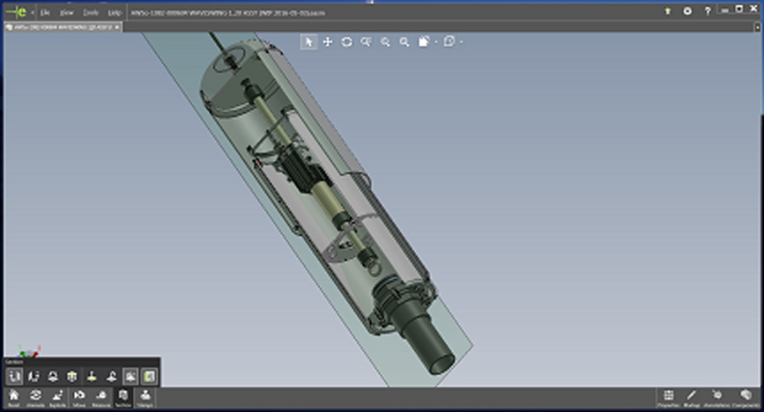
CAD model of the Waveswing 1:20 scale device (Photo: WEP)
Waveswing America, one of the finalists in the Wave Energy Prize challenge, has finalized the design and started construction of its 1:20 scale wave energy converter ahead of Carderock testing.
The Waveswing America team focused on improving the fidelity of the model, incorporating the active PTO system and engineering for reduced losses, the team informed.
In parallel with the mechanical design, Waveswing America has been progressing its dynamic control software, and according to the team, data from the 1:50 trials was used to to refine and validate WEC’s numerical models which are essential for tuning the control system so it achieves maximum output.
Over the next few weeks, Waveswing America will start assembling the model, complete the design and build of the self-deploying anchor system necessary for the large tank, finalize the control systems and make preparations for a return to the University of Iowa for pre-testing of the 1:20 scale model.
The team is developing subsea pressure-differential point-absorber wave energy device, which takes highly efficient point-absorber concept and combines it with efficient linear generator technology and advanced control algorithms to maximise yield, with the potential ratings of 500 kW and above.
The testing of the 1:20 scale model will be conducted this summer at the Naval Surface Warfare Center’s Maneuvering and Seakeeping (MASK) wave-making facility at Carderock, Maryland.

Hydro World
Hydro Headlines Weekly Newscast
May 12, 2016; by Gregory Poindexter and Marla Barnes
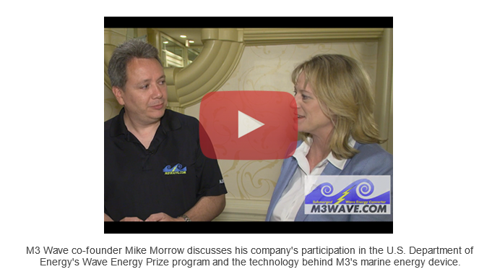
Note: There is a second story announcing the Wave Energy Prize Finalist Teams in the newscast.

Tidal Energy Today
Introducing Mocean Energy’s hinged raft WEC
May 13, 2016
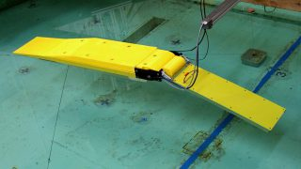
Mocean Energy's scaled WEC (Photo: Mocean Energy)
Mocean Energy, one of the alternate teams to 9 Wave Energy Prize challenge finalists, is moving forward with the design of their 1:20 scale wave energy converter (WEC).
The Mocean WEC is a hinged raft which works as wave forcing and the bodies’ dynamic responses lead to a motion about the hinge, called flex, which drives a power take-off mechanism that converts the kinetic energy into electricity.
The device has seven degrees of freedom, with the design innovation of Mocean WEC being in the shapes of the bodies, which improves its dynamics and thus power absorption, the company states.
The configurations are based around varying the ratio and position of the water-plane area to the submerged volume, where the water-plane area affects the hydrostatic restoring force and the volume affects the mass and added mass.
By changing these values one can induce coupling between the modes and tune the resonant response to improve performance in wavelengths that are significantly longer than the overall length of the machine.
Consequently, although the power take-off is solely in flex around the hinge, there is extensive cross-coupling with other degrees of freedom, Mocean Energy states.
When it is excited by wave action, the device responds not only in flex, but substantially in heave and also pitch and surge. This results in greater cancellation of the incoming wave and a broader bandwidth response than a standard hinged raft, according to Mocean Energy.
Mocean Energy is the second alternate team, with Wave Energy Conversion Corporation of America (WECCA) being the first, to the 9 finalists selected by the Wave Energy Prize challenge judges.
This means that if two teams drop out or are eliminated following the next stage gate review, Mocean Energy will have a chance to compete in the finals.
To remind, Mocean Energy, together with the University of Edinburgh, has also been backed by Wave Energy Scotland with approximately £300,000 for the development of its WEC.
Take a look at the video showing Mocean WEC model testing at Stevens University as part of the US DoE Wave Energy Prize.

Utility Dive
Making waves: DOE reboots marine hydrokinetic energy program to push commercialization
May 18, 2016; By Herman K. Trabish

Can a new competition and funding move MHK technologies out of the 'Wright brothers stage of development?'
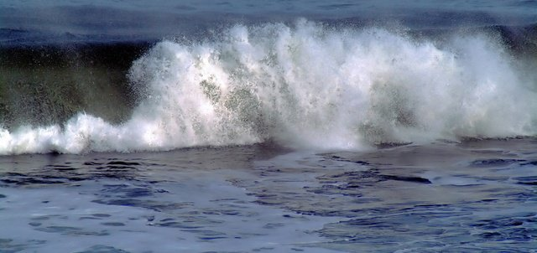
Though the marketplace has backed off from wave, tidal, and current energies, the Obama Energy Department has rebooted its effort to grow them.
These marine hydrokinetic (MHK) energies could potentially provide power for more than half of the U.S. population that lives along the coast, but they have one big barrier: No one’s come close to developing a cost-effective model for MHK deployment in the U.S.
The people in DOE’s Water Program persist even though they see the failures in early efforts to commercialize the potential of waves, tides, ocean currents, river flows and marine thermal gradients. Though the marketplace remains dubious, DOE has a plan to turn potential into reality.
“Utilities and major investors were brought in on this technology some years ago with big promises from vendors but the vendors did not deliver,” said Stewart Bible, team leader at Harvest Wave Energy, an MHK startup. “The utilities and investors remain snake-bitten.”
One of the major U.S. utility efforts validates Bible’s point. Despite $12 million in funding for tidal research from DOE and other agencies and its own $4.4 million investment, Snohomish County Public Utility District decided to cancel its effort in 2014, said Spokesperson Neil Neroutsos.
“The research was important but project costs got too high and it became too cumbersome to move forward,” he told Utility Dive.
That experience is not a unique one. From 2008 to 2015, DOE’s program awarded an estimated $136 million for 92 MHK energy projects, according to the Department’s recent project update. Yet there are no U.S. commercial installations and few pilots with real promise.
Aware of such failures, the DOE Water Program is “trying to reboot, prove we can get techno-economic performance, and then bring those stakeholders back in,” Bible said. “Conversations about commercialization will come after that.”

Radical innovation
Bible’s company is one of nine finalists in DOE’s 20-month Wave Energy Prize competition, which pushes companies to design, build and test MHK technologies that could scale up to commercial deployment.
DOE is asking for radical innovation from Wave Prize competition entrants, said Mike Morrow, CEO of M3 Wave, another finalist. The $1.5 million first prize will go to the technology that goes farthest beyond the minimum threshold of doubling the amount of power from a marine source per unit cost. Prizes of $500,000 and $250,000 will go to others that beat the threshold.
DOE envisions using the wealth of U.S. ocean and river resources to build a cost-competitive MHK industry that would diversify the nation's energy portfolio and expand U.S. marine energy companies into global markets, an Energy Department spokesperson emailed Utility Dive.
To realize its vision, DOE wants to drive near-term deployment in “early-adopter and distributed generation markets.” Those markets are primarily in "coastal population centers where the price of electricity is high and in alternate and niche applications," the spokesperson wrote.
Long term, the goal is “deployment in large-scale utility markets.”
“DOE has seen the value and stepped up,” said Alex Hagmuller, founder of AquaHarmonics, another competition finalist.
The three “core” obstacles to MHK energy growth are “technology maturity, deployment barriers, and market development,” DOE’s spokesperson noted.
But niche markets may be opening up for these less mature technologies and that could break down deployment barriers, said Tim MacDonald, team leader for competition finalist Sea Potential.
Unlike most renewables, which are pure energy plays, wave energy could have multiple applications, said MacDonald, an attorney who specializes in renewables. Sea Potential has begun exploring potential alternative revenue streams from using its 1 MW buoys as platforms to host and power scientific and national security communication electronics at sea.
Efforts by the U.S. Navy and the National Oceanic and Atmospheric Administration to use solar and wind for those purposes have been unsatisfactory.
“Our primary purpose is to get to utility-scale generation,” MacDonald said. “But it is reasonable to say that getting to where wind and solar are is a multi-year undertaking.”

Immense potential
Recent analysis shows the “technically recoverable” potential of MHK resources is immense. For wave energy alone, it’s between 898 TWh and 1,229 TWh each year, accessible along each major American ocean coastline, according to a recent study commissioned by DOE.
“If only 5% of the potential is recovered, millions of homes could be powered by wave energy,” DOE’s spokesperson pointed out. A single TWh of electricity is typically considered enough to power about 92,000 homes.
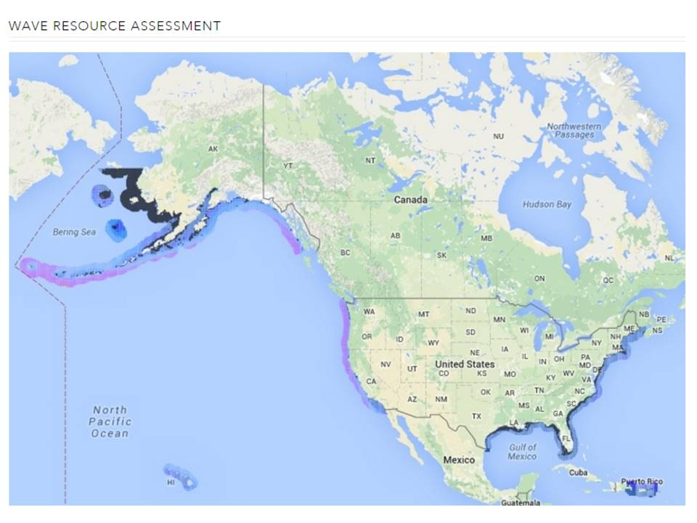
DOE resource assessments for wave energy along U.S. coastlines
Credit: DOE MHK energy resource assessment

There is an additional technically recoverable 222 TWh/year to 334 TWh/year from U.S tidal energy sites and 45 TWh/year to 163 TWh/year in ocean current sites along both the Atlantic and Pacific coasts, according to a DOE study. The Mississippi River contains almost half the potential U.S. river current energy of up to 120 TWh/year. There is also an estimated 576 TWh/year of recoverable ocean thermal energy in U.S. waters.
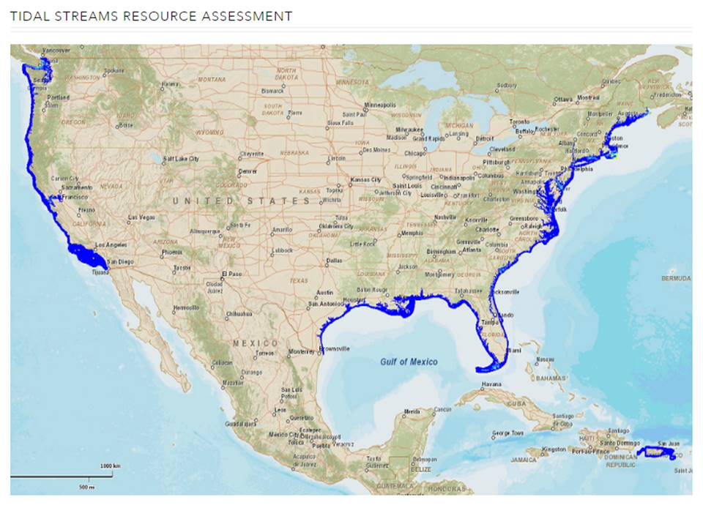
DOE assessment for tidal energy along U.S. coastlines
Credit: DOE MHK energy resource assessment

Though actual deployment numbers are never likely to approach the “technically recoverable” numbers, they give a sense of the massive potential of such technologies. Even the low end estimates add up to more than 1,8000 TWh annually — nearly half of the 4,000 TWh the U.S. consumes each year.
But whether it’s the U.S. or elsewhere, deployment numbers pale in comparison to the potential.
Global MHK energy installed capacity at the end of 2014 was approximately 530 MW, mostly from tidal energy installations, according to REN 21’s Renewables 2015 Global Status Report.
The world’s potential is estimated to be from 20,000 TWh to 80,000 TWh of electricity per year, which would be 100% to 400% of current global demand, according to the International Renewable Energy Agency (IRENA) 2015 ocean energy report.
Early European wave energy technologies obtained utility backing, IRENA reported. German utility E.ON and Scottish Utility SSE have backed away, but Finland’s Fortum, Spain’s Iberdrola, ScottishPower Renewables, France’s EDF, and Sweden’s Vattenfall continue to work with prototypes.
"The contribution of ocean energy to the global energy mix now and in the next five years remains very small, with technologies still in the development and demonstration phases," IRENA acknowledged.
But some in the industry see a brighter future. The projected $200 billion market for global renewable energy and 14-year Compound Annual Growth Rate of 27.6% suggest a potential market size for wave energy systems of more than $10 billion by 2030, Harvest Wave Energy estimates, if they can be successfully commercialized.
Two technologies approached commercial success in the UK — Pelamis Wave Power and Aquamarine Power — Hagmuller said. But both seemed to move ahead too fast and ran into financial difficulties.
“Pelamis should have spent more time optimizing,” the AquaHarmonics founder said. “But the backbone of wave technology is what we learned from the failure.”
Though spending has been cut back in Europe, it remains ahead of the U.S. in technology.
"The DOE reboot is a recognition that the U.S. is still at the Wright brothers stage of development,” Hagmuller said.

DOE reboot
In it's latest project update, DOE recounts where its efforts began.
“Before 2008, people saw the significant potential in the available MHK resources...[but] it became apparent that a government role would be beneficial to help remove some of the barriers to industry commercialization.”
DOE has funded projects in 24 states, with over 30% of that going to Maine, Oregon, and Hawaii. But over 85% of the funding for the 92 projects DOE has supported has gone to Technology Development and Market Acceleration. Projects aimed at Deployment received only 11% of the funding.
DOE's reboot is intended to spur independent providers to overcome obstacles to deployment. Beyond the Wave Energy Prize, it also includes $22 million of funding for marine energy demonstration and environmental monitoring technologies and a $10.5 million allocation of durability and survivability advances.
Congress and the White House have been supportive of funding requests for MHK energy research, development, and demonstration, DOE’s spokesperson said. Provisions in the Obama administration 2017 budget and in Senate and House energy bills are now working their way through the legislative process.
The 20 states that count MHK energy toward their renewables mandates are important, DOE’s spokesperson said. There is also a $0.01/kWh federal Production Tax Credit for projects of at least 150 kW in nameplate capacity and a 10% Business Energy Investment Tax Credit for tidal energy projects. Some states, including Alaska and Oregon, offer added incentives.

The innovators' perspectives
The Wave Prize finalists see the reboot as opening the door to wave energy innovation.

Harvest Wave Energy
DOE is going back to step one because the companies that had been moving toward commercialization are now stuck and no one will invest in their technologies, Harvest Wave Energy’s Bible said. The focus is now on techno-economic performance so the products its investments produce will attract investors.
“What has been tried to this point has not come close to economic competitiveness and most of the products that failed were buoy type point absorbers,” Bible said. “We decided that bottom-hinged, oscillating wave surge collectors produce the best techno-economic performance."
But even the competition finalists remain a long way from commercialization, he added.
“Technologies that meet the competition’s economic standard, get the right financial backing, and develop a good business strategy might be marketable in around five years.”

M3 Wave
For M3 Wave, the newest devices are so innovative they do not fall into traditional technology categories because they were built on lessons learned and designed to be more cost effective, Morrow said.
The key lessons learned are that the ways to bring the cost per kWh down are to make the device easier to deploy, more survivable, and easier to maintain, he said.
“Our technology sits on the bottom where there is less energy. But it is more survivable because there are no exposed moving parts,” Morrow said. “New companies learn that the ocean eats man-made things for breakfast. It is not a forgiving place.”
After working on ocean energy designs for over two decades, Morrow has concluded that “we will not have utility-scale wave energy powering coastal communities any time soon in the Pacific Northwest because the price of energy is just too low for it to be economically viable.”
Like other companies in the field, M3 Wave is looking at markets where there is no alternative or the price of power is exceptionally high. On islands and in isolated communities, the electricity price can be $0.30/kWh and more.
“At those prices, we can start to get competitive,” Morrow said. “That would allow us to prove deployability and survivability.”

Sea Potential
While the M3 technology sits on the ocean floor, Sea Potential took a different approach. To benefit from both the heave and the pitch-surge motions of waves, the Sea Potential's DUO connects fixed and floating oscillating bodies with angled pre-tensioned cables. The design allows power generation from both wave motions, increasing the energy capture per unit cost.
There could be important repercussions to potential secondary revenue streams derived from the fixed buoy's use in niche applications like serving as a platform for meteorological, oceanographic, and military electronics, MacDonald said.
“We see this as a stimulus for an economy that needs to be rejuvenated in our home base in Bristol, Rhode Island,” he said. “Roger Williams University and the community have supported us and we want to give back to them through this industry.”
Other niche opportunities MacDonald has been exploring are in aquaculture and ocean ecosystem protection. “Instead of a threat, wave energy technologies might be a safe haven for ocean life.”

AquaHarmonics
“To enhance survivability, AquaHarmonics’ “next generation” point absorber buoy technology seals its mechanical engineering inside a protected compartment.
Getting energy from waves is not new or different and there are many ways to do it, Hagmuller said. “The question is, can you do it economically? The competition is to find the most economical technology.”
The wind industry is a long way down the road to “optimizing” its turbine technology, he noted, but the wave energy industry does not yet know what its standard technology “will even look like.” It might turn out to be “different for different applications and locations.”
Because of Pelamis, “we have a much more realistic understanding of how to test for what is economically viable and we know estimates through numerical analysis are incorrect but we don’t yet know how incorrect they are,” Hagmuller added.
The industry must expect more failures along with the successes that are ahead, he believes. And it cannot expect private investment support. “They want a quick return on their money and that is not going to happen in wave energy.”
The next step in the competition requires a real world test of a one-twentieth scale prototype. If Aquaharmonics were to win the funding, it would have to do further numerical analysis and tank testing of a one-fourth scale prototype, Hagmulller said.
More tank testing of a redesigned device and another year of real-world testing would follow. That would lead to another year of technology development and more real-world testing, he went on. “Getting through all that and the permitting and grid connection processes to a real world test of a full-scale device would probably take five to seven years.”
Because commercialization remains beyond the horizon, many in the industry are reluctant to say what their estimates of what a price per kWh might be, he added. “The industry has had too many ‘snake-oil salesmen’ promises. This technology is still too immature to even know what we might have wrong.”

CalWave
For the competition, CalWave redesigned its WaveCarpet device for deep water generation, according to Marcus Lehmann, project lead atthe Lawrence Berkeley National Laboratory Cyclotron Road program, which is supporting the project.
Lehmann was unwilling to disclose details about the LBNL technology except to say that it does not fit any traditional categories and could be called a “next generation” technology.
He was also reluctant to talk about when or how wave technology might become a common commercial resource. Wind and solar went through a series of development stages and the wave energy industry also has to go through them, he noted.

Other finalists
The other four finalists in the wave power competition are Oscilla Power, RTI Wave Power, SEWEC, and Waveswing America. Those companies did not respond to inital Utility Dive requests for comment for this story.

The future of MHK
"The best case is we will be pursuing a 20 MW or 50 MW commercial, utility-scale installation in five years, and it most likely would be in California, Oregon, Washington, or Hawaii because they have big renewables mandates," Bible said.
Solar will become less competitive as its penetration rises because its high midday output will drive electricity prices down. Peak demand period power prices will, however, remain high, he said. Utilities will begin to see wave energy as competitive because it is a more steady and predictable resource.
“That transition in utilities’ perspective should start to happen in the next five years,” Bible said.
A really aggressive estimate of where his technology could get to in that best case might be as low as $0.08/kWh, Bible speculated. Wave energy cannot match the low costs of wind and solar, “but utilities can sell the electricity from wave energy during peak demand periods at perhaps twice what they pay for off-peak wind and solar.”
Both Morrow and MacDonald are looking to smaller markets.
“If we continue lowering the cost, we become competitive in secondary applications,” MacDonald said. We are years from utility-scale generation but potentially near revenue streams for hosting electronics and serving aquaculture.”
Investors, Morrow said, are “watching but they are not playing because the payback time is too far out for venture capitalists and institutional investors are waiting to see what bubbles to the top.”
Without private sector financial support, a full-scale M3 Wave prototype might have an LCOE of no better than $0.35/kWh to $0.40/kWh, he estimates. A 100 MW utility-scale build-out could bring the cost down to $0.15/kWh, but getting to the capital necessary to do that will require a series of smaller demonstrations.
“We need to go to applications where solar and wind are not a good fit,” he said. “Those small markets can be lucrative for small companies.”
In ten years, “there will be a couple of companies that have flourished in various niche markets, one with some island systems, and one or two providing power to the military,” Morrow added. “Getting the whole industry started and making millions of these devices to power cities is a heavy lift. It will take a great deal of financial commitment.”

Tidal Energy Today
Wave Energy Prize Teams presented at Waterpower Week
May 20, 2016
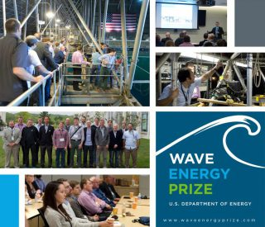
(Image: Wave Energy Prize)
Finalists and alternative teams competing for the Wave Energy Prize have been showcased during the Waterpower Week 2016 that took place last month in Washington DC.
The week’s events kicked off during the National Hydropower Association Annual Conference’s opening plenary session on Monday, April 25 when José Zayas, Director of the US Department of Energy’s Wind and Water Power Technologies Office, highlighted the work of the teams to the more than 700 conference attendees.
The teams had their 1:50 scale WEC models on display during April 25-26, and have also attended a Wave Energy Prize Team Summit, as part of Waterpower Week, where they were able to meet each other and share ideas, and learn about the requirements of upcoming Technology Gates 3 and 4.
The teams then traveled to the MASK Basin at Carderock, Maryland, on April 27 to better understand the logistical and technical requirements related to 1:20 scale testing, and to tour the world-class facility where they will test their prototype devices beginning in August.
The Wave Energy Prize team has informed it’s well on its way to being fully prepared to welcome the first finalist team arriving at Carderock for testing.
Data analysts are working with each finalist and alternate team to develop comprehensive test and evaluation plans tailored for each team’s device, which include how the devices will be rigged, derigged, moored, tested, and evaluated.
Also, Wave Energy Prize Team said it successfully ran all of the 1:20 scale waves in the MASK Basin, the waves that the finalists’ devices will be exposed to during testing this summer.

Clean Technica
Waves & Tides Star As DOE Rekindles Marine Hydrokinetic Energy Program, Targeting Commercialization
May 20, 2016; By Glenn Myers
We are happy to report waves and tides have returned to the US renewable energy research and development boards by targeting hydrokinetic energy development.
Though the marketplace has steered away from wave, tidal, and current energies, UtilityDIVE reports the Department of Energy has renewed its effort to develop a viable commercial market for this abundant source of renewable energy.
According to the National Hydropower Association, the energy landscape is potentially huge:
“Wave and tidal power technologies represent a huge opportunity to create reliable, clean energy. While these technologies are currently in various stages of research, development and deployment, industry estimates have pegged US wave potential at 90 GW. In Florida alone, an estimated 4 to 10 GW of potential is thought possible, according to a University of Florida study.”
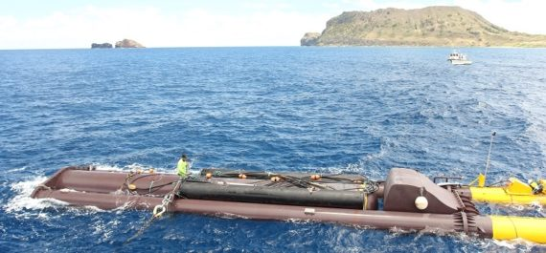

DOE Water Power Program
By accelerating the development of markets for hydropower and marine and hydrokinetic (MHK) projects, the Water Power Program states it targets the development of the next generation of water power tools and technologies, while jump-starting the private sector innovation critical to the country’s long-term economic growth, energy security, and international competitiveness.
The challenge? Developing technological and market-driven solutions which are deemed fundamental in lowering deployment barriers using the nation’s abundant water resources.
“The Water Power Program’s marine and hydrokinetic research and development efforts focus on advancing technologies that capture energy from the nation’s oceans and rivers. Unlike hydropower, marine and hydrokinetics represent an emerging industry with hundreds of potentially viable technologies. The program is therefore leading efforts to prove functionality; evaluate technical and economic viability; and generate cost, performance, and reliability data for a variety of devices.
“Marine and hydrokinetic energy technologies convert the energy of waves, tides, and river and ocean currents into electricity. The Department of Energy’s “Marine and Hydrokinetic 101” video explains how these technologies work and highlights some of the Water Power Program’s efforts in R&D in this area.”
These marine hydrokinetic (MHK) energies could potentially provide power for more than half of the U.S. population that lives along the coast, but they have one big barrier: No one’s come close to developing a cost-effective model for MHK deployment in the US.

Proving hydrokinetic’s business viability
“Utilities and major investors were brought in on this technology some years ago with big promises from vendors but the vendors did not deliver,” said Stewart Bible, team leader at Harvest Wave Energy, an MHK startup. “The utilities and investors remain snake-bitten.”
From 2008 to 2015, DOE programs awarded an estimated $136 million for 92 MHK energy projects, according to the Department’s recent project update. Unfortunately, there are no US commercial installations and few pilots with real promise.
Mr. Bible’s company is one of nine finalists in the DOE’s Wave Energy Prize competition. The goal of this competition is to identify companies which can design, build, and test MHK technologies which can be scaled up for commercial deployment. A $1.5 million first prize will be awarded to the winning technology.

Immense potential
“If only 5% of the potential is recovered, millions of homes could be powered by wave energy,” DOE’s spokesperson pointed out. A TWh of electricity is considered enough to power about 92,000 homes.
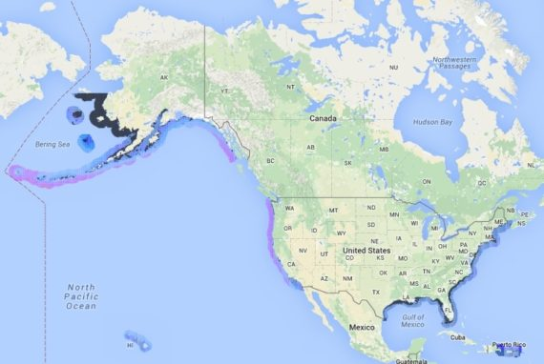
DOE resource assessments for wave energy along U.S. coastlines
“There is an additional technically recoverable 222 TWh/year to 334 TWh/year from U.S tidal energy sites and 45 TWh/year to 163 TWh/year in ocean current sites along both the Atlantic and Pacific coasts, according to a DOE study. The Mississippi River contains almost half the potential U.S. river current energy of up to 120 TWh/year. There is also an estimated 576 TWh/year of recoverable ocean thermal energy in U.S. waters.”
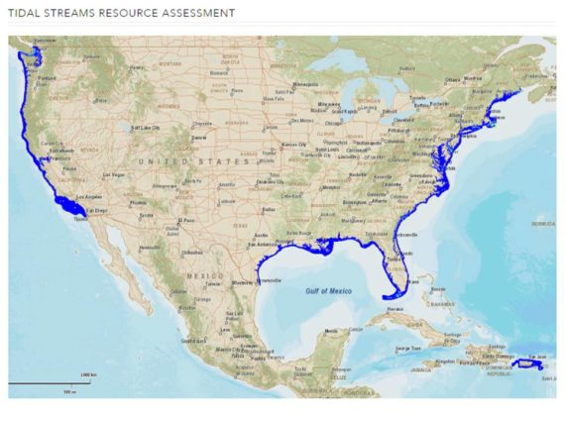
DOE assessment for tidal energy along U.S. coastlines
Global MHK energy installed capacity at the end of 2014 totaled approximately 530 MW, mostly from tidal energy installations, according to REN 21’s Renewables 2015 Global Status Report.
To date, the US has funded projects in 24 states, with over 30% of that going to Maine, Oregon, and Hawaii. But over 85% of the funding for the 92 projects DOE has supported has gone to Technology Development and Market Acceleration. Projects aimed at Deployment received only 11% of the funding.
Congress and the White House have been supportive of funding requests for MHK energy research, development, and demonstration, DOE’s spokesperson said. Provisions in the Obama administration 2017 budget, and in Senate and House energy bills, are now working their way through the legislative process.
The 20 states that count MHK energy toward their renewables mandates are important, DOE’s spokesperson said. There is also a $0.01/kWh federal Production Tax Credit for projects of at least 150 kW in nameplate capacity and a 10% Business Energy Investment Tax Credit for tidal energy projects. Some states, including Alaska and Oregon, offer added incentives.
According to the DOE, its “Water Power Program is committed to developing and deploying a portfolio of innovative technologies for clean, domestic power generation from resources such as hydropower, waves, and tides.”
We wish this rekindled waves and tides program a bright future.
Read the UtilityDIVE report on the Wave Prize finalists.
Image via DOE
Maps via DOE MHK energy resource assessment

Tidal Energy Today
SEWEC starts WEC assembly process
May 23, 2016
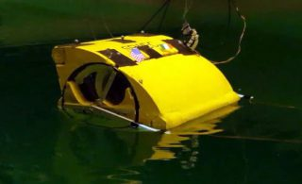
1:50 scale SEWEC device (Photo: Wave Energy Prize)
SEWEC, one of the finalist teams of Wave Energy Prize challenge, has started the assembly process of its 1:20 scale wave energy device.
SEWEC team is developing an oscillating water column (OWC) type of wave energy converter.
An oscillating water column is a partially submerged, hollow structure. It is open to the sea below the water line, enclosing a column of air on top of a column of water.
Waves cause the water column to rise and fall, trapping the air, which flows to and from the atmosphere via a turbine. The rotation of the turbine is used to generate electricity.
The SEWEC wave energy converter is a free-floating and specially adapted to withstand the more challenging offshore, deep water environment where available energy levels are higher and more widespread than those available nearshore, according to the SEWEC team.
The SEWEC device extends the proven OWC concept, enabling devices to be moored offshore in a much wider range of locations than conventional shore-based devices.
Unlike shore-based OWC’s, only minimal site work is required to set up a SEWEC wave energy farm by simply towing out devices to their moorings, SEWEC team states.
The team has finished the construction of the 1:20 scale model, and started the assembly process of the device.
In parallel to the assembly, the team is configuring the device to maximize energy capture from particular sea states.
The testing of the finalist teams’ 1:20 scale devices for the Wave Energy Prize challenge will be conducted at MASK basin in Carderock starting from August.
The team that ranks the highest after testing the 1:20 scaled WEC device model will be awarded $1.5 million.
The second team will win an award in the amount of $500,000, and the third-placed team will be awarded $250,000. The winners are expected to be announced in November.
Take a look at the video showing the SEWEC wave energy device being tested at 1:50 scale at the University of Michigan’s Wave Test Tank in December 2015.

Renewable Energy World
Award-winning Wave Energy
By Alison LaBonte; June 1, 2016

The Wave Energy Prize was announced in 2015 during the keynote address at the National Hydropower Association conference, International Marine Renewable Energy Conference, and Marine Energy Technology Symposium. This announcement represented a milestone for the U.S. Department of Energy's (DOE) Wind and Water Power Technologies Office - the commencement of its first public prize challenge, with a total purse of US $2.25 million, stemmed from realizing that a technology leap in the efficiency of wave energy converters (WEC) was needed to jolt wave energy toward sweeping cost reductions. This pathway could ultimately make wave energy, still in early stages of development, competitive with more traditional forms of energy, paving the way to large-scale implementation within a generation.

Fast-forward a year - 92 teams registered for the Wave Energy Prize, with 66 of these submitting technical data for review by the judging panel. In August 2015, 20 teams were qualified and began developing 1/50th scale models of their WEC devices. Between then and January 2016, they submitted revisions, numerical modeling results, model design and construction plans, and results from their 1/50th scale model tank testing in order to move to the next round of evaluation.

On March 1, DOE announced nine finalists and two alternates. Each finalist will now receive up to $125,000 of seed funding from DOE, with alternates receiving up to $25,000 to develop 1/20th scale models of their WEC technologies. These models will be tested at the Naval Surface Warfare Center's Maneuvering and Seakeeping (MASK) Basin at Carderock, Md., beginning this summer.

ACE - a benefit-to-cost ratio - was selected as a metric appropriate for comparing low technology readiness level WEC concepts when there is not enough data to calculate the levelized cost of energy from a device. ACE is determined by dividing, in essence, the wave energy extraction of a WEC by its structural cost. Finalists were determined based on their potential to double the current state-of-the-art ACE value of 1.5 meters per million dollars (m/$M) to 3 m/$M during 1/20th scale tank testing at the MASK Basin, making them eligible to win the grand prize of $1.5 million.

esting is to begin in August and run through mid-October, with the prize winner(s) announced in November. For information about the teams, click here

This article was previously published in the April issue of Hydro Review magazine.

Alison LaBonte, PhD, is the marine and hydrokinetic technology program manager for the U.S. Department of Energy's Wind and Water Power Technologies Office.

The Energy Times
West Coast Ocean Power Surge
June 3, 2016; By Jason R. Busch

Driving down costs of potential limitless ocean energy
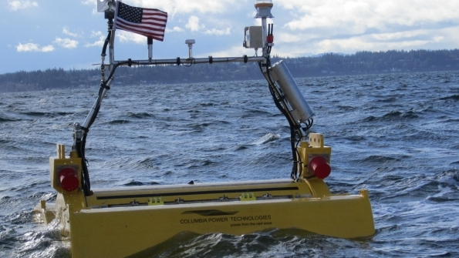
OWEC
EDITOR's NOTE: The last of a series. Last week:Ocean Electricity
Several wave energy technologies are approaching the need for a full-scale demonstration project in a fully energetic test environment. Four companies have deployed at the Hawaiian WETS location, or will over the next two years. That site is an excellent location to deploy, test, and build familiarity with the operations of the various technologies.
However, those companies will need to move their devices to a fully energetic testing and demonstration site in the future, in order to demonstrate the commercial viability of their respective technologies. That’s why the U.S. Department of Energy’s financial support for a test site is so important. Without such a facility, U.S. based companies will have to take their technologies overseas for that final push to commercialization, robbing the U.S. of the benefits of its investment.
Commercial opportunities for wave energy are currently limited to niche markets like Hawaii and Alaska, where the cost of power is highest in the nation. While the above market price of MHK technologies may seem prohibitive, every effort must be made to ensure that the early projects get financed.
The efficiency curve does not kick in until projects are happening and the costs start to decline. Hence the importance of state and federal policies that incentivize these early projects such California and Oregon’s recent adoption of a 50 percent renewable portfolio standard. These nationally leading RPSs will drive the market to bring on more renewables, and as the cost of power from wave energy declines over time, projects on the west coast become more viable.
Several companies are tracking toward commercial viability:
Columbia Power Technologies – The StingRAY represents the culmination of over 10 years of academic and corporate development. The system is based on a design philosophy that values simplicity, high efficiency and durability. Columbia Power’s product development effort emphasizes stepped-scale testing. In the past three years, their third-generation system has been modeled over thousands of hours, tank-tested prototypes four times and successfully completed thirteen-month sea trials of an intermediate-scale prototype. In 2018, Columbia Power plans to deploy a full-scale device at the Navy’s Wave Energy Test Site in Hawaii.
Resolute Marine Energy – Resolute Marine Energy is focused on developing a near-shore, bottom-mounted hinged flap design. As a near-shore, shallow water WEC technology, a much lower proportion of total project costs need to be spent on the transmission system (pipes and cables) that carries energy from the device to shore. Resolute’s technology can also be used to create clean drinking water from seawater. Resolute Marine plans to deploy a demonstration project in 2017 at Oregon’s Camp Rilea.
M3 Wave – M3 Wave’s device is a submerged, stationary wave energy device that converts wave pressure into electricity. Resting completely underwater and out of site, this class of technology reduces impacts on viewsheds. M3 successfully completed a month long sea trial of the technology in 2013 at Camp Rilea. The company is also a finalist in the DOE’s Wave Energy Prize Competition, where they are working on a version of the technology suited for deeper water.
Northwest Energy Innovations – NWEI’s Azura technology is a multi-mode, point absorber wave energy converter that extracts power from both the heave and surge motions of waves to maximize energy capture. The system produces power as a result of the relative rotational motion between the hull and float. The power takeoff system is based on high pressure hydraulics and is located within the Powerpod. The Azura device was tested in Oregon in 2012 and is currently undergoing testing at the Navy’s Wave Energy Test Site in Hawaii. NWEI has been awarded an additional $5 million to deploy their next generation, full scale technology at WETS in 2018.
Cal Wave – The WaveCarpet is a novel wave energy converter that is simple and scalable. The unique converter design uses a synthetic-seabed-carpet that has the ability to extract wave energy from waves passing along the surface, an approach inspired by the ability of a muddy seafloor to effectively absorb overpassing ocean waves. The WaveCarpet operates below the surface, allowing it to survive stormy seas while causing no visual pollution or posing any collision dangers.
Ocean Energy USA – Ocean Energy’s cornerstone product is the OE Buoy. The OE Buoy is a wave power generation platform designed around the oscillating water column principle. The result of over 10 years of research and development, the OE Buoy has only a single moving part and has just completed over 3 years of rigorous testing in Atlantic waters. The Ocean Energy is scheduled to begin testing at the Navy’s Wave Energy Test Site in 2017.
Fred Olsen – Fred Olson’s Lifesaver technology is an advanced electro‐mechanical point absorber WEC platform that uses point absorber hull and power take‐off configurations to harness and convert the energy of the nearshore to electricity. The technology is currently deployed at the Navy’s Wave Energy Test Site in Hawaii.
Jason R. Busch is executive director of the Oregon Wave Energy Trust.

Tidal Energy Today
Wave Energy Prize recap ahead of TG3 review
June 17, 2016

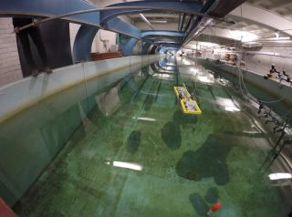zoomIllustration/WECCA WEC (Photo: Wave Energy Prize)
Wave Energy Prize challenge teams, numbering 9 finalists and 2 alternative teams, are currently finalizing their 1:20 scale prototypes that will be tested the US Navy’s MASK Basin from August through early October.
So far, the qualified teams built and tested their 1:50 scale wave energy device models at university facilities across USA, and conducted significant numerical modeling studies to meet the requirements for the second technology gate (TG) review.
The nine finalist and two alternate teams have introduced various wave energy converter (WEC) designs, including two submerged areal absorbers, four point absorbers, two attenuators, and three terminators.
Wave Energy Prize team states a number of technical innovations in the areas of geometry, materials, power conversion and controls has been presented in the WEC designs, including:
- adaptive sea state-to-sea state control,
- wave-to-wave control,
- power absorption in multiple degrees of freedom,
- optimized float shapes and dimensions for energy absorption for broad bandwidth of wave frequencies,
- survival strategies such as submerging beneath the surface for extreme storms,
- use of structures and materials that are cost effective to manufacture, and
- flexible membranes that react to the wave pressure over a broad area.
For the TG3 review that will verify the level of build progress and test readiness of the identified finalist teams and alternates, and determine the finalist teams that will participate in the 1:20 scale testing , the teams were required to submit the relevant documentation by June 15.
The finalists who pass the TG3 review, securing the chance to test their devices at 1:20 scale at US Navy’s MASK Basin in Carderock, will be announced no later than July 1.
The team that ranks the highest after testing the 1:20 scaled WEC device model will be awarded $1.5 million. The second team will win an award in the amount of $500,000, and the third-placed tam will be awarded $250,000.
The winners(s) of the Wave Energy Prize challenge will be announced on November 13, 2016.

Tidal Energy Today
Video: Harvest Wave Energy scale WEC testing
June 20, 2016
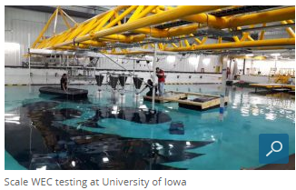
One of the finalist teams competing for the Wave Energy Prize, Harvest Wave Energy, has performed preliminary wave tank testing of its 1:20 scale wave energy device.
Harvest Wave Energy team, previously known as Team Flapper, is developing a combined oscillating wave surge converter (OSWC) and heaving device wave energy system.
The design of the WEC the team is developing is expected to introduce a number of innovative, patent-pending technologies that will enable the economic capture of deep water wave power for the first time, according to Harvest Wave Energy.
Operating at depths up to 100 meters, the device is expected to be rated at approximately 5 MW, Harvest Wave Energy informed.
Although the information about the internal mechanisms of the device has not been revealed due to intellectual property concerns, general operation is characterized by a conversion of the kinetic energy from wave swells into electrical energy through a power conversion chain that includes a hydraulic power take off, hydraulic motor and electrical alternator.
In preparation for Wave Energy Prize final round of model testing, which will be carried out from August to October at US Navy’s MASK Basin, the team has conducted a series of 1:20 scale model tests at the University of Iowa in order to make final adjustments to its wave energy device.
As reported earlier, all finalist and alternative teams were required to submit the relevant documentation about the progress and test readiness of their 1:20 scale devices for the third technology gate review (TG3) by June 15.
The results of the review are expected to be announced no later than July 1, and the teams who pass the TG3 will get a chance to test their devices at MASK Basin in Carderock, Maryland.

University of California News

From the test tank to the open ocean: Wave energy’s make-or-break moment

By Brian Back, UC Newsroom, June 20, 2016

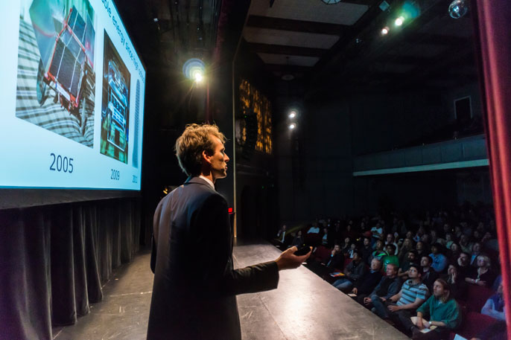
Credit: Lawrence Berkeley National Laboratory
Marcus Lehmann presents the Wave Carpet at Berkeley Lab's June 1 Pitchfest in San Francisco.
The waves that crash along the Pacific coast are so powerful they produce enough energy to light up 50 million homes. It’s a virtual tsunami of endless, clean energy – but only if the right idea comes along for how to capture it.
Today, wave energy is on par with wind energy decades ago: All sorts of technologies are being tested, but none has emerged as an optimal solution that could sweep the globe.
Yet as populations swell among coastal cities, the potential remains huge. Waves create energy day and night: on a sunny day or during a dark storm, whether it’s breezy or calm.
The Department of Energy is so bullish on wave energy it’s doling out more than $2.5 million in prize money to researchers with the most promising new technology.
Among those who could come out on top is the CalWave team led by Marcus Lehmann, a visiting student-researcher at Lawrence Berkeley National Laboratory, who is working to take a unique “wave carpet” technology out of the test tank and into the open ocean.
Based on the technology, Lehmann has launched CalWave Power Technologies, a startup that offers a relatively safe and economically competitive approach to harnessing wave energy from muddy seabeds below the ocean’s surface. Lehmann has a lot riding on the next six months, a period of time in which he will complete his doctorate, graduate CalWave from Berkeley Lab’s inaugural Cyclotron Road incubation platform, and learn if the Wave Carpet will win the DOE’s Wave Energy Prize.

"Magic carpet"
The Wave Carpet – which looks much like its name suggests – was developed by Reza Alam, a UC Berkeley assistant professor of mechanical engineering who in previous research identified the incredible amount of energy that can be extracted from muddy seabeds, the pockets of the shoreline that fishing boats often retreat to during storms. It’s these less choppy waters that absorb more energy underneath the surface.

Lehmann first learned about Alam’s research in an MIT Technology Review article he read shortly after beginning a master’s program at Technical University of Munich in his native Germany. In 2012, he arrived in Berkeley and joined Alam’s Theoretical and Applied Fluid Dynamics Laboratory.
Although handed a different assignment, Lehmann gravitated to the wave business. Over the holiday break, Lehmann and fellow researchers built an impromptu Wave Carpet prototype out of scrap materials, including bike tires, a pump and pingpong balls. Eventually, with Alam’s support, he built his masters degree around its proof-of-concept.
One 30-by-30-foot shallow water modular unit, which Lehmann says could power 180 San Francisco homes, features an elastic composite “magic carpet” stretched across a grid of cylinders and double-action piston pumps.
Placed below the water’s surface near the seafloor, the carpet adopts the wave motion of the ocean, moving the attached pumps to produce hydraulic pressure that is then piped onshore and converted into power.
Unlike other technologies that often rely on turbines or gadgets at the ocean’s surface to gain higher efficiencies, the Wave Carpet has less interference with shipping lines, fishing operations and marine wildlife, Alam says.
“There are more than 1,000 patents on different ideas to harness energy from oceanic waves, and believe it or not they are all different,” he says. “And believe it or not, they all work.”
What sets the Wave Carpet carpet apart is its “survivability,” a common problem among emerging wave energy companies.
Built with corrosion-resistant materials, the Wave Carpet is submerged and thus unseen, sheltered from collision dangers and violent storm conditions scientists expect will intensify with the continued onset of global warming.

Lab to market
The Wave Carpet – which has been featured in National Geographic, Fast Company, Reuters, and other media outlets – is among the first technologies incubated by Berkeley Lab’s Cyclotron Road program, which supports new energy breakthroughs by bridging the arduous science-to-product gap.
Cyclotron Road founder and director Ilan Gur, whose track record includes the launch of two former clean-tech startups built on UC intellectual property, describes the program as less of a traditional incubator and more of an “entrepreneurial postdoc.”
Researchers accepted into the increasingly competitive two-year program receive a $500,000 seed investment, access to Berkeley Lab’s world-class facilities, mentorship, and help with proposal writing, project management, partnerships and strategy.
“Cyclotron Road helped us to build an ecosystem, know what conferences to attend, advisors to seek out – it really focused our efforts,” Lehmann says. “This is critical because time is limited and we are a small team.”
UC filed a utility patent for the Wave Carpet in 2015, and Alam’s student researcher team secured a permit with UC San Diego to conduct an ocean demo project. But then, Lehmann says, “the prize came up.”

Eyes on the prize
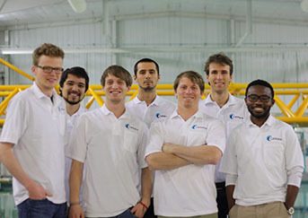
The CalWave student research team
Credit: UC Berkeley
As an opportunity to prove the Wave Carpet’s prowess among its peers, DOE’s Wave Energy Prize was too good to pass up.
The two-year competition began in 2015 with 92 teams. CalWave was still standing after judges whittled the initial field down to 20 finalists. Tasked with designing and building 1/50-scale prototypes for testing, the teams were then slashed to nine.
CalWave earned the highest score of the remaining finalists, and it especially stood out in the category of economic viability, which focused on the costs of mass production.
That’s critical, Lehmann says.
“What energy utilities are looking at before they even talk to you is, ‘What are your generation costs?’” he says. “A lot of Ph.D. students focus for years on performance, and in the end they have the Formula 1 car. But nobody can afford it.”
Alam asserts the science behind wave energy is very complicated.
The nine Wave Prize finalists received $125,000 to develop 1/20-scale models to test this summer at the nation’s most advanced wave-making facility, the football field-sized Naval Surface Warfare Center’s Maneuvering and Seakeeping Basin in Maryland. In June, Lehmann and his team deployed to a tank facility in Maine to begin preparations.
Come autumn, Wave Prize winners will be announced, with first place raking in $1.5 million, second place securing $500,000, and third place taking $250,000.
Lehmann says the cash prizes are key to continuing CalWave’s operations. At about the same time winners are revealed, CalWave’s seed investment from Cyclotron Road will be drying up.
But, quoting author Steven Pressfield, Lehmann says: “The artist doesn’t wait for inspiration, he acts in the anticipation of its apparition.”

Tidal Energy Today
Waveswing America makes waves in Iowa
June 23, 2016
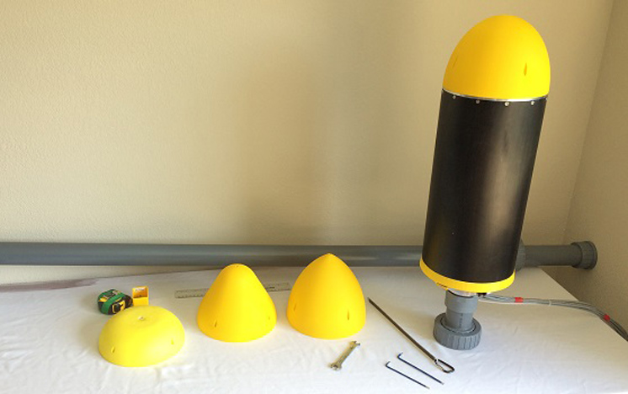Complete 1:20 scale Waveswing model with a selection of nose-cone options (Photo: Wave Energy Prize)
Waveswing America has started the wave tank testing of its 1:20 scale wave energy device at the University of Iowa.
One of the finalist teams competing in the Wave Energy Prize challenge, Waveswing America has completed the construction of its 1:20 scale subsea pressure-differential point-absorber wave energy device.
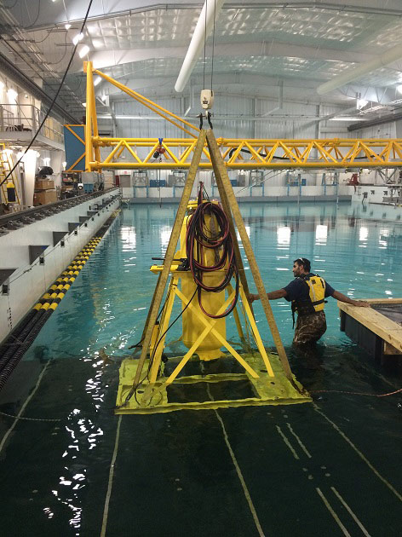
Anchor frame being lowered into the tank at Iowa University (Photo: Wave Energy Prize)

The Waveswing America team has also informed they have started the pre-testing of the device at the wave tank at the University of Iowa, ahead of the final testing at the Naval Surface Warfare Center’s Maneuvering and Seakeeping (MASK) wave-making facility at Carderock, Maryland, set to take place this summer.
“This will allow us to tune the control system and iron out any problems with the device before finally packing up for shipping to Carderock,” Waveswing America team said. “Our direct-drive PTO unit is working better than expected with excellent force and velocity control response which allows us to implement the most advanced control strategies available.”
The technology the team is developing takes a highly efficient point-absorber concept and combines it with efficient linear generator technology and advanced control algorithms to maximise yield, with the potential ratings of 500 kW and above, according to Waveswing America.

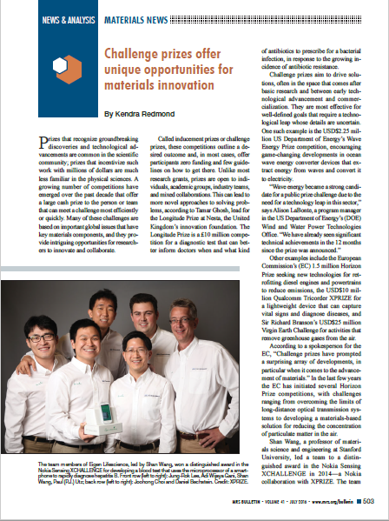
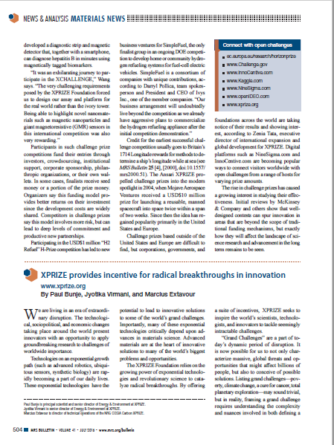

Tidal Energy Today
Finalists move ahead in Wave Energy Prize
July 4, 2016

zoomMASK basin at Carderock (Photo: EERE)
All nine finalist teams have passed the third technology gate review (TG3) as part of the Wave Energy Prize challenge, securing the chance to test their wave energy devices at 1:20 scale at US Navy’s MASK Basin in Maryland.
The TG3 review verified the level of build progress and test readiness of the identified finalist teams and alternates.
All finalist teams, announced on March 1, have passed the review and will proceed to test their 1:20 scale wave energy converter prototypes at the Navy’s Maneuvering and Seakeeping (MASK) Basin beginning next month, the Wave Energy Prize administration informed.
Two alternate teams, including WECCA and Mocean Energy, who continued work on their technologies since March, will not get the chance to test their scale devices at MASK Basin in this challenge.
The finalist teams are finalist teams are AquaHarmonics, CalWave, M3 Wave, Oscilla Power, RTI Wave Power, Sea Potential, SEWEC, Harvest Wave Energy and Waveswing America.
The team that ranks the highest after testing the 1:20 scaled WEC device model will be awarded $1.5 million. The second team will win an award in the amount of $500,000, and the third-placed tam will be awarded $250,000.
The winners(s) of the Wave Energy Prize challenge will be announced on November 13, 2016.

Portland Business Journal

Portland startup's wave invention lands on national stage

July 21, 2016; By Pete Danko

AquaHarmonics among 9 companies nationally — and two from Portland — in finals of U.S. Department of Energy's Wave Energy Prize competition
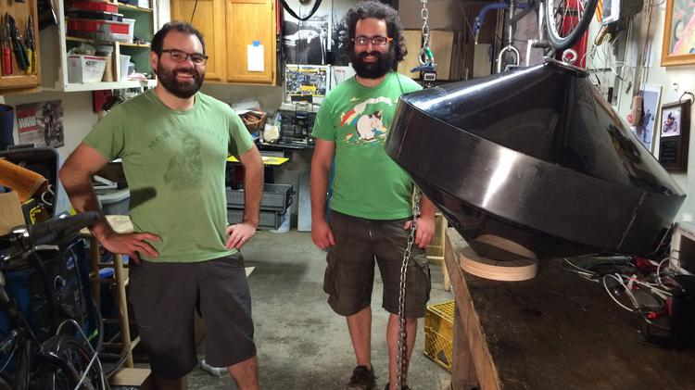Enlarge
The AquaHarmonics team — Alex Hagmuller, left, and Max Ginsburg — stand with the… (rest of content is subscriber only)
Tidal Energy Today
Triton WEC heads to Carderock
July 22, 2016
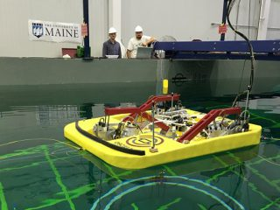
Triton WEC under tests at UMaine (Photo: Oscilla Power)
Oscilla Power has shipped its Triton wave energy converter to MASK wave-making facility at Carderock, Maryland, following the conclusion of pre-testing activities.
Oscilla Power completed the pre-testing of its 1:20 scale Triton WEC at the University of Maine (UMaine) Harold Alfond W2 Ocean Engineering Lab.
The team competing for the Wave Energy Prize is developing a two-body multi-mode point absorber consisting of a catenary moored surface float and a suspended asymmetric heave plate.
“Testing of the 1:20 scale Triton WEC went smoothly and power results showed good agreement with our numerical model predictions. Design improvements implemented between the 1:50 and 1:20 rounds of the competition proved fruitful in significantly boosting WEC’s wideband power capture,”the team informed.
Triton WEC is now heading to the Naval Surface Warfare Center’s Maneuvering and Seakeeping (MASK) wave-making facility where it will be tested in September.
Triton works when ocean waves excite the surface float, and cause it to react against the heave plate, generating tension changes in the tethers that are applied to the linear drivetrain that converts the mechanical motion into electricity.
Oscilla Power is amongst 8 finalist teams competing in the Wave Energy Prize challenge, launched by the US Department of Energy, to accelerate the development of wave energy technologies.
Take a look at the video of 1:20 scale Triton testing at UMaine Harold Alfond W2 Ocean Engineering Lab.

Solar Thermal Magazine
Wave Energy Prize Team Updates
July 25, 2016

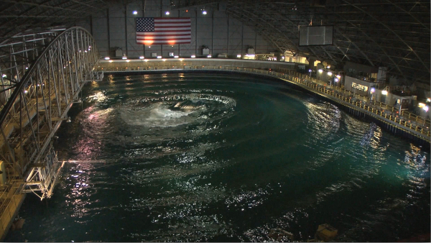
The Wave Energy Prize is a public prize challenge sponsored by the U.S. Department of Energy (DOE)‘s Water Power Program. The prize is designed to increase the diversity of organizations involved in Wave Energy Converter (WEC) technology development, while motivating and inspiring existing stakeholders. DOE envisions this competition will achieve game-changing performance enhancements to WEC devices, establishing a pathway to sweeping cost reductions on a commercial scale.
The Wave Energy Prize has passed through the third of four Technology Gates, and the official 9 Finalist Teams are now preparing for Technology Gate 4 which will begin in August.
Here are the updates from some of the teams:
Sea Potential
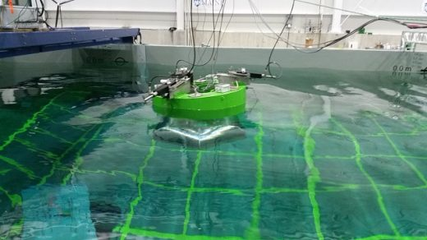
We were setup and ready for some wet-testing in University of Maine’s new W² Wind-Wave Basin we got confirmation thatwe were going to Carderock.
It has been a great effort to date from all involved with the Sea Potential team and we’ll be doing everything we can to bring the prize back to the “Ocean State”.
We had heard about the impressive facilities in UMaine’s Orono campus from the teams that did their 50th scale tests at the W² Wind-Wave Basin and were looking forward to getting the DUO launched into action.
Oscilla Power
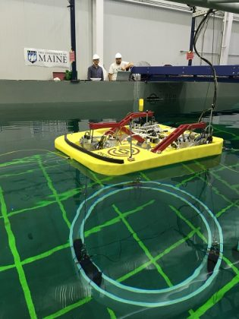
Oscilla Power has just returned from a productive week of tank testing at University of Maine’s W2 basin. Testing of the 1:20 scale Triton WEC went smoothly and power results showed good agreement with our numerical model predictions. Design improvements implemented between the 1:50 and 1:20 rounds of the competition proved fruitful in significantly boosting WEC’s wideband power capture.
With a big thank you to the staff at the University of Maine, the 1:20 Triton model is now en route to the MASK basin, and we look forward to official testing in September.
Harvest Wave Energy
The Wave Energy Prize final round build has been such an exciting challenge that it is bittersweet to say goodbye for a little while to our 1:20th prototype. Next stop, the Naval Surface Warfare Center, Carderock Division. It is going to be a long month waiting for our chance to test.
We can’t end without a big thank you to our corporate partner, Resolved Analytics, for all of the excellent CFD modeling support they have provided that has helped us optimize our WEC power capture.
M3 Wave
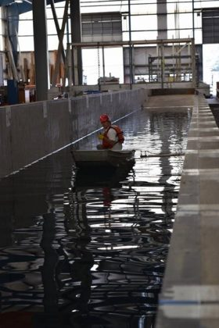
In June we did a “wet run” in the wave tank at Hinsdale at Oregon State University.
We tested punt deployment, rigging to morring system, remote descent to operational depth, mooring dynamics, and line tending/device management under crane.
We also ran waves and collected power data.
Finally, for fun, we ran bigger waves at a shallower-than-normal operating depth just to stress test the system. After a successful week in the tank, we packed up.

AquaHarmonics
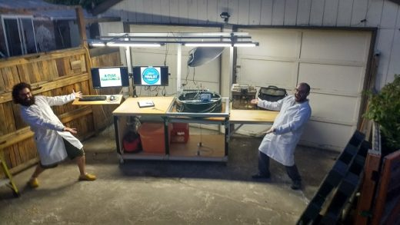
Team AquaHarmonics is nearly across the finish line! Since our testing at Oregon State University, we have made some updates to the device and controls software and built a mobile work bench that will serve as our base of operations during testing at Carderock.
We were able to get some volunteer help from my brother in law with the work bench and packing to help get everything complete prior to shipping-thanks Reuben! Our container is packed with our device, spares, tools and our mobile workbench/control center awaiting to be picked up.
We are very excited to start testing at Carderock, and are also looking forward to a small break before final testing!
SEWEC
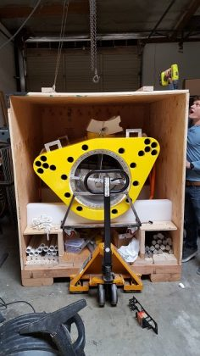
The last month has seen a flurry of activity. On June 19th we finished the 1/20th scale model and loaded it into the crate (Photo Patrick with crate) in California. Over the next 3 days it was driven non-stop across the USA to Maine whereupon Nick G, Nick W and Sean prepped it for operation (see photo Sean and Nick with wires) in the new wave tank at the University of Maine Advanced Structures and Composites Center in Orono. Sewec 1/20 was splashed on June 28th and floated to her marks! We then spent five days putting her through her paces – and everything worked – thanks to Byron and Nick G. We even ran the configuration to skip every second wave – reported as a simulation curiosity in an earlier team update – see the video https://youtu.be/hRo8dCcDndc so bravo to Sewec’s numerical modelling crew. And a big thank you to Anthony Viselli, Matt Fowler and Matt Cameron who got us up and running and got a ton of data for us at U of M.
Then back into the crate (see photo Tom with crate 2) minus PTO valve and orifice plates which we finally calibrated the following week at San Jose State University, in an upgraded rig. Back on the plane to Bangor the following Monday with the valve and orifices, get Sewec out of the crate and run a vacuum test at the U of M. The Advanced Structures and Composites Center routinely vacuum bag their composites and they kindly deployed their equipment and considerable expertise to evacuate and catch every last air leak on Sewec. The photo (Chris with vacuum) shows Chris Urquhart, vacuum maestro at U of M listening for leaks and photo (0.28 psia) shows the steady state value we ultimately reached of 0.28 psia. We need 1/20th of an atmosphere absolute (0.75 psia) in the Carderock test to account for scaling of the OWC air volume, so we should be ok. As far as we know, this will be the first time this technique has been used to increase scale model air elasticity so we really wanted to be sure we could pump 95% of the air out of Sewec, without leaks or structural collapse. Our fabricator Tom Johansing ran a stress analysis in May and said then “You’re good”. Thanks to Tom we are good to go.
Our team is the last to test at Carderock and this thought cheered me a lot as I loaded Sewec back in the crate Friday evening. Team Sewec “has a wrap” and is looking forward to an extended summer break.
RTI Wave Power
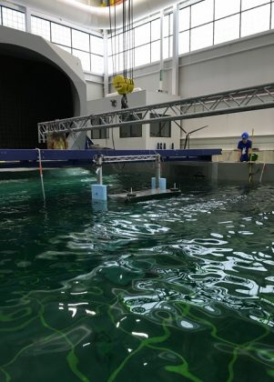
June was the first month in the water for our RTI F2 QD. Our “first splash” and “first waves” were in the UNH Chase Labs deep tank and wave tank, respectively (RTI Teammates Toby Dewhurst and Sean Lewis in lower left, setting up for “first waves”). All key components arrived in time for a final assembly by mid-June. A special thanks to team sponsors Sensata-BEI (providing marine grade high resolution encoders), Interface (submersible Load Cells) and UNH Chase Labs (wave tank access).
A successful series of shakedown and preliminary performance tests were conducted in late June at the U. of Maine, Alfond W2 Wind-Wave Facility in Orono Maine (photo lower right). This new world class wave tank facility with its 5 meter depth and Edinburgh Engineering wave makers allowed us to more closely simulate the ONR Carderock Mask basin Wave Energy Prize test conditions. Apparently many of the 9 Finalists also discovered this facility with others testing before and after us. This was the first time our electrical and control system (developed by our Marquette U. E&C group of Drew Maatman and Ramin Katebi under Dr. Nathan Weise plus Diane Liskey) was merged with our RTI F2 QD hydrodynamic and mechanical hardware numerically modeled, designed and fabricated by our Maine/New Hampshire group of Sean Lewis, Toby Dewhurst, Dick Akers, Mike Macnicoll and yours truly, John Rohrer).
Convergence on the most cost effective ocean survivable Wave Energy Converter (WEC) configuration (a major objective of the Wave Energy Prize) is essential before the nascent WEC industry can effectively tap the huge global wave energy resource which has several times more energy density than the solar and wind energy which produces ocean waves. We continue to believe this WEC convergence is pointing towards surface deployed elongated wave terminator type WECs intercepting maximum wave front using minimum vessel volume (and cost). The patented RTI F2 QD is the only such WEC which floods and totally submerges its elongated surface float safely below the troughs of even 15 meter high waves for secure survival in seas which would destroy other surface WECs.
CalWave Power Technologies
After completion of our pretesting and the positive notification of advancing to Technology Gate 4, CalWave is finalizing its 1/20 scale prototype for shipment.
The results of the pretesting is used to further validate our numerical model and control strategy.
Our team is looking forward to the final testing at MASK.
Waveswing America
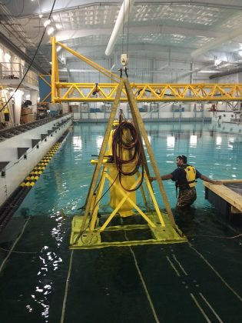
The Waveswing America team has been working hard to finish the build and testing of the 1:20 scale Waveswing with excellent results. Our direct-drive PTO unit is working better than expected with excellent force and velocity control response which allows us to implement the most advanced control strategies available. Combined with the low absorber mass giving excellent response and the low structural volume, we really feel that the Waveswing is the Ferrari of wave power!
We have now assembled the complete system at the University of Iowa wave tank and commence testing in earnest tomorrow. This will allow us to tune the control system and iron out any problems with the device before finally packing up for shipping to Carderock. It is really pleasing to see the efforts of so many different people all coming together to
produce such a great result.

Tidal Energy Today
Video: AquaHarmonics to test at Carderock end of August
July 28, 2016
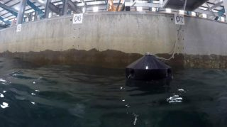
AquaHarmonics' WEC being tested at OSU
One of the finalist teams in the Wave Energy Prize challenge, AquaHarmonics, has completed its 1:20 scale WEC ahead of the final testing at the US Navy’s maneuvering and seakeeping basin (MASK) in Carderock scheduled for the last week of August.
The two-member AquaHarmonics team is developing a point absorber wave energy device.
It is comprised of power take-off (PTO) system system mounted in a cylinder shaped hull with a single mooring line that has a power cable at its core.
The team has conducted preliminary testing of their 1:20 scale device, which is using a phase control strategy developed by AquaHarmonics team to maximize energy capture from irregular waves, at the O.H. Hindsdale Wave Research Laboratory at Oregon State University in June this year.
“Since our testing at Oregon State University we have made some final modifications to the device, some updates to the control system software, acquired every possible spare and built a custom workbench/control center that will serve as our mobile base of operations while we are testing,” the team informed.
AquaHarmonics’ WEC only generates power on the rise of the wave, and during the fall of the wave the generators are operated as motors to reel in the mooring line for the next wave cycle.
The team is scheduled to undertake the final tests of their WEC at MASK Basin from August 29 until September 2, 2016 as part of the US Department of Energy-funded Wave Energy Prize challenge.
After all of the 9 finalist teams have tested their WECs at MASK Basin, the winner(s) will be announced on November 13, 2016.
Take a look at the video showing the 1:20 AquaHarmonics WEC testing at Oregon State University.

HydroWorld

DOE to fund test facility for U.S. waters as Wave Energy Prize competition continues

Aug. 2, 2016; By Gregory Poindexter

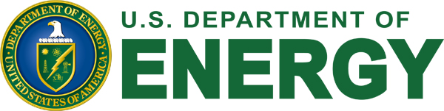
On July 21, the DOE’s Water Power Program announced it intends to issue a Funding Opportunity Announcement to construct a national wave energy test facility inside U.S. federal or state waters.
To support the full-scale testing of MHK wave energy devices, up to US$40 million in funding will be provided to fund development and construction activities for a grid-connected wave test facility capable of independently and simultaneously testing at least three wave energy devices, according to the DOE.
To learn more, prospective applicants are encouraged to review the full notice of intent posted eere-exchange.energy.gov.
Wave Energy Prize
In early July, the U.S. Department of Energy announced that the nine finalist teams for the Wave Energy Prize identified on March 1 will all proceed through Technology Gate 3 to test their 1/20th scale wave energy converter prototypes at the Navy’s Maneuvering and Seakeeping (MASK) Basin -- part of the Naval Surface Warfare Center (NSWC) in Carderock -- beginning in September.
Headquartered in West Bethesda, Md., NSWC Carderock employs approximately 3,600 scientists, engineers, technicians and support personnel.
Final testing is scheduled to begin during the first week of August. Each team’s device will be individually and rigorously tested at the MASK Basin over a one-week span. Teams are vying to win part of the $2.25 million Wave Energy Prize purse, and the winner(s) will be announced at the Wave Energy Prize Innovation Showcase in mid-November.

Oregon Best
M3 Wave to be First in the Water as Part of DOE Wave Prize Competition
Aug. 2, 2016
Oregon Team is one of 9 remaining finalists competing for a multimillion dollar prize purse.
Salem, Oregon (August 1, 2016). – Today M3 Wave LLC announced they will be the first competitor to test in the water as part of the U.S. Department of Energy’s Wave Energy Prize competition. The design-build-test competition is intended to encourage the development of innovative, game-changing wave energy conversion technology like M3’s. “This is the culmination of years of work and the team is excited to lead the way into the final phase of the competition,” said Mike Morrow, company president and CEO.
The M3 team is currently in Maryland at the Navy Surface Warfare Center, Carderock Division, preparing to deploy NEXUS, a deep-water, high power variant of their venerable DMP/APEX technology. NEXUS is designed with survivability in mind and has no exposed mechanical or electrical components, very similar to the APEX device that M3 deployed in the Pacific Ocean off Astoria, Oregon in the summer of 2014 with support from Oregon Wave Energy Trust. The simplicity of the technology ensures straightforward scale up from lab to prototype to pilot project.
According to company CTO Mike Delos-Reyes, "NEXUS allows us to take our existing APEX technology and deploy it in more areas around the globe at a lower cost of energy. This has the potential to be a game -changer for disaster resilience, islands, isolated communities, and military operations.”
M3 Wave’s Northwest team includes fabrication by Ershigs out of Ridgefield, Washington, wave tank pre-testing and power system characterization by Oregon State University, mooring dynamics by Glosten out of Seattle, and Deployment Ops by RPS Evans-Hamilton, also from Seattle.
About M3Wave, LLC. http://www.m3wave.com
Based in Salem, Oregon, M3Wave, LLC is a leader in the field of submerged pressure differential wave energy devices. Founded by "three guys named Mike," M3 is focused on commercializing a unique submerged wave energy conversion technology, called DMP, which was first pioneered by Mike Morrow and Mike Delos-Reyes at Oregon State University in 1991. DMP sits below the ocean surface safely away from storms, ships, and ocean views. Technology development has been accelerated by commercialization grants from Oregon Wave Energy Trust, Oregon BEST, and early seed funding from the U.S. Dept. of Energy, as well as private funding.

Tidal Energy Today
M3 Wave to Test NEXUS Next Week
Aug. 3, 2016
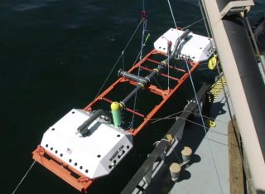
Illustration/M3 Wave's APEX device
M3 Wave team, a finalist in the Wave Energy Prize challenge, will be the first competitor to test its wave energy device at the MASK Basin in Carderock, Maryland.
M3 Wave’s entry into the Wave Energy Prize competition is NEXUS, a mid-column variant of their DMP/APEX submerged pressure differential technology.
NEXUS turns the pressure fluctuations under ocean waves into alternating expansion and compression cycles of air inside an enclosed pipe.
Power is harnessed with a bi-directional air turbine.
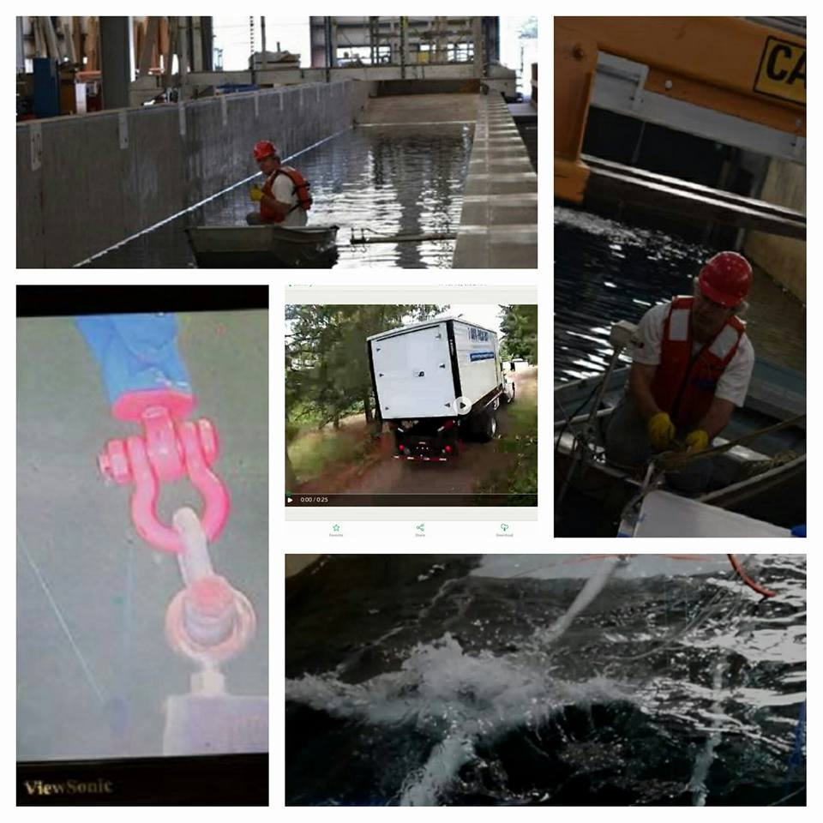
M3 Wave preparing for MASK testing (Image: Wave Energy Prize)
The M3 team is currently in Maryland at the Navy Surface Warfare Center, Carderock Division, preparing to deploy NEXUS which will be tested from August 8 to 12, 2016.
Mike Delos-Reyes, M3 Wave’s CEO, said: “NEXUS allows us to take our existing APEX technology and deploy it in more areas around the globe at a lower cost of energy. This has the potential to be a game -changer for disaster resilience, islands, isolated communities, and military operations.”
M3 Wave’s Northwest team includes fabrication by Ershigs out of Ridgefield, Washington, wave tank pre-testing and power system characterization by Oregon State University, mooring dynamics by Glosten out of Seattle, and Deployment Ops by RPS Evans-Hamilton, also from Seattle.

Tidal Energy Today
Video: Test tank for Wave Energy Prize finalists
Aug. 3, 2016
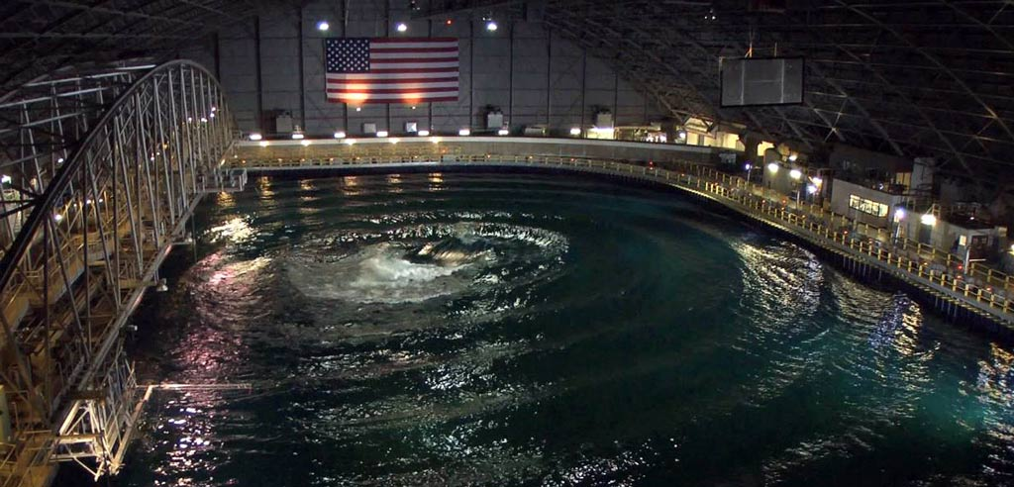MASK Basin at Carderock (Photo: Wave Energy Prize)
US Navy’s Maneuvering and Seakeeping (MASK) Basin at Naval Surface Warfare Center in Carderock, Maryland, will be a center of wave energy development activities this month as the finalists for the Wave Energy Prize challenge conduct final tests of their scaled wave energy devices.
The 360-foot long and 240-foot-wide facility holds approximately 12 million gallons of water and is used to evaluate the maneuverability, stability and control of scale models.
It’s one of the largest indoor oceans in the world, making the MASK one of the most advanced test facilities of its kind.
The first team testing its wave energy device at MASK Basin as part of the Wave Energy Challenge isM3 Wave with its NEXUS device, starting from August 8.
The testing will continue throughout August and September, with the final team, SEWEC, scheduled to test its wave energy device from October 3 to 7, 2016.
Take a look at the video released by US Department of Defense to learn more about the MASK Basin.

Tidal Energy Today
Video: M3 Wave tests wave energy device in MASK Basin
Aug. 16, 2016
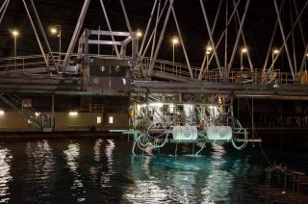
M3 Wave testing NEXUS at MASK Basin (Photo: Wave Energy Prize)
M3 Wave team has conducted the final testing of their wave energy device at MASK Basin in Carderock as part of the Wave Energy Prize challenge.
The Oregon-based company was the first wave energy developer to test its NEXUS device – a submerged mid-column pressure differential harvester WEC at MASK Basin.
NEXUS turns the pressure fluctuations under ocean waves into alternating expansion and compression cycles of air inside an enclosed pipe.
Power is harnessed with a bi-directional air turbine, according to M3 Wave.
The testing was conducted from August 8 to 12, 2016, and the next team slated for MASK Basin trials is Waveswing America which will be testing their device this week.
Take a look at the video showing NEXUS wave energy device under tests at MASK Basin.

Salon.com
Is blue the new green? Wave power could revolutionize the renewable-energy game
Aug. 27, 2016

There's enough wave energy in the oceans to power the world, and scientists are finally close to harnessing it.
DIANE STOPYRA
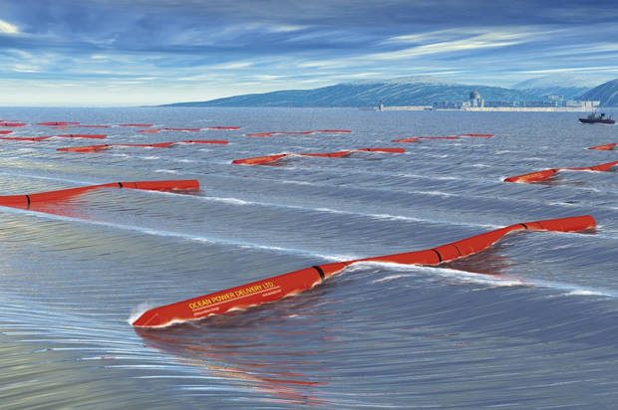A 30 MegaWatt "wave farm" of Pelamis Wave Energy Converters (Credit: Business Wire)

Unless you’re a surfer, a sailor or the owner of beachfront property during hurricane season, you probably don’t spend much time thinking about the power of waves. That may be changing soon.
Like a large, slowly building swell miles from shore, the wave-power revolution has quietly and gradually gained momentum. And this month it began the crest: The Department of Energy announced it would allocate as much as $40 million in funding to develop of the nation’s first open-water wave-energy-testing facility in a location to be determined.
When it comes to tapping the commercial viability of this renewable resource, we could be on the cusp of a tidal change. For decades wave energy has lagged behind wind energy and solar, in part because harnessing it is so complex. It involves a number of factors — the speed, height, direction of a swell and the intervals between swells — and more variables equal higher costs.
Additionally, harnessing wave power involves installing costly equipment in a corrosive and treacherous environment. Then there’s the challenge of transmitting that energy from offshore to the power grid. These realities have scared away many would-be investors. Regulatory hurdles have put off others: In 2008, what would have been the first commercial wave-energy project in the country was nixed by California’s Public Utilities Commission, which said the technology was too new to be trusted.
Skeptics think wave energy will always be a younger sister to wind and solar. “It should be studied, and it should be part of the mix,” Luigi Martinelli, an associate professor of mechanical and aerospace engineering at Princeton University, told Salon. “I just don’t see it being a large part of our renewable portfolio.”
But many other American researchers continue to refine their wave-energy converter systems. That’s largely because the potential is so huge: A report from the Intergovernmental Panel on Climate Change suggests the power-generating potential of the world’s oceans exceeds human energy requirements. Imagine no need for coal, fossil fuels, nuclear generators, solar arrays or wind turbines — and no need to rely on overseas suppliers. According to the U.S. Department of Energy, waves along American coastlines have the potential to generate as much 2,640 terrawatt hours a year — enough to power more than 200 million American households, free of emissions.
There’s more: Waves are more consistent and predictable than either solar or wind power, meaning it will be easier to plan the integration of wave energy into a power grid. They also pack a bigger punch. Water moving at 12 miles a hour (normal for a standard day at the beach) offers the same power potential as wind moving at 110 miles per hour (not so standard for a day anywhere).
The Scottish-built Pelamis, the world’s first commercial wave farm, launched off the coast of Portugal in 2008. The system, which consisted of four caterpillar-like converters spanning a total of more than 1,500 feet, began supplying 1,500 homes with clean electricity but was shut down after two months due to frequent breakdowns and financial struggles. The U.S. Navy-sponsored Azura system, however, currently powering a Marine Corps base near Hawaii’s Kaneohe Bay on the north shore of Oahu has been successfully tapping the ocean’s power supply for a year. The 45-ton floating device rotates 360 degrees and, unlike many other wave converters, is able to extract power from both the horizontal and vertical motions of the waves. Since March of last year a larger implementation, the first wave farm consisting of multiple units, has been making headlines in Australia.
In an effort to accelerate innovation and jumpstart commercialization, the Department of Energy has increasingly been funneling money into research and development. In 2015, the agency announced a Wave Energy Prize competition, or the ultimate science fair for America’s biggest wave-energy nerds. Ninety-two entries came from universities, startups and clean-energy companies that entered with a goal of doubling the output of existing wave-energy converters, as determined by a 2014 report from the National Renewable Energy Laboratory. The winner, assuming there is one, will be awarded more than $2 million and likely the backing of investors.
So far, more than 1,000 patents have been issued for wave-energy converter devices in North America, Asia and Europe. Some of these prototypes sit near shore, others offshore; some 40 meters below sea level and others on the surface. Made largely of steel, concrete or composite material, they’ve all been labeled according to three categories: attenuators (snake-like structures composed of semi-submerged cylinders that flex in wave action, kick-starting electrical generators), point absorbers (buoys that compress gas or liquid as waves bob them up and down, activating a turbine) and terminators (wide, floating reservoirs that sit perpendicular to a wave to intercept its energy before pressurizing it like a car piston).
“The main principle is always the same,” said Spyridon Kinnish, professor of engineering at the University of Texas at Austin. “There’s a rotating portion, like a cylinder, that’s moved by wave action, and there’s a fixed portion. The relative motion of one to the other creates energy that’s carried into the grid by cables.”
The Wave Prize entries work this way but many incorporate novel advances like the ability to submerge for protection during large storms. And some are difficult to classify at all. Take CalWave, the wave carpet entry from researchers at the University of California, Berkeley. The carpet, made from a proprietary material, covers 3 miles of coastline and works by mimicking a muddy seafloor, absorbing the energy of waves that pass over its surface. As a bonus, it multitasks by desalinating water for drinking.
Historically when it has come to advances in wave technology, necessity has been the mother of invention. In the 1970s, the oil crisis sparked a flurry of wave-energy research, which tapered off once the price of crude stabilized. Now as concerns about climate change intensify, experts are anticipating another research and development frenzy. According to a Department of Energy spokesperson, the goal is for 80 percent of the nation’s electricity to come from clean energy sources by 2035. Hence the rush for entrepreneurs to get their wave energy projects in the pipeline.
But will a single industry standard technology emerge?
“I wouldn’t say that,” said Mark Lehmann, CalWave’s project leader. “Renewable energy is never going to be a monoculture — it’s always going to be a healthy mix. But our goal is to reduce costs. Our goal is to make it competitive.”

Navy News Service
Carderock Supports Energy Innovation with Wave Energy Prize Tests
By Dustin Q. Diaz, Naval Surface Warfare Center, Carderock Division Public Affairs; Aug. 29, 2016
WEST BETHESDA, Md. (NNS) -- Employees at Naval Surface Warfare Center (NSWC), Carderock Division, and members of private industry began testing game-changing improvements in the efficiency of wave energy conversion (WEC) devices by effectively capturing more energy from ocean waves Aug. 8.
The Wave Energy Prize is a public prize competition open to all U.S. entities, sponsored by the U.S. Department of Energy (DOE) and supported by the Office of Naval Research (ONR) and NSWC Carderock Division. Carderock established an interagency agreement with DOE spring 2014 and contest registration began April 2015. The contest will run 20 months from beginning to end, including design, building and testing.
Carderock employees account for this phase's test directors, signal conditioning and data acquisition, general logistics team, mooring team and optical tracking team. Dave Newborn, an ocean engineer with Carderock's Maritime Systems Hydromechanics Branch, said he and Miguel Quintero, an ocean engineer with the Full-Scale Trials Branch, have been involved throughout the process -- including writing the competition rules, serving as judges and test directors, and providing technical and logistical support for contestants and program identified partners like the Sandia National Laboratory (SNL) in Albuquerque, New Mexico, and the National Renewable Energy Laboratory (NREL) in Golden, Colorado.
Given the large number of initial applicants to the Wave Energy Prize, Dr. Dylan Temple, an engineer with the Seakeeping and Testing Branch, also served as a judge for technology gate one, the initial application stage.
"There's been a colossal effort by Miguel and I, other Carderock employees and a number of other entities to make all this happen," Newborn said. "If you look at the [organization] chart, it gets pretty expansive pretty quickly, but it's very much a collaborative project."
Previous stages, called technology gates, in the Wave Energy Prize involved competitors designing different archetypes for WEC devices, such as point absorbers, line absorbers and terminators. The Wave Energy Prize involved building and numerically modeling the devices, and testing prototypes built to 1/50 scale. Newborn said this has narrowed down the original 68 competitors to the nine currently conducting tests on 1/20-scale prototypes in the Maneuvering and Seakeeping (MASK) Basin in preparation for the fourth and final gate.
"The reason the testing has moved here at this stage is that no one has a facility this large that can generate waves of this size to get the appropriate scale for the devices," Newborn said. "The DOE came to us because of the big tank, the big waves we can make, and the expertise we have here. There's a lot of money at stake here. With a vital program like this one, the data has to be as thorough and accurate as possible."
With this testing, each competing team ships its equipment to the West Bethesda facility -- where Newborn, Quintero and their team spend a week helping them to unpack the shipping containers, set up a work environment, reassemble their devices, conduct spot checks to ensure instrumentation is working properly and address any issues that are found. The equipment then goes in the basin during the second week to expose the WECs to 10 different wave conditions simulating different environmental conditions, and conduct tests to compute the metrics for the prize. Newborn said this dynamic is different from the testing usually done in the MASK -- instead of being a 10-week test, he said, they are essentially conducting nine one-week tests. When each test is complete, data analysts from program identified partners (SNL and NREL) verify the finished data and ensure its legitimacy.
"With this type of testing, the routine is that there is no routine," Newborn said. "What you have to do to commission a device to be ready for testing is different for every team and every device. We did a dry-run test before testing to prepare for that, and we've learned a lot as we go. A lot of work goes into ensuring we are providing the same level of support to all the teams."
With wave energy in its infancy, the goal of the Wave Energy Prize is to determine which archetype of device is best to move forward with. Newborn compared it to the development of wind energy, with several different formats and methods competing until today's standard was found. One of the metrics each team is judged on is how much energy their WEC absorbs, but equally important, Newborn said, is how much it costs to get that energy. Providing value to the taxpayer is the emphasis, and he said it can be a tough balancing act for the competitors.
"It's about what it costs to get the power; not just getting renewable energy, but doing it at a cost that makes sense," Newborn said.
The $1 million prize at stake is incentivizing the pursuit of this efficiency, as well as attracting top talent to the competition, according to Newborn. Only U.S. entities such as corporations, small businesses and start-ups are permitted to compete, but these entities may bring in expertise via qualified foreign nationals and many do.
"DOE is very happy with the kind of collaboration they got between experts who were eager to use their expertise in this field and the teams who were looking to add people with those capabilities," Newborn said. "I think it's worked out pretty well for them."
Carderock's support of the Wave Energy Prize has brought unexpected but welcome benefits to the command, such as the development of the underwater optical tracking system used in the tests, Newborn said. The underwater system provides six degrees of freedom motions of rigid bodies and 3-D translations of points on the surface of bodies. The ability to track motions for submerged or surface-piercing bodies is a significant capability enhancement across a wide range of hydrodynamic testing performed at Carderock.
"We reverse engineered the system to work underwater; it has never worked underwater anywhere before," Newborn said. "We formed a CRADA (Cooperative Research and Development Agreement) with the company that develops the hardware. What we've learned about putting it underwater they can learn from, and we can learn from them as well."
The ultimate goal, as the underwater system is tuned and modified for use at Carderock, is to establish a flexible, reconfigurable motion-capture system that could track bodies in the entire MASK basin and sections of the other basins around base.
The development of an emerging technology like wave energy fulfills Carderock's congressional charter, which states the command not only supports Navy operations and research and development, but the maritime industry as well -- as stated in OPNAV Notice 5450, 23 December 1991. Newborn said the final test in this phase of the Wave Energy Prize is scheduled to end Oct. 7, and should one of the teams meet all the requirements and win the contest, it will be announced in November. For more information on the Wave Energy Prize, visit http://waveenergyprize.org/about/.
Naval Surface Warfare Center, Carderock Division, a part of Naval Sea Systems Command, leads the Navy in hull, mechanical and electrical engineering. Headquartered in West Bethesda, Maryland, Carderock Division employs approximately 2,000 scientists, engineers, technicians and support personnel and includes detachments in Norfolk (Little Creek); Port Canaveral, Florida; Fort Lauderdale, Florida; Memphis, Tennessee; Bangor, Washington; Ketchikan, Alaska; and Bayview, Idaho.
For more information, visit www.navy.mil, www.facebook.com/usnavy, or www.twitter.com/usnavy.
For more news from Naval Surface Warfare Center Carderock, visit www.navy.mil/local/nswcc/.

OSTP Blog

Prizes Creating “Waves” in the Energy Sector
AUGUST 31, 2016 AT 9:15 AM ET BY NOËL BAKHTIAN, AUSTIN BROWN, AND CHRISTOFER NELSON
TWITTER FACEBOOK EMAIL
Summary:
Energy Department’s prizes for game-changing technology advancements comes to a head this month; finalists in the Wave Energy Prize compete for a total of $2.25 million.
Energy prizes are a potentially transformational method for the Federal government to help create clean energy technology. DOE’s Wave Energy Prize is an exciting initiative that represents an innovative approach to funding technological advancements to tap water-energy resources. The past decade has been transformative for wind and solar photovoltaic technologies, which have seen their costs fall and deployment increase dramatically. With this progress, coupled with extended tax credits for these technologies, the energy community expects years of continued growth. This does not mean that innovation in other clean technologies loses its value, however. Energy systems are most resilient when they can draw from multiple sources. In the electricity sector, for example, solar and wind produce energy only some of the time, and will need to be complemented by baseload and dispatchable low-carbon technologies such as batteries, pumped storage hydropower, geothermal energy, and other options. It is always challenging for new technologies and novel companies to enter a market, but energy has proved to be a particularly challenging sector. High capital investment requirements, long technology lifetimes, and entrenched market participants all create barriers to innovative new participants.
Incentive prizes can break through these barriers and rapidly advance the state-of-the-art by defining a problem, setting ambitious but achievable goals, and inviting diverse individuals and teams to develop solutions that are rigorously tested and only awarded if they meet high performance standards. Prizes and challenges create new avenues for organizations that would not otherwise work with the government. Innovation challenges have a track-record of engaging non-traditional audiences; for example, the recent FTC Robocall Challenge received 798 submissions and of the four winners, none had previously worked with the government. Since 2010 when the General Services Administration launched Challenge.gov, more than 700 prizes and challenges have been run by U.S. Federal Agencies. According to a 2015 report from Deloitte on prize design, between 2010 and 2014, “incentive prizes have transformed from an exotic open innovation tool to a proven innovation strategy.”
The nascent wave energy industry is an example of a “prizable” sector. First, there’s potential: more than 50% of the U.S. population living within 50 miles of coastlines, and developing just a small fraction of the available wave energy resource (the technically recoverable U.S. wave energy resource is estimated at 900-1200 terawatt hours per year) could allow for millions of American homes to be powered with this clean, reliable form of energy. Secondly, the wave energy industry is young and experiencing many new innovations and growth in patent activity across a myriad of device types, indicating potential for rapid innovation. Finally, there’s a critical need for funding in order for the private sector to develop early-concept devices and conduct prototype wave tank testing, key steps in advancing wave energy technologies through the technical readiness levels to reach commercialization.
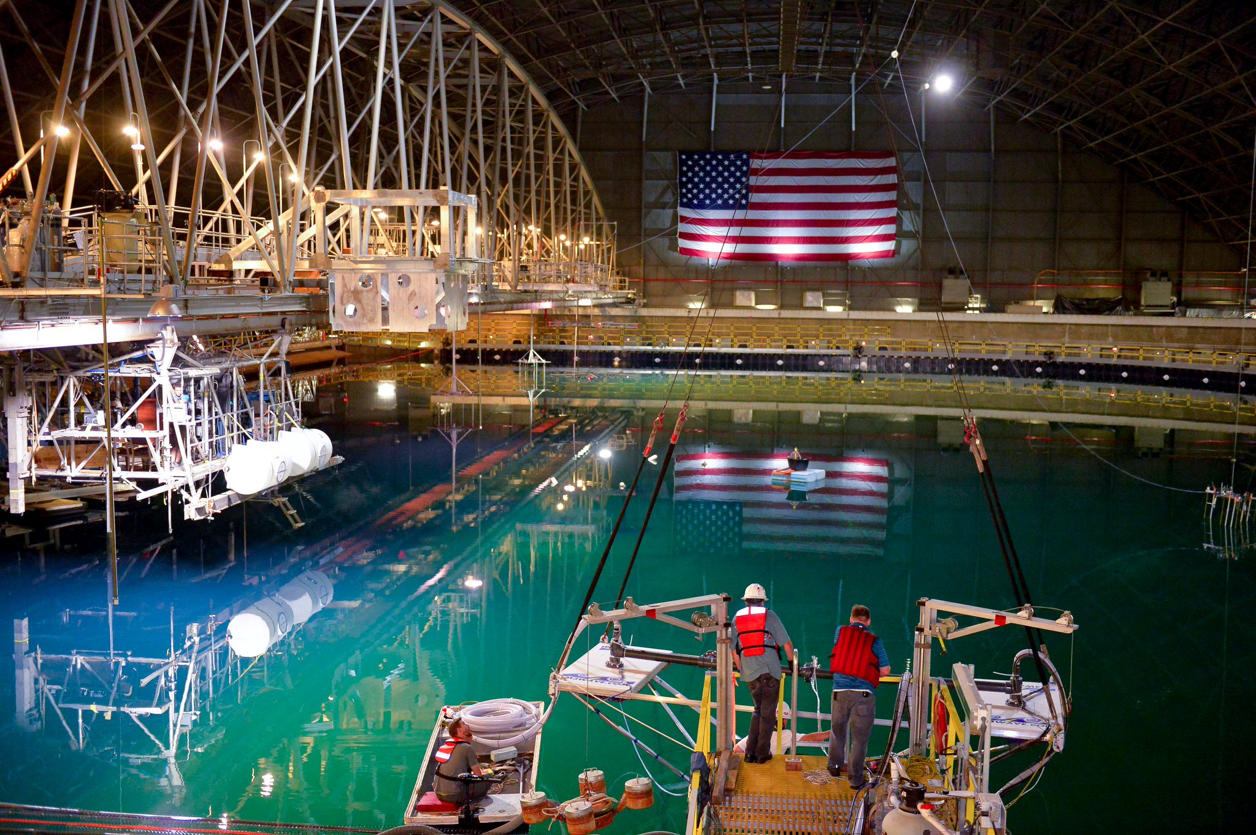The 12-million-gallon "indoor ocean" where Wave Energy Prize tesing occurs. (DOE)
The DOE Wave Energy Prize responds to this opportunity and aims to achieve game-changing improvements in the efficiency of wave energy converter (WEC) devices, establishing a pathway to sweeping cost reductions on a commercial scale and making them more competitive with traditional energy solutions. The 18-month design-build-test prize is now in the final stage: this month marks the start of the final prize phase in which 9 finalist teams will be competing for a grand prize of $1.5 million (with 2nd and 3rd place receiving $500k and $250k, respectively) by testing their 1/20th scale WEC devices at the nation’s most advanced wave-making facility, the U.S. Navy’s Maneuvering and Seakeeping Basin facility in Carderock, Maryland. A diverse set of 92 registered teams were incentivized to compete in this structured prize not only by the prize purse, but also through seed funding for building prototypes and covering the shipping and travel costs for teams; access to multiple testing facilities and the feedback of expert judges; and an online “marketplace” to allow for shared resources and matchmaking between teams, investors, and contributors.
The Wave Energy Prize is just one of many DOE-supported prizes designed and implemented in the energy sector to advance energy technologies, address soft costs, promote student engagement, and enhance business practices, including:
- SunShot Catalyst Energy Innovation Prize
- H2 Refuel H-Prize
- Cleantech University Prize
- L-Prize
- National Clean Energy Business Plan Competition
- EcoCAR3 Advanced Vehicle Technology Competition
- Clean Energy Ministerial’s Global Efficiency Medals
- Workplace Charging Challenge
- Solar Decathlon
- Microgrid MVP Challenge
- SunShot Prize: Race to 7-Day Solar
- Collegiate Wind Competition
- Geothermal Design Challenge 2016
- OpenWARP Challenge
- Apps for Energy
- Remote Alaskan Community Energy Efficiency Competition
- American Energy Data Challenge
- Race to Zero Student Design Competition
- Buildings Crowdsourcing Community Campaign
- Progressive Insurance Automotive X PRIZE
- BioenergizeME Infographic Challenge
In fact, DOE introduced an internal Community of Practice on Prizes, Challenges, and Innovation to share best practices and lessons learned across the Department and support nascent and current activities. Of course, DOE is not the only player in this space. Other energy sector prizes include the 1776 Challenge Cup, Clean Energy Trust Clean Energy Challenge, NRG COSIA Carbon XPRIZE, Wendy Schmidt Oil Cleanup X Challenge, and the Zayed Future Energy Prize.
Innovation will be a key ingredient for a clean energy future. Prizes in the energy space will be a valuable tool to incentivize that innovation, involve new participants in energy technology development, and gather a more diverse array of ideas than would otherwise be possible.

Noël Bakhtian is a Senior Policy Advisor at the White House Office of Science and Technology Policy.
Austin Brown is Assistant Director for Clean Energy and Transportation at the White House Office of Science and Technology Policy.
Christofer Nelson is Assistant Director for Open Innovation at the White House Office of Science and Technology Policy.

Belfast Telegraph
Scheme gives Northern Ireland tech companies the chance to pitch directly to Prince Andrew
By Yvette Shapiro; Sept. 6, 2016
Paul Brewster of Pure Marine was a previous winner
Technology start-ups from Northern Ireland will have the chance to compete for a place on a high profile entrepreneurship programme run by Prince Andrew.

Shortlisted companies will deliver pitches at Hillsborough Castle later this month as part of the Duke of York's Pitch@Palace initiative.

The scheme was launched in 2014 and has helped scores of new businesses to access investment, advice and mentoring.
Some have gone on to huge global success, including London-based artificial intelligence specialist Magic Pony which was recently acquired by Twitter for a reported $150m (£113m).
In total, Pitch@Palace companies have created almost 350 jobs and reached £124m in turnover.
Writing on the programme's website, the Duke of York said: "A more entrepreneurial economy and people with an enterprising culture will create jobs for our next generation workforce. Our prominence in science, technology and engineering is undisputed, creating valuable ideas and inventions to seed business of the future.
"We also see across the educational landscape numerous projects aimed at building young people's entrepreneurial skills. More businesses can be created in the UK through a combination of these factors. A key task is to now ensure we do more to help these businesses to scale."
Belfast company Pure Marine was one of the programme's winners in 2014.
The firm, based at Catalyst Inc (formerly the Science Park), has developed a wave energy converter capable of generating competitively priced electricity. Earlier this year, its DUO technology was selected as one of only nine finalists for the US Department of Energy's wave energy prize competition.
"Taking part in Pitch@Palace was a unique experience that opened up new opportunities and introductions to some of the biggest players in the global energy industry," said director Paul Brewster.
"Our prize included a trip to the World Economic Forum in Davos, Switzerland, and I also was invited to join the Duke of York on a trip to Saudi Arabia which provided the opportunity to meet a number of influential investors."
Three entrepreneurs will be selected from the Belfast event to attend Pitch@Palace Boot Camp with the potential to be selected, as one of 15 finalists, for the Pitch@Palace final at St James's Palace, London, in November.
This year's theme is technology and the organisers are hoping to attract companies involved in biotech, cyber security, education, financial and consumer tech, data and analytics, and artificial intelligence.
Alan Watts, director of Halo at Catalyst Inc, said: "We are delighted that Pitch@Palace on Tour will be taking place in Hillsborough Castle on September 29. While the funding is certainly central to Pitch@Palace, the access to top UK CEOs and influencers is what makes this experience unique.
"Start-ups emerge with connections and prospects which undoubtedly add significant value to the company.
"We know we have many world- leading technology start-ups in Northern Ireland and Pitch@Palace is a great opportunity that could catapult a business to the next level."
The closing date for applications is on Friday. Applications can be submitted online at http://pitchatpalace.com

Tidal Energy Today
Video: Ongoing Wave Energy Prize WECs testing
Sept. 9, 2016

Video: Ongoing Wave Energy Prize WECs testing
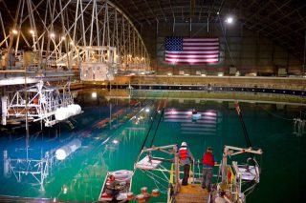zoomMASK Basin (Photo: DoE)
US Department of Energy has released a video update on the final wave energy testing for its Wave Energy Prize challenge.
The total of nine finalist teams will test their 1:20 scale wave energy devices at the US Navy’s Maneuvering and Seakeeping (MASK) Basin at Naval Surface Warfare Center in Carderock, Maryland, throughout September, and October.
The final team, SEWEC, is scheduled to test its wave energy device from October 3 to 7, 2016.
The MASK Basin is 360 feet long and 240 feet wide facility that holds approximately 12 million gallons of water and is used to evaluate the maneuverability, stability and control of scale models.
José Zayas, Director at Wind & Water Power Technologies Office, said: “We’ve seen some remarkable technologies that all have different attributes and value propositions, and we may actually find more than one team that really meets the requirements of the Department, and that’s what’s really exciting.”
The team that ranks the highest after testing the 1:20 scaled WEC device model will be awarded $1.5 million. The second team will win an award in the amount of $500,000, and the third-placed tam will be awarded $250,000.
The winner(s) of the Wave Energy Prize challenge will be announced on November 13, 2016.

WUSA-9 (CBS affiliate)
Teams compete to find clean energy using the ocean's waves
Sept. 15, 2016
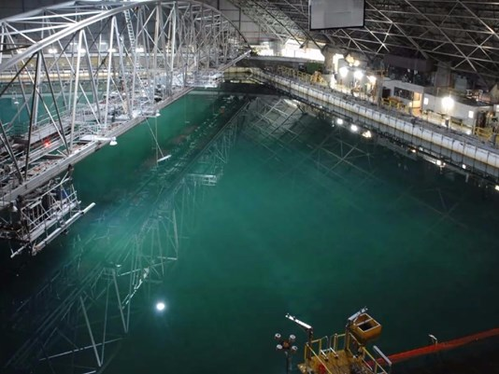
(Photo: Naval Surface Warfare Center)
CARDEROCK, MD (WUSA9) - What if the ocean waves you dive though on a hot day, could actually power your home? They could, and some of the technology already exists, but it’s considered to be relatively young.
In Carderock, Maryland, teams of engineers are coming from all over the country to test newer and more advanced wave energy conversion (WEC) devices.
They’re testing it inside a place few people are allowed to see: the hydrodynamic facilities at the Naval Surface Warfare Center. It’s called the Maneuvering and Sea Keeping Basin, but the people work with it simply know it as “the MASK.”
On the surface, it seems to be a gigantic indoor swimming pool.
It’s 360 feet long by 240 feet wide, and anywhere from 20 to 35 feet deep.
With the push of a button, the MASK can fill with waves so extreme an experienced captain would struggle to navigate through it.
Miguel Quintero, an Ocean Engineer at Carderock, said the MASK can model any type of waves from any part of the world.
"Be it in the Atlantic Ocean [or the] Pacific [Ocean],” he said. “We can model it.”
With the click of a button, the engineers can create a calm day in the ocean or a typhoon.
"There's 216 paddles on a curve. You will see the wave surface move and we can make what we call a bullseye wave or a singularity wave where you can see one large wave in the tank,” Quintero said.
Most days, engineers use the MASK to test submarines and ships, and Quintero said the main goal is “to make sure [naval ships] are safe, and the vessel and the personnel survive all their [weather] conditions.”
Today, the MASK is producing energy for a tiny, yellow machine.
It’s a machine created by one of nine teams working to create bigger, better WEC devices and win a $2 million prize.
It's part of a competition sponsored by the Department of Energy.
They’re interested in making wave energy “more competitive with traditional energy solutions” and see it as an “untapped renewable resource.”
Jose Zayas, the director of the Department’s Wind and Water Power Technologies Office, said “waves, tides, and ocean currents could provide clean, affordable energy to homes and businesses across the country.”
Seven teams have already completed their tests. The winner will be announced in November.

Providence Journal
Providence energy developer’s DUO device is a finalist for $1.5M award
Sept. 18, 2016
Ocean waves are an untapped source of clean, renewable power could be an important part of the future, he says.
By Alex Kuffner
Journal Staff Writer
PROVIDENCE — As Tim MacDonald talks about using the ocean’s waves to generate electricity, he points to one simple reason why he believes this largely untapped source of clean, renewable power could be an important part of the future.
Many of the world’s largest cities that have the greatest electric demands are on the coasts within easy reach of the powerful waves that MacDonald, a Providence energy developer, wants to harness.
“We’re not going to power the world on wave energy,” MacDonald said. “But we can make an important contribution.”
He and his partners in Northern Ireland believe the key could be a device they’ve named the DUO that is one of nine finalists in a U.S. Department of Energy contest with a first-place award of $1.5 million.
The finalists, chosen from a pool of 92 entrants, are each going through a weeklong series of tests at a state-of-the-art Navy wave tank in Carderock, Maryland. Testing started in August and is set to wrap up in October. The DUO’s turn in the water starts Monday.
Paul Brewster, the Belfast-based ocean engineer who designed the double-hulled device believes it has an advantage over competitors because it generates power from both the up-and-down motion of the waves, as well as the side-to-side movement.
“We figured out how to capture both,” he said. “And that’s obviously twice as efficient.”
The DOE estimates that the amount of wave power that could be developed off U.S. coasts is equivalent to just under a third of total annual electricity usage in the nation. Tapping into just 5 percent of that resource could power 5 million homes, the agency says.
But no projects in the United States have been developed beyond the testing stage and only a handful have gone forward in other countries. According to a 2015 International Energy Agency report, the total installed capacity in the United Kingdom, Portugal, Spain, China, South Korea and the four other countries with wave energy systems adds up to only 3 megawatts — or one-tenth of the capacity of the just-completed offshore wind farm near Block Island, which is considered a test project.
Cost has been an obstacle. Building anything in the ocean is more expensive than doing so on land, and that’s especially true when it comes to power generation. That’s why offshore wind turbines are much more costly to install than their onshore counterparts.
But at least with wind power, there was a standard design that had been proven on land before going offshore. There’s no equivalent for wave energy.
And finding the optimal design has been a challenge because of the inherent complexity of waves, which vary endlessly by height, frequency and direction. One system deployed off Portugal eight years ago used undulating caterpillar-like attenuators. Other prototypes resemble buoys that pump up and down like pistons.
The DUO has one hull that floats and another that sits just below the water’s surface. As the two halves pull in different directions, they generate mechanical energy that can be converted to electricity, says Brewster, chief technology officer with Pure Marine, a Belfast company.
Brewster came up with the design several years ago and Pure Marine has won grants in the United Kingdom to continue its development but sought out a partner in the United States after hearing about the large DOE prize.
Through mutual acquaintances in the renewable energy industry, Brewster found MacDonald, a tax attorney by training who has set up financing for clean power projects that include a 205-megawatt wind farm in Washington state and has consulted for solar developer Sunrun and fuel cell company Bloom Energy. They formed a company called Sea Potential that is basing its U.S. operations in Bristol.
“When I heard that was in the Ocean State, I said, 'That’s where we have to do this,'” Brewster recalled.
The DOE contest requires a 1/20-scale model for testing. With the help of Tinker Bristol, a manufacturing incubator, MacDonald and Brewster hired a local company, Luther’s Welding, to fabricate the aluminum hulls for the four-foot diameter prototype and had engineering students at Roger Williams University assemble them.
The DOE expects to announce the winner of the competition in November. In the meantime, MacDonald has been meeting with elected officials, including Sens. Sheldon Whitehouse and Jack Reed and Congressman David Cicilline, to build support for Sea Potential and explore other funding options.
The next step is building a larger model, possibly out of highly-durable composite materials, that would be tested in Rhode Island waters. Sea Potential envisions arrays of one- to two-megawatt devices that could power cities and smaller versions that could be used for weather buoys or aquaculture operations.
“This could be the next generation,” MacDonald said.
akuffner@providencejournal.com
(401) 277-7457

Tidal Energy Today
Wave energy testing at Carderock nears conclusion
Sept. 28, 2016
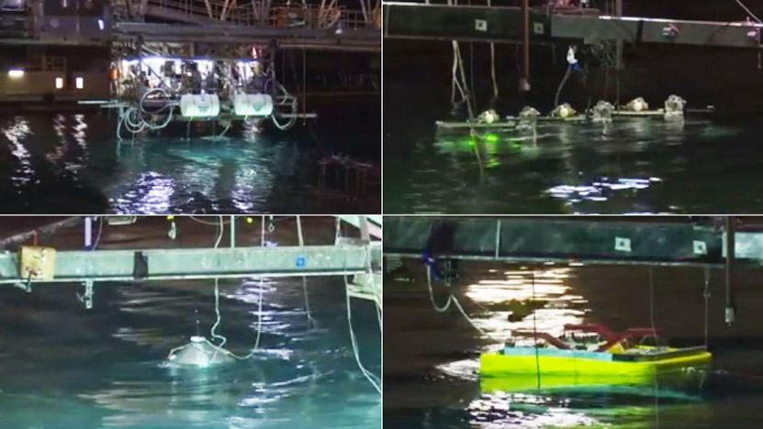Final WECs testing at MASK Basin (Photo: Wave Energy Prize)
Wave energy converters testing is coming to a close with only two more developers left to test their 1:20 scale devices as part of US Department of Energy’s funded Wave Energy Prize challenge.
The final testing of the devices began in August at the US Navy’s Maneuvering and Seakeeping (MASK) Basin, Carderock, Maryland.
The first finalist team, out of 9 total, which completed the trials was M3 Wave, followed by Waveswing America, Harvest Wave Energy (Team FLAPPER), AquaHarmonics, CalWave Power Technologies, Oscilla Power and Sea Potential.
The team currently testing at MASK Basin is RTI Wave Power, while the last team, SEWEC, is onsite building its device, Wave Energy Prize administration informed.
Alison LaBonte, Marine and Hydrokinetic Technology Program Manager at DoE’s Water Power Technologies Office, said: “Watching our finalist teams’ WEC concepts come to life at the MASK Basin has been a thrill. We’re looking forward to the Judges’ analyses of the nine weeks of testing and learning how many and which technologies surpassed our goal of doubling the energy capture efficiency of wave energy converters.”
The team that ranks the highest will be awarded $1.5 million. The second team will win an award in the amount of $500,000, and the third-placed tam will be awarded $250,000.
The winner(s) of the Wave Energy Prize challenge will be announced on November 16, 2016.

PDQ@RWU

Architecture Student Collaborates on Wave Energy Project Competing for $1.5 Million

Oct. 5, 2016
Working with the Sea Potential team via Tinker Bristol, Andy Cole designed a scale model of the DUO Wave Energy Converter
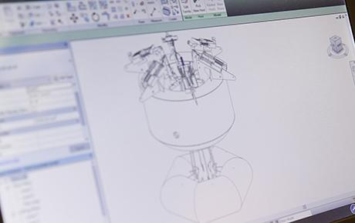
Andy Cole's scale model design of the DUO Wave Energy Converter.
By: Public Affairs Staff
BRISTOL, R.I. – When the inventors of a cutting-edge wave energy technology needed help to take their concept to beta-testing for a chance at $1.5 million in funding, they turned to the experts at RWU’s School of Architecture, Art and Historic Preservation.
Master of Architecture student, Andy Cole, worked with the Sea Potential team via Tinker Bristol to design a scale model of the DUO Wave Energy Converter, which was recently named a finalist competing for a U.S. Department of Energy (DOE) prize in alternative energy sourcing.
“I helped them redesign some of the linkage, reduce the drag, reduce the friction loss – basically, putting together the drawing package that we were then able to send out and get quotes for,” Cole said. “The experience of working with clients outside of the (architecture) school is by far the best experience you can get. Being able to talk to the client and know what they want while you’re working on a project for school credit is great.”
With a final design completed, the SEA Potential team assembled the DUO prototype at HawkWorks, the University’s 5,600-square-foot fabrication facility, before the apparatus shipped off for testing in the DOE competition in September. The first-place winner will be announced in November.

Product Design & Development

Can Department of Energy Prize Encourage the Proliferation of Wave Energy Projects?

Oct. 12, 2016; By Sheri Kasprzak
Wave energy is the redheaded stepchild of the renewable energy world.
It would make up only 0.4 percent of renewable energy sources by 2050 if the United States transitions to 100 percent renewable energy sources, according to Stanford University projection. Wave is dwarfed by onshore wind, which could make up 30.9 percent of the U.S.’s renewable energy sources under such a scenario.
The U.S. Department of Energy’s Wave Energy Prize aims to entice developers to experiment with wave energy converter technologies that can reduce the cost of wave energy, making it competitive with traditional energy solutions.
Corporate teams are competing for the $2.25 million prize purse.
This year’s competition includes AquaHarmonics of Portland, Ore.; CalWave Power Technologies of Berkeley, Calif.; M3 Wave of Salem, Ore.; Oscilla Power of Seattle, Wash.; RTI Wave of York, Maine; Sea Potential of Bristol, R.I.; SEWEC of Redwood City, Calif.; Harvest Wave Energy of Research Triangle Park, N.C.; and Waveswing America of Sacramento, Calif.
“The Wave Energy Prize, a 20-month design-build-test competition, is encouraging the development of game-changing wave energy converter technologies that will reduce the cost of wave energy, making it more competitive with traditional energy solutions,” said a Department of Energy statement.
The winners of the prize will be announced Nov. 16.

White House Blog

Advancing the Frontiers of Clean Energy Innovation

By Ali Zaidi, Lynn Orr; Oct. 13, 2016
Summary:
America must continue to push the boundaries of clean energy innovation by doubling down on Federally-funded research and accelerating new technologies.
Note: This post was last updated at 11:30 AM ET on October 13, 2016.
Today, President Obama is hosting the White House Frontiers Conference in Pittsburgh to imagine our Nation and the world in 50 years and beyond, with America continuing to push the boundaries of science, technology, and innovation.
This kind of American leadership is essential in meeting the global challenge of climate change.
Just last week, the world crossed the threshold needed to bring the historic Paris Agreement into force, committing more than 190 countries to set the world on a course to reduce greenhouse gas emissions. In the President’s words, “by sending a signal that this is going to be our future—a clean energy future—[this agreement] opens up the floodgates for businesses, and scientists, and engineers to unleash high-tech, low-carbon investment and innovation at a scale that we’ve never seen before.”
Indeed, the United States is well on its way to achieving its near-term Paris Agreement commitments, thanks in part to past public investments in technologies that are now being deployed at scale. The pace of change is breathtaking: Wind and solar provided two-thirds of all new electricity generation capacity last year, with more than a million solar systems now on rooftops across the country; nearly half a million electric vehicles are on the road, with battery costs falling 73 percent since President Obama took office; and energy-efficient LED bulb costs plummeted 94 percent over the same period, with sales more than doubling last year alone.
To achieve a clean, thriving, low-carbon economy over the next 50 years, we need to double down on investments in the next generation of clean energy technologies. That’s why President Obama joined with other world leaders last year to launch Mission Innovation, a commitment by more than 20 countries to double their public funding of clean energy research and development (R&D) over the next five years, to nearly $30 billion per year by 2021.
The United States is by far the world’s largest funder of clean energy R&D, and the President’s FY2017 Budget proposes to double this funding over the next five years, from $6.4 billion government-wide in Fiscal Year (FY) 2016 to $12.8 billion in FY 2021. Today, the Office of Management and Budget is releasing an updated summary of the FY 2017 plan for Mission Innovation, which lays out how the investments would be used. And in the weeks ahead, we will publish a framework for how these public investments can continue to advance the frontiers of clean energy innovation.
Of course, capturing all of the economic and national security benefits of clean energy innovation isn’t just a matter of how much we invest—it’s how effectively we invest. That’s why the Department of Energy (DOE) continues to pursue path-breaking new models for rapidly moving R&D out of the lab and into the marketplace. Here are just a few examples from the past few months:
Funding High-Impact Research
The Advanced Research Projects Agency-Energy (ARPA-E) was established at the beginning of the Obama Administration with the mission to advance potentially transformational energy technologies that are too early in their development to attract private-sector investment. Since 2009, ARPA-E has funded more than 500 projects that have gone on to secure more than $1.25 billion in cumulative follow-on funding from the private sector. A recent report on successful project outcomes includes promising technologies to dramatically reduce battery costs, improve the resiliency of the electric grid, boost renewable power, and more.
At the same time, many other DOE programs continue to invest in the basic and applied research essential to solving the 21st century grand challenges of clean energy, including generating fuels from sunlight, making electric vehicles as affordable and convenient as gas-powered vehicles,harnessing energy from ocean waves, and making solar energy cost-competitive nationwide by the end of this decade.
Harnessing the National Labs
As described in today's new Technology Transfer Execution Plan, DOE is engaged in an unprecedented range of activities to maximize the economic impact of its 17 National Laboratories, which are home to many of the world’s fastest supercomputers, most sophisticated scientific instruments, and most talented researchers. For instance, DOE’s:
- Lab-Embedded Entrepreneurship Programs are recruiting world-class entrepreneurial researchers to advance their cutting-edge energy technologies toward product launch within Berkeley Lab in northern California (Cyclotron Road), Argonne National Laboratory near Chicago (Chain Reaction Innovations), and most recently Oak Ridge National Laboratory in Tennessee (Innovation Crossroads). Cyclotron Road just announced a pioneering partnership withActivation Energy, a new nonprofit designed to help drive these energy technologies to market faster and more efficiently.
- Lab-Corps works in the other direction, empowering National Lab researchers to achieve their entrepreneurial potential through an intensive customer-focused training program.
- Small Business Vouchers allow innovative renewable energy, energy efficiency, and nuclear companies to access and work with the National Labs. In the first year of this program, 76 small businesses have received $15 million in “vouchers” to fund their work with lab equipment and researchers. This week, DOE announced that up to $12 million in additional small business vouchers will be made available in current and upcoming rounds.
- Lab-Bridge is testing new approaches to further reduce barriers to collaboration between the National Labs and the private sector, including efforts to streamline intellectual property licensing and enabling students to pitch business plans around Lab-developed technologies.
- The Technology Commercialization Fund lets the National Labs compete for $20 million of DOE funding for the most promising private-sector collaborations to bring energy technologies to market.
Growing the Nation’s Clean Energy Innovation Ecosystem
The National Labs are a critical part of our energy innovation ecosystem, and DOE also supports complementary efforts to build a robust commercialization pathway for new clean energy technologies. We need a new generation of talented entrepreneurs pushing the boundaries of clean energy innovation, and new support mechanisms to help them get nascent technologies to market. That’s why DOE continues to invest in the entire ecosystem of clean energy entrepreneurship across the country.
- The Cleantech University Prize (Cleantech UP) enables some of the nation’s top students across the country to compete in regional and national clean energy business plan competitions, so far training nearly 400 teams that have gone on to launch more than 70 ventures and generate more than $60 million in follow-on funding.
- Build4Scale was just launched to provide clean energy entrepreneurs with training on the fundamentals of manufacturing, which are essential to successfully making the leap from lab project to commercial product.
- The National Incubator Initiative for Clean Energy supports a consortium of clean energy focused startup incubators across the country that have collectively supported more than 350 companies and helped catalyze over $1 billion in follow-on funding.
Taken together, these investments in R&D, lab impact, and entrepreneurial talent will increase the number of cutting-edge clean energy technologies ready for follow-on investment from the private sector. Through the Administration’s Clean Energy Investment Initiative, a range of foundations, institutional investors, and other long-term investors have committed more than $4 billion to bring such technologies to market.
Tune in to today’s Frontiers Conference to be inspired by the many ways that American innovation will continue to push the boundaries of what’s possible in the century ahead.
Ali Zaidi is the Associate Director for Natural Resources, Energy, and Science at the White House Office of Management and Budget.
Lynn Orr is the Under Secretary for Science and Energy at the U.S. Department of Energy.

Eureka Alert!

Wave energy researchers dive deep to advance clean energy source

Oct. 13, 2016
E-MAIL
ALBUQUERQUE, N.M. -- One of the biggest untapped clean energy sources on the planet -- wave energy -- could one day power millions of homes across the U.S. But more than a century after the first tests of the power of ocean waves, it is still one of the hardest energy sources to capture.
Now, engineers at Sandia National Laboratories are conducting the largest model-scale wave energy testing of its kind to improve the performance of wave-energy converters (WECs). The project is taking place at the U.S. Navy's Maneuvering and Sea Keeping facility at the Carderock Division in Bethesda, Maryland, one of the largest wave tanks in the world at 360 feet long and 240 feet wide and able to hold 12 million gallons of water.
Sandia project leads Ryan Coe and Giorgio Bacelli spend long days in the dark wave tank, where minimal lighting reduces the growth of algae in the water. They are collecting data from their numerical modeling and experimental research to benefit wave energy technology with improved methodologies, strategic control systems design and testing practices for wave energy converters.
"Our goal is to improve the economic viability of these devices," said Coe. "In order to do so, we are working out ways to control the WEC's generator to increase the amount of power it absorbs. At the same time, we are looking at how to reduce the loads and stresses on these devices in harsh conditions to ultimately lengthen a WEC's lifespan in the water."
Coe said numerous initial studies estimate that improving control of the WECs' generators can dramatically increase energy absorption by as much as 300 percent. Transitioning these simplified studies to more realistic large-scale devices is the challenge at hand.
To control the dynamics for better, faster results in the wave tank, Coe and Bacelli are using modeling and control methods that have been successful in other industries, such as in the aerospace industry.
"The systems we used have been around for a while, but strangely enough they had never been applied to wave energy converters," Bacelli said. "So far, we know the techniques we are using are more efficient and cost-effective than existing methods. We are getting more information in a fraction of the time."
Now that Sandia has completed the first round of analyses in the water, Coe said the goal is to process all the collected data to develop a new, enhanced model that will make sure the next test yields even more valuable results.
"Make no mistake, these are extremely complex machines," Bacelli said. "They have to be fine-tuned continuously because ocean waves are constantly changing. With this setup at the Navy's facility, we have a unique opportunity to study the problems and quantify the effects. We want to help the industry by offering solutions to the challenges the wave energy world is facing."
Sandia's continuing wave energy project, Advanced WEC Dynamics and Controls, kicked off in 2013 and is funded by the Office of Energy Efficiency and Renewable Energy.
Innovations from Sandia's Water Power Technologies Program advance our nation's energy security by making renewable energy more economically feasible. Contributions include WEC-Sim, an open source code for modelling the performance of wave energy converters, extreme-conditions modeling and tidal and turbine modeling. Sandia researchers serve as advisers and judges for the Department of Energy's Wave Energy Prize competition.
###
Sandia National Laboratories is a multimission laboratory operated by Sandia Corporation, a wholly owned subsidiary of Lockheed Martin Corp., for the U.S. Department of Energy's National Nuclear Security Administration. With main facilities in Albuquerque, N.M., and Livermore, Calif., Sandia has major R&D responsibilities in national security, energy and environmental technologies and economic competitiveness.
Sandia news media contact: Rebecca Brock, rabrock@sandia.gov, (505) 844-7772

AZO Cleantech

Sandia Engineers Try to Optimize Performance of Wave-Energy Converters

Oct. 14, 2016
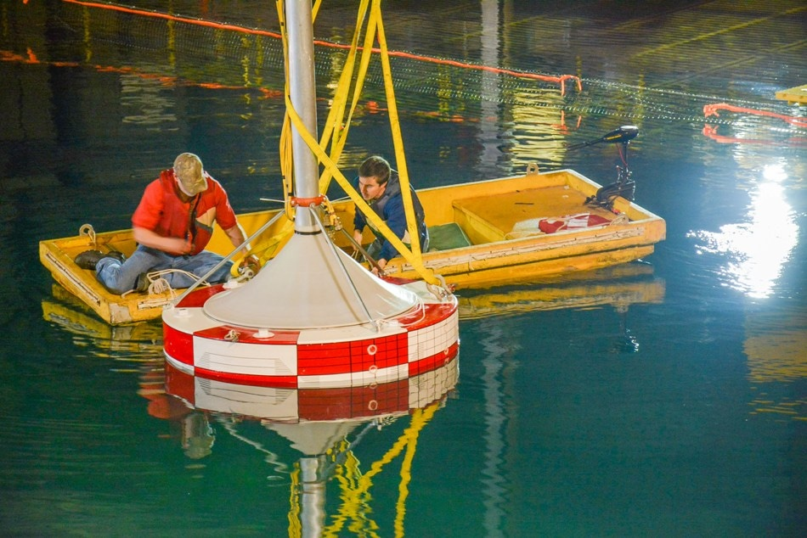
Sandia National Laboratories research engineers Ryan Coe and Giorgio Bacelli are collecting new information to optimize wave energy converter testing. (Photo courtesy of Sandia National Laboratories)
Wave energy is one of the largest unexploited clean energy sources on earth, and one day it could potentially power millions of households across the United States. Although it has been years since the power of ocean waves was first analyzed, wave energy continues to be one of the toughest energy sources to harness.
In order to enhance the performance of wave-energy converters (WECs), engineers atSandia National Laboratories are performing the largest model-scale wave energy testing. This research project is being conducted at the U.S. Navy’s Maneuvering and Sea Keeping facility at the Carderock Division in Bethesda, Maryland, which is one of the largest wave tanks in the world. This tank measures 360 ft in length and 240 ft in width, and can contain up to 12 Mgal water.
Ryan Coe and Giorgio Bacelli who head the Sandia project spend long hours in the dark wave tank. As the tank is dark, the growth of algae in the water is minimized. The researchers are collecting data from experimental research and numerical modeling, so that wave energy technology can benefit from the strategic control systems design, testing practices for wave energy converters and improved methodologies.
Our goal is to improve the economic viability of these devices. In order to do so, we are working out ways to control the WEC’s generator to increase the amount of power it absorbs. At the same time, we are looking at how to reduce the loads and stresses on these devices in harsh conditions to ultimately lengthen a WEC’s lifespan in the water.
Ryan Coe, Sandia National Laboratory

Related Stories
- Wave Power: Theory Behind Ocean Waves
- Types of Renewable Energy - An Overview
- Innovations In Wave Power: An Interview With Dr. George Taylor
According to Coe, many preliminary studies suggest that the energy absorption capacity can be increased up to 300% by improving control of the WECs’ generators. The present challenge confronted by the team is to transform these simplified studies into more realistic large-scale devices.
Coe and Bacelli are using control techniques and modeling that have already proven to be successful in other industries like aerospace, to control the dynamics, and obtain better and quicker results.
The systems we used have been around for a while, but strangely enough they had never been applied to wave energy converters. So far, we know the techniques we are using are more efficient and cost-effective than existing methods. We are getting more information in a fraction of the time.
Giorgio Bacelli, Sandia National Laboratory
As the initial round of analysis in the water has now been completed at Sandia, Coe said that the team would be focused on processing all the collected data and building a new and better model to ensure that subsequent test yields even more valuable results.
“Make no mistake, these are extremely complex machines,” Bacelli said. “They have to be fine-tuned continuously because ocean waves are constantly changing. With this setup at the Navy’s facility, we have a unique opportunity to study the problems and quantify the effects. We want to help the industry by offering solutions to the challenges the wave energy world is facing.”
Sandia is continuing to work on the ‘Advanced WEC Dynamics and Controls’ wave energy project that started in 2013. The Office of Energy Efficiency and Renewable Energy has funded this project.
Since renewable energy will be made more cost-effective because of the innovations from Sandia’s Water Power Technologies Program, there is scope for the energy security of the United States to improve.
Some of the contributions of this project include turbine and tidal modeling, extreme-conditions modeling and WEC-Sim, which is an open source code for modeling the performance of wave energy converters. Sandia researchers also serve as judges and advisers for the Department of Energy’s Wave Energy Prize competition.

Tidal Energy Today

White House Frontiers Conference welcomes wave energy

Oct. 20, 2016
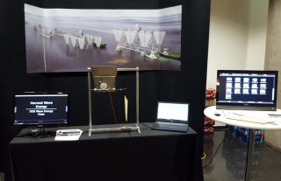
Harvest Wave Energy's exhibition stand (Photo: Harvest Wave Energy)
Harvest Wave Energy, one of the finalists of the US Department of Energy sponsored Wave Energy Prize competition, has presented its wave energy technology at the White House Frontiers Conference held last week.
The conference was hosted by the US President Barack Obama, together with the University of Pittsburgh and Carnegie Mellon University, with the aim to explore the future of innovation in the US and around the world.
In addition to Harvest Wave Energy, the list of other exhibitors included some of the world’s greatest research and technology teams working on space exploration, artificial intelligence, smart cities, precision medicine, and clean energy.
Harvest Wave Energy team presented its wave energy technology – a combined oscillating wave surge converter (OSWC) and heaving device wave energy system.
The team has recently completed the final 1:20 scale WEC testing at the MASK Basin in Carderock, Maryland, along with the other finalist teams competing for the cash prize.
The winner(s) of the Wave Energy Prize challenge, which aims to double the performance of wave energy conversion devices, will be announced on November 16, 2016.

WRAL TechWire

Triangle startup Harvest Wave Energy draws White House attention (+ video)

By Bill Warner; Oct. 28, 2016

RESEARCH TRIANGLE PARK, N.C. — The White House Office of Science and Technology recently honored Harvest Wave Energy, an RTP-based renewable energy technology company, at the first White House Frontiers Conference held recently in Pittsburgh.
Harvest Wave was selected for their technology innovation in developing an entirely new approach to capturing energy from ocean waves that has promise to be another viable and more consistently available source of renewable energy.
They are currently participating as a finalist in the Department of Energy’s Wave Energy Prize which culminates by the end of they year, and were the only finalist invited to the event.
“We were totally surprised by the invitation and are proud to be recognized for being part of America’s renewable energy technology vision,” said Stewart Bible, CEO of Harvest Wave.
Co-hosted by President Obama, Carnegie Mellon University and the University of Pittsburgh, the conference was intended to imagine our Nation and the world in 50 years, and beyond. The list of other exhibitors included some of the world’s greatest research and technology teams working on space exploration, artificial intelligence, smart cities, precision medicine, and clean energy.
The purpose of the conference was to explore the innovations that will make the world healthier, more prosperous, more equitable, and more secure, and to spark conversation in five frontiers of innovation:
- Advancing healthcare innovation and precision medicine;
- Building smart and inclusive communities;
- Harnessing the potential of artificial intelligence;
- Accelerating the clean energy revolution; and
- Fostering space exploration, including our journey to Mars
That wave energy was one of 24 invited exhibitors speaks to the fact that the wave energy industry is gaining traction as an emerging technology capable of meaningfully contributing to our Nation's and the world’s clean energy challenges.
Harvest Wave took full advantage of the opportunity to spread the word about the potential of the world's oceans to power the world's homes and businesses. Their work continues to unlock all of these wonderful opportunities, and the progression of their technology over the last year and half creates great optimism for the future. 2017 promises to be another exciting year, full of continued technology development and front-end engineering of the first ocean going demonstration.
Tidal Energy Today
Wave Energy Prize winner to be unveiled mid-November
Nov. 1, 2016

zoomIllustration (Image: Wave Energy Prize)
Wave Energy Prize challenge, launched by the US Department of Energy, will unveil the winner(s) of the 18-month long competition on November 16.
The winner(s) will be revealed during the Wave Energy Prize Innovation Showcase to be held at Naval Surface Warfare Center Carderock, Maryland.
The competition, which started back in spring 2015, saw 9 finalist teams overcome several challenges including writing technical submissions, test plans, and build plans; construction of 1:50 scale models; small-scale testing; and numerical modelling of their WEC’s performance.
Finally, after building 1:20 scale WEC prototypes, the teams completed the testing of their devices at the Navy’s Maneuvering and Seakeeping (MASK) Basin in Carderock.
“For our teams, whether they are the winner of the $1.5 million grand prize or not, November 16 is not the end, but rather a new beginning. In the months following the Prize, the teams will analyze the data obtained during testing at the MASK Basin to help bring their innovative technologies to the market,” Wave Energy Prize administration said.
Having completed all testing activities, the teams are now waiting for the judges to determine how many teams were able to meet or exceed the Prize’s goal of doubling the energy captured from ocean waves, and to ultimately announce whose technology met or exceeded the required average climate capture width per characteristic capital expenditure (ACE) value and produced the highest hydrodynamic performance quality (HPQ).

Portland Business Journal

Portland wave energy team snags a coveted $1.5M prize

Nov. 16, 2016; By Pete Danko

Score one for the underdogs, the outsiders, the dreamers, the guys with day jobs toiling in the early mornings and late at night.
And score one for Oregon, the state that has positioned itself as the nation’s wave energy leader.
Enlarge
The AquaHarmonics team — Alex Hagmuller, left, and Max Ginsburg — stand with the… more
REBECCA HAGMULLER
AquaHarmonics, the Portland duo of Alex Hagmuller and Max Ginsburg, won a remarkable victory Wednesday morning, taking the $1.5 million first prize in the U.S. Department of Energy’s Wave Energy Prize.
AquaHarmonics emerged the winner from among 92 teams that entered the competition in early 2015. All the teams were aiming to reach a standard set out by the competition, to double the energy capture of wave energy per unit structure cost.
There was no guarantee that anyone would hit the mark, but four teams did, with AquaHarmonics posting the highest score and taking the top prize.
A second Oregon team, M3 Wave of Salem, also advanced to the nine-team finals, and placed eighth.
“It’s actually pretty unbelievable,” AquaHarmonics team leader Hagmuller said in an interview from suburban Washington, D.C., where the competition finals and Wednesday's announcement were held, at the Naval Surface Warfare Center Carderock Division.
“We always liked our concept, of course, but then the competition and all the testing gave us the chance to learn so much and really advance our technology. We wanted to take advantage of those opportunities, and in the end the work paid off.”
Nobody in wave energy is flush with money, but several of the teams in the competition were past DOE grant recipients. Not so AquaHarmonics.
The Oregon State University alums — Hagmuller graduated in 2009, Ginsburg in 2010 — entered the competition mostly in the hope of advancing far enough to get the chance to test their concept in a wave pool, a cost-prohibitive proposition otherwise.
Qualifying for the finals was a huge breakthrough, giving them $125,000 to build the 1/20th-scale device and pay for testing at OSU's Hinsdale Wave Research Lab early this summer. Then came two weeks Back East for the finals, providing yet more opportunity to dial in the tech.
The team’s wave energy converter falls in the category of “point absorber.” It’s a cylindrical buoy with a cone top and bottom and a mooring line that reels out on the rise of the wave, generating power, then is reeled back in on the wave’s fall. Hagmuller has referred to it as a “glorified winch.”
It's a smallish device — 50 feet in diameter at full scale — but one that has a big brain, you might say, with sophisticated controls used to maximize power capture. As one of the judge's noted in a video on the winners, that allows the device "to do well across across a range of sea states."
Beyond the technical aspects of their device, Hagmuller said the key to victory was teamwork. "Max and I match up really well," he said, with Ginsburg strong on electronics and software and Hagmuller strong on mechanics.
Hagmuller said he and Ginsburg are eager to use the money to scale up their device, but for now they're keeping their days jobs, Hagmuller at Precision Castparts, Ginsburg at the cybersecurity firm Cylance. One thought is to leverage their winnings to pursue a possible DOE funding opportunity that would finance development and testing of a quarter-scale device in open water.
Then again, maybe being Wave Energy Prize winners will open the door to other possibilities.
Hagmuller was hopeful but unsure on that count. He did, though, allow for one certainty: "I guess we're not the unknowns we were before."

renews

AquaHarmonics wins wave prize

Nov. 16, 2016

CalWave, Waveswing America take second and third place
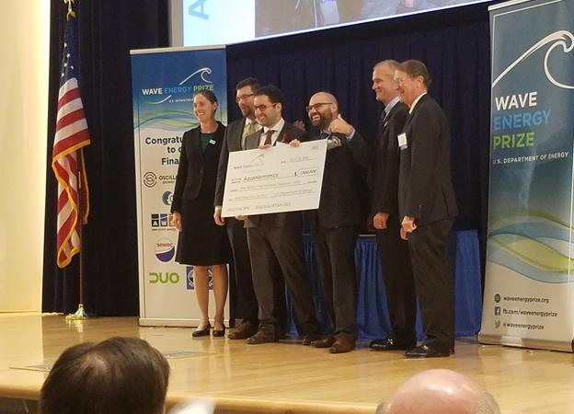16/11/2016
Oregon's AquaHarmonics has won the US Department of Energy’s $1.5m Wave Energy Prize.
Second place was awarded to California’s CalWave Power Technologies, with Scottish developer AWS Ocean Energy’s US subsidiary Waveswing America taking third prize.
The Wave Energy Prize kicked off in spring 2015 with 92 contestants submitting technical submissions, test plans and build plans.
The plans culminated in the construction of 1/50th-scale models.
In March, nine finalists were then chosen to build 1/20th-scale wave energy converter prototypes and test their devices at the US Navy’s Maneuvering and Seakeeping Basin in Maryland.
Image: Wave Energy Prize ceremony (US DoE/Seth Larson)
Voice of America
Team Wins $1.5 Million for Wave Energy Device
Nov. 17, 2016; By George Putic

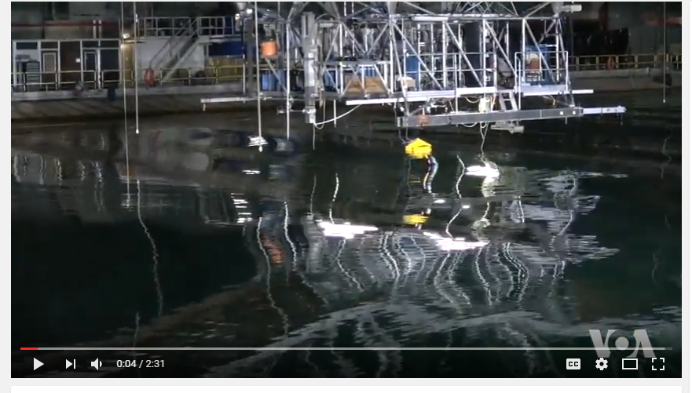
Two engineers from Oregon have won the U.S. Department of Energy's competition for devices that capture the energy of ocean waves. Their small firm, Aqua Harmonics, will receive $1.5 million for the design of a prototype that could cheaply and effectively generate electricity. VOA's George Putic reports.
Tidal Energy Today
AquaHarmonics scoops $1.5M US wave prize
Nov. 17, 2016
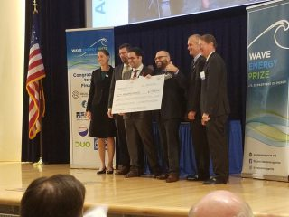
Aquaharmonics presented with the award (Photo: US DoE/Seth Larson)
AquaHarmonics has been declared a winner of US Department of Energy’s Wave Energy Prize challenge, securing a $1.5 million cash prize.
CalWave Power Technologies and Waveswing America were awarded second and third place, respectively, with $500,000 and $250,000 in cash prizes, following an 18-month long competition.
Ninety-two teams registered for the competition back in April 2015, for which the main goal was to develop game-changing wave energy devices that will ultimately reduce the cost of wave energy.
Lynn Orr, US Department of Energy’s Under Secretary for Science and Energy, said: “The Wave Energy Prize marks a significant advance for marine energy. This competition set a difficult threshold of doubling the energy captured from ocean waves, and four teams surpassed that goal. AquaHarmonics’ technology leap incentivized by the Energy Department demonstrates how rapid innovation can be achieved in a public prize challenge.”
AquaHarmonics was competing with its point absorber with latching/de-clutching control wave energy converter, CalWave Power Technologies with submerged pressure differential device, and Waveswing America with subsea pressure differential point absorber wave energy device.
Over the course of the competition, a panel of judges ultimately identified nine finalists and two alternates, which were announced in March.
These teams received up to $125,000 in seed funding to build scaled prototypes of their wave energy converter devices.
With the support of the US Navy, the finalist teams tested their prototype devices at the Naval Surface Warfare Center’s Maneuvering and Seakeeping Basin at Carderock, Maryland.

Navy News Service
Carderock Division Hosts Wave Energy Prize Innovation Showcase
Nov. 17, 2016
By Petty Officer 2nd Class Jackie Hart, Defense Media Activity
WEST BETHESDA, Md. (NNS) -- Naval Surface Warfare Center, Carderock Division hosted the Wave Energy Prize Innovation Showcase in West Bethesda, Maryland, Nov. 16.
Distinguished guests for the showcase included U.S. Department of Energy Under Secretary for Science and Energy, Dr. Franklin Orr; Assistant Secretary of the Navy (Energy, Installations & Environment), retired Vice Adm. Dennis McGinn; Deputy Assistant Secretary of the Navy for Energy, Joseph Bryan; and Founder, Chairman, and CTO of Masten Space Systems, David Masten, who also served as guest speaker.
The showcase featured nine finalist teams from around the U.S. who designed, built, and tested devices aimed to harness the power of the ocean, in an effort to establish a way forward in commercializing a cleaner and seemingly endless form of energy.
"If you look around, it doesn't take long to go to the beach and see, 'Wow, that's a lot of energy,'" said McGinn. "So figuring out how we can harvest that energy in an inexpensive, reliable way makes so much sense. It will add to our energy portfolio ... having this added to it, along with wind and solar [power] just makes a lot of sense."
Development stages for the Wave Energy Prize consisted of 68 competitors designing devices such as terminators, line absorbers, and point absorbers, then building and testing them on a 1/50 scale. The nine finalists also conducted further testing on 1/20-scale prototypes of their devices in Carderock's Maneuvering and Seakeeping (MASK) Basin, which is capable of simulating precise wave environments with 216 individually-controlled, electro-mechanical wave boards.
In the end, AquaHarmonics, a two-person team from Portland, Oregon, won first prize with a device which quintupled the baseline energy production requirement.
"Our goal was to build a device that would extract energy from ocean waves, and we attempted to do that by building a buoy with a generator inside, anchored to the seafloor, [so] any relative motion from the point on the seafloor to the elevation of the device will cause the generator to spin, producing electricity," said Max Levites-Ginsburg of AquaHarmonics. "We were working out of a garage, we didn't have a lot of resources, [and] we didn't have great facilities ... it was very surprising to us what we were able to achieve."
Levites-Ginsburg and teammate, Alex Hagmuller, began building small-scale wave energy prototypes five years ago, and their collective knowledge gained along the way led to a simple, efficient, and superior design worthy of the Wave Energy Prize.
"It says so much about America, about America's innovation, [and] our inventors that this small team literally operating out of a garage in Portland, Oregon, [has] won this $1.5 million Wave Energy Prize," said McGinn. "For them, this is just the beginning. It's a wonderful milestone, and they will be moving forward to continue to refine and scale up this type of technology."
The Wave Energy Prize is a public prize competition open to all U.S. entities, sponsored by the U.S. Department of Energy and supported by the Office of Naval Research and NSWC, Carderock Division.
Naval Surface Warfare Center, Carderock Division, a part of Naval Sea Systems Command, leads the Navy in hull, mechanical, and electrical engineering. Headquartered in West Bethesda, Maryland, Carderock Division employs approximately 2,000 scientists, engineers, technicians, and support personnel and includes detachments in Norfolk (Little Creek); Port Canaveral, Florida; Fort Lauderdale, Florida; Memphis, Tennessee; Bangor, Washington; Ketchikan, Alaska; and Bayview, Idaho.
For more information, visit http://www.navy.mil/, http://www.facebook.com/usnavy/, or http://www.twitter.com/usnavy/.
For more news from Naval Surface Warfare Center, Carderock Division, visit http://www.navy.mil/local/nswcc/.

UC Newsroom

CalWave rides Wave Energy Prize

Nov. 17, 2016; By Brian Back, UC Newsroom

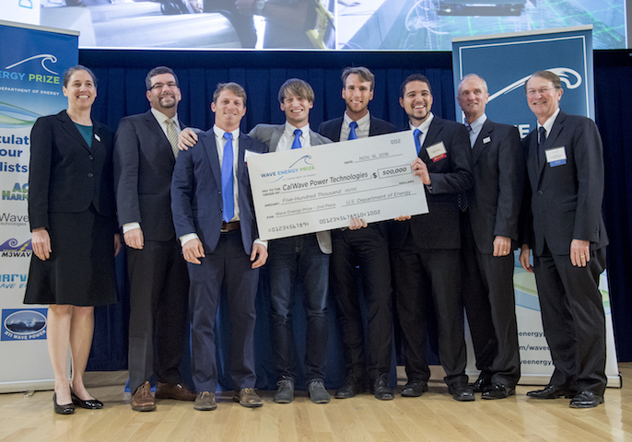
Credit: U.S. Department of Energy
Led by Marcus Lehmann (fourth from right), the CalWave Power Technologies team accepts its Wave Energy Prize.
UC startup CalWave Power Technologies and its novel “wave carpet” earned second place out of an initial 92 teams vying for the Wave Energy Prize, the U.S. Department of Energy announced this week.
The two-year competition to accelerate the reliability and affordability of renewable wave energy will yield CalWave $500,000 in prize money, in addition to the $125,000 in seed funding it earned as a finalist. First place went to AquaHarmonics of Portland, OR.
After final testing of 1/20-scale models this summer at the nation’s most advanced wave-making facility, the football field-sized Naval Surface Warfare Center’s Maneuvering and Seakeeping Basin in Maryland, CalWave was one of four teams that surpassed a goal of doubling the energy captured from ocean waves, said Lynn Orr, DOE’s undersecretary for science and energy. CalWave especially stood out in the category of economic viability, which focused on the costs of mass production.
Marcus Lehmann, a visiting student-researcher at Lawrence Berkeley National Laboratory, launched the startup based on technology pioneered by Reza Alam, a UC Berkeley engineering professor. Lehmann and his team were among the first cohort of the competitive Cyclotron Road incubator at Berkeley Lab. He said the prize money will allow CalWave to continue operations as it graduates from Cyclotron Road.
Unlike many of its peers, CalWave’s technology extracts energy not at the choppy surface of the ocean but from muddy sea beds that absorb more energy below. It features an elastic composite “magic carpet” stretched across a grid of corrosion-resistant cylinders and double-action piston pumps.
“We have not yet reached the limits of our performance,” Lehmann said. “The Wave Energy Prize was a great way of learning that will lead to another round of iteration.”
Renewable energy experts peg wave energy at the place wind energy was decades ago: Many technologies are being tested, but none has emerged as an optimal solution that could sweep the globe. Yet with more than 50 percent of the population living within 50 miles of coastlines in the United States alone, the potential remains huge.
Lehmann said CalWave is now focused on securing grant money to further optimize the technology in a deep-water application, which he hopes will ultimately lead to full-scale ocean demonstration.
CalWave has been featured in National Geographic, Fast Company, Reuters and other media outlets.

HydroWorld

DOE names AquaHarmonics winner of US$1.5 million in Wave Energy Prize competition

Nov. 17, 2016; By Greg Poindexter, Associate Editor
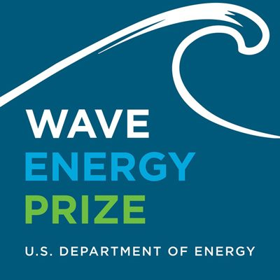
Yesterday the U.S. Department of Energy's (DOE) Office of Energy Efficiency and Renewable Energy announced Portland, Oregon-based AquaHarmonics will receive US$1.5 million as the first place winner of the Wave Energy Prize competition.
Two California-based contestants – CalWave Power Technologies out of Berkley, and Waveswing America in Sacramento – were awarded second and third place, respectively, with $500,000 and $250,000 in cash prizes.
An 18-month design-build-test competition, the Wave Energy Prize focuses on catalyzing the development of game-changing wave energy converters that will ultimately reduce the cost of wave energy. Wave energy technology could one day provide clean, cost-competitive, reliable energy for homeowners, communities, businesses, and government in geographically suited parts of the United States.
"The Wave Energy Prize marks a significant advance for marine energy," said Lynn Orr, DOE under secretary for Science and Energy. "This competition set a difficult threshold of doubling the energy captured from ocean waves, and four teams surpassed that goal. AquaHarmonics' technology leap incentivized by the Energy Department demonstrates how rapid innovation can be achieved in a public prize challenge."
Ninety-two teams registered for the prize beginning in April 2015. Over the course of the competition, a panel of judges ultimately identified nine finalists and two alternates, which were announced in March. These teams received up to $125,000 in seed funding to build scaled prototypes of their wave energy converter devices. With the support of the U.S. Navy, the finalist teams tested their prototype devices at the nation's most advanced wave-making facility, the Naval Surface Warfare Center's Maneuvering and Seakeeping Basin at Carderock, Maryland.
Wave energy is produced by converting the energy from waves into electricity. It has the potential to be a substantial resource to deliver renewable energy to the United States. The wave energy sector is in its early stages of development, and the diversity of technologies makes it difficult to evaluate the most technically and economically viable solutions.
The Wave Energy Prize Competition has addressed this challenge by comparing a wide range of device types and evaluating them against a threshold requirement for high energy capture. The Prize has already facilitated rapid technical innovation, and in the next year, the Energy Department will publish data from all the finalist teams' test results to further accelerate advancement of this sector.
"It's been a project we've been working on since even before the Wave Energy Prize was announced," said Max Ginsburg from AquaHarmonics. "As we progressed towards the finals, it just got more and more exciting."
Go to water.energy.gov for information on the Water Power Technologies Office funding opportunities that sponsor the development of innovative technologies that generate renewable, environmentally friendly, and cost-competitive electricity from water resources. To see the full results of the competition or for more information about the Wave Energy Prize, go to waveenergyprize.org.

Utility Dive

Wave energy developer AquaHarmonics wins DOE $1.5M prize

Nov. 17, 2016; By Robert Walton

Dive Brief:
- The U.S. Department of Energy has selected winners of its Wave Energy Prize, awarding Portland-based AquaHarmonics its top prize of $1.5 million for the group's point-absorber energy technology.
- CalWave Power Technologies, which focused on deep-water power generation, was awarded the second prize of $500,000.
- The 18-month design-build-test competition aimed to reduce the cost of wave energy. DOE officials called AquaHarmonics project a "technology leap" forward.

Dive Insight:
More than half of the United States population lives within 50 miles of coastline, but wave-energy technology has thus far been cost prohibitive at large scale. However the DOE hopes to move the technology forward through this program, and has tapped three technologies for further development, envisioning a future of clean energy along the country's coast.
In addition to AquaHarmonics and CalWave, competitor Waveswing America took third place in the competition and won $250,000.
“This competition set a difficult threshold of doubling the energy captured from ocean waves, and four teams surpassed that goal," said Lynn Orr, DOE’s Under Secretary for Science and Energy.
But the projects haven't always proven successful. From 2008 to 2015, DOE’s program awarded an estimated $136 million for 92 MHK energy projects, according to the Department’s recent project update. Yet there are no U.S. commercial installations and few pilots with real promise.
More than 90 teams registered for the competition in spring 2015, with judges ultimately identifying nine finalists and a pair of alternates. Those teams received up to $125,000 to build scaled prototypes of their wave energy converter devices. The devices were then tested at the Naval Surface Warfare Center's Maneuvering and Seakeeping Basin at Carderock, Md. The top prize was awarded to the project farthest along in development.

Marine Technology News

Wave Energy Prize's $1.5 Million Winner Announced

Nov. 17, 2016; By Eric Haun

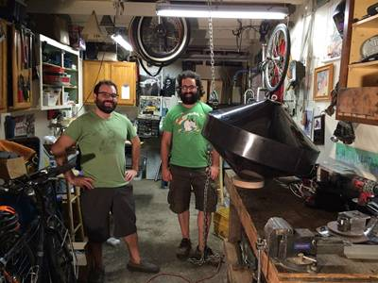
The AquaHarmonics team, Alex Hagmuller and Max Ginsburg, stand with its 1/20th scale device. (Photo: Wave Energy Prize)
Ninety-two teams competed in the U.S. Department of Energy’s (DOE) Wave Energy Prize, which began in April 2015 and seeks to spur the development of wave energy converters that will ultimately reduce the cost of wave energy in the U.S.

Now, following 18 months of designing, building and testing, a winner has emerged.

A duo from Portland, Ore., Alex Hagmuller and Max Ginsburg – together AquaHarmonics – were named the winners of the $1.5 million grand prize for their AquaHarmonicsWEC concept, a point absorber with latching/de-clutching control.

Though the contest officially kicked off in 2015, the team’s work together stretches about five years, when Hagmuller started to build small scale wave energy prototypes and enlisted Ginsburg, his friend from Oregon State University, to help design the electrical components and software. Together they built and tested several different wave energy prototypes, and the knowledge gained from each has led to many improvements and changes in the design.

“It’s been a project we’ve been working on since even before the Wave Energy Prize was announced,” Ginsburg said. “As we progressed towards the finals, it just got more and more exciting.”

Over the course of the competition, a panel of judges narrowed down the competition pool to nine finalists and two alternates, which were announced in March. These teams received up to $125,000 in seed funding to build scaled prototypes of their wave energy converter devices. With the support of the U.S. Navy, the finalist teams tested their prototype devices at the nation's most advanced wave-making facility, the Naval Surface Warfare Center's Maneuvering and Seakeeping Basin at Carderock, Md.

“This competition set a difficult threshold of doubling the energy captured from ocean waves, and four teams surpassed that goal,” said Lynn Orr, DOE’s Under Secretary for Science and Energy. “AquaHarmonics’ technology leap incentivized by the Energy Department demonstrates how rapid innovation can be achieved in a public prize challenge.”

Wave energy is produced by converting the energy from waves into electricity. This technology is expected to be a substantial resource in the delivery of renewable energy to the U.S. According to the DOE, hopes are that wave energy technology could one day provide clean, cost-competitive, reliable energy for homeowners, communities, businesses and government in geographically suited parts of the U.S.

The wave energy sector, however, is in its early stages of development, and the diversity of technologies makes it difficult to evaluate the most technically and economically viable solutions. The Wave Energy Prize Competition, which compared a wide range of device types and evaluated them against a threshold requirement for high energy capture, has already facilitated rapid technical innovation.

“The Wave Energy Prize marks a significant advance for marine energy,” Orr said.

In the next year, the Energy Department will publish data from all the finalist teams’ test results to further accelerate advancement of this sector.

CalWave Power Technologies and Waveswing America were awarded second and third place, respectively, with $500,000 and $250,000 in cash prizes.

KATU-2 (Portland, OR)

Portland wave-energy company wins grand prize in USDOE competition

Nov. 17, 2016

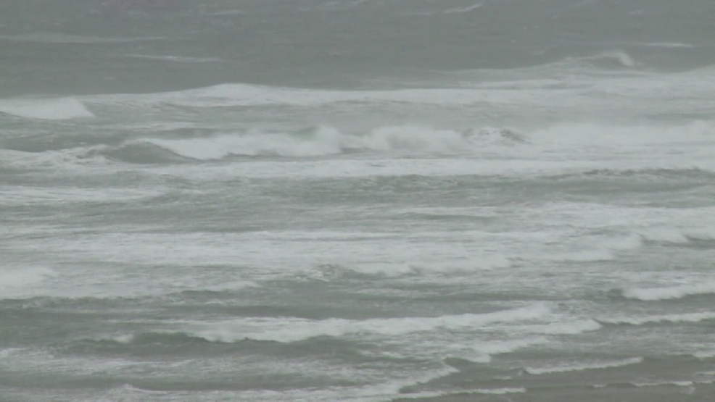
KATU File Photo.
PORTLAND, Ore. — Oregon is emerging as one of the country’s leaders in wave-energy development, and a local company is helping pave the way.
The federal government awarded Portland’s AquaHarmonics $1.5 million Wednesday. The company beat out 92 teams in the U.S. Department of Energy’s wave-energy competition.
The company came up with a way to double how much energy researchers can collect from waves.
M3 Wave of Salem placed eighth in the competition. The company successfully deployed a test wave-energy device off the coast of Oregon for about two weeks in September 2014. Its technology sits on the bottom on the ocean and uses the motion of waves to inflate and deflate bags. The moving air is used to turn a turbine.
KATU.com featured the scrappy startup in August of that year.
The state of Oregon has worked to form rules to regulate the industry off its coast. In January 2013, a commission approved rules outlining where wave-energy companies can deploy their devices.
But not everything has gone smoothly for the nascent technology industry in Oregon.
In the spring of 2014, New Jersey’s Ocean Power Technologies Inc. pulled the plug on its planned wave-energy park off the coast of Reedsport. The company ran out of money, ran into technical problems and said federal requirements helped contribute to the end of its Oregon project.
Nevertheless, USDOE has continued to support the birth of the wave-energy industry in the United States. It said in a news release about the AquaHarmonics wave-energy prize that more than half of the population of the United States lives within 50 miles of a coast and “there is vast potential to provide clean, renewable electricity to communities and cities across the United States using wave energy.”
The agency said its prize has helped catalyze innovation in the industry.

SeeNews Renewables

AquaHarmonics wins USD-1.5m wave energy grant from US DOE

Nov. 17, 2016; By Ivan Shumkov
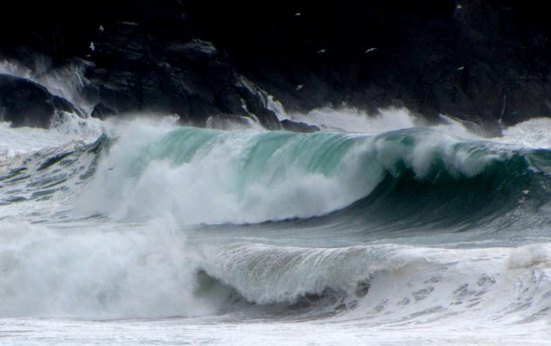Wave. Author: Barbara Walsh. License: Creative Commons. Attribution 2.0 Generic
November 17 (SeeNews) - AquaHarmonics has won the USD-1.5-million (EUR 1.4m) grand prize in a 18-month design-build-test competition for developers of ocean wave energy converters (WEC), the US Department of Energy (DOE) said on Wednesday.
The runner-up in the so-called Wave Energy Prize competition is CalWave Power Technologies, which got a USD-500,000 grant, while Waveswing America ended on third position and received a USD-250,000 cash prize.
The competition started in April 2015, when 92 teams were registered. In March 2016, a panel of judges selected nine finalists and two alternates that were then tasked with developing a 1/20th-scale model of their WECs. They tested their prototypes at the Naval Surface Warfare Center's Maneuvering and Seakeeping Basin at Carderock, Maryland.
“This competition set a difficult threshold of doubling the energy captured from ocean waves, and four teams surpassed that goal,” said Lynn Orr, the DOE’s Under Secretary for Science and Energy.
The DOE will publish data from all the finalist teams’ test results next year.
(USD 1.0 = EUR 0.935)

Kallanish Energy

AquaHarmonics wins $1.5 million Wave Energy Prize

Nov. 18, 2016
An Oregon company has won a $1.5 million Wave Energy Prize from the U.S. Department of Energy.
(Subscription only)

Clean Technica
Giant Floating Frisbee Wins $1.5 Million Wave Energy Grant From DOE
Nov. 18, 2016; By Tina Casey
The makers of a prototype wave energy converter that looks like a conical floating Frisbee have won $1.5 million in funding from the US Department of Energy, enabling them to keep working toward a commercial scale device. The grant comes from the agency’s Wave Energy Prize, a competition designed to fast track solutions for squeezing the most renewable energy juice out of coastal waters at the lowest cost.
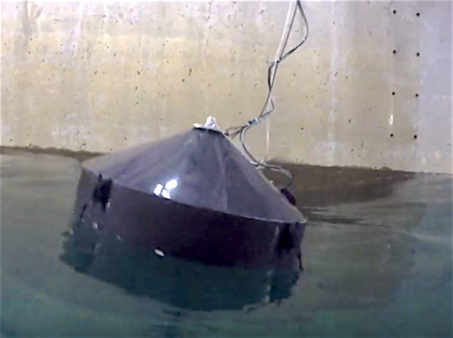

What’s Behind The Wave Energy Prizewinner
The current crop of buoy-type wave energy devices can be roughly divided in two types. In one type, the “works” are unenclosed. The benefits are that you shed the weight and expense of an outer hull, but anti-corrosion measures have to be stepped up.
The kelp-like bioWave and the US Navy-backed StingRAY are two examples of that type.
The other type hides all the goodies within a fully enclosed hull. One example of that type is already well on its way to commercialization. That’s the device from Australia’s Carnegie Wave Energy, which CleanTechnica has been following along with our sister site PlanetSave. Carnegie has already hooked up its technology with a naval base in Australia, and it recently announced plans to go international with an installation at the UK’s Cornwall Wave Hub.
Unfortunately for us, the Wave Energy Prizewinner — Portland, Oregon’s Aquaharmonics — has followed the Carnegie approach. They don’t have a schematic readily available (if you can find one, drop a note in the comment thread), so there’s not much we can show you on that score.
However, if you take a look at the photos on the Aquaharmonics website (here’s that link again), you can pick up a few clues about what’s going on inside that sleek hull.

What’s Really Behind The Wave Energy Prizewinner
If the photos don’t seem to reveal any new, cutting edge technology, that’s on purpose. Aquaharmonics’s winning strategy is based on deploying known technology in an optimal way.
The hull, for example, is made of carbon fiber reinforced plastic. CFRP provides the required level of durability while providing for a lightweight, relatively inexpensive enclosure:
That choice of material also gave the team an important edge in the time-sensitive Wave Energy Prize competition. This update provides some insight:
The other exciting thing about CFRP is making a back up device becomes pretty easy and quick once the molds are made. Our first layer of carbon has been laid up, and many of the custom fabricated components are complete and en-route to us. This means that the hull is now waiting on these parts for completion instead of the other way around!
As for the device’s innards, the team took a look at other technologies that have been optimized, such as wind turbines, cars, and airplanes. They came to this conclusion:
As humans we are very good at optimizing something once we know what to optimize, and with wave energy, we don’t know what that is yet. We all know the best ways to make power from wind energy for instance. It is a blade attached to a generator placed on a tower.
[snip]
Wave energy simply hasn’t found the device to focus on for optimizing. Once we do, the development will certainly move very quickly to becoming highly competitive.
And, here’s how the team sums up its approach:
Our device Power Take Off is unique in that it uses relatively simple and well known power technologies to convert wave motion to electrical power in very few steps, with no limit in operational stroke, meaning it can make full use of any given wave height with no “end stop” conditions.

Game-Changing Energy For The USA
The US has some catching up to do when it comes to the global ocean energy scene, but the payoff could be significant. Here’s how the Energy Department sums it up:
With more than 50 percent of the U.S. population living within 50 miles of coastlines, there is vast potential to provide clean, renewable electricity to communities and cities across the United States using wave energy.
There is certainly plenty of interest in the engineering community. The agency’s 18-month design/build competition attracted 92 entries.
As for the future of federal funding for wave energy development in the US, the incoming Trump Administration appears to be playing a giant guessing game as the Oval Office transitions to a new occupant.
On the other hand, the US Navy provided its test facilities to support the Wave Energy Prize, so it’s possible that some further assistance from the Department of Defense will enable Aquaharmonics and the two runners-up (CalWave Power Technologies and Waveswing America) to continue working along the path to commercialization.
Follow me on Twitter and Google+.
Image (screenshot, enhanced): via Aquaharmonics.

The Maritime Executive
Over $2 Million for Wave Energy Winners
Nov. 18, 2016
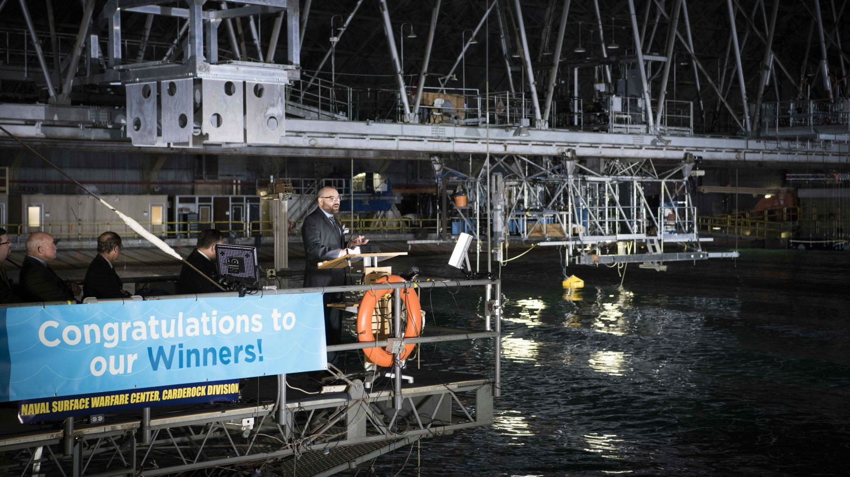
The U.S. Department of Energy’s Office of Energy Efficiency and Renewable Energy has awarded AquaHarmonics its Wave Energy Prize which comes with a $1.5 million grand prize.

CalWave Power Technologies and Waveswing America were awarded second and third place, respectively, with $500,000 and $250,000 in cash prizes.
With more than 50 percent of the U.S. population living within 50 miles of coastlines, there is vast potential to provide clean, renewable electricity to communities and cities across the United States using wave energy, says the department.
An 18-month design-build-test competition, the Wave Energy Prize focuses on catalyzing the development of wave energy converters that will ultimately reduce the cost of wave energy.
Ninety-two teams registered for the prize beginning in April 2015. Over the course of the competition, a panel of judges ultimately identified nine finalists and two alternates, which were announced in March. These teams received up to $125,000 in seed funding to build scaled prototypes of their wave energy converter devices.
With the support of the U.S. Navy, the finalist teams tested their prototype devices at the nation's most advanced wave-making facility, the Naval Surface Warfare Center's Maneuvering and Seakeeping Basin at Carderock, Maryland.
Wave energy is produced by converting the energy from waves into electricity. The wave energy sector is in its early stages of development, and the diversity of technologies makes it difficult to evaluate the most technically and economically viable solutions. The Wave Energy Prize Competition addressed this challenge by comparing a wide range of device types and evaluating them against a threshold requirement for high energy capture.
AquaHarmonics won the contest with their WEC concept and model of a point absorber with latching/de-clutching control. Alex Hagmuller and Max Levites-Ginsburg of team AquaHarmonics are both civilian engineers and graduates of Oregon State University.
"Our goal was to build a device that would extract energy from ocean waves," Levites-Ginsburg said. "Early on, we were working out of a garage and we didn't have a lot of resources or great facilities. We approached it trying to make the best of what we had, but we didn't really have a lot. It was really surprising what we were able to achieve."
Levites-Ginsburg said they built a buoy with a generator inside, anchored to the sea floor. Any relative motion from the point on the sea floor to the elevation of the device caused the generator to spin and produce electricity.

Tolerance.ca
Team Wins $1.5 Million for Wave Energy Device
Nov. 18, 2016
Two engineers from Oregon have won the U.S. Department of Energy's competition for devices that capture the energy of ocean waves. Their small firm, Aqua Harmonics, will receive $1.5 million for the design of a prototype that could cheaply and effectively generate electricity. VOA's George Putic reports.
(links to VOA story)

KBND (radio)
Portland Company Wins Wave Energy Tech Grant
Nov. 18, 2016
(Portland, OR) -- The federal government is giving a Portland company over a-million-dollars to develop its wave-energy technology. AquaHarmonics was announced the winner of the one-and-a-half-million-dollar federal grant on Wednesday, beating out over 90 other teams that competed for the prize. The company uses the force of ocean waves to create energy.

Portland Business Journal

The breakthrough that won the $1.5M Wave Energy Prize for Portland's AquaHarmonics
Nov 22, 2016, 9:48am PST Updated: Nov 22, 2016, 11:46am PST
Alison LaBonte, marine and hydrokinetic technology manager for the DOE, said she believes AquaHarmonics
The U.S. Department of Energy launched the Wave Energy Prize in search of breakthroughs for an industry struggling to reach commercial viability, and the department believes the winning team from Portland has hit on a big one.
“They did something nobody has really been able to accomplish before,” said Alison LaBonte, marine and hydrokinetic technology manager for the DOE, in the wake of last week’s announcement that AquaHarmonics had won the competition’s $1.5 million grand prize.
The big innovation by the team of Alex Hagmuller and Max Ginsburg was in devising a control system for their energy-absorbing buoy that keeps it in tune with the unpredictable rising and falling of the sea.
“People have theorized that doing so could result in a massive improvement in wave energy capture,” LaBonte said.
AquaHarmonics proved that out, shooting way past the competition’s goal of doubling today’s standard of energy capture at a set dollar cost.
Hagmuller called their approach “pay to play.”
Their buoy generates power when it rises on a wave and pulls out from a tether, spinning a generator inside the buoy. Keeping the line at just the right tension allows the device to perform most efficiently — and that extends to reeling the device back in at the moment and to the degree that is optimal.
Doing this eats up some of the energy the device has generated; that’s the pay. But AquaHarmonics found that if they dial the tension in just right, and time the reel-back precisely, it would yield net energy gains.
“We always have instantaneous control on that line,” Hagmuller explained. “It’s always under tension. That’s key in the control system.”
Remarkably, this isn't quite the method they went into the competition aiming to employ. Instead of maintaining constant control of the line tension, they had planned on using a "latching/declutching" system that grabs the device at its lowest point in the wave cycle, then lets go at a precisely determined time.
Insights from an engineer friend suggested a possible better way, and they set out to try to make it work. It was harrowing at times.
"There was a period where we were certain that nothing was going to work," he said.
It was in testing at Oregon State University in June — financed by making the Wave Energy Prize finals — that the new control system came together, setting the team up for a surprise victory in the finals.
LaBonte said the fact that AquaHarmonics was pretty much unknown in the wave energy world before the competition showed the Wave Energy Prize’s value. There are people out there who for a range of reasons aren't in a position to get the funding they need to pursue potentially significant innovations; the Wave Energy Prize, she said, opened a door for those people.
“When we put this out to the public, we were hoping to draw out of the woodwork ideas that were stewing,” she said. “By giving (AquaHarmonics) timelines and a clear, focused metric, then getting them in a test tank, they were able to do in 18 months what otherwise would have taken several years.”
Now she thinks AquaHarmonics is set up to grow from the competition experience and make a real difference in wave energy's prospects.
“They are being elevated and recognized by the broader sector now as having a winning technological concept with real potential,” she said. “They’re going to be able to quickly accelerate into connections they need in order to being successful.”
In a sign of just that, Hagmuller said a large company with an energy innovation arm contacted them. He didn’t want to name the company because the contact was quite preliminary, and he didn’t know what, if anything, would come of it.
For now, he said, AquaHarmonics was planning to get an accountant to help manage their funds — a “problem” they never had to worry about before, and chill a bit through the holidays before plotting a course for further work on their technology in the new year.
Pete Danko
Staff Reporter
Portland Business Journal

ExecutiveBiz

AquaHarmonics Wins DOE Wave Energy Converter Devt Competition

Nov. 21, 2016; By Ramona Adams

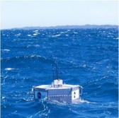AquaHarmonics has won a $1.5 million grand prize in the Energy Department‘s design-build-test competition that aims to support the development of wave energy converters.
DoE said Wednesday CalWave Power Technologies and Waveswing America will receive $500,000 and $250,000 in respective cash prizes as second and third place winners of the Wave Energy Prize.
“This competition set a difficult threshold of doubling the energy captured from ocean waves, and four teams surpassed that goal,” said Lynn Orr, DOE undersecretary for science and energy.
DOE added the 18-month challenge attracted 92 teams in April 2015 that a panel of judges narrowed down to nine finalists and two alternates in March.
All finalists received up to $125,000 in funds to develop wave energy converter prototypes that were tested at the Naval Surface Warfare Center’s Maneuvering and Seakeeping Basin in Carderock, Maryland, DOE noted.
The department will release data from the finalists’ test results to support the growth of the wave energy sector.

Daily Energy Insider
Energy Department awards AquaHarmonics Wave Energy Prize
Nov. 22, 2016

The Office of Energy Efficiency and Renewable Energy at the U.S. Department of Energy (DOE) awarded Oregon-based AquaHarmonics its Wave Energy Prize to facilitate the development of technology to convert energy from waves into electricity.
The award is the culmination of an 18-month design-build-test competition that comes with a grand prize of $1.5 million.
The Wave Energy Prize focuses on the development of wave energy converters that aims to reduce the cost of wave energy. Although the wave energy sector is in its early stages of development, the hope is that one day it will provide clean, reliable and cost-effective energy for many communities near coastlines in the United States.
“This competition set a difficult threshold of doubling the energy captured from ocean waves, and four teams surpassed that goal. AquaHarmonics’ technology leap incentivized by the Energy Department demonstrates how rapid innovation can be achieved in a public prize challenge,” Lynn Orr, the DOE’s Under Secretary for Science and Energy, said.
Second place winner CalWave Power Technologies will receive $500,000, and third place Waveswing America won $250,000 in seed funding to build scaled prototypes of their proposed converter devices.
The DOE said the prize has already facilitated innovation in the technologies and next year, the Energy Department will publish data from test results of all the finalist teams to further accelerate advancement of this sector.

Planetsave
Wave Energy Converter Prize is Awarded to AquaHarmonics
Nov. 23, 2016; By Carolyn Fortuna
AquaHarmonics has won a $1.5 million grand prize to support the development of wave energy converters. The U.S. Department of Energy’s (DOE) Office of Energy Efficiency and Renewable Energy announced the winner of the Wave Energy Prize, which is an 18-month design-build-test competition that assesses early stage wave energy technologies by comparing a wide range of device types and evaluating them against a threshold requirement for high energy capture.
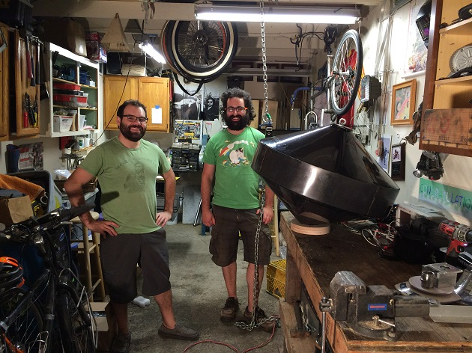

What is wave energy?
Wave energy is produced by converting the energy from waves into electricity. Since 50 percent of the U.S. population lives within 50 miles of coastlines, energy captured from ocean waves provides a vast potential for clean, renewable electricity to communities and cities. It is estimated that the technically recoverable wave energy resource is approximately 1,170 terawatt hours (TWh) per year, distributed across Alaska, the West Coast, the East Coast, the Gulf of Mexico, Hawaii, and Puerto Rico. Developing just a small fraction of the available wave energy resource could allow for millions of American homes to be powered with this clean, reliable form of energy.
The wave energy sector is in its early stages of development, and the diversity of technologies makes it difficult to evaluate the most technically and economically viable solutions. Wave energy converters capture the energy to generate electricity in three main categories:
- oscillating water columns that use trapped air pockets in a water column to drive a turbine;
- oscillating body converters that are floating or submerged devices using the wave motion (up/down, forwards/ backwards, side to side) to generate electricity; and,
- overtopping converters that use reservoirs to create a head and subsequently drive turbines.
Beginning in April 2015, ninety-two teams registered for the Wave Energy Prize. As the competition progressed, a panel of judges ultimately identified nine finalists and two alternates, which were announced in March. These teams received up to $125,000 in seed funding to build scaled prototypes of their wave energy converter devices. Their common thread was a willingness to consider non-traditional options and approaches alongside their dedication to the idea of bringing viable Wave Energy Converter technologies to the clean energy mix.
With the support of the U.S. Navy, the finalist teams tested their prototype devices at the nation’s most advanced wave-making facility, the Naval Surface Warfare Center’s Maneuvering and Seakeeping Basin at Carderock, Maryland. It’s the Navy’s biggest wave pool: 360-foot long, 240 foot-wide, and holds approximately 12 million gallons of water. It’s used to evaluate the maneuverability, stability and control of scale models. Carderock built the MASK Basin in 1962 to test the scale model performance of ships, platforms, and moored systems in realistic sea conditions.

The Wave Energy Prize as Innovation
The Wave Energy Prize has “been a project we’ve been working on since even before the Wave Energy Prize was announced,” said Max Ginsburg from AquaHarmonics. “As we progressed towards the finals, it just got more and more exciting.” The AquaHarmonics team officially consists of just two engineers working out of a garage. Ginsburg’s partner is Alex Hagmuller.
CalWave Power Technologies and Waveswing America received second and third places, respectively, in the Wave Energy Prize competition, with $500,000 and $250,000 in cash prizes.
The U.S.Wave Energy Prize focuses on catalyzing the development of game-changing wave energy converters that will ultimately reduce the cost of wave energy. The wave energy industry is young and is experiencing many new innovations, as evidenced by a sustained growth in patent activity. Wave energy technology could one day provide clean, cost-competitive, reliable energy for homeowners, communities, businesses, and government in geographically suited parts of the United States. The Wave Energy Prize has already facilitated rapid technical innovation, and in the next year, the Energy Department will publish data from all the finalist teams’ test results to further accelerate advancement of this sector.
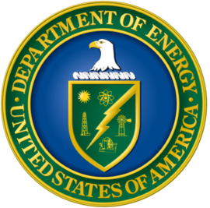
“The Wave Energy Prize marks a significant advance for marine energy,” said Lynn Orr, DOE’s Under Secretary for Science and Energy. “This competition set a difficult threshold of doubling the energy captured from ocean waves, and four teams surpassed that goal. AquaHarmonics’ technology leap incentivized by the Energy Department demonstrates how rapid innovation can be achieved in a public prize challenge.”
For both planning and technology development purposes, synergies with other offshore industries may become advantageous to the wave energy industry. Opportunities to develop dedicated infrastructures – including ports and transmission grids – to support the installation and operation and maintenance of wave energy converters are also on the forefront of energy evolution.

Harnessing a wave’s energy
Basically, a wave’s energy (95%) is located between the water surface and the top quarter of the wave length. One way to categorise wave energy technologies is by how the device extracts the surge, heave or sway motions of the wave (or a combination of each) (EMEC, 2014). In general, point absorbers convert the “heave” to drive a piston up and down, terminators and oscillating wave surge converters convert the “surge”, and attenuators convert the “pitch” of the wave to drive a rotor. Over half (53%) of WEC concepts developed are point absorbers, 33% terminators, and 14% attenuators (IRENA, 2014).
The wave energy market is still dominated by start-up companies and university spin-offs, which have been focusing on bringing technologies to pre-commercial status, promoting easy access to research facilities or supporting the creation of new demonstration sites at sea. Government funding through public research and development (R&D) investments, such as the Wave Energy Prize, has been key in this process. The DOE has chosen to focus on deep water devices, as driving down the cost of harnessing wave energy and deploying wave energy technologies at a large commercial scale requires proximity to close-to-shore markets as well as high wave energy resources.

Other resources about wave energy
Water Power Technologies Office website is a valuable source of information, as it sponsors the development of innovative technologies that generate renewable, environmentally friendly, and cost-competitive electricity from water resources. The Marine and Hydrokinetic Technology Database on the Open Energy Information (OpenEI) website provides information on wave energy projects, both in the United States and around the world.

Sources:
EMEC (The European Marine Energy Centre Ltd.) (2014), “Wave Devices”, www.emec.org.uk/marine-energy/wave-devices.
IRENA (International Renewable Energy Agency) (2014), Ocean energy technology: Innovation, Patents, Market Status and Trends, International Renewable Energy Agency, June 2014.

ENGINEERING.com
Two Guys in a Garage Win $1.5M Wave Energy Prize
Nov. 27, 2016; By Tom Lombardo
Some pretty famous business ventures began with two guys working out of a garage: Hewlett-Packard, Apple … even the Car Talk radio show, if you want to stretch it a bit. Engineers Alex Hagmüller and Max Ginsburg hope to add their company - AquaHarmonics - to the list. The duo is off to a good start, as they just won the US Department of Energy's 2016 Wave Energy Prize. Of the ninety-two teams that entered the competition, nine made it to the final round. Three walked away with a cash award, with AquaHarmonics taking home the gold. The $1.5M award will allow Hagmüller and Ginsburg to scale up their wave energy harvesting device in hopes of making it a commercially viable source of renewable energy.
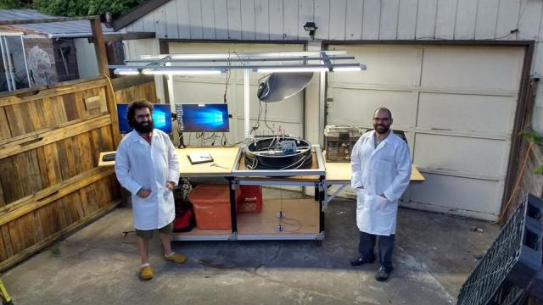
Max Ginsburg and Alex Hagmüller Outside The AquaHarmonics Laboratory

The AquaHarmonics wave energy converter is a point absorber that floats on the ocean surface while being tethered to the seafloor. Inside the buoy is a winch that acts as both a motor and a generator.

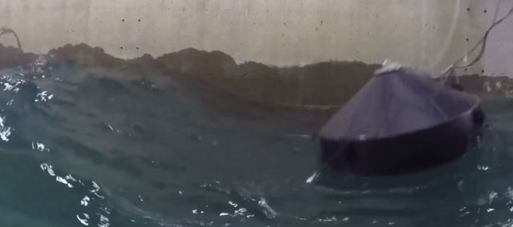
Wave Energy Converter in the Testing Tank

I asked Alex Hagmüller for more details about their prize-winning device. He was eager to share some information.

TL: What type of technology converts wave motion into electricity?
AH: The device is a point absorber style wave energy device, much like any typical buoy. Inside the buoy is Power Take Off (PTO) that essentially consists of an "over glorified winch". The winch has a motor/generator connected to the shaft, and its line end is connected to the sea floor. When the wave pushes the buoy up, power is extracted. On the fall of the wave, a clever control system activates the generator as a motor and reels up the line, until the next wave occurs.

TL: What is the output power of the small-scale prototype?
AH: The small scale prototype maximum peak output is around 800 watts, though this is in a storm condition, and this is instantaneous not average output.
TL: To what level can it be scaled up?
AH: The device tested is 1/20th scale, and our plan is to work on the design of a 1/4 scale device. The 1/20th scale device is approx. 2.5ft in diameter and at full scale the device would be around a 50-foot diameter. As far as power output at full scale, we are still awaiting all the data from testing, so I cannot speak accurately on that yet.
They'll Need a Much Bigger Car for the Full-Scale Device

TL: What price range are you shooting for ($/kW)?
AH: This is a difficult one to pin down for wave energy. For the wave energy prize, a metric was developed called the "ACE" metric. more here:
https://waveenergyprize.wordpress.com/2016/08/18/how-does-the-wave-energy-prize-calculate-ace/
https://waveenergyprize.wordpress.com/tag/representative-structural-thickness/
"The Wave Energy Prize has determined that the ACE value is 1.5 meters per million dollars (1.5m/$1M) in typical deep water locations on the West Coast of the United States. At the final gate, testing at 1/20th scale, WECs must achieve a threshold of 3m/$1M to be eligible to be considered for winning a monetary prize"
Therefore, the state of the art is not given a $/kW value for low technology readiness levels-it wouldn't be accurate. What I can say is that our device per the Wave Energy Prize beat the state of the art by a factor of around 4.9, so 4.9 times cheaper than current state of the art technology based on the scope of the wave energy prize.Our final score was 7.4m capture width per million dollars capital investment.
TL: Are there certain locations that lend themselves well to your product?
AH: West coast conditions have good energy flux/density and would be the best for cost effectiveness, however, they may be not the best places to do initial testing. That is to be determined.
TL: What advantages does your product have over other wave power devices?
AH: Our device is simple and robust, as well as efficient, over current wave energy devices. There are very few moving parts and the control system allows the device to actively input power back into the system at the right time in the waves so that greater power can be extracted over just passively damping the waves. This is what is known as "active control" or "reactive power" in the control world of wave energy devices.
Our device without a control system suffers from the same inefficiencies as any point absorber would if it were just passively damping the waves. This is due to the fact that the natural or resonant frequency of the device is higher than that of the waves that it is operating in. If the device can be tricked into resonance, then greater power can be extracted. Going back to the physics of a simple harmonic oscillator, the knobs you have to work with are mass, spring rate, and damping. Damping does not do much to change the natural frequency of the device, you don't want to make the device excessively heavy so mass is fixed, and therefore spring rate is all you have to tune. We tune this value dependent on the wave state to achieve maximum power output.

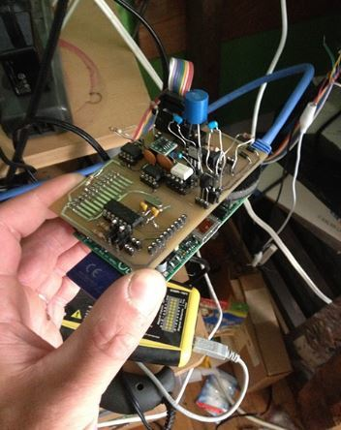
The Control System Works with a Raspberry Pi

The official Wave Energy Prize page has more information about the other teams in the competition. To learn about different kinds of wave energy devices, check out this article.

Images courtesy of AquaHarmonics

E&E News

2016 — the end or beginning of an era for marine energy?

Nov. 28, 2016; By Christa Marshall
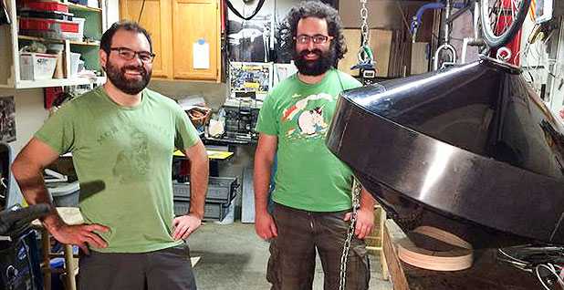
Alex Hagmuller and Max Ginsburg with their wave energy device. Photo courtesy of Rebecca Hagmuller.
Alex Hagmuller's years of tinkering in his garage just made him a millionaire.
The 34-year-old Oregonian led a team that this month won the Department of Energy's first-ever $1.5 million "wave energy prize," which awarded the device that most effectively at least doubles the energy captured from ocean waves via new technology.
Hagmuller and Max Ginsburg were able to quintuple the captured wave energy of previous devices, by building a system with a generator inside an anchored buoy to detect the tiniest of motions. Advocates said they hoped the technology might help lower costs.
"We're two guys who had an idea straight out of the garage, and we were able to achieve something big," Hagmuller said.
The engineer said he started building small prototypes in his house with Roomba vacuum cleaner parts and bicycle components after being inspired by an early wave energy device as a student at Oregon State University.
While the $1.5 million technically could be used for "going to Disneyland," the plan is to use it to apply for more federal grants to scale up the technology, he said.
The prize comes during a year that wave and tidal energy are, well, riding a wave.
In addition to the DOE announcement, the first U.S. grid-connected wave energy test facility became fully operational in July at a military base in Hawaii. Weeks later, Scotland launched the world's first large-scale tidal farm attached to the grid and Canada saw the deployment of a tidal turbine at a test facility in the Bay of Fundy.
"I've been working on this for 8 ½ years now, and this by far is the most exciting year. There's no question," said Paul Gay, vice president of Strategic Marketing Innovations.
The wave and tidal energy firsts are occurring now because of earlier policies and incentives converging at the same time.
The wave prize, for example, came after almost two years of winnowing 92 applicants and testing devices at the Navy's 2.5-acre wave pool in Carderock, Md.
Similarly, it took years to secure the resources necessary to complete the Navy's Wave Energy Test Site off Marine Corps Base Hawaii, which now comprises three wave energy devices at various depths in Kaneohe Bay near Oahu.
The first shallow device was deployed in 2001, followed by deeper-water devices this year. The project — the first to power a U.S. grid with wave energy — moved along as the Navy searched for more clean energy to power offshore installations, and DOE and companies provided support.
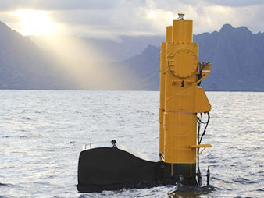
A wave energy device at the U.S. Navy's Wave Energy Test Site in Hawaii. Photo courtesy of U.S Department of Energy.
The state also has a mandate for 100 percent renewable power by 2045. In remarks this summer, officials cited President Obama's 2015 executive order calling for federal emission cuts as a driver.
"More power from more places translates to a more agile, more flexible and more capable force," Deputy Assistant Secretary of the Navy for Energy Joseph Bryan said at the time.
With tidal energy, renewable policy incentives put in place in Europe years ago are now leading to actual deployment of devices, said Angus McCrone, an analyst at Bloomberg New Energy Finance.
"It has taken a while for projects to be developed, utility-scale machines to be built and financing to be put in place," McCrone said. "Hence 2016 is going to be an important year for actual deployment of machines, and 2017 for gauging the performance of those devices."
Initial turbines from the MeyGen project in Scotland, the world's first large-scale tidal farm, produced electricity for the first time this year. Scotland's government is supporting the project via a renewable energy investment fund, with a goal of meeting a 100 percent renewable energy target. By the early 2020s, MeyGen Ltd. envisions 398 megawatts of offshore tidal turbines at the site.
The wave energy prize, meanwhile, was part of a broader push at DOE on a range of marine and hydrokinetic technologies, including devices that harness river currents or aim to harness power through temperature differences between the surface and ocean depths.
The goal is to tackle technical barriers such as corrosive seawater and storms that pose a threat to existing designs. There's also the challenge of getting more power per square inch of a device — a key factor in lowering costs. The current estimated cost of electricity from ocean energy is more than double that of solar, according to the National Renewable Energy Laboratory.
Hagmuller's AquaHarmonics — which is essentially a one-man company — was one of only four teams that was able to succeed in at least doubling the amount of energy captured from ocean waves though wave energy conversion devices.

High hurdles
In a sign of how young the U.S. industry is, both Hagmuller and Ginsburg — who met at Oregon State — have day jobs as engineers.
Hagmuller started years ago building a prototype for fun and testing gadgets off the Oregon coast, before spending about $10,000 of his own money to prepare for the DOE competition. The department provided $125,000 to build a larger model once AquaHarmonics became one of nine finalists.
The winning device is a variation of a technology known as a point absorber that resembles a Frisbee-like buoy.
Hagmuller said he spent years researching the right size for the device, which is smaller than most to reduce capital costs. It also uses a new type of control system to maximize output partly by allowing its generators to act as motors during the downswell of a wave.
There's been some interest from private investors since the prize announcement, Hagmuller said. DOE said it would publish data in the next year from all nine finalists to accelerate technology development.
Technology prizes may be limited in helping the industry, though.
Overall, marine and hydrokinetic technologies are where wind and solar were more than a decade ago, and they are not getting the needed federal support to jump to the commercial stage, advocates say. Europe invested about three times as much money as the United States over the past decade on marine technologies.
Despite increases in recent years, federal funding still lags behind wind and solar by about a third, Strategic Marketing Innovations' Gay said. Part of the reason for that is the Obama administration was focused on deploying technologies that could have a material impact on climate change within a decade, he said.
"I don't think we've been within that window," said Gay. When recently extended tax credits are included, current federal investments become "even more skewed toward wind and solar," Gay said.
Funding for DOE's water technologies program jumped from about $7 million in 2008 to $45 million last year, but advocates are calling for $125 million to boost the U.S industry.
DOE says the "technically recoverable" amount of wave energy is 1,170 terawatt-hours — 5 percent of that would be enough to power 5 million homes. Even so, Bloomberg New Energy Finance downgraded the outlook this year for both technologies, projecting a modest 87 MW of tidal and 15 MW of wave power will be online globally by decade's end.
With wave energy in particular, there have been many global setbacks in the last three years, including the bankruptcy of leading players like Pelamis, McCrone said.
The number of technology developers with sizable demonstration projects has shrunk, and investors are short of confidence, he said.
Tidal power is further along, partly because of lower costs than some other marine technologies. But there's little development outside Europe. The main tidal stream development of note in North America is at the Bay of Fundy in Nova Scotia, McCrone added.
As for President-elect Donald Trump, advocates are not entirely pessimistic. The military's support for marine technologies is providing some hope that project planning will continue.
"We are looking forward to working with the new administration," said Linda Church Ciocci, executive director of the National Hydropower Association.

Interesting Engineering

Garage Project Garners $1.5 Million Energy Award

Nov. 29, 2016; By Shelby Rogers

There have been several popular companies spawning from garages. Engineers Alex Hagmuller and Max Ginsburg hope to join the likes of Apple and Hewlett-Packard in taking their garage company AquaHarmonics to the next level.
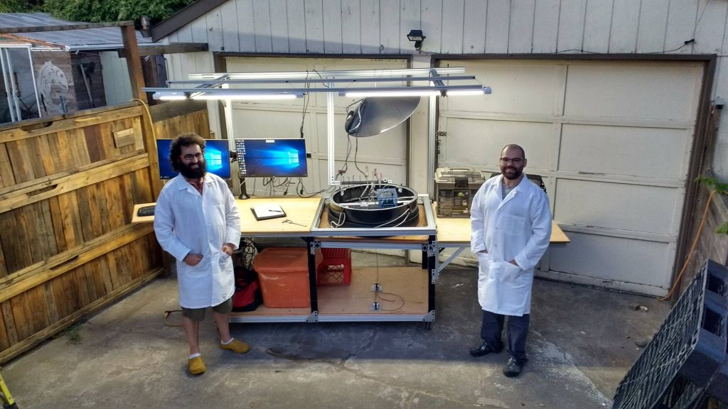[Image Courtesy of AquaHarmonics on Facebook]
AquaHarmonics recently won the US Department of Energy’s Wave Energy Prize. To be selected, they were one of nine finalists and had to be among the top three entries for cash earnings. The duo hopes to use the money and scale up their industry.
The prize itself looks for the best technology to take advantage of wave energy, both as a converter and as a product to lower current costs of wave energy. AquaHarmonics’s wave energy converter is a point absorber. It floats atop the ocean while being tethered to the seafloor. The buoy contains Power Take Off (PTO), “an over glorified winch” that serves as a motor and generator. The wave pushes the buoy up and power gets extracted. To conserve energy, the sysetm reels in the tethering line until the next wave comes.
In an interview with Engineering.com, Hagmuller said the small-scale prototype has a max output of 800 watts during storm conditions. He said AquaHarmonics wants take their 1/20 testing prototype and design a 1/4 scale device.
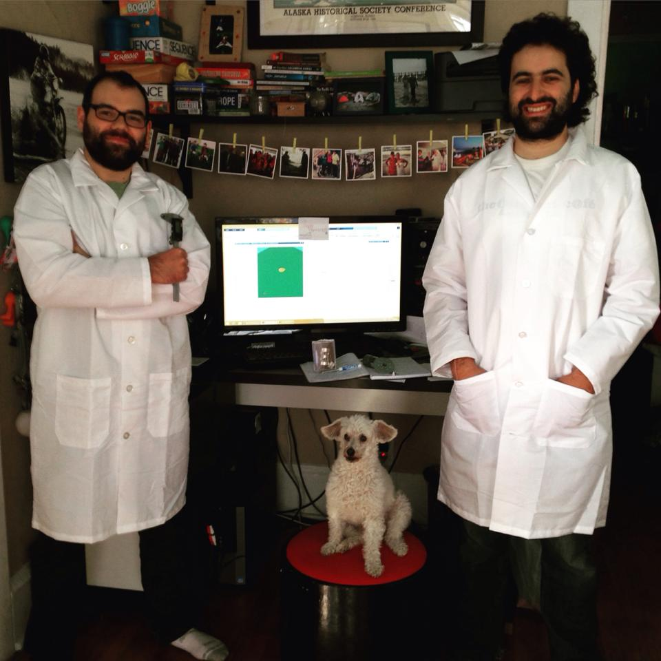
[Image Courtesy of AquaHarmonics on Facebook]
“The Wave Energy Prize marks a significant advance for marine energy,” said Lynn Orr, DOE’s Under Secretary for Science and Energy. “This competition set a difficult threshold of doubling the energy captured from ocean waves, and four teams surpassed that goal. AquaHarmonics’ technology leap incentivized by the Energy Department demonstrates how rapid innovation can be achieved in a public prize challenge.”
Wave energy is in early stages of development. Nearly 50 percent of the US lives within 50 miles of coastline. Over the last several years, engineers have developed ways to convert wave energy into electricity. However, the equipment (and subsequent energy produced) runs a high price. The Wave Energy Prize looks for economically viable solutions as well as those that can meet a high energy capture threshold.
“It’s been a project we’ve been working on since even before the Wave Energy Prize was announced,” said Ginsburg. “As we progressed towards the finals, it just got more and more exciting.”
For an overview of the growth in wave energy technology, check out this video below from The National:

Energy Harvesting Journal
AquaHarmonics wins wave energy prize
Nov. 30, 2016

The U.S. Department of Energy's (DOE) Office of Energy Efficiency and Renewable Energy announced AquaHarmonics as the winner of the Wave Energy Prize - which comes with a $1.5 million grand prize. CalWave Power Technologies and Waveswing America were awarded second and third place, respectively, with $500,000 and $250,000 in cash prizes. With more than 50 percent of the U.S. population living within 50 miles of coastlines, there is vast potential to provide clean, renewable electricity to communities and cities across the United States using wave energy.
An 18-month design-build-test competition, the Wave Energy Prize focuses on catalyzing the development of game-changing wave energy converters that will ultimately reduce the cost of wave energy. Wave energy technology could one day provide clean, cost-competitive, reliable energy for homeowners, communities, businesses, and government in geographically suited parts of the United States. "The Wave Energy Prize marks a significant advance for marine energy," said Lynn Orr, DOE's Under Secretary for Science and Energy.
"This competition set a difficult threshold of doubling the energy captured from ocean waves, and four teams surpassed that goal. AquaHarmonics' technology leap incentivized by the Energy Department demonstrates how rapid innovation can be achieved in a public prize challenge."
Ninety-two teams registered for the prize beginning in April 2015. Over the course of the competition, a panel of judges ultimately identified nine finalists and two alternates, which were announced in March. These teams received up to $125,000 in seed funding to build scaled prototypes of their wave energy converter devices. With the support of the U.S. Navy, the finalist teams tested their prototype devices at the nation's most advanced wave-making facility, the Naval Surface Warfare Center's Maneuvering and Seakeeping Basin at Carderock, Maryland.
Wave energy is produced by converting the energy from waves into electricity. It has the potential to be a substantial resource to deliver renewable energy to the United States. The wave energy sector is in its early stages of development, and the diversity of technologies makes it difficult to evaluate the most technically and economically viable solutions. The Wave Energy Prize Competition has addressed this challenge by comparing a wide range of device types and evaluating them against a threshold requirement for high energy capture. The Prize has already facilitated rapid technical innovation, and in the next year, the Energy Department will publish data from all the finalist teams' test results to further accelerate advancement of this sector.
The AquaHarmonics wave energy converter is a point absorber that floats on the ocean surface while being tethered to the seafloor. Inside the buoy is a winch that acts as both a motor and a generator.
"It's been a project we've been working on since even before the Wave Energy Prize was announced," said Max Ginsburg from AquaHarmonics. "As we progressed towards the finals, it just got more and more exciting."
Source: US Department of Energy
Top image: AquaHarmonics
Read more at: http://www.energyharvestingjournal.com/articles/10286/aquaharmonics-wins-wave-energy-prize

