Triton–C



Preliminary System Design Package

DE-FOA-0001418: Demonstration of an Advanced Multi-Mode Point Absorber for Wave Energy Conversion

Award Number: DE-EE0007819.0000

Principle Investigator: Tim Mundon. Ph.D.

Submission Date: October 3, 2017

Milestone 1 (M1)

Deliverable 3 (D3)

Following drawings provided:

1418.WEC.A100

1418.WEC.A110

1418.WEC.A120

# Table of Contents:

Table of Contents: 1

System Overview 2

System Description 2

Surface Float 2

Drivetrain 3

Reaction Structure 5

Mooring 6

Target Mass Properties 7

Survival Strategy 8

System Analysis 9

Wave Conditions 9

System Loads 11

System Performance 14

Bibliography 17

Index of Figures 17

Index of Tables 17

Appendix 1 18

Numerical Model Baseline Parameters 18

# System Overview

The Triton C is a community/facility scale WEC with a 100kW[1] nameplate capacity that will produce around 20kW annual average power in a well-suited wave climate. The system is architecturally similar to the utility-scale Triton system and geometrically 1/3 the size. The device is intended for deployment in fully energetic wave environments with energies up to 40kW/m. Further, the system is designed to provide a simple and effective self-deployment mechanism that substantially reduces the cost of installation and recovery operations. For extreme conditions, the system self-ballasts to sink below the surface to reduce the impact of large waves.

### Overall System Specifications

|  |  |
| --- | --- |
| Overall System Displacement | 72.3m3 |
| Length Overall (LoA) | 10m |
| Beam | 7.67m |
| Installation Draft | 3.7m |
| Operational Draft | 24.5m |
| Surface Float Mass | 27.4T |
| Reaction Structure Mass | 79.6(in air) 45.2T (submerged) |
| Nameplate Rated Power | 100kW |

# System Description

Figure : Triton-C System Arrangement

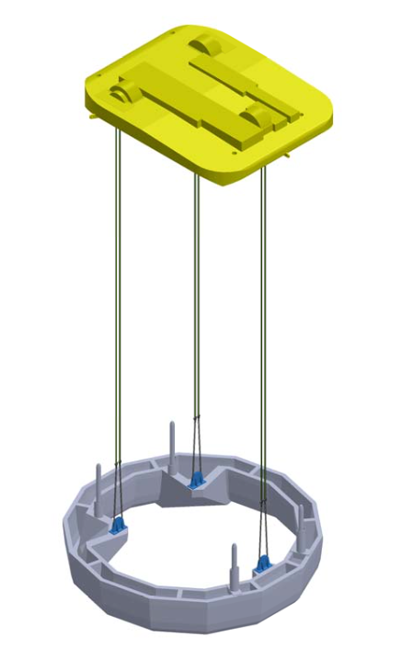

## Surface Float

The geometry of the Hull is described in drawings 1418.WEC.A100 - A120. The geometry of the hull is the same as the larger utility-scale Triton system. It was confirmed through a numerical modeling exercise that the larger system’s geometry was equally as applicable to the smaller system and better than a number of alternative shapes. There may be further optimization that can be done in the future, but only small gains are expected through geometry alone. This optimization exercise did identify that power can be gained through a shifting of the float center of gravity (CoG) further to the rear. Also, that reducing the mass of the float, and increasing the mass of the reaction structure, while keeping the overall displacement the same, will result in increased power.

The drawings provided form a preliminary design, which has been informed by the loads and motions that were generated from a series of numerical models evaluated with the Orcina Orcaflex software. Details of the numerical output are discussed below.

The float will contain three drivetrains for conversion of mechanical motion into electrical power. Power will be aggregated and grid conditioned into a single 4 kV or 11 kV, 3-phase export system that will include fiber optic cable for communication and control.

## Drivetrain

The reaction ring is suspended from the float via three tendons that attach to drivetrains within the float. The drivetrains convert the relative force and displacement of the movement of these two bodies (float and reaction ring) into electrical power.

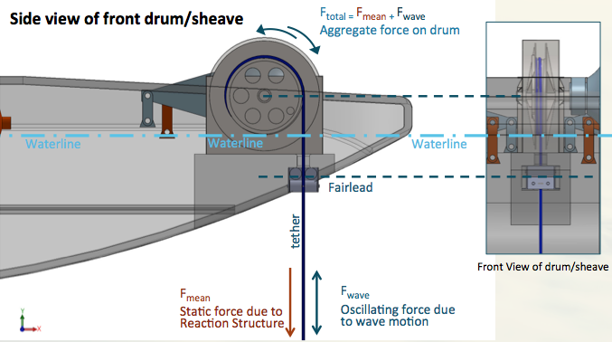 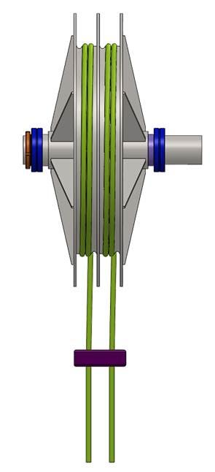

Figure : Drivetrain operating principle, Dual-Fall sheave shown on right.

Figure 2 shows the basic operation of the drivetrain. In practice, the tendon consists of two 36mm Cortland BoB ropes in parallel, which wrap onto a divided sheave/winch drum. The drum is grooved to allow the rope to self-wind correctly. At the lower end of the tendon, the two ropes connect to a single point on the reaction ring in such a way as to balance the load equally between them. The design for this connection needs to be completed, but the design shown uses a block that the line passes through (so making a continuous line). An alternative approach may be to use a load distribution plate. No particular preference is indicated and other options may be applied, although it is important that the redundancy of the two lines should be kept.

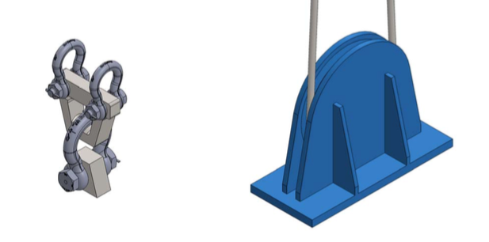

Figure : Tendon to Reaction structure connection approaches. Right; block. Left; load distribution plate

The location of the drivetrains and equipment is such that the center of gravity of the float is kept as far to the rear and centerline of the float as possible.

The architecture of the power conversion is still under development, but the current approach uses a hydraulic system. The power conversion part of the drivetrain comprises two components, a ‘return spring’ and a ‘Power Take Off’ (PTO). The purpose of the return spring is to balance the static torque imposed by the hanging mass of the reaction ring, while the PTO extracts the energy from the wave imposed torque and motion of the sheave.

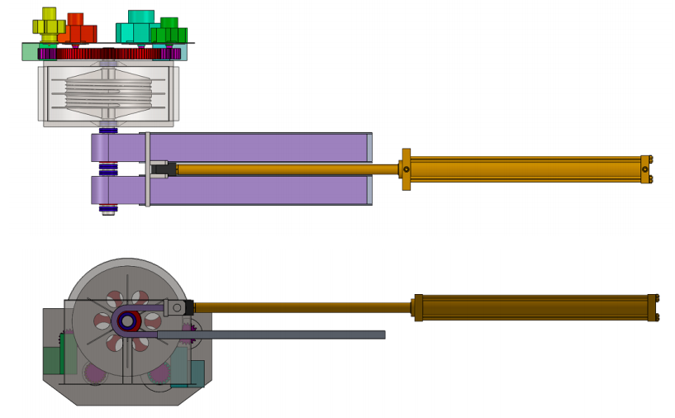

PTO

Return Spring

Figure : Current drivetrain design. Plan view (top), Side view (bottom)

The drivetrain arrangement and foundations in the attached drawings are provided only for information and guidance. Fairlead/sheave locations are unlikely to change, but orientation of the required interior foundations and equipment spaces is likely to be different from these drawings. The specific layout and supports will need to be refined iteratively with the drivetrain development team as FEED progresses.

### Return Spring

The return spring is implemented as a hydraulic cylinder applying a tensile load to a roller chain, which wraps around a sprocket attached to the axle of the sheave. The hydraulic cylinder is connected directly to a gas charged accumulator, where the volume and pressure of the gas are used to set the spring rate and pre-tension, respectively, of the spring.

### PTO

The power take off consists of four radial piston pumps being driven by a large ring-gear attached to the sheave axle on the opposite side to the return spring. As the sheave rotates, this action drives the pumps and pushes high-pressure hydraulic fluid into single common storage accumulator located at the center of the float.

The fluid in this common storage accumulator is used to drive a high-speed hydraulic motor connected to a generator.

### Electrical Export

Electrical output from the generator is conditioned and fed to a grid-tied inverter and transformer. Enclosures for control and power conditioning will be typical 6ft floor-standing types (assuming space is available). Three of these are expected to be sufficient, plus space for the transformer. The transformer will be floor mounted requiring roughly a 3’ cube. Spacing between components is TBD. These articles are not currently shown in the provided drawings.

Power will be exported from the Triton C using an umbilical that will penetrate the hull below the waterline. The connector that we anticipate using will be a variant of the Konekta2[2] being developed by Ditrel. This connector has a number of advantages, but may require too much space inside the hull. It occupies a 1m ∅ space on the hull bottom, and also requires working space for the mating operation.

## Reaction Structure

The reaction structure is shown in Figure 5. It is a large torus with an elliptical cross sectional profile. This serves as a structure that the surface float can react against to produce power. The preliminary design consists of a polygonal ring with a faceted profile so that it may be easier to cast from concrete. It is expected that this design will be fabricated in sections such that it can be assembled and transported.

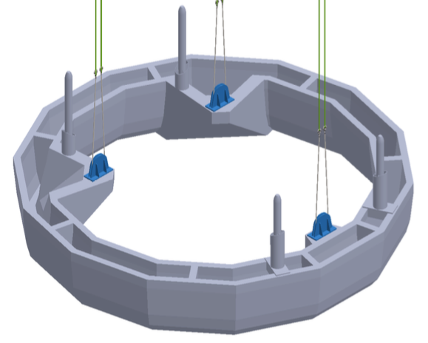

Figure : Reaction Structure. Polygonal design is used for ease of casting in concrete.

For installation of the system, the reaction structure is attached directly to the surface float at four points. The interconnection points for the tendons on the reaction ring are directly below the drivetrains. The drivetrain is used as a winch to lower the reaction structure to an operating depth. The tendons will therefore be parallel in operation. Further, the center of gravity of the reaction structure needs to be directly below the center of buoyancy of the float, while the diameter of the ring needs to be maximized for peak power capture. As a result of these factors, the points where the tendons connect with the reaction ring must be offset from the ring centerline via a corbel structure. The interconnection method between tendon and corbel is discussed above.

The connections between the reaction structure and the float are required to hold the two bodies together without any assistance from the drivetrain during maintenance and towing operations. No design of this has been completed but it is expected to comprise a ‘seat’ and short ‘post’ on the reaction structure, which would engage with a conical ‘socket’ on the float. As the drivetrain winches up the reaction structure, the post would center within in the socket and the seat would rest upon the float hull. Upon engagement, a securing bolt, post or pin would then be manually used to affix the two bodies together.

## Mooring

The triton C is scheduled to be deployed at the WETS 30m berth which has three pre-installed anchors. The system mooring will need to connect to these anchors (installing new anchors is possible, but potentially problematic and expensive) and as such it has been used as the basis of all numerical modeling work to date. Maximum mooring loads for these anchors were proof tested to ~50t, although they are expected to be capable of higher loads. The mooring design used is shown below in Figure 6, it is a straightforward design with two 2” nylon lines and a surface float. No work has yet been done to optimize this.

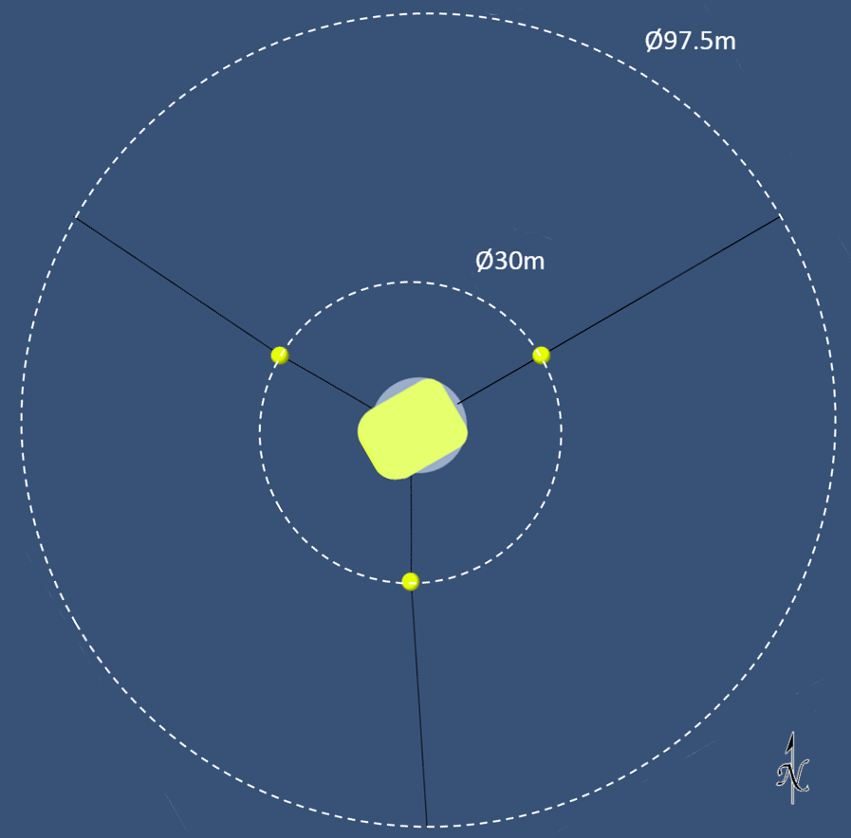 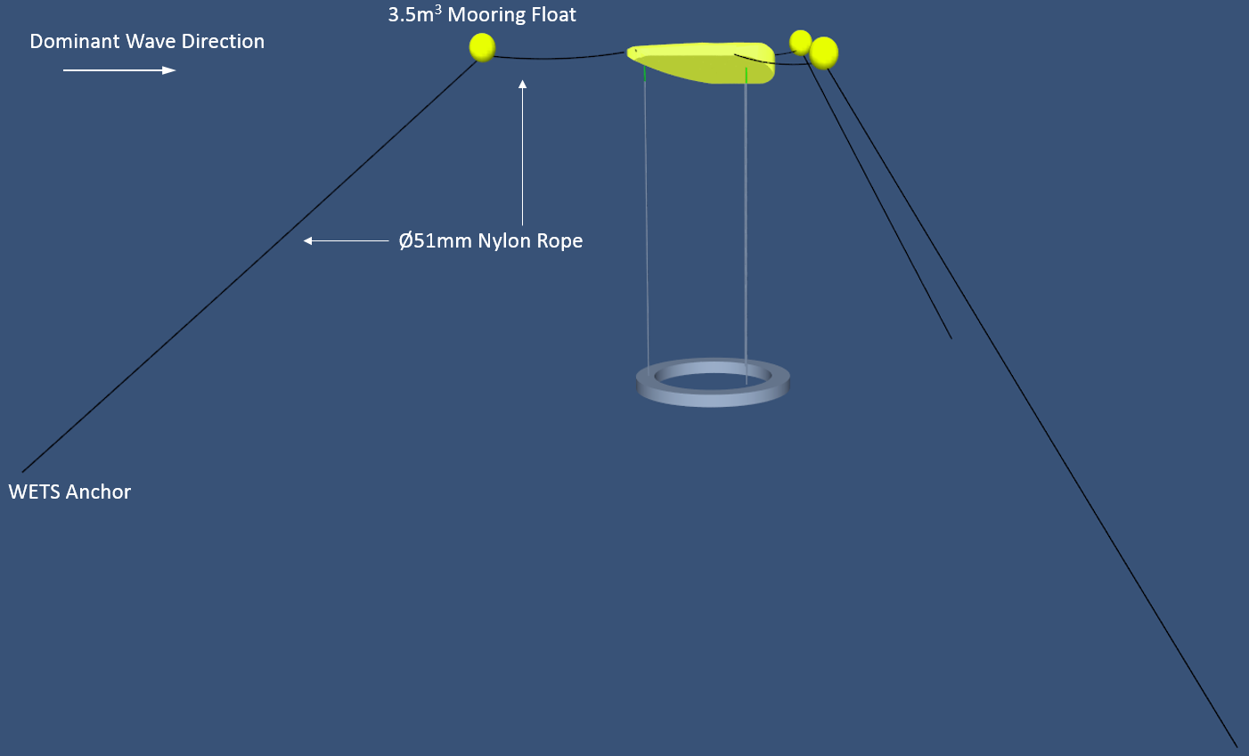

Figure : Mooring arrangement

There is a possibility to deploy at the 60m deep berth at WETS if the mooring arrangement at the 30m berth is not acceptable. The berth is oriented at approximately 60 degrees, aligning the device into the predominant waves. However as can be seen in Figure 7 there are a number of larger events that are incident from 345-0 degrees.

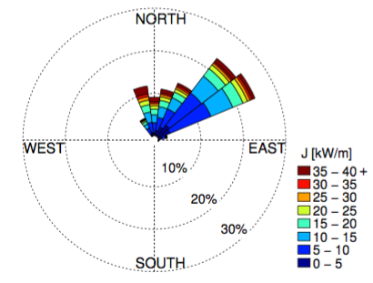

Figure : Wave rose showing predominant directions and energies for WETS, HI

## Target Mass Properties

The mass properties indicated here are those that were used in the numerical model to identify best performance. These were selected as achievable quantities, but it is appreciated that in the course of design, these values may not be met. Column 4 in the table below indicates the importance of meeting or exceeding these values

Note reference coordinate system.

* x = 0 lies at the centre of the float in the lengthwise direction
* y = 0 lies at the centre of the float along the width
* z = 0 lies at the bottom of the float
* x is positive from stern to bow
* y is positive from starboard to port
* z is positive upwards
* roll is positive clockwise around the positive x direction
* pitch is positive clockwise around the positive y direction
* yaw is positive clockwise around the positive z direction

|  |  |  |  |
| --- | --- | --- | --- |
| **Float** | *Value* | *Units* | *Ideal Direction* |
| Mass | 27.4 (of which 8.4 for hull) | Tonnes | Priority Meet or Reduce |
| Centre of Gravity (X, Y, Z) | -1.24, 0, 1.64 | Metres | Preferred Meet |
| Centre of Buoyancy (X, Y, Z) | -0.67, 0, 1.22 | Metres | Preferred Meet |
| Displaced volume | 72.3 | Cubic metres | Priority Meet |
|  |  |  |  |
| **Reaction structure** | *Value* | *Units* |  |
| Mass | 79.6 (in Air) | Tonnes | Needs to balance overall mass |
| Centre of Gravity | Centre of ring |  |  |
| Centre of Buoyancy | Centre of ring |  |  |
| Displaced volume | 34.4 | Cubic metres |  |

Table : Target mass properties

## Survival Strategy

The Triton-C is expected to replicate the survival strategy of the larger Triton system, although this has not been investigated in detail yet for the Triton-C. This will involve the float being ballasted with water until it becomes slightly negatively buoyant; at which point it will sink below the surface and be supported by the mooring floats (see Figure 8). This substantially reduces the wave loading on the system and allows continued power production in extreme waves. However designing the system for the hydrostatic loads associated with full submergence, plus inclusion of ballast tanks within the float, has not yet been considered.

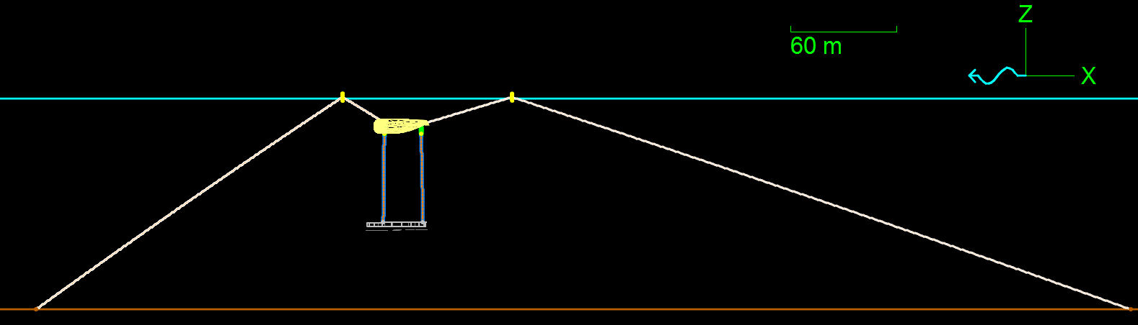

Figure : Triton in submerged survival configuration

# System Analysis

The Triton-C system has been numerically simulated with Orcaflex. The model was based upon a validated model of the utility-scale Triton developed from the wave energy prize physical model tests. The model has been modified to fit the parameters of the Triton-C and the coefficients are described in Appendix 1.

## Wave Conditions

The system was modeled in conditions that are representative of the climate at WETS in Hawaii. The occurrence matrix shown in Figure 9 is based on measured data from National Data Buoy Center buoy 51207 in Kaneohe bay over the period 2013 – 2017.



Figure : Probability of occurrence matrix for WETS, HI

A set of 22 sea states was chosen to represent the conditions experienced at WETS. The set was chosen so that a large fraction (47%) of the total occurrence was covered, but also to ensure that inter- and extrapolation onto the entire power matrix could be performed accurately. Sea states 21 and 22 were included specifically for interpolation purposes. The sea states are shown in Table 2.

|  |  |  |
| --- | --- | --- |
| **Sea state** | **Hs (m)** | **Tz (s)** |
| 1 | 0.25 | 3.5 |
| 2 | 0.25 | 8.5 |
| 3 | 0.25 | 12.5 |
| 4 | 0.75 | 4.5 |
| 5 | 0.75 | 6.5 |
| 6 | 0.75 | 10.5 |
| 7 | 1.25 | 5.5 |
| 8 | 1.25 | 7.5 |
| 9 | 1.75 | 4.5 |
| 10 | 1.75 | 5.5 |
| 11 | 1.75 | 6.5 |
| 12 | 1.75 | 9.5 |
| 13 | 1.75 | 13.5 |
| 14 | 2.25 | 7.5 |
| 15 | 2.25 | 11.5 |
| 16 | 2.75 | 6.5 |
| 17 | 3.25 | 5.5 |
| 18 | 3.25 | 12.5 |
| 19 | 3.75 | 8.5 |
| 20 | 4.75 | 6.5 |
| 21 | 0.25 | 14.5 |
| 22 | 5.75 | 14.5 |

Table : Sea state definitions for simulations

The sea states are modelled using the Bretschneider energy density spectrum, which has been shown to accurately represent the measured energy spectrum at the site.

Additionally, the site experiences low velocity ocean currents up to 0.12m/s with a fairly constant SE direction. The strongest winds are typically from the west to east and can be above 16m/s with a mean wind speed around 7-8m/s. Table 3 shows the seasonal wind and current variations for the site.

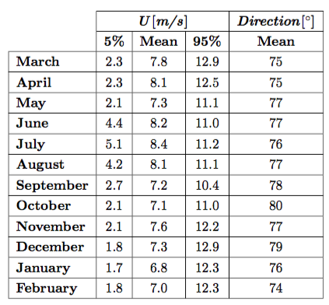 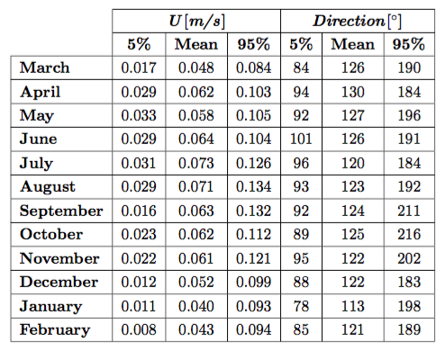

Table : Seasonal Wind(left) and ocean current(right) statistics for WETS, HI [2]

### Design Conditions:

The system will be deployed for 12 months at the WETS site and we have selected a 1 in 20 year return period to define the design conditions. This provides an approximate 5% probability of exceedence during the deployment.

1:50 or 1:100 return periods are typically used in the design of offshore structures or WEC’s with deployment lengths in the region of 20 years. The probability of a 1 in 20 year event occurring in a 1-year deployment is equivalent to a 1 in 100 year event occurring during a 5-year deployment.

Based upon a first pass, sea state 20 from Table 2 (Hs 4.75m, Tz 6.5s) is just outside of the contour of measured events in the occurrence matrix and can therefore be assumed to be a rare event with severe load conditions.

A more accurate determination of the 1 in 20 year events is currently underway, which will take into account the loads associated with events as well as the occurrence of a sea state. Until a 1:20 year load definition has been determined, this sea state will be used for this purpose.

## System Loads

Loads were calculated from peaks occurring in design conditions, and also statistically, identifying probabilities of occurrence across an expected annual climate.

Tether loads shown in Figure 10 are calculated as the absolute value of the spread around the mean. The mean load in the front tether is 147.5kN and the mean load in the rear tethers is 144.5kN, which means the overall mean load is 147.5 + 2 x 144.5 = 436.5 kN. This is due to the weight of the reaction structure (435 kN submerged weight). The max and mean values are absolute differences from the original mean, and the standard deviation is based on the spread around the original mean. The methodology to obtain the distribution below was:

* Normalize the spread around the mean by the standard deviation for each of the 22 sea states
* As the resulting distributions are very similar in shape and values for all sea states, create an ‘average’ distribution
* Standard deviations of the loads are interpolated over the entire sea state matrix
* The ‘average’ distribution is then multiplied by the standard deviation for each sea state
* The resulting distributions for each sea state bin are then divided into new bins with equal spacing
* The re-binned probability of occurrence distribution in each sea state is then multiplied by the sea state occurrence for that sea state
* The weighted, re-binned probability distributions are then summed across all sea states to give an annual probability distribution
* The cumulative probability of the annual distribution can then be calculated. The CDF for tether loads is shown below in Figure 10 and Figure 11.

This method ensures that the occurrence factor for each sea state is accounted for in the cumulative distribution.



Figure : Cumulative distribution of tether loads (Mean Removed)

The cumulative distribution of the tether load without removing the mean is shown below. The negative minimum value for the front tether load indicates a slack event in the tether.



Figure : Cumulative distribution of tether loads.

Below the interpolated matrices of the standard deviation and the maximum of the front tether load are shown.



Figure :Standard deviation of front tether load (kN)



Figure : Maximum of front tether load (kN)

The matrix below shows the weighted standard deviation tether load, which was obtained by multiplying the matrix in figure 12 with the occurrence matrix. This can be seen as an early stage indicator of the most damaging sea states. During the FEED and detailed design, a more in-depth analysis is required based on a more detailed knowledge of damage due to load levels (e.g. is the damage due to 5 times 10kN the same as the damage due to a single 50kN event; the exact load vs damage curve will depend on the material chosen).



Figure : Standard deviation of front tether load weighted by sea state occurrence (kN)

## System Performance

Power production is calculated from simulations using the tether velocity relative to the float (v) and the linear damping coefficient (BPTO) that is representative of the power take-off damping.

$$P=B_{PTO}v^{2}$$

The power from each tether, one at the front and two at the rear of the device is summed to give the total power. A flat efficiency for the PTO system of 70% is subsequently applied to results for all sea states.

The cumulative probability distribution for the instantaneous power was calculated using the first method in the loads section and therefore inherently accounts for the sea state occurrences during the year.



Figure : Cumulative distribution of instantaneous power

Note that all subsequent values are provided as effective linear quantities as it was felt that this would be the most useful for the marine system design. No conversion to rotary quantities has been applied. A sheave diameter of 1m should be used if conversion to torque is needed.

The optimal stiffness of the return spring and generator damping coefficient for the power take-out system were determined for each sea state by running a matrix of simulations with different combinations of stiffness and damping. The optimal stiffness (in kN/m) and damping (in kNs/m) that provided the largest average power for each sea state is shown below.



Figure : Optimal return spring stiffness matrix



Figure : Optimal generator damping coefficient (kNs/m)

The optimum stiffness for the 2 largest sea states (Tz 6.5s Hs 4.75m and Tz 14.5s Hs 5.75m), with respect to performance, is 17 kN/m as can be seen from the trend in the rest of the sea states, but here the higher stiffness of 33 kN/m was used to minimize the number of snatch events on the tethers and possible clashes of the reaction structure with the sea floor.

The power calculated for the 20 sea states is interpolated onto a surface that covers all possible combinations of wave height and period. It should be noted that the extreme lower left conditions in these matrices, where there is short periods and high wave heights, cannot and do not occur in reality.

Below are shown the power matrices with the mean power per sea state in the top figure. This surface is multiplied by the occurrence matrix and the weighted annual average power per sea state at WETS is shown in the bottom figure. The sum of the bottom matrix gives the annual average energy production for the Triton C device at WETS. This sum is 9.9 kW (after PTO efficiency).

In the mean power matrix, the maximum power is capped at 50 kW, but, as can be seen in Figure 9, this power cap does not affect the average power capture because the sea states in which the cap is applied do not occur at WETS



Figure : Power matrix for the Triton-C system. Includes drivetrain efficiency. Cells represent average energy delivered in each sea state

# Design Review.

On the 24th October OPI convened a design review meeting to discuss the preliminary system design, and identify major risks going forward.

Participants:

* OPI: Tim, Eric, Andy, Brian, Balky, David (phone)
* Glosten: Ben Ackers, Ian McCauley
* Janicki: Rob Anderson, Eric Jambor
* input from University of Maine received via email.

### Key notes from the review were as follows:

Concerns were raised that with the current drivetrain layout there may not be enough space internally (or it would be very difficult) to allow for a fully submerged survival strategy, such that is being developed for the Utility scale Triton. It is not expected, although not confirmed, that the HI climate will require submergence, however, the hope is to re-deploy the system to WA after the initial HI deployment. This climate would likely require a submergence strategy and it is hoped that this can be retrofitted, so not impacting the 1418 project.

It was noted that if a submergence strategy is required, a sump needs to be included on the hull and the hull needs to be designed for hydrostatic loads. This will increase hull mass over a non-submerged design. Retrofitting of a submergence strategy is possible but will make the hull even heavier than if it was designed for the strategy from the start.

*Mitigation/Action: The additional design and material needed to make the prototype suitable for submergence, is impractical as part of this project. Review subsequent WA deployment locations (after HI) to see if suitable locations exist that would not need a survival strategy.*

Concerns were raised that the features on top of the hull deck, which were made to allow additional space for the drivetrain components could lead to potential water entrapment, which could lead to increased corrosion and biofouling and increased green water loads.

*Mitigation/Action: A domed deck was suggested as an alternative to improve water shedding, strength, and capacity for man-access.* It was agreed that this *would be taken into consideration in future revisions of the hull design.*

There was some concern over the reaction-ring to hull interface during the installation configuration. In particular, it was felt that the loads on the interface points would be high during the towing operation. Alternative arrangements to the four posts were suggested, with suggestions being made that the optimum might be a cradle design, rather than a pin and socket. However no viable mating alternative was quickly identified. An oval ring, or potential cowling was suggested as this could reduce drag on the ring during towing, reducing loads. It was ultimately accepted that the pin and socket would work if the towing loads were low enough. There was also concern over the mating operation, and it was suggested that the maximum wave conditions for mating could severely limit recovery operations. Having elastomeric caps on the interface points would absolutely be needed to reduce/distribute impacts during mating.

*Mitigation/Action: Understand the towing loads and mated configuration in more detail. OPI will try to develop an improved mating arrangement that reduces structural loads on the ring during towing. Attempt to model mating operation to identify the maximum wave conditions for recovery (assumes installation mating would be in a protected bay with no waves). Add elastomeric caps on mating structure.*

Glosten commented that more work needs to be done to understand the approach of dissipating heat. The design and approach of heat exchanger, i.e. a pumped solution or passive keel cooler could impact the marine design. Understanding the heat buildup in the drivetrain will be critical to inform this decision.

Concern was raised over the fatigue life of the tether connections. Shackle connections are not preferred for this type of loading. Glosten will investigate this in the FEED work.

Questions were asked about what the appropriate metrics and methods for numerical modeling to inform FEED. Using simplified long crested seas will underestimate the fatigue loading, but will somewhat overestimate the ultimate peak loads. More computational burden, complexity and uncertainty if you use short crested seas. It was suggested that peak differential tether loads and max tension range would be a good metric, but that we should arrange a subsequent meeting to discuss the specifics about the requirements from the numerical modeling

### General Comments:

Must consider loss of grid on the drivetrain, navigation lighting and cooling requirements.

Additional certainty is needed on the drivetrain design before a general arrangement can be produced. The general arrangement is the first step in the FEED design development, although there are some other components, such as tether interconnections and cooling approaches that can be developed independent of this.

## Design and Failure Mode Analysis

As a result of the meeting a list of the key risk items was developed, along with a preliminary list. A summary of the high-level risk areas are listed below. This list was circulated around all involved parties to add risks within the various areas and score as per the risk management plan, which is in development with NREL. These results will be included in the project risk management plan.

Risk areas:

* Drivetrain / Electrical system (Separate risk register – high level risks here)
* SCADA and instrumentation
* Mooring & Umbilical
* Tethers & connections (including sheave mechanism)
* Hull
* Reaction structure
* Marine operations (excluding installation/Recovery)
* Installation/Recovery

# Bibliography

[1] Li, N. and Cheung, K.F., Wave Energy Resource Characterization at the US Navy Wave Energy Test Site and other Locations in Hawai‘i. University of Hawai‘i, November 2014

[2] Ann R Dallman and Vincent S Neary, “Characterization of U.S. Wave Energy Converter (WEC) Test Sites: A Catalogue of Met-Ocean Data” (Sandia National Laboratories, September 2014).

# Index of Figures

Figure 1: Triton-C System arrangement 2

Figure 2: Drivetrain operating principle, Dual-Fall sheave shown on right. 3

Figure 3: Tendon to Reaction structure connection approaches 4

Figure 4: Current drivetrain design. Plan view (top), Side view (bottom) 4

Figure 5: Reaction Structure. Polygonal design is used for ease of casting in concrete. 6

Figure 6: Mooring arrangement 7

Figure 7: Wave rose showing predominant directions and energies for WETS, HI 7

Figure 8: Triton in submerged survival configuration 9

Figure 9: Probability of occurrence matrix for WETS, HI 9

Figure 10: Cumulative distribution of tether loads (Mean Removed) 12

Figure 11: Cumulative distribution of tether loads. 13

Figure 12:Standard deviation of front tether load (kN) 13

Figure 13: Maximum of front tether load (kN) 14

Figure 14: Standard deviation of front tether load weighted by sea state occurrence (kN) 14

Figure 15: Cumulative distribution of instantaneous power 15

Figure 16: Optimal return spring stiffness matrix 15

Figure 17: Optimal generator damping coefficient (kNs/m) 16

Figure 18: Power matrix for the Triton-C system. Includes drivetrain efficiency. 16

# Index of Tables

Table 1: Target mass properties 8

Table 2: Sea state definitions for simulations 10

Table 3: Seasonal Wind(left) and ocean current(right) statistics for WETS, HI [2] 11

# Appendix 1

## Numerical Model Baseline Parameters

Water depth = 30m

Sea water density = 1025 kg/m3

### Surface Float

The shape of the surface float is the same as for the full-scale Triton, described in the Wave Energy Prize Test Plan, but scaled down by a factor 3.

#### Float dimensions:

* Length (dimension parallel to predominant incoming waves): 10m
* Width (dimension perpendicular to predominant incoming waves): 7.67m
* Height (bottom to top): 2.67m
* Draft (bottom to water surface): 1.9m

#### Coordinate system:

* x = 0 lies at the centre of the float in the lengthwise direction
* y = 0 lies at the centre of the float along the width
* z = 0 lies at the bottom of the float
* x is positive from stern to bow
* y is positive from starboard to port
* z is positive upwards
* roll is positive clockwise around the positive x direction
* pitch is positive clockwise around the positive y direction
* yaw is positive clockwise around the positive z direction

### General:

* Displaced volume: 72.3 m3
* The coordinates of the centre of gravity are: [-1.24, 0, 1.64] (1.64 = 1.33 + 0.31)
* The coordinates of the centre of buoyancy are: [-0.67, 0, 1.22] (1.22 = 1.9 – 0.68)
* The offset in the x-direction between the centres of gravity and buoyancy means that the float sits at a slight negative pitch angle at equilibrium.
* The mass of the surface float is 27.4 Tonnes, including Power Take-Off system(s).
* The mass of the hull only is assumed to be 8.4 Te.

**Moments of inertia (Te.m2):**

|  |  |  |  |
| --- | --- | --- | --- |
|  | x | y | z |
| x | 80 | -10.6 | 15.8 |
| y | -10.6 | 241 | -2.27 |
| z | 15.8 | -2.27 | 290 |

**Hydrostatic stiffness matrix:**

|  |  |  |  |
| --- | --- | --- | --- |
|  | Heave | Roll | Pitch |
| Heave | 709 (kN/m) | 0 (kN/rad) | -959 (kN/rad) |
| Roll | 0 (kN) | 2713 (kN.m/rad) | 0 (kN.m/rad) |
| Pitch | -959 (kN) | 0 (kN.m/rad) | 6296 (kN.m/rad) |

* The quadratic (viscous) damping coefficients for surge, sway, heave: 2.25, 3.25, 16.5 kN/(m/s)2 which corresponds to Cd = 0.5 with submerged projected areas: 9, 13, 66 m2
* The quadratic (viscous) damping coefficients for roll, pitch, yaw: 10, 50, 30 kN.m/(rad/s)2

### Reaction structure

* Inner diameter: 8.4m
* Outer diameter: 11m
* Height: 2.5m
* Annulus width: 1m
* Mass: 79.6 Tonnes
* Volume: 34.4 m3 (Underwater Mass: 34.4 x 1.025 = 35.26 (– 79.6) = 44.34t)
* Centre of mass in the centre of the ring.
* The centre of mass is straight below the centre of buoyancy of the surface float (to minimise equilibrium tilt of the float and heave plate).

In OrcaFlex the heave plate is represented as a cylinder with the correct inner and outer diameter, but with a height of 0.868m to represent the correct volume. The normal drag force area is set to 25 m2.

Moments of inertia (kN.m2), cross-coupling components are negligible:

* Roll: 1014
* Pitch: 1014
* Yaw: 1945

The center of mass of the heave plate sits 23.5m below water level at equilibrium.

The added mass coefficients:

* Normal: 0.53
* Axial: 3.15

Added moment of inertia: 600 Te.m2 in the normal direction.

The tether connection points on the heave plate are straight below the connection points to the PTO on the float.

### Sea parameters

The seas will be simulated using the Breitschneider spectrum with a spreading factor of 2 and as directed by Glosten in order to determine required design loads. More detail can be found in the numerical modeling report.

1. Although a 60 or 80kW nameplate could have been chosen with only a minor impact to annual average power, 100kW was selected as there was a minimal cost delta to design for this power.
2. Information can be found here: http://www.ditrel.es/konekta2