C-Plane Tow Tank Test Plan

Aquantis, Inc.
101 E. Victoria Street, Suite F
Santa Barbara, CA 93101
Tel. +1 805 845 7575 Fax +1 805 845 7266
aquantistech.com

Authors
Henry Swales, Aquantis, Inc.
Richard Banko, NSWC
David Coakley, NSWC

Contents
C-Plane Tow Tank Test Plan 1
Summary 3
Objectives 3
Background 3
Test Facility 3
Schedule 4
Technical Approach 5
Captured & Moored Testing 5
Coordinate System 6
Free-body Diagram 7
Scaling 8
Scope 8
Model and Test Set-Up 9
General Specifications: 9
Center of Buoyancy & Center of Gravity: 10
Instrumentation 10
Captured Test 11
Rig Design 11
Test Cases 11
Moored Test 12
Rig Design 12
Test Cases 12
Results 13
Data Processing 13
Uncertainty Analysis 13

Summary

Objectives
- Validate stability models and passive depth control.
- Validate behavior during all modes of operation and response to failure events.
- Reduce technical risk in key areas of design.

Background
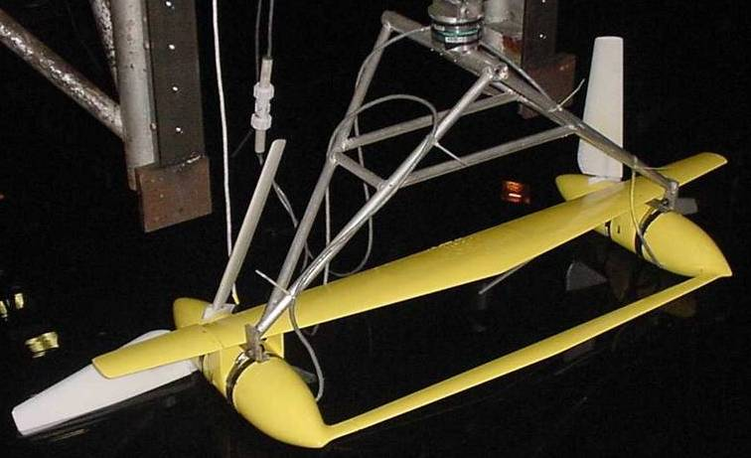
Model Test at Carderock circa 2000
- Jim VanSweden FAU Thesis
- Tested functionality of active control surfaces
- Vibration Issues
  - Modal analysis of new captured rig completed
  - NSWC has developed data processing techniques to filter vibration of carriage

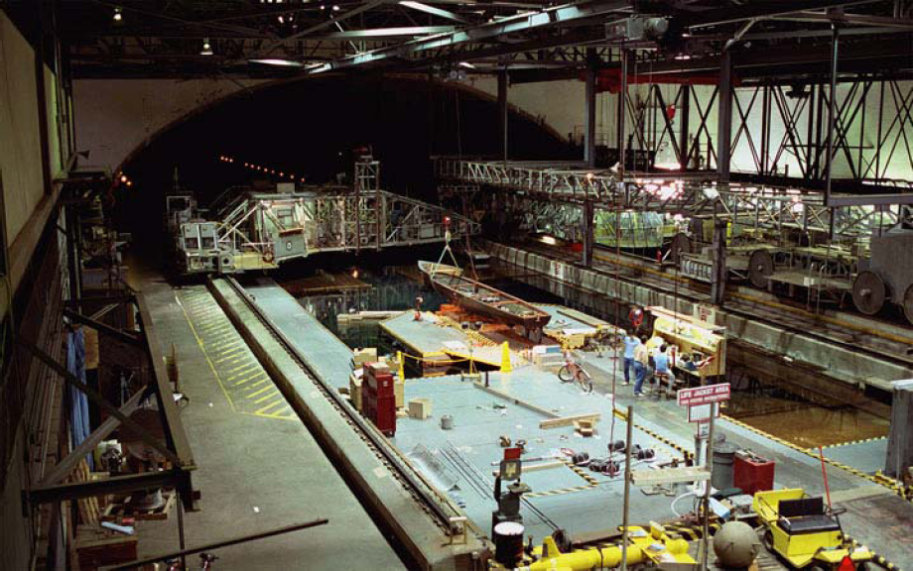
Test Facility
The Deep Water Basin facility is located at the Naval Surface Warefare Center, Bethesda, MD.
The basin has the following dimensions:
- Width: 15.5m (51 ft)
- Depth: 6.7m (22 ft)
- Length: 575m (1,886 ft)

Schedule

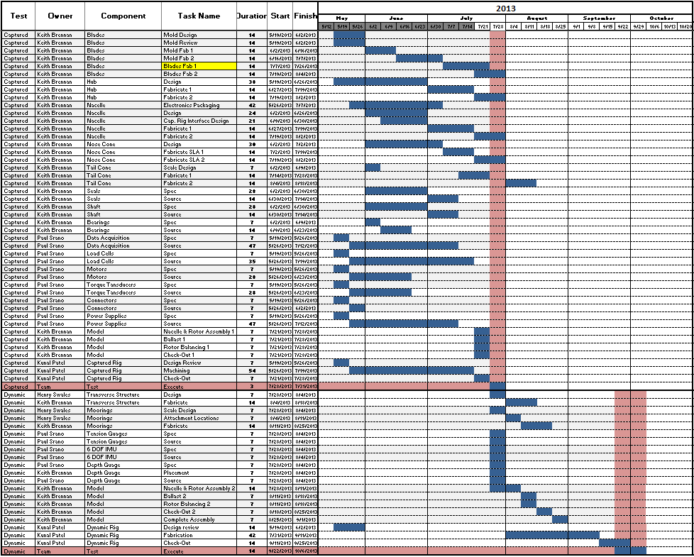

Technical Approach

Phase 1: Captured Test
    - Validate hydrodynamic coefficients and calibrate rotor speed and thrust.

Phase 2: Free (Moored) Test
    - Demonstrate passive depth control
    - Demonstrate all modes of operation (start-up, shut-down, etc.)
    - Demonstrate stability during flow events
    - Demonstrate response to failure events (loss of drivetrain torque, etc.)

Captured & Moored Testing
For the moored test to be successful and accurate, it is critical that the rotors perform as predicted. Blade-element-momentum (BEM) analysis has proven itself to be an accurate and reliable method of predicting rotor performance compared to test data, but this is predicated on the quality of hydrodynamic inputs and accuracy of the model geometry. The ultra-low Reynolds number of the model test as well as other flow phenomena (3D root effects, trailing edge thickness, surface roughness, etc.) all play a role in how well the model rotor performance is predicted by BEM analysis. Because many of these contributing factors are significantly different on a 1/25 scale model, the captured model approach to testing will allow the rotors to be calibrated to match rotor thrust as closely as possible with scaled values of the full-size rotor. This calibration may include torque/rotor speed and/or pitch/ trailing edge flap adjustments.

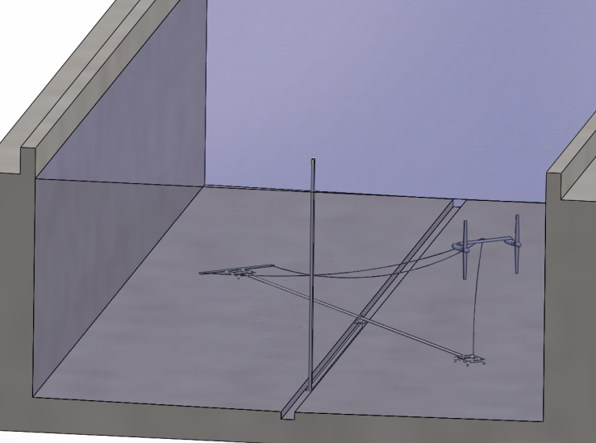
Captured Rig Design Moored Rig Design

Coordinate System

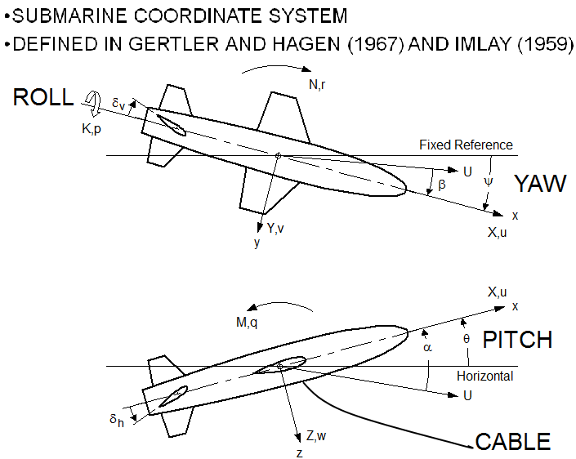
Coordinate System for Simulation and Testing

Moored System Free-body Diagram

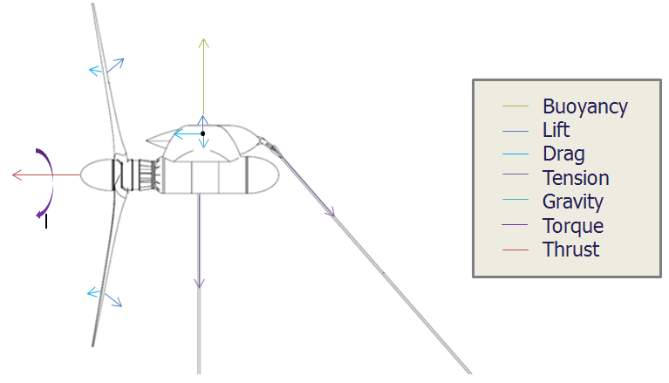
Free Body Diagram (Side View)

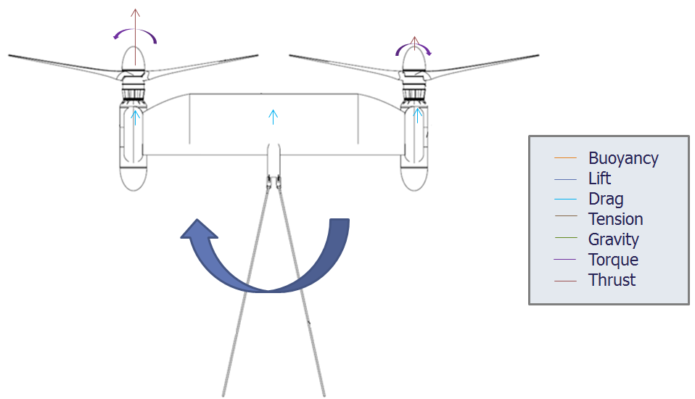
Free Body Diagram (Top View)

Scaling
Froude scaling is the most appropriate scaling approach in which gravitational effects (platform weight and buoyancy) are major contributors to the characteristics that control stability. Froude scaling laws dictate the following scaling factors (λ=1/25 of full scale)

Parameter, Loading | Components | Scaling Factor:  Model to Full scale
Current Speed | Environment | λ^{1/2}
Buoyancy | Nacelle  Wing/truss  Blades | λ³
Mass | Nacelle  Wing/truss  Blades | λ³
Reynold’s Number | Wing/truss  Blades | λ^{1.5}
Hydrodynamic Lift | Wing/truss  Blades | λ³
Hydrodynamic Drag | Wing/truss  Blades  Platform | λ³
Torque | Blades | λ⁴
Thrust | Blades | λ³
RPM | Blades | λ^{-1/2}
Cavitation | Blades | Not possible to achieve pressure requirements in tank
Tension – Forward | Forward mooring line | λ³
Tension – Aft | Aft mooring line | λ³
Structural loading: pressure @ depth, torsional, bending | Nacelle  Wing/truss  Blades/attachments | Not possible to achieve pressure requirements in tank
Time | General | λ^{-1/2}

Scope
Not all platform design challenges can be practically resolved through tow tank testing:

Shear / dynamic pitch response
- Developing an accurate shear profile is very difficult/expensive
- Recommend analyzing in dynamics simulation (once validated with test results)

Response to flow acceleration (speed overshoot during PDC)
- Need static disks or controller to test
- Recommend analyzing in dynamics simulation (once validated with test results)

Upstream structure wake / blade root bending
- Sub-component testing at full-scale Reynolds numbers very expensive
- Recommend analyzing in CFD validated by NSWC LCC data

Stall Regulation
- 1/125 Reynolds number reduction prevents attaining accurate rotational stall behavior in tow tank.

Model and Test Set-Up

General Specifications:

Specs | Full Scale | 1/25 Scale
Platform
LOA (rotor tip-to-tip): | 96 m | 3.840 m
Rotor Separation Shaft-to-Shaft: | 50.5m | 2.020 m
Weight: | 750,000 kg | 48 kg
Buoyancy: | 875 kN | 56 N
Structure: | Streamlined ‘Main Wing’ | Streamlined ‘Main Wing’
Structure Chord: | 9m | 0.360 m
Structure Foil Section: | NACA 64-021 | SD 8020 w/ BL Trip
Rotors
Configuration: | Downwind | Downwind
Diameter: | 45.5 m | 1.820 m
No. Rotors | 2 | 2
No. Blades per Rotor | 2 | 2
Rated Power (electrical): | 1200 kW | 15 W
Blade Foil Sections: | NREL S816,S817,S818 | SD 2030 w/ BL Trip
Design Flow Speed | 1.6 m/s | 0.32 m/s
Design TSR / RPM: | 8.0 / 5.37 RPM | 8.0 / 26.87 RPM
Design AoA: | 5 deg | 4 deg
Thrust @ Design Point | 1647 kN | 105.4 N
Torque @ Design Point | 2486 kN*m | 6.24 N*m
Nacelles (Power Pods)
Power Pod Length: | 23.2 m | 0.928 m
Length with Nose Fairing: | 25.7 m | 1.028 m
Power Pod Diameter: | 4.3 m | 0.172 m
Power Pod Dry Weight: | 300,000 kg | 19.2 kg
Tail Cone Length: | TBD | TBD
Moorings
Configuration: | 3-Point | 3-Point
Material: | Polyester Line/Chain | Polyester Line/Chain
C-Plane Depth (minimum) | 50.0m | 2.0m
Water Depth (nominal) | 300.0m | 6.4m
Forward Mooring Line Diameter | 167mm | 6.2mm
Aft Mooring Line Diameter | 125mm | 4.6mm
Forward Mooring Chain | R4 Studless bottom, 90mm
Aft Mooring Chain | R3 Studded (top), 70mm  R4 Studless (bottom), 70mm

Center of Buoyancy & Center of Gravity:

See “CG Calc v2 (hs 7-24-2013)” for resolved CG and CB Locations, and Buoyancy and Ballast Adjustments

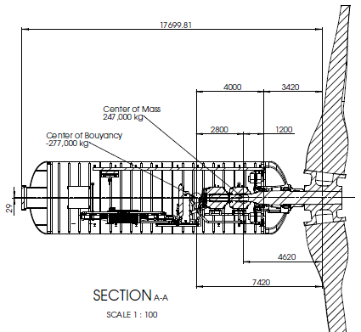
Full-Scale TRB Design CG & CB Locations

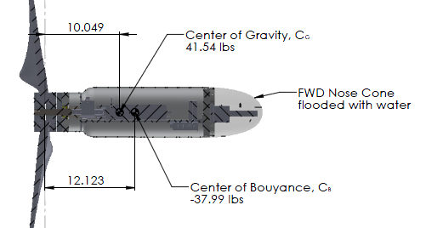
Tow Tank Model ‘Bare” CG & CB Locations

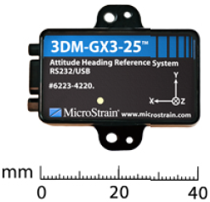
Instrumentation

Captive Model Testing
- 6 component Load cell
  - Mx Limit: 1000 in*lb
  - My Limit: 1000 in*lb
  - Mz Limit: 500 in*lb
- GX3 Inertial Measurement Unit (IMU)
- Tachometer(s)
  - Rotor Speed Limit: 57 RPM
- Carriage speed
- Depth gage
- Thrust on shaft
- Torque on the shaft
  - Mx Limit: 25.5Nm (18.8 ft*lbf)
Moored Model testing
- GX3 Inertial Measurement Unit (IMU)
- Tachometer(s)
- Carriage speed
- Depth gage
- Thrust on shaft
- Torque on the shaft
- Video adequate for yaw measurement
- 2 or 3 tension gages, one at each mooring point

Captured Test

The captured test is intended to verify and calibrate the hydrodynamic coefficients of the nacelle and rotor. For simplification, this will be conducted on a single power pod.

Procedural Notes:
Attain rotor speed prior to increasing carriage speed to avoid exceeding 25.5Nm torque. Reduce carriage speed before reducing rotor speed. See “MHK_Scaled45.5m_Re168k_Fresh_v4(Perf_Swpv2).oup.xlsx” for loads envelope.

Rig Design
Vertical faired strut with yaw adjustability in 2.5deg increments up to 45deg.

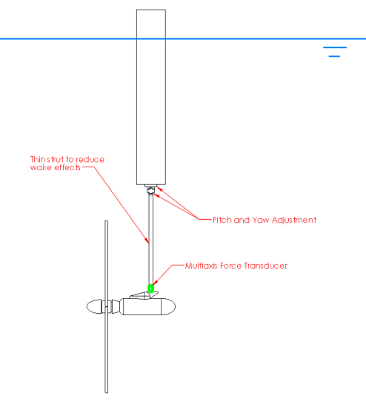
Captured Rig Diagram

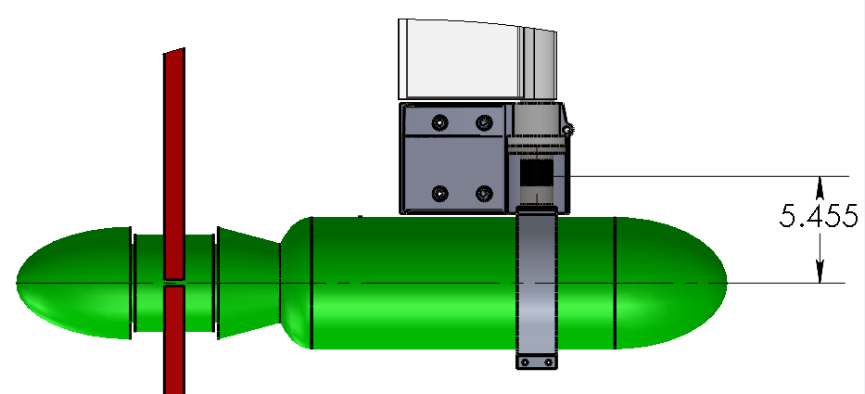
6DOF Load Cell Z-Location

Test Cases

Collect force data over 3 days of testing (12hrs testing per day).
See “Test Matrix (hs 7-19-2013).xlsx” for test cases.
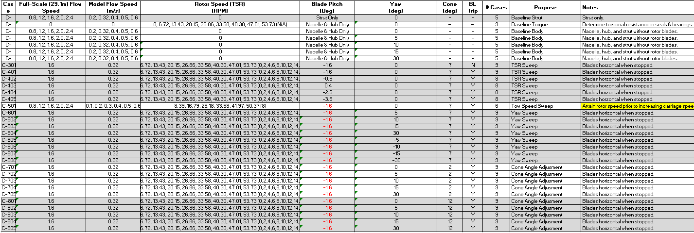
Summary of Captured Test Cases

Dynamic Test

The dynamic test is intended to demonstrate all modes of operation including passive depth control and various system failures as well as validate platform response as simulated in DCAB stability models.

Model Design

Due to the transverse structure adapter plate, the load cell is spaced laterally 0.5” further from the rotor axis during the captured test.

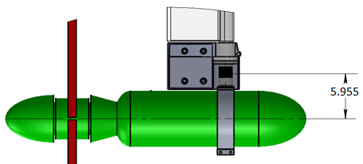

The transverse structure adapter plate also has the effect of lowering the load cell 2.15” below the rotor axis.

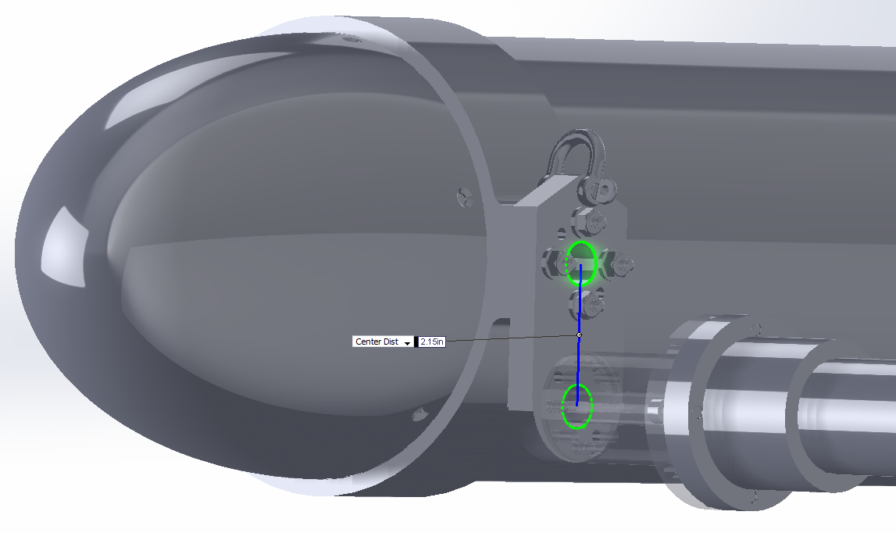

Rig Design
Rig is designed for 40deg yaw articulation. Tank depth requires reduction in length of scaled mooring lines. This reduction must be accounted for in the specification of the model mooring lines.

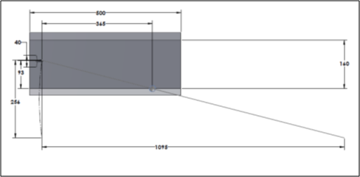
Mooring Length Reduction Diagram

Test Cases

Collect force, inertial acceleration, and video data over 6 days of testing (12hrs testing per day).
Specific test cases remain to be finalized.

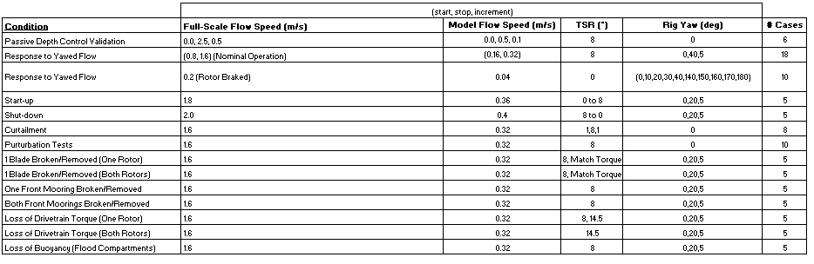

Data Processing

General
To convert measured loads to coefficients for use in stability simulations, data is nondimensionalized by the method of Gertler and Hagen:
- Forces are nondimensionalized by ½ ρ D² U²
  - ρ is fluid density, D is rotor diameter
  - U is the resultant flow velocity relative to the turbine [U = sqrt( u^2 + v^2 + w^2)]
- Moments are nondimensionalized by ½ ρ D³ U²
- D = 45.5m
- ρ = 1025 kg/m^3
- Output rates P, Q, R, u, v, w are nondimensionalized with U.

Model Characterization
- The following properties shall be measured and reconciled with the CAD and DCAB models:
  - Weight, CG Location
  - Buoyancy, CB Location
  - 3-Axis Inertia
  - Rotor Balance
  - Rotor Rotational Inertia

- The following properties shall be measured and used to calibrate captured test results:
  - 6 DOF loads of any supporting structure between the load cell and model
  - 6 DOF loads of model without blades
  - Torsional resistance of bearings and seals

Captured Test Data
- 6DOF forces and moments shall be calibrated for each component (nacelle or rotor).
  - Rotor Thrust Force is equal to the x-axis force (Fx_{r}) measured at the load cell minus Fx_{n} (no blades).
    - Rotor Thrust Force shall be measured when Pitch Moment (My) is minimum, indicating blades are horizontal (not in strut wake).
    - An average of at least 10 data points shall be used.

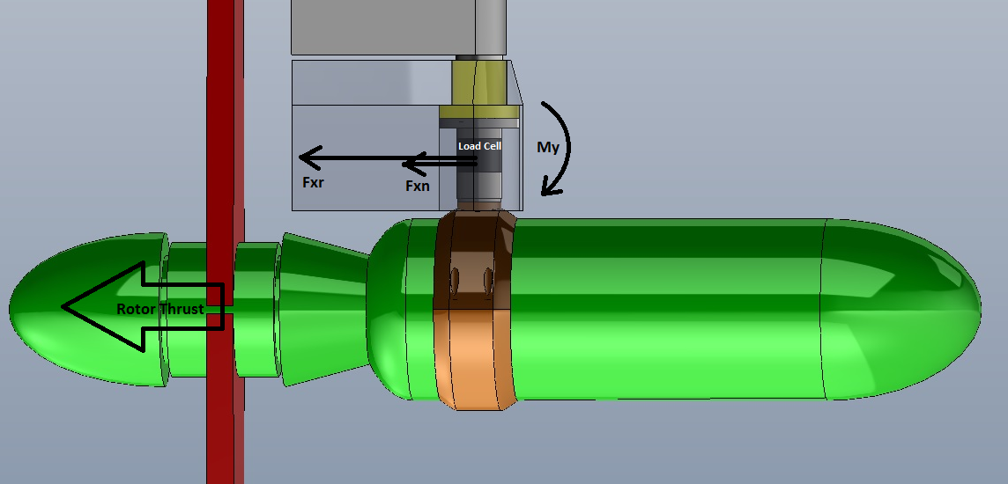
Captured Test Side-View Free-Body Diagram (Z-Forces Negated)

  - Rotor yaw moment is equal to (Mz_{r} - Mz_{n}) – ((Fy_{r} - Fy_{n})*XposLoadCell)
    - A minimum time average of 10 rotations shall be used.

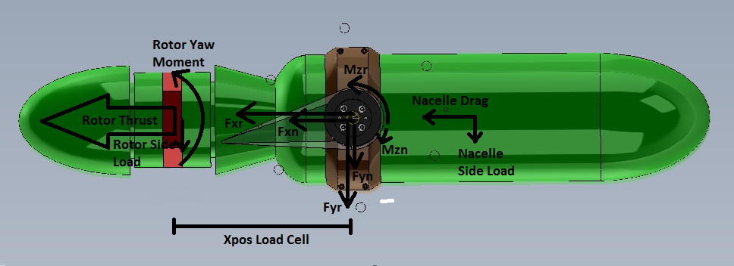
Captured Test Top-View free-Body Diagram

- 6 DOF nacelle loads (calibrated for support structure) shall be Froude scaled (λ=1/25) and compared to full-scale predictions calculated by DCAB.
  - If time allows, some model calibration using boundary layer trips and/or tabs may be done.
  - DCAB body coefficients will be adjusted to match test data if prediction is outside test uncertainty.
- 6 DOF rotor loads (calibrated for nacelle and support structure) shall be compared model predictions calculated by WT_Perf, and Froude scaled (λ=1/25) to compare to full-scale predictions calculated by WT_Perf and Flightlab.
  - If time allows, some model calibration using boundary layer trips may be done.
  - Blade pitch angle shall be determined by best match of zero yaw rotor thrust to full-scale prediction at each tested TSR. Accuracy of Yaw Moment prediction will determine use of FlightLab and/or WT_Perf full-scale calculations for comparison to test data.
  - DCAB rotor coefficients will be adjusted to match test data if prediction is outside test uncertainty.
- Rotor torque (calibrated for seal and bearing torsional resistance) shall be compared to model predictions calculated by WT_Perf.
  - If time allows, some model calibration using boundary layer trips may be done; however, accurately modeling rotor thrust takes precedence.
- Loads Predictions:
  - WT_Perf Model Rotor Loads Predictions File:
    - “MHK_Scaled45.5m_Re168k_Fresh_v4(Perf_Swpv2).oup.xlsx”
    - Additional test case files
  - WT_Perf Full-Scale Rotor Loads Predictions File:
    - “MKH_45.5m_8tsr_30Thick(RPMvsSpd).oup.xlsx”
  - Flightlab Full-scale Rotor Loads Predictions File:
    - “TurbineCoeffs_CCW_WriteFile_Rev10 - Copy-rev12onRDTE.xlsm”
  - DCAB Full-scale Nacelle Loads Predictions File:
    - “CARR01OUT.xlsm”

Dynamic Test
- Platform pitch, roll, and depth shall be compared to DCAB zero-shear predictions.
- Mooring line tension will be compared to DCAB zero-shear predictions.
- Video and IMU data will be reviewed to determine platform yaw and regions of instability.
- Restoring force due to rotational and linear displacements (perturbations) shall be compared to simulations.
- DCAB Dynamic Predictions:
  - “allcal2-base2-rev12c-wtadjust001.xlsm”

Uncertainty Analysis
To determine the accuracy of the test data, an uncertainty analysis should be conducted. This should include the accuracy of all test articles and measurement systems.
- Tow speed accuracy: +/- 0.003m/s

