Standardized Cost and Performance Reporting for Marine and Hydrokinetic Technologies

# Overview and Introduction

As a research and development (R&D) organization, the U.S. Department of Energy’s (DOE’s) Wind and Water Power Technologies Office (WWPTO) assesses, evaluates, and funds technologies that vary significantly on issues of maturity, scale, design, and resource. Targeting high-impact R&D, as well as communicating the state of the marine and hydrokinetic (MHK) industry and the subsequent rationale for program investments to internal and external stakeholders requires a uniform assessment of the diverse set of MHK technologies. To this end, DOE uses the Levelized Cost of Energy (LCOE) as an integrated metric, combining cost and performance. LCOE is the level of sales revenue per megawatt-hour (MWh) of grid-tied electricity production needed for an electricity-generating venture to “break even” in the sense that the project covers all capital and operating expenses and satisfies a minimum rate of return for investors over the project’s lifetime.

However, the assumptions embedded within the LCOE equation can vary significantly, and without adequate transparency it is difficult to conduct meaningful analysis of the techno-economic viability of wave and current (tidal, river, and ocean) energy resources using real industry data—let alone understand differences in cost and performance across devices of the same type. Facilitating an “apples-to-apples” comparison is inherently difficult between MHK technologies, as each developer conducts his/her own analyses, marketing, and R&D decision-making based on unique cost, financial, and resource assumptions. Owing to the nascent stage of the industry, varying levels of technological maturity and numerical model validation introduce an additional layer of uncertainty to MHK LCOE estimates. In order to build DOE and investor confidence in estimates developed by the sector, the lack of uniform and transparent calculation of LCOE must be addressed. Armed with a set of transparent and defensible LCOE estimates, and a unique ability to continue to gather broad and representative data, DOE may demonstrate quantitatively the position of the MHK industry along the technological “learning curve,” and key areas for technology advancement that will lead to reduced LCOE and a substantial potential of MHK to contribute to the nation’s energy system.

To normalize competing claims of LCOE**,** DOE has developed—for its own use—a standardized cost and performance data reporting process to facilitate uniform calculation of LCOE from MHK device developers. DOE is initially targeting two specific audiences to follow the standardized cost calculation and performance reporting: (1) recipients of Water Power Program technology development financial assistance awards to provide initial feedback, and after refining based on this feedback (2) applicants to future DOE funding announcements . In the former case, uniform data collection allows DOE to make thorough estimates of the current state of the MHK industry. In the latter case, by collecting cost and performance data as part of the award process, DOE is able to make informed judgments on the funding of high-impact technologies.

It is important to note that this standardization framework is only the first version in what is anticipated to be an iterative process that involves industry and the broader DOE stakeholder community. Feedback from DOE’s current awardees will produce significant refinements and improvements to the framework, and the goal of this submission is to both raise awareness among potential applicants for future funding opportunities and solicit initial comments from industry. The procedure for comment on this document can be found in the “Comment Process and Contact Information” section at the end of the document.

The standardized data reporting and LCOE calculation includes three different elements:

1. **A standardized cost-reporting framework** that specifies the scale, scope, and categories of the cost estimate. The intent of this framework is to: (a) normalize deployment scale—developers will be asked to report costs at both the single device and a specified array scale to capture infrastructure, operational, and manufacturing economies of scale; (b) ensure that costs encompass all project development activities, are current, and *do not* include forecasted components of future technological learning; and (c) provide uniform categories and definitions for cost elements to ensure reported costs are comparable.

These costs will be reported in a “Cost Breakdown Structure” (CBS) workbook to provide a uniform platform to estimate or track capital and operational costs that accrue during the entire project lifetime. The CBS is structured to be product-oriented in a hierarchical fashion, and includes both technology-specific elements (e.g., a float or rotor) and soft costs (e.g., warranty, siting, and scoping).

DOE’s WWPTO is itself transitioning to a similar CBS format for all of its technology market segments (MHK, hydropower, land-based wind, and offshore wind).

1. **DOE-provided reference resources** to normalize assumptions related to deployment location and resource intensity to produce comparable energy generation calculations. Developers are expected to calculate specified energy production metrics based on the reference resource and their performance simulation models. A standard array scale (in terms of annual generation) is dictated for each of the reference resources. For additional context, DOE is also seeking a narrative description of the model software used in estimating device performance, including assumptions and simplifications, and the validation approach. A separate document will detail reporting parameters for validation data.

For wave technologies, the reference resource is given by a scatter diagram (for details see the Wave Performance Reporting section below) representing the wave climate off the coast of northern California. For near-shore technologies, the matrix will be modified to reflect the reduced energy content in the waves. The array scale that corresponds to the wave reference resource is a deployment that delivers 260,000 MWh of energy per year to the grid.

The tidal reference resource is representative of current speeds in Puget Sound’s Admiralty Inlet and is provided in bins with a granularity of 0.1 meters per second. Flow speed variation within the water column is accounted for through the use of a 1/7 power-law relationship. The array scale that corresponds to the tidal reference resource is a deployment that delivers 136,000 MWh of energy per year to the grid.

In addition to the reference resource, developers are also welcome to provide a set of performance and cost estimates in their own “design” resource.

1. **Uniform financial parameters** (such as tax, inflation, and project financial structure) to remove outstanding financial variables from what is intended to be a technology question. The standardized financial parameters explicitly remove incentives from the calculation of LCOE to isolate technology cost drivers and inform R&D programming.

Where possible, DOE is attempting to maintain consistency with the emerging set of power performance and resource assessment standards under development by the International Electrotechnical Commission’s (IEC’s) Technical Committee (TC) 114: Marine Energy – Wave, tidal, and other water current converters[1]. As currently written, the standardized reporting framework relies on the existing published technical specifications [1,2,3] and some of the initial work completed on unpublished drafts. The TC 114 documents have not formally reached the level of “Standard” and are subject to change as they undergo broader industry review and acceptance. As these standards evolve, so too might DOE’s reporting standards.

# An Introduction to Levelized Cost of Energy

Levelized Cost of Electricity (LCOE) is the level sales revenue per unit of grid-tied electricity production (this document uses megawatt-hours [MWh]) needed for an electricity-generating venture to “break-even” in the sense that the project covers all capital and operating expenses and satisfies a minimum rate of return for investors over the projects lifetime. A simplified equation for LCOE is presented below:

$$LCOE=\frac{ICC*FCR+O\&M}{AEP}$$

Where:

* **ICC**, installed capital costs, represents all capital expenditures associated with the planning, design, manufacturing, deployment, and project management of a WEC array (“wet capex”);
* **FCR**, fixed charge rate, is the annual return, represented as a fraction of installed capital costs, needed to meet investor revenue requirements;
* **O&M**, operations and maintenance costs, includes all routine maintenance, operations, and monitoring activity (i.e. non-depreciable);
* and **AEP**, annual energy production, describing the average annual energy generated (after accounting for device or array availability) and delivered to the point of AC grid interconnection (i.e. the measurable basis for power purchase contracts).

# Reporting Power Performance

This section details the process and reporting transparency necessary for DOE to have full context and confidence in a reported estimate of power performance. Guidelines for both Wave and Tidal energy converters are discussed, including the description of a “reference resource” chosen by DOE for each technology class. This document will only contain a summary of the reference resource details; more granular datasets than those provided here will be necessary to adhere to the reporting standards. These datasets should be gathered and archived in accordance with the appropriate MHK Content Model (Wave, Current, Lab Test, Field Test, etc.). The content models will be made available on the MHK Data Repository (MHKDR) page on OpenEI <https://mhkdr.openei.org/models/>.

Terminology and standards are adapted—with effort to maintain consistency where possible—from three standards: the 62600-1: “Terminology” Technical Specification [1], the 62600-100: “Electricity producing wave energy converters—Power performance assessment” Technical Specification [2], and the 62600-200: “Power performance assessment of electricity producing tidal energy converters” Draft Technical Specification [3].

Only one major term is substantially redefined from the TC 114 publications: Annual Energy Production. In the wave and tidal “Power Performance” standards, AEP is typically defined as the power measured at the output terminals of an energy generating device at 100% availability. AEP is redefined here to match internal DOE convention across multiple R&D programs. For the purposes of this document, Annual Energy Production is the annual energy delivered to the point of transmission interconnection when accounting for both transmission losses and device/array availability (see the Wave and Tidal Performance Reporting sections for more detail).

## Wave Energy Converter (WEC) Guidance

This section details the methodology for calculating and communicating WEC and WEC array performance, and describes the major characteristics of the wave reference resource. Reporting requirements are summarized at the end of the section.

### Wave Performance Reporting

The following terms are defined for clarity and consistency in the calculation of power production:

* Deep-water depth is the spatial location where water depth is greater than or equal to half of the wavelength. Intermediate depth is less than half the wavelength but greater or equal to a twentieth. Shallow water depth is less than a twentieth of wavelength.
* Wave power is the terminology used to describe the time-averaged power of a given sea state, expressed in terms of kW/m. In literature, this is also referred to as “wave energy flux per unit width” (IEC, 2011) and “wave power density” (EPRI, 2011), among other terms; depending on source, the distinction between terminologies can be contradictory.
* Significant wave height (Hs) is traditionally defined in physical oceanography as the statistical measurement of the average of the largest one-third of wave heights in an irregular sea state[2], expressed in meters. Peak period ( $T_{p})$ is the wave period corresponding to the maximum value of the wave spectrum[3], expressed in seconds.
* The **mechanical power extraction** of a WEC is the physical power extracted from an incident wave prior to any mechanical or electrical processes that converts this extracted power to electrical power.
* The electrical power capture of a WEC is power production at the point nearest where mechanical power is converted to smoothed and of grid-quality electrical power, net of power drawn by onboard electrical systems. This “nearest point” (point of power capture) would typically be the output terminal (per TC 114, the point of A/C export) of a WEC or post-generation smoothing/aggregation mechanism (e.g. storage batteries, super capacitors). This should necessarily include all mechanical and electrical losses in the conversion system prior to transmission system interconnection.
* As a technology performance measure, the estimate of total energy production at the point of power capture of a WEC or array across a year and assuming 100% availability is **theoretical annual energy production (TAEP)*[4]***.
* As practical performance measure, when TAEP is modified by availability it becomes **actual energy capture (AEC)**, when AEC is further modified by transmission losses to the point of grid interconnection (i.e. delivered power) it becomes **Annual Energy Production (AEP)**. Availability losses can either be **forced** (unplanned) or **unforced** (planned).

Note: Rated capacity would be expected to closely match a WEC/array’s peak power capture, which should dictate requirements for power transmission infrastructure and grid interconnection. However, in the absence of a rating standard with respect to aggregation and smoothing, rated capacity may currently be inconsistently defined between WEC technologies. Insofar as device and array power production limitations are embodied in power capture, and subsequently constrain energy production, rated capacity is unnecessary for calculating LCOE.

Calculating and Documenting Annual Energy Production (AEP)

Developers will need to calculate their device and array performance using a **time-domain numerical model**. The simulation needs to be performed based on the wave statistical dataset provided by DOE. More details and the general process for calculating AEP are described as follow:

1. DOE will provide a standard wave statistical dataset, which represents the typical sea states of Northern California coast. The wave statistics data are often presented in terms of their joint probability distribution (JPD), which is defined based on given significant wave heights and peak wave periods. We refer this type of dataset as a scatter diagram according to IEC TC114.
2. Developers should calculate performance in the reference resource (see the following section on the Wave Reference Resource) and supply 1) a mechanical power matrix, and 2) an electrical power capture matrix, mapping mechanical power extraction and electrical power capture respectively, to the scatter diagram bins defined by significant wave height, Hs, and energy period, Te. The two power matrices should be developed as follows. Please also include an itemized description of mechanical and electrical losses in the conversion system.
   1. A time-domain numerical simulation must be performed to calculate the device power matrices. First, the technology developer shall produce a time series using the Bretschneider spectrum combinations of Hs and Te corresponding to the reference site scatter diagram (see wave reference resource section for more details on the next page). The length of time series must be at least 200Te and it is recommended that time step be 0.01Te[5]. For consistency, the time series should be generated using the standard Bretschneider spectrum. This time series serves as the input to device performance codes to produce power output at the specified combination of Hs and Te. By repeating this procedure for all combinations of Hs and Te within the scatter diagram, one can produce the complete power matrix.
   2. Bin sizes should follow the bin size of the scatter diagram and be a maximum of 0.5 meters (significant wave height) by 1 second (energy period).
   3. Because the device performance analysis was conducted using numerical simulations, additional modeling and design parameters (e.g., the selection of viscous damping coefficient and the configuration of the mooring design) will need to be addressed and documented.
   4. Depending on device design and capture mechanism, additional variables may need to be taken in to account, such as mean wave direction. Specifically for those devices that are directionally sensitive, DOE plans to include a directional dataset in future iterations of this document. However, for the sake of simplicity, developers with a directionally sensitive device should take a standardized 10% loss in AEP (Babarit et al., 2012)[6].
   5. Matrix entries should be equal to zero for sea states in which the WEC technology is in survival mode.
   6. For WECs that are installed in shallow water, assuming that the wave statistics in shallow water are the same as in deep water would overestimate the device AEP. Therefore, developers should to include their own estimate of the shallow water reduction in energy with supporting documentation, or take an averaged 10% loss in AEP (Folley and Whittaker, 2009). In future iterations of this guidance DOE will provide a more detailed shallow water representation of the reference site.
   7. In the cases where developers elect to include an additional “design resource”, the same procedure described in steps a. through g. above should be followed. **Regardless of the choice to include performance estimates for the design resource, developers must evaluate device and array performance in the reference resource.**
3. Array losses (for the reporting cases at array scale) should also be estimated and reported. Developers should either consider a 10% loss on AEP (Babarit, 2012; Babarit, 2013) for device spacing equal to or greater than 10 device sizes, or provide their own analysis on the array lost. If array power output is estimated through numerical simulations or experimental wave tank tests, please report additional array-level mechanical power and power capture matrices. If other non-modeled estimates are used (e.g. rules of thumb, results in literature, and prior experience), please list assumptions and descriptions of the process and rationale for the selection of the array loss value.
   1. Losses must also include instances where power output is limited due to generator rating, and/or zero due to extreme condition survivability modes when applicable.
4. AEP is estimated after averaging annually, accounting for availability, and adjusting for transmission losses. AEP should be reported in MWh.

Please provide the results with a narrative description of the numerical model and the current extent and results of numerical model validation. If a device performance analysis was developed through experimental wave tank tests, these results should be used for comparison and verification of the numerical simulations. Any additional test settings and parameters (e.g., the instrument settings and the configuration of the mooring design) that are relevant to LCOE calculations should be comprehensively described and documented according to the specifications provided in the MHK Content Models (<https://mhkdr.openei.org/models/>).

### Wave Reference Resource

The wave reference resource is adapted from DOE’s Reference Model projects. The reference site is in Northern California near Humboldt Bay. The resource data is determined based on the nearby National Data Buoy Center measurements, and the data is represented in an annual scatter diagram[7]. In addition, DOE request the time-series be based on a Bretschneider spectrum, to replicate the wave elevation at the site. The developers can import the wave elevation time history data directly into their time-domain numerical simulations for the power performance calculation if needed. A MATLAB script for generating the time series data is provided in the Appendix.

The scatter diagram for the Northern California Site is shown below in Figure 1. An excel representation of the scatter diagram is available on the OpenEI website. The site is assumed have a water depth of 70m and sit approximately 5km from shore.



Figure 1 - Humboldt Bay Scatter Diagram

Future iterations of this guidance will make at least two significant refinements to this reference resource. First, the data will be presented in the form of 12 monthly scatter diagrams to facilitate more accurate energy estimates for those developers with advanced control and O&M strategies with significant seasonal variation. Second, directionality will be added to better estimate energy production from devices with significant directional sensitivity. Both of these changes have been withheld from this original version of the LCOE reporting guidance to simplify the initial analytical needs and reduce the burden on the developers providing the first results and feedback.

### Summary Reporting Requirements

Overall, DOE is requesting that power performance be estimated at both the single device and array scales in the DOE reference resource, resulting in two estimates of AEP. If a developer disagrees with, or finds the use of the reference resource unfavorable to their device, they are free to provide an additional set of single device and array performance estimates as well. The following documentation must accompany the calculation of AEP in each resource (the DOE reference resource and the developer design resource):

1. Device Mechanical Power Matrix
2. Device Power Capture Matrix
3. Itemized Losses between Mechanical Power and Power Capture Matrices, in matrix form if available
4. Description of Wave Power Production Model
5. Array Loss Factor
6. (If Available) Array Power Capture Matrix
7. Description and Justification of Array Calculations
8. Availability Losses
9. Description and Justification of Availability Loss Calculations
10. Device and Array TAEP
11. AEC and AEP at device and array scales
12. (Optional) Additional Resource Location and Deployment Depth
13. (Optional) Additional Resource Scatter Matrix
14. (Optional) Additional Resource Array Scale
15. (Optional) Additional Resource Description and Justification

## Tidal Energy Converter (TEC) Guidance

### Tidal Performance Reporting

For tidal energy converters, Net Electrical Power Output (“power output”) is power exported from a TEC as measured at device output terminals and net of power drawn by onboard electrical systems. It is represented graphically and in tabular form as a “Power Curve” relationship between power output and average current speed at the hub-height of the TEC. The power curve should account for cut-in and cut-out water velocities.

Power output (and delivered power) should necessarily include all losses in the conversion system prior to transmission to shore. The physical power transferred to the device from the current flow is mechanical power—the fraction of physical power vs. extracted power is represented dimensionless form as the coefficient of performance (CP). Prior to conversion to electrical power, some power is lost within the mechanical conversion system (e.g. friction) these are mechanical losses. Losses experienced during electrical conversion (e.g. generator efficiencies) are considered electrical losses. Both mechanical and electrical losses should be itemized in describing the development of the power curve.

As a technology performance measure, the estimate of total energy production at the point of power output of a TEC or array across a year and assuming 100% availability is **theoretical annual energy production (TAEP)**. TAEP is meant only to represent technology performance and subsequently does not account for device availability or transmission losses.

As practical performance measures, when AEP is modified by availability and array losses it becomes **actual energy capture (AEC),** when AEC is further modified by transmission losses to the point of grid interconnection (i.e. power output to delivered power) it becomes **annual energy production (AEP)**. Availability losses can either be forced (unplanned) or unforced (planned).

Note: Rated capacity would be expected to closely match a TEC/array’s peak power output, which should dictate requirements for power transmission infrastructure and grid interconnection. However, in the absence of formal industry standards rated capacity may be inconsistently defined between TEC technologies. Insofar as device and array power production limitations are embodied in power capture, and subsequently constrain energy production, rated capacity is unnecessary for calculating LCOE.

*Calculating AEP*

The general process for calculating AEP is as follows:

1. Developers should prepare a representation of device performance in the form of the power curve as described above (as average kW within .1 m/s bins). A representation of a similar curve depicting Cp vs. flow should also be prepared.
2. Multiplying a velocity distribution by the device power curve, and this result by 8,766 hours yields theoretical annual energy production (TAEP).
3. AEP is estimated after averaging annually, accounting for availability, and adjusting for transmission losses. AEP should be reported in MWh.
   1. Averaging the results from step 2 on an annual basis will produce TAEP. Applying an availability factor will reduce TAEP to AEC.

Ideally, the power curve will be produced from full-scale in-water deployment data in accordance with (IEC 2012b). If full-scale deployment data is unavailable (i.e. for lower TRL projects), please provide a narrative description of the model architecture used to estimate power output and CP, accompanied by the extent and results of model validation with physical tests**.**

### Tidal Reference Resource

The reference tidal resource is presented as a probability distribution function derived from a composite of the Tacoma Narrows and Admiralty Inlet portions of the Puget Sound in Washington State. The tidal regime is mixed but mainly semidiurnal, and surface tidal currents are assumed to experience maximum flows of 3.3 m/s.

For the purposes of this standardized but simplified LCOE evaluation DOE is making a number of simplifying assumptions. Specifically, it is assumed that the extraction plane of the tidal energy converter is always oriented normal to incoming flows, and power law velocity distributions provide an adequate approximation of flow speed variation with water column depth. A power law of 1/7 is assumed for the reference resource and the water depth is assumed to be 60 meters. While this is accurate in a general sense, important context and caveats can be found in the technical report (Polagye, 2012) describing the development of these resource characteristics for DOE’s Tidal Turbine Reference Model Project. The distribution of surface current velocity for the Puget Sound resource is displayed below in Figure 2. An excel representation of the resource is available on the OpenEI website.

Figure 2 - Tidal Reference Resource

### Summary Reporting Requirements

Overall, DOE is requesting that power performance be estimated at both the single device and array scales in the DOE reference resource, resulting in two estimates of AEP. If an awardee disagrees with, or finds the use of the reference resource unfavorable to their device, they are free to provide an additional set of single device and array performance estimates. The following documentation must accompany the calculation of AEP in each resource (the DOE reference resource and the optional additional resource):

1. Device CP Curve
2. Device Power Curve
3. Itemized Losses between Device Mechanical Power and Power Capture Matrices, preferably in “curve” form
4. Description of Device Losses Estimation (i.e. field test data or modeled performance)
5. Array Loss Factor
6. Description and Justification of Array Calculations
7. Availability Losses
8. Description and Justification of Availability Loss Calculations
9. TAEP
10. AEC and AEP at device and array scales
11. (Optional) Additional Resource Location and Deployment Depth
12. (Optional) Additional Resource Velocity Distribution
13. (Optional) Additional Resource Array Scale
14. (Optional) Additional Resource Description and Justification

## Cost Reporting Guidance

To enable apples to apples comparisons of cost, DOE asks that all device and project costs be reported within the framework of the DOE MHK Cost Breakdown Structure (CBS). The CBS is a hierarchical system for categorizing and itemizing the costs associated MHK project development. The scope of the CBS covers all lifecycle expenditures from the costs associated with project planning and permitting to generating equipment and supporting infrastructure to operations and maintenance. The hierarchy in the CBS consists of 5 levels; level 1 is very general (capital expenditures and operating expenditures) and each subsequent level in the hierarchy is increasingly specific. The CBS was developed to be general and able to accommodate cost data from a variety of technologies. As a result, the detailed levels of the CBS (particularly levels 4 and 5) contain cost elements that are only applicable to some technologies. Figure 2 below shows the full CBS down to the third level, and Figure 3 provides an example of the fifth level of detail for the subsea cable system.

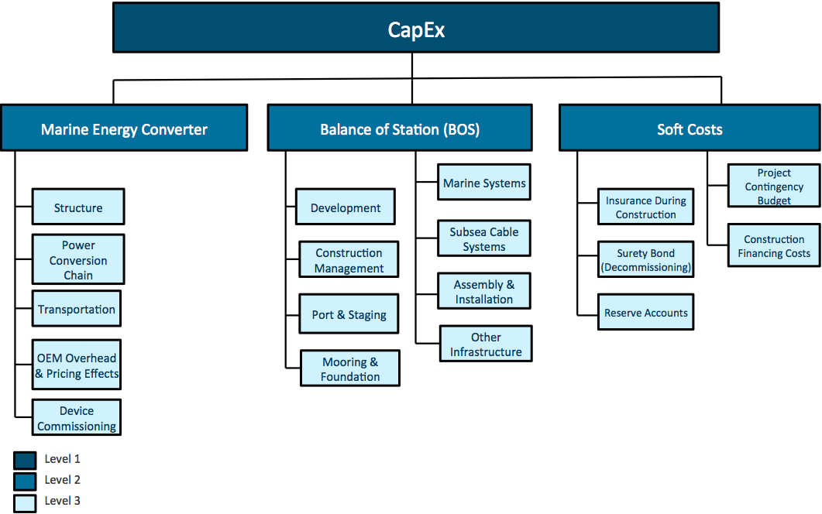

Figure 3 - CBS Levels 1-3

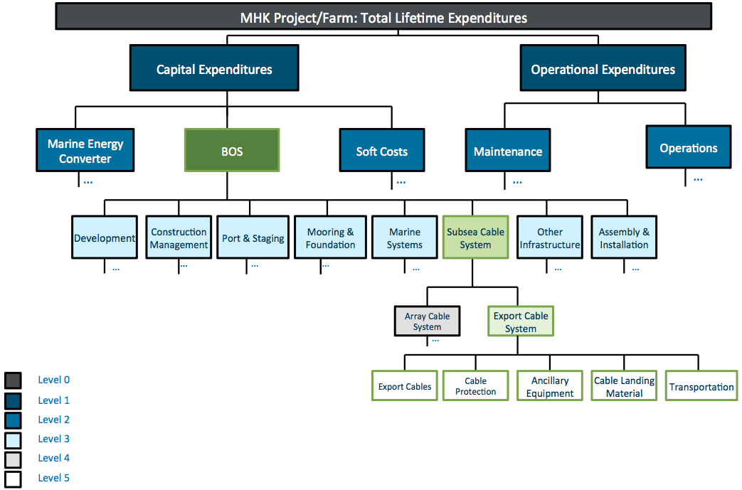

Figure 4 - CBS Level 5 for Export Cable System

The CBS spreadsheet used for reporting purposes is included on OpenEI in a separate discussion forum from the broader LCOE reporting document:

<http://en.openei.org/community/document/mhk-cost-breakdown-structure-draft>

DOE does not expect all developers to have cost estimates for every level of detail in the CBS, either for a single prototype of a device or for a fully commercial device deployed in a utility scale array (utility scale as defined in the reference resource sections). However, DOE is still requesting that awardees report costs from the perspective of the full lifecycle cost of deployment (the CBS should facilitate reporting costs from this perspective). Awardees are required to provide cost estimates for the first two levels of the CBS; (level 1: CAPEX and OPEX; level 2: Marine Energy Converter, BOS, Soft Costs, Operations, and Maintenance). DOE requests that awardees with sufficient information to estimate costs at a more detailed level (level 3, level 4, or level 5) do so, even if the awardee only has cost estimates for a fraction of the level 3 or level 4 items.

The full lifecycle costs of a fully commercial device deployed in a utility scale array should account for additional costs associated with the necessary infrastructure and proposed installation, operations, and maintenance (IO&M) activities, as well as the anticipated reductions in costs due to economies of scale. DOE provides the following guidance on array scaling and prototype scaling.

### Array-Scaling

To better understand the nature of the unique assumptions underpinning each reported estimate, DOE requires that the following information be provided:

* Description of how Balance of Station (BOS) costs were estimated, including:
  + Mooring (or foundation) assumptions
  + Assembly and installation assumptions
  + Other assumptions about infrastructure or development
* Description of how Soft Costs were estimated (likely to be a percentage of total capital costs)
* Description of how O&M costs were estimated

The purpose of providing these descriptions is to ensure transparency in all cost estimates. It is expected that some cost estimates will be based on more detailed assumptions than others. For example, in some cases, developers will have detailed information about the assumed IO&M strategy; in another case a developer may have a detailed mooring design but only a very rough estimate of the O&M costs. In summary, awardees are required to provide a clear description of assumptions used to estimate array-scale costs.

If additional guidance on array scaling is necessary, funding recipients should reference the National Energy Technology Laboratory (NETL) technology learning curve technology guidelines (NETL, 2013). Significant deviations from the NETL guidance must include justification (e.g. additional scaling guidelines, lessons learned, etc.). Depending on the award type the awardees may be required to scale components individually instead of plant level array scaling. In these instances all assumptions must be laid out regarding initial technology level, and assumed scaling rates, for each component affected by array scaling. This is especially critical when scaling sub-systems that comprise of components that have different levels of maturity. An example of this scenario might be a hydraulic drivetrain with a novel hydraulic motor design. While typical hydraulic components, and their scaling relationships, are well understood any novel components will likely have a more exaggerated scaling curve due to the early device uncertainty.

The NETL scaling relationships rely primarily on the learning curve method which implies that some cost reduction is achieved every time production is doubled. Mathematically this represents the following exponential function:

$$Y={AX}^{-b}$$

Where Y= the cost to produce the Xth unit.

A = the Cost to produce the first unit

b = the learning rate exponent.

The learning rate exponent (b) is expresses as:

$$b= \frac{-\log{(1-R)}}{\log{(2)}}$$

The assumed learning rate (R) is a function of the technology maturity. An R value of 0 relates to a component that can no longer achieve any cost reductions do to doubling, while an R value of 0.5 equates to a b value of 1, meaning that every doubling translates to a halving in cost. Typical R values fall between 0.01 and 0.12, or 1-12%.

### Prototype Scaling

In addition to scaling single device costs to the cost of an array, many developers of lower TRL devices may not yet have a complete 1:1 scale cost estimate and must instead extrapolate from scale prototype to full scale costs. To ensure complete transparency in the assumptions used to scale from prototype to commercial device parameters, DOE requires that awardees provide a description of their assumptions behind any cost savings realized (e.g. commercial scale device and power conversion chain costs were assumed to be 10% lower than for the prototype). DOE requests that awardees provide a justification for their assumptions (e.g., consistent with the findings in {name of report or publication} we assumed a 10% reduction in device costs).

### Summary Reporting Requirements

The CBS is provided in an Excel spreadsheet format. Developers with full cost estimates for a 1:1 scale device should report:

1. Single device costs
2. Estimated array costs

Those developers with only scale device cost estimates should report three cost profiles:

1. Actual scale device costs

2. Estimated full-scale single device costs

3. Estimated array costs.

In addition, please also document the information requested with respect to the assumptions used in array and prototype scaling.

*Note*: **Costs should not reflect any improvement in technology (e.g. the use of “progress ratios”), only economies of scale in manufacturing, infrastructure, and operations and maintenance.**

# LCOE Financial Assumptions

Under this simplified LCOE methodology, seven parameters, determine the rate at which an MHK project must recover costs through the choice of discount rate and fixed charge rate. The assumptions underlying the choice of financial variables can lead to significant variations in LCOE even when cost and performance are subject to standardized formulations. DOE is specifying the following standardized choice of parameters as seen in the table below.

Table 1 - Standardized Financial Variables

|  |  |  |
| --- | --- | --- |
| **Symbol** | **Variable** | **Standard Value** |
| $$r$$ | Real discount rate (i.e. real WACC[8]) | .07 |
|  | Inflation rate | .025 |
| $$τ$$ | Composite federal-state tax rate | .396 |
| $$MACRS_{t}$$ | Depreciation schedule | MACRS 5-Year Property |
| $$D$$ | Present value of depreciation tax shield | .309 |
| $$N$$ | Project economic life | 20 Years |
| $$FCR$$ | Fixed charge rate | .108 |

Two of these parameters, the depreciation tax shield, *D*, and fixed charge rate, *FCR*, are derived from the choice of other financial variables.

*D* is the present value of the depreciation tax shield such that:

$$D=τ×\sum_{t=1}^{t=6}{\frac{MACRS_{t}}{{\left(1+r\right)}^{t}*{\left(1+i\right)}^{t}}}$$

Where t is the year of the depreciation schedule and $MACRS_{t}$ is the annual fractional share of installed costs (ICC) according to the full-year convention Manually Accelerated Cost Recovery Schedule for 5-year properties. This implicitly assumes that a) all project costs fall under the MACRS and b) in the future, MHK devices become MACRS-eligible through appropriate legislation.

The Fixed Charge Rate (FCR) is the fraction of capital expenditures necessary to recover project costs and meet investor revenue requirements.

$$FCR = \frac{r}{1-\frac{1}{{\left(1+r\right)}^{N}}}×\frac{\left.1-D\right.}{1-τ}$$

The only “incentive” that should be included in this LCOE calculation is the use of accelerated depreciation. Other benefits such as bonus depreciation, low-cost financing, grants, and tax-credits should be excluded as they muddle the evaluation of technology competitiveness.

# Comment Process and Contact Information

This is intended to be a living document, and your comments and suggestions will only serve to improve the quality of information that DOE receives, and where possible simplify process of providing this information for developers reporting performance to DOE. The standardized guidance documents and excel version of the tidal and wave resource data are available in the public forum on OpenEI for comment here:

<http://en.openei.org/community/document/mhk-lcoe-reporting-guidance-draft>

**Please note that any comments in this forum will be public**. If you do not wish to comment publically, you can direct your comment or question to the following individuals:

* For specific questions or comments regarding wave performance reporting or the wave reference resource, please contact Mike Lawson ([Michael.Lawson@nrel.gov](mailto:Michael.Lawson@nrel.gov)) or Yi-Hsiang Yu ([Yi-Hsiang.Yu@nrel.gov](mailto:Yi-Hsiang.Yu@nrel.gov))
* For specific questions or comments regarding cost reporting and the Cost Breakdown Structure, please contact Scott Jenne ([Dale.Jenne@nrel.gov](mailto:dale.jenne@nrel.gov))
* For all other comments and general questions regarding this guidance, please contact Alison LaBonte ([alison.labonte@ee.doe.gov](mailto:alison.labonte@ee.doe.gov))

# References

Babarit, A.; Hals, J.; Kurniawan, A.; Muliawan, M.; Moan, T. and Krokstad, J. 2011. “The NumWEC project: Numerical estimation of energy delivery from a selection of wave energy converters”.

Babarit, A. Hals,J. Muliawan,M.J.,Kurniawan,A. Moan,T. and Krokstad,J.. 2012. “Numerical Benchmarking Study of a Selection of Wave Energy Converters.” Renewable Energy 41:44–63.

Babarit, A.. 2012. “A review of the park effect in arrays of wave energy converters.” International Conference on Ocean Energy, ICOE, Dublin, Ireland.

Babarit, A.. 2013. “On the park effect in arrays of oscillating wave energy converters”. Renewable Energy 58:68-78..

Beels, C. Henriques, J.C.C. Rouck J De,Pontes M.T., Backer,G. De and Verharghe H. 2007 “Wave energy resource in the north sea” 7th European Wave and Tidal Energy Conference, Porto, Portugal.

EPRI. 2011. “Mapping and Assessment of the United States Ocean Wave Energy Resource”. Technical Report 1024637.

Folley M, and Whittaker TJT.. 2009. Analysis of the nearshore wave energy resource. Renewable Energy;34:1709-15.

IEC 62600-1. 2011. “Marine energy—Wave, tidal, and other water current converters—Part 1: Terminology”.

IEC 62600-100. 2012. “Marine energy—Wave, tidal, and other water current converters—Part 100: Electricity producing wave energy converters—Power performance assessment”.

IEC 62600-200. 2012. “Marine energy—Wave, tidal, and other water current converters—Part 200: Power performance assessment of electricity producing tidal energy converters”.

NETL. 2013. “Quality Guidelines for Energy System Studies: Technology Learning Curve (FOAK to NOAK)”. DOE/NETL-341/081213.

Polagye, B. 2012. “Reference Model 1 Tidal Energy: Resource” <http://energy.sandia.gov/wp/wp-content/gallery/uploads/RM1_Tidal-Turbine_UW-Tidal-Resource.pdf>

1. <http://www.iec.ch/dyn/www/f?p=103:7:0::::FSP_ORG_ID:1316>
2. The significant wave height can be calculated based on zero down crossing analysis from time history data or four times the square root of the zeroth-order spectral moment of the wave energy spectrum (IEC TC114). The symbol H1/3 is often used for the first definition, and Hm0 is often used for that latter definition.
3. We use peak period, as it is more practical for industry. Alternatively, one can use the energy period Te. Theoretically, they will be converge to nearly the same value when the data sample is large enough, i.e., sufficient time. For example, Beels et al (2007) demonstrate a scenarios where Te=Tp×1.162.
4. TAEP is the direct analogue of Mean Annual Energy Production (MAEP) as defined in IEC 2012a.
5. The technology developers can use their own simulation duration or time step size, but we do recommend the length should be at least 200Te seconds. Note that the simulation duration used by Babarit et al. (2011) is 15Te+1200s with a time step size between 0.01s and 0.05s.
6. At this stage, we do not include the further directionality calculation here, although we understand its importance and would include it in the future.
7. At this stage, we do not include detailed monthly or seasonal data, although we understand their importance and will include them in the future.
8. Weighted Average Cost of Capital