Post Access Report
Tidal Turbine Test
Awardee: Downeast Turbines
Awardee point of contact: George McBride
Facility: Alden
Facility point of contact: Greg Allen
Date: 3-26-2022

Appendices A, B, and C are included in this document
Appendix A – Project Specific Hazard Assessment
Appendix B – Instrumentation Details
Appendix C – Post Access Supplement Report

Appendices D, E, and F are separate files
Appendix D – Test Data Workbooks.zip
Appendix E – Post Access Figures.zip
Appendix F – References.zip

Executive Summary
Please see Appendix C – Post Access Supplement Report, for a full description.

In July 2021, Downeast Turbines tested an instream tidal turbine prototype in the big flume at Alden Lab.
Downeast Turbines’ prototype is a ducted turbine with two elements of design: 1) A rotor/channel system that takes in flowing water from a stream and extracts power from it, and 2) A lateral effluent discharge apparatus (LEDA) that provides the means to discharge turbine effluent back out to the stream.
In its application for the Tidal Turbine Test at Alden Lab, Downeast Turbines stated an objective to, “Characterize the turbine’s performance, and in that process validate, from a technical perspective, fundamental elements of design as they relate to configurations of the channels, rotors, and lateral effluent discharge apparatus (LEDA).”
The test plan had a simple protocol – to measure the performance of the tidal turbine prototype with rear-mounted LEDA, in Alden Lab’s big flume, and see how it compares with performance of the same prototype without the LEDA.
The setup of the flume proceeded to the plan. On Day 1 of testing, it became evident that the turbine prototype with rear-mounted LEDA did not produce sufficient power to validate two elements of design – the rotor/channel system and the LEDA. It was not clear to what extent each element of design contributed to the disappointing outcome.
From that point on, the focus of the testing was to dissect what went wrong.
On Days 2 and 3 of testing, additional turbine prototype configurations, with the LEDA structures mounted at the sides (lateral discharge wings, or LDWs), made it to the flume for testing.
On Days 4 and 5 of testing, a lateral discharge wing, or LDW, was tested in the flume, by itself, without the turbine. Metrics of performance were pressure differential and volumetric flow, and the influence of several different gap widths was explored.
On Day 5, there was the “boat test,” a demonstration of the LEDA drawing volumetric flow.
Post-test analysis found that “Outlet velocity,” more than any other metric, shows how actively the LEDA makes a volumetric flow of water go away.
The power of the LEDA’s interaction with the stream can be investigated, and improved. Larger gap widths, longer wings, and other profile changes, as well as shape considerations derived in the “boat test,” all offer prospects to increase performance in the metrics of pressure differential and the rate of volumetric flow.
3D-CFD would be a helpful tool to characterize, and then improve upon configurations of the LEDA. One goal is to arrange for 3D-CFD experiments, to gain more data on the lateral effluent discharge apparatus (LEDA), refine its shape, and explore its limits of performance.
Next, would be to remake lateral discharge wings (LDWs), with reference to the 3D-CFD findings, bring them back together with the present configuration of the rotor/channel system and try that combination as an incremental change for experimental continuity.
And finally, the rotor/channel system of the turbine prototype would optimized together with the LEDA. Rotor size can be enlarged to better match the LEDA’s contributions for the pressure differential and rate of volumetric flow, and rotors’ transformation ratio can be increased to regain rpm.
All the projections leading to this test event – structural, operational, societal, environmental, and economic benefits – are still desired, and Downeast Turbines’ two elements of design still hold promise toward achieving those projections.
Finding the means of effluent discharge that will augment performance of a tidal turbine puts Downeast Turbines back on track to validate its rotor/channel system and the LEDA. Then it can get on with the next phase of development, choosing a market and designing a product.
3D-CFD will likely be a topic for Downeast Turbines’ next DOE TEAMER application.

Introduction to the project
Downeast Turbines of Whitneyville, Maine will bring a tidal turbine prototype to Alden Research Laboratory, Inc (Alden) for testing. The prototype will be tested in Alden’s large flume, capable of recirculating up to 500 cfs, to see how well it works!
The turbine’s rotor/channel system captures tidal current flow and feeds it into small, enclosed, fast-turning rotors, to generate useful power. A lateral effluent discharge apparatus (LEDA) harnesses the action of the stream to energize flow of water through the rotors. Rotor/channel system and discharge apparatus both have US patents.
The company seeks to commercialize its technology in the worldwide industry of large-scale tidal power for mini and micro sized hydro plants. There are implications for the industry at large. Economic benefits include reducing upfront costs of design, manufacturing and improving power performance for higher lifetime revenues.
The company’s objectives are:
- Prove out the technology to get on with product development, potentially attracting investment from other companies in the industry to help speed that along.
- Gain credible test results backed by the expertise and skill of a well-respected lab that performs the testing.
- Validate 2D-CFD findings that were obtained on the LEDA in 2017.
- Validate fundamentals of design as they relate to configurations of the channels, rotors, and discharge apparatus.
Alden’s large flume has a depth of 10-ft and a test area about 80 ft in length and 20 ft wide. Flow is recirculated through the flume by two 5.5 ft diameter bow-thrusters (400 hp each) located beneath the test flume floor (i.e., flow passes vertically between the upper test channel and lower recirculation channel tunnels). To achieve the desired velocities for testing, the flume will be narrowed to 10 ft wide with 6 ft high false walls. The turbine will be suspended in the flume at the end of the constricted test channel. A range of approach velocities will be tested to collect the necessary operating data of the turbine.
Testing will also allow the evaluation of the effects of LEDA on turbine efficiency. Testing of the turbine prototype will include testing with and without the LEDA attached to the turbine. This will provide the opportunity for comparing performance data with and without the LEDA. In 2017 an extensive analysis of the LEDA was performed using two-dimensional, computational fluid dynamics modeling (2D-CFD) and the test data collected will allow for validation of the CFD model for future geometric iterations of the turbine.

Roles and Responsibilities of Project Participants
Below are the roles and responsibilities for the applicant and network facility.

Applicant Responsibilities and Tasks Performed
(Applicant) Downeast Turbines- George McBride
- Test plan development input and oversight
- Supply the turbine ready for installation
- Installation oversight
- Testing oversight
- Turbine removal oversight
- Data management, processing and analysis
- Reporting

Network Facility Responsibilities and Tasks Performed
(Network facility) Alden
- Test plan development
- Test facility configuration design and construction for turbine installation
- Turbine installation
- Instrumentation and data collection design and installation
- Facility operation for turbine testing
- Turbine removal
- Test facility configuration demobilization
- Data management, processing and analysis support
- Reporting support and review

Project Objectives
Please see Appendix C – Post Access Supplement Report, for a full description.

Key updates:
The technical assistance objectives were adapted to the situation, when the first results did not work out as anticipated.
The first objective called for power curves to characterize performance of the turbine, based on torque and rpm, and that objective was accomplished.
But the level of performance remained insufficient to validate the elements of design. The turbine failed to generate sufficient torque and rpm, and the focus of necessity turned to dissecting what went wrong. The rotor/channel system of the turbine prototype was tested with additional LEDA variations.
The second objective, to quantify effects of the lateral effluent discharge apparatus (LEDA), was adjusted to include testing a lateral discharge wing (LDW) by itself without the turbine, to ascertain how much pressure differential and volumetric flow the LEDA by itself was able to create.
The third objective, to develop data that supports commercializing the technology remains unchanged. As regards this test event, the results are but a step along the way – there is more to be done.
_____________________________________________________________________________________

Downeast Turbines’ technical assistance objectives are three-fold.
First is to characterize the turbine’s performance, and in that process validate, from a technical perspective, fundamental elements of design as they relate to configurations of the channels, rotors, and LEDA. It will be desirable to develop power curves that show how the system responds to variations in ambient flow speed, and load, requiring performance data in the speed range for which this prototype turbine is designed, 2-knot (3.4 ft/sec) to 4-knot (6.8 ft/sec) flows. Access to the needed test equipment – flume, dynamometer, data acquisition system – will enable that to happen. For this prototype it is not practical to avoid the losses of the drive train – measurements must be taken from a power-accessible shaft. Estimates of turbine efficiency will be based on inlet area, not rotor size.
Second is to discover and quantify effects of the lateral effluent discharge apparatus on turbine efficiency. This will be the first time testing the turbine prototype with the discharge apparatus affixed, and it provides a prime opportunity for comparing performance data with and without the discharge apparatus. In 2017 an extensive analysis of the discharge apparatus was performed using two-dimensional, computational fluid dynamics modeling (2D-CFD), and it will be desirable to compare CFD and experimental findings as a validation step which will impart more confidence on any future geometric iterations of the turbine.
Third is the commercial objective to validate the turbine system as a power generator, building on what was done before, and especially to acquire results through a credible, transparent process, harnessing the expertise of the test facility to ensure validity of testing, lending authority to the results. The company needs to have convincing evidence that the whole system works so that it can get on with the next phase of product development, which is choosing a market and designing a product. There are two elements of success relating to this objective – success of the lateral effluent discharge apparatus and success of the turbine prototype with lateral effluent discharge apparatus attached.
The company seeks to commercialize its technology in the worldwide industry of large-scale tidal power for mini and micro sized hydro plants, and significant startup costs and investments are required. The company will seek a partner, a target company, to take on further development, manufacture, large scale deployment and marketing of its technology, and that target company will need data – evidence of product performance in terms of efficiency – to support the significant time and monetary investment required to complete testing and regulatory approvals prior to market launch.

Test Facility, Equipment, Software, and Technical Expertise
Please see Appendix C – Post Access Supplement Report, for a full description.

Key updates:
Because the first results did not work out as anticipated, some further tests were done with the lateral effluent discharge apparatus (LEDA) tested in the flume without the turbine. A lateral discharge wing (LDW) was attached to the bottom of the flume, with performance metrics of pressure differential and volumetric flow. One more set of tests involved tethering a floating vessel with a LEDA in its hull to characterize, and demonstrate, its discharge rate of volumetric flow.
_____________________________________________________________________________________

Testing will be conducted in a large re-circulating flume located in the Taft Fisheries Research and Test Facility building at Alden’s campus in Holden, MA. The flume has 10-ft high walls and a test area that is about 80 ft in length and 20 ft wide. Flow is recirculated through the flume by two 5.5 ft diameter bow-thrusters (400 hp each) located beneath the test flume floor (i.e., flow passes vertically between the upper test channel and lower recirculation channel). The bow-thrusters are capable of pumping up to 500 cfs through the flume channel. Turning vanes are located at both ends of the flume to turn the flow directing it to the bow thrusters and turning the flow before entering the upstream end of the flume test channel. Fixed isolation screens are located at each end of the test channel to prevent debris from potentially being entrained through the bow thrusters. The test configuration requires the flume to be narrowed to a 10 ft width with 6 ft high false walls. The turbine will be suspended in the flume at the end of the constricted test channels. A torque transmitter and air cooled brake will be attached to the output shaft of the turbine for data collection.
Alden has conducted numerous tests on hydrokinetic / tidal turbines evaluating the engineering and biological (fish passage and survival) performance of the turbines. Our extensive experience with a wide range of design in combination with our closed loop test facility makes Alden qualified to provide testing for Downeast Turbines. Alden’s staff is composed of engineers, biologist, technicians and skilled craft/tradesmen which will be available to support all aspects of this project.

Test or Analysis Article Description
Please see Appendix C – Post Access Supplement Report, for a full description.

Key updates:
Nine test articles were tested during five days of testing.
During the first three days of testing, five turbine prototype test articles were tested in the flume. The rear-mount LEDA shown in Figure 4, (with added fairing) was attached for Test Article #1, the turbine prototype with rear-mounted LEDA, and then removed to make Test Article #2, the turbine prototype without the LEDA. That was the first day of testing.
Test Article #3 had exhaust channels removed, as well as the rear-mounted LEDA.
Test Articles #4 and #5 had side-mounted LEDA structures, termed lateral discharge “wings,” or LDWs.
During the last two days of testing, one LDW was removed from Test Article #5 and tested in the flume, by itself without the turbine. Test Articles #6 - #8 were all the same LDW but with three different gap width settings of the LEDA outlets, tested in the flume to measure pressure differential and volumetric flow.
Test Article #9 was a “boat test,” a 7’ long test vessel with LEDA structure built into the bottom of its hull, tethered in the flume to characterize, and demonstrate, its discharge rate of volumetric flow.
_____________________________________________________________________________________

Downeast Turbines has two patents advancing the technology of marine current energy conversion. One is a novel turbine configuration based on streamlines modeling, with inward flow reaction rotor and a channel system to capture and to concentrate the flow, and the other is a lateral effluent discharge apparatus (LEDA), that aids the turbine in generating power. Relevant analytical and numerical modeling, lab and bench testing, and open water testing have validated concepts that were disclosed in these two patents, and the prototype presented here for testing combines elements from both.
The test article is a prototype turbine apparatus measuring 37” high, 34” wide, and 41” long, configured to be immersed in a flowing water stream, such as ocean current, tidal stream, or river flow, to harvest useful power from momentum of the stream. The apparatus includes two mirror image rotors, mounted on a single, transverse shaft, and enclosed within a channel system that takes in water from the stream, accelerates it, and directs it through the rotors to get power.
Each rotor is contained within a volute. A common intake channel with inlet facing to the stream feeds both volutes. A volute creates an inward-spiral flow which the rotor housed therein receives through a peripheral rotor inlet. A plurality of rotor vanes redirects the flow, which departs the rotor in an axial direction through a circular outlet at the rotor’s distal end. Spent flow from rotors passes through exhaust channels, and aided by the LEDA, is discharged to the stream.
By redirecting flow, the rotors take up power and cause the shaft to turn, generating electricity or any other form of useful power.
Each rotor by design has a no-load rate of spin that synchronizes to the speed of water flowing through. An idealized flow path for redirecting water through the stationary space that the rotor occupies is modeled using streamlines in a ranked array, then a rotational transformation, or mathematical “twisting,” is applied. The amount of rotational transformation applied to the ranked array of streamlines predicts the designation of the rotor’s no-load rate of spin, and the ranked array of rotationally transformed streamlines models a rotor vane configuration that will approximate the original, idealized, redirected path for water flowing through, when the rotor achieves its designated no-load rate of spin.
A rotor’s no-load rate of spin is designated with a value of percent. It is the travel speed of the perimeter of the outlet of the rotor, in ratio to the speed of water flowing through. The test article’s two rotors have outlet diameters of 4”, and no-load rate of spin for both is designated at 100%. As an example, 4 knots of flow through these rotors matches by design a no-load rate of spin of 387 rpm. A shaft’s actual rate of spin at any given time varies with the speed of water flowing through, and, of course, will be diminished by losses, and its load.
Moving water expends energy in generating power. At a turbine installation in a hydropower dam, discharged effluent escapes, with its energy mostly spent, to a downstream race through which it flows away. In contrast, at an instream hydropower turbine installation there is no downstream race to take spent flow away. The turbine apparatus by its presence in the stream, instead creates a wake, an opposing flow that impedes the turbine’s discharge. The lateral effluent discharge apparatus (LEDA) provides a means to overcome the wake and to facilitate the discharge of spent flow to the stream.
The LEDA has three surfaces that control portions of the stream, generating a low-pressure region nearby the turbine through which spent flow can be drawn away. It includes a discharge opening, which is an outlet to the stream that connects via exhaust channels to the rotor outlets. The forward-most surface, an ambient flow deflector, imposes an outward component of motion to an oncoming portion of the stream. Where the outermost edge of the ambient flow deflector releases its constraint, the deflected stream portion curves back toward its original direction of flow, and just inside that curve is generated a low-pressure region where the discharge can occur. Behind the ambient flow deflector is a mixing surface, and between that surface and the outermost edge of the ambient flow deflector is where the discharge opening is made. For the test article the discharge opening is a gap, about 0.40” wide and 48” long overall. Upon the mixing surface, which extends even farther out into the stream than the outermost edge of the ambient flow deflector, are blended ambient and deflected portions of the stream together with the discharge of the turbine, to carry spent flow away. A third surface, the backflow preventer, keeps the downstream wake of the turbine from interfering with the action of the stream at the LEDA’s discharge opening.
The test article has a sturdy standpipe, or riser, that provides a means for mounting the turbine to a platform suspended over, or floating on, a stream. A chain drive mechanism runs through a dry space inside the standpipe and connects the rotors’ shaft to a secondary, power-accessible shaft mounted at the top. Photos of the test turbine and streamlines are presented below (Figures 1 through 4).
Dimensions of the prototype turbine apparatus include:
- Overall dimensions: 37” high, 34” wide, and 41” long
- Semi-circular inlet opening – about 133 sq. in.
- Rotors – overall dimensions: 6” overall dia., about 6” long
- Rotors – outlet diameter: 4”
- Semi-circular LEDA outlets: 0.40” gap width by about 48” (total both sides)
- Shafts: 1/2” dia. SS

Materials of construction are wood, and fiberglass reinforced polymer (FRP) composite, for the channels, rotors, and structural supports. The drive mechanism, axles (shafts), bearings, and chain drive, are mostly stainless steel.
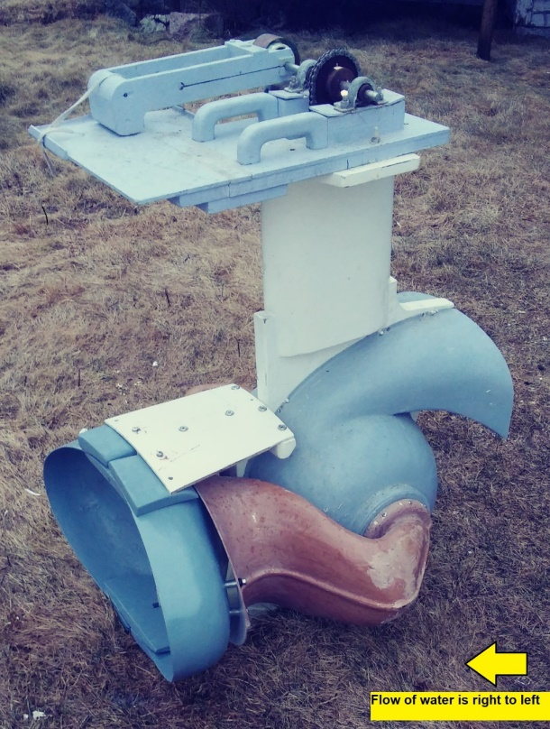
Figure 1, Prototype turbine apparatus

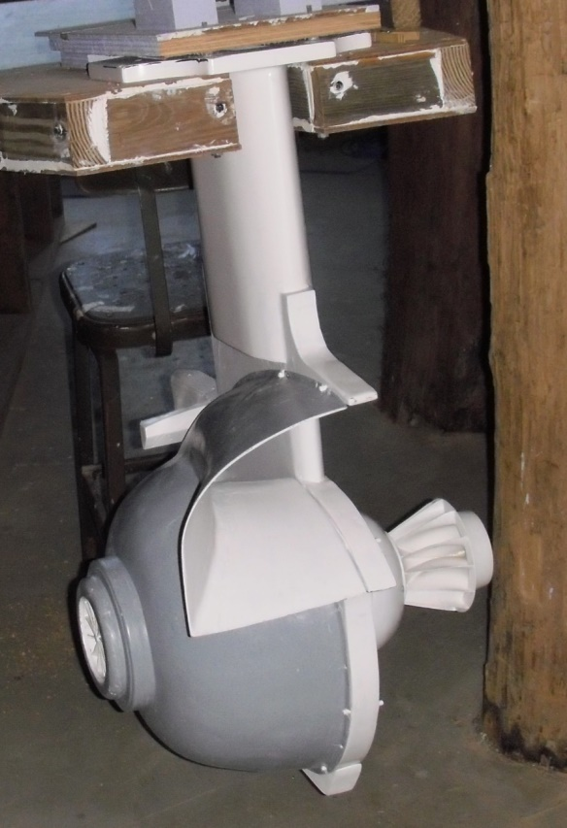
Figure 2, Cutaway view showing rotors.

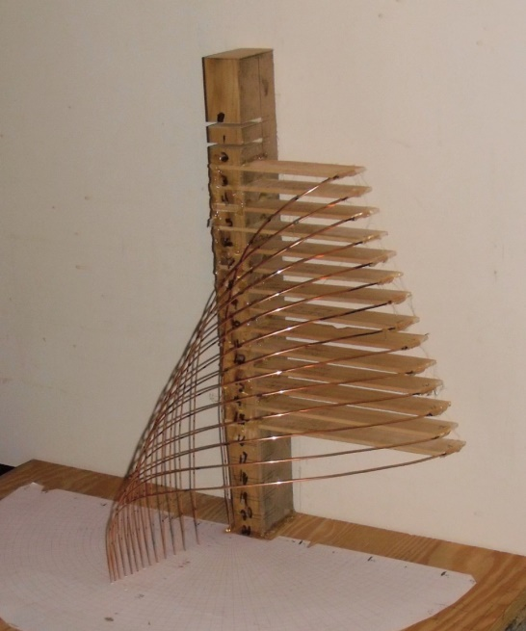
Figure 3, Idealized water flow path, for rotors

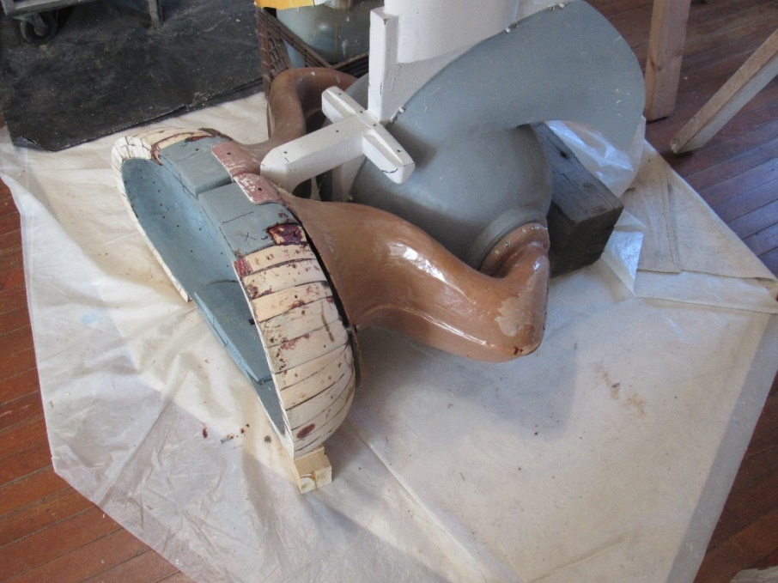
Figure 4, Lateral effluent discharge apparatus – attached to prototype

Work Plan
The following tasks are required for testing of the Downeast turbine:
- Development of a test plan (presented here)
- Design of the test facility modifications
- Instrumentation selection
- Test facility preparations and modifications
- Installation of the turbine
- Installation of the instrumentation
- Testing – presented below
The test plan presented here is subject to change based on the detail design of the facility modifications and final selection of instrumentation. Any deviations from the test plan presented will be described in the post access report.
Testing will commence as presented here at the completion of the instrumentation installation. The test facility will be filled with water to the desired test depth (approximately 5 ft). Preliminary shakedown test will be conducted at a range of velocities from 2 knots (3.4 ft/sec) up to 4 knots (6.8 ft/sec) to ensure the operation of the turbine, instrumentation and the data collection equipment.
Turbine test will be conducted at 6 velocity conditions from 2 knots (3.4 ft/sec) to 4 knots (6.8 ft/sec) and up to 10 turbine speed conditions as shown in the test matrix provided in Section 6.3 (Figure 2). Velocities shown are target velocities, due the operation characteristics of the facility actual test velocities may vary from the target velocity slightly. For each test condition water depth, water velocity, torque and RPM will be recorded.
The turbine will be tested with and without the lateral effluent discharge apparatus (LEDA) on the turbine.

Experimental Setup, Data Acquisition System, and Instrumentation
Please see Appendix C – Post Access Supplement Report, for a full description.

Key updates:
The experimental setup was as described below.
In the last two days of testing, a simple structure made of MDX (exterior grade fiberboard) was mounted to the bottom of the channel in the flume, to support an LDW tested by itself, without the turbine prototype.
Additional instrumentation – for pressure differential and volumetric flow – was incorporated for the LDW tests.
_____________________________________________________________________________________

The flume channel will be narrowed to 10 ft with false walls to allow for the maximum test velocities (4 knots/ 6.8 ft/sec) to be achieved. The false wall will be 6 ft high and support a walkway and the turbine on the downstream end of the channel. A general arrangement of the test facility is shown on Figure 5. The water depth in the flume will be adjusted to account for the varying channel water surface slope and losses in the test channel to provide similar submergence on the turbine for each of the test velocities. The expected water depth will be about 5 ft, which provides about 1.4 ft of submergence at the centerline of the turbine.
The turbine output shaft will be fitted with a S. Himmeltein & Company non-contact DC operated compact digital torquemeter, model No. MCRT® 48202V(5-2)NN (Appendix B) and an air cooled friction brake to allow for a range of speeds to be tested. The output from the torque transmitter will provide torque and RPM which will be recorded on a data acquisition computer utilizing Labview 2018 – DataCollect 4.X. software. Velocities will be measured about 5 channel widths upstream of the turbine inlet by a wall mounted Sontek Argonaut –SL 3000 KHz and recorded on a dedicated velocity measurement computer utilizing Sontek proprietary software. The Argonaut will be raised and lowered to conduct velocity traverses for selected test conditions.
The desired test flow conditions will be set in the flume and the velocity monitored until it has stabilized (typically on the order of 10 minutes). Once the velocity conditions and the turbine speed are stabilized, data will be collected. Data would then be collected by varying load on the turbine for different turbine speed conditions. For each condition, data would be collected once the turbine speed and approach velocity have stabilized. Data will be collected and averaged over a 1 minute period. This will be repeated for the test conditions identified in the test matrix. At the beginning of the testing four one minute tests will be conducted and the data will be reduced to determine the variation in the conditions tested.
All data will be collected on the dedicated computers. Data will be saved in a format compatible with Microsoft Excel and will be backed up daily at the completion of testing on Alden’s internal file server system.

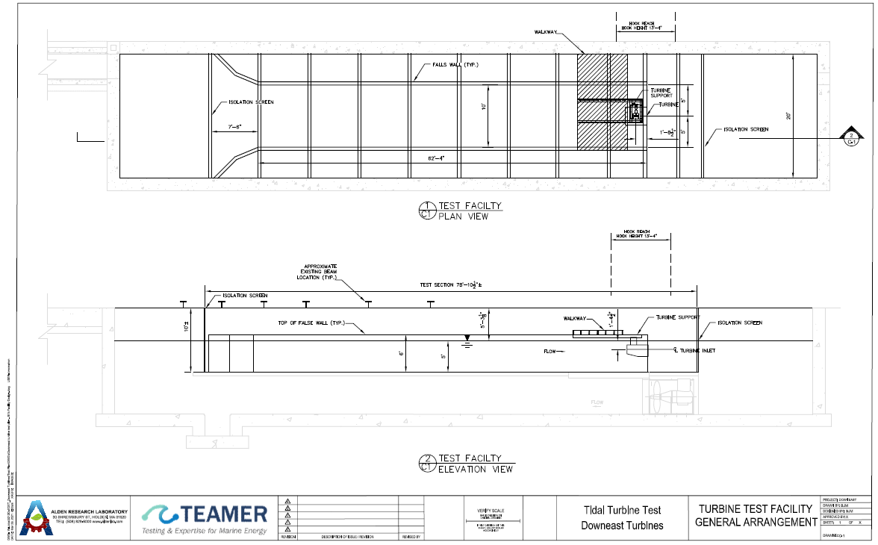
Figure 5, General arrangement of test facility

At each flow speed that is tested in the flume, a brake will be applied to the power-accessible shaft, allowing torque and rpm measurements at several different loads. Torque and rpm data will be used to determine how much energy from water flowing through the turbine is converted into power at the shaft.
The formula for calculating power is:
$$Power=Torque x angular velocity$$
Power curves will be generated relating power coefficient of performance (C_{P}) to rpm, to show how the turbine responds to variations in ambient flow speed and load.

Numerical Model Description

Previous Numeric Modeling Work
At many instream turbine installations, the rate of current energy conversion is diminished by ineffective discharge, impeded by the counter flow of a downstream wake. Downeast Turbines’ lateral effluent discharge apparatus (LEDA) uses flow-directing surfaces to make an outlet that puts turbine effluent, the spent flow, laterally into a nearby portion of the stream.
In 2017, a series of 2-dimensional computational fluid dynamics (2-D CFD) computer simulations were performed at the University of Rochester, to assess how the discharge apparatus works. Technical Note, “Lateral Effluent Discharge Apparatus for a Tidal Turbine (Where Does the Water Go?)” describing that experimental series was published in the peer-reviewed “Marine Technology Society Journal,” Vol. 51, No. 6, Nov/Dec 2017.
Nine configuration variations were modeled and tested in varying conditions of ambient water flow speed and turbine load. Over 250 simulations were performed. A substantial amount of data was acquired and entered to a Microsoft Excel spreadsheet for analysis.
A computation model employing 2D data for pressure and velocity was used to calculate an array of 3D power curve projections for Downeast Turbines’ prototype. From these projections were selected the most promising dimensions of size, proportion, and outlet opening (gap width) to shape the LEDA of the test article that is presented here.
The in water testing will assess validity and accuracy of prior 2D modeling. Test data collected will allow for validation of the CFD model for future geometric iterations of the turbine.

Test and Analysis Matrix and Schedule
Please see Appendix C – Post Access Supplement Report, for a full description.

Key updates:
Two more designated target flume flow speeds were added for the LDW tested in the flume without the turbine, and the “boat test.” These are:
0.9 knots, 1.5 fps
1.3 knots, 2.2 fps
Testing occurred on July 12-14 for Test Articles #1-5, the turbine prototypes, and on July 27-28 for Test Articles #6-9, the LDWs that were tested in the flume without the turbine.
Data analysis and reporting may be considered complete as of the date of this Post Access Report.
_____________________________________________________________________________________

The test matrix for the turbine testing includes six target velocities and up to 10 speeds to be tested with the LEDA on the turbine (Figure 6). Shake down testing will be conducted to determine the sensitivity of the turbine and brake to provide the resolution for up to 10 speed conditions. Testing without LEDA on the turbine will also be conducted following the same test matrix to allow for comparison of the two conditions.
Velocity |  | Load Condition
knots | Ft/sec | 1 | 2 | 3 | 4 | 5 | 6 | 7 | 8 | 9 | 10
2.0 | 3.4
2.3 | 3.9
2.9 | 4.9
3.4 | 5.7
3.7 | 6.2
4.0 | 6.8
FIGURE 6, Test Matrix
Provided below is the anticipated project schedule for testing the Downeast turbine in the Alden test facility including data analysis and reporting (Figure 7).
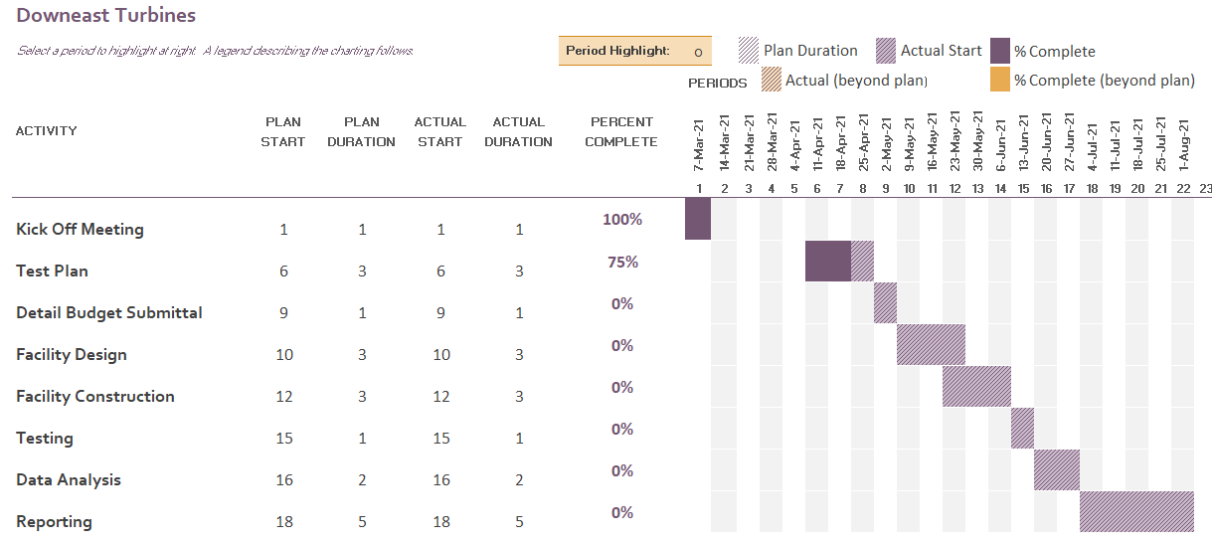
FIGURE 7, Project schedule

Safety

Prior to start of work a kick off meeting will be held to inform staff and Downeast Turbine’s onsite visitors on the project the task needed to complete the project and the associated hazard and personal protective equipment (PPE) that will be needed.
At the start of each day a “tailgate” meeting will be held to discuss the task for the day, any changes in the work that may require different procedures or equipment and address any issues that have arisen.
All Alden employees have been trained under Alden’s Health and Safety Manual, Revision 4, October 2020. As guidance to employees working on the project a Project Specific Hazard Assessment (Appendix A) has been completed to provide guidance on potential hazards and Personal Protective Equipment required.

Contingency Plans

In the event that testing cannot commence on schedule or has to be interrupted due to circumstances beyond our control such as equipment failure, power failure or other unforeseen event. The project will be halted, the nature of the interruption will be evaluated, a plan and schedule to correct the issue will be developed and the project partners will be notified. The schedule will be adjusted and testing will commence with all efforts to minimize the impacts to the project schedule.

Data Management, Processing, and Analysis
Please see Appendix C – Post Access Supplement Report, for a full description.

Key updates:
Raw data was augmented to include pressure differential and rate of volumetric flow for LDWs tested in the flume without the turbine, and processed data was augmented accordingly.
_____________________________________________________________________________________

Data Management
Raw data will be transferred to Downeast Turbines’ computer in a format compatible with MicroSoft Excel. Downeast Turbines has responsibility for processing the data, with support from Alden. Backup copies of raw and processed data will be kept by Downeast Turbines, and all raw data collected will be backed up daily at the completion of testing on Alden’s internal file server system (Table 1).

Data type | Description of data | Format
Background information | Completed test report | Word document
Raw data | Flume water flow velocity, torque, shaft rpm | Comma-separated file, or other Microsoft Excel compatible format
Processed data | Raw data, inlet/outlet dimensions, pertinent rotor dimension, power calculations, power coefficients of performance | Microsoft Excel file(s)
Processed data | Performance curves | Graphs
Table 1, Data to be submitted to the MHK DR

Data Processing
Data analysis will use spreadsheet calculations to convert raw data into processed form. A sample table of power calculations will be on hand during testing to help identify if torque and rpm data being collected are correct. A Prony brake with separate torque readout will be on hand to validate torque measurements should that be required, and a handheld frequency meter will be on hand to validate rpm.
Raw and processed data will be kept, and intermediate process files will be identified with a time stamp in their name.
Uncertainty in measurements will be quantified to the extent possible. Accuracy of measuring tools will be noted with the data. The speed of water through the flume presents a possible measurement uncertainty due to potential for variations in the flow. A figure of uncertainty will be noted with the data.
Reynolds Number (Re) is a dimensionless quantity used here to predict the flow characteristic (laminar vs. turbulent) of water current in the flume external to the ambient flow deflector (AFD) of the lateral effluent discharge apparatus (LEDA) of the prototype turbine machine. The formula for Reynolds Number is:

$$Re=\frac{Inertial force}{Viscous force}$$

$$Re=\frac{ρ×V×L}{μ}$$
Re = Reynolds Number
ρ = density of water (999 kg·m⁻³ at 18° C)
V = velocity of ambient water current in the flume (see range of values below)
L = Characteristic length, the curve length of the modeled ambient flow deflector (in line with the stream)
µ = dynamic viscosity of fluid (0.0010518 N*s/m2 at 18° C)
Based on the expected test range of ambient water current speeds (1.03 – 2.06 m·s⁻¹), and the curve length of the modeled ambient flow deflector (in line with the stream), according to which the prototype LEDA is constructed (0.1573 m), Reynolds Number is calculated to fall within the range:

$$Re=153,900 (min)$$
$$Re=307,800 (max)$$

For external flow, a Reynolds Number between 100,000 and 500,000 characterizes a flow in the transition between laminar flow and turbulent flow. The flow characteristic (laminar vs. turbulent) of water current in the flume external to the ambient flow deflector (AFD) of the lateral effluent discharge apparatus (LEDA), is therefore characterized as being in the transition between laminar flow and turbulent flow.
The turbine when installed will be in a 10 ft. wide channel and test depth of 5 ft. with a cross sectional area of 50 square feet. The blockage area of the turbine with the LEDA is 3.52 square feet and 3.20 square feet without the LEDA which is a blockage ratio of 7.1% and 6.4% respectively. Water surface upstream and downstream of the turbine will be measured and recorded for each test condition to allow for a review of potential corrections to be made for facility boundary effects.

Data Analysis
Please see Appendix C – Post Access Supplement Report, for a full description.

Key updates:
Turbine power co-efficient of performance, Cp, was ascertained for “rotor shaft” power as measured, and for “test shaft” power, which takes into account a “baseline/zero rpm torque value for each [test] condition caused by the mechanical set up and bearing friction in the test stand.”
Reference power value of Cp calculations was provided in two alternatives – first as the amount of power in the water flow presented to the turbine at its inlet opening, and second as the amount of power in the water flow presented to the turbine at its rotors.
Data analysis was augmented to include measurements of pressure differential, rate of volumetric flow, and “Outlet velocity,” as presented in the test results.
_____________________________________________________________________________________

Torque and rpm data are sufficient to ascertain turbine power:
Power = Torque x Angular Velocity
Power = Watts $\left(\frac{kgm^{2}}{s^{3}}\right)$
Torque = Newton meters $\left(\frac{kgm}{s^{2}}m\right)$
Angular velocity = radians per second $\left(\frac{1}{s}\right)$
Angular velocity = $πn_{rpm}/30$ $\left(\frac{1}{s}\right)$
Power co-efficient of performance (C_{P}), an important figure of merit for these tests, is derived as a comparison or ratio of the power generated by the turbine (P_{T}) to a reference power value (P_{W}) for each test:
$$C_{P}= \frac{P_{T}}{P_{W}}$$
Cp – the co-efficient of turbine performance, is a calculation whose varying value is expected to derive from several, mutually interacting qualities of the tests that will be performed, and these include speed of ambient water current flow in which the prototype is immersed and amount of load resistance that will be applied during any given test, as well as innate performance characteristics of the turbine.

Calculations of Cp in these tests will be documented in power curves during follow-up data analysis after testing. Power data can and will be expressed not just in terms of power generated (watts), but also in ratio to a reference power value that is the amount of power in the water flow presented to the turbine at its inlet opening. Any average Cp calculation will require integrating site-specific expectations of generated power through the expected periodic variation in speed of ambient water current flow and the load conditions expected to be imposed.

Reference power value is the amount of power in the water flow presented to the turbine at its inlet opening:
$$P=\frac{ρAV^{3}}{2}$$
Where:
P = Power (watts)
ρ = density of water
A = inlet opening area
V = Velocity (speed) of ambient water flow
Power curves will be developed and reported that relate turbine shaft rpm (x-axis) to power co-efficient of performance (y-axis), for all flow speed and load conditions tested.
Performance data with and without the lateral effluent discharge apparatus (LEDA) will be compared to evaluate the effects of LEDA on turbine efficiency.
The torque transmitter calibration will be spot checked by applying a known torque and comparing it to the output. The output RPM will be verified with a handheld RPM meter and compared to the output. These checks will be made prior to testing to ensure proper output of the torque transmitter and the proper configuration of the data collection software.
Velocity will be measured with a side looking ADCP instrument and spots checks will be conducted with a handheld ADV instrument. These checks will be conducted at random intervals during testing to ensure proper test conditions.

Project Outcomes
Please see Appendix C – Post Access Supplement Report, for a full description.

Results

Key updates:
Downeast Turbines’ first objective was to validate fundamental elements of turbine design, for the rotor/channel system and the LEDA, based on performance of its turbine prototype, but the first results were disappointing and did not support the expected validation.
From there, the focus turned to dissecting what went wrong. Several variants of turbine prototype configuration, including two with side-mounted LEDA structures called lateral discharge wings (LDWs), were tested in the flume, and useful observations were obtained.
“Outlet velocity” is the rate of volumetric flow through the turbine divided by the cross-sectional area of the LEDA’s discharge outlet, a metric that shows how actively the LEDA operates to draw the turbine’s effluent away.
A separate LEDA structure, called lateral discharge “wing,” (LDW), was tested in the flume without the turbine to get a handle on pressure differential and rate of volumetric flow performance. Both metrics showed positive correlations with flume flow speed (values of both metrics increased as flume flow speed increased), and with LDW outlet gap width (values of both metrics increased as outlet gap width was increased).
Lastly, a “boat test” was performed. A small floating vessel with LEDA fitted underneath was tethered in the flume. At 3.4 feet per second (fps) of flume flow speed, about 2 knots, it achieved a volumetric flow rate of drain of 25 gallons per minute (gpm), and “Outlet velocity” of 3.2 fps, or 0.94 (94%) of flume flow speed (Test 75).
Testing observations make it clear that LEDA performance can be improved. Larger gap widths, longer “wings,” other profile changes, as well as shape considerations developed in the “boat test,” all offer prospects to increase the pressure differential and/or rate of volumetric flow performance.
Appendix D – Test Data.zip is a zip file that contains fourteen Excel workbooks. Nine workbooks prepared by Alden Lab contain raw data. Five workbooks have data tables, calculating tables, and graphs prepared by Downeast Turbines.
Appendix E – Post Access Figures.zip is a zip file that contains 45 photos, charts and graphs to illustrate the test setup and key results.

Lesson Learned and Test Plan Deviation

The lesson learned is to continue on in the face of disappointment.
Downeast Turbines is particularly appreciative of Alden Lab’s support in helping to keep the testing going in the face of what seemed insurmountable odds, ensuring that all possible value was extracted from the five days of testing that were planned.
The Alden team made available not just their facility but also their expertise, to help finish and attach the two LDWs to the turbine prototype, that added value to the testing.
The Alden team applied their expertise again, setting up an LDW in the flume by itself without the turbine, to make the last two days of testing fit within the schedule and budget and to get some data on pressure differential and volumetric flow.
An incredibly useful look into the LDW performance was obtained.

Conclusions and Recommendations
Please see Appendix C – Post Access Supplement Report, for a full description.

Key updates:
It looks like optimizing LEDA structure and bringing its performance capability as feedback to make a better combination with the rotor/channel system, can be done.
One goal is to arrange for 3D-CFD experiments, to gain more data on the lateral effluent discharge apparatus (LEDA), refine its shape, and explore its limits of performance.
Next, would be to remake lateral discharge “wings,” or LDWs, with reference to what refinements can be made, and assemble them together with the rotor/channel system as it is, in an incremental change for experimental continuity of testing.
Finally, with better information and better capabilities in pressure differential and volumetric flow, the rotor/channel system can be revised in better combination with the LEDA to meet Downeast Turbines’ first objective, to validate two fundamental elements of tidal turbine design.

References
Please see Appendix F – References.zip, for the reference documents used in this report

Ref. 1 – https://www.powermag.com/understanding-hydro-turbine-draft-tubes-and-their-importance/
Ref. 2 – Kirke, B. 2005. Developments in Ducted Water-Current Turbines (This paper was originally written in 2003 and published on www.cyberiad.net. This version includes some updates on tests conducted in 2005). Sustainable Energy Center, University of South Australia, Mawson Lakes, Australia.
Ref. 3 – https://www.engineeringtoolbox.com/velocity-head-d_916.html

Acknowledgements
Downeast Turbines gratefully acknowledges the U.S. Department of Energy’s Water Power Technologies Office (WPTO) and Pacific Ocean Energy Trust (POET) for its TEAMER RFTS2 support for testing Downeast Turbines’ tidal turbine prototype, at Alden Lab.
Downeast Turbines gratefully acknowledges the expertise of Alden Lab’s team of engineers, and the excellence of its facility, to enable the testing sequence to unfold.

Appendix
Appendices A, B, and C are included in this document:
Appendix A – Project Specific Hazard Assessment
Appendix B – Instrumentation Details
Appendix C – Post Access Supplement Report

Appendices D, E, and F are separate files:
Appendix D – Test Data Workbooks.zip
Appendix E – Post Access Figures.zip
Appendix F – References.zip

Appendix A – Project Specific Hazard Assessment 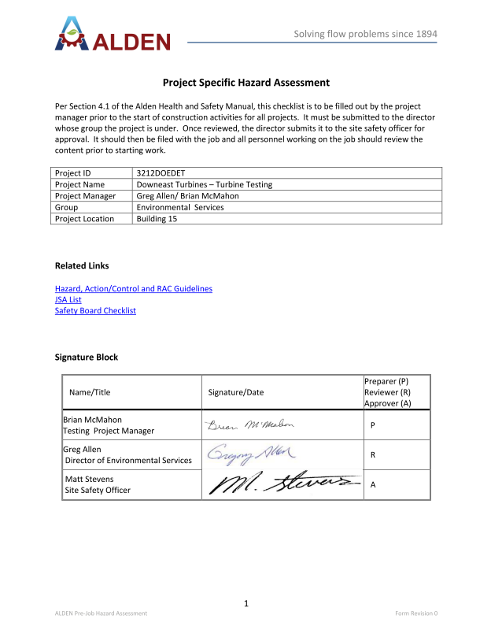
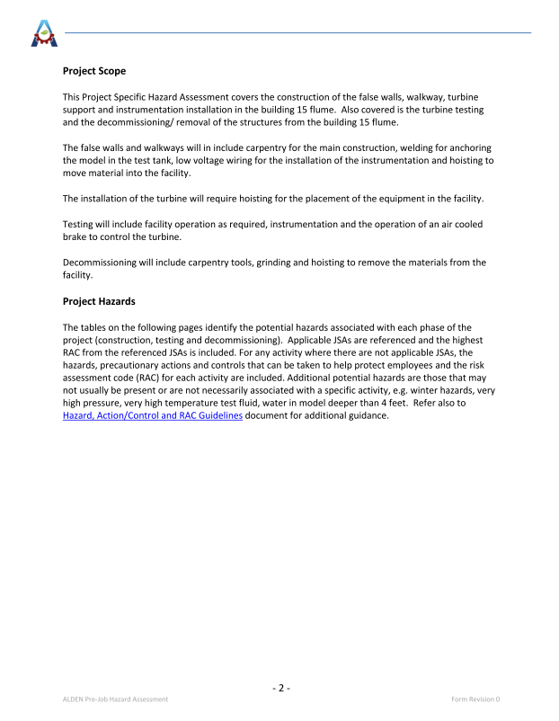
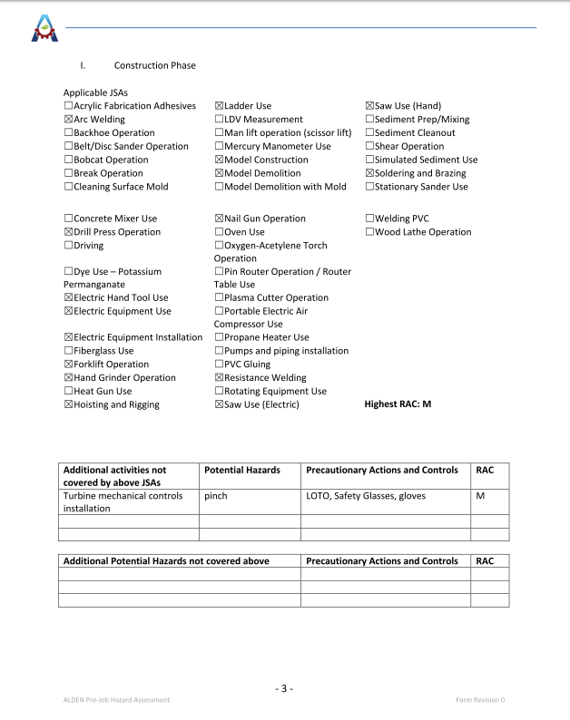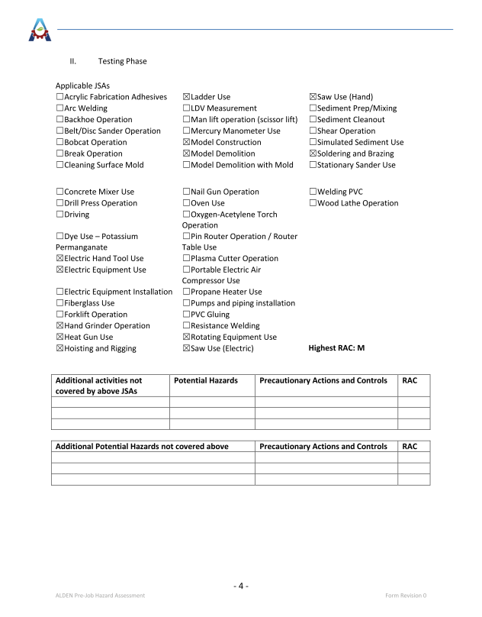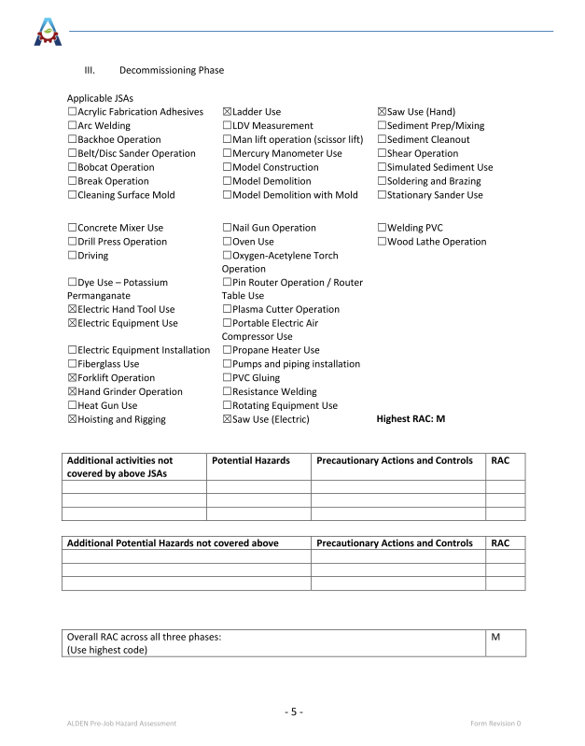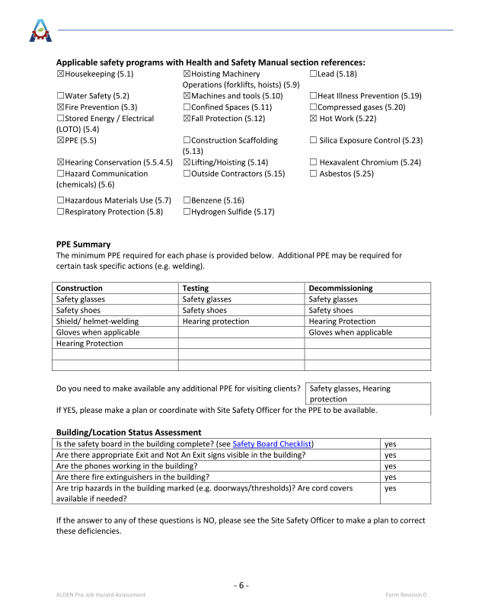

Appendix B – Instrumentation Details
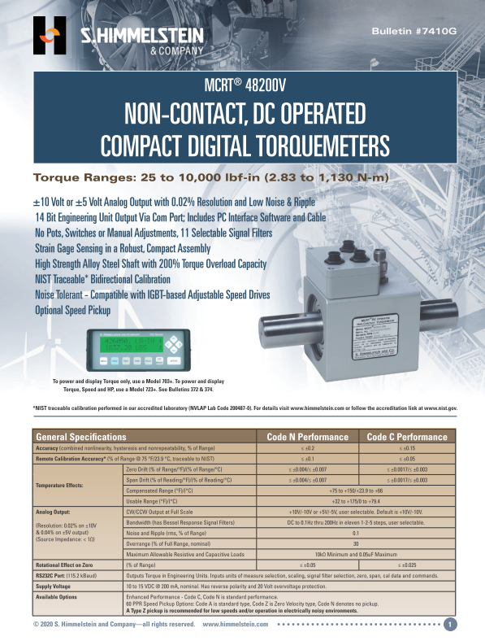
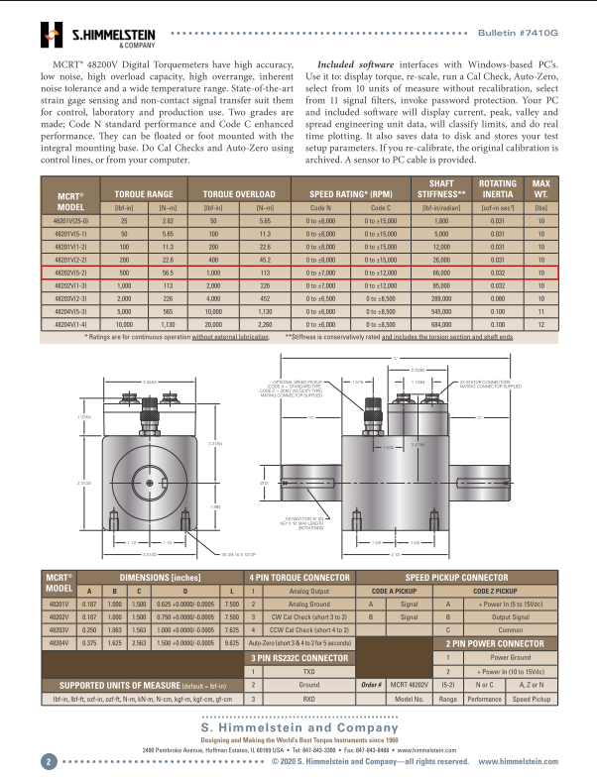

Appendix C – Post Access Supplement Report

Appendix C – Post Access Supplement Report

Tidal Turbine Test
Awardee: Downeast Turbines
Awardee point of contact: George McBride
Facility: Alden
Facility point of contact: Greg Allen

Prepared for: DOE TEAMER RFTS2
By: George McBride

Date: 03/23/2022

Appendices D, E, and F are separate files
Appendix D – Test Data Workbooks.zip
Appendix E – Post Access Figures.zip
Appendix F – References.zip

Post Access Supplement Report – Outline
- Overview
  - Introduction
  - Purpose
  - Torque and rpm results
  - Pressure differential and volumetric flow
  - “Outlet velocity”
  - Deciding what to do
  - LEDA test/LDW (“wing”)
  - “Boat test”
  - Research value
  - Pathway to success
- Background
  - Team
  - Test plan
  - Setup
  - Data collection
  - Numbering
  - Baseline torque
- Testing narrative (Days 1-3 of testing)
  - 7/12/2021 (Day 1)
  - 7/13/2021 (Day 2)
  - 7/14/2021 (Day 3)
- Interlude
  - Decision 1
  - Decision 2
  - Decision 3
- Testing narrative (Days 4-5 of testing)
  - 7/27/2021 (Day 4)
  - 7/28/2021 (Day 5)
- Test Data Workbooks List (See Appendix D – Test Data Workbooks.zip)
  - Alden Lab – raw data
  - Downeast Turbines – data, calculations, and graphs
- Results
  - Torque cell
  - Test Articles #1-5
  - Test Articles #6-8
  - LDW test results – cartoons
  - Submersible pump – impact on results
  - Test Article #9, “boat test”
- Turbine prototype – analysis
  - Turbine rotor/channel system
  - Transformation ratio
  - Diffuser
  - Adding LEDA to the turbine
  - Turbine power
  - No-load rate of volumetric flow
  - “Outlet velocity”, turbine
- LEDA – analysis
  - What the LEDA does
  - Performance terms defined
  - “SP Diff. 1” and “‘Q’ Vol. Flow”
  - “SP Diff. Head”
  - “Outlet velocity,” LDWs
  - “‘Q’ Vol. Flow” prediction
  - Test Article #9
  - LEDA questions
- Feedback to the turbine
  - Estimates for volumetric flow
  - Rotor size enlargement
  - 3D-CFD
- Instrumentation List
- Post Access Figures List (See Appendix E – Post Access Figures.zip)
- References List (See Appendix F – References.zip)

_____________________________________________________________________________________

I. Overview
From Matt Sanders: “…The purpose of the report is to detail the work that was completed, not necessarily to tell a story about the technology. One of the great things about TEAMER is you can take what you learned from one test and make changes and test again.”
“I guess that’s what testing is for, confirm keep going or learn and adjust directions” (Martin Smith).

Introduction
In July 2021, Downeast Turbines tested an instream tidal turbine prototype in the big flume at Alden Lab.
Downeast Turbines’ prototype is a ducted turbine with two elements of design: 1) A rotor/channel system that takes in flowing water from a stream and extracts power from it, and 2) A lateral effluent discharge apparatus (LEDA) that provides the means to discharge turbine effluent back out to the stream.
In its application for the Tidal Turbine Test at Alden Lab, Downeast Turbines stated an objective to, “Characterize the turbine’s performance, and in that process validate, from a technical perspective, fundamental elements of design as they relate to configurations of the channels, rotors, and lateral effluent discharge apparatus (LEDA).”
The test plan had a simple protocol – to measure the performance of the tidal turbine prototype with rear-mounted LEDA, in Alden Lab’s big flume, and see how it compares with performance of the same prototype without the LEDA.

Purpose
Without the LEDA, Downeast Turbines’ prototype discharges turbine effluent through an expansion channel segment known as a “diffuser.”
A diffuser is an element of design developed for a hydropower dam by Benoit Fourneyron. “In 1855 he patented a diffuser… He explained the benefit a diffuser provided his turbine design by slowing the velocity of discharge… and thus recovering the pressure further downstream from a new point of discharge” (Ref. 1).
Used on a tidal turbine, a diffuser “…will draw more fluid through [the duct] and will also increase the available pressure drop across the turbine by recovering some of the velocity head downstream as pressure head. The turbine then becomes “diffuser-augmented (Ref. 2).”
The diffuser of Downeast Turbines’s prototype presents an expanding, internal cross-section to the turbine’s discharge flow that culminates in a large, rearward facing outlet to the stream. The turbine’s effluent passes slowly through the outlet to a downstream wake, where it lingers, forming eddies with the streamflow that will carry it away.
Even with a diffuser, the amount of power generated by Downeast Turbines’ prototype in prior testing has been low. Not enough water flows through the rotor/channel system when it can go around.
The LEDA is a novel channel element for a ducted turbine that takes the place of a diffuser. Its purpose is the same, to augment performance of the turbine, but it operates to accomplish that in a different way.
The LEDA has three surfaces – an ambient flow deflector (AFD), mixing surface, and backflow preventer – that extend out to the stream and interact with it, deflecting and releasing from deflection portions of the nearby streamflow to create a lower-pressure region in the stream.
The LEDA does not slow the turbine’s discharge flow but, to the contrary, enables its swift passage through one or more, narrow discharge outlet(s) that communicate with the lower-pressure region in the stream. The turbine’s effluent, re-energized by the pressure differential in the stream, passes to the mixing surface where it encounters streamflow that mixes with it there, and carries it away.
2D-CFD computer simulations done in 2017, showed, at least in two dimensions, that a LEDA serving as the means to discharge effluent of a simulated turbine, contributed significantly to the turbine’s power.
Based on that and other reasons, for this test event it was anticipated that Downeast Turbines’s prototype would, by its performance, validate the elements of design – the rotor/channel system and the LEDA.
The plan allowed five days of testing.

Torque and rpm results
Torque and rpm are metrics of performance for the turbine, based on the relation:
Power = Torque x Rpm
By the end of Day 1 of testing, it was clear that Downeast Turbines’ rotor/channel system with rear-mounted LEDA had failed to generate sufficient torque and rpm to meet the test event’s objective.
The test event had failed to validate both elements of design, not either one. The test event appeared to be a failure. But why?
It was not clear to what extent each element of design contributed to the disappointing outcome.
One hypothesis is that the LEDA, rear-mounted to the turbine, experiences shielding from the stream that interferes with its performance.
Even before the test event began, construction had been started on two new LEDA channel structures that would mount over the rotors and extend out to the sides of the turbine prototype, where shielding would not occur. The two new LEDA structures were termed lateral discharge “wings,” or LDWs, or just “wings.”
The lateral discharge “wings,” or LDWs, were hurriedly completed and mounted to the turbine prototype for Day 2 of testing.
But again, the torque and rpm results were low.
In the evening of Day 2, after testing, a thought occurred to author and designer, George McBride, a recognition that he had incorrectly transferred a key dimension, the AFD height ratio, while taking pattern lines from the 2D-CFD model for the LDW build. On Day 3, the AFD height ratio was corrected. With full support from Alden Lab, two new ambient flow deflectors (AFDs) were fabricated for the LDWs and attached.
On Day 3, the prototype in testing showed the first slight uptick in performance, in both torque and rpm, not enough to validate the rotor/channel system and the LEDA, but nonetheless distinct, a first small step toward what might become Downeast Turbines’ pathway to success.

Pressure differential and volumetric flow
With small success in metrics of performance – torque and rpm, the focus of the testing turns to metrics of the water volume flowing through the rotor/channel system and the LEDA, pressure differential and rate of volumetric flow, for dissecting what went wrong.
In the turbine testing setup, there is no way of measuring the pressure differentials that occur within the rotor/channel system, but from rpm results there is a way to ascertain the rates of volumetric flow.
For Downeast Turbines’ prototype, volumetric flow is an estimated value, derivable for each test article configuration and each condition of the tests with a calculation that involves a rotors’ designated transformation ratio and the no-load rpm. (See “DET_04, Test results – turbine.xlsx,” for the calculations).
Based on calculations, the evidence is that all configurations of the turbine prototype in this test event, did achieve estimated rates of volumetric flow.

“Outlet velocity”
Another metric for the rate of water volume flow is the speed at which the turbine’s effluent passes through the LEDA (or diffuser) outlet to the stream. Termed “Outlet velocity,” in this report, the metric is derivable from estimated rate of volumetric flow, and the outlet area, according to the relation:
“Outlet velocity” = Estimated rate of volumetric flow ÷ LEDA (or diffuser) outlet area
It is a noteworthy and positive observation that, in similar test conditions of the same flume flow speed, with similar torque and rpm performance, and similar estimated rates of volumetric flow:
A configuration of the rotor/channel system with the LEDA achieved 11.4 x greater “Outlet velocity” than did the same configuration of the rotor/channel system with diffuser.
By this metric of performance, the LEDA demonstrates its active contribution to the estimated rate of water volume flowing through the turbine.
The comparison serves to demonstrate how much better is the prospect for the LEDA as a means to augment the performance of a tidal turbine, than it is for its predecessor to that purpose, the diffuser.

Deciding what to do
After three days of testing, there were mostly questions. Might it be the case that the LEDA achieves a useful pressure differential, but not enough of volumetric flow to meet the rotor/channel need? Or enough of volumetric flow, but not as much of pressure differential as desired?
Two more days of testing were on the schedule. At this point, Alden Lab’s Greg Allen graciously offered to hold the turbine setup in the flume for two weeks, while we worked out what to do. Email communications went back and forth, and in two weeks’ time it had been decided what to do. The last two days would have an LDW tested in the flume without the turbine.
It was hoped that this would shed some light on what went wrong in the turbine testing, open up a path to optimize performance of the LEDA, and ultimately allow an improved LEDA to be reconnected with the turbine prototype for another, future test event.
Performance metrics would be pressure differential and volumetric flow.

LEDA test/LDW (“wing”)
One LDW was removed from the turbine prototype and set up in the flume. Its inner channel element was connected with an elbow to a 4” diameter pvc standpipe, having open termination 6” above the quiet water level in the flume, allowing measurement of pressure differential and acceptance of a measured rate of volumetric flow, poured in from a pump.
The LDW has two long and narrow gaps that are the outlets, where the AFD is spaced out from the mixing surface by two stand-off brackets that affix it there. The gap widths could be changed by swapping out the stand-off brackets, and that was done. Three gap widths settings of 0.40”, 0.65”, and 0.25” were tested, in that order, to see how they compared.
According to the test results, the LDW generates, by its interaction with the stream, a pressure differential that has a positive correlation to the flume flow speed, in the domain of flume flow speeds observed.
The LDW can accept a measured rate of volumetric flow, poured into the open termination of its standpipe, and that metric, too, has a positive correlation to the flume flow speed, in the domain of flume flow speeds observed.
Both metrics of LDW performance, pressure differential and the rate of volumetric flow, also have a positive correlation to the LDW outlet gap width setting. Within the domain of LDW outlet gap widths tested, both metrics were greatest at the largest outlet gap width setting, 0.65”.
“Outlet velocity” is a metric of performance derivable from the measured rate of volumetric flow, and the LDW outlet area, according to the relation:
“Outlet velocity” = Measured rate of volumetric flow ÷ LDW outlet area
“Outlet velocity” correlates to a measure of performance termed “SP Diff. Head,” in this report, a comparison of two pressure differentials observed, one with and one without a measured rate of volumetric flow.
There are many data points, but just for reference, the highest LDW “Outlet velocity” performance in this test event is as follows: At 6.8 feet per second (fps) of flume flow speed, the LDW with 0.40” gap width achieved “Outlet velocity” of 1.48 feet per second (fps), or 0.22 (22%) of flume flow speed (Test 44).

“Boat test”
A small floating vessel with LEDA fitted underneath was tested in the flume, Test Article #9. The vessel, built in 2020, has a discharge outlet that is 10” long, with 0.25” gap width. Discharge outlet area is 2.5 square inches.
At 3.4 feet per second (fps) of flume flow speed, about 2 knots, the LEDA on the floating vessel achieved a volumetric rate of drain of 25 gallons per minute (gpm), and “Outlet velocity” of 3.2 fps, or 0.94 (94%) of flume flow speed (Test 75).

Research value
Downeast Turbines has met one objective – to acquire results through a credible, transparent process, harnessing the expertise of the test facility to ensure validity of testing, lending authority to the results.
Test results show that the lateral effluent discharge apparatus (LEDA) generates a pressure differential and makes a volumetric flow of water go away. “Outlet velocity,” more than any other metric, shows how active is the LEDA, interacting with the stream.
All the projections leading up to this test event – structural, operational, societal, environmental, and economic benefits – are still desired, and Downeast Turbines’ rotor/channel system and the LEDA still hold promise toward achieving those projections.

Pathway to success
Post-test analysis suggests that the power of the LEDA’s interaction with the stream can be investigated, and improved. Larger gap widths, longer wings, other profile changes, as well as shape considerations derived in the “boat test,” all offer prospects to increase performance in the metrics of pressure differential and the rate of volumetric flow.
3D-CFD would be a helpful tool to characterize, and even optimize, configurations of the LEDA. One goal is to arrange for 3D-CFD experiments, to gain more data on the lateral effluent discharge apparatus (LEDA), refine its shape, and explore its limits of performance for pressure differential and rate of volumetric flow.
Next, would be to remake lateral discharge wings (LDWs), with reference to the 3D-CFD findings, bring them back together with the present rotor/channel system, and try that combination as an incremental change for experimental continuity.
And finally, the rotor/channel system of the turbine prototype would be revised. The rotor size can be enlarged to better take advantage of the pressure differential, which now is better understood. With better information on the LEDA, and better yet, if LEDA can be optimized, rotor size can be adjusted to match its volumetric flow performance, and rotors’ transformation ratio can be increased to regain rpm.
Finding the means of effluent discharge needed to augment performance of a tidal turbine puts Downeast Turbines back on track to validate the turbine prototype’s two elements of design, the rotor/channel system and the LEDA. Then it can get on with the next phase of product development, which is choosing a market and designing a product.
3D-CFD will be a likely topic for Downeast Turbines’ next DOE TEAMER application.

_____________________________________________________________________________________

II. Background
This section provides background information to help the reader understand how the flume was set up, how the turbine tests were done, and how the data was recorded.

Team
Downeast Turbines’ crew was George McBride, (author of this report), Phil McBride, of Dennysville, ME, and Martin Smith, of Westborough, MA. Alden Lab’s team of engineers was Brian McMahon, Jacob LaFontaine, and Nicholas Lucia, with Gregory Allen as TEAMER contact.

Test plan
Downeast Turbines delivered its tidal turbine prototype to Alden Lab on July 6, 2021, for fitting and alignment in Alden Lab’s big flume. Five days of testing would occur, to evaluate the performance of the turbine and validate the effects of the lateral effluent discharge apparatus, LEDA, on its performance.
The approved test plan envisioned a simple protocol to validate two elements of design for a tidal turbine, combined in one turbine prototype for testing.
The first design element comprises a rotor/channel system, patented, configured, and prototyped prior to the application for this test event. Capturing and channeling water flow into fully enclosed rotors for power generation paves the way for a variety of structural, operational, societal, environmental, and economic benefits to accrue, while designing and building profitable products.
The rotor/channel system as initially configured, makes use of a channel element called a “diffuser,” to “increase the available pressure drop across the turbine,” and thereby “augment” its power (Ref. 2). Two exhaust channels that communicate with the outlets of the rotors, one on either side of the turbine prototype, turn and sweep backwards, flaring open, and coming together at the rear to form a single rearward facing discharge outlet with the outline of an ellipse, about 24” wide x 17.5” high, that has total cross-sectional area of roughly 330 square inches.
Prior testing has shown that the rotor/channel system as originally configured works to a measurable degree, but power generation has been low, insufficient to commercialize a product.
The second design element, a Lateral Effluent Discharge Apparatus, or LEDA, was supposed to improve upon the diffuser.
Downeast Turbines designed and built a first configuration of the LEDA, a rear-mount structure for the rotor/channel system, with cross-section extracted from a 2D model, showed to work through 2D-CFD analysis done in 2017. The LEDA structure has three surfaces that redirect stream flow to create a low-pressure region in the stream, where turbine effluent can escape into the ambient stream that carries it away. The forward-most LEDA surface is the ambient flow deflector, which in this first configuration is the outer surfaces of two exhaust channels, the original diffuser. The aftmost LEDA surface, the backflow preventer, is an impermeable shield that separates downstream turbulence in the stream from the LEDA’s discharge outlet. The surface in between is the mixing surface, for which 44 separate wood pieces were shaped and attached to a backflow preventer that had already been designed and built. The wood pieces extend the mixing surface beyond the outermost edge of the ambient flow deflector, while keeping conformity to its elliptical outline.
In between the mixing surface and that outermost edge of the ambient flow deflector is the LEDA’s discharge outlet, a gap that follows the diffuser’s outline all the way around, 0.40” wide and roughly 48” long. The total cross-sectional area of the LEDA’s discharge outlet is about 19.2 square inches.
Two test articles were in the plan – the tidal turbine prototype with, and then without, the rear-mount LEDA attached. The expectation was that the prototype with the rear-mount LEDA would experience a greater pressure differential through the turbine, and out-perform the prototype without.
Initial tests did not provide the expected validation. The turbine prototype failed to generate sufficient useful power to validate the two elements of design. At that point, the focus of the test event turned to dissecting what went wrong. Questions that came to mind at that time included:
- Which of two design elements caused the failure? Was it one? Was it both? Was it neither, by itself, but how they were combined?
Five consecutive days of testing were in the schedule. In the first three days, the turbine prototype in five configurations was tested in the flume. Without a clear result, there was a two-week interlude while the team decided what to do. In the last two days of testing, the LEDA was tested by itself, without the turbine.
In five days of testing, nine test articles made it to the flume. A flow chart for the time sequence of testing is provided (Figure 8).
Test Articles #1-9 are described more fully in the “Testing Narratives” that follow.

Setup
On the morning of July 12, 2021, Downeast Turbines’ crew assembled at Alden Lab.
Alden Lab’s engineers had a channel all set up inside the flume (Figure 9).
Instrumentation was in place to measure water current speeds, and a list of designated target flume flow speeds was on hand (Figure 10).
The channel had a sturdy work platform at the downstream end, and a smaller test platform fastened under that. Downeast Turbines’ prototype, Test Article #1, hung inside the channel, underneath the test platform, affixed to it, facing toward the stream (Figures 11-13).
On the test platform is a “test shaft,” mounted and connected by a chain drive to the turbine’s “rotor shaft.” The turbine’s rotor shaft is the primary power shaft, and the test shaft is secondary to it. A third shaft is the “load shaft,” also mounted on the test platform, in-line with the test shaft. Connecting the two in-line shafts is the torque cell, which also touches on the platform in between. The load shaft has a brake disk mounted to it. An adjustable caliper mechanism, mounted on the test platform, applies the load. A non-contact torque meter (torque cell) measures differential torque between the two, in-line shafts (Figures 14-15).
A frequency meter on the test shaft measures turbine rpm. A computer is on hand that displays torque and rpm data and records it to a spreadsheet, at one-second intervals.
Upon arrival of Downeast Turbines’ crew, all that remained for Alden Lab’s engineers to do, was to fill the flume, and start the water flowing.

Data collection
Water current flow inside the channel would be the source of power for the turbine prototype. Water fills the flume, and big pumps start to generate a flow. When the accelerating water current flow inside the flume reaches a designated target flume flow speed, the big pumps hold it steady there, until sufficient wait time passes to ensure that water current speed is at the target value. When the water current flow has reached a speed at which the shafts will start to turn, instruments transmit performance data to the computer for display. First, at no-load condition, an engineer records the torque and rpm, then, at incrementally increasing loads applied by means of the adjustable caliper brake, continues collecting data until the load has reached a point at which it stalls the shafts. At each new flume flow speed and each new load condition, a wait time of sufficient length lets the turbine stabilize before the engineer records the next results of torque and rpm.
60 seconds’ worth of time-averaged torque and rpm results, makes a data point and constitutes one test for this report.

Numbering
To avoid ambiguity in reporting data, two non-recurring, consecutive number sequences identify the test articles and the tests, over and above any other test descriptions used (Figure 16).
- Test articles have sequential numbers applied to identify them according to the sequence of their deployment. Test Articles #1-5 are turbine prototypes. Test Articles #6-9 represent a LEDA tested by itself, without the turbine.
- Tests have sequential numbers applied to identify them according to the sequence in which they were performed. Tests #1-37 were for turbine prototypes. Tests #38-78 represent a LEDA tested by itself, without the turbine.

Baseline torque
For Test Articles #1-5, (tests 1-37), Alden Labs assigned a “baseline/zero rpm torque value for each [test] condition caused by the mechanical set up and bearing friction in the test stand.”
Baseline torque is the measured torque differential between the two in-line shafts at no load rpm, for each test article, at every flume flow speed in which the rotors turned. Average torque, measured over 60-second intervals at no load rpm, at designated target flume flow speeds in which the rotors turned, constitutes the baseline torque.
A person could feel torque in the load shaft with a hand grip on the brake disk, even before the water current in the flume reached a speed at which the shafts started turning on their own. Hand turning the load shaft against the water current met with detectable resistance. Hand turning with the water current, the shaft would turn more easily and sometimes, given a little start in that direction, would run along for two or three rotations on its own.
Baseline torque does not include mechanical setup and bearing friction in the rotor shaft, the test shaft, or the chain drive.
The purpose of this topic heading is to alert the reader that power performance data for Test Articles #1-5, (tests 1-37), is presented in this report two ways – as “rotor shaft” power, calculated from measured rpm and torque, and as “test shaft” power, calculated from measured rpm and torque, with so-called “baseline torque” subtracted out of torque.
“Test shaft” power data will be of use for assessing fitness of the turbine to a future application once prototype gets to higher levels of performance.
“Rotor shaft” power data exhibit greater variation which, given the small amount of power that was measured in this test event, is helpful in distinguishing small differences in performance among the several turbine prototype configurations.
Power performance results for Test Articles #1-5, (tests 1-37), appear in this report, both ways.

_____________________________________________________________________________________

III. Testing narrative (Days 1-3 of testing)
The narrative guides the reader through the sequence of events and explains why deviations from the plan occurred and how they were addressed.
Workbook “DET_04, Test results - turbine.xlsx” contains detailed performance results for Days 1-3 of testing (See Appendix D – Test Data Workbooks.zip).

7/12/2021 (Day 1)
Test Articles #1-3 went into the flume on Day 1 of testing:
Test Article # | Test Date | Description
1 | 7/12/2021 | Turbine prototype, LEDA mounted at the rear (Day 1, Tests 1-2)
2 | " | Turbine prototype, LEDA removed (Day 1, Tests 3-11)
3 | " | Turbine prototype, LEDA and yellow arms removed (Day 1, Tests 12-13)

Test Article #1 is the tidal turbine prototype with rear-mount LEDA and rotor/channel system presented in Test Plan, Section 5, entitled “Test … Article Description.” The purpose for Test Article #1 was to validate the two elements of design, a rotor/channel system and LEDA, in combination.
The prototype as delivered, appeared as follows: The intake, and spiral channels that surround the rotors, are blue. The “yellow arms” that are exhaust channels, turn and sweep backwards, flaring open as they go to make the ambient flow deflector at the rear. Behind that are the mixing surface and backflow preventer, also painted blue. The outlet gap, between the outermost edge of the ambient flow deflector (yellow) and the mixing surface (blue), is 48” long all the way around, and 0.40” wide (Figure 17).
The total cross-sectional area of Test Article #1’s discharge outlet gap is about 19.2 square inches.
At 6.2 fps of flume flow speed with no brake load on the shaft, the rotors turned at 91 rpm and generated 3.2 watts of “rotor shaft” power/0.0 watts of “test shaft” power (Test 1). At peak power under load, the rotors turned at 91 rpm and generated 3.5 watts of “rotor shaft” power/0.4 watts of “test shaft” power (Test 2).
Test Article #1 clearly did not produce power sufficient to meet its intended purpose and received no more testing beyond 6.2 fps of flume flow speed, to preserve it intact from greater forces of the flume for comparison testing still to come.

Test Article #2 is the rotor/channel system of Test Article #1, without the mixing surface and backflow preventer, painted blue. The “yellow arms” that are exhaust channels serve as a diffuser and combine to form a single, rearward facing discharge outlet at the rear, shaped as an ellipse, about 24” wide x 17.5” high. The purpose for Test Article #2 was to provide a performance benchmark for comparison with Test Article #1.
The total diffuser outlet area for Test Article #2 is 330 square inches.
At 4.9 fps of flume flow speed with no brake load on the shaft, the rotors turned at 65 rpm and generated 2.1 watts of “rotor shaft” power/0.0 watts of “test shaft” power (Test 3). At peak power under load, the rotors turned at 66 rpm and generated 2.2 watts of “rotor shaft” power/0.1 watts of “test shaft” power (Test 4).
At 5.7 fps of flume flow speed with no brake load on the shaft, the rotors turned at 160 rpm and generated 5.7 watts of “rotor shaft” power/0.0 watts of “test shaft” power (Test 5). At peak power under load, the rotors turned at 152 rpm and generated 6.3 watts of “rotor shaft” power/0.9 watts of “test shaft” power (Test 8).
At 6.2 fps of flume flow speed with no brake load on the shaft, the rotors turned at 209 rpm and generated 7.7 watts of “rotor shaft” power/0.0 watts of “test shaft” power (Test 9). At peak power under load, the rotors turned at 189 rpm and generated 9.5 watts of “rotor shaft” power/2.5 watts of “test shaft” power (Test 11).
Test Article #2 received no more testing beyond 6.2 fps of flume flow speed. It already had fulfilled its benchmark purpose for comparison with Test Article #1.

Test Article #3 is the rotor/channel system of Test Article #2, but with yellow exhaust channels removed, so that rotor outlets discharge directly to the stream. Years before this test event, a graduate student who operated the tow tank at another testing facility had wondered aloud how the rotor/channel system would perform if rotors discharged directly to the stream. Now, there was nothing else to do with Test Articles #1-2, the prototype was in the flume, and Day 1 still had open time. This was a perfect opportunity to run another test.
The purpose for Test Article #3 was to assess how the rotor/channel system would perform when rotors discharge directly to the stream.
One rotor has a discharge outlet area of 12.57 square inches, and the total discharge area for Test Article #3, both rotors, is 25.1 square inches.
At 4.9 fps of flume flow speed with no brake load on the shaft, the rotors turned at 75 rpm and generated 2.4 watts of “rotor shaft” power/0.0 watts of “test shaft” power (Test 12). At peak power under load, the rotors turned at 71 rpm and generated 2.4 watts of “rotor shaft” power/0.2 watts of “test shaft” power (Test 13).
Test Article #3 received no more testing beyond 4.9 fps of flume flow speed as partial disassembly of the turbine prototype, having “yellow arms” removed, made it structurally unfit for higher flume flow speeds.

7/13/2021 (Day 2)
Test Article #4 went into the flume on Day 2 of testing:
Test Article # | Test Date | Description
4 | 7/13/2021 | Turbine prototype, with LDWs first configuration ("wings added"), (Day 2, Tests 14-23)

By end of Day 1 of testing, it was clear that the lateral effluent discharge apparatus (LEDA), as initially built and mounted on the turbine, did not make an improvement upon the original diffuser, but why?
One hypothesis is that the rear mounted LEDA, behind the turbine, experiences shielding from the stream which causes it to suffer in performance. Based on that hypothesis, construction had already begun on two new LEDA structures that would mount onto the turbine prototype and extend out to the sides, where shielding could not occur. Termed “lateral discharge wings,” or LDWs, the two identical structures house channels that would accept outflow from the turbine rotors, and LEDA surfaces, bilaterally symmetric (top and bottom), to facilitate discharge to the stream. The attached screenshot shows the channel of an LDW, and its LEDA surfaces, in multiple perspectives (Figure 18).
As Day 1 testing winded down, Downeast Turbines’ crew strove to finish the construction, with Alden Lab’s support, and working in the Alden Lab facility. At end of day Downeast Turbines’ crew removed the two new structures to finish their construction off-site, overnight. By morning that construction was complete. The two new LDWs were ready for a test, though not especially pretty.
On Day 2 of testing, Downeast Turbines’ crew attached the two new LDWs to the turbine prototype, again with Alden Lab’s support, and in the Alden Lab facility. The method of attachment that we devised together was strong, and the LDWs remained attached through all the subsequent testing that they endured (Figures 19-21).

Test Article #4 is the same rotor/channel system as Test Article #3, but with LDWs first configuration attached at either side. The purpose for Test Article #4 was to see if putting LEDA structures at the sides instead of having one behind the turbine, would improve the prototype’s performance.
LDWs first configuration have ambient flow deflectors (AFD) made of molded fiberglass. Top and bottom discharge outlets are 15.75” long and the discharge outlet gaps are 0.40” wide. Combined, the two LDWs have 25.2 square inches of discharge opening.
At 5.7 fps of flume flow speed with no brake load on the shaft, the rotors turned at 96 rpm and generated 3.3 watts of “rotor shaft” power/0.0 watts of “test shaft” power (Test 14). At peak power under load, the rotors turned at 82 rpm and generated 3.0 watts of “rotor shaft” power/0.2 watts of “test shaft” power (Test 16).
At 6.2 fps of flume flow speed with no brake load on the shaft, the rotors turned at 146 rpm and generated 5.3 watts of “rotor shaft” power/0.0 watts of “test shaft” power (Test 17). At peak power under load, the rotors turned at 135 rpm and generated 5.6 watts of “rotor shaft” power/0.7 watts of “test shaft” power (Test 18).
At 6.8 fps of flume flow speed with no brake load on the shaft, the rotors turned at 191 rpm and generated 8.6 watts of “rotor shaft” power/0.0 watts of “test shaft” power (Test 21). At peak power under load, the rotors turned at 176 rpm and generated 8.7 watts of “rotor shaft” power/0.8 watts of “test shaft” power (Test 23).
Test Article #4 did not demonstrate an improvement in performance over Test Article #2.
One negative data point in the “test shaft” power data (Test 22) demonstrates how close to zero the “test shaft” power data are. According to Brian McMahon of Alden Lab, “We have double checked the data and the data is correct for the condition that was tested. There was so little variation that it is difficult to tease out a clear output. We were at such a low output that the averaging does show some different variation that wouldn't be present if there was a wider range between the operating point of the turbine.”

7/14/2021 (Day 3)
Test Article #5 went into the flume on Day 3 of testing:
Test Article # | Test Date | Description
5 | 7/14/2021 | Turbine prototype, with LDWs second configuration ("updated wings"), (Day 3, Tests 24-37)

Day 3 started with a meeting at Alden Lab.
Day 2 of testing had showed little progress, but, later, that same evening, a thought occurred to author and designer, George McBride, that he might have made an error when extracting the cross-section from a 2D-CFD model for the LDW build. He had extracted top and bottom LEDA surfaces, but not the central feature of a Rankine disk. The cross-section that resulted had the same surface shapes, top and bottom, but a different ratio of ambient flow deflector (AFD) height to LDW height overall, that had gone unnoticed.

This raised the question:
- Could an inadvertent change in AFD height dimension ratio interfere with static pressure draw at the LDW outlet?
After brief discussion, Brian McMahon of Alden Lab quickly found a way to remedy the error. He and his team fabricated larger AFDs from sheet steel and attached them to the LDWs. The attachment was secure (including duct tape, judicially applied).

Test Article #5 is the same turbine prototype as Test Article #4, but with LDWs second configuration attached at either side. The purpose of its testing was to see if adjusting, or correcting, the ratio of AFD height to LDW height overall would improve the prototype’s performance. LDWs second configuration have the same ratio of AFD height to LDW height overall as does the 2D-CFD model (Figure 22).

Test Article #5 was ready for deployment on Day 3, in the early afternoon. Top and bottom discharge outlets are 15.75” long and the discharge outlet gaps are 0.40” wide. Combined, the two LDWs have 25.2 square inches of discharge opening (Figures 23-25).
At 4.9 fps of flume flow speed with no brake load on the shaft, the rotors turned at 61 rpm and generated 2.2 watts of “rotor shaft” power/0.0 watts of “test shaft” power (Test 24).
At 5.7 fps of flume flow speed with no brake load on the shaft, the rotors turned at 159 rpm and generated 6.3 watts of “rotor shaft” power/0.0 watts of “test shaft” power (Test 25). At peak power under load, the rotors turned at 80 rpm and generated 4.6 watts of “rotor shaft” power/1.4 watts of “test shaft” power (Test 28).
At 6.2 fps of flume flow speed with no brake load on the shaft, the rotors turned at 182 rpm and generated 7.4 watts of “rotor shaft” power/0.0 watts of “test shaft” power (Test 29). At peak power under load, the rotors turned at 123 rpm and generated 7.7 watts of “rotor shaft” power/2.7 watts of “test shaft” power (Test 34).
At 6.8 fps of flume flow speed with no brake load on the shaft, the rotors turned at 250 rpm and generated 11.1 watts of “rotor shaft” power/0.0 watts of “test shaft” power (Test 35). At peak power under load, the rotors turned at 220 rpm and generated 13.5 watts of “rotor shaft” power/3.8 watts of “test shaft” power (Test 37).
Test Article #5 showed the first sign of promise for Downeast Turbines’ rotor/channel system and the LEDA. It generated more “rotor shaft” power than Test Article #4, with a distinct uptick in performance resulting from only a slight change in LDW shape. Test Article #5 did not quite measure up to Test Article #2, at the flume flow speeds at which they were compared, but it did come close.
At 13.5 watts of “rotor shaft” power/3.8 watts of “test shaft” power, Test Article #5 gave the turbine prototype’s best performance (Test 37).
_____________________________________________________________________________________
IV. Interlude
Five days of testing were on the schedule. Three days into it, there were still questions – might it be the case that the LEDA achieves a useful pressure differential, but not enough of volumetric flow to meet the rotor/channel need? Or enough of volumetric flow, but not as much of pressure differential as desired?
It was not clear what next to do. Alden Lab’s Greg Allen graciously offered to hold the setup in the flume for a couple of weeks, while we worked out what to do.
Email communications went back and forth, and in two weeks’ time it was decided that the last two days of testing would have an LDW tested in the flume without the turbine. Performance metrics would be pressure differential and volumetric flow. It was hoped that this would shed some light on what went wrong with the turbine tests, open up a path to optimize performance of the LEDA, and ultimately allow an improved LEDA to be reconnected with the turbine prototype for another, future test event.
The last two days of testing had an LDW tested in the flume, without the turbine.

Decision #1
During these last two days of testing there would be no further experimentation with the rotor/channel system of the turbine. There still is a need to understand what is going on inside the rotor/channel system, but at this point there was no clear path for how to work on that.
Downeast Turbines had inquired if Alden Lab could do one test without the flume, which would be to pour a measured water volume flow rate through the turbine’s rotor/channel system and calibrate the rotors’ designated transformation ratio to a measured, no-load rate of spin (Figure 26).
If the rotors’ designated transformation ratio could be calibrated to a measured, no-load rate of spin, then the volumetric flow rate through the turbine, back calculated from its no-load rpm, would be confirmed as a diagnostic tool for teasing out respective contributions to performance of the rotor/channel system and the LEDA.
That confirmation will be necessary at some point in the future, but on this occasion, the additional setup required, external to the flume, put the inquiry beyond the scope of budgeting and time.

Decision #2
For these last two days, testing would focus on one LDW from Test Article #5, without the turbine, measuring how much static pressure differential the LDW can produce, and, to the extent possible, how much volumetric flow rate it will handle. Three LDW gap widths would be used – 0.40”, 0.65”, and 0.25” – to learn how gap width affects the LDW’s performance, both in terms of static pressure differential and rate of volumetric flow.
In the last two days of testing, one LDW from Test Article #5 would be mounted in the flume by itself, without the turbine. The LDW would be connected to a pvc standpipe for pressure differential, resulting from the flow of water in the flume, to be observed.
A sketch was made to show the setup. The LDW would be mounted near the bottom of the flume, centered between the two false walls that make the inner channel. It would be oriented horizontally, facing into the flow, with a 4” diameter, horizontal plastic pipe connecting to its inlet, and leading to an elbow bend in the quiet water just outside one false wall in the flume. A pvc standpipe of the same diameter would be connected to the elbow and rise to an open termination, about 6” above the quiet water level of the flume (Figure 27).
This arrangement would ensure that the LDW’s inner channel communicates with the water in the flume only through its discharge outlet gaps. A differential pressure transmitter would be used to measure and record any static pressure differential arising in the pvc standpipe in relation to the flume.
Each summary data record containing 60 seconds’ worth of time-averaged results, still constitutes one recorded test.
Characterizing LDW performance in terms of how much volume flow it might draw, would be another useful tool. It was requested that the LDW installation include an open termination, submerged to take in water, with a valve gate to control the flow, and a current meter to ascertain the rate of volume flow achieved, but that request could not be accommodated for the expected conditions of these tests.
As noted by Brian McMahon of Alden Lab:
“We don't have a means of measuring the flow without adding loss to the pipe section which will impact the flow by increasing the head loss in the pipe,”
And:
“We do have clamp on acoustic meters but not one that will be applicable for this size pipe and flow.”
An alternative approach was offered – that was to put a flow meter in-line with the 2” discharge hose of a submersible pump. Pouring water from the pump into the open termination of the pvc standpipe, would give some information on how much water volume flow rate the LDW would take, at a given flume flow speed.

Decision #3
If time allowed, a small floating vessel with LEDA fitted underneath might be tested in the flume. The vessel was built in 2020 and successfully deployed in a river flow that year. A successful test of this craft in controlled conditions of the flume might further validate the LEDA and perhaps enable quantitative measurements of the rate of volumetric flow.
_____________________________________________________________________________________
V. Testing narrative (Days 4-5 of testing)
The purpose of this section is to describe what testing activities occurred during the last two days of testing, why they occurred, and what were the results.
Workbook “DET_05, Test results - LEDA.xlsx” contains detailed performance results for Days 4-5 of testing (See Appendix D – Test Data Workbooks.zip).

7/27/2021 (Day 4)
Test Articles #6-7 went into the flume on Day 4 of testing:
Test Article # | Test Date | Description
6 | 7/27/2021 | Lateral Discharge Wing (LDW), 0.40" opening (Day 4, Tests 38-44)
7 | “ | Lateral Discharge Wing (LDW), 0.65" opening (Day 4, Tests 45-58)

Test Article #6, with “LDW second configuration, (“updated wings”),” was removed from Test Article #5, and mounted in the flume without any further configuration change. It was positioned in the center of the flume, about 3’ off the bottom, facing toward the flow. A 4” diameter plastic pipe was fitted to its inlet channel with a rubber boot. From there the 4” plastic pipe passed horizontally through one false wall of the channel in the flume to an elbow fitting, which connected to a pvc standpipe of the same diameter, that passed vertically to an open termination about 6” above the quiet water level in the flume. Behind the false walls of the channel, the water would remain relatively quiet no matter how fast the flow between the channel walls (Figures 28-30).
A Rosemount differential pressure transmitter (gauge) with two pieces of small diameter plastic tubing connected to it, sent data on the pressure differential in the pvc standpipe, in relation to the flume, to the computer. One piece of tubing terminated on an underwater fitting that passed through the pvc standpipe wall, and the other piece terminated nearby, in quiet water behind the channel wall. A positive pressure reading on the differential gauge means that water level in the pvc standpipe is lower than the quiet water level in the flume, and a negative pressure reading on the differential gauge means that water level in the pvc standpipe is higher than the quiet water level in the flume (Figures 31-33).
Test Article #6 has top and bottom discharge outlets 15.75” long and the discharge outlet gap width is 0.40”, to make a total outlet opening of 12.6 square inches presented to the stream (Figure 34).
The pressure differential gauge started showing positive pressure readings at very low flume flow speeds. At 3.4 fps of flume flow speed, the first recorded test, the pressure differential was 1.03 (in. H₂O), (test 38), and at 6.8 fps of flume flow speed, the pressure differential was 4.32 (in. H₂O), (test 43).

It was the purpose for Test Article #6 to characterize the LDW in terms of outlet pressure differential, “draw,” and in that respect it was a good success. There also was a purpose for Test Article #6 to find out how much water volume flow rate the LDW would take, and pass through to the stream, and yet another purpose was to see how water volume flow rate would affect the LDW’s static pressure “draw.” Test Article #6 had one more test that day.
A submersible pump, capable of providing 0-58 gallons per minute (gpm) of continuous water flow, was suspended in the flume outside one false wall, and connected to it was a length of 2” diameter hose. An Omega flowmeter rated at 0-100 gpm was connected in-line with the 2” hose, and a shut-off valve was fitted at the end. Terminating the assembly, on the shut-off valve a 2-foot length of 3” ID plastic pipe and elbow was affixed. The purpose of the pump and hose assembly was to provide a controlled, measured rate of volume flow. The purpose of the 3” ID termination was to reduce velocity of the water pouring out the end (Figures 35-39).
At 6.8 fps of flume flow speed, the submersible pump was turned on and the 3” ID plastic pipe was inserted to the open termination of the pvc standpipe. The shut-off valve was opened, gradually, to see how much volumetric flow the LDW would take in, without spillover. The LDW kept taking all the volumetric flow the pump would give, and when the shut-off valve was fully open, 58 gpm of water volume flow was going through the LDW, while a negative pressure differential of – 0.98 (in. H₂O) was maintained.
The notation with the data (Table 38) of “Negative differential, forcing water through the turbine,” means that water level in the pvc standpipe was higher, by the measured value, than the quiet water level in the flume (test 44).

Test Article #7 is the same LDW as Test Article #6, but Test Article #7 has slightly longer stand-offs to affix the AFD, which gives a slightly larger width to the discharge outlet gaps. Test Article #7 has top and bottom discharge outlets 15.75” long and the discharge outlet gap width is 0.65”, to make a total outlet opening of 20.5 square inches presented to the stream (Figure 40).
The pressure differential gauge started showing positive pressure readings at very low flume flow speeds. At 2.2 fps of flume flow speed, the first recorded test, it was 0.44 (in. H₂O), (test 45), which dropped to 0.03 (in. H₂O) when 2 gpm of water volume flow was introduced into the pvc standpipe (test 46).
At 4.9 fps of flume flow speed the static pressure differential was 2.55 (in. H₂O), (test 51), which dropped to 0.82 (in. H₂O) when 58 gpm of water volume flow, the maximum available, was introduced into the pvc standpipe (test 52).
At 6.8 fps of flume flow speed the static pressure differential was 5.13 (in. H₂O), (test 57), which dropped to 2.68 (in. H₂O) when 58 gpm of volume flow rate, the maximum available, was introduced into the pvc standpipe (test 58).
Purposes for Test Article #7 were to characterize the LDW in terms of outlet pressure differential, “draw,” to find out how much water volume flow rate the LDW would take, and pass through to the stream, and to see how water volume flow rate would affect the LDW’s static pressure differential, “draw.”
For measuring outlet pressure, “draw,” the tests were a success. For measuring how much water volume flow rate the LDW would take in, and how the water volume flow rate would affect the LDW’s static pressure differential, “draw,” the tests were successful up to the limit of volume flow that the submersible pump provided.
By all appearances, at flume flow speeds of 4.9 fps and above, Test Article #7 would have taken more than 58 gpm of water volume flow, if more had been available.

7/28/2021 (Day 5)
Test Articles #8-9 went into the flume on Day 5 of testing:
Test Article # | Test Date | Description
8 | 7/28/2021 | Lateral Discharge Wing (LDW), 0.25" opening (Day 5, Tests 59-72)
9 | “ | "Boat test," with LEDA thru-hull, 0.25" opening (Day 5, Tests 73-78)

Test Article #8 is the same LDW as Test Article #6, but Test Article #8 has slightly shorter stand-off brackets for the AFD, and a slightly smaller gap width at the discharge outlets. Test Article #8 has top and bottom discharge outlets 15.75” long and the discharge outlet gap width is 0.25”, to make a total outlet opening of 7.9 square inches presented to the stream (Figure 41).
The pressure differential gauge started showing positive pressure readings at very low flume flow speeds. A positive pressure reading means that water level in the pvc standpipe was lower, by the measured value, than the quiet water level in the flume. At 2.2 fps of flume flow speed, the first recorded test, it was 0.14 (in. H₂O), (test 59), which dropped to 0.06 (in. H₂O) when 1 gpm of volume flow rate was introduced into the pvc standpipe (test 60).
At 6.8 fps of flume flow speed the static pressure differential was 2.19 (in. H₂O), (test 71), which dropped to – 0.06 (in. H₂O) when 26 gpm of volume flow rate was poured into the pvc standpipe from the pump (test 72).
Purposes for Test Article #8 were to characterize the LDW in terms of outlet pressure differential, “draw,” to find out how much water volume flow the LDW would take, and pass through to the stream, and to see how water volume flow rate would affect the LDW’s static pressure differential, “draw.” For all these purposes, the tests were a success.
Within the domain of LDW gap widths tested – 0.25”, 0.40”, and 0.65” – the LDW’s effectiveness increases with increasing gap width, both in terms of static pressure differential and rate of water volume flow.

There was time for one more set of tests.
Test Article #9 is a small, flat-bottomed vessel, 7’ long x 2’ wide, and 7” deep. It has scow ends, and a LEDA, with an oval presentation to the flow, built into the bottom of its hull. The discharge outlet is 10” long and 0.25” wide, to make a total outlet opening of 2.5 square inches presented to the stream.
The purpose of Test Article #9 was to provide a visual of the LEDA draining water from the hull, and to quantify, if possible, the correlation of its rate of discharge to the water current speed within the flume.
A piece of plastic tubing was cut to the right length to make a plug for the discharge opening. Twenty-four scoops of a measuring pitcher, with 4 liters per scoop, were poured into the vessel to calibrate a horizontal tape line put inside the hull. Filling the vessel to the bottom of the tape line made it about half-full, with a water burden of about 96 liters contained within the hull.
The vessel was put into the flume and tethered to the work platform. Once the flume was up to speed, the vessel was filled with water to the bottom of the tape line. When the plug was pulled, the amount of time it took to fully drain the hull was measured with a stopwatch.
From these measurements the rate of discharged water volume flow can be determined.
At 1.5 fps of flume flow speed, approximately 96 liters of water was put into the vessel. It took 4:34 minutes (274 seconds) to fully drain the hull. The average discharge rate was roughly 0.35 liters per second/5.6 gpm (test 73).
At 2.2 fps of flume flow speed, approximately 96 liters of water was put into the vessel. It took 2:19 minutes, (139 seconds), to fully drain the hull. The average discharge rate was roughly 0.69 liters per second/10.9 gpm (test 74).
At 3.4 fps of flume flow speed, approximately 96 liters of water was put into the vessel. It took 1:01 minutes, (61 seconds), to completely drain the hull. The average discharge rate was roughly 1.57 liters per second/24.9 gpm (test 75).
At higher flume flow speeds the average discharge rate did not improve. It is hard to tell if this was real, or an artifact of the test conditions. As flume flow speed increased it became increasingly difficult to fill the hull, to hold the vessel steady in the stream, and to keep the water of the flume from overpouring in the front and sides. The data at the higher flume flow speeds is included for reference (tests 76-78).
Video screenshots show Test Article #9 deployed – A little food coloring provides a visual of the discharge at 1.5 fps of flume flow speed (Figure 42); The pump is used to partly fill the vessel at 3.4 fps of flume flow speed (Figure 43); The vessel is almost fully drained, at 3.4 fps of flume flow speed (Figure 44).
_____________________________________________________________________________________

VI. Test Data Workbooks List
(See Appendix D – Test Data Workbooks.zip)
Post access data – raw data tables, calculating tables, and graphs – are presented in fourteen Excel workbooks, nine of them prepared by Alden Lab, and five by Downeast Turbines.
This section lists all post access data used in this report.

Alden Lab – raw data
This topic heading covers nine workbooks with raw data tables prepared by Alden Lab.
“Alden data_01, LEDA Installed Data Summary.xlsx” workbook contains three worksheets of raw data for Test Article #1, for all flume flow speeds at which turbine shaft rotation did occur.
- “60s Average” worksheet contains torque and rpm results, averaged over 60-second, data collection periods.
- “Running Data” worksheet contains individual data points for torque and rpm, collected at 1-second intervals and used to find the averages.
- “Velocity Data” worksheet shows the flume flow speeds used in testing.
“Alden data_02, LEDA Removed Data Summary.xlsx” workbook contains three worksheets of raw data for Test Article #2, for all flume flow speeds at which rotation occurred, in similar format as above.
“Alden data_03, LEDA and Yellow Arms Removed Data Summary.xlsx” workbook contains three worksheets of raw data for Test Article #3, for all flume flow speeds at which rotation occurred, in similar format as above.
“Alden data_04, Wings Attached Data Summary.xlsx” workbook contains three worksheets of raw data for Test Article #4, for all flume flow speeds at which rotation occurred, in similar format as above.
“Alden data_05, New Wings Attached Data Summary.xlsx” workbook contains three worksheets of raw data for Test Article #5, for all flume flow speeds at which rotation occurred, in similar format as above.
“Alden data_06, Wing Testing 0.40in Opening Summary.xlsx” workbook contains three worksheets of raw data for Test Article #6.
- “Wing Test Summary” worksheet contains differential pressure results, averaged over 60-second data collection periods.
- “Running Data” worksheet contains individual data points for differential pressure, collected at 1-second intervals and used to find the averages.
- “Velocity Data” worksheet shows the flume flow speeds used in testing.
“Alden data_07, Wing Testing 0.65in Opening Summary.xlsx” workbook contains three worksheets of raw data for Test Article #7, in similar format as above.
“Alden data_08, Wing Testing 0.25in Opening Summary.xlsx” workbook contains three worksheets of raw data for Test Article #8, in similar format as above, plus one more worksheet.
- “Boat Test” worksheet contains raw data on how much time it took to drain Test Article #9, at designated target flume flow speeds.
“Alden data_09, Baseline Torque.xlsx” workbook contains one active worksheet.
- “Sheet 1” worksheet shows a “baseline/zero rpm torque value for each [test] condition (for Test Articles #1, 2, 4, and 5), caused by the mechanical set up and bearing friction in the test stand,” as stated by Alden Lab.

Downeast Turbines – data, calculations, and graphs
This topic heading covers five workbooks with data tables, calculating tables, and graphs prepared by Downeast Turbines.
“DET_01, Test Articles.xlsx” workbook contains a single worksheet.
- “Test Articles” worksheet contains a single table.
  - Table 1 – lists the test articles along with brief descriptions, what days they were tested, and test #’s.
“DET_02, Flume Flow Speeds.xlsx” workbook contains a single worksheet.
- “Flume flow speeds” worksheet contains a single table.
  - Table 2 – lists designated target flume flow speeds, in units of feet per second (fps) and nautical miles per hour (knots).
“DET_03, Sample Data Stats.xlsx” workbook contains three worksheets that present sample computations of measurement uncertainty for one raw data workbook (“Alden data_05, New Wings Attached Data Summary.xlsx”).
- “60 Second Average” worksheet contains one table added to the original data content.
  - Table 3 – displays the “Running Data” stats for sample count, torque std. dev., and rpm std. dev., for the raw torque and rpm data.
- “Running Data” worksheet contains one table added to the original data content.
  - Table 4 – does the calculations for sample count, average value, and standard deviation, for the raw torque and rpm data.
- “Velocity Data” worksheet contains one table added to the original data content.
  - Table 5 – does the calculations for sample count, average value, and standard deviation for the raw velocity data of stabilized flume flow speed.
“DET_04, Test results – turbine.xlsx” workbook contains twelve worksheets of test findings and performance calculations for Test Articles #1-5.
- “Test Articles #1-5” worksheet contains one table.
  - Table 1, copy (in relevant part) – reproduces for reference the list of Test Articles #1-5.
- “Flume flow speeds” worksheet contains one table.
  - Table 2, copy – reproduces for reference the list of designated, target, flume flow speeds.
- “Baseline Torque” worksheet contains one table.
  - Table 6 – reproduces the table in Alden Lab’s raw data file, “Alden data_09, Baseline Torque.xlsx”, adding test article identification, test #’s, and rpm data for reference.
- “TA #1-5, Power Calculations” worksheet contains five tables, each with seven sub-tables.
  - Tables 7-11 – calculate results for turbine power (watts) and coefficients of performance (Cp), for Test Articles #1-5.
- “TA #1, Power curves” worksheet contains two tables and graphs.
  - Tables 12-13, with graphs – display “rotor shaft”/”test shaft” power and performance curves at “peak power,” for Test Article #1. “Peak power” refers to the test event having the greatest amount of “rotor shaft” power generated at a given flume flow speed.
- “TA #2, Power curves” worksheet contains two tables, and graphs.
  - Tables 14-15, with graphs – display “rotor shaft”/”test shaft” power and performance curves at “peak power,” for Test Article #2.
- “TA #3, Power curves” worksheet contains two tables, and graphs.
  - Tables 16-17, with graphs – display “rotor shaft”/”test shaft” power and performance curves at “peak power,” for Test Article #3.
- “TA #4, Power curves” worksheet contains two tables, and graphs.
  - Tables 18-19, with graphs – display “rotor shaft”/”test shaft” power and performance curves at “peak power,” for Test Article #4.
- “TA #5, Power curves” worksheet contains two tables, and graphs.
  - Tables 20-21, with graphs – display “rotor shaft”/”test shaft” power and performance curves at “peak power,” for Test Article #5.
- “TA #1-5, Power comparisons” worksheet contains seven tables, and graphs.
  - Table 22 – assembles and displays the test #’s for reference in the tables that follow.
  - Tables 23-28, with graphs – assemble and display “rotor shaft”/”test shaft” power and performance comparisons at “peak power,” for Test Articles #1-5 together.
- “TA #1-5, Vol. flow calculations” worksheet contains five tables, each with two sub-tables.
  - Tables 29-33 – do volume flow (gpm) calculations at no-load rpms, for Test Articles #1-5, at all flume flow speeds at which rotation occurred.
- “TA #1-5, Outlet velocity” worksheet contains four tables, and graphs.
  - Table 34 – do “Outlet velocity” (fps) calculations, based on calculated rates of no-load volume flow and discharge outlet areas, for Test Articles #1-5.
  - Table 35, with graphs – assembles and displays calculated rates of no-load volume flow for Test Articles #1-5.
  - Table 36, with graphs – assembles and displays outlet velocities (fps) for Test Articles #1-5.
  - Table 37, with graphs – assembles and displays normalized outlet velocities (ratio to flume flow speed), for Test Articles #1-5.
“DET_05, Test results – LEDA.xlsx” workbook contains six worksheets of performance calculations and test findings for Test Articles #6-9.
- “Test Articles #6-9” worksheet contains one table.
  - Table 1, copy (in relevant part) – reproduces for reference the list of Test Articles #6-9.
- “Flume flow speeds” worksheet contains one table.
  - Table 2, copy – reproduces for reference the list of designated, target, flume flow speeds.
- “TA #6-9, Raw data” worksheet contains four tables.
  - Table 38 – reproduces differential pressure outcomes for Test Article #6, found in raw data workbook “Alden data_06, Wing Testing 0.40in Opening Summary.xlsx”, worksheet “Wing Test Summary,” adding test # for reference.
  - Table 39 – reproduces differential pressure outcomes for Test Article #7, found in raw data workbook “Alden data_07, Wing Testing 0.65in Opening Summary.xlsx”, worksheet “Wing Test Summary,” adding test # for reference.
  - Table 40 – reproduce differential pressure outcomes for Test Article #8, found in raw data workbook “Alden data_08, Wing Testing 0.25in Opening Summary.xlsx”, worksheet “Wing Test Summary,” adding test # for reference.
  - Table 41 – reproduces volume flow rate measurements for Test Article #9, found in raw data workbook “Alden data_08, Wing Testing 0.25in Opening Summary.xlsx”, worksheet “Boat Test,” adding test # for reference.
- “TA #6-8, SP Diff. and ‘Q’” worksheet contains twelve tables, and graphs.
  - Tables 42-44 – do calculations for pressure differential and volume flow results for Test Articles #6-8, in preparation for display.
  - Tables 45-53, with graphs – assemble and display a variety of pressure differential and volume flow results for Test Articles #6-8, for subsequent analysis.
- “TA #6-8, Outlet velocity” worksheet contains four tables, and graphs.
  - Table 54 – do calculations for “Outlet velocity” for Test Articles #6-8, based on measurements of volumetric flow.
  - Table 55, with graphs – assembles and displays “Outlet velocity” results for Test Articles #6-8, for subsequent analysis.
  - Table 56, with graphs – assembles and displays normalized outlet velocities (ratio to flume flow speed), for Test Articles #6-8, for subsequent analysis.
  - Table 57, with graph – assembles and retrieves data to display correlation between “Outlet velocity” and SP Diff. Head, for Test Articles #6-8.
- “Test Article #9” worksheet contains four tables, and graphs.
  - Table 58, with graph – calculates and displays volumetric rates of drain for Test Article #9.
  - Table 59 – calculates outlet velocities for Test Article #9, based on volumetric rates of drain.
Table 60, with graphs – assembles and displays “Outlet velocity” results for Test Article #9.
  - Table 61, with graphs – assembles and displays normalized outlet velocities for Test Article #9 (ratio to flume flow speed).
_____________________________________________________________________________________

VII. Results
The purpose of this section is to gain a deeper understanding of the test results, and to set the stage for the analysis.

Torque cell:
The purpose of this topic heading is to clarify that Downeast Turbines is responsible for a torque cell being specified that has more torque range than the test event required.
The torque cell that was specified met the author’s projection for this test event – 0-25 lb-ft range for torque, and 0-1200 rpm range for rotational speed. That projection substantially exceeded the torque and rpm that were actually achieved.
Despite its being over specified for the need, the torque cell demonstrated adequate sensitivity for the test results obtained. Workbook “DET_03, Sample Data Stats.xlsx,” shows standard deviations for raw torque data, at 2-10% of “60 second average[s],” which given how close to zero the power data are, is acceptable.
Hopefully, in future test events, the torque cell will come closer to employing its full range.

Test Articles #1-5
In the first three days of testing, five test articles were tested in the flume:
Test Article # | Test Date | Description
1 | 7/12/2021 | Turbine prototype, LEDA mounted at the rear (Day 1, Tests 1-2)
2 | " | Turbine prototype, LEDA removed (Day 1, Tests 3-11)
3 | " | Turbine prototype, LEDA and yellow arms removed (Day 1, Tests 12-13)
4 | 7/13/2021 | Turbine prototype, with LDWs first configuration ("wings added"), (Day 2, Tests 14-23)
5 | 7/14/2021 | Turbine prototype, with LDWs second configuration ("updated wings"), (Day 3, Tests 24-37)

The purpose for Test Article #1 was to validate two elements of the turbine prototype design – the rotor/channel system, and the LEDA – by measuring power performance of the two elements combined.
The purpose for Test Article #2 was to provide a performance benchmark for comparison, for Test Article #1. Test Article #2 also provides a benchmark for comparison, for Test Articles #3-5.
The purpose for Test Article #3 was to take advantage of the moment to find out how that configuration would perform.
The purpose for Test Article #4 was to see if putting two LEDA structures at the sides instead of having one LEDA behind the turbine, would improve the prototype’s performance.
The purpose for Test Article #5 was to see if adjusting, or correcting, the ratio of AFD to LDW height would improve the prototype’s performance.

Workbook “DET_04, Test results - turbine.xlsx” contains detailed performance results for Days 1-3 of testing – all the relevant data, tables and graphs that show how the turbine prototype variants performed.
Selected worksheets are presented for discussion:
- “TA #1-5, Power Calculations” worksheet contains five tables, each with seven sub-tables.
  - Tables 7-11 – calculate and display results for turbine power (watts) and coefficients of performance (Cp), for Test Articles #1-5.
  - The sub-tables are as follows:
    - “60s Average” displays raw torque and rpm data.
    - “Rotor shaft power (rotor shaft torque x RPM / 60)”
    - “Test shaft power, (test shaft torque x RPM / 60)”
    - “Rotor shaft Cp, as to rotors”
    - “Rotor shaft Cp, as to duct”
    - “Test shaft Cp, as to rotors”
    - “Test shaft Cp, as to duct”
Turbine power (watts) is presented two ways. “Rotor shaft” power is calculated directly from measured torque and rpm. “Test shaft” power is calculated from measured torque and rpm, but with baseline torque subtracted out of measured torque.
Power co-efficient of performance, Cp, is displayed four ways, two for “rotor shaft” power and two for “test shaft” power, as a comparison or ratio of the turbine’s generated power (P_{T}) to a reference power value (P_{W}) for each test:
CP= PTPW
“Cp, as to rotor,” takes for its reference the amount of power in the water flow presented to the rotors, with a cross-sectional area, normal to the flow, equal to 25.12 square inches for two rotors.
“Cp, as to duct,” takes for its reference the amount of power in the water flow presented to the turbine’s channel inlet, with a cross-sectional area, normal to the flow, equal to 133 square inches.

- “TA #1-5, Power comparisons” worksheet contains seven tables that display “rotor shaft”/”test shaft” power and performance comparisons at “peak power,” for Test Articles #1-5 together.
  - Table 22 – gives the test #’s for which the data in the other tables are derived.
  - Table 23, and graph – gives peak “rotor shaft” power (watts).
  - Table 24, and graph – gives “rotor shaft Cp, as to rotor.”
  - Table 25, and graph – gives “rotor shaft Cp, as to duct.”
  - Table 26, and graph – gives peak “test shaft” power (watts).
  - Table 27, and graph – gives “test shaft Cp, as to rotor.
  - Table 28, and graph – gives “test shaft Cp, as to duct.

“Rotor shaft” power data exhibit a greater variation of results which, given the small amounts of power achieved in this test event, is more helpful in analyzing present performance of the turbine.
“Peak power” refers to the highest level of “rotor shaft” power generated at a given flume flow speed.
At 6.8 fps of flume flow speed, Test Article #5 achieved 13.5 watts of “rotor shaft” power, the greatest amount that was achieved in this test event (Test #37).
At 5.7 fps and 6.2 fps of flume flow speed, Test Article #2 achieved slightly higher values of “rotor shaft” power than did Test Article #5. Test Article #2 did not receive a test at 6.8 fps of flume flow speed.
The highest “rotor shaft Cp, as to rotor” was 0.187 (Test #37).
The highest “rotor shaft Cp, as to duct” was 0.035 (Test #37).

“Test shaft” power data will be of use for assessing fitness of the tested prototype to a future application once it gets to higher levels of performance.
At 6.8 fps of flume flow speed, Test Article #5 achieved 3.79 watts of “test shaft” power, more than that achieved in any other test, but not enough yet to put the turbine into use (Test #37).
At 5.8 fps and 6.2 fps of flume flow speed, Test Article #2 did not get higher values of “test shaft” power than did Test Article #5. Test Article #2 did not receive a test at 6.8 fps of flume flow speed.
The highest “test shaft Cp, as to rotor” was 0.052 (Test #37).
The highest “test shaft Cp, as to duct” was 0.010 (Test #37).

In summary, for this worksheet:
Test Article #1 did not validate the elements of turbine design – the amount of power it generated was too small.
Test Article #2 performed about as expected, generating a little bit of power, but not enough for intended applications.
Test Article #3 is of peripheral interest in this test event. At 4.9 fps of flume flow speed, it worked a little better than Test Article #2. It did not receive testing at higher flume flow speeds because of structural concerns relating to the prototype. Also, the structural, operational, societal, environmental, and economic benefits leading to this test event are still desired, and even though it worked a little better than the diffuser, there is no clear path forward for Test Article #3, to improve its configuration toward those ends – how to scale, how to manage trade-off between static pressure draw and volume flow, how to promote mixing, how to keep downstream turbulence out of the way?
Test Article #4 was the first attempt at dissecting what went wrong. Like Test Article #1, it did not generate useful power and did not validate the two elements of turbine design. Honestly, after Test Article #4, it felt like the test event had reached a dead end.
Test Article #5 showed the first sign of promise for Downeast Turbines’ rotor/channel system and the LEDA. It generated more “rotor shaft” power than Test Article #4, with a distinct uptick in performance that resulted from just a slight change in LDW dimension. Test Article #5 did not quite measure up to Test Article #2, at the flume flow speeds at which they were compared, but it did come close.
Test Article #5 produced 13.5 watts of “rotor shaft” power at 6.8 fps of flume flow speed, which was the turbine’s best performance (Test 37).

- “TA #1-5, Vol. flow calculations” worksheet contains five tables, each with two sub-tables.
  - Tables 29-33 – present estimated values for the rates of volume flow (gpm) for Test Articles #1-5, calculated from no-load rpm at all flume flow speeds for which rotation occurred.
  - The sub-tables are as follows:
    - “60s Average” displays raw torque and rpm data.
    - “Volume flow thru a single rotor (100% rotor transformation, no-load rpm)” calculates the estimated values for rate of volume flow.
An estimated value for the rate of no-load volume flow passing through a single rotor at a given flume flow speed, is determined from the turbine’s no-load rpm and transformation ratio of the rotors.
The rotors of Test Articles #1-5 have a 100% designated transformation ratio. No-load rpm comes from the test results.
The calculating table assigns a value for the water flow velocity at the rotor’s outlet to be 100% of, or equal to, the rotor’s peripheral, travel speed, as measured at the outlet of the rotor. It multiplies the assigned velocity together with the rotor’s outlet area, normal to the flow, to generate an estimated value for the rate of no-load volume flow through a single rotor.
Estimated rates of no-load volume flow for Test Articles #1-5 go to the next worksheet, that calculates “outlet velocities” for the turbine effluent from no-load volume flow.

- “TA #1-5, Outlet velocity” worksheet contains four tables, with graphs.
  - Table 34 – calculates “outlet velocities,” based on estimated rates of no-load volume flow and discharge outlet areas, for Test Articles #1-5. “Outlet velocity” refers to the velocity of water flow through the LDW discharge outlet. Rate of water volume flow divided by cross-sectional area of the LDW outlet gives an “Outlet velocity” data point.
  - Table 35 – has two graphs, an X Y (Scatter) chart with lines and markers, and a 3D Column chart, that show how no-load volume flow results calculated in the previous worksheet vary with flume flow speed, for Test Articles #1-5.
Test Article #1 has only one data point – 62 gpm of volume flow at 6.2 fps of flume flow speed.
Test Article #2 shows a positive correlation for estimated rate of volume flow and flume flow speed, with 143 gpm of volume flow at 6.2 fps of flume flow speed.
Test Article #3 has only one data point – 51 gpm of volume flow, at 4.9 fps of flume flow speed.
Test Article #4 shows a positive correlation for estimated rate of volume flow and flume flow speed, with 100 gpm of volume flow at 6.2 fps of flume flow speed, and 130 gpm of volume flow at 6.8 fps of flume flow speed.
Test Article #5 shows a positive correlation for estimated rate of volume flow and flume flow speed, with 124 gpm of volume flow at 6.2 fps of flume flow speed, and 171 gpm of volume flow at 6.8 fps of flume flow speed.
Volume flow rates for Test Articles #1-5 are only estimates but are encouraging, nevertheless. You wouldn’t guess without doing the calculations how much water volume flow is going through the rotor/channel system. Comparing Test Articles #2 and #5, despite their obvious differences in discharge configuration, they had similar estimated rates of water volume flow. Comparing Test Articles #4 and #5, a slight adjustment to the LEDA’s shape resulted in a noticeable uptick in the estimated rate of water volume flow.
The main use for the water volume flow rate estimation is that it enables calculating “outlet velocities” for better comparing performances of Test Articles #1-5.
  - Table 36 – has two graphs, an X Y (Scatter) chart with lines and markers, and a 3D Column chart, that show how velocity estimates at the discharge outlets vary by configuration, and with flume flow speed. Flume flow speeds included in the graphs provide a visual comparison.
Test Article #1 has only one data point – 2.07 feet per second (fps) of “Outlet velocity” at 6.2 fps of flume flow speed.
Test Article #2 shows a positive correlation for “Outlet velocity” and flume flow speed, and a data point of 0.28 fps of “Outlet velocity” at 6.2 fps of flume flow speed.
Test Article #3 has only one data point – 1.31 fps of “Outlet velocity”, at 4.9 fps of flume flow speed.
Test Article #4 shows a positive correlation for “Outlet velocity” and flume flow speed, and data points of 2.54 fps of “Outlet velocity” at 6.2 fps of flume flow speed, and 3.32 fps of “Outlet velocity” at 6.8 fps of flume flow speed.
Test Article #5 shows a positive correlation for “Outlet velocity” and flume flow speed, and data points of 3.17 fps of “Outlet velocity” at 6.2 fps of flume flow speed, and 4.34 fps of “Outlet velocity” at 6.8 fps of flume flow speed.
“Outlet velocities” for Test Articles #1-5 are estimates but the results seem remarkable. Comparing Test Article #2 with Test Article #5, although the volume flow rates are similar their “outlet velocities” widely differ. At 6.2 fps of flume flow speed, for example, Test Article #5 has 11.4 x the “Outlet velocity” of Test Article #2.
  - Table 37 – has two graphs, an X Y (Scatter) chart with lines and markers, and a 3D Column chart, that show how “Outlet velocity” estimates, normalized to flume flow speed, vary according to configuration, and with the flume flow speed. Flume flow speeds normalized to 1, provide a visual comparison, for reference.
Normalized “Outlet velocity” is the ratio of estimated “Outlet velocity” to flume flow speed. Flume flow speeds are normalized to 1, for reference, and normalized “Outlet velocity” results are ratios.
Test Article #1 has only one data point – 0.33 (33%) normalized “Outlet velocity” at 6.2 fps of flume flow speed.
Test Article #2 shows a positive correlation for normalized “Outlet velocity” and flume flow speed and achieved 0.04 (4%) normalized “Outlet velocity” at 6.2 fps of flume flow speed.
Test Article #3 has only one data point – 0.27 (27%) normalized “Outlet velocity” at 4.9 fps of flume flow speed.
Test Article #4 shows a positive correlation for normalized “Outlet velocity” and flume flow speed and has 0.41 (41%) normalized “Outlet velocity” at 6.2 fps of flume flow speed, and 0.49 (49%) normalized “Outlet velocity” at 6.8 fps of flume flow speed.
Test Article #5 shows a positive correlation for normalized “Outlet velocity” and flume flow speed. At 6.2 fps of flume flow speed, Test Article #5 achieved 0.51 (51%) normalized “Outlet velocity” which is 1.25 x the normalized “Outlet velocity” achieved by Test Article #4, 1.53 x the normalized “Outlet velocity” achieved by Test Article #1, and 11.4 x the normalized “Outlet velocity” achieved by Test Article #2, at that flume flow speed.
At 6.8 fps of flume flow speed, Test Article #5 achieved 0.64 (64%) normalized “Outlet velocity”, which is 1.31 x the normalized “Outlet velocity” achieved by Test Article #4 at that flume flow speed.

Test Articles #6-8
The objective in the last two days of testing did not differ from what it was before, to validate two design elements of a turbine structure, the rotor/channel system, and the LEDA. The last two days of testing focused on one LDW, without the turbine, followed by a boat test.

In the last two days of testing, four LDW test articles were tested in the flume:
Test Article # | Test Date | Description
6 | 7/27/2021 | Lateral Discharge Wing (LDW), 0.40" opening (Day 4, Tests 38-44)
7 | “ | Lateral Discharge Wing (LDW), 0.65" opening (Day 4, Tests 45-58)
8 | 7/28/2021 | Lateral Discharge Wing (LDW), 0.25" opening (Day 5, Tests 59-72)
9 | “ | "Boat test," with LEDA thru-hull, 0.25" opening (Day 5, Tests 73-78)

The purpose for testing one LDW on its own was to find out how much pressure differential a LEDA can produce, and, to the extent possible, how much volumetric flow rate it can draw. Getting an impression on how one LDW can perform gives a chance to see how pressure differential and water volume flow rate trade off against each other, and perhaps a way of validating its usefulness for augmenting the performance of a turbine. How do potential energy and kinetic energy of the water flowing through a rotor/channel system, interact?
Test articles #6, #7, and #8 all comprise one “LDW second configuration” that was removed from Test Article #5. They are identical to each other, but with different settings for the outlet gap width – TA #6 at 0.40”, TA #7 at 0.65”, and TA #8 at 0.25”. In these tests, it was the purpose to observe how pressure differentials generated in the LDW in the flume, change with gap width setting.
It also was the purpose of Test Articles #6, #7, and #8 to characterize, to the extent possible, how much water volume flow the LDW will take in and pass through to the stream. Yet another purpose was to see how water volume flow rate and pressure differential trade off against each other, how they interact.

“DET 05, Test Results – LEDA.xlsx” workbook contains all the relevant data, tables and graphs that show how the LDW test articles performed. Discussion for selected worksheets appears below.
- “TA #6-8, SP Diff. and ‘Q’” worksheet contains twelve tables, with graphs.
  - Tables 42-44 – pull in data for Test Articles #6-8, from the raw data files, and perform the calculations for pressure differential and volume flow, in preparation for display. “SP Diff.__” refers to measures of static pressure differential and “‘Q’” refers to volumetric flow.
  - Table 45 – has two graphs for Test Articles #6-8, an X Y (Scatter) chart with lines and markers, and a 3D column chart, to show how “SP Diff. 1” and “Flume VP” vary with flume flow speed. The 3D column chart offers a good visual for how the test articles performed, while the X Y (Scatter) chart with lines and markers portrays the data values more precisely.
“SP Diff. 1” is a measured value of static pressure differential observed with zero volumetric flow of water through the LDW.
“Flume VP” represents the source of power for “SP Diff. 1” pressure differentials and provides a reference backdrop for the graphs. “Flume VP” is the calculated value of velocity pressure for a given flume flow speed.
“SP Diff. 1” shows a positive correlation to flume flow speed at all gap widths tested, and it also shows a positive correlation to gap width, at all flume flow speeds tested.
At 6.8 fps of flume flow speed, the maximum “SP Diff. 1” value is:
For Test Article #6 (0.40” gap) – 4.32 (in. H₂O).
For Test Article #7 (0.65” gap) – 5.13 (in. H₂O).
For Test Article #8 (0.25” gap) – 2.19 (in. H₂O).
“SP Diff. 1” curves, and “Flume VP,” appear to fit “x-squared” correlation curves, relative to flume flow speed (Figure 45).
  - Table 46 – has two graphs for Test Articles #6-8, an X Y (Scatter) chart with lines and markers, and a 3D column chart, that show how “Normalized SP Diff. 1” varies with “Normalized Flume VP.”
“Normalized SP Diff. 1” is defined as “SP Diff. 1” data presented in ratio to the velocity pressure of the flowing water current in the flume. “Normalized Flume VP” is defined as “1.00,” at all flume flow speeds.
“Normalized SP Diff. 1” curves are relatively flat, which indicates that, for each gap width tested, ratios of “SP Diff. 1” to “Flume VP” are relatively constant, across the domain of flume flow speeds applied.
“Normalized SP Diff. 1” shows a positive correlation to gap width.
Average values for Test Articles #6-8 are:
For Test Article #6 (0.40” gap) – 0.49 (ratio to VP).
For Test Article #7 (0.65” gap) – 0.57 (ratio to VP).
For Test Article #8 (0.25” gap) – 0.27 (ratio to VP).
  - Table 47 – has one graph for Test Articles #6-8, an X Y (Scatter) chart with lines and markers, that shows how “SP Diff. 1” varies with the LDW outlet gap width, at various flume flow speeds.
“SP Diff. 1” values have a positive correlation to gap width at every flume flow speed, within the domain of gap widths tested. TA #7, with 0.65” gap width, produced higher “SP Diff. 1” readings than did TA #6, with 0.40” gap width, which produced higher “SP Diff. 1” readings than did TA #8, with 0.25” gap width, at all flume flow speeds for which the measurements occurred.
At 0.65” gap width, the “SP Diff. 1” curves are still rising, appear to be leveling off, but have not peaked, which suggests yet larger gap widths might result in higher “SP Diff. 1” values. Further exploration is in order, to find out how much larger the gap width can be, to maximize the “SP Diff. 1” values, and what those maximums might be.
  - Table 48 – has one graph for Test Articles #6-8, an X Y (Scatter) chart with lines and markers, that shows how “Normalized SP Diff. 1” varies with the width of LDW outlet gap, at several different flume flow speeds.
“Normalized SP Diff. 1” curves are very close together – the ratio of “SP Diff. 1” to “Flume VP” for each gap width is almost the same across all flume flow speeds.
“Normalized SP Diff. 1” values have a positive correlation to the width of LDW outlet gap. The averages of those values are:
For Test Article #6 (0.40” gap) – 0.49 (ratio to “Flume VP”).
For Test Article #7 (0.65” gap) – 0.57 (ratio to “Flume VP”).
For Test Article #8 (0.25” gap) – 0.27 (ratio to “Flume VP”).
At 0.65” gap width, the “Normalized SP Diff. 1” curves are still rising, appear to be leveling off, but have not peaked, which suggests yet larger gap widths might result in higher “Normalized SP Diff. 1” values. Reinforcing the observation (above) for Table 47, further exploration is in order, to find out how much larger the gap width can be, to maximize the “Normalized SP Diff. 1” values, and what those maximums might be.
  - Table 49 – has two graphs for Test Articles #6-8, an X Y (Scatter) chart with lines and markers, and a 3D column chart, that show how “‘Q’ Vol. Flow” varies with flume flow speed.
“‘Q’ Vol. Flow” is a rate of water volume flow poured into the open termination of the pvc standpipe from a submersible pump, and accepted without spillover, passing through the LDW into the flowing water of the flume.
Test Article #6 has only one data point – “‘Q’ Vol. Flow” is 58 gpm, at 6.2 fps of flume flow speed – which is not conclusive as to correlation with the flume flow speed.
Test Article #7 has a positive correlation for “‘Q’ Vol. Flow” and flume flow speed, at lower flume flow speeds. The irregularity of the correlation curve may be due to differences in measurement technique where “SP Diff. 2” values are not close to zero (as discussed below).
At 4.9 fps and higher rates of flume flow speed, Test Article #7 accepted 58 gpm of volume flow, the highest rate of water volume flow that the submersible pump was able to provide. It looks like Test Article #7 would have accepted more water volume flow at higher flume flow speeds, if more had been available from the pump.
Test Article #8 shows a positive correlation for “‘Q’ Vol. Flow” and flume flow speed, across the whole domain of flume flow speeds at which the measurements occurred – 2.2 – 6.8 fps of flume flow speed. The irregularity of the correlation curve may be due to differences in measurement technique where “SP Diff. 2” values are not close to zero (as discussed below).
There is a positive correlation of “‘Q’ Vol. Flow” with LDW gap width. Comparing all three test articles at 6.8 fps of flume flow speed:
Test Article #6 (0.40” gap) – accepted 58 gpm (but with some forcing).
Test Article #7 (0.65” gap) – accepted 58 gpm (and likely would have accepted more).
Test Article #8 (0.25” gap) – accepted 26 gpm (the most it would accept without spillover).
  - Table 50 – has two graphs for Test Article #6, an X Y (Scatter) chart with lines and markers, and a 3D column chart, that shows how “SP Diff. 1,” “SP Diff. 2,” “SP Diff. Head,” and “Flume VP,” vary with flume flow speed.
Test Article #6, in its last test of the day, at 6.8 fps of flume flow speed, was the subject of the first attempt in this test event to get a data reading on “‘Q’ Vol. flow.”
Each “‘Q’ Vol. flow” observation involves two tests done consecutively, at a single designated target flume flow speed. The first test has no water volume flow poured into the open termination of the pvc standpipe, and “SP Diff. 1” is the measured static pressure differential with zero rate of volumetric flow. The second test has water volume flow poured at a steady rate into the open termination of the pvc standpipe. “‘Q’ Vol. flow” is the rate of volumetric flow poured in, with no spillover, and “SP Diff. 2” is the measured static pressure differential that accompanies the measured rate of volumetric flow.
“SP Diff. Head” compares two test results at a single designated target flume flow speed. “SP Diff. Head” equals “SP Diff. 1” minus “SP Diff. 2.”
At 6.8 fps of flume flow speed, Test Article #6 accepted 58 gpm of “‘Q’ Vol. flow.” The rate of volume flow was adjusted to make sure that no spillover occurred. However, no special attempt was made to make “SP Diff. 2” equal zero.
In this observation, the negative “SP Diff. 2” value of – 0.98 (in. H₂O) indicates forcing water through the LDW. “SP Diff. Head” has a greater value than “SP Diff. 1” (Tests 43-44).
“Flume VP” provides a reference backdrop for the graphs.
  - Table 51 – has two graphs for Test Article #7, an X Y (Scatter) chart with lines and markers, and a 3D column chart, that show how “SP Diff. 1, SP Diff. 2, SP Diff. Head, and Flume VP,” vary with flume flow speed.
For all tests with “‘Q’ Vol. flow,” adjustment to the rate of volume flow ensured that no spillover occurred. For some tests with “‘Q’ Vol. flow,” adjustment to the rate of volume flow brought “SP Diff. 2” value close to zero, but not for all. These graphs allow the reader to observe how close “SP Diff. 2” values are to zero, and how close “SP Diff. Head” values are to “SP Diff. 1” values.
“Flume VP” provides a reference backdrop for the graphs.
  - Table 52 – has two graphs for Test Article #8, an X Y (Scatter) chart with lines and markers, and a 3D column chart, that show how “SP Diff. 1, SP Diff. 2, SP Diff. Head, and Flume VP,” vary with flume flow speed.
For all tests with “‘Q’ Vol. flow,” adjustment to the rate of volume flow ensured that no spillover occurred. For some tests with “‘Q’ Vol. flow,” adjustment to the rate of volume flow brought “SP Diff. 2” value close to zero, but not for all. These graphs allow the reader to observe how close “SP Diff. 2” values are to zero, and how close “SP Diff. Head” values are to “SP Diff. 1” values.
“Flume VP” provides a reference backdrop for the graphs.
  - Table 53 – has one graph for Test Articles #6-8, a 3D column chart, that shows how “SP Diff. 1, SP Diff. Head” and “Scaled 'Q' Vol. flow,” stack up against each other in a series of separated data points, at target flume flow speeds.
“Scaled ‘Q’ Vol. flow” has units of (gpm ÷ 5), scaled to make an easier visual connection for how the pressure differentials, “SP Diff. 1,” and “SP Diff. Head,” correlate to “‘Q’ Vol. flow.”
It is possible that “SP Diff. Head” correlates better with “‘Q’ Vol. flow,” than “SP Diff. 1” does, especially where “SP Diff. 2” (not shown) is not close to zero.

- “TA #6-8, Outlet velocity” worksheet contains three tables, with graphs.
  - Table 54 – is the “Outlet velocity” calculation table for Test Articles #6-8. “Outlet velocity” refers to the velocity of water flowing through an LDW discharge outlet. Rate of water volume flow, “‘Q’ Vol. Flow,” divided by cross-sectional area of the LDW outlet gives an “Outlet velocity” data point.
  - Table 55 – has three graphs for Test Articles #6-8. The first one is an X Y (Scatter) plot with lines and markers that shows how “Outlet velocity” varies with flume flow speed. The second one, another X Y (Scatter) plot with lines and markers, adds the flume flow speed for reference, which changes the vertical scale. The third one is a 3D column chart shows the same information with a different visual effect.
Test Article #6 has only one data point. At 6.8 fps of flume flow speed, Test Article #6 achieved “Outlet velocity” of 1.77 feet per second (fps).
Test Article #7 shows a positive correlation for “Outlet velocity”, and flume flow speed, up to 4.9 fps of flume flow speed. The irregularity of the correlation curve may be due to variations in measuring protocol, with no attempt to bring “SP Diff. 2” values close to zero.
At 4.9 fps of flume flow speed, Test Article #7 displays “Outlet velocity” at 1.09 fps, which value does not change at higher flume flow speeds as the submersible pump could not provide a higher rate of water volume flow. The upper limit for Test Article #7’s “Outlet velocity” performance remains unknown.
Test Article #8 shows a positive correlation for “Outlet velocity”, and flume flow speed. The irregularity of the correlation curve may be due to variations in measuring protocol, with no attempt to bring “SP Diff. 2” values close to zero.
At 6.8 fps of flume flow speed, Test Article #8 displays “Outlet velocity” at 1.27 fps.
Comparing all three test articles, Test Article #7, with 0.65” gap width, has the largest outlet area. Test Article #6, with 0.40” gap width, has the next largest outlet area. Test Article #8, with 0.25” gap width, has the smallest outlet area.
There might be a positive correlation between “Outlet velocity” and LDW gap width showing on this graph, but it is a little hard to tell.
Test Article #6 (0.40” gap width) has the highest value, but that might be because “SP Diff. 2” was negative, forcing extra water down the pvc standpipe.
Test Article #7 (0.65” gap width) surely would have higher values if more “‘Q’ Vol. Flow” had been available. It doesn’t show in this graph how Test Article #7 would compare with Test Article #6, if Test Article #6 had data to compare at all flume flow speeds.
Test Article #8’s data points at 2.2, 6.2 and 6.8 fps of flume flow speed, correspond to tests for which “SP Diff. 2” was brought close to zero (Tests 60, 70, and 72), which possibly provides a standard according to which other graphed values might be evaluated. By this standard, Test Article #6’s single data point at 6.8 fps is high (“SP Diff. 2” is negative, Test 44), Test Article #7’s data points are low (“SP Diff. 2” is positive, Tests 48, 50, 52, 54, 56, 58), and all the rest of Test Article #8’s data points are also low (“SP Diff. 2” is positive, Tests 62, 64, 66, 68).
It is not quite clear from this table if “Outlet velocity” has a positive correlation with LDW gap width.
Test Article #7 has an 0.65” gap width. Per discussion (above) regarding “SP Diff. 1” vs. LDW gap width (Table 47), how much larger can the gap width be, and would greater “Outlet velocity” result?
  - Table 56 – has three graphs for Test Articles #6-8. The first one is an X Y (Scatter) plot with lines and markers that shows how normalized “Outlet velocity” varies with flume flow speed. The second one, another X Y (Scatter) plot with lines and markers, adds the normalized flume flow speed for reference. Normalized flume flow speed is 1. The third one is a 3D column chart that provides an effective visual for normalized discharge flow velocities, with normalized flume flow speed included as a backdrop, for reference.
Test Article #6 has only one data point. At 6.8 fps of flume flow speed, Test Article #6 displays normalized “Outlet velocity” at 0.26 (ratio to flume velocity).
Test Article #7 shows a positive correlation for normalized “Outlet velocity” with flume flow speed, up to 4.9 fps of flume flow speed. At 4.9 fps of flume flow speed, Test Article #7 displays normalized “Outlet velocity” 0.22 (ratio to flume velocity). Test Article #7 shows a negative correlation for normalized “Outlet velocity” with flume flow speed, from 4.9 to 6.8 fps of flume flow speed. At 6.8 fps of flume flow speed, Test Article #7 displays normalized “Outlet velocity” at 0.16 (ratio to flume velocity).
Test Article #8 shows a generally positive correlation for “Outlet velocity” with flume flow speed, but not uniformly so, possibly because not all tests included an attempt to adjust the rate of volume flow to bring the “SP Diff. 2” value close to zero. At 6.8 fps of flume flow speed, Test Article #8 displays “Outlet velocity” at 0.19 (ratio to flume velocity).
With normalized data in the graphs, it seems easier to read distinctions between the three test articles. If enough water volume flow had been available, and Test Article #7 observed the same, generally positive correlation as did Test Article #8, Test Article #7 surely would exceed Test Article #8 in normalized “Outlet velocity” values at the higher flume flow speeds.
It seems plausible to consider that Test Article #7 would also exceed Test Article #6 in normalized discharge flow velocities, across the whole domain of flume flow speeds, especially if all tests included an attempt to adjust the rate of volume flow to bring the “SP Diff. 2” value close to zero.
Test Article #7 has an 0.65” gap width. Per discussion (above) regarding “Normalized SP Diff. 1” vs. LDW gap width (Table 48), how much larger can the gap width be, and how much greater normalized “Outlet velocity” would result?
  - Table 57 – has one graph for Test Articles #6-8, an X Y (Scatter) chart that shows how “Outlet velocity” varies with “SP Diff. Head,” (equal to “SP Diff. 1” minus “SP Diff. 2”). The graph shows a clear, positive correlation for “Outlet velocity” with “SP Diff. Head,” that doesn’t appear to depend on what the gap width is.

LDW test results – cartoons
Cartoons that illustrate all the LDW tests performed, help the reader to visualize the results (Figures 46-48).
Sample observations are listed here to point out how results compare for tests with volume flow, and tests without, including tests with spillover, for two test articles, at two flume flow speeds:
- Test 45 – at 2.2 fps of flume flow speed, Test Article #7 achieved static pressure differential 0.44 (in. H₂O), with no water volume flow.
- Test 46 – at 2.2 fps of flume flow speed, Test Article #7 accepted 2 gpm of water volume flow, with static pressure differential 0.03 (in. H₂O).
- Test 46 (ref.) – At 2.2 fps of flume flow speed, Test Article #7 would not accept more than 2 gpm of water volume flow, without spillover.
- Test 57 – at 6.8 fps of flume flow speed, Test Article #7 achieved static pressure differential 5.13 (in. H₂O), with no water volume flow, confirmed with a tape measure at the open termination of the pvc standpipe.
- Test 58 – at 6.8 fps of flume flow speed, Test Article #7 achieved 58 gpm of water volume flow with static pressure differential 2.68 (in. H₂O).
- Test 59 – at 2.2 fps of flume flow speed, Test Article #8 achieved static pressure differential 0.14 (in. H₂O), with no water volume flow.
- Test 60 – at 2.2 fps of flume flow speed, Test Article #8 accepted 1 gpm of water volume flow, with static pressure differential 0.06 (in. H₂O).
- Test 60 (ref.) – At 2.2 fps of flume flow speed, Test Article #8 would not accept more than 1 gpm of water volume flow, without spillover.
- Test 71 – at 6.8 fps of flume flow speed, Test Article #8 achieved static pressure differential 2.19 (in. H₂O), with no water volume flow.
- Test 72 – at 6.8 fps of flume flow speed, Test Article #8 accepted 26 gpm of water volume flow, with static presser differential – 0.06 (in. H₂O).

Submersible pump – impact on results
For some LDW tests with metered rates of water volume flow, the 3” ID pipe at the end of the submersible pump’s hose assembly was inserted to the open termination of the pvc standpipe. An inline shut-off valve controlled the water flow.
Because the 3” ID pipe went down into the pvc standpipe, a question has been raised – did pressure differential created by the pump affect the rates of water volume flow accepted by the LDW, as measured in the tests?
At the lowest flume flow speed of 2.2 fps, Test Articles #7 and #8 accepted only very small rates of water volume flow. Even with the 3” ID pipe inserted in the pvc standpipe, Test Article #7 accepted only 2 gpm of water volume flow (test 46), and Test Article #8 accepted only 1 gpm of water volume flow (test 60). In both tests the inline valve was barely open.
At 2.2 fps of flume flow speed, it was hard to get the inline valve set exactly right. There was a small delay between opening the valve and getting to a stable reading for the pressure differential in the pvc standpipe. Opening the valve too much, or too quickly, even a tiny bit, would abruptly cause upwelling flow to rise and spillover the open termination of the pvc standpipe, and then it took a second or two, each time, to see if spillover would stop, and the increased rate of volumetric flow go down and through.
At 2 gpm of pumped flow in the hose assembly, restricted to that volumetric rate by the inline valve, velocity of poured flow coming from the 3” ID pipe is 0.091 fps, and velocity head for that is 0.002 (in. H₂O), (Ref. 3). Any added pressure differential in the pvc standpipe’s water column due to velocity pressure of the poured in flow is too small to materially affect the speed of water going down and through.
It is not known what static pressure is in the pumped flow in the hose assembly, but between the outer wall of the 3” ID pipe and the inner wall of the 4” ID pvc standpipe was about 1/4" of clearance all the way around, ample to relieve any over-pressure coming through the inline valve.
1/4” of clearance all the way around makes an annular passage with cross-sectional area, normal to an upwelling flow, of 2.945 square inches. For 2 gpm of poured in flow, even if the whole of it was overflow, velocity upwelling through the clearance passage would not exceed 0.218 fps, and the velocity head for that is 0.009 (in. H₂O). Any added pressure differential in the pvc standpipe’s water column due to static pressure of the poured in flow is too small to materially affect the speed of water going down and through.
The open termination of the pvc standpipe was 6 inches above the quiet water level in the flume, which meant that a spillover event abruptly added 6 (in. H₂O) of pressure differential on the water column in the pvc standpipe. But at 2.2 fps of flume flow speed, once the metered rate of water volume flow had reached a certain limit that the test article would accept, the added 6 (in. H₂O) of pressure differential wouldn’t make another gallon more go down and through.
These results suggest that any pressure differential created by the pump did not materially affect the rates of water volume flow accepted by the LDW, in these tests.

Test Article #9, “boat test”
Test Article #9 is a small, flat-bottomed vessel, 7’ long x 2’ wide, and 7” deep. It has scow ends, and it has a LEDA with an oval presentation built into the bottom of its hull (Figures 49-51).
For Test Article #9, it was the purpose to provide a visual of the LEDA draining water from the hull, and to quantify, if possible, the correlation of its water discharge volumetric flow rate to the water current speed within the flume.
“DET_05, LEDA performance.xlsx” workbook, worksheet “Test Article #9,” has relevant data in tables and graphs, that show how Test Article #9 performed.
- “Test Article #9” worksheet contains four tables, with graphs.
  - Table 58 – has one graph, that shows at 1.5 – 3.4 fps of flume flow speed, a positive, roughly linear correlation of volumetric rate of drain, ‘Q’, with flume flow speed.
As the flume’s water current speed increased beyond 3.4 fps of flume flow speed, the floating vessel’s angle of attack appeared increasingly difficult to control. The boat pitched back, which made filling to the tape line less reliable as a means for knowing amount of water burden poured into the hull.
As water current in the flume reached 5.7 fps of flume speed, water could be seen pouring in over the bow and sides.
No further tests were done at higher flume flow speeds. The vessel would have been too difficult to control.
  - Table 59 – performs “Outlet velocity” calculations for Test Article #9. Volumetric rate of drain, ‘Q’, divided by cross-sectional area of the LEDA outlet gives an “Outlet velocity” data point.
  - Table 60 – has two graphs. The first one is an X Y (Scatter) plot with lines and markers that shows how “Outlet velocity” varies with flume flow speed for Test Article #9. The graph includes the flume flow speed as a reference. The second one is a 3D column chart that provides an effective visual, with flume flow speed included as a reference.
  - Table 61 – has two graphs. The first one is an X Y (Scatter) plot with lines and markers that shows how normalized “Outlet velocity” varies with flume flow speed for Test Article #9. The graph includes normalized flume flow speed, set to 1, as a reference. The second one is a 3D column chart that provides an effective visual, with normalized flume flow speed included as a reference.
_____________________________________________________________________________________

VIII. Turbine prototype – analysis
The purpose of this section is to assemble pertinent test results and report the story that they tell.

Turbine rotor/channel system
Downeast Turbines’ prototype as originally configured was a rotor/channel system with diffuser.
The rotor/channel system takes in water through a forward-facing inlet. The intake channel feeds two volutes each with inward-spiral flow directed to a rotor housed therein. Rotors take in flow and redirect it to an axial direction, which causes them to spin. Rotors’ no-load rate of spin varies with the speed of water flowing through according to a transformation ratio applied in their design.
Spent flow coming from the rotors enters two exhaust channels, which curve around and meet behind the turbine, expanding as they go. Expanding channels serve as a diffuser, which slows the flow, and spent flow leaves the rotor/channel system through a rearward facing outlet to the stream.

Transformation ratio
The transformation ratio is a parametric tool, a patented element of Downeast Turbines’ prototype design, whose usage is as follows.
Downeast Turbines’ prototype has inward-flow reaction rotors with channels shaped for constant speed of water flowing through. Water enters in the rotor’s peripheral inlet as a spiral inward flow and exits axially, at the rotor’s outlet end.
Rotors have a designated no-load rate of spin that is based on speed of water flowing through and a transformation ratio applied in their design.
Rotor design starts with a ranked array of streamlines modeled to trace out a path for water flowing through the stationary space occupied by rotor channels while the rotor turns. A mathematical procedure transforms the modeled, ranked array to a frame of reference that rotates on the axis of the rotor at a rate of spin according to the transformation ratio applied.
The transformation ratio is a ratio percent. It is the quotient of a rotor’s peripheral travel speed at no-load rpm, as measured at the outer diameter of the outlet of the rotor, divided by the speed of water flowing through.
A rotationally transformed, ranked array of streamlines gives the shape for rotor vanes whose surfaces will trace out channels for the modeled path of water flowing through, when the rotor spins at its designated no-load rate of spin.
A rotor’s designated no-load rate of spin, also known as no-load rpm, varies with the speed of water flowing through, in accordance with the transformation ratio applied in its design. Downeast Turbines has built and operated matching pairs of rotors having 0%, 50% and 100% designated transformation ratios.
The rotors used in this test event, installed in Test Articles #1-5, have a designated transformation ratio of 100%. In this test event, at no-load rate of spin, rotors’ peripheral travel speed, as measured at the outer diameter of the outlet of the rotor, is equal to the speed of water flowing through.

Diffuser
To complete the rotor/channel system, Downeast Turbines’ prototype included a diffuser.
A diffuser is an element of design for a hydropower dam, developed by Benoit Fourneyron. “In 1855 he patented a diffuser… He explained the benefit a diffuser provided his turbine design by slowing the velocity of discharge… and thus recovering the pressure further downstream from a new point of discharge” (Ref. 1).
The cited phrase, “…recovering the pressure further downstream from a new point of discharge,” presumes a downstream location for the turbine’s discharge that is lower than the height of water level retained behind the dam.
The diffuser of an instream hydropower turbine installation has a similar purpose as at a hydropower dam – that is to recover velocity pressure in the turbine’s discharge flow – but the circumstances that surround its use are different.
The diffuser is an expanding channel segment designed to decelerate a rotor’s discharge flow, with the purpose to “…draw more fluid through [the turbine] and …also increase the available pressure drop across the turbine by recovering some of the velocity head downstream as pressure head. The turbine then becomes ‘diffuser-augmented’.” (Ref. 2).
An instream hydropower turbine is sitting in the stream. There is no point of discharge for the turbine that is lower than the stream in which it sits. Except for local variation, the ambient static pressure is the same behind the turbine as it is before.
The stream’s velocity pressure, the momentum of its flow, is the only source of energy available to drive a turbine’s load. Even velocity pressure is the same behind the turbine as it is before, once you get far enough away, downstream.
The diffuser recovers pressure differential from an instream hydropower turbine’s discharge flow to augment its performance but does not add pressure differential to the rotor/channel system overall. Here is an example:
Hypothetically, a “‘diffuser-augmented’ turbine” sits in a 6.8 fps (4-knot) flowing stream. Velocity pressure of the stream is 8.62 (in. H₂O). At 59.3% efficiency, the Betz limit for Cp (as to duct), velocity pressure of 5.11 (in. H₂O) will drive the load. If the diffuser recovers all the pressure differential from the turbine’s discharge flow, that leaves 3.51 (in. H₂O) to draw the water through. Of course, if velocity head were fully “recover[ed],” there would be no flow through at all.
As the diffuser’s purpose is to “…draw more fluid through,” this example illustrates the built-in limitation of its worth. It doesn’t matter how good is the diffuser – its contribution to the rotor/channel system’s pressure differential will not exceed a minor fraction of velocity pressure inherent to the stream.

Adding LEDA to the turbine
Downeast Turbines’ prototype with rotor/channel system and diffuser has generated measurable power, when tested in the past, but the amount of power generated has been small, not enough to justify commercializing a product.
The lateral effluent discharge apparatus, or LEDA, is a novel channel element designed to take the place of a diffuser. The LEDA has three surfaces that control portions of the stream, generating a low-pressure region nearby the turbine through which spent flow can be drawn away.
The LEDA has the same goal as a diffuser, to draw more fluid through an instream turbine, but it operates to accomplish that in a different way.
Where the diffuser’s channel outlet is large and faces backwards to the stream, the LEDA has outlets that are long and narrow, and oriented sideways to the stream.
A diffuser operates internally – its expanding channel slows the turbine’s effluent to help it pass through to the stream, but the LEDA interacts with the stream outside the channels to rapidly draw effluent away.
A diffuser allows slow passage of the turbine effluent to a downstream wake, where it mingles, in eddies, with streamflow that will eventually carry it away, but the LEDA allows swift passage to a mixing surface, where streamflow mixes with the turbine effluent and more immediately carries it away.
A diffuser augments performance of an instream turbine by drawing down velocity pressure of the flow inside the rotor/channel system, but the LEDA exploits velocity pressure of the stream outside the rotor/channel system and provides an active contribution to the pressure differential that draws an instream turbine’s effluent away.

Turbine power
See Workbook “DET_04, Test results - turbine.xlsx.”
There was an expectation for this test event that adding a LEDA to the rotor/channel system would augment turbine power, a key performance attribute that combines measured torque and measured rpm. Test Articles #1-5, in the first three days of testing, had measured test values for torque and rpm, but the amount of power generated in any combination of rotor/channel system, with or without the LEDA, was insufficient to validate that expectation.
On Day 3 of testing, Test Article #5, Turbine prototype, with LDWs second configuration ("updated wings"), had a power uptick in comparison to Test Article #4, Turbine prototype, with LDWs first configuration ("wings added"), as measured by the torque and rpm. The only difference in the two configurations was in the height ratio of ambient flow deflector (AFD) height to lateral discharge wing (LDW) height overall. Test Article #5 had 0.67, or 67%, AFD height ratio as compared to Test Article #4, at 0.50, or 50%, AFD height ratio, a modest change. All other aspects of the LEDA were unchanged – the other LEDA surfaces and the size of outlet gaps.
There are many questions about how to shape the LEDA. The power uptick that resulted from this modest change in shape was the first, slight sign to indicate that the LEDA can provide a means of effluent discharge that will augment the performance of a tidal turbine, the first indication in the test event that Downeast Turbines’ work might eventually succeed (Tables 22-28).

No-load rate of volumetric flow
See Workbook “DET_04, Test results - turbine.xlsx.”
Because the purpose of the LEDA is to “…draw more fluid through [the turbine],” it makes sense to look at no-load rates of volumetric flow.
No-load rate of volumetric flow is an estimated value derived from turbine’s no-load rpm.
No-load rpm permits an estimate of the speed of water flowing through a rotor by a calculation based on rotor’s size and transformation ratio.
The speed of water flowing through a rotor, multiplied together with the cross-sectional area of the rotor’s outlet, normal to the flow, gives an estimated value for the no-load rate of volumetric flow of a single rotor (Tables 29-33).
All five turbine variants did achieve an estimated, no-load rate of volumetric flow (Tables 34-35).
A sample of results for Test Article #5, with the best performing LEDA, and Test Article #2, with a diffuser, are as follows.
Test Article #2, Turbine prototype, LEDA removed, has diffuser outlet shaped as an ellipse. At 6.2 feet per second (fps) of flume flow speed, the turbine’s no-load rate of spin was 209 rpm, and its calculated no-load rate of volumetric flow is 143 gpm, through a single rotor (Test 9).
Test Article #5, Turbine prototype, with LDWs second configuration ("updated wings"), has the same rotor/channel system as Test Article #2, but in place of the diffuser it has LEDA outlets on lateral discharge wings (LDWs). At 6.2 fps of flume flow speed, the turbine’s no-load rate of spin was 182 rpm, and its calculated no-load rate of volumetric flow is 124 gpm, through a single rotor (Test 29).
At 6.8 fps of flume flow speed, Test Article #5’s no-load rate of spin was 250 rpm, and its calculated no-load rate of volumetric flow is 171 gpm, through a single rotor (Test 35).

Outlet velocity, turbine
See Workbook “DET_04, Test results - turbine.xlsx.”
Outlet velocity is the speed at which a turbine’s effluent will pass through the channel outlet(s) of the LEDA or diffuser. It is the estimated no-load rate of volumetric flow per unit area of the channel outlet(s).
Outlet velocity gives a basis for comparing the different means of discharge used in all five turbine variants. Here are Test Articles #5, and #2, compared.
Test Article #2 has diffuser outlet shaped as an ellipse, about 24” wide x 17.5” high. Half the outlet area (for a single rotor) is about 165 square inches. At 6.2 fps of flume flow speed, the estimated no-load rate of volumetric flow, 143 gpm, means that “Outlet velocity” of the turbine’s effluent is 0.28 fps, or 4% of flume flow speed (Test 9). At 6.8 fps of flume flow speed, Test Article #2 was not tested.
Test Article #5 has LDW outlet gaps 15.75” long, with gap width set at 0.40”. With two outlet gaps the LDW outlet area (for a single rotor) is 12.6 square inches. At 6.2 fps of flume flow speed, the estimated, no-load rate of volumetric flow, 124 gpm, means that “Outlet velocity” of the turbine’s effluent is 3.17 fps, or 51% of flume flow speed (Test 29).
At 6.2 fps of flume flow speed, the greatest speed at which they are compared, Test Article #5, with LDW, achieved 11.4 x greater “Outlet velocity” than did Test Article #2, with a diffuser (Tables 34-37).
At 6.8 fps of flume flow speed, the estimated no-load rate of volumetric flow for Test Article #5, 171 gpm, means that “Outlet velocity” of the turbine’s effluent is 4.34 fps, or 64% of flume flow speed (Test 35).
_____________________________________________________________________________________

IX. LEDA – analysis
What the LEDA does
Through interaction with a flowing stream, the LEDA puts a pressure differential to a chamber in the stream, extracts the water burden from a vessel in the stream, and helps to draw a volumetric flow of water through the channel outlet(s) of an instream tidal turbine.
Most basically, the LEDA makes a volumetric flow of water go away, downstream.

Performance terms defined
See Workbook “DET_05, Test results - LEDA.xlsx.”
“LDWs,” or “lateral discharge wings,” are two structures that house channels to accept outflow from the prototype turbine’s rotors, with bilaterally symmetric (top and bottom) LEDA surfaces promoting discharge to the stream. In the last two days of the test event, one LDW, tested in the flume without the turbine, had a pvc standpipe connected to it, to enable measurements of pressure differential and volumetric flow.
“SP Diff. 1” is a measured value of pressure differential observed with zero volumetric flow.
“Flume VP” is a calculated value of velocity pressure that has an “x-squared” correlation to flume flow speed. “Flume VP” is the power source for “SP Diff. 1” measurements and provides a reference backdrop for “SP Diff. 1” graphs.
“Normalized SP Diff. 1” is “SP Diff. 1” data presented as a ratio to “Flume VP,” at various flume flow speeds.
“Normalized Flume VP” is defined as “1.00,” at every flume flow speed, and provides a reference backdrop for “Normalized SP Diff. 1” graphs.
“‘Q’ Vol. Flow” is a rate of volumetric flow of water poured into the open termination of the pvc standpipe, and accepted without spillover, as it passes through the LDW mounted in the flume below.
“SP Diff. 2” is a measured value of pressure differential observed with non-zero “‘Q’ Vol. Flow.”
“Flume VP” provides a reference backdrop for “SP Diff. 2” graphs.
“Normalized SP Diff. 2” is “SP Diff. 2” data presented as a ratio to “Flume VP,” at various flume flow speeds.
“Normalized Flume VP” is defined as “1.00,” at every flume flow speed, and provides a reference backdrop for “Normalized SP Diff. 2” graphs.
“SP Diff. Head” equals “SP Diff. 1” minus “SP Diff. 2,” a comparison of pressure differentials with and without “‘Q’ Vol. Flow.”
“Normalized SP Diff. Head” is “SP Diff. Head” data presented as a ratio to “Flume VP.”
“Scaled ‘Q’ Vol. flow” has units of (gpm ÷ 5), scaled to fit on a graph with “SP Diff. 1,” and “SP Diff. Head,” just to make a visual connection of how two different values for pressure differential correlate to “‘Q’ Vol. flow.”
“Outlet velocity” is “‘Q’ Vol. Flow” divided by discharge outlet area.

“SP Diff. 1” and “‘Q’ Vol. flow”
The LDW draws a pressure differential, “SP Diff. 1,” which is positively correlated to the rate of flume flow speed. “SP Diff. 1” also correlates positively with the LDW gap width, within the domain of gap widths that were tested – 0.25”, 0.40”, and 0.65”. From appearance of the curves, it seems likely that gap widths can be larger and the LDW would draw even greater values of “SP Diff. 1,” but how much larger gap widths and how much greater “SP Diff. 1” values are still unknown.
The LDW draws a volume flow, “‘Q’ Vol. Flow,” which is positively correlated to the rate of flume flow speed, LDW gap width, “SP Diff. 1,” and “SP Diff. Head.”

“SP Diff. Head”
See Workbook “DET_05, Test results - LEDA.xlsx.”
Observation of “‘Q’ Vol. flow” involves two tests done at one flume flow speed. The first test has no volumetric flow of water poured into the LDW pvc standpipe, and “SP Diff. 1” is the measured pressure differential with zero volumetric flow.
The second test has a steady, measured rate of volumetric flow poured into the open termination of the pvc standpipe, with no spillover, and “SP Diff. 2” is the measured pressure differential observed with non-zero “‘Q’ Vol. Flow.”
“SP Diff. Head” is the difference of the two.

“Outlet velocity,” LDWs
See Workbook “DET_05, Test results - LEDA.xlsx.”
“Outlet velocity” can be a useful test parameter for assessing how an LDW performs. See Table 54 for calculations.
Table 57 – has one graph for Test Articles #6-8, an X Y (Scatter) chart that shows how LDW “Outlet velocity” correlates to “SP Diff. Head,” without regard to flume flow speed. All three test articles have the same configuration except for gap width. All three gap widths appear together in this graph.
“Outlet velocity” has a positive correlation with “SP Diff. Head” that doesn’t much depend on what the gap width is.
Test Article #8 (0.25” gap) achieved “SP Diff. Head” value of 2.25 (in. H₂O), with “Outlet velocity” coming in at 1.06 fps (Tests 71-72).
Test Article #6 (0.40” gap) achieved “SP Diff. Head” value of 5.30 (in. H₂O), with “Outlet velocity” coming in at 1.48 fps (Tests 43-44).
Test Article #7 (0.65” gap) achieved “SP Diff. Head” value of 2.45 (in. H₂O), with “Outlet velocity” coming in at 0.91 fps (Tests 57-58).

“‘Q’ Vol. Flow” prediction
It might be feasible and a good idea to introduce a standard protocol of two tests in observing “‘Q’ Vol. Flow.” In the first test, one would get a pressure differential reading, “SP Diff. 1,” while there is no volumetric flow. In the second test, one would introduce a rate of volumetric flow that is adjusted to make the second pressure differential reading, “SP Diff. 2,” close to zero.
This would make the difference of two readings, “SP Diff. Head,” roughly equal to the “SP Diff. 1” value every time, as a matter of procedure, cutting out one aspect of the variation seen in Table 57.
Regardless of the lack of such a protocol having been employed, the graph for Table 57 seems to have results that are sufficiently consistent that one can use them to predict what Test Article #7’s “‘Q’ Vol. Flow” might have been at 6.8 fps of flume flow speed, had a pump with more than 58 gpm capacity been on hand.
This is speculation, but it’s interesting. Here goes.
First, the scatter plot gets a best-fit line, drawn in by hand. A point marked on the best-fit line goes where the x-coordinate on the line, an “SP Diff. Head” value, matches Test Article #7’s “SP Diff. 1” test result at 6.8 fps of flume flow speed. See Table 43 for “SP Diff. 1” data.
Test Article #7’s “SP Diff. 1” test result at 6.8 fps of flume flow speed was 5.13 (in. H₂O), (Test 57). A horizontal line projected to the y-axis, indicates that the corresponding value for “Outlet velocity” according to this projection is 1.44 fps, (Figure 52).
For volumetric flow, the “Outlet velocity” projection, 1.44 fps, is multiplied by the LDW outlet area, which for Test Article #7, having two outlet gaps, each 15.75” long and 0.65” wide, is 20.5 square inches, or 0.142 square feet. The resulting volumetric flow prediction for “‘Q’ Vol. Flow” is 0.205 cubic feet per second (cfs), 12.3 cubic feet per minute (cfm), or 92 gallons per minute (gpm).
According to this graph and this projection, with sufficient pump capacity, following a standard protocol where one adjusts the volumetric flow to bring “SP Diff. 2” close to zero:
At 6.8 fps of flume flow speed, Test Article #7 would likely have achieved “‘Q’ Vol. Flow” of 92 gpm.

Test Article #9
See Workbook “DET_05, Test results - LEDA.xlsx.”
Test Article #9 achieved high performance in terms of “Outlet velocity.” Here it is compared with Test Article #8 to assess the magnitude of superiority of its performance in that regard.
Both test articles have the same 0.25” gap width.
Test Article #9, "Boat test," with LEDA thru-hull, 0.25" opening, has discharge outlet that is 10” long, with 0.25” gap width. Discharge outlet area is 2.5 square inches. At 3.4 fps of flume flow speed, Test Article #9 had a volumetric rate of drain, ‘Q’, of 25 gpm and achieved “Outlet velocity” of 3.2 fps, or 0.94 (94%) of flume flow speed (Test 75).
Test Article #8, Lateral Discharge Wing (LDW), 0.25" opening, has two discharge outlets 15.75” long, with 0.25” gap width. Discharge outlet area is 7.9 square inches. At 3.4 fps of flume flow speed, Test Article #8 had a volumetric rate of discharge outlet flow, “‘Q’ Vol. Flow,” of 6 gpm, and achieved “Outlet velocity” of 0.24 fps, or 0.07 (7%) of flume flow speed (Tests 61-62).
Test Article #9 had 13 x the “Outlet velocity” performance of Test Article #8.
Looking at pressure differentials, at 3.4 fps of flume flow speed “SP Diff. 1” for Test Article #8 is only 0.59 (in. H₂O), and “SP Diff. Head” is 0.38 (in. H₂O), (Test 61).
By way of comparison, at 3.4 fps of flume flow speed “SP Diff. 1” for Test Article #9 is not known. “SP Diff. Head” likewise is not known, but if Test Article #9 achieved “Outlet velocity” of 3.2 fps, the “SP Diff. Head” would seem to be not less than 1.91 (in. H₂O), the velocity pressure of its “Outlet velocity,” not including any losses (Ref. 3).
The question is raised:
- What is the cause of the observed 13x increase in “Outlet velocity” performance for Test Article #9, as compared to that of Test Article #8?
Here are more questions:
- What would happen if you pushed Test Article #9’s hull farther down into the water, so that its LEDA outlet is farther down below the surface of the water? How much pressure differential will it hold?
- How far down can it go and still draw volumetric flow?
- How far down would it have to go before backfilling occurs through the LEDA outlet?

LEDA questions
- Why does Test Article #9 work so well?
Test Article #9 has 13x the “Outlet velocity” of Test Article #8. That translates to higher volumetric flow per unit outlet length and, likely, higher-pressure differential across the outlet gap, as well. What is it about Test Article #9’s configuration that gives it such a good performance?
Both test articles have 0.25” gap width. Otherwise, they share the same cross-sections, but at slightly different scales (Test Article #9 is smaller). Another difference is extrusion profile.
Extrusion profile is the shape you see when looking at the LEDA from head on. Test Article #9’s LEDA is elliptical, viewed head on, protruding down into the stream from the vessel’s wide, sloped hull. Its middle portion protrudes the most, while both ends are up, close to the hull. Gap ends are protected from abrupt distortions of stream flow by their proximity to the surface of the hull.
In contrast, Test Article #8 has top and bottom LEDA structures on a central plane. Its LEDA surfaces protrude uniformly to the stream, and gap ends are near square cut-offs at the LDW ends, where abrupt distortions of stream flow undoubtedly occur.
Is it the elliptical extrusion profile that gives Test Article #9’s advantage? Or is it proximity of the LEDA to the wide, sloped surface of the vessel’s hull?
- How do ratios of shape and scale in LDW cross-section affect performance?
Cross-section profile is the shape you see when looking at the LEDA from the side.
2D-CFD modeling done in 2017 showed that elongation of the LEDA – a one-dimensional scale change as viewed from the side – improved LEDA performance in terms of pressure differential and volumetric flow. Would elongating the LEDA in 3D improve test outcomes as well?
In this test event, an uptick in performance resulted from an increased AFD height dimension ratio in Test Article #5, as compared to Test Article #4. What other changes to cross-section profile would improve LDW performance?
- What is the optimal LEDA gap width?
Before this test event it wasn’t really known what the LEDA gap width ought to be, and it seems like something of a lucky break that all three gap widths tested, 0.25”, 0.40”, and 0.65”, worked at target flume flow speeds. A positive correlation for gap width with “SP Diff. 1” performance, (Tables 47-48), and with “‘Q’ Vol. Flow" (Tables 49, 53), demonstrates that larger gap widths likely will achieve even higher values for pressure differential and volumetric flow. How much larger can the gap width be and still increase performance? Is there a point of diminishing returns for making gap width larger? What limit might there be before the correlation starts to go the other way?
- Optimizing LDW gap width versus target flume flow speed?
What shape works best probably varies versus target flume flow speed. Here are further questions about optimizing gap width:
  - How does gap width optimum vary versus target flume flow speed?
  - What is the gap width optimum at two to four knot flume flow speeds?
- How do volumetric flow and pressure differential across the LEDA outlet trade off against each other? Specifically:
  - How does “SP Diff. 1” correlate to gap width, gap length, gap area?
  - How does “SP Diff. Head” correlate to “Outlet velocity” and “‘Q’ Vol. Flow?”
  - How does “Outlet velocity” correlate to gap width, gap length, gap area?
  - How does “‘Q’ Vol. Flow” correlate to gap width, gap length, gap area?

_____________________________________________________________________________________

X. Feedback to the turbine
Estimates for volumetric flow
One way to increase performance of the turbine is to increase the volumetric flow.
In the analysis above, a procedure based on rotors’ transformation ratio and no-load rpm was used to make the estimates for rate of no-load volumetric flow through the turbine prototype (See “Turbine prototype – Analysis, No-load volumetric flow,” above).
Are estimates made according to that procedure, reasonable?
The analysis below attempts to show that this is so, and by that means support the notion that the rotors’ transformation ratio is operative as designed.
Knowing how much pressure differential is created by the LEDA makes it possible to know an upper limit for the pressure differential, “head,” for the rotor/channel system overall. From this, and from a limiting constraint for volumetric flow within the rotor/channel system, an upper limit for the rate of no-load volumetric flow at a given flume flow speed, can then be known.
If an estimate for rate of no-load volumetric flow, based on rpm and transformation ratio, falls well within an upper limit that is known, the result is reasonable. It doesn’t prove, but it supports the notion that the turbine’s transformation ratio is operative as designed.
This analysis calls on Test Article #6 – Lateral Discharge Wing (LDW), 0.40" opening, as the sample LDW, Test Article #5 – Turbine prototype, with LDWs second configuration ("updated wings"), as the turbine prototype, and 6.8 fps as the given flume flow speed. It takes advantage of the fact that Test Article #6 was an LDW component, part of Test Article #5.
Pressure differential, “head,” for the rotor/channel system overall, is the combined pressure differential at the inlet and the outlet of the turbine. At the turbine inlet, that faces toward the flow, there is a pressure differential, “push,” created by the onslaught of a portion of the stream. At the LEDA outlet there is a pressure differential, “draw,” created by deflection of the stream. The “push” part of the pressure differential is the same as velocity pressure in the stream. The “draw” part of the pressure differential is the “SP Diff. 1” result.
At 6.8 fps of flume flow speed, the “push” part of the pressure differential, “head,” at the inlet of the turbine, is 8.6 (in. H₂O), (Ref. 3), and the “draw” part of the pressure differential, “head,” at the LEDA outlet, is 4.32 (in. H₂O), the “SP Diff. 1” result for Test Article #6 (Table 42, Test 43). Combining these two values, adding them together, makes 12.92 (in. H₂O) the upper limit for the pressure differential, “head,” for the rotor/channel system overall.
An upper limit for the rate of no-load volumetric flow derives from the upper limit for the pressure differential, “head,” and a limiting constraint of the rotor outlet area, within the rotor/channel system of the turbine prototype. Here is how:
The speed of water flowing through a portion of the rotor/channel system is dependent on the pressure differential, “head,” with relationship as follows (Ref. 3):
h = v^2/2g
By this relationship, an upper limit for the pressure differential “head,” for the rotor/channel system overall, 12.92 (in. H₂O), makes the upper limit for the speed of water flowing through any portion of the rotor/channel system, to be 8.33 feet per second (fps).
The speed of water flowing through a portion of the rotor/channel system is inversely proportional to the area of the cross-section of the portion that it flows through, by law of conservation of volumetric flow. The portion of the rotor/channel system with the smallest channel area, normal to the flow, has the highest water speed.
As the outlet of the rotor is the portion of the rotor/channel system of Test Article #5 that has the smallest channel area, it therefore has the highest speed of water flowing through.
Test Article #5’s rotor outlet has 4” of diameter, and 0.0873 square feet of channel area normal to the flow. Multiplying the rotor outlet area, 0.0873 square feet, with the upper limit for the speed of water flowing through, 8.33 fps, makes known an upper limit for the rate of no-load volumetric flow that is 0.727 cubic feet per second (cfs), or 326 gpm.
At 6.8 fps of flume flow speed, Test Article #5’s estimated rate of no-load volumetric flow, through a single rotor, based on rotor’s transformation ratio and no-load rpm, is 171 gpm (Table 33, Test 35). That falls well within the upper limit for the rate of no-load volumetric flow, just derived, with a ratio of 52%.
Given that there are losses in the rotor/channel system, and perhaps inefficiencies in the spiral channel flow into the rotors, due to relatively low internal speeds, and even a little “rotor shaft” power generated in “no-load condition,” 11.1 watts (Table 11, Test 35), 52% of the known upper limit for no-load volumetric flow seems to be a reasonable result.
As noted in the “Interlude, Decision 1” above, calibrating rotors’ transformation ratio to a measured rate of no-load rpm will be necessary at some point in the future, to confirm the estimation of the turbine’s rate of no-load volumetric flow, as a diagnostic tool.
This analysis, subject to a future calibration, shows that the estimates for no-load rpm are reasonable, and that supports a notion that the rotors’ transformation ratio is operative as designed.

Rotor size enlargement
One way to increase volumetric flow is to increase channel area of its limiting constraint, which is the rotor outlet area.
The rotor/channel system has room inside for a larger rotor. Doubling the rotor’s diameter, just for an example, would quadruple the rotor’s outlet area, normal to the flow, and that would mean quadrupling the turbine’s volumetric flow.
The LEDA would require adjustment to support that increase. Based on test results, adjustments are available. Just increasing gap width to 0.65,” as in Test Article #7, increased LDW performance with higher pressure differentials. Even if “Outlet velocity” will remain the same, the larger gap width means there is a larger LDW outlet area and corresponding increase in volumetric flow. Further adjustments also might include optimizing shape and adding length, to the LDWs.
Power generation is proportional to the volumetric flow in a one-to-one relationship. Quadrupling the rate of volumetric flow through the turbine means quadrupling the availability of generated power.

3D-CFD
Another way to increase volumetric flow is to increase flow velocity and adding pressure differential by the action of the LEDA has an influence on that.
There are many questions as to optimizing size and shape of LEDA surfaces, and 3D-CFD investigation would be a good place to start in finding answers to these questions.
Characterizing Test Articles #6-8 in a standard testing protocol would confirm outcomes of this test event and validate the 3D-CFD procedure.
Larger gap widths, longer wings, better profiles (extrusion and cross-sectional), as well as other shape considerations offer prospects for improvement to the lateral effluent discharge apparatus (LEDA).
Flow velocity through the rotor/channel system increases with the square root of the pressure differential, and power generation increases with the cube of flow velocity. This means that power generation increases with the pressure differential in a 3/2 power relationship.
That’s better than a one-to-one.
It would be good to learn how to optimize the LEDA, and then bring those results as feedback to the turbine, correlating two elements of design, the rotor/channel system and the LEDA, into a working combination.
3D-CFD will be the subject for a future DOE TEAMER application.

_____________________________________________________________________________________

XI. Instrumentation List
- S. Himmeltein & Company non-contact DC operated compact digital torquemeter
  - Model No. MCRT® 48202V(5-2)NN
- Labview 2018 - DataCollect 4.X. data acquisition software
- Sontek Argonaut –SL 3000 KHz to measure flume velocities
  - Wall mounted
  - Sontek proprietary software
- Rosemount differential pressure transmitter
  - Model 1DP4E23M1B3
  - Range 0-12”
- Omega flow meter
  - 2” diameter
  - Range 0-100 gpm

___________________________________________________________________________________

XII. Post Access Figures List
(See Appendix E – Post Access Figures.zip)

Figure 8 –Time sequence of testing (diagram)
Figure 9 – Channel set up inside the flume
Figure 10 – Designated target flume flow speeds (list)
Figure 11 – Test Article #1, mounted for testing
Figure 12 – Test Article #1, mounted for testing
Figure 13 – Test Article #1, mounted for testing
Figure 14 – Test platform with two, in-line shafts
Figure 15 – Non-contact torque meter (torque cell)
Figure 16 – Numbered test articles (full list)
Figure 17 – Test Article #1, outlet gap
Figure 18 – LDW channel inside, multiple perspectives (renderings)
Figure 19 – Test Article #4, mounted for testing
Figure 20 – Test Article #4, mounted for testing
Figure 21 – Test Article #4, mounted for testing
Figure 22 – Ambient flow deflector, AFD/LDW height ratio correction (sketches)
Figure 23 – Test Article #5, mounted for testing
Figure 24 – Test Article #5, mounted for testing
Figure 25 – Test Article #5, mounted for testing
Figure 26 – Setup inquiry for turbine no-load rate of spin (sketch)
Figure 27 – Proposed setup for LDW test (sketch)
Figure 28 – Test Article #6, mounted for testing
Figure 29 – Test Article #6, mounted for testing
Figure 30 – Test Article #6, standpipe connection
Figure 31 – Differential pressure transmitter (gauge)
Figure 32 – Differential pressure transmitter (gauge)
Figure 33 – Differential pressure transmitter (gauge)
Figure 34 – Test Article #6, outlet gap
Figure 35 – Submersible pump
Figure 36 – Omega in-line flowmeter
Figure 37 – Omega in-line flowmeter
Figure 38 – 2” dia. hose (red), with shut-off valve
Figure 39 – 3” ID plastic pipe inserted in the open termination of the standpipe
Figure 40 – Test Article #7, outlet gap
Figure 41 – Test Article #8, outlet gap
Figure 42 – Test Article #9, a little food coloring shows the draining action
Figure 43 – Test Article #9, using the pump to put water in
Figure 44 – Test Article #9, almost drained
Figure 45 – “SP Diff. 1” and “Flume VP,” “x-squared correlation” (graph)
Figure 46 – Test Articles #6-8, test results, “SP Diff. _,” and “‘Q’” (cartoon series)
Figure 47 – Test Articles #6-8, test results, “SP Diff. _,” and “‘Q’” (cartoon series)
Figure 48 – Test Articles #6-8, test results, “SP Diff. _,” and “‘Q’” (cartoon series)
Figure 49 – Test Article #9, layout
Figure 50 – Test Article #9, forward-facing LEDA
Figure 51 – Test Article #9, outlet gap
Figure 52 – Predicting “‘Q’ Vol. Flow”

_____________________________________________________________________________________

XIII. References List
(See Appendix F – References.zip)

Ref. 1 – https://www.powermag.com/understanding-hydro-turbine-draft-tubes-and-their-importance/
Ref. 2 – Kirke, B. 2005. Developments in Ducted Water-Current Turbines (This paper was originally written in 2003 and published on www.cyberiad.net. This version includes some updates on tests conducted in 2005). Sustainable Energy Center, University of South Australia, Mawson Lakes, Australia.
Ref. 3 – https://www.engineeringtoolbox.com/velocity-head-d_916.html

_____________________________________________________________________________________

