Within the contents of all three zip files are the following folder structure:

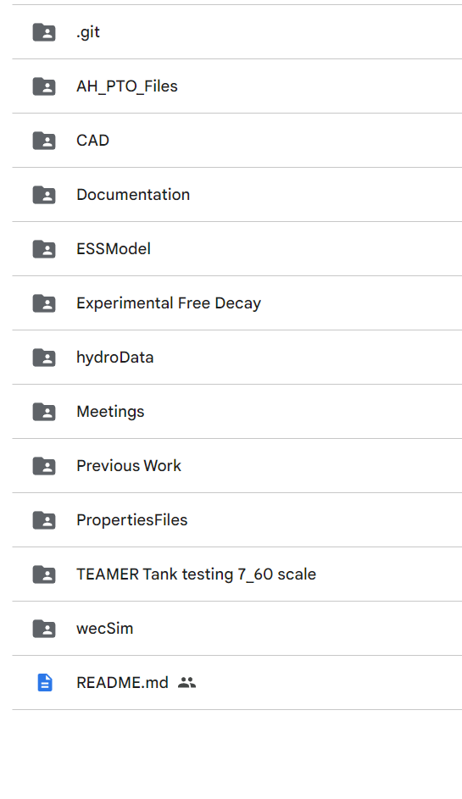

The folder : " Documentation"

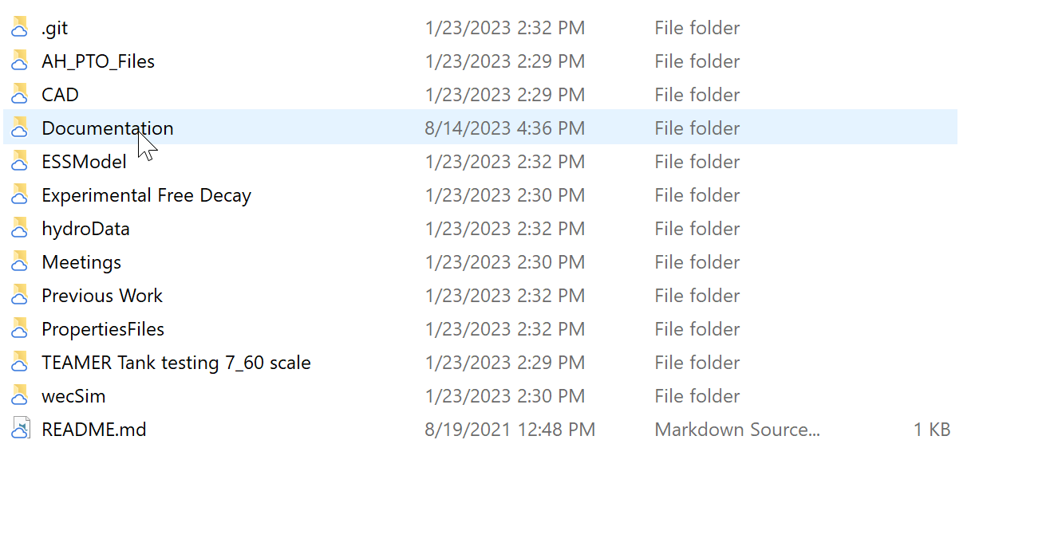

contains the following files:

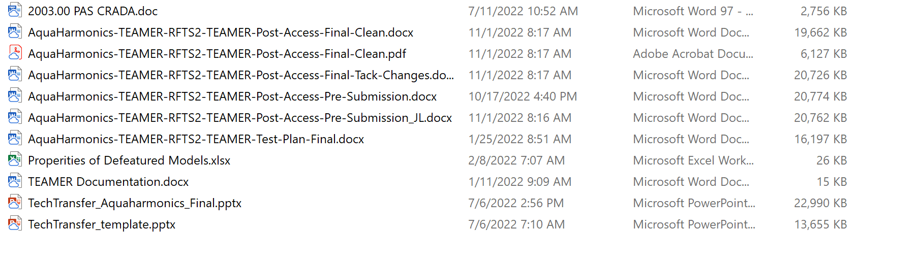

The file " AquaHarmonics-TEAMER-RFTS2-TEAMER-Post-Access-Final-Clean" contains information regarding the scope of work for the project, model setups, outputs, etc. and is setup in a way such that someone could duplicate the runs conducted via WEC-Sim.

The folder "AH_PTO_Files" is AquaHarmonics original WEC-Sim model with PTO parametric model coupling, and is setup for use within WEC-Sim. :

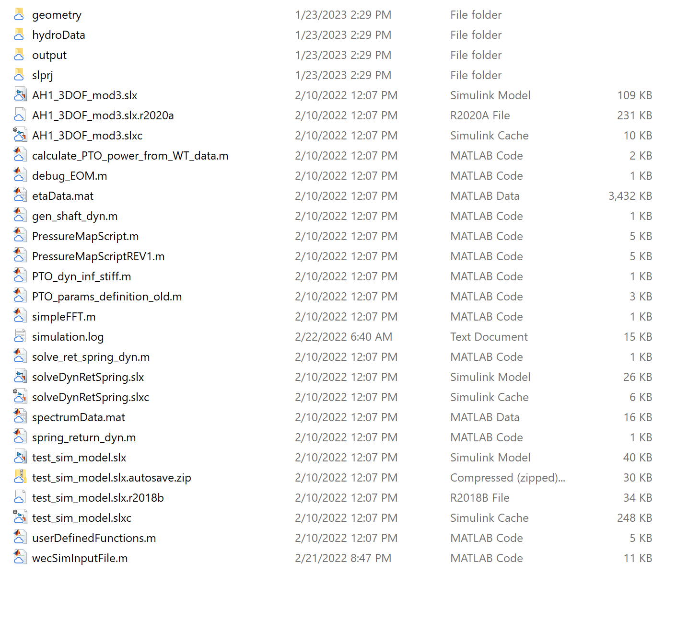

The folder "CAD" contains geometries developed within the TEAMER scope of work:

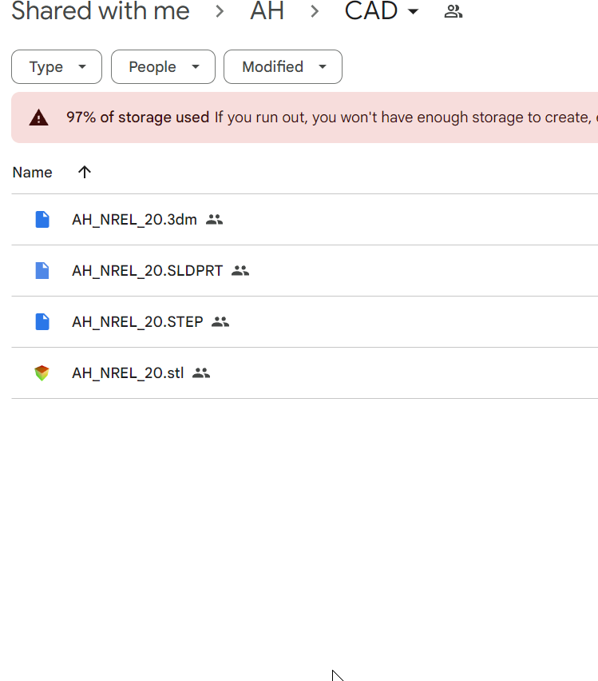

The folder "ESSModel" contains original runs and models for development of our ESS in the actual 1:7 scale device. This was to be coupled with the WEC-Sim model in the TEAMER scope of work.

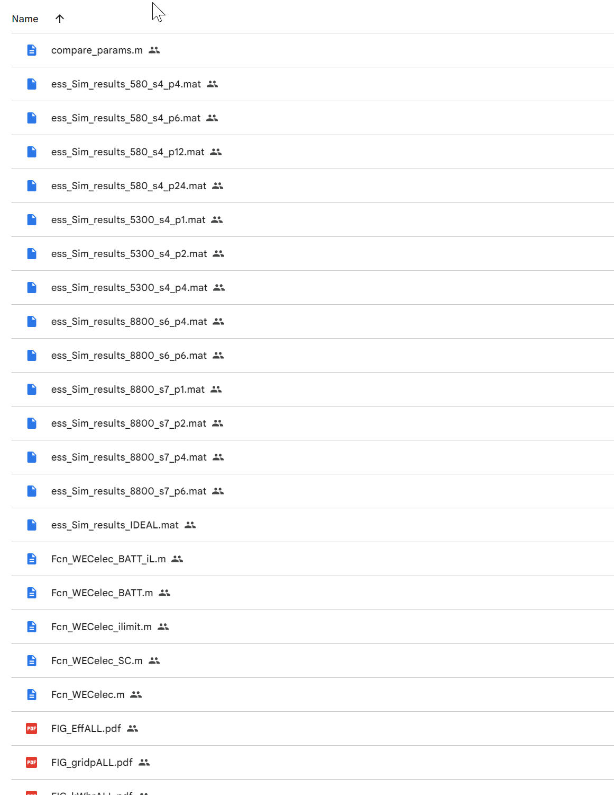

The folder "experimentalFreeDecay" contains tanks test data used in checking the WEC-Sim model via experimental free decay tests from tank testing:

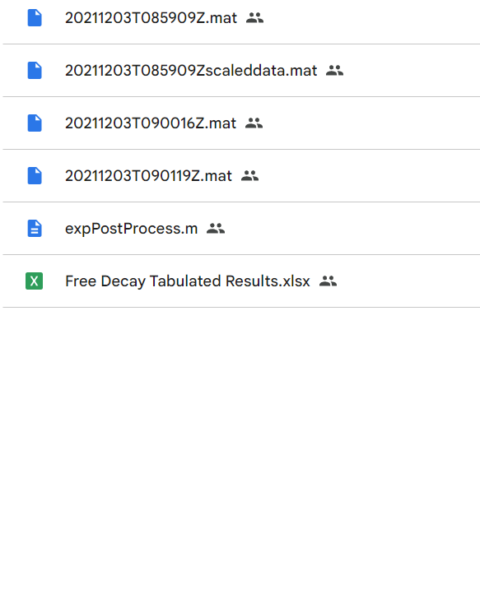

The folder " hydrodata" contains the various geometries analyzed in this scope of work as well as scripts for plotting outputs and BEMIO.

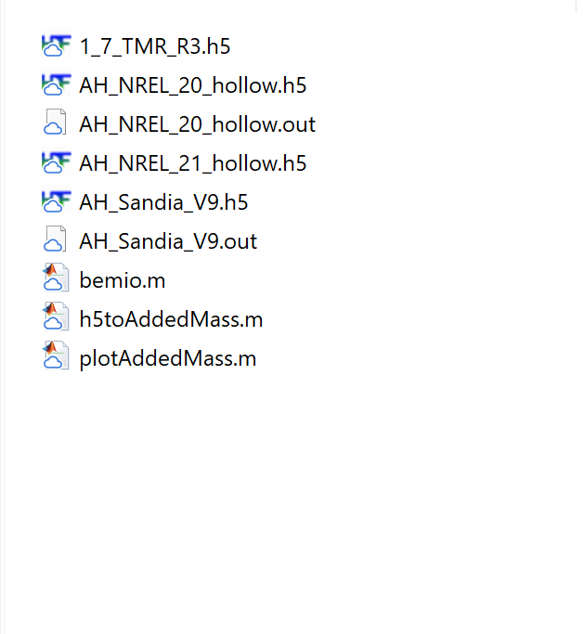

The folder "meetings" contains all of the project meetings and discussion points through the duration of the project:

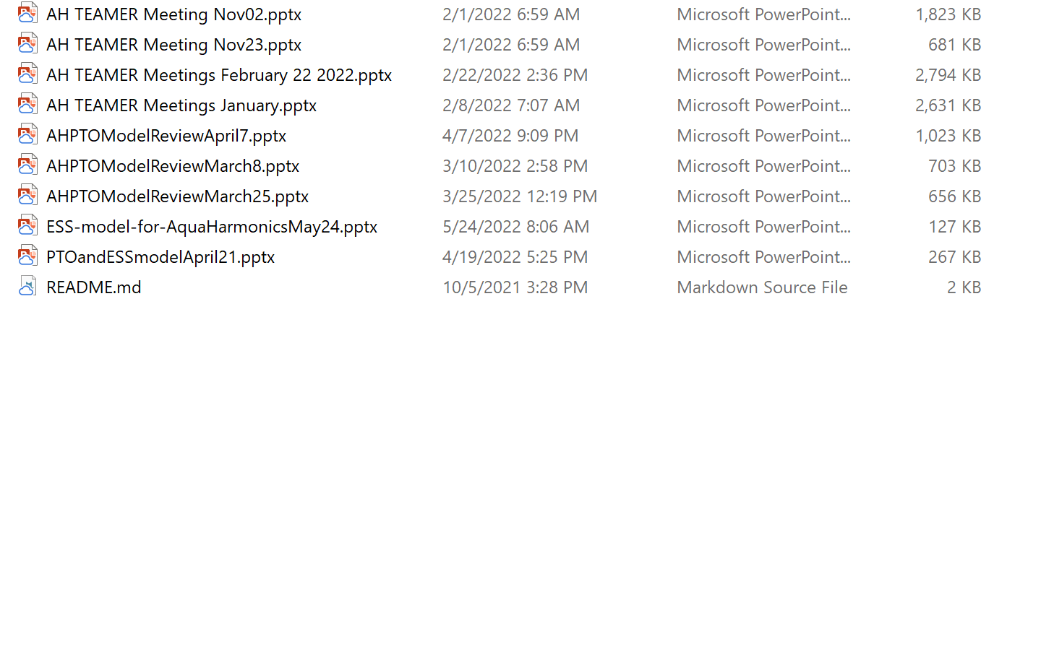

The folder "previous work" contains initial work conducted within WEC-Sim as described in the documentation:

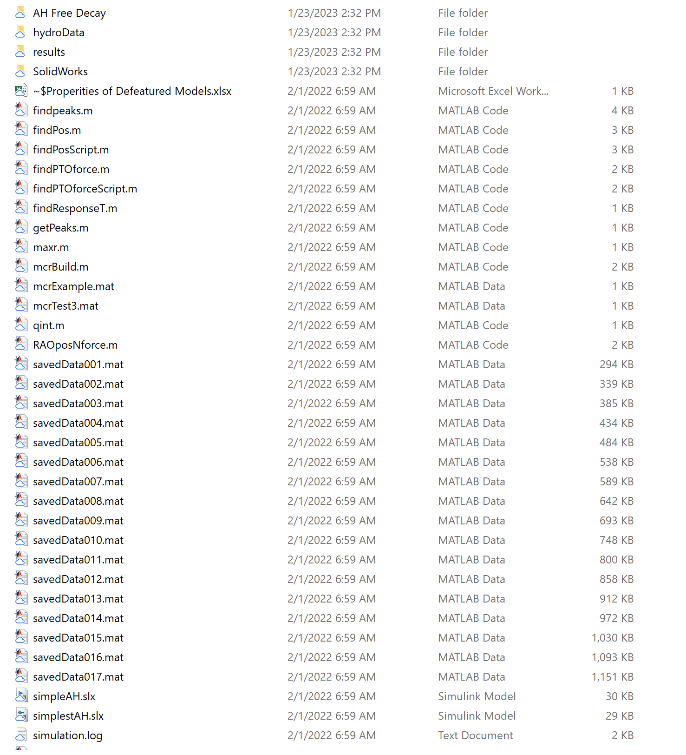

The folder "PropertiesFiles" contains short reports, documentation and block diagrams which describe the PTO parametric model, and the ESS model as well as block diagrams of the PTO in regards to conventions, etc. and a simplified solid model as the basis of the design.

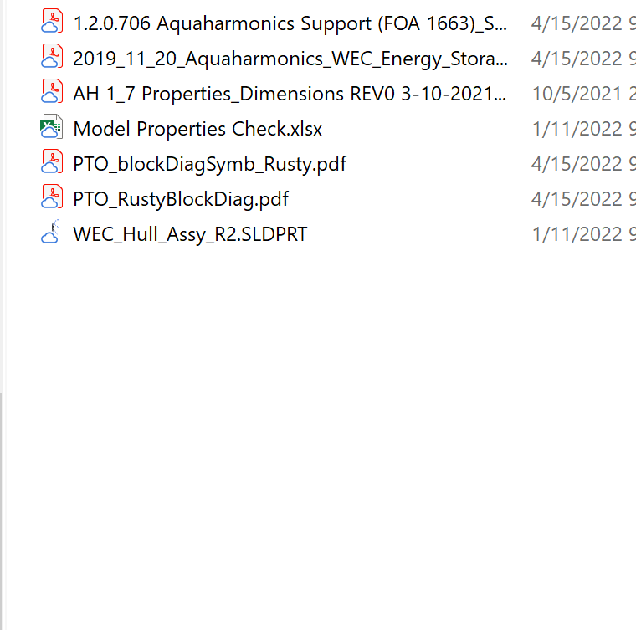

The folder " Teamer Tank testing 7_60th scale" contains scripts written by AquaHarmonics to analyze the tank test data from our other Teamer award to derive results for which we could compare the new coupled model outputs to as described in the documentation:

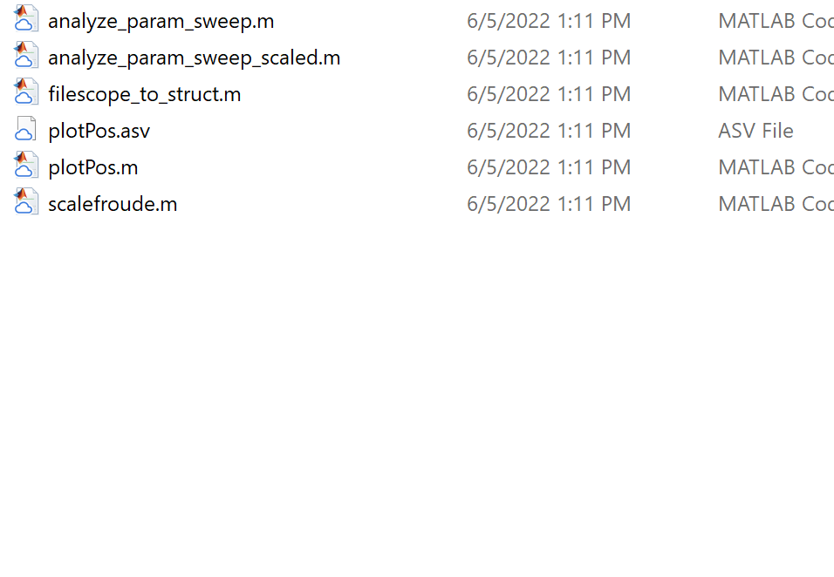

The folder wecSim contains the run data from the final coupled WEC SIm model. :

