# How to Use this Test Plan & Post Access Report Template

This document provides a template for both the Test Plan and the Post Access Report. Instructions on how to use this template are as follows:

* When developing the Test Plan, please complete Sections 1-6 of the template. Sections 7-10 can be removed. Please add Appendices as needed.
* When developing the Post Access Report, please complete all sections of this template. Sections 1-6 should be based on the Test Plan that was submitted. For the Post Access Report, Sections 1-6 must be updated to reflect where actual work deviated from the Test Plan, or where additional information is needed to describe the work actually performed during testing. Any changes to Sections 1-6 in the Post Access Report must be indicated using track changes for Version 2 described below.
* The Executive Summary section of the template should only be completed for the Post Access Report and does not need to be completed for the Test Plan
* Mark all items that are considered intellectual property (IP) in the document by highlighting in yellow. IP highlighting will be reviewed to ensure consistency with the IP agreement established with the TEAMER Network Director.
* Provide two (2) versions of the finalized Post Access Report. Version 1 should include information for immediate public viewing with protected data redacted or excluded. Version 2 must include all protected data as stated by the data requirement guidelines for the award.

Notes on guiding text provided throughout this template:

* Blue text provides guidance throughout this template. All blue text must be removed prior to submitting the completed Test Plan and Post Access Report documents.
* Black text defines the structure for the Test Plan and Post Access Report. Black text should not be removed or modified without approval from the TEAMER Network Director.

**Post Access Report**

Mooring Modelling and Analysis for Floating Oscillating

Surge Wave Energy Converter

Awardee: Virginia Tech

Awardee point of contact: Lei Zuo

Facility: NREL

Facility point of contact: David Ogden

Date: 6/14/2022

Authors: Stein Housner, Salman Husain, David Ogden, Xian Wu, Lei Zuo

# Executive Summary

Floating oscillating surge wave energy converters (FOSWECs) offer several advantages over bottom-hinged oscillating surge wave energy converters, including large wave potential at deep-water sites with fewer permitting and environmental concerns outside territorial waters. As a team, Stevens Institute of Technology, Virginia Tech and Resolute Marine Energy are designing a 100 klW FOSWEC with DOE support (2020-2021) for the PacWave test site. The proposed FOSWEC consists of a floating platform, pivoting flap, and a rotational power-take-off (PTO). The overall goal of the project is to design, build, deploy and analyze a 1:2 scale (100-kW annual averaged electrical power output) device with reduced levelized cost of energy (LCOE).. The objective of this TEAMER project is to develop a mooring configuration for the FOSWEC design that is suitable for PacWave deployment at a reasonable cost. This study will investigate and select a mooring configuration after considering the trade-offs between the system performance, design loads, and cost.

# Introduction to the project

Floating oscillating surge wave energy converters (FOSWECs) offer several advantages over bottom-hinged oscillating surge wave energy converters, including large wave potential at deep-water sites with fewer permitting and environmental concerns outside territorial waters. As a team, Stevens Institute of Technology, Virginia Tech and Resolute Marine Energy are designing a 100 kW FOSWEC with DOE support (2020-2021) for the PacWave test site “PacWave.”. The proposed FOSWEC consists of a floating platform, pivoting flap, and a rotational power-take-off (PTO),, as illustrated in Figure 1.

Figure 1. FOSWEC design with floating platform and two pivoting flaps.

The overall goal of the project is to design, build, deploy and analyze a 100-kW device with reduced levelized cost of energy (LCOE) and peak-to-average power ratio, through the co-design and control of the PTO, WEC, and floating platform. The base FOSWEC design is an improvement and extension of Reference Model 5 (RM5) “Reference Model Project (RMP).”, as shown in Figure 2.

Figure 2. Original DOE RM5 OSWEC and proposed FOSWEC design.

Estimates from the DOE RM5 design have shown the mooring/foundation costs to be about 11.1% of the total capital expenditure, and that the mooring configuration has a large influence on the system performance. Hence, the mooring system is a critical part of the proposed system, which will not only impact the system performance, but also affect the LCOE. The PacWave south test site, however, does not provide mooring systems for test devices. This was unanticipated in the original project proposal and scope, therefore, the TEAMER project, described subsequently, will address the mooring system design, modelling, and analysis. The goal of the TEAMER project is to perform a comprehensive mooring analysis, considering both the technical and economic issues.

# Roles and Responsibilities of Project Participants

List all relevant roles and responsibilities. Identify roles and responsibilities for the applicant and network facility.

## Network Facility Responsibilities and Tasks Performed

|  |  |
| --- | --- |
| NREL team member | Responsibility |
| David Ogden | Development of meshing scripts, Capytaine and WEC-Sim models |
| Stein Housner | Development of MoorDyn models, design and analysis of different mooring configurations |
| Sal Husain | WAMIT and WEC-Sim modelling |

# Project Objectives

There are three objectives with this TEAMER project:

1. Review the preliminary mooring design configuration.
2. Build a model coupling the mooring system and the floating platform interactions.
3. Using the coupled model, perform a parameter optimization considering both technical and economic impacts.

# Test Facility, Equipment, Software, and Technical Expertise

NREL develops, validates, and disseminates the open-source Wave Energy Converter SIMulator (WEC-Sim) “WEC-Sim.”. The code is developed in MATLAB/SIMULINK using the multi-body dynamics solver Simscape Multibody. WEC-Sim can model devices composed of rigid bodies, joints, power take-off systems, and mooring systems.

MoorDyn “MoorDyn.”, which is developed and maintained by a current NREL researcher, is a lumped-mass mooring line model for simulating the dynamics of moorings connected to floating offshore structures. The ability to couple WEC-Sim and MoorDyn has already been developed and verified.

The original OSWEC RM5 model was also developed and analyzed at NREL “Reference Model Project (RMP).”.

# Test or Analysis Article Description

As stated previously, the base FOSWEC design is an improvement and extension of the RM5 WEC, as shown in Figure 2. However, unlike the single floating flap concept in RM5, this project proposes a novel floating oscillating wave surge converter which comprises two flaps. These two flaps will be hinged on a 15 m wide, 50 m long floating semisubmersible platform. The dynamic forces and moments on the frame will be largely self-cancelling resulting in self-balancing of the whole system. In addition, researchers from NREL have determined that a two-flap design can yield more than three times the annual energy production of a single flap design using the same mooring method.

The mechanical motion rectifier (MMR) PTO developed by Dr. Lei Zuo and applied in both point absorber and OWSC WECs has been proven effective in improving the system energy capture ratio as well as efficiency. However, the current MMR gearbox that transfers bidirectional motion into unidirectional motion required by the generator currently will only passively engage and disengage the generator, which fully depends on speeds of the input and output shafts, i.e., buoy/flap motions and generator rotations. In many forms of WEC control, including latching control, model predictive control (MPC), LQG, or complex conjugate impedance matching, it is necessary to force the buoy/flap motion to be in phase with the wave excitation force (heave/surge direction) to maximize power extraction. The MMR’s passive engagement and disengagement of the PTO restricts the ability of the PTO to execute active control, as the MMR PTO is not capable of providing input power to the buoy/flap to allow them to move in phase with the excitation force, especially when the MMR-based PTO disengages both the WEC and generator. The new concept of applying controllable magnetic clutches enables flexible engage/disengage control with the capability to let the generator drive the WEC to achieve active control. The overall project will design, simulate, and develop the active-MMR based controllable PTO with test validation of the control algorithm for power maximization.

# Work Plan

This section should provide a high level description of the research methods. Regardless of the type of support being provided, this section should ***include sufficient detail, within reason, to allow the methods to be duplicated and for all results to be understood and interpreted.***

## Numerical Model Description (Only Required if Numerical Analysis Work is Being Performed, Note that Experimental Projects May Have Some Numerical Modeling)

* Provide a comprehensive description of the numerical model or simulation tool that will be used/was used.
* Identify the simulation tool and provide details on the numerical methods. In addition, any work that will be performed to verify and validate the numerical method should be provided (e.g. mesh and time step studies, ensuring appropriate boundary conditions)
* Provide a discussion of previous studies that have verified the accuracy and validity of the numerical model (e.g. mesh and time step convergence studies, previous validation against experimental results). The applicant and facility should develop the test plan to ensure validity and accuracy of the computational results.

To achieve the TEAMER project objectives, NREL will assist the team by completing the mooring modelling and analysis in the four steps outlined in Figure 3.

Figure 3. Project work plan and schedule.

1. The specifications for the anchor system at the PacWave south site will be analyzed to determine the design constrains and limitations. The specifications of the anchor system will be the footstone of the mooring system. Specifically, the maximum load and stress will be reviewed, and the desired connection points will be checked.
2. The preliminary mooring design (as shown in Figure 1 for the 70m-deep PacWave site) will be reviewed and modified based on the anchor specifications and the IEC standards (IEC TS 62600-10 Assessment of Mooring System) International Electrotechnical Commission, “IEC TS 62600-10.”. The Virginia Tech team has developed a preliminary mooring configuration and created a simplified model in ANSYS-AQWA. To meet the final goal of field testing at the PacWave site, the mooring system design will consider both the anchor specifications, as well as the design standards. The preliminary mooring configuration will be reviewed by NREL and the design will be finalized.
3. The numerical model will be built using WEC-Sim and MoorDyn to simulate the FOSWEC with its mooring system. The modelling of the mooring system will consider the interaction with the wave energy converter.
4. The techno-economic analysis will be completed by industry collaborator Resolute Marine Energy (RME), based on the modelling results obtained by NREL. RME has more than ten years’ experience on marine renewable energy and extensive experience on installation, operation, and maintenance (IO&M) strategies. The key components will be selected, and the desired manufactures will be engaged. The final mooring design will be ready for manufacturing and testing in PacWave south at the end of this project.

The overall objective of the project is to develop a mooring configuration for the FSWEC design that is suitable for PacWave deployment with reasonable cost. This study will investigate a set of mooring configurations and investigate the trade of between the system performance with each mooring design concept and design loads, which are used as a matrix for estimating the cost. Key parameters to be evaluated by the models and techno-economic analysis include:

1. Maximum load on the anchor
2. Dynamic stress on mooring line
3. Average motion on platform
4. Average absorbed power

## Test and Analysis Matrix and Schedule

As described in 6.1 and Figure 3, the project is expected to run 6 months from the start date. The project tasks will roughly follow the schedule given below.

Specification Check – 0.5 month

Design Review – 1.0 month

Numerical Modeling – 3.5 month

Techno-Economic Analysis – 1.0 month

## Safety

The TEAMER project is wholly computational. Applicable office safety standards will be followed.

## Contingency Plans

Not applicable.

## Data Management, Processing, and Analysis

### Data Management

WEC-Sim-generated data will be stored locally on the machine the code is run on and backed up using OneDrive (up to 1TB available). The final dataset containing results from the numerical modelling campaign will uploaded to MHK DR.

### Data Processing

WEC-Sim saves the data from each run as a .mat file (binary), which can be read into memory with MATLAB or Python for post-processing. Meaningful directory and file names will be used for clarity and figures will be provided with the plot-generation scripts attached for complete traceability and reproducibility.

### Data Analysis

The WEC numerical model data will be analyzed in accordance with IEC Technical Specification 62600-100 International Electrotechnical Commission, “IEC/TS 62600-100.” for power performance estimates of electricity producing wave energy converters and IEC Technical Specification 62600-10 for mooring system analysis.

# Project Outcomes (Results)

## Development of a coupled WEC-Sim/MoorDyn model of the VT FOSWEC

### System description: geometry, mass and inertia properties

As the VT FOSWEC concept is still being iterated on, the dimensions shown in Figure 2 do not necessarily represent the system’s final design. The updated dimensions used in the majority of the WEC-Sim+MoorDyn simulations are shown in Table 1.

|  |  |  |  |  |
| --- | --- | --- | --- | --- |
| **Body** | **Center of Gravity**  **[x, y, z] (m)** | **Dimensions**  **L x B x H (m)** | **Mass (kg)** | **Moment of Inertia: ${[I}_{xx},I_{yy},I_{zz}] (kgm^{2})$** |
| **Base** | $$\left[\begin{matrix}0 \\ 0 \\ -6.25\end{matrix}\right]$$ | $$45×12×0.50$$ | $$276,750$$ | $$\left[\begin{matrix}3,245.6 \\ 45,568.1 \\ 48,802.5\end{matrix}\right]$$ |
| **Flaps** | $$\left[\begin{matrix}0 \\ 0 \\ -3.20\end{matrix}\right]$$ | $$2×12×4.20$$ | 109,265 | $$\left[\begin{matrix}1,578,848.7 \\ 230,614.9 \\ 1,421,077.1\end{matrix}\right]$$ |

Table 1. Centers of Gravity and approximate dimensions of the FOSWEC device's components in cartesian coordinates.

In order to rapidly update the system’s geometry and inertia properties in the future, meshing scripts were developed using PyGmsh (<https://github.com/meshpro/pygmsh>) - a Python API for the popular open-source meshing tool, Gmsh (<https://gmsh.info/>). With this approach, the system could be parameterized by its main dimensions:



Figure 3. Snippet of meshing script using PyGmsh.

Using the open-source Python package MeshMagick (developed by Ecole Centrale de Nantes: <https://github.com/LHEEA/meshmagick>), other key information about each body (e.g. hydrostatic stiffness matrix, inertia values, center of buoyancy) could also be computed automatically and saved to disk – ready to be used in WEC-Sim.

Figure 4. Example of meshes produced using PyGmsh workflow (panel normal vectors shown).

### WEC-Sim model development

Figure 6 shows the block diagram of the WEC-Sim/Simulink model of the VT FOSWEC. Two mooring blocks represent the two different options used for modeling the system’s mooring; a linear mooring stiffness matrix and a fully dynamics lumped-mass mooring model (using MoorDyn – commented out in the diagram view).

Figure 5. WEC-Sim/Simulink block diagram model of the VT FOSWEC.

### Inerter PTO description

The FOSWEC device used an Inverter PTO that uses the PTO angular acceleration and exerts a PTO torque on the system. Here is a high-level description of the Inerter PTO.,

$$I_{PTO}=η^{2}I_{inerter}$$

$${τ_{PTO}}_{Inerter} =-I_{PTO}α$$

where $η$ is the Inerter gear ratio, $I_{inerter}$ is the Inerter inertia, $I_{PTO}$ is a clubbed term that represents the PTO inertia, and $α$  is the angular acceleration in some general degree of freedom.

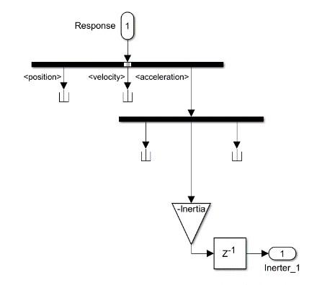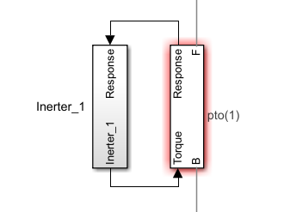

Figure 6 Implementation of the Inerter PTO in the WEC-Sim model.

Figure 4 shows the Simulink model of the Inerter PTO used in the WEC-Sim model. The PTO inertia is evaluated in the setup script, the Inerter uses the PTO acceleration as feedback with the PTO inertia as its gain, thereby actuating the system from its PTO torque contributions.

### Locking the flaps

For the purpose of mooring design, the system would be simulated in selected ‘extreme’ sea states (taken from the perimeter of the PacWave contour plot). Simulating the system with the flaps ‘unlocked’ in these conditions (and body-to-body interactions ‘on’) with WEC-Sim caused extremely high computation times. Hence, a separate single-body model was created for mooring design, with the flaps tied down to the base. This single body model significantly reduced the computational effort required to simulate the system – enabling faster iterations on the mooring design. The mooring tensions and behaviors were compared between the extreme sea state model and the original model using the same sea state, and the extreme sea state model was shown to produce higher tensions, meaning that the extreme sea state model is the model that should be used to calculate the extreme loads on the mooring system.

Figure 7. Top: VT FOSWEC in operational conditions (flaps active). Bottom: VT FOSWEC in extreme conditions (flaps locked down).

## Mooring design process

The mooring system design process for any floating body involves many variables and considerations, such as the type of mooring system or the mooring line configuration. Many of these variables were adjusted throughout the design process to investigate the effects they had on the mooring design performance and cost. The main parameters that were kept constant were the mooring system water depth, which was set at 70 meters, characteristic of the PacWave site, and the number of lines of the mooring system, which was set at four. Figure 3 depicts this assumed mooring system configuration and Table 1 lists the remaining design parameters involved in the design process.

Figure 8. Mooring layout configuration used for WEC-Sim/MoorDyn modeling. Base length initially 55m, then changed to 45m.

Table 3. Mooring design parameters.

|  |  |
| --- | --- |
| **Parameter** | **Value** |
| Depth | 70 m |
| Length | Variable |
| Number of Lines | 4 |
| Orientation of Lines | Variable |
| Individual Line Configuration | Variable |
| Maximum Surge Offset Amplitude | WEC-Sim |
| Mean Horizontal Force | WEC-Sim |
| Target Mooring Stiffness | 60 kN/m |

The length of the FOSWEC was determined by the larger VT team and was out of scope of this mooring design process to determine the optimal body length. In the earlier stages of the project, the length was set at 55m, but in later stages of the project, the length was set at 45m. The orientation of mooring lines was varied between 45°, 12°, and 27° headings for the 55m platform, and 45°, 15°, and 27° headings for the 45m platform (with 27° headings, for example, meaning lines at 27°, 153°, 207°, and 333° headings around the FOSWEC) to determine if certain orientations are better than others. The three individual line configurations planned to be designed were a catenary-chain line with a drag-embedment anchor (catenary-chain), a taut-polyester rope line with a suction pile anchor (taut-rope), and a **semi-taut chain-polyester rope line with a suction pile anchor (semi-taut chain-rope).**

The mooring design process involves the use of NREL’s internal, quasi-static mooring design tools, and the dynamic simulation tools of WEC-Sim and MoorDyn to calculate the dynamics on the floating body and mooring system, respectively. The maximum surge offset amplitude and the mean horizontal force are parameters based on the PacWave environment but are first assigned assumed values in the initial quasi-static mooring design process, but then are more accurately calculated using WEC-Sim and MoorDyn. The general design process is shown in Figure 4.

Figure 9. Mooring system design process for VT’s FOSWEC.

The quasi-static design process tunes the line diameters, lengths, and anchor spacings of the various line configurations to achieve the most cost-effective design, while meeting all constraints. Common constraints include ensuring the platform does not offset within a certain amount, or ensuring the maximum tensions of the mooring lines do not exceed the minimum breaking load (MBL) of the line. The optimized designs are then passed to WEC-Sim and MoorDyn for a dynamic analysis to ensure all the same constraints are satisfied in a dynamic environment. Once those constraints are met in WEC-Sim and MoorDyn, the design is considered feasible, and its cost can be evaluated.

A unique feature of this design process is that the quasi-static design tools can tune the parameters of the mooring lines to ensure the total mooring system achieves a certain stiffness.

### Site Conditions

The site selected by VT for deployment of the FOSWEC is the PacWave South site off the coast of Newport, Oregon, which experiences consistent and energetic waves. The design of a mooring system relies on the extreme conditions of the site, as well as any physical constraints imposed by the site. Using a 50-year contour for wave data in the PacWave region, a point on the outer envelope was chosen as the extreme sea state, with a significant wave height of 11.3 meters and a peak period of 19.2 seconds, which will drive the mooring design of the FOSWEC (Figure 1) [1]. It was determined that this combination of wave height and period would produce the most significant motions and tensions on the FOSWEC. The waves primarily travel from west to east at PacWave.

The boundaries of the PacWave test site berths should also be considered, especially for potential widespread mooring configurations. There are four testing berths at PacWave, each with a length of 1,850 m and a width of 925 m. Depending on the number of WECs expected to be in each berth at one time, these dimensions can create a maximum anchor spacing for the mooring design (Figure 2) [2].

|  |  |
| --- | --- |
|  |  |
| Figure 10: 50-year sea state envelope for PacWave region | Figure 11: PacWave Testing Berth Dimensions |

These sea state parameters and physical boundaries provide necessary inputs to the mooring design process.

A target system stiffness was found to be 60 kN/m based on sweeps of power output and mooring stiffness, and the parameters of the line configuration were adjusted to not only calculate the most cost-effective design, but also ensure the system achieves the target stiffness.

### Anchor Spacing Definition

There are three main design variables that are optimized in the quasi-static design process for the catenary-chain and taut-rope configurations: anchor spacing, line length, and line diameter. Anchor spacing is defined as the horizontal distance between the anchor point and the fairlead (Figure 6). Other versions of these designs may have had the anchor spacing relative to the origin or a centerline point on the FOSWEC, but the following results have the spacing anchor relative to the fairlead for clarity.

|  |
| --- |
|  |
| Figure 12: Definition of the anchor spacing variable |

For designs with 45° headings, the quasi-static design tool optimizes the anchor spacing relative to the centerline point, depicted by the green dot in Figure 5. However, the anchor spacings listed in the following results are the horizontal distances between the anchor point and the fairlead point, depicted by the length of the black line in Figure 5, which simply subtracts the distance from the centerline point to the fairlead.

### Berth Boundaries

Due to the dimensions of the PacWave berths, the maximum anchor spacing of the mooring lines is limited based on the mooring line headings. Figure 5 shows the approximate shape of the maximum anchor spacings of mooring systems assuming only one FOSWEC per PacWave berth for three different line headings. Figure 6 shows the approximate shape of the maximum anchor spacings of mooring systems assuming 2, 3, or 4 FOSWECs in a vertical row in a PacWave berth. It is assumed that for mooring systems with multiple FOSWECs in a berth, they would all be in the same vertical plane where their anchor points would connect at the same position, rather than having the FOSWECs be offset horizontally.

|  |  |  |
| --- | --- | --- |
| Diagram, rectangle  Description automatically generated  (a) | A picture containing text, table  Description automatically generated  (b) | Diagram, rectangle  Description automatically generated  (c) |
| Figure 13: Maximum anchor spacing limits of mooring systems with (a) 45° headings, (b) 12° headings, and (c) 27° headings. | | |
|  |  |  |
|  |  |  |
| Figure 14: Maximum anchor spacing limits of multiple 2, 3, and 4 mooring systems in a vertical row with (a) 45° headings, (b) 15° headings, and (c) 27° headings. | | |

The resulting catenary-chain designs have minimized costs at high anchor spacings and line lengths, which means that all of the catenary-chain designs are at these maximum anchor spacing bounds. The taut-rope designs have minimized costs at lower, more reasonable anchor spacings, so those designs are not constrained by these maximum anchor spacing bounds.

### Cost Estimation

The cost of each mooring system component is calculated using the following equations, which were derived from industry recommendations.

|  |  |  |
| --- | --- | --- |
|  | $${cost}_{chain}=51,440\frac{\$}{m^{3}}*d^{2}\left[\frac{\$}{m}\right]$$ |  |
|  | $${cost}_{polyester}=2,810\frac{\$}{m^{3}}*d^{2}\left[\frac{\$}{m}\right]$$ |  |
|  | $${cost}_{DEA}=\left[0.188\frac{\$}{kg}*\frac{\max\left(F_{anchor}\right)}{g}\right]*1.5 [\$]$$ |  |
|  | $${cost}_{suction-pile}=\sqrt{{\left(1.6*\frac{F_{H}}{9.81}\right)}^{2}+{\left(2.0*\frac{F_{V}}{9.81}\right)}^{2}}*\frac{\$1.08}{kg}$$ |  |

The safety factors of 1.5 for DEAs and 1.6 and 2.0 for deadweight anchors are based off of design standards [3]., Other system costs, such as installation and O&M costs, are not included in this analysis.

## Numerical Modelling Results

### Mesh convergence study

A flap with nPanels = 756 was determined to have sufficient convergence in added mass at higher frequencies.

The hydrodynamic coefficients were found to have a distinctive ‘sawtooth’ characteristic, which has been noted in other FOSWEC concepts, including the F3OF model used in Wave Energy Converter Code Comparison Project (WEC3). This has been attributed to flap 1 radiating waves that are reflected off flap 2. Superposition leads to constructive interference at some frequencies and destructive interference at other frequencies (Combourieu et al., 2015).

Figure 15. Selection of meshes used in BEM convergence study, shown in Rhino. The finer mesh was used as the benchmark, the 'converged mesh' was found to have sufficient resolution to provide convergence in added mass at higher frequencies.

Figure 16. Non-dimensionalized added mass coefficients computed by WAMIT for the front flap in pitch. A flap with nPanels = 756 was found to have sufficient convergence (by comparison with a finer mesh with nPanels = 1166).

### Ensuring hydrostatic equilibrium

To ensure that all mass properties and initial positions were defined properly, the system was simulated in still water, to ensure no movement. Figure 17 shows the absolute position of the base, fore-flap, and aft-flap. Figure 18 shows the root-mean squared error (RMSE) between the initial position and the position of the three components. It can be observed that the position of the components of the FOSWEC maintain their initial position with machine precision.

Figure 17. Still water test results to ensure hydrostatic equilibrium – absolute heave positions for each body in the system (1000s).

Figure 18. Still water tests (60s) to show that the VT FOSWEC system properties have been defined correctly and that deviations from equilibrium positions are on the order of $1∙{10}^{-15}$.

### Mooring stiffness studies

The device was simulated in waves of period $5 s$ to $20 s$, and the mooring stiffness was varied from $40 kN/m$ to $120 kN/m$. For the FOSWEC device with a base-length of $55 m$, the average power produced by the PTOs on Fore-Flap and Aft-Flap was highest when the mooring stiffness was $70 kN/m$; as shown in the heat-map in Figure 19 and the surface plot in Figure 20. The incoming wave for the mooring stiffness studies was $1 m$ and the wave periods were varied from to .

Figure 19 Heat-map of Average Power for a range of mooring stiffness constants for the FOSWEC with base-length 55 m.

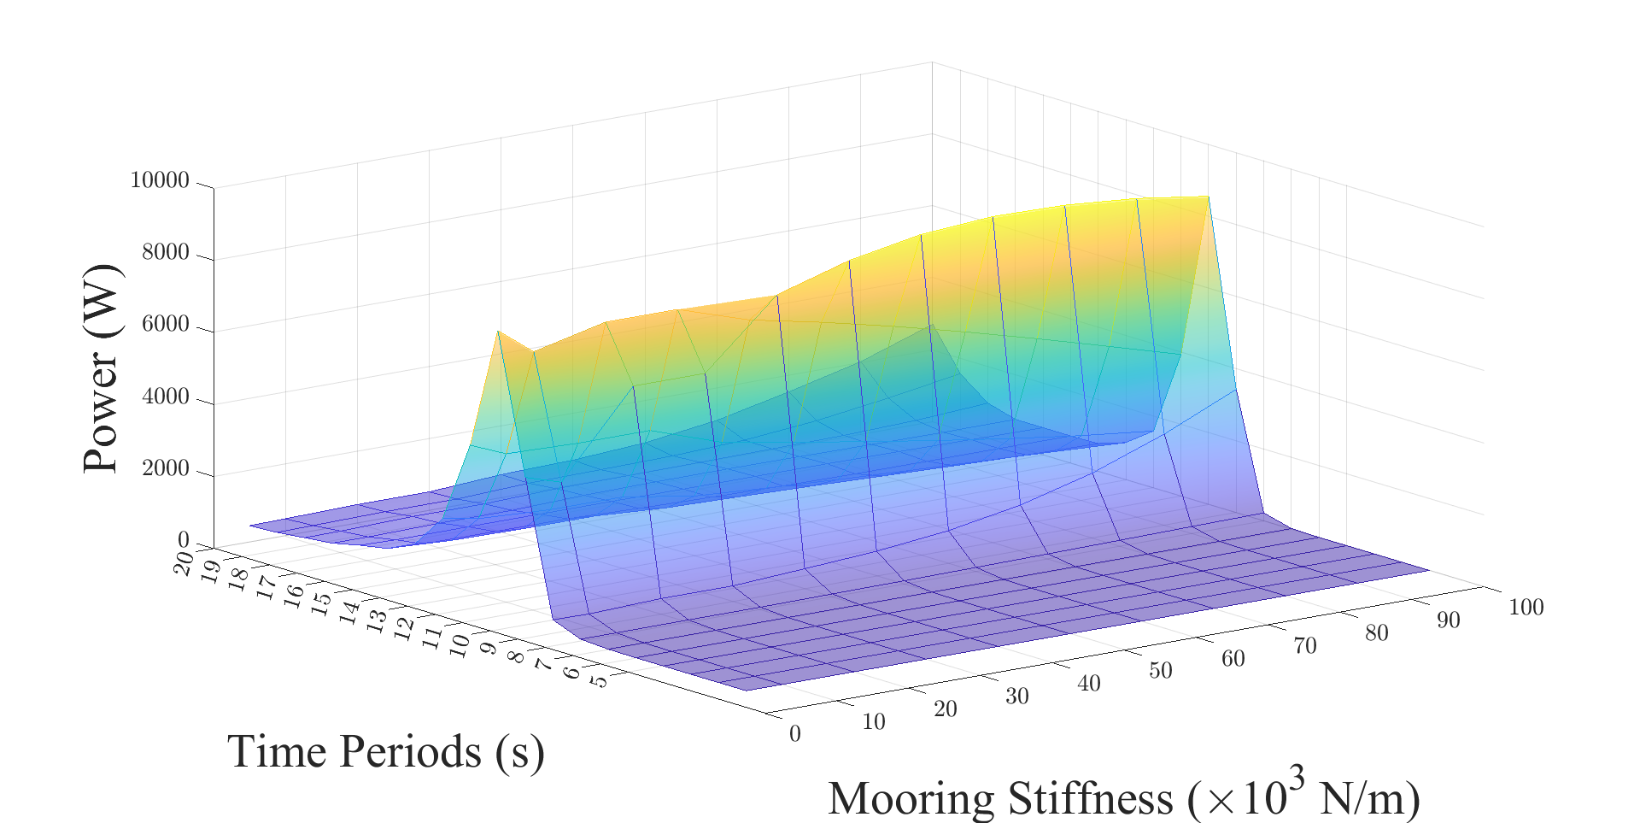

Figure 20 Surface plot of Average Power for a range of mooring stiffness constants for the FOSWEC with base-length 55 m.

Figure 21 and Figure 22 show that for the FOSWEC device with a base-length of $45 m$, the average power produced by the PTOs was highest when the mooring stiffness was $60 kN/m$ and the wave period was $15 s$. This helped establish the baseline value of mooring stiffness at $60 kN/m$, to maximize the average power produced by the PTOs.

Figure 21 Heat-map of Average Power for a range of mooring stiffness constants for the FOSWEC with base-length 45 m.

Figure 22 Surface plot of Average Power for a range of mooring stiffness constants for the FOSWEC with base-length 45 m.

### Base length studies

The device configuration was characterized by analyzing the effect of varying the base-length on which the fore-flap and aft-flap are mounted. Figure 23 shows the Response Amplitude Operators (RAOs) for a FOSWEC device whose base-length is varied from $30 m$ to $55 m$. The techno-economic analysis indicated that the base-length of $45 m$ satisfied the load and economic constraints. The incoming wave for the base-length studies was 0. $1 m$ and the wave periods were varied from to .

Figure 23 Response Amplitude Operators (RAOs) of the FOSWEC device for a range of bases of different lengths.

In the discussion that follows the FOSWEC with a base-length of $45 m$ is used to identify suitable PTO characteristics, wave conditions, and design a mooring system that satisfied the techno-economic constraints while maximizing energy yields.

### PTO stiffness studies

The rotational PTOs for the FOSWEC device were located at the hinge joints between the base and fore-flap, and the base and aft-flap. The PTO was modelled as a linear spring-damper system that was characterized by varying the PTO stiffness coefficients.

Figure 24 and Figure 25 show the Response Amplitude Operators (RAOs) for the average power produced by the FOSWEC device as the PTO stiffness is varied from $210 kN/m$ to $380 kN/m$. It can be observed that the energy yield is highest when the PTO stiffness is $310 kN/m$.

This approximation of the PTO characteristics can then be used to guide the design of a more sophisticated PTO that can be deployed on sea-worth device. The incoming wave for the PTO stiffness studies was $0.1 m$ and the wave periods were varied from to .

Figure 24 Heat-map of the Response Amplitude Operators (RAOs) for a range of PTO stiffness coefficients.

Figure 25 Surface plot of the Response Amplitude Operators (RAOs) for a range of PTO stiffness coefficients

### System power matrix

The system response for a range of permutations of wave heights and wave periods was analyzed to estimate the average power that can be produced by the FOSWEC device. The power matrices shown in Figure 26 and Figure 27 can then be used to identify the suitable sites that can maximize power yields or to design active controllers that can influence the system’s dynamical response.

Figure 26 Power matrix of the FOSWEC device represented as a heat-map indicating the wave conditions that result in highest energy yields.

Figure 27 Power matrix of the FOSWEC device represented as a surface plot indicating the wave conditions that result in highest energy yields.

Note, although a certain wave-climate may be more lucrative for energy production, the device must survive the respective loads on its structure. The survivability of the device is constrained by the deployment infrastructure as discussed in the techno-economic analysis of the mooring system, in the sections that follow.

### Catenary-chain designs

Using the extreme sea state model, many different styles of catenary-chain mooring systems were designed that satisfy all design constraints and meet target mooring system stiffnesses. Due to time and budget constraints of the project, as well as project scope, not all mooring design parameters were varied, but enough to show the trends of the designs. These designs can be found in Table 3.

Table 3: Catenary-chain mooring designs

|  |  |  |  |  |  |  |  |
| --- | --- | --- | --- | --- | --- | --- | --- |
| **FOSWEC Length (m)** | **Headings (°)** | **FOSWECs in Berth** | **Mooring System Stiffness (kN/m)** | **Anchor Spacing (m)** | **Chain Length (m)** | **Chain Diameter (mm)** | **Line Cost ($)** |
| 55 | 45 | 1 | 40 | 644.2 | 652.5 | 30.4 | 31,019 |
| 55 | 45 | 1 | 50 | 644.8 | 652.4 | 31.1 | 32,459 |
| 55 | 45 | 1 | 60 | 644.1 | 651.4 | 33.6 | 37,829 |
| 55 | 45 | 1 | 70 | 645.0 | 651.2 | 32.0 | 34,302 |
| 55 | 45 | 1 | 80 | 642.3 | 648.4 | 34.1 | 38,784 |
| 55 | 12 | 1 | 60 | 913.8 | 921.2 | 27.0 | 34,545 |
| 55 | 12 | 1 | 40 | 914.8 | 922.7 | 23.1 | 25,327 |
| 55 | 12 | 1 | 80 | 916.7 | 923.7 | 30.1 | 43,049 |
| 55 | 27 | 1 | 60 | 1,006.2 | 1,012.5 | 27.1 | 38,250 |
| 55 | 27 | 1 | 120 | 1,002.5 | 1,006.0 | 30.4 | 47,824 |
| 45 | 45 | 2 | 60 | 318.1 | 335.6 | 93.1 | 149,631 |
| 45 | 45 | 3 | 60 | 207.8 | 226.7 | 102.1 | 121,564 |
| 45 | 45 | 4 | 60 | 153.7 | 172.5 | 101.1 | 90,697 |
| 45 | 15 | 2 | 60 | 831.7 | 838.6 | 25.0 | 26,961 |
| 45 | 15 | 3 | 60 | 550.0 | 557.8 | 28.6 | 23,470 |
| 45 | 15 | 4 | 60 | 406.3 | 419.2 | 44.7 | 43,086 |
| 45 | 27 | 2 | 60 | 493.3 | 503.9 | 37.8 | 37,036 |
| 45 | 27 | 3 | 60 | 325.0 | 340.0 | 59.3 | 61,502 |
| 45 | 27 | 4 | 60 | 241.3 | 262.6 | 98.0 | 129,732 |

|  |  |  |  |  |  |  |  |  |  |  |
| --- | --- | --- | --- | --- | --- | --- | --- | --- | --- | --- |
| **FOSWEC Length (m)** | **Headings (°)** | **FOSWECs in Berth** | **Mooring System Stiffness (kN/m)** | **Max Surge (m)** | **Mean Surge (m)** | **Max Fairlead Tension (kN)** | **Mean Fairlead Tension (kN)** | **Max Anchor Load (kN)** | **Mean Anchor Load (kN)** | **DEA Anchor Cost ($)** |
| 55 | 45 | 1 | 40 | 10.6 | -0.01 | 621.9 | 119.0 | 574.3 | 108.7 | 16,508 |
| 55 | 45 | 1 | 50 | 9.8 | -0.01 | 650.1 | 139.2 | 603.8 | 128.6 | 17,357 |
| 55 | 45 | 1 | 60 | 8.3 | -0.005 | 643.7 | 169.7 | 599.2 | 157.6 | 17,226 |
| 55 | 45 | 1 | 70 | 7.9 | -0.004 | 653.4 | 187.5 | 613.0 | 176.6 | 17,623 |
| 55 | 45 | 1 | 80 | 6.8 | -0.004 | 635.1 | 216.2 | 601.9 | 203.8 | 17,301 |
| 55 | 12 | 1 | 60 | 8.4 | -0.009 | 487.0 | 100.8 | 441.1 | 92.8 | 12,681 |
| 55 | 12 | 1 | 40 | 11.0 | -0.02 | 486.2 | 70.8 | 435.2 | 64.2 | 12,511 |
| 55 | 12 | 1 | 80 | 6.5 | -0.004 | 453.7 | 131.1 | 418.9 | 121.6 | 12,038 |
| 55 | 27 | 1 | 60 | 9.4 | -0.008 | 519.1 | 117.5 | 470.2 | 109.4 | 13,517 |
| 55 | 27 | 1 | 120 | 5.6 | 0.004 | 512.2 | 229.4 | 490.4 | 219.5 | 14,097 |
| 45 | 45 | 2 | 60 | 9.0 | -0.02 | 764.6 | 336.5 | 583.9 | 243.4 | 16,784 |
| 45 | 45 | 3 | 60 | 9.5 | -0.02 | 793.3 | 360.2 | 585.8 | 248.5 | 16,840 |
| 45 | 45 | 4 | 60 | 8.9 | -0.02 | 924.7 | 357.0 | 707.2 | 246.6 | 20,329 |
| 45 | 15 | 2 | 60 | 7.7 | -0.008 | 438.5 | 96.1 | 401.7 | 89.3 | 11,548 |
| 45 | 15 | 3 | 60 | 5.2 | -0.006 | 418.7 | 113.9 | 388.8 | 105.3 | 11,178 |
| 45 | 15 | 4 | 60 | 5.9 | -0.01 | 470.8 | 128.6 | 403.7 | 107.4 | 11,605 |
| 45 | 27 | 2 | 60 | 6.0 | -0.01 | 483.3 | 126.0 | 431.4 | 110.8 | 12,402 |
| 45 | 27 | 3 | 60 | 6.9 | -0.01 | 556.2 | 177.1 | 453.2 | 139.5 | 13,028 |
| 45 | 27 | 4 | 60 | 9.8 | -0.02 | 703.4 | 278.7 | 506.7 | 177.6 | 14,565 |

First, in the original configuration, the length of the FOSWEC was 55 meters, and various catenary-chain mooring systems were designed with different mooring line headings to achieve various mooring system stiffnesses. The parameter that was not initially specified was the number of FOSWECs desired to be in one PacWave berth at one time, so it was assumed that the mooring systems would be designed for one FOSWEC in a berth. The physical boundaries of the PacWave berths created maximum anchor spacings for different mooring designs depending on the heading direction of the mooring lines. For example, mooring systems with line headings of 45° could only have a maximum anchor spacing of 645 meters, since any longer anchor spacing would set the anchor outside the dimensions of the berth, with the FOSWEC on the centerline of the berth. Skinnier mooring systems, with line headings of 12° or 27°, could have larger maximum anchor spacings, since their mooring footprints would have more space to extend before reaching a PacWave berth boundary.

In the updated design, the length of the FOSWEC was 45 meters, and various catenary-chain mooring systems were also designed with different mooring line headings to achieve a target system stiffness of 60 kN/m, but the maximum anchor spacings were adjusted to support multiple FOSWECS in the same PacWave berth. For example, mooring systems with line headings of 45°, with the minimum of 2 FOSWECs in a vertical line in a berth, could only have a maximum anchor spacing of 327m. Figure 19 shows an example of the catenary-chain mooring design with 27° line headings with a minimum of two FOSWECs in a vertical line in the berth. The figure provides the dynamic constraints that were checked in WEC-Sim, a perspective view of the mooring system, and a comparison between the mooring system stiffness and the mooring line cost. Note that the horizontal black line in the fairlead tension time series of Figure 19a represents the MBL of the chain line divided by the required dynamic safety factor of 1.67, set by the standards [3].

|  |  |
| --- | --- |
|  |  |
|  |
| Figure 28: A catenary-chain mooring system with 27° line headings with dynamic constraint checks in WEC-Sim (a), a perspective view of the mooring system (b), and a graphical representation of the tradeoff between mooring system stiffness and mooring line cost (c). | |

In general, the optimal catenary-chain configurations settled on large mooring systems, with high anchor spacings and long line lengths, but with small line diameters, since line diameter is the primary contributor to mooring line cost. For the catenary-chain mooring systems that were designed to achieve different system stiffnesses, the changes in chain diameter were not significant, but the total line cost still varied on the order of one thousand dollars. For the designs with 45° headings and only one FOSWEC in the berth, there is approximately a change of $1,750 for every 10 kN/m of stiffness, but only a change of 0.8mm of chain diameter for every 10 kN/m of stiffness. For the catenary-chain mooring systems that were designed to include multiple FOSWECS in one berth, conclusions on cost and stiffness are difficult to draw since all designs have the target stiffness of 60 kN/m, however, they can be used to reference smaller catenary-chain mooring designs to include multiple FOSWECS in one berth.

### Taut-Polyester Designs

The second mooring configuration that was designed using the extreme sea state model was a taut configuration that uses a synthetic polyester rope. This taut-rope configuration went through the design process of Figure 4 and the following designs were able to meet all dynamic constraints in WEC-Sim and MoorDyn. The dynamic constraint results from WEC-Sim for the 55m-long design that achieved the target stiffness of 60 kN/m are shown as an example in Figure 5a, with a view of the complete mooring system in Figure 5b. The taut-polyester mooring designs that achieved other system stiffnesses are tabulated in Table 3, and the line cost to system stiffness relationship is shown in Figure 5c. The line cost is calculated using a cost per meter coefficient of polyester rope that is a function of the rope’s diameter, which is the multiplied by the length of the rope.

Table 4: Taut-polyester mooring line designs

|  |  |  |  |  |  |  |  |
| --- | --- | --- | --- | --- | --- | --- | --- |
| **FOSWEC Length (m)** | **Headings (°)** | **FOSWECs in Berth** | **Mooring System Stiffness (kN/m)** | **Anchor Spacing (m)** | **Polyester Rope Length (m)** | **Polyester Rope Diameter (mm)** | **Line Cost ($)** |
| 55 | 45 | 1 | 40 | 453.1 | 424.2 | 87.7 | 9,180 |
| 55 | 45 | 1 | 50 | 389.2 | 360.0 | 90.3 | 8,260 |
| 55 | 45 | 1 | 60 | 383.4 | 354.6 | 98.2 | 9,620 |
| 55 | 45 | 1 | 70 | 379.2 | 350.7 | 105.5 | 10,980 |
| 55 | 45 | 1 | 80 | 340.6 | 315.8 | 107.7 | 10,300 |
| 55 | 45 | 1 | 90 | 323.5 | 298.3 | 111.0 | 10,340 |
| 55 | 45 | 1 | 100 | 321.7 | 296.6 | 116.7 | 11,360 |
| 45 | 45 | 1 | 60 | 329.0 | 321.9 | 93.9 | 7,975 |

|  |  |  |  |  |  |  |  |  |  |  |
| --- | --- | --- | --- | --- | --- | --- | --- | --- | --- | --- |
| **FOSWEC Length (m)** | **Headings (°)** | **FOSWECs in Berth** | **Mooring System Stiffness (kN/m)** | **Max Surge (m)** | **Mean Surge (m)** | **Max Fairlead Tension (kN)** | **Mean Fairlead Tension (kN)** | **Max Anchor Load (kN)** | **Mean Anchor Load (kN)** | **Anchor Cost ($)** |
| 55 | 45 | 1 | 40 | 16.7 | -0.02 | 629.6 | 367.7 | 590.1 | 365.7 | 116,940 |
| 55 | 45 | 1 | 50 | 16.9 | -0.03 | 788.9 | 486.3 | 768.7 | 484.5 | 152,340 |
| 55 | 45 | 1 | 60 | 16.7 | -0.04 | 927.0 | 574.1 | 907.6 | 572.5 | 179,850 |
| 55 | 45 | 1 | 70 | 16.6 | -0.02 | 1064.0 | 661.4 | 1049.3 | 659.5 | 207,940 |
| 55 | 45 | 1 | 80 | 16.4 | -0.01 | 1107.6 | 643.5 | 1093.6 | 641.4 | 216,720 |
| 55 | 45 | 1 | 90 | 14.5 | -0.009 | 1236.8 | 757.2 | 1231.9 | 755.0 | 244,110 |
| 55 | 45 | 1 | 100 | 12.1 | -0.005 | 1308.3 | 838.1 | 1306.4 | 835.8 | 258,880 |
| 45 | 45 | 1 | 60 | 17.2 | -0.02 | 773.6 | 393.7 | 754.9 | 391.8 | 149,590 |

|  |  |
| --- | --- |
|  |  |
|  |
| Figure 29: A taut-rope mooring system with 45° line headings with dynamic constraint checks in WEC-Sim (a), a perspective view of a taut-rope mooring system (b), and a graphical representation of the tradeoff between mooring system stiffness and mooring line cost (c). | |

Before the mooring design process started, the mooring system stiffness that produced the highest power output was determined to be 60 kN/m. However, there are taut-rope designs with lower stiffnesses that are cheaper. This relationship between material cost of the mooring line and mooring system stiffness could provide an interesting tradeoff; less stiff mooring systems could offer cost benefits. There is a change of $410 per 10 kN/m of mooring stiffness, which is lower than that of the catenary-chain systems, and a change of 5mm of rope diameter for every 10 kN/m of mooring stiffness, which is higher than that of the catenary-chain systems.

The costs used in this project are simply the material cost of one mooring line. Complete mooring system costs could include the cost of all four lines, as well as anchor material costs, and installation, operation, maintenance, and decommissioning costs. These system cost versus system stiffness comparisons were done using the 55m-long FOSWEC. A separate taut-rope mooring system was designed for the 45m-long FOSWEC that could also achieve a 60 kN/m stiffness.

## Results for an updated FOSWEC design

|  |
| --- |
| A picture containing building  Description automatically generated  Figure 30. Updated Mooring Layout. |

Using a 50-year contour for wave data in the PacWave region, a point on the outer envelope was chosen as the extreme sea state that will drive the mooring design of the FOSWEC as shown in Figure 10. The boundaries of the PacWave test site berths should also be considered, especially for long catenary mooring configurations that require long line lengths on the seabed. There are four testing berths at PacWave, each with a length of 1,850 m and a width of 925 m, which creates a maximum anchor spacing of a line at about 1,900 m. Due to the dimensions of the PacWave berths, the maximum anchor spacing of the mooring lines is limited based on the mooring line headings. Previous designs assumed 1, 2, 3, or 4 FOSWECs in a vertical row in a PacWave berth. It is assumed that for mooring systems with multiple FOSWECs in a berth, they would all be in the same vertical plane where their anchor points would connect at the same position, rather than having the FOSWECs be offset horizontally.

By calculating the point on the outer envelope from the 50-year contour for wave data in the PacWave region, the extreme wavelength considered is 575 m. From literature review, the distance between each WEC is normally kept around one wavelength. So the layout is updated accordingly, where 6 FOSWECs are placed in the berth.

Figure 31. Updated catenary-chain designs.

The resulting catenary-chain designs have minimized costs at high anchor spacings and line lengths, which means that all of the catenary-chain designs are at these maximum anchor spacing bounds. Thus, by changing the heading angle (angle between the horizonal direction to the mooring direction), the anchor location is selected on the spacing limit as shown in red in Figure 31. Meanwhile, different chain diameters are also considered.

The taut-rope designs have minimized costs at lower, more reasonable anchor spacings, so those designs are not constrained by these maximum spacing. So, considering a circular shape for anchor spacing, by changing the spacing radius and heading angle (as shown in Figure 32), different rope diameter diameters are considered for the mooring design.

Figure 32. Updated taut-rope designs.

* **Results**

Two types of mooring configurations have been designed for the FOSWEC in its “extreme sea state” configuration at PacWave: a catenary-chain configuration with drag-embedment anchors and a taut-polyester rope configuration with suction piles. Each configuration was run through the quasi-static design optimization tool to design the parameters of the mooring lines to achieve a target mooring stiffness while satisfying all constraints, and then checked in a dynamic environment using WEC-Sim and MoorDyn.

* **Catenary-chain configuration**

angle, the original length of the chain makes a small difference on the results. Thus a 1.1 length ratio between the chain length and the geometric length is selected.

Figure 33. Maximum and mean surge motion vs chain diameter at different heading angles.

As show in Figure 33, the maximum and mean surge motion at different chain diameters and heading angles are compared. The results shows that the heading angle does not make a large difference on the surge motion of the device. However, chain diameter plays a more important role. A smaller chain diameter will lead to a larger maximum surge motion, which means that the chain with small diameter can not hold the position under the extreme wave condition. Meanwhile, a larger chain diameter makes mean surge motion to a lager negative value, which may be caused by the large weight from the chain at large diameter. The results suggests to choose the chain diameter from a smaller range (around 0.04 m to 0.08 m) to reach both smaller maximum and mean surge motion.

Figure 34. Maximum and mean fairlead tension vs chain diameter at different heading angles.

Figure 35. Maximum and mean anchor tension vs chain diameter at different heading angles.

For the maximum and mean fairlead tension vs chain diameter at different heading angles as shown in Figure 34, the heading angle also does not make a large difference. Both the maximum and mean fairlead tension decreases with the increase of chain diameter. The same trend can also be observed from the maximum and mean anchor tension vs chain diameter at different heading angles as shown in Figure 35, except for several points having clearly large maximum anchor tension.

The cost estimation for the chain, anchor and the total mooring system is shown in Figure 36. Again, there is no clear difference from the heading angle, since there is no large anchor spacing difference in the given region. However, there is a clear linear relation between the chain diameter and the cost except few points with floating maximum anchor tension and anchor cost. According to the results of chain simulation, the diameter of the chain needs to be choose as the minimum from the small range (around 0.04 m) to reach lower cost and lower surge motion in the same time.

Figure 36. Chain cost, anchor cost, and total cost vs chain diameter at different heading angles.

* **Taut-polyester rope configuration**

By changing the anchor spacing radius (from 150 m to 250 m), the heading angle (from 10 degree to 60 degree), and chain diameter (from 0.09m to 0.12m), 120 cases in total are calculated. While the anchor spacing is dominated by the anchor spacing radius and heading angle, the original length of the polyester makes a small difference on the results. Thus a 0.9 length ratio between the polyester length and the geometric length is selected.

Figure 37. Maximum and mean surge motion vs polyester diameter at different heading angles.

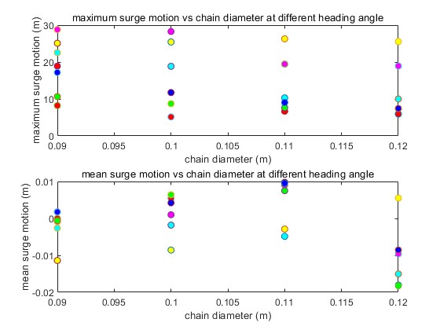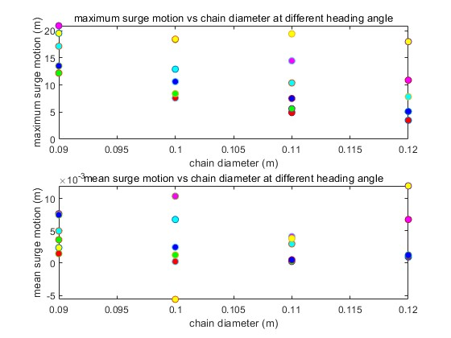

As show in Figure 37, the maximum and mean surge motion at different polyester diameters and heading angles are compared. Unlike the chain cases, different heading angle has some effects on the surge motion of the device while the diameter has a weak influence. Smaller heading angle (like 10 degree in red) has smaller maximum and mean surge motion, while larger heading angle (like 60 degree in yellow) has larger surge motion.

For the maximum and mean fairlead tension vs polyester diameter at different heading angles as shown in Figure 38, the heading angle also does not make a large difference same as in chain cases. However, unlike the decrease trend in chain cases, both the maximum and mean fairlead tension increases with the increase of polyester diameter. The same trend can also be observed from the maximum and mean anchor tension vs polyester diameter at different heading angles as shown in Figure 39, except for several points having clearly large maximum anchor tension.

Figure 38. Maximum and mean fairlead tension vs polyester diameter at different heading angles.

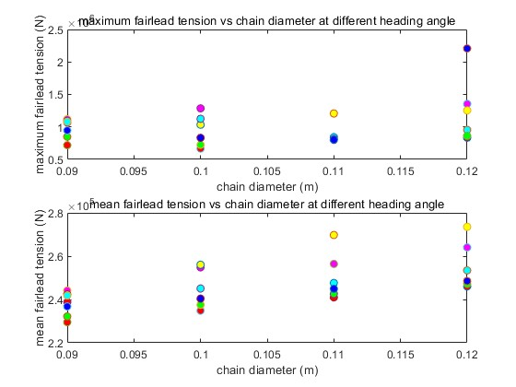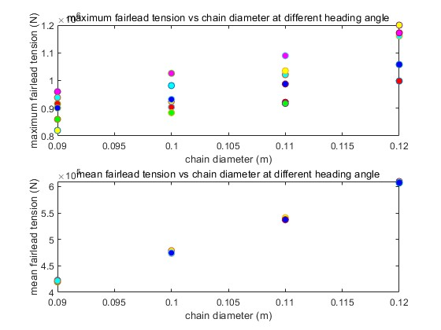

Figure 39. Maximum and mean anchor tension vs polyester diameter at different heading angles

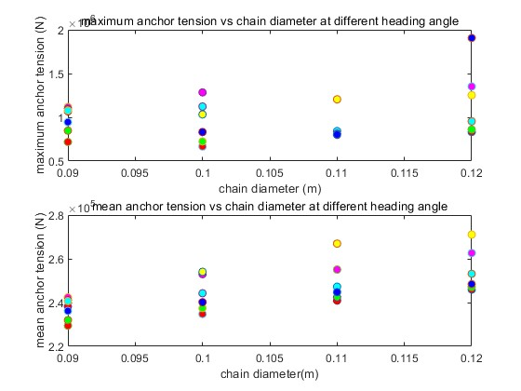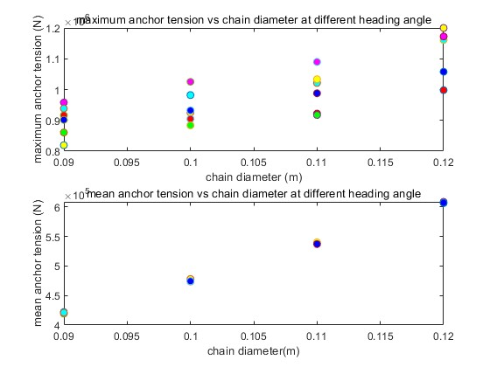

As shown in Figure 40 and Figure 41, the cost are estimated for the taut-polyester rope configuration at different design parameters. Both the polyester, anchor and the total mooring system have a clear linear relation with the polyester diameter. With different anchor spacing radius, the chain cost increases with the lager radius, while anchor cost decreases. Overall, the larger anchor spacing radius has the lower total mooring cost. While smaller heading angle leads to lower tension and lower cost, the optimum design tends to have larger anchor spacing radius, smaller polyester radius and smaller heading angle.

Moreover, comparing with the catenary-chain configuration, even the cost of the polyester line is cheaper, the total cost of the taut-polyester rope system is higher due to the high cost of suction pile anchoring. A better mooring design may be considered in the future to combine using polyester and drag-embedment anchor to reach lower total cost.

Figure 40. Chain cost, anchor cost, and total cost vs polyester diameter at different heading angles at r = 150 m.

Figure 41. Chain cost, anchor cost, and total cost vs polyester diameter at different heading angles at r = 250 m.

## Discussion & Conclusions

Section 7.1 describes the development of a numerical model using meshing tools, BEM software to compute hydrodynamics, and WEC-Sim to convert frequency-domain hydrodynamic coefficients into time-domain forces to solve the dynamics of the nonlinear, multibody WEC system – with joints, PTO and nonlinear mooring (modeled by MoorDyn). This model has been used to investigate how different variables in the system can influence the performance and cost of the WEC – the main findings are summarized here.

### Summary of main findings

**Linear WEC-Sim model**

For parametric studies, a linear WEC-Sim model (constant mooring stiffness coefficient, constant PTO stiffness and damping coefficients) was developed. This model enabled us to identify target stiffness for the nonlinear mooring and PTO models.

* **Mooring stiffness:** a range of mooring stiffnesses (using a linear mooring model) were evaluated for both the 45m and 55m base length designs. Overall, the performance of the system was not very sensitive to the changes in mooring stiffness, but values of 60kN/m and 70kN/m produced slightly higher average power outputs for the 45m and 55m designs (respectively). These values were used as target stiffness values for the different nonlinear mooring designs explored later on.
* **PTO stiffness:** Similarly, a linear PTO model was used to explore a range of PTO stiffness values. PTO stiffness appears to be significantly more influential on the overall performance of the WEC, with a PTO stiffness of 310kN/m being determined to provide the optimal power output.

**Survival WEC-Sim model**

In order to evaluate the mooring designs under extreme conditions, 50-year storm conditions were simulated in WEC-Sim. However, the loads on the flaps were too great under these conditions, which created unrealistic responses (where the flaps would rotate through 360 degrees). Hence, in order to represent the system in a more realistic configuration during these extreme conditions, the flaps were rotated 90 degrees towards the base and fixed in this position. Therefore the system simulated in extreme conditions effectively had a single floating body.

**Mooring Configurations**

The main focus of this study was to use a coupled WEC-Sim and MoorDyn model to explore various mooring options for the WEC. Two mooring archetypes were investigated in this study; catenary (chain) and taut (polyester). A range of configurations for each archetype were simulated, with cost estimates provided based on the material costs. The results highlight the numerous trade-offs between line cost, anchor cost and system performance. These design considerations need to be taken into account in conjunction with the design of the floating structures and PTO/controller – in order to develop the most effective solution. However, the design of the FOSWEC is not yet finalized – hence it is difficult to determine at this stage which mooring option is most suitable.

In Figure 14 several potential array layouts were explored for fitting multiple FOSWECs into a PacWave berth. The 6 device layout shown in Figure 30 was deemed to provide the most suitable device spacing. The mooring footprint can be obtained accordingly.

### Interpretation of results

The results of the numerical modeling study are useful in guiding the performance optimization and design of the floating oscillating surge wave energy converter (FOSWEC) concept. These findings offer important insights into the relationship between mooring configurations, power take-off (PTO) systems, and overall WEC performance, emphasizing the need for a holistic design approach.

Noteworthy findings include the relatively low sensitivity of the FOSWEC's performance to changes in mooring stiffness, suggesting flexibility in mooring material and configuration selection. In contrast, the significant impact of PTO stiffness on performance highlights the need for careful optimization in the design and development of PTO systems to maximize energy extraction.

The study also revealed the importance of evaluating mooring systems under extreme conditions, such as 50-year storm scenarios, to ensure structural integrity and long-term survivability. The investigation of various mooring configurations and array layouts underscored the intricate trade-offs between cost and performance, emphasizing the need for a comprehensive design approach.

In summary, the results of this study provide valuable guidance for the ongoing development of the FOSWEC concept and wave energy converters in general. The models developed during this project and the insights gained from these findings will aid designers and engineers in making informed decisions to optimize energy extraction, cost-effectiveness, and survivability.

### Limitations of the study

This study has several limitations that could impact the results and their interpretation:

1. Device Cost Estimates: The analysis only considered material costs, omitting other factors like manufacturing, installation, maintenance, and decommissioning. Future work should include a comprehensive cost analysis.
2. Limited Sea-States: The study focused on a narrow range of sea-states, potentially affecting the accuracy of the WEC's performance evaluation. Future research should assess a broader range of wave conditions.
3. Modeling Extreme Waves: Potential flow theory may not accurately capture wave-structure interactions in extreme conditions. Alternative methods, such as computational fluid dynamics (CFD), should be explored in future studies.
4. No Verification/Validation: The numerical model has not been verified or validated against experimental data, which may limit the reliability of the results. Future work should incorporate experimental validation to strengthen the study's findings.

Addressing these limitations in future work will improve the study's reliability and accuracy, leading to more robust design decisions for wave energy converters.

### **Suggestions for future research**

To build upon the current study, several areas of future research are recommended:

1. Additional Parametric Studies: Investigate more parameters, such as wave direction, period, and floating structure geometry, to identify further design optimizations.
2. Detailed Mooring System Analyses: Examine long-term performance and reliability factors, including material fatigue, corrosion, and wear, to better understand different mooring configurations.
3. Evaluating Trade-offs: Develop novel techniques for assessing cost-performance trade-offs, considering aspects such as environmental impact, installation complexity, and maintenance requirements.
4. High fidelity modeling: Improve wave-structure interaction predictions by using computational fluid dynamics (CFD) or smoothed-particle hydrodynamics (SPH) simulations.
5. Experimental Validation: Enhance the reliability of findings by validating the numerical model through laboratory-scale or full-scale experiments.
6. Multi-Objective Optimization: Employ techniques to simultaneously optimize multiple parameters, providing a comprehensive understanding of the complex interplay between design variables.

These research suggestions aim to further advance wave energy converter development and mooring system optimization, contributing to the broader adoption of wave energy as a renewable energy source.

# Conclusions and Recommendations

This numerical modeling study has provided valuable insights into the performance and design of wave energy converters, specifically for the novel floating oscillating surge wave energy converter (FOSWEC) concept. By investigating various mooring configurations and their impact on system performance, the study has highlighted the importance of a holistic design approach, considering the interplay between mooring systems, floating structures, and power take-off (PTO) systems.

The findings have emphasized the significance of optimizing PTO stiffness and understanding the trade-offs between cost and performance when selecting mooring configurations. Additionally, the study has demonstrated the importance of evaluating WECs and their mooring systems under extreme conditions to ensure long-term survivability.

Despite the identified limitations, this study contributes to the field of wave energy converters by offering guidance for the ongoing development and optimization of the FOSWEC concept and similar systems. The suggestions for future research aim to further advance wave energy converter development, ultimately promoting the broader adoption of wave energy as a viable renewable energy source.

In conclusion, the insights gained from this study will aid designers and engineers in making informed decisions, ultimately leading to more efficient, cost-effective, and robust wave energy converter designs that can withstand the challenges of real-world conditions and contribute significantly to the global transition toward renewable energy.

# References

Falnes, Johannes. *Ocean Waves and Oscillating Systems: Linear Interactions Including Wave-Energy Extraction*. Cambridge: Cambridge University Press, 2002. https://doi.org/10.1017/CBO9780511754630.

Falnes, Johannes, and Adi Kurniawan. “Fundamental Formulae for Wave-Energy Conversion.” *Royal Society Open Science* 2, no. 3 (March 2015): 140305. https://doi.org/10.1098/rsos.140305.

Husain, Salman, Jacob Davis, Nathan Tom, Krish Thiagarajan, Cole Burge, and Nhu Nguyen. “Influence on Structural Loading of a Wave Energy Converter by Controlling Variable-Geometry Components and the Power Take-Off.” National Renewable Energy Lab.(NREL), Golden, CO (United States), 2022.

International Electrotechnical Commission. “Marine Energy - Wave, Tidal and Other Water Current Converters - Part 10: Assessment of Mooring System for Marine Energy Converters (MECs).” International Electrotechnical Commission, 2015.

———. “Marine Energy – Wave, Tidal and Other Water Current Converters – Part 100: Electricity Producing Wave Energy Converters – Power Performance Assessment.” International Electrotechnical Commission, 2013.

Korde, Umesh A., and John Ringwood. *Hydrodynamic Control of Wave Energy Devices*. Cambridge University Press, 2016.

Mehaute, B.L. *An Introduction to Hydrodynamics and Water Waves*. Springer Study Edition. Springer Berlin Heidelberg, 2013. https://books.google.com/books?id=-FPuCAAAQBAJ.

“MoorDyn,” n.d. https://www.nrel.gov/wind/nwtc/moordyn.html.

Newman, J. N. *Marine Hydrodynamics*. Cambridge, Mass: MIT Press, 1977.

Newman, J.N. “The Theory of Ship Motions.” In *Advances in Applied Mechanics*, 18:221–83. Elsevier, 1979. https://doi.org/10.1016/S0065-2156(08)70268-0.

“PacWave,” n.d. http://pacwaveenergy.org/.

“Reference Model Project (RMP),” n.d. https://energy.sandia.gov/programs/renewable-energy/water-power/projects/reference-model-project-rmp/.

“WEC-Sim,” n.d. https://wec-sim.github.io/WEC-Sim/.