**Control Methodology: Passive Depth Control**

Introduction

Passive depth control (PDC) works by balancing the vertical component of the front mooring line tension (FTv) and the buoyant force as shown below.

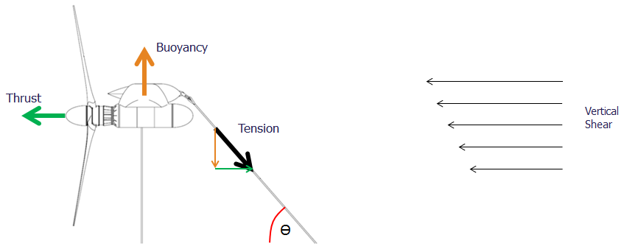

FTv

FTh

PDC behavior can be described by solving the following set of equations for the three operating regions below:

$$Thrust=Ct*0.5*Rho*RotorArea*V_{hub}^{2}=FrontTension*\cos{θ={FT}_{h}}$$

$${FT}_{h}=FrontTension*\sin{θ}$$

$$Buoyancy<?>{FT}_{h}$$

1. Below rated thrust, the buoyant force is designed to be greater than FTv, thereby keeping the aft mooring line under tension and the device at its minimum operating depth.
2. At rated thrust, the buoyant force is equal to the FTv; the aft mooring line is unloaded but the device is still at the minimum operating depth.
3. **Above rated thrust the FTv is greater than the buoyant force and the device dives until equilibrium is restored. Equilibrium is found as flow speeds (and therefore thrust and FTv) usually reduce at depth, as shown by the ‘vertical shear’ in flow velocity.**

Loads Control

**Design loads are a direct function of the maximum flow speed through the rotors. The flow speed at the hub-depth at which equilibrium is found is a direct function of the angle of the front mooring line as described by the equation below:**

$$Thrust=Ct*0.5*Rho*RotorArea*V_{hub}^{2}=FrontTension*\cos{θ={FT}_{h}}$$

**As the device dives, the front mooring angle reduces, which means a greater amount of thrust is required to attain greater depths. If TSR is held constant and device pitch is maintained at zero, the flow speed through the rotors must increase above the level required to unload the aft mooring line to generate the requisite thrust to dive.**

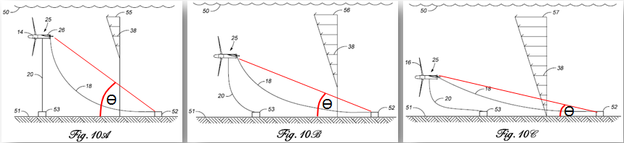

**For a max flow speed at 70m depth of 2.2m/s, a non-pitching constant-TSR device will dive to ~1.9m/s with a nominal shear of 0.0040 mps/m. This equates to ~40% increase in thrust load over rated.**

**This dive response can be improved by locating the attachment point of the forward mooring line in such a way as to cause the device to pitch nose-up as the angle of the forward mooring line reduces. This causes the thrust of the rotors to be vectored downward thereby counter-acting the buoyant force and resulting in greater depth response and flow speed through the rotors. Using this approach, for a max flow speed at 70m depth of 2.2m/s, a passive-pitching constant-TSR device can be made to dive to ~1.71m/s with a nominal shear of 0.0040 mps/m. This equates to ~14% increase in thrust load over rated. This approach may also have a small impact on fatigue loads due to increased non-axial flow resulting from roughly 5 deg of pitch articulation.**

**Another aspect to consider is the variation in shear strength. Analysis of the available resource data collected from the Florida current shows a significant range of shear strength exists. There is a correlation between higher surface flow speeds and higher mean shear strength, which attributes to very few hours (~10hrs/yr) of flow speed above 1.6m/s at 200m depth as seen in the plot below.**



**Higher shear strengths are beneficial as they require the device to dive less to maintain rated flow speed; this results in less change in forward mooring line angle and therefore less thrust above rated being required to attain rated flow speed at hub depth. The correlation between shear strength and flow speed also helps to articulate the pitch of the platform thereby assisting PDC as described above. Higher shear strengths will also result in higher fatigue loads. For a max flow speed at 70m depth of 2.2m/s, a passive-pitching constant-TSR device can be made to dive to ~1.66m/s if the shear strength increases to 0.0048 mps/m (shear strength resulting in 1.6m/s at 200m). This equates to ~7.6% increase in thrust load over rated.**

**Despite the correlation of high flow speeds with high shear strength described above, a range of shear strengths should be expected at any flow speed. Variation in shear strength at a given flow speed will impact the pitch attitude of the device and thus the flow speed at which dive is initiated. This would result in either increased loads due to reduced dive response (below design shear strength), or reduced energy capture due to increased dive response (due to above design shear strength). The variation in shear strength for a variety of depth ranges is shown in the following plots for 1.6, 1.9, and 2.2 m/s at 50m depth.**

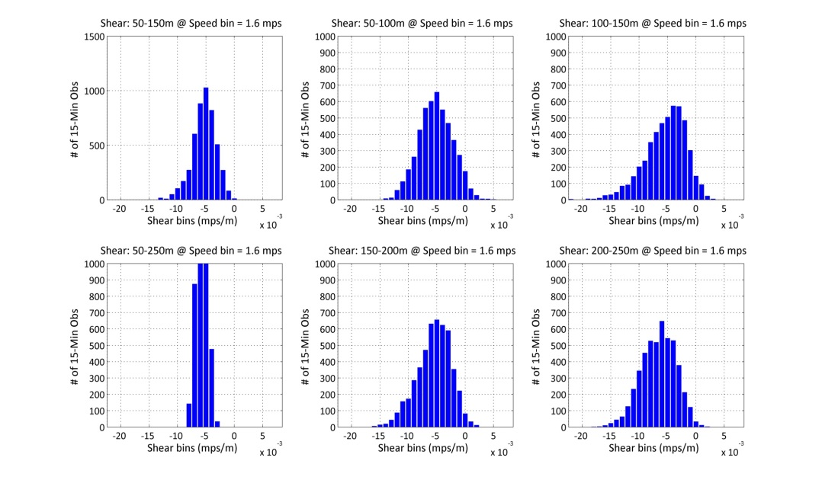

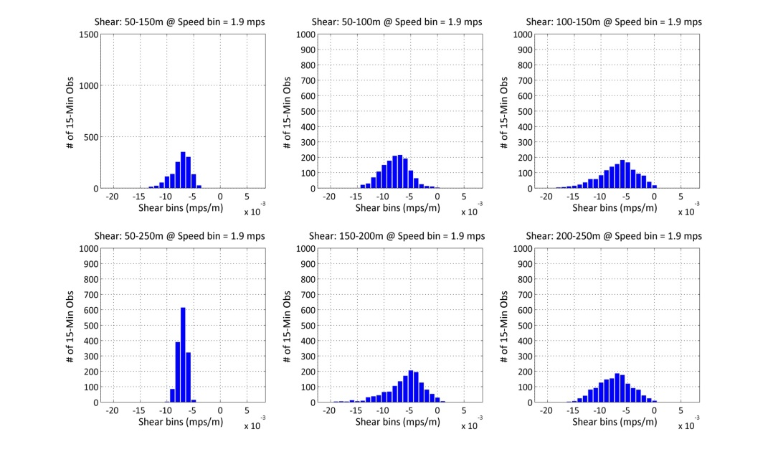

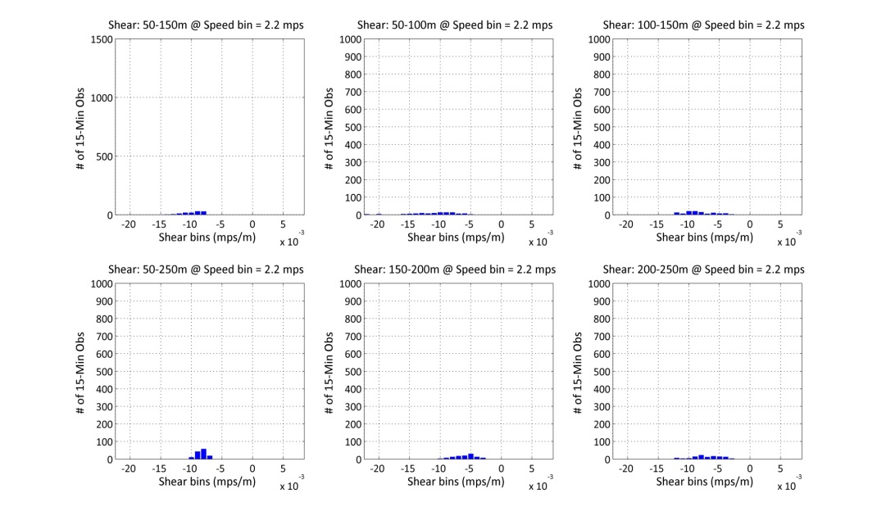

**A few additional considerations need to be made for stability when considering a platform which articulates through a substantial pitch range (5-10deg) to improve dive response. The first item is pitch-yaw coupling; when a coned rotor is presented to the flow at a global pitch angle, a lateral force is created. In a counter-rotating two-rotor system, this lateral force is equal and opposite on each rotor. For a single rotor system, this will initiate a yaw angle and further contribute to a side-slip (lateral translation) in platform position. This can be avoided if the rotor is kept to a zero cone (flat plane) rotor. The second item is roll-yaw coupling. In order to enable passive pitch articulation to improve dive response, the front mooring lines are attached below the rotor axis. When a single-rotor device rolls to react rotor torque, this offsets the mooring tension to one side of the rotor thrust thereby causing the device to yaw and subsequently side-slip.**

**Further considerations should be made for the mooring architecture. The above discussion has focused on a mooring system in which the device is directly moored to the sea floor. If a sub-sea buoy and horizontal tether line is implemented, it will be very difficult to enable the desired pitch articulation. This will result in the aforementioned 40% loads increase due to poor dive response of a non-pitching device.**

**Another option, which might be of particular interest for non-pitching devices is to allow the rotor speed to increase above the design TSR thereby increasing thrust load and actively assisting dive response. Unfortunately, it has been determined that this approach requires an 80% increase in thrust to attain 1.6m/s through the rotors – twice as much thrust as simply allowing the device to operate at the design TSR at a higher flow speed.**

**A last consideration to be made in light of the above discussion precluding a zero-pitch tethered mooring system for PDC applications is the need for a vertical mooring line to restrain the minimum operating depth. The use of such a line may increase the complexity of systems required to deploy and retrieve the device.**

Power Performance

**It terms of AEP, there is no difference between a variable depth device and a constant depth device if the drivetrains are equivalent. This is because both control scenarios operate at the minimum operating depth (and thus flow speed histogram) up to rated flow speed (and rated power). Above rated flow speed, both control scenarios generate rated power regardless of depth. However, different control scenarios can impact the size and thus efficiency of the drivetrain. PDC and pitch regulation will have the same efficiency and AEP as they produce equivalent torque duty cycles and therefore require equivalent drivetrains. However, stall regulation will require an approximately 50% larger drivetrain which will have reduced efficiency. Increasing the size of a gearbox drivetrain 50% has a small impact (~1-2%) on efficiency, but increasing the size of a hydrostatic drivetrain 50% has a substantial impact (~5-10%) on efficiency due to reduced operational pressure.**

**The other power performance aspect to consider is the impact of shear variation. Shear strength above the design value may result in some loss in AEP due to diving below rated flow speed (AEP impact TBD). On the other hand, flow events resulting in very low shear strength may require the device to be shut-down to avoid loads exceedances; however, these events should be rare.**

Conclusion

A PDC system can be developed to regulate speed through the rotors to within less than ~0.1 m/s of rated for a given shear strength and shear correlation with flow speed. The next step would be to quantify the impact on loads and energy capture of shear strength variations and the impact on fatigue loads of operating at a significant pitch angle for extended periods. PDC pitch and roll stability issues also need to be resolved for single-rotor applications.

**Blade Configuration: Variable Pitch vs. Fixed Pitch**

One of the primary reasons given for implementing active blade pitch mechanisms is a perceived reduction of loads leading to reduced blade (and downstream component) costs as a result of reduced structural mass. To understand how a blade pitch system might reduce loads, or increase performance, in an MHK turbine, it is helpful to review how a modern pitch-controlled wind turbine control system operates, and see how this control scheme might be applied to an ocean-current turbine. The diagram below breaks a typical power curve up into 3 separate control regions. Each region is discussed below moving from lower to higher flow speeds.

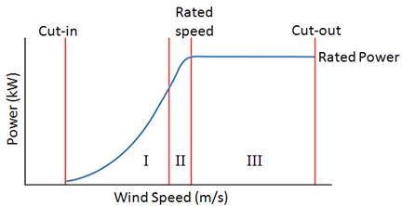

In Region I, the turbine is operating solely under torque control to maintain its optimal TSR; blade pitch is held constant at the angle which maximizes Cp for that TSR. The turbine controls torque to adjust its rotor speed to maintain the optimal TSR across the range of flow speeds in Region I, and as the TSR does not change, the corresponding optimal blade pitch angle does not change. This control strategy for this region would be the same for a variable or fixed pitch ocean-current turbine.

Region I turns into Region II when the turbine reaches its maximum rotor speed. This is usually governed by a max blade tip speed constraint to address noise concerns (or cavitation in the case of shallow-water tidal). In Region II, blade pitch is controlled to maximize Cp as TSR reduces due to flow speed increasing and RPM being held constant at its max value; torque is also controlled in Region II to maintain a constant RPM. Because of the low flow speeds and relatively deep operational depth of an ocean current turbine, it does not encounter a tip speed limit or max RPM before rated power. Thus, Region II does not exist for an ocean current turbine. An ocean current turbine will operate at its optimal TSR and the single corresponding optimal blade pitch angle until it reaches rated power regardless of whether or not it has variable pitch capability. Aquantis MHK designs for the Florida Current operate below rated power 72% of the time. This means the turbine will remain at a fixed pitch angle for a very long duration (potentially months at a time). This creates a problem in wind turbines as pitch bearings wear grooves in their races due to inactivity and poor distribution of lubricants. One solution is to occasionally perform a pre-programed pitch rotation to redistribute the lubricant and possibly re-locate the rolling elements (if used); however, some efficiency and/or availability is lost during these operations. Sliding bearings may be better suited to this application, but pitch torque requirements go up significantly.

Region II (or Region I in the case of an ocean current turbine) turns into Region III when rated power is reached. In Region III, torque, RPM, and thus power are all constant (assuming steady flow). Blade pitch is controlled to keep torque, and thus RPM, at their rated levels. Region III control would be much the same for a variable-pitch MHK turbine. In both cases, for steady flow conditions (as is anticipated for ocean currents), the maximum bending load is experienced at rated power, before the blades begin to pitch significantly at higher flow speeds. A fixed-pitch variable-speed turbine will also experience max load at rated power in steady flow. The graph below shows that above rated speed (1.6m/s), a fixed-pitch turbine reduces rotor speed significantly in order to maintain a constant power output. This results in a high level of control authority and a substantial reduction blade bending loads at all higher flow speeds. Reducing rotor speed at rated power requires approximately 50% increased torque capacity – a cost which should be weighed against the cost of a variable pitch system.

For unsteady (stochastic) flow conditions, gusts and other flow phenomena may cause higher loads (and significant torque spikes) at above-rated flow speeds; this is because the blade pitch system can only react to, and not anticipate, a gust (without forward-looking LIDAR or other advanced systems). In some IEC-required load cases, a pitch system without careful controller design can exacerbate the blade loads as it pitches the blades to power in reaction to the wind slacking just before a gust hits. A pitch system does afford faster response times, which can be helpful in reducing fatigue loads in very dynamic flow fields; however, the flow field of the Florida Current and other deep-water resources is expected to be much steadier than wind resources resulting in much slower control cycles. Another interesting possibility with blade pitch systems is the potential for advanced control schemes such as independent blade pitch control (IBC). This can be used to mitigate the off-axis moment loads imposed by a vertical flow velocity shear profile; however such advanced control systems will take significant development. Furthermore, in a moored device, the platform can be designed to have low pitch inertia so the platform can passively move in response to off-axis loads instead of being rigidly fixed to a machine base and tower thereby being forced to drive off-axis loads through the main shaft bearings. Another historical issue with fixed-pitch blades in Region III is poor power quality resulting from stochastic wind events coupled with fixed-speed operation. Having a steady marine flow field and variable speed control is anticipated to eliminate this issue.

For a steady ocean current flow field, fixed and variable pitch turbines are not expected to have any significant difference in rotor performance, loads, or power quality. In addition to the above control regions and design drivers, there are several additional considerations to be made. These include start-up, reliability/maintenance, and fault response.

To provide start-up torque a variable-pitch system can articulate the blades. A fixed-pitch system may not have adequate zero-RPM torque to overcome the bearing friction. If this is the case, the generator would be required to provide motoring torque. For a gearbox drivetrain, one means of accomplishing this is with full power rectification, which results in a more complex power electronics package. An alternative method to reduce complexity is to apply a nominal start-up torque using a starting winding. The reliability of these relatively simple power electronics required to provide motoring capability should be weighed against the reliability of an active pitch system.

There are several fault cases which should be considered in the selection of fixed pitch or variable pitch. The first fault case is a loss of grid power and thus generator torque. A variable pitch system, when equipped with a back-up power supply, provides an additional means of stopping the rotor thereby reducing the design requirements for a main shaft (or high-speed shaft) brake. Alternatively, a fixed pitch rotor can utilize a resistive load to provide a secondary means of shutdown torque in the absence of grid power.

The second fault case which should be considered is a failed torque linkage between the generator and rotor; potentially caused by a failed flex coupling. In my opinion, if a flex coupling is utilized, certification will require a blade-based means of stopping the rotor. However, by utilizing a single rotor device, the platform has a much greater ability to move in response to off-axis loads as mentioned previously. In addition, wake fractions are almost completely eliminated thereby drastically reducing flow asymmetries before off-axis loads even begin. I believe these two measures may eliminate the need for a flex coupling by greatly reducing non-toque loads and enabling a conventional main shaft and bearing design. Furthermore, the long-term high-risk development schedule associated with a wet bearing is eliminated.

In addition to the variable-pitch blade concerns of increased blade complexity resulting from additional bearings, seals, and bolted connections, a split blade presents some unique challenges. While the total moment load at the split line is reduced compared to the root (a major concern with full-pitching MHK blades), the cross-sectional area and therefore strain levels have increased, making the connection more critical. The connection is also being made at a much more critical area for performance. In addition, the resulting blade now has a portion which is pitch-controlled, and a portion which is still required to stall as a fixed-pitch blade. Development of the stall-regulated fixed-pitch portion of the blade must still be completed, and the cost and reliability issues of fixed-pitch system (increased torque and power electronics) have been replaced with pitch motors, bearings, seals, and added blade complexity.

For the reasons stated above, I believe a fixed pitch rotor with a conventional main shaft bearing package can be developed faster and with less risk, and will result in a lower-cost and more reliable MHK device. Several examples of fixed pitch MHK turbines can be seen in operation today which support this conclusion.

The following is the start of a high-level hierarchical listing of design drivers to aid in understanding how various innovations could help achieve the desired results, and what else can be done to achieve the top-level goals.

* **Reduce CoE Through Rotor Design**
  + Increase Rotor Performance
    - Optimize TSR
    - Hydrofoil Design
    - Passive Devices (VGs, Root Flap, Winglets, etc.)
    - Anti-Fouling Measures
    - Reduce Thickness Distribution
    - Optimize Inboard Stations – very expensive compared to other passive devices.
  + Reduce Rotor Cost
    - Reduce Material Cost
      * Reduce Spar Size
        + Reduce Loads – not achieved by pitch control in steady flow fields.

Avoid Wave Loads

Develop Controls

* + - * + Increase Thickness

Increase Thickness Distribution

Reduce TSR

Reduce Hydrofoil Cl

* + - * Reduce Shell Cost
        + Reduce Shell Area

Reduce Chord

Increase Hydrofoil Cl

Increase TSR

* + - * + Reduce Shell Thickness

Reduce Operating Depth

* + - * Reduce Foam Cost
        + Reduce Foam Volume

Reduce Chord and Thickness

Reduce Thickness Distribution

Increase TSR

Increase Hydrofoil Cl

* + - * + Reduce Foam Material Cost

Reduce Pressure

Increase shell thickness

Reduce Operating depth

Specify material with appropriate properties

* + - * Reduce Mechanisms
    - Reduce Fabrication Cost
      * Reduce Material Required
        + See ‘Reduce Material Cost’ Above
      * Reduce Structural Complexity
        + Simplify Fabrication Technique
        + Simplify Root Connection
        + Reduce Mechanisms
  + Reduce Rotor Maintenance Cost
    - Reduce Mechanisms
    - Reduce Bolted Connections
    - Reduce Bio-Fouling
* **Reduce Development Time to First At-Sea Prototype**
  + Avoid adding complexity for little/no anticipated benefit (optimized root).
  + Use conventional components where possible (main shaft bearing).
  + …