Post Access Report
Drifting Hydrophone Development - Spar2
Awardee: Haru Matsumoto
Awardee point of contact: James Turnbull
Facility: Pacific Northwest National Laboratory
Facility point of contact: Joe Haxel
Date: 12/29/2023
*Revised: 3/13/2024

Executive Summary
OSU requested technical assistance from PNNL for system design, hardware configuration, assembly, and bench testing of 4 drifting hydrophones per OSU technical specifications aligned with IEC TS 62600 -40 Acoustic Characterization of Marine Energy Converters. As stated in the RFTS2 application, the technical assistance objective of this request is for:

- Design assistance, assembly, and bench testing of 4 state-of-the-art drifting hydrophone systems for operational use at PacWave to increase the facility’s operational readiness level and support wave energy converter testing activities for the industry.

The PNNL and OSU teams met bi-weekly during the first six months of the project to design the new system from the bottom up. Meetings also periodically included a hardware/software developer from Embedded Ocean Systems who designed and manufactured the WISPR (Wideband Intelligent Signal Processor and Recorder) controller, a low-power, low-system-noise data acquisition system. OSU shared system details from the first-generation Spar 1 drifting hydrophone system and discussed design revisions with PNNL for Spar 2, including new electronics. The PNNL team took the lead for designing the new spar buoy platform, system configuration including housing designs and cabling, electronic circuitry within the housings, integrations of peripheral systems including Global Navigation Satellite Systems Pulse Per Second (GNSS PPS) timing signal and cellular modem communications, tank testing of the housings for water tightness, and bench testing of the electronic components for preamplifier calibration and control of the system peripherals.

After OSU purchased, built, and shipped the available parts identified in the newly designed Spar 2 system, PNNL began fabrication, integration, and bench and tank testing of as many of the components and housings as possible. Because several of the cables and connectors required had extensive lead times (up to 6 months) during the COVID-19 pandemic, PNNL was not able to build the complete configuration of the system and perform an end-to-end bench test. Instead, PNNL tested electronics within each modular component of the system in the absence of the cable connections between the housings.

The objectives of finalizing a system design, building the circuitry, integrating the components within the housings, and modular testing of the electronics within each housing component were achieved. Without the cables and connectors for the top and bottom sides of the spar buoy and the spar to the lower electronics housing, PNNL was not able to complete an end-to-end bench test of the complete system. A clear next step was to complete the system with the specified cables and move the system toward open water testing.

Introduction to the project
The first generation of Oregon State University (OSU) drifting hydrophones (Spar1) were developed for underwater noise measurements at marine energy project sites. The hydrophone sensor suspended by a rigid line from the surface platform tends to be noisy due to the static pressure change associated with low-frequency surface wave motions. However, the hydrophone suspended from the spar buoy with a bungee and a dynamic heave plate mitigates the low-frequency noise. With recent advancements in microprocessor technologies, support from this RFTS2 is focused on the development and integration of a newly designed hydrophone logging and data acquisition system building off of the Spar1 platform that includes significant refinements and several new capabilities to OSU’s legacy drifting hydrophone. The new systems are aligned with the IEC 62600 -40 Acoustic Characterization of Marine Energy Converters Technical Specification for underwater noise measurements at marine energy projects worldwide. The major advancements of the new Spar2 system include logging system hardware upgrades with increased sample rates up to 250 kHz, 24-bit data resolution, GNSS PPS timing, and a rechargeable Li-ion battery. Leveraging the Pacific Northwest National Laboratory’s (PNNL) TEAMER facility expertise will provide significant improvements to this new drifting hydrophone technology with additional added value through hardware and sensor integration, wireless communication, commercial pressure housing modifications, bench testing, and calibration.

Roles and Responsibilities of Project Participants
The project will be accomplished through close coordination of tasks between OSU and PNNL.

2.1 Applicant Responsibilities and Tasks Performed
OSU will contribute to the conceptual technical design and hardware integration of the system.
Task 1. Dr. Matsumoto will provide technical support for setting up the WISPR2 processor and logging system and work closely with the PNNL team to advise on integrating peripheral components.
Task 2. OSU will deliver the sensors and logging system hardware components to PNNL, including:
- 5 WISPR2, 5 pre-amplifier boards, and 5 1-TB SD cards (4 + 1 spare)
- 4 hydrophone sensors (4 High Tech Inc. model HTI92WB) endcap mountable
- 5 GNSS/GPS boards (https://www.sparkfun.com/products/15712 )
- 5 Bluetooth modules and antenna (https://www.sparkfun.com/products/12582)
- 5 Cellular network interfaces (https://www.digikey.com/en/products/detail/sierra-wireless-airlink/RV50_1102555/6235917)
- 4 endcap pressure release valves (SeaVent DDS from DeepSea)
- 4 MCBH10F (SubCon 10 pin female bulkhead 1-ft lead) serial connector
- 4 MCDC10M (SubCon 10-Pin dummy connector).
- 1 MCIL10M (SubCon 10 contact Male inline connector 2-ft cable)
- Falmat cabling and connectors (spar buoy to subsea hydrophone system)
Task 3. Continued collaboration with PNNL throughout build and testing phases (bi-weekly calls) providing feedback on testing results and system modifications.

2.2 Network Facility Responsibilities and Tasks Performed
PNNL will collaborate with OSU on the technical design, perform the hardware and software integration, and the mechanical build of the Spar2 system. PNNL will be responsible for all system integration, assembly of the components, and cycled testing of the integrated system.
Task 1. PNNL will provide additional circuit board and software development to support the Spar2 system peripherals (GPS location, GPS PPS timing, cellular communication). Testing of circuit board and software development will include power efficiency and subsystem monitoring, system stability tests with 8-hour test cycles for acquisition, PPS signal latency characterization, and determination of the noise floor.
Task 2. PNNL will bench-test WISPR2 and Raspberry PI with system peripherals (GPS, cellular link, Bluetooth) through 8-hour endurance tests to mimic all deployment conditions.
Task 2. PNNL will identify, provide, and test a rechargeable Li-ion battery for system power. Battery testing will include battery life characterization, thermal characterization during charge/discharge cycles, and testing the integrated battery control printed circuit board for over/under voltage tolerance.
Task 3. PNNL will design and build a spar buoy per the specifications required by the onboard and suspended payloads. The spar will incorporate water-tight compartments for electronics, antenna mounts, and cable connections.
Task 4. PNNL will design and build a pressure housing for the subsea hydrophone sensor and logging system, including machining endcaps and bulkhead connectors for the sensor, communications, and pressure release valve. PNNL will also be responsible for the design and 3D printing of the internal electronic boards, chassis, and internal wirings. Pressure housings will be tested for waterproofness in a tank at MCRL-PNNL.
Task 5. PNNL will also be responsible for the drifting hydrophone rigging, including shock cords (bungee), static lines, heave plates, bridles, and ballast weights.

Project Objectives
- OSU is requesting technical assistance for the design configuration, assembly, and bench testing of 4 state-of-the-art drifting hydrophone systems per OSU technical specifications and aligned with IEC TS 62600 -40 Acoustic Characterization of Marine Energy Converters. The objectives of the technical assistance will significantly advance OSU’s existing drifting hydrophone technology and enable them to provide important state-of-the-art hydrophone sensors and platforms for monitoring devices in support of marine energy testing activities across the industry.

- The project will provide significant upgrades from the existing OSU Spar1 to the next generation Spar2 drifting hydrophone system that includes:
- Increase sample rate from 32kHz max to 250 kHz
- Increase data resolution from 16-bit to 24-bit
- Two-way cabled communication to/from the surface buoy to the sensor package, enabling timing synchronization by GPS,
- Upgraded GNSS system with enhanced accuracy and PPS timing
- Change from expendable alkaline battery to rechargeable Li-ion battery power

- These project upgrades bring the OSU Spar2 system into better alignment with the IEC 62600 -40 Technical Specification for measuring sound around marine energy converters.

Test Facility, Equipment, Software, and Technical Expertise
The PNNL Marine and Coastal Research Laboratory (MCRL) maintains several electronics laboratory spaces with 3D printing, power supplies, signal generators, oscilloscopes, solder stations, and other tools and resources for embedded system development and testing. Additionally, project personnel will utilize Matlab™, Linux OS microcomputers, Python-based interface tools, and acoustic analysis software packages (Ishmael, Audacity) to evaluate technology performance. The project team includes an electrical systems engineer, two mechanical/ ocean engineers, and an ocean acoustic research scientist with 20 years of experience in hydrophone data systems, data collection and analysis, embedded systems, and wireless communication. MCRL also has vessels, a research dock with reference hydrophones, and direct access to a tidal channel for open-water testing.

Test or Analysis Article Description
- The OSU Spar2 drifting hydrophone system is intended for rapid measurement and characterization of marine energy project noise levels in alignment with IEC 62600 -40 TS.
- This technical assistance project will upgrade the legacy OSU Spar1 drifting hydrophone to a state-of-the-art system capable of supporting environmental monitoring at any marine energy project site (CEC or WEC).
- The major advancements resulting from this support of the OSU Spar2 system are in the hardware and increased capability of the hydrophone instrument technology through circuitry board development, Bluetooth communications/ data transfer, and GPS timing. The re-designed OSU drifting hydrophones consist of:
- surface spar buoy with GNSS antenna/receiver and data logging for high accuracy positioning and PPS triggered time reference for acoustic signal timing ;
- surface communications module capable of allowing power control, remote diagnostics, and communication with boat and shore-based systems
  - spar buoy with dynamic and static line combination allows decoupling the hydrophone from surface motion and places the sensor at a user-defined depth;
  - a heave plate to further mitigate the surface motion of the spar buoy from the sensor;
  - a custom OSU-designed state-of-the-art autonomous hydrophone with acquisition suite (including sensor, electronics - preamplifier/ WISPR2, data storage, and custom pressure housing)
  - A Raspberry Pi-based computer for pre-processing and managing remote interfaces
  - cable for power/data transfer - sensor to surface buoy
  - rechargeable Li-ion battery
  - optimum ballast weight
The OSU Spar2 can be launched for continuous recording immediately before deployment via a Bluetooth interface. The hydrophone records continuously at sample rates up to 250 kHz with 24-bit resolution. The small surface area of the buoy and the inherent reduced dynamic vertical response of the spar to surface waves and currents make the design ideal for drifting hydrophone measurements in high-energy environments where drift velocities of the unit are similar to mean currents and surface motion is largely decoupled from the sensor resulting in reduced flow noise contamination and improved data quality.
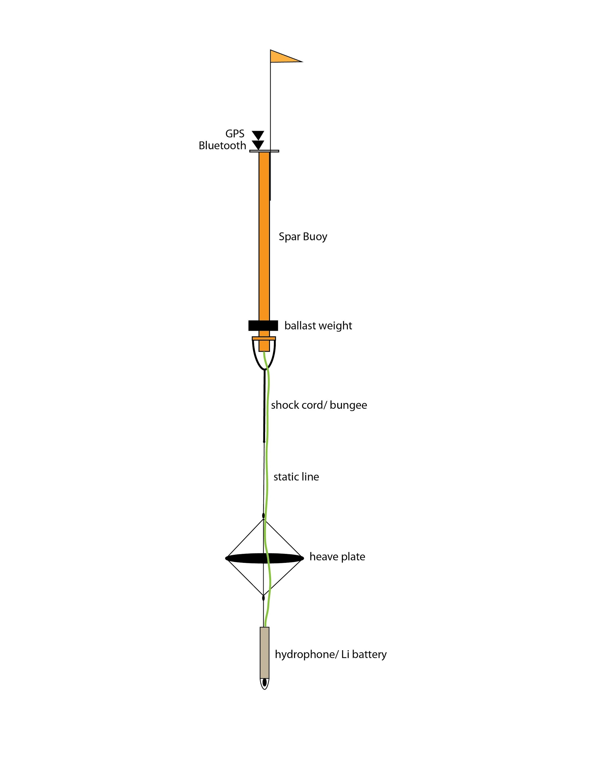
Figure 1. A drawing of the OSU Spar2 including the rigging and mechanical components.
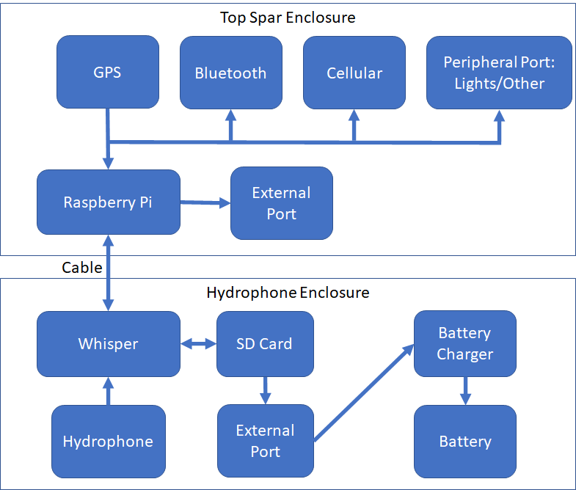
Figure 2. A block diagram of the OSU Spar2 system proposed in the first stage.
- OSU drifting hydrophones electronics system will consist of the following:
  - Top Spar Enclosure
    - GPS + Antenna-- < 2-m accuracy and PPS timing pulse
    - Cellular communications- capable of two-way communications for telemetry and data downloads.
    - Peripheral plug- for adding power/data to a peripheral system on the top spar
    - Raspberry Pi is running Debian/Linux handling all interfaces and communications to users for remote control and access diagnostics of the system.
    - External Port- for accessing the system for diagnostics
    - WISPR2 data logger with 2 SD cards
    - Li-ion Battery- capable of supporting up to 8 hours of deployment
  - Ballast weight
  - Kevlar-enforced underwater power/data communication cable with a bungee and a heave plate to dump the surface wave motion
  - Hydrophone Enclosure
    - Interface board- Controls data and power interfaces between the WISPR and the top spar. Will also include battery charger and control.
    - SD card- capable of storing data from the WISPR or being accessed through a peripheral plug on the housing
    - External port- Used to charge the battery or access the SD card for data retrieval
    - Battery Charger- Will recharge the integrated lithium ion battery pack
    - Battery- capable of supporting up to 8 hours of deployment
    - Hydrophone sensor

Work Plan

6.1 Experimental Setup, Data Acquisition System, and Instrumentation
- Preamplifier circuit boards will be tested and calibrated with a regulated power supply with measured input voltage and preamplifier response using an oscilloscope. The list of response frequencies that will be measured for each board includes 1 Hz, 5Hz, 10 Hz, 20 Hz, 50 Hz, 100 Hz, 200 Hz, 500 Hz, 1 kHz, 2 kHz, 5 kHz, 10 kHz, 20kHz, 50 kHz, and 100 kHz (equally spaced in log-scale). A continuous preamplifier response curve will be generated by interpolating between the measured values at 1 Hz intervals. This will test and provide a measurement of the system’s sensitivity response.
- Any design alterations will be discussed with OSU and mutually agreed upon. Full cycle prototype bench testing will include: 2) acoustic data logging up to 8 hours in duration and 3) cellular link communications for position reporting up to 8 hours in duration
- After the integration and assembly of the first hydrophone system, full cycle bench testing of the hydrophone acquisition system with integrated GPS timing signal will be performed. Acoustic data files in (flac2 compression) will be archived and downloaded for analysis with Matlab software. System noise will be evaluated.
- When the initial system has met design and performance requirements on the bench. The other three systems will be built in an assembly line approach for efficiency and then bench-tested individually.

6.2 Numerical Model Description
N/A

6.3 Test and Analysis Matrix and Schedule
- Task 1: Hardware/software integration hydrophone module (preamp & WISPR2 boards) with spar buoy (GPS/Cellular) - test 1X March 31, 2022
- Task 2: Hydrophone module pressure housing (internal chassis, end cap ports, sensor mounting, battery, and charger) - test 1X March 31, 2022
- Task 3: Spar buoy design and rigging; payload validation - test 1X July 31, 2022
- Task 4: Assemble three additional duplicate systems - test 3X October 1, 2022
- Task 5: Bench test all four systems - November 1, 2022
- Task 6: Post Access Report - deferred until Open Water testing completed

6.4 Safety
All work scopes and funding must be authorized by one or more responsible managers, depending on the type of work being performed, and all work activities conducted in laboratory or operations spaces must be conducted under a project management office director-approved electronic prep and risk (EPR) and appropriate work planning and controls.

Hazards and risks associated with the work follow the requirements in hazard-specific work controls and are reviewed with assistance from the PNNL Safety and Health representative and/or a PNNL subject matter expert (SME).

Plan controls to mitigate hazards in the following order:
· elimination or substitution of hazards
· engineered controls
· work practices and administrative controls
· personal protective equipment.

Determination of appropriate work controls relevant to the work performed is found in the PNNL Lab Assist document. Lab Assist is a central document that includes work controls, applicable training, associated hazards, and approved lab spaces that all workers must review and acknowledge before performing work. For work activities outside of Lab Assist locations, follow the risk mitigation approach documented in the project management plan or off-site risk management plan. Contact the project manager for information before planning or conducting work.

6.5 Contingency Plans
If personnel (health) or electronics lab resources critical to the project are compromised at MCRL, the project can be executed with assistance from resources at the PNNL Richland, WA campus. The lead systems engineer stepped away from PNNL in 2021, and additional expertise was sought within the Lab to complete the project.
Before building the system, a preliminary design review will be conducted with all engineering and program staff to address any electronics or mechanical alterations. During the assembly and testing phases, if any alterations to capabilities or form are necessary, they will be discussed between PNNL and OSU until a mutually acceptable decision is reached. The design documentation will be altered to reflect the changes.

6.6 Data Management, Processing, and Analysis

6.6.1 Data Management
- Preamplifier calibration data will be stored in MS Excel spreadsheet format. Raw acoustic data from the logging systems will be stored in FLAC format (Free Lossless Audio Codec - a popular lossless compression format for audio). All data will be stored on PNNL’s shared drive server resources and uploaded to MHKDR.

Data Processing
Test plans for acoustic processing of bench collected data following IEC 62600 -40 technical specification guidance could not be carried out because of long delays in the delivery of critical cables connecting the hydrophone/pre-amp enclosure, lower data acquisition system (WISPR) and surface housing. This eliminated the ability for end-to-end bench testing, including acoustic data collection with the integrated components of the system.

Data Analysis
See description in section 6.6.2 regarding lack of acoustic data for analysis. Alternatively, Section 11 Appendix includes an example of data collected with respect to component level response (pre-amplifier). Additionally, component testing data from all 4 pre-amplifier boards has been uploaded to MHKDR.

Project Outcomes

7.1 Results
Through an iterative six-month process of design discussion with OSU, PNNL and OSU engineers advanced and finalized the electrical and mechanical design of the Spar 2 drifting hydrophone system for a prototype. The new Spar 2 buoy system (Figure 3) and block diagram (Figure 4) show the updated buoy and electrical components configuration respectively, compared to the early design shown in Figures 1 & 2. OSU ordered commercial components and parts and shipped custom-made preamplifiers and WISPR boards to PNNL. Unfortunately, Covid-19 supply chain challenges in 2021 and 2022 significantly delayed delivery of cabling and connectors between the upper and lower electronics within the spar buoy (Figure 3a) as well as between the lower housing of the spar buoy and the sensor payload lower housings (Figure 3a-b). These delays impacted the full end-to-end testing of the completed system and PNNL’s proposed schedule. OSU concurred to test the individual electrical components and bench calibration of the preamplifiers.
System design updates from the original Spar 2 include:
- Spar Surface Expression (see Figure 3a)
  - External port functional as shorting plug power switch and battery charging
  - GPS GNSS antenna
  - Cellular antenna
  - Battery-powered light to improve visibility of spar on the surface
  - Flag
- Spar Buoy
  - Two-piece, 2.7 m long by 6-inch outer diameter (OD) spar hull, instead of a single piece, 3 m long x 4-inch OD. This change in design allows for the spar to be broken down in half, which fits a single pallet for easy shipping and transporting. Additionally, the increase in OD of the spar better accommodates the added weight of the new hardware, battery, and ballast system.
  - Waterproof coax and 6-pin electrical cables and connectors from the surface expression components to the spar subsurface enclosure
- Spar Buoy Electronics Housing (see Figure 3a)
  - GPS GNSS receiver with high accuracy positioning and PPS-triggered time reference for acoustic signal timing
  - Cellular modem capable of two-way communications for telemetry and data downloads
  - Raspberry Pi is running Debian/Linux handling all interfaces and communications to users for remote control and access diagnostics of the system.
  - Interface board- Controls data and power interfaces between the Wideband Intelligent Signal Processor Recorder (WISPR™) ADC and logging board and the top spar. It also includes a battery charger and control.
  - 1 TB SD card- capable of storing data from the WISPR or being accessed through a peripheral plug on the housing
  - Rechargeable Li-ion battery- capable of supporting a minimum of 8 hours of deployment
  - Battery Charger- recharge the integrated lithium-ion battery pack
  - External port- Used to charge the battery, to access the SD card for data retrieval, to access system for diagnostics
- Spar buoy ballast weights (see Figure 3a)
- Waterproof, 10-m long, 10-pin power/data communication cable connecting spar subsurface enclosure to the lower, suspended hydrophone sensor housing
- Dynamic shock cord and static line combination that decouples surface motion and positions the sensor at a user-defined depth
- A heave plate to further mitigate the surface motion of the spar buoy from the sensor (see Figure 3b)
- Hydrophone Sensor Payload Housing & ballast weights (see Figure 3b)
  - Hydrophone pre-amplifier
  - Pressure sensor to monitor the depth and stability of the hydrophone sensor

In addition to these hardware-based design improvements, PNNL also developed software for the Raspberry Pi (R-Pi) microcontroller integration of the peripheral systems (GNSS PPS timing and location, cellular modem, lower housing pressure sensor) with the WISPR board.

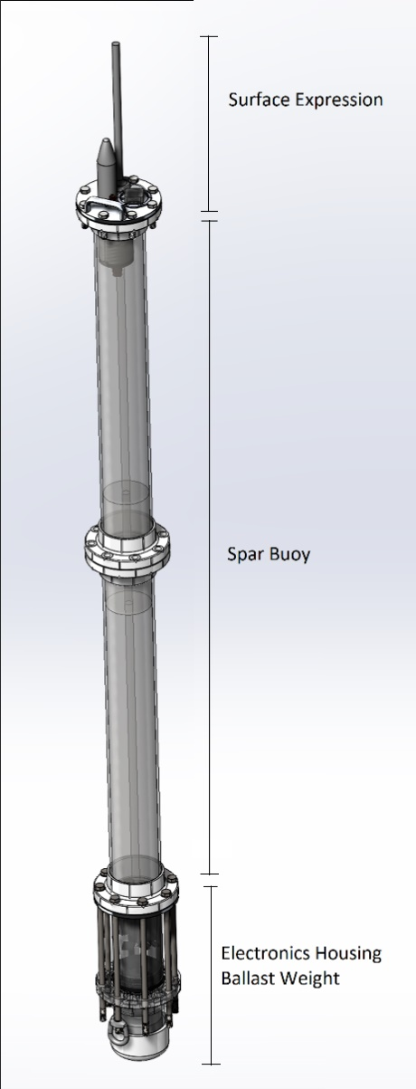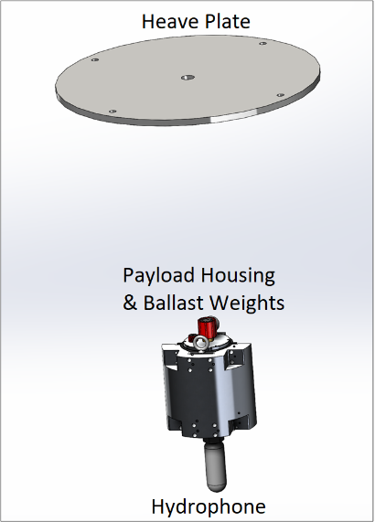
(a) (b)
Figure 3. CAD drawings of the new Spar 2 drifting hydrophone system. The buoy (a) includes an upper housing with GNSS-PPS and cellular modem antennas, light, and handle for deployment recovery with waterproof connections and cabling through the 2.7 m long spar buoy to a housing with the LiPo battery, R-Pi, and WISPR. A 10-m long cable connects the lower spar buoy housing to the sensor payload with the preamplifier board and hydrophone (b).
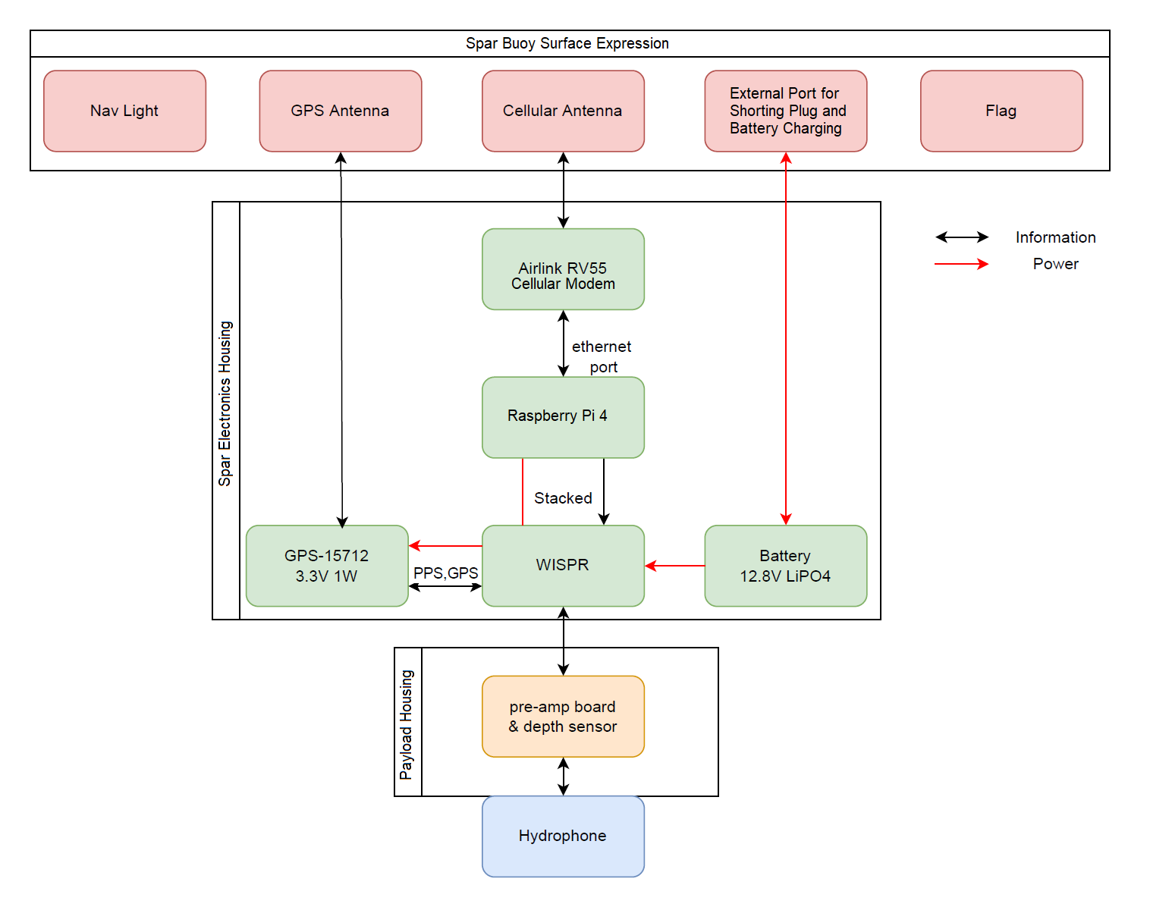
Figure 4. A block diagram of the revised OSU Spar2 electronics system.

PNNL was responsible for design and fabrication of the internal frames for the electronics boards and circuitry design. Custom 3D printed frames and trays were fabricated and installed in the upper and lower housings to mount electronics boards, components, and wiring (Figure 5). The commercial off-the-shelf waterproof housings for the electronics were purchased from Blue Robotics Inc. and required custom machined endcaps for bulkhead connectors. PNNL did the engineering design for the endcaps and contracted a local machine shop to fabricate them (Figure 6a). Heave plate design and fabrication and rigging for the compliant lines, swivels, and shackles for the spar buoy and suspended sensor payload was also done by PNNL.
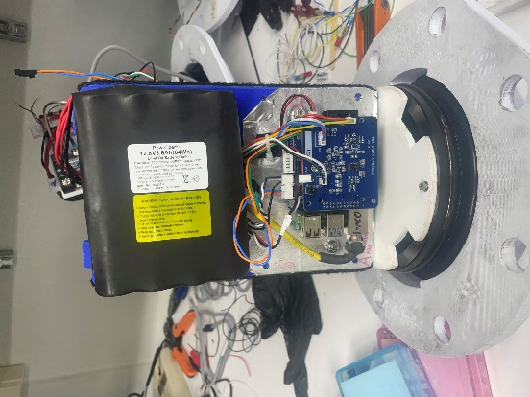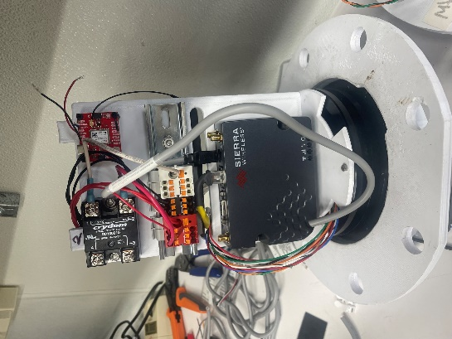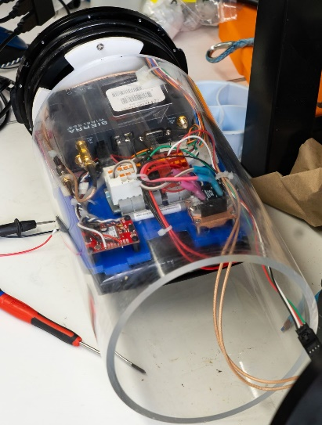
(a) (b) (c)
Figure 5. The endcap, electronics frame, wiring and components of the lower spar buoy housing showing the WISPR and LiPo battery (a) and R-Pi, bus relay, and cellular modem (b). In (c) the Blue Robotics acrylic housing is shown over the electronics board and frame.

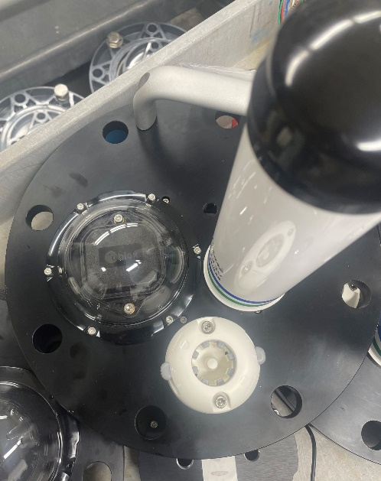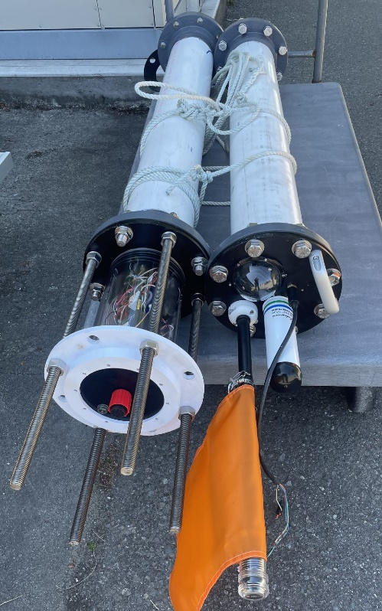
(a) (b)
Figure 6. The top view of the spar buoy surface expression endcap showing the GPS antenna, cellular antenna, light attachment, and handle (a) and the spar buoy broken into two parts with the surface expression topside on the right and lower electronics housing on the left (b). Note the ballast module is not connected to the threaded rods of the lower unit housing in this image.
The endcaps and electronics housings were tested in seawater tanks at PNNL Sequim’s shoreline facility and left for 24 hours on the bottom of a tank at a depth of 0.75 m to test and confirm the housings were watertight (Figure 7).
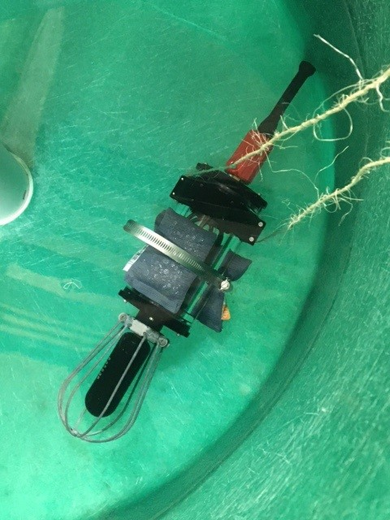
Figure 7. The lower sensor payload housing includes hydrophone, preamplifier electronics, endcaps, Blue Robotics housing, and bulkhead connectors under submergence testing in a seawater tank at PNNL-Sequim.

Each OSU preamplifier was bench-calibrated with a signal generator and oscilloscope for its frequency-dependent gain response. An example of the output of these tests is shown in Appendix A. All preamplifiers provided by OSU were calibrated for future integration into Spar2 systems.

7.2 Lesson Learned and Test Plan Deviation
Projects requiring significant re-design, such as this one, can be challenging and time consuming as modifications are proposed, discussed, and decided upon in an iterative process amongst the team. In the future, an operational prototype ready for end-to-end bench testing would accelerate this process and require only slight changes in system design during the testing support period. The length of the re-design process, Covid supply chain delays, and changes in key engineering staff at PNNL all contributed to timeline delays and budget challenges for this project. For projects requiring additional technology development and sensor integration, adding more contingency for budgetary support during the planning phase could be beneficial dependent on the type of project.

With concurrence from OSU, PNNL deviated from the original test plan for complete system bench testing to modular, component-based tests because of significant Covid related supply chain delays for the underwater cables and connectors. For example, the preamplifiers were all independently tested and calibrated for frequency dependent gain response. Likewise, the R-Pi controlled peripherals (GNSS-PPS and cellular communications) were tested in a temporarily “wired” configuration with the WISPR on the bench, but not in the designed configuration with the 3 m coaxial cabling running through the Spar2 hull.

Conclusions and Recommendations
Despite timeline delays from supply chain and changes in personnel, the results from this phase of the project were a major advancement in the re-design of the Spar2 system with some initial fabrication and assembly of key components. A newly re-designed Spar2 prototype was successfully assembled, except for the connecting cables, achieving the project goals for standing up another drifting hydrophone system for Marine Energy environmental monitoring, with a clear path forward to Open Water testing and validation.

References
International Electrotechnical Commission: Technical Specification 62600-40: Marine Energy-Wave, tidal and Other Water Current Converters – Part 40. Acoustic Characterization of Marine Energy Converters. Geneva, Switzerland, 2019; p. 44. Available online: https://webstore.iec.ch/publication/31031

Acknowledgements
The authors would like to thank Nicole Sather (PNNL) for programmatic and institutional support and Chris Jones from Embedded Ocean Systems (EOS) LLC for software and design discussions including the WISPR2 microcontroller board.

Appendix
OSU PreAmp 31. Gains and system sensitivities at logarithmically equally spaced frequencies
Freq [Hz] | Vin [V] |  |  | Vout [V] | Gain dB | Sensitivity dB
1 | 0.5 |  |  | 0.188 | -8.5 | -228.5
2 | 0.3 |  |  | 0.338 | 1.0 | -212.9
5 | 0.2 |  |  | 0.663 | 10.4 | -195.6
10 | 0.2 |  |  | 0.962 | 13.6 | -186.4
20 | 0.2 |  |  | 1.090 | 14.7 | -179.4
50 | 0.2 |  |  | 1.144 | 15.1 | -171.8
100 | 0.2 |  |  | 1.181 | 15.4 | -167.6
200 | 0.2 |  |  | 1.250 | 15.9 | -165.1
500 | 0.1 |  |  | 0.831 | 18.4 | -161.8
1000 | 0.1 |  |  | 1.288 | 22.2 | -157.8
2000 | 0.05 |  |  | 1.040 | 26.4 | -153.6
5000 | 0.03 |  |  | 0.994 | 30.4 | -149.6
7000 | 0.01 |  |  | 0.370 | 31.4 | -148.6
8000 | 0.01 |  |  | 0.363 | 31.2 | -148.8
10000 | 0.01 |  |  | 0.375 | 31.5 | -148.5
20000 | 0.01 |  |  | 0.388 | 31.8 | -148.2
30000 | 0.01 |  |  | 0.388 | 31.8 | -148.2
40000 | 0.01 |  |  | 0.387 | 31.8 | -148.2
50000 | 0.01 |  |  | 0.375 | 31.5 | -148.5
60000 | 0.01 |  |  | 0.375 | 31.5 | -148.5
70000 | 0.01 |  |  | 0.369 | 31.3 | -148.7
80000 | 0.01 |  |  | 0.350 | 30.9 | -149.1
90000 | 0.01 |  |  | 0.338 | 30.6 | -149.4
100000 | 0.01 |  |  | 0.331 | 30.4 | -149.6
120000 | 0.01 |  |  | 0.313 | 29.9 | -150.1
140000 | 0.01 |  |  | 0.289 | 29.2 | -150.8

