Final Report
Creek Tides Energy & Power – Reactive Reversible Blade Turbine for Power Generation
Awardee: Creek Tides Energy & Power
Awardee point of contact: Scot Cumming
Facility: FAU Hydrodynamics Laboratory
Facility point of contact: Oscar Curet
Date: 05/25/2022

Executive Summary
In this work a model of a “reactive reversible blade turbine for power generation” from Creek Tides Energy & Power was tested in the Hydrodynamics Laboratory at Florida Atlantic University. The turbine features a set of 5 blades that can rotate around its leading edge while also the entire turbine rotates around its central axis. The turbine had an overall diameter of 27.9 cm and a height of 28.6 cm. The turbine was tested in a re-circulating flume (122 width and water height of 30 cm) with a flow speed between from 0 to 0.5 m/s. In total, nine loads and nine velocities were tested in which the rotational speed and torque of the turbine were measured. The kinematics, force and power output are presented for the different cases. The hydromechanical power of the turbine is computed based on the power output and rotational speed. The turbine has a maximum efficiency of approximately 18% when the V_{tip}/U is approximately 0.4. The efficiency follows a common trend between the different cases where there is a sudden increase in efficiency followed by a decrease in efficiency as V_{tip}/U increases. Future improvement to could include improvement in the design of the blades, reducing friction in the pivot points for the blade motion and adjusting the rotational angle of the blade to improve performance.

Introduction to the project
This project characterized the performance of a novel reactive reversible blade system designed for power generation. The reversible blade system is composed of a series of blades that can pivot around their span axis while the forces on the blades generate a torque that may be useful for power generation (Fig 1. It is theorized that as the blades rotate, drag decrease on the system, thus allowing an increase in rotational speed and power output. The system may therefore be well suited for slow currents.
As no previous numerical models or testing of the Creek Tides technology are available, these tests collected preliminary fundamental performance data on the turbine concept without a priori scaling requirements. Rather than the typical approach which identifies full scale system performance goals and then selects suitable scaled experimental conditions, these tests evaluated the prototype’s performance at its current scale and extrapolate equivalent larger scale projected performance.
A prototype of the turbine with a set of 5 reactive blades has been constructed by Creek Tides (CT), and was tested in Florida Atlantic University’s (FAU) Hydrodynamics Laboratory recirculating flume at varying flow speeds, with and without mechanical load applied. These experiments included 1) measure the rotational speed as a function of incoming flow speed 2) measure torque as a function of incoming flow speed and 3) compute power efficiency as a function of flow speed.
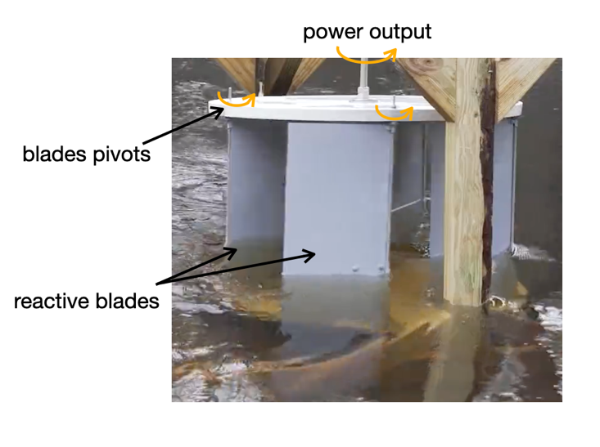
Figure 1: Testing of the reactive reversible blade turbine for power generation featuring blades that can pivot around their span axis to minimize drag. A scaled version was tested in laboratory conditions.

Roles and Responsibilities of Project Participants

Applicant Responsibilities and Tasks Performed
The applicant, Scot Cumming (CT), provided a prototype of the power generation system to FAU. Mr. Cumming participated in meetings during test setup, performance, and data analysis phases.

Network Facility Responsibilities and Tasks Performed
FAU was responsible for the following:
- Characterizing the performance of the prototype. This includes:
  - Measuring rotational speed
  - Measuring mechanical power output
  - Data analysis (computing power output and efficiency, non-dimensional parameters)
- Provide a report of results and upload data to MHKDR
- Host weekly progress meetings to discuss milestones, objectives and the experimental results. In addition, FAU updated the applicant, Scot Cumming, in a bi-weekly basis.

Project Objectives
The overall objective of this project was to investigate the fundamental performance of a drag-based turbine concept, with the goal of characterizing its potential for larger scale applications and compare it to other drag-based turbines. By evaluating an 11”x11” prototype of a “reactive reversible blade turbine,” shown in Figure 4, CT hopes to observe its operation in controlled laboratory conditions, establish a baseline for its performance at that scale, and calculate non-dimensional parameters that can be used to estimate its performance at larger scales.

Test Facility, Equipment, Software, and Technical Expertise
The proposed research was performed in the Hydrodynamic Laboratory at the Department of Ocean and Mechanical Engineering at FAU in the Institute for Ocean and System Engineering (SeaTech) campus at Dania Beach, FL.
SeaTech campus: SeaTech is a 4,645 square meters educational and research center aimed at solving problems in the ocean and related fields. It is located in eight acres of land between the Atlantic Ocean and the Intracoastal Waterway in Dania Beach, FL with valuable easy access to the ocean and estuaries.
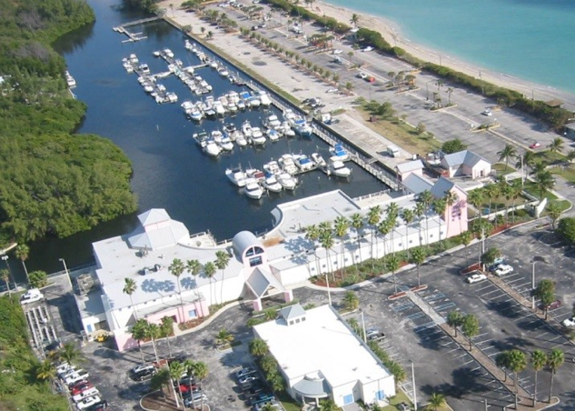
Hydrodynamics Laboratory: The room has an area of approximately 21.3 x 6.2 m. This room houses a low-turbulence water tunnel and a wave/towing/flume tank (described below). The laboratory is equipped with working benches, mechanical tools, electronics (oscilloscopes, voltmeters, power supplies, etc.), compressed air, optics, cameras, and lenses.
Figure 2: SeaTech Campus at Dania Beach. This educational and research center has access to the Intracoastal waterway and Atlantic Ocean. It houses multiple labs including the Hydrodynamics Lab and the Autonomous Underwater Vehicle (AUV) Lab.
Wave/towing/flume (18.3 x 1.2 x 1.2 m): A recirculating water system that can generate simple waves, and can tow physical models. The flume can obtain velocities of 0.5 m/s and the tow carriage can achieve maximum speeds of 1 m/s (combined 1.5 m/s). All walls are made of glass. Specific capabilities to be used for these experiments include:
Figure 3: FAU’s wave, towing, and flume tank (test section is 1.2 x 1.2 x 18.3 m).
- Acoustic doppler velocimeter: high-resolution acoustic velocimeter to measure 3D water velocity at a 25 Hz rate (Nortek Vectrino).
- Force sensors: The lab has multiple force sensors including a 6-component force transducer (ATI ISA Gamma load cell with a force range reading of 1-100 lbs), 5 lbs, 2 lbs, 1 lbs, and 100g load cells (Futek, LSB200).
- DAQ boards and amplifier system: National Instruments cDAQ 9178 and NI USB-6211 with different modules for analog inputs/output running with LabView.
- High-speed camera and optics: three Photron FASTCAM Mini UX50 with 4 GB of memory. This camera can record at maximum resolution of 1280 x 1024 pixel resolution at 2,000 frames per second (fps). Photography accessories: tripods, multiple lenses, filters, Nikon camera and lighting.
- Others: oscilloscopes, various small dc motors with gear heads and encoders (Maxon motors), power supplies, computer software (Matlab, SolidWorks, Rhinoceros), working benches and sort of mechanical and electronic tools.
Below is the estimated free stream velocity in the flume as a function of the motor controller frequency for a water depth of 16 inches. Note that the flow speed were measured using a high definition acoustic dopple velocimeter (Vectrino – Nortek) . The experiments the pump was operated between 10 to 60 Hz..
Table 1. Recirculating flow pump motor controller frequency vs. flow speed
Motor Controller Freq., Hz | Flow speed (V), m/s
10 | 0.102
20 | 0.170
30 | 0.261
40 | 0.355
50 | 0.431
60 | 0.500
Velocities greater than 0.5 m/s can be achieved with the following options: 1) reduction in the frontal area of the test section or 2) a combination of flow speed with the motor controller (flume) and moving the turbine in the carrier thus increasing the relative velocity between the turbine and the surrounding fluid. However, the intention is to limit evaluation flow for this preliminary assessment of the prototype’s performance. Higher speeds may be considered for future assistance requests.
Computing: The Hydrodynamics Laboratory is equipped with 5 Dell computers - 2 desktops and 2 laptops with high-speed Internet connections for data acquisition. There is one IT employee dedicated to SeaTech. There is also a server in the Hydrodynamic Laboratory for data storage.
Expertise:
- Dr. Oscar Curet coordinated and oversaw the overall project and is the faculty manager of the Hydrodynamics Laboratory.
- One graduate student conducted the experiments.
Additional Technical support can be provided as needed by two electrical engineers and one machinist.

Test Article Description
The device to be tested is a current energy converter. Primary potential advantages include efficient performance in low-speed flows and can be installed in multiple orientations. It is expected that the prototype would work submerged in a current up to approximately 90 cm/s, potentially outperforming fixed blade turbines of similar scale (higher cut-in speed). The CT turbine is predicted to also perform in flows that reverse in direction without re-orientation of the turbine. The design allows blades that have rotated past their maximum angle of attack to feather away and not induce additional drag as they rotate back into their position exposed to incoming flow.
Description of the system
The small scale proof-of-concept prototype (device under test or DUT) consists of five blades that rotate on the outer disk edge on a five-star pattern (Figure 4). The blades pivot on a single $1/4"$ threaded road attached at the outer edge of the disk on a five-star pattern. The diameter and height of the turbine were 27.9 cm and 28.6 cm, respectively (Fig. 5). The prototype design includes mechanical stops that prevent over-rotation of each blade and allow for the transfer of force from the blades as rotational torque around a center shaft. The prototype’s blades are made of a dense wood and are hinged to each $1/4"$ rod. A removable screen is available that can be used to further constrain blade motion and is intended to ultimately deflect debris/marine life from turbine blades. The shaft is made from $1/4"$ square stock. The turbine assembly utilizes a top and bottom disk made of $1/2"$ thick clear Lexan.
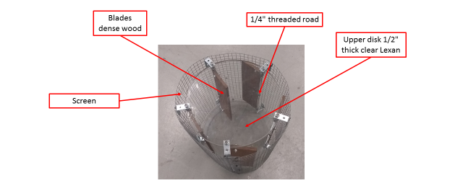
Figure 4: Reactive reversible Blade Turbine Prototype for Power Generation.

Work Plan
Turbine characterization was investigated for two operating states: no-load and loaded performance. Because no previous numerical models or performance evaluation results are available, it is imperative to first determine the turbine’s cut in speed and observe its basic operation. After unloaded cut-in speed was observed, turbine performance under loaded conditions was evaluated.. The test campaign included three phases: (1) experiment set-up, (2) no load evaluation, and (3) under load evaluation.
Phase 1: Experiment Set Up
- CT turbine was fitted to temporary frame for attachment to flume (suspended from tank walls)
- Nortek Vectrino 3D was installed and oriented in the tank to measure free stream incoming flow
- CT turbine was lowered into tank to its experiment position
- Encoder and Prony brake system (load cell) was fitted and connections tested (as well as camera)
- Final tank fill to experiment depth
- Flume pump motor frequency was calibrated to actual measured flow velocities
Phase 2: No Load Testing
- The torque measurement system was disengaged so the CT turbine can rotate freely in the flow. Starting from slowest speeds, with motor controller increments of 5 Hz, the flow was increased until the CT turbine begins to operate. Turbine kinematics was observed and recorded using an encoder.
Phase 3: Under Load Testing
- Torque measurement system was engaged with minimal torque applied (10%). Flume flow was then be increased 5 Hz until maximum flume flow is reached (or mechanical instability is observed).
- This procedure was repeated for pump frequencies from 15 Hz to 60 Hz in increments of 5 Hz.
- Output shaft RPM was recorded for all combinations of torque and flow speed.

Experimental Setup, Data Acquisition System, and Instrumentation
The experiments was conducted in the Hydrodynamic Laboratory’s large flume/wave/towing tank (Figure 3) at SeaTech. The turbine prototype was installed on a fixed structure with respect to the flume, and submerged into the water, see schematic in Figure 5. The friction torque sensor was attached to the turbine as well a digital encoder. Data was recorded through a National Instrument data acquisition system and MATLAB was used to process the data.
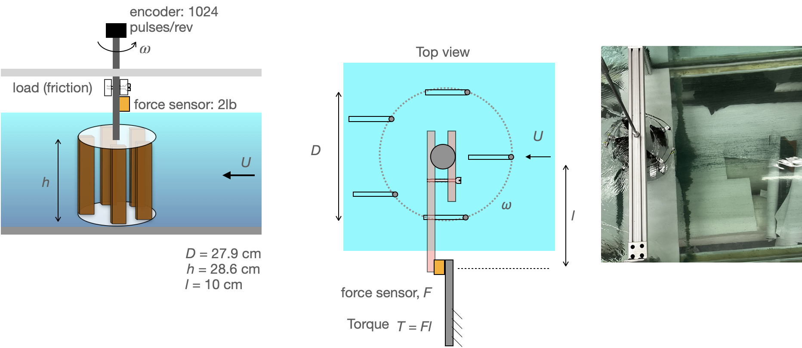
Figure 5: Overview of the experimental setup. Left and Center: Schematic of the experimental setup. Right: Top-view picture of the model turbine in the flume. Some parameters are also shown: h and D = height and diameter of the turbine, l = torque arm length.
The main bulk of the tests was obtained quasi-steady state values of critical variables, including rotational power, rotational dynamic torque, and rotational speed. Time varying values were recorded when possible (rotational speed,). Each test was characterized by a stream flow velocity in the flume, with the prototype turbine fixed with respect to the laboratory reference system.
Control Parameters:
- Motor frequency to control flow speed
- Load friction (Prony brake system)
Measured Parameters
The following measurements were obtained:
- Incoming free-stream flow, U (acoustic velocimeter)
- Turbine output shaft angular velocity, ω (digital shaft encoder)
- Linear force, F (load cell)
Incoming free-stream flow:
A high-resolution acoustic velocimeter was used to measure the speed of the incoming flow (Nortek Vectrino 3D). This instrument can measure 3D velocity at a particular point at sample rate of 1-200 Hz at with an accuracy of ± 0.5% of the measured value ± 1 mm/s.
Angular shaft speed:
The angular speed as well as angular acceleration were derived from measuring the angular position as a function of time, through a digital encoder. Speed and acceleration were calculated by numerical differentiation of the angular position and low pass filters.
Rotational dynamic torque:
The torque was measured using a load cell (Futek LSB 200).
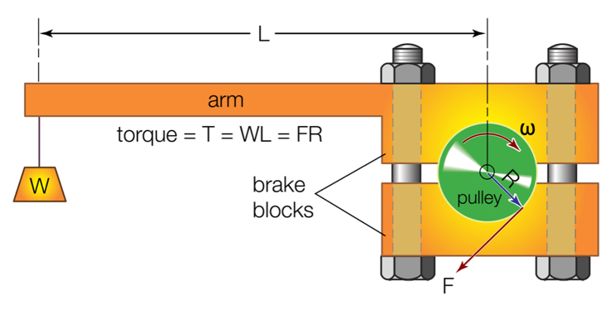
Figure 6: Elements of a Prony brake system to measure torque on a rotating shaft. Pictured modified from Britannica. (Picture Source: Wikipedia).
Computed Parameters
- Torque, T = Fl
- Power flow,
where $\dot{m}=$ mass flow rate, $ρ$ = water density, $h$ and $D$ are turbine’s height and diameter, and U is the incoming flow speed.
- Mechanical power, $P_{out}=Tω$
- Efficiency, $η=P_{out}/P_{in}$

Key non-dimensional parameters computed:
- Reynolds number based on the incoming flow, U, and tip velocity, V_{tip}.
,

where $μ$ is the dynamics viscosity of water.

- Strouhal number

- Tip-speed and flow speed ratio

The blockage of the flume was approximately 0.22, which will result in moderately augmented efficiency relative to unconfined conditions. No blockage corrections were performed as these would require a measurement of turbine thrust.

Turbine performance
The turbine performance was evaluated based on the hydrodynamics efficiency given by the mechanical power to incoming flow power ratio:
$$η=\frac{P_{out}}{P_{in}}=\frac{Tω}{0.5 ρhDU^{3}}$$

Test and Analysis Matrix and Schedule
Table 3 summarizes the experiments conducted. The first set of experiments was to measure the flow speed in the flow for different pump frequencies. The flow speed was measured with an acoustic velocimeter (Vectrino) at a sampling rate of 200 Hz. Note that the flow measurements is based on a calibration between pump frequency and velocity measurements. The velocimeter was not in operation while the turbine was tested, so minor reductions in flow velocity due to turbine flow resistance are not reflected in the results.
The second set of experiments were the experiments conducted to evaluate the turbine. The frequency of the pump was varied from 0 Hz to 60 Hz in steps of 5 Hz (13 speeds in total). For each flow speed the load in the turbine was varied for 9 different loads, L1 = no load, and L9 is the higher load. In this set of experiments, the force was measure with a 2-lb load cell (Futek) and the rotational speed was measured with an encoder with a resolution of 1024 pulses per revolution. Force and encoder measurements were recorded at a sampling rate of 10,000 Hz. Experiment set 2 was run twice, for a total of 162 test experiments (9 flow speed x 9 loads x 2 repetitions). Data collection was for a 20 second period. There was a waiting period of approximately 2 minutes when the frequency of pump was changed, prior to initiating data collection to allow equipment and tank flow to reach stead-state.
Table 3. Experiments conducted.
Experiment | f_{pump} (Hz) | Load | Measured | Sampling rate, Hz
1 ( flume calibration) | 5:5:60 | — | U | 200
2 | 15:5:60 | L1:L9  (no load): (higher load) | F, ω | 10,000

Safety
All the experiments and data collection were conducted in accordance with the safety protocols and under the guidelines provided by the Office of Environmental Health and Safety at Florida Atlantic University (https://www.fau.edu/ehs/) .

Contingency Plans
The following major risks for the completion of the test plan were identified:
- Failure of the physical model
- Failure of the motor and/or motor controller that drive the flume flow speed
- Failure of test tank
- Failure of sensors

Failure of the physical model
In the unlikely event of the physical model is damaged, the model is simple enough that is straightforward to repair or remake (the Seatech campus and university are equipped with machine shops for onsite repairs). The installation of the system was coordinated between FAU and Mr. Cumming to ensure that the system is well mounted. The physical model wastested with small increment of flow speed to mitigate potential damage of do to increase in the load.
Failure of motor or motor controller for flume flow speed
In case the motor or motor controller for the flume fail, they would be replaced. As an alternative option, the experiments could be conducted by mounting the turbine in the carrier above the tank and towing the turbine along the tank without a flow.
Failure of test tank
Failure of the test tank could result in a critical test failure. The approximated water level for the experiments was around 12inches. These water levels are not high risk for the tank size.
Failure of sensors
It is possible that one of the required sensors fail during operation. Below are alternatives if one of the main sensors fail:
- Rotational encoder (measure rotational velocity): Replace.
- Acoustic doppler velocimetry (measure free stream velocity): Alternative - measure velocity by recording the motion of a particle or object in the water along a known distance (manually/PIV system).
- Prony brake system (measure power output): Alternative - electric alternator.
- Video camera (observe blade kinematics): Swap (several replacements are on-hand).
All sensors operated normally during the experiments.

Data Management, Processing, and Analysis

Data Management
All data either raw data, preprocess and processed data was stored on a server on the Boca Raton Campus at the College of Engineering and Computer Science. All data obtained in tests, including raw data, preprocessed data, and processed data was submitted to MHKDR.

Data Processing
Raw data was preprocessed by applying low pass filters to damp out noises embedded in measured signals, inherited from the sensors, especially the friction brake. All different tests repeated during the session, for the same settings for two trials.

Data Analysis
Raw data was filtered out before processing. This includes the application of low pass filters.. All diagrams and graphical plots wredone using MATLAB.
When the frequency of the pump was changed to achieve another flow speed, to ensure that steady-state flow is achieved, a minimum 2 minute delay before the next recorded experiment was enforced. All data was recorded for multiple cycles to ensure high quality average calculations and standard deviations. If fluctuations in peak-to-peak measurements of power and kinematics are present, the average values were computed for a fixed number of cycles.

Project Outcomes

Results

Figure 7 shows the results from the Experiment set 1 where the incoming flow speed in the flume was measured for the different pump frequencies. In the graph a linear fit is also shown for the data collected.
Figure 7: Experiment set 1: incoming flow measurements vs. pump frequency. Circles: experimental flow measurements, solid: linear fit.

Figure 8: Calibration of the load cell, circles: experimental data, solid line: linear regression.
Figure 8 shows the calibration of the load cell. A linear fit was obtained from the calibration data. This linear fit was used to convert the recorded data from the experiments to force.
Figure 9 shows the force as a function of time (blue line) and the average force for the duration of the experiment (dashed line). This case is for U = 36.5 cm/s and a load level 8. This case corresponds to the peak efficiency of the turbine.
Figure 9: Force measurement as a function of time, U = 36.5 cm/s and L = 8 (case with peak efficiency). Dashed line shows the average force.
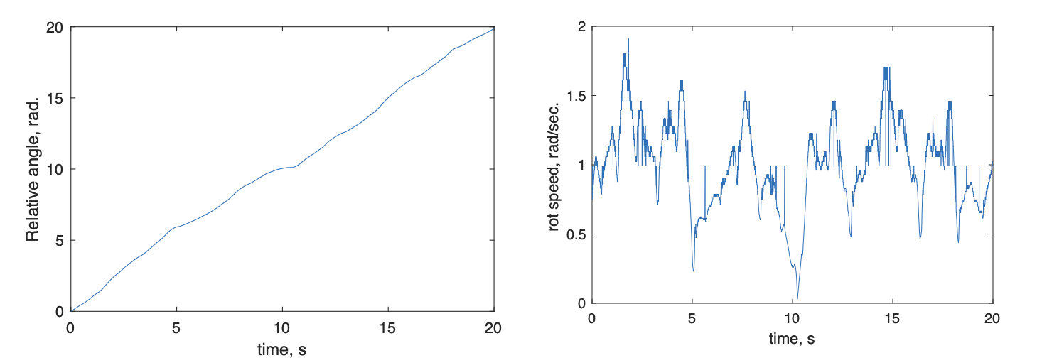
Figure 10: Rotation vs. time. Left: relative angel vs. time. Right: rotational speed, $ω$, vs. time. U = 36.5 cm/s and L = 8 (case for peak performance)
Figure 10 (left) shows the relative angle of the turbine as a function of time. The differentiation of this data with respect time was used to compute the rotational speed (Fig. 10 right). From these data, mean rotational speeds were computed.
Figure 11: Mean rotational speed in revolutions per minutes (rpm) vs. flow speed. Each line represents a different load.
Figure 11 shows the mean rotational speed of the turbine in revolutions per minute as a function of flow speed. For low load conditions the turbine starts to spin at lower the flow and the flow speed where the turbine starts to spin increases with load.
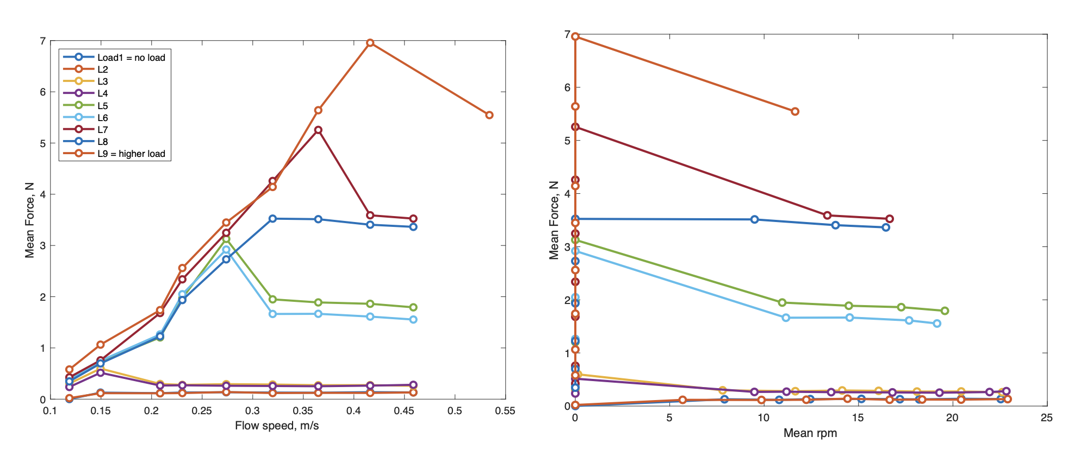
Figure 12: Mean force vs. flow speed (left) and mean force vs. rotational speed (right).
Figure 12 shows the mean force measured as a function of flow speed. In general, the force in the turbine increases with flow until it drops or plateau. This drop in force corresponds when the turbine starts to spin.

Figure 13: Hydrodynamics turbine power output vs. flow speed for different load conditions.
Figure 13 depicts the mechanical power generated by the turbine, based on the torque and rotational speed of the turbine, $P_{out}=Tω$. As it can be observed, even though the low-load cases (L1-L4) have a high rotational speed (Fig. 11) , the torque in those cases is very small (Fig. 12) resulting in low power output. In the other hand, the higher load cases, L5-L9, are able to generate higher power given the torque output and rotational speed.
Figure 14 shows the efficiency of the turbine (left panel) and the incoming power from the flow as a function of flow speed. The efficiency of the turbine is zero while it is not spinning then increase rapidly when it starts to spin follow by a decay of the efficiency. The peak efficiency occurs for the case with load L8 and a flow speed of approximately 0.36 m/s.

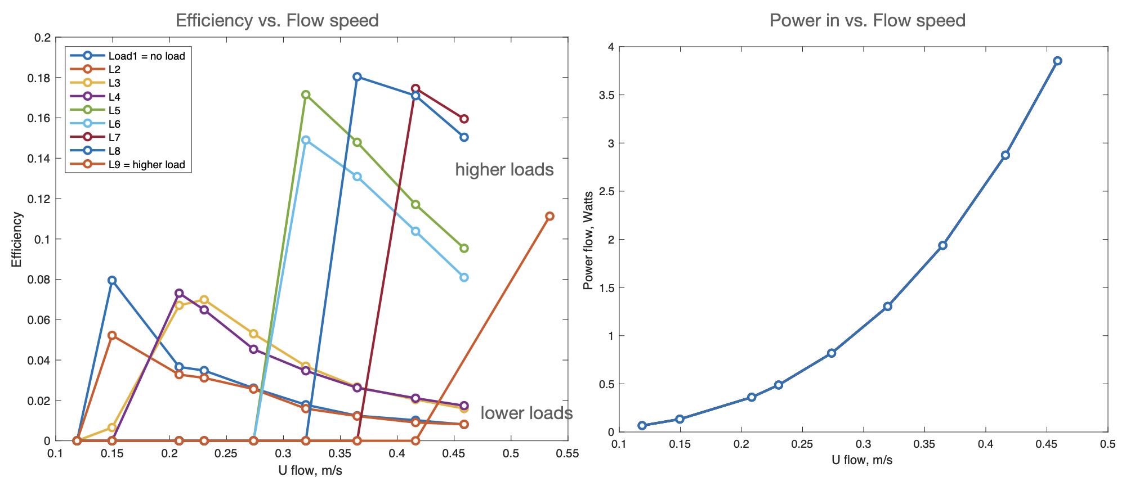
Figure 14: Turbine efficiency vs. incoming flow speed (left). Incoming flow power vs. flow speed (right).
Figures 15-18 shows the efficiency of the turbine as a function of different parameters: ratio between tip and flow speed (Fig. 15), tip velocity (Fig. 16), Reynolds number based on tip velocity (Fig. 17), and Strouhal number (Fig. 18).
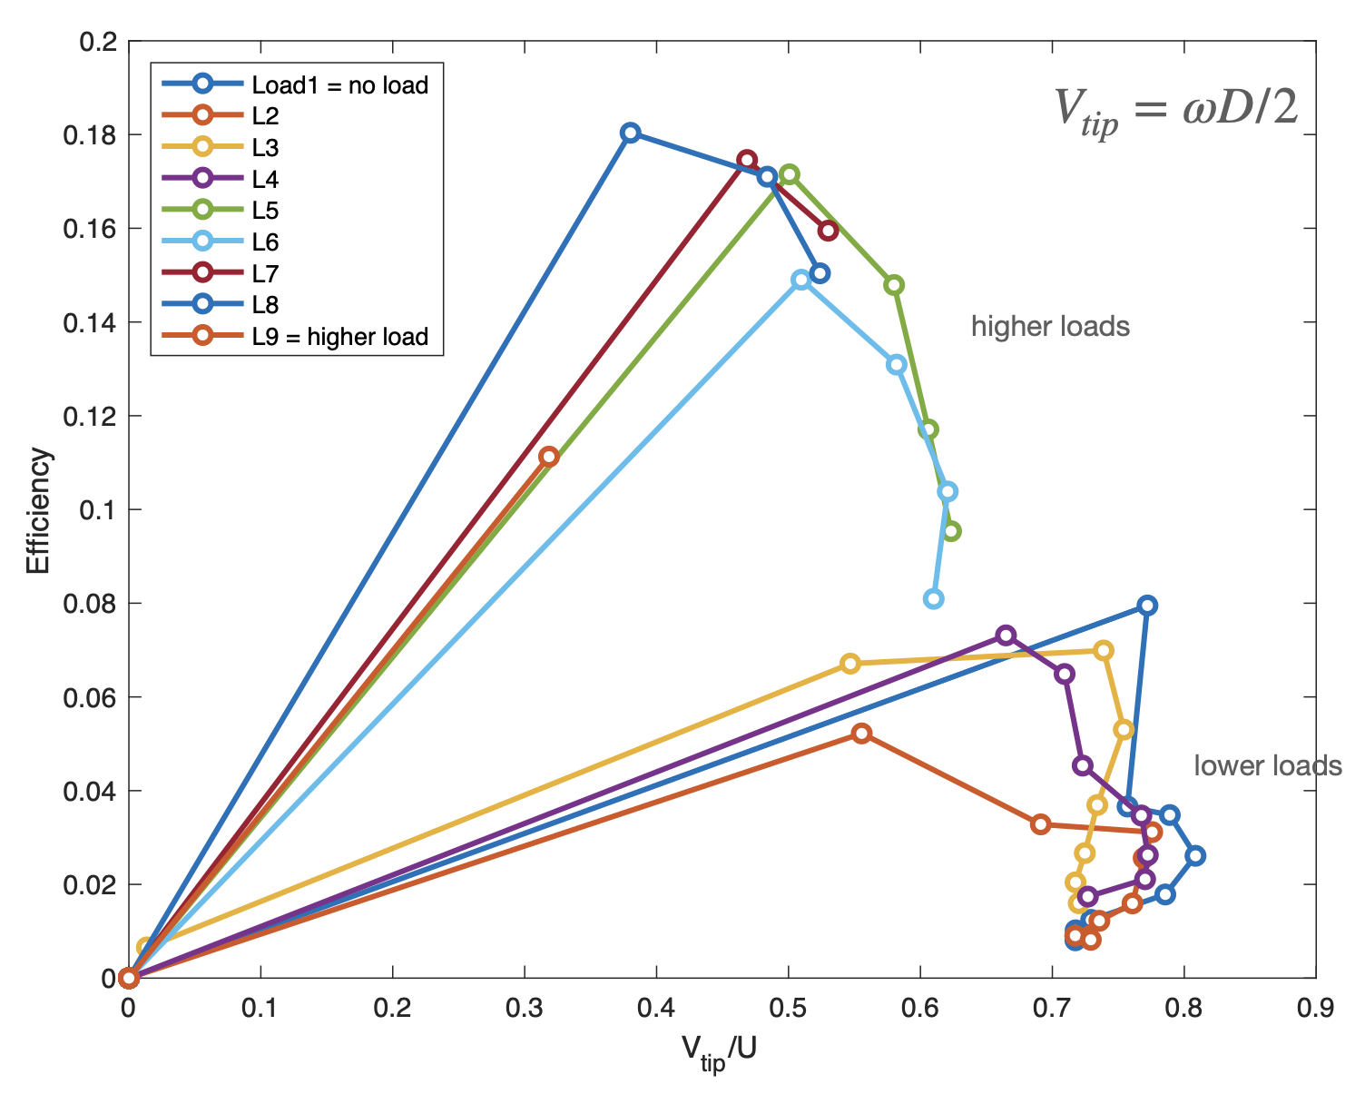
Figure 15: Turbine efficiency vs. V_{tip}/U for different load conditions.
In Figure 15 it can be observed that the efficiency follows a common trend between the different cases where there is a sudden increase in efficiency followed by a decrease in efficiency as V_{tip}/U increases. The cases for lower loads (L1-L4) and higher loads (L5-L9) seams to cluster as for higher loads results in lower V_{tip}/U for the flow speeds tested. For the turbine tested the peak performance was around 0.18 for a $\frac{V_{tip}}{U}≈0.4$.
Figure 16: Turbine efficiency vs. V_{tip}
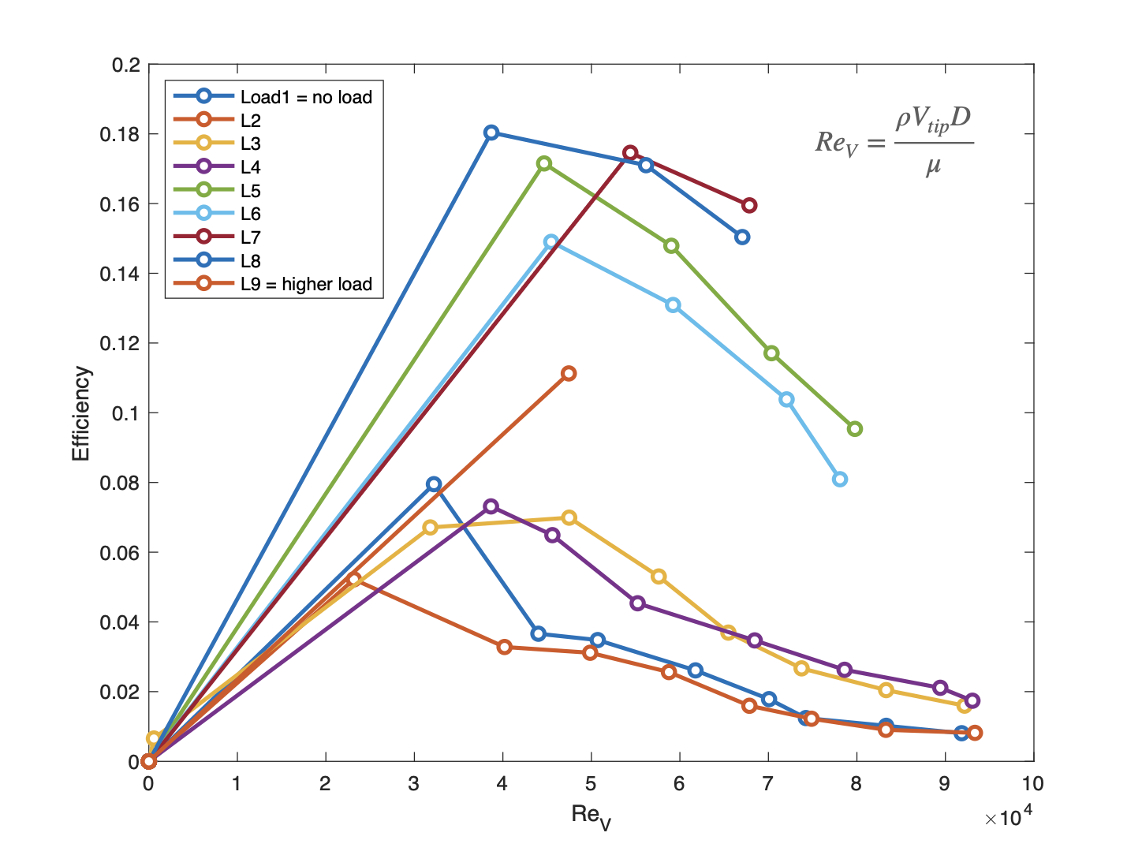
Figure 17: Turbine efficiency vs. Re_{V}
The efficiency as a function of tip velocity and Re_{V} are show in Figures 16 and 17, respectively. The peak performance for the different load tested occurred around ${Re}_{V}≈4 x {10}^{4}$.
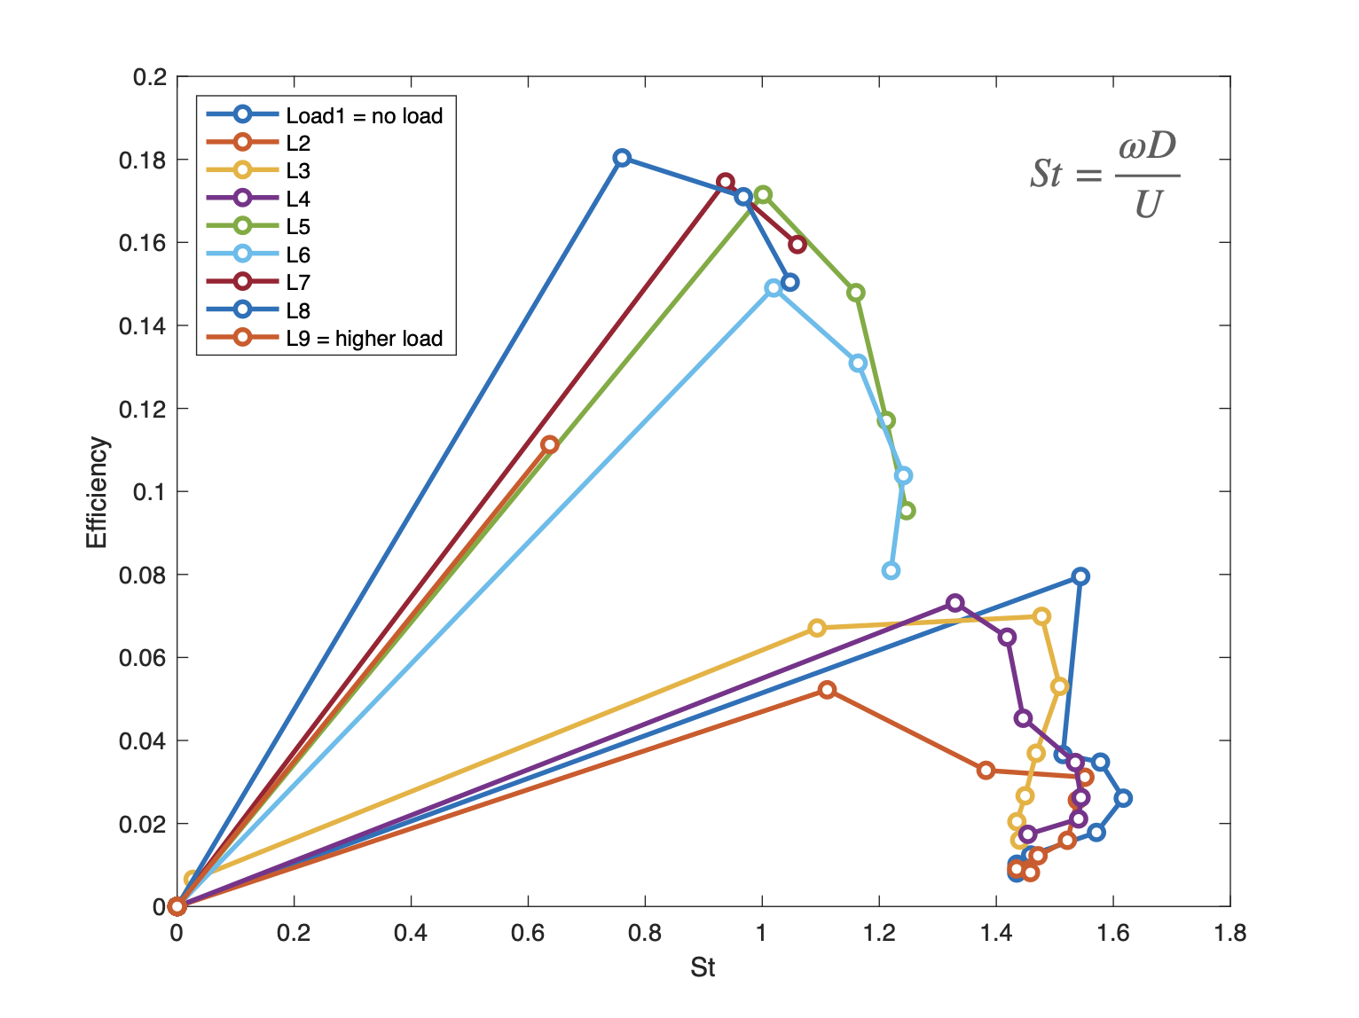
Figure 18: Turbine efficiency vs. Strouhal number
Figure 18 shows the efficiency as a function of Strouhal number which follow same trend as Fig. 15 given that Strouhal number is based also in the ratio between rotational and incoming flow speed. The peak performance occurred when Strouhal number was approximately 0.7-0.8.

Lesson Learned and Test Plan Deviation
This project took longer than expected in part to ensure that the mounting and support for the turbine were adequate. Initial testing of the mounting had high friction. However, once the setup for the turbine was satisfactory the data collection and analysis were conducted as planned. Unfortunately, the mounting system for the blade had to be bigger and sturdier that initially we expected, resulting in not been able to use the carrier mechanism to explore higher flow conditions.

Conclusions and Recommendations
In this work a model of a “reactive reversible blade turbine for power generation” from Creek Tides Energy & Power was tested in the Hydrodynamics Laboratory at Florida Atlantic University. The turbine features a set of 5 blades that can rotate around its leading edge while also the entire turbine rotates around its central axis. The turbine had an overall diameter of 27.9 cm and a height of 28.6 cm. The turbine was tested in a re-circulating flume (122 width and water height of 30 cm) with a flow speed between from 0 to 0.5m/s. In total nine loads and nine velocities were tested in which the rotational speed and torque of the turbine were measured. The kinematics, force and power output are presented for the different cases. The hydromechanical power of the turbine is computed based on the power output and rotational speed. The turbine has a maximum efficiency of approximately 18% when the V_{tip}/U is approximately 0.4. The efficiency follows a common trend between the different cases where there is a sudden increase in efficiency followed by a decrease in efficiency as V_{tip}/U increases.
Future recommendations: There are many ways that the efficiency of this turbine could be improved including: hydrofoils designs for the blades, bearings to reduce friction in the rotation of the blades. In addition, further optimization on the rotational angle of the blades could be explored to improve efficiency. Future work could also include connection to a generator and evaluation of electric output, higher flow speeds and field testing.

