**Post Access Report**

WEC-Sim Modeling of Laminar Scientific’s patented seesaw Wave Energy Converter (RFTS9)

Awardee: Laminar Scientific

Awardee point of contact: Narayan Iyer

Facility: WEC-Sim

Facility points of contact: Adam Keester (Sandia), Salman Husain (NREL)

Report author: Narayan Iyer and Nathan Tom (Sections 1-6), Chelsea Kimball, Salman Husain, Adam Keester (Sections 7-11)

Date: 11/21/2024

# Executive Summary

Laminar Scientific’s patented nearshore seesaw wave energy converter has several features that will be assessed in this study utilizing the Wave Energy Converter SIMulator (WEC-Sim) Facility. One of these features is the ability to change spacing between two spherical floats of the seesaw to adjust to different sea-states and maximize rotational motion produced at the pivot. Conversely, severe wave conditions would warrant the minimization of rotational motion by minimizing float spacing. This study will test the hypothesis that the seesaw wave energy converter (WEC) can generate out-of-phase behavior between its fore and aft floats and that spacing adjustments will lead to improved power capture across a range of sea-states.

# 1 Introduction to the project

There exists a need for a simple, primarily surface dwelling WEC for a nearshore environment. Laminar Scientific (LS) tested a WEC configuration similar to other 1 degree of freedom surface WECs and found that when iterating towards a larger generator, the float would not downstroke fast enough prior to the next wave, and non-optimal power capture occurred due to reduced average velocities. A controller could cut downstroke power to allow for this return, but LS ideated an alternative that may not need to cut power: splitting the float into two floats that encounter opposing peak-trough wave phases. The main float would then be forced to return prior to next wave and said large generator would face higher velocities without cutting downstroke power, potentially leading to higher power conversion. Therefore, Laminar Scientific is proposing a patented seesaw WEC that forces out-of-phase behavior between two absorber floats that are connected to each other by arms about a pivot. The absorber floats are spaced out such that when the leading float is at the wave crest, the trailing float is at the trough. Hydraulic actuators can adjust the spacing between the floats, to adapt to different sea-states and maximize rotation about pivot. Since this is a nearshore focused WEC, waves will tend to be unidirectional due to refraction, therefore no orientation mechanisms would be needed.

LS believes that there are multiple ways in which the adjustable seesaw method can be manifested. One such method is a standalone WEC, shown in Figure 1, wherein the power take-off (PTO) housing/pivot (in gray) is kept stiff from rotation using a subsea high added-mass anti-rotation cup (this case is not studied in RFTS 9). Other possible manifestations could include fixing the seesaw PTO housing/pivot directly with the seafloor such that the PTO housing pivot can be considered fixed, shown in the left side of Figure 2, without any specific analysis of the different manifestations (no cup, pier etc.). This concept could be fixed to the seafloor via monopiles, fixing said pivot under a pier, or beneath a platform at sea. The monopile concept is of special interest for nearshore applications; it’s the concept explored in this RFTS9 award.

There may be questions of wake effects from the leading float negatively impacting the trailing float, therefore in some embodiments, the back section is split into two floats that are separated from each other to allow reduced wake effects from the leading float, as shown in the right side of Figure 2.

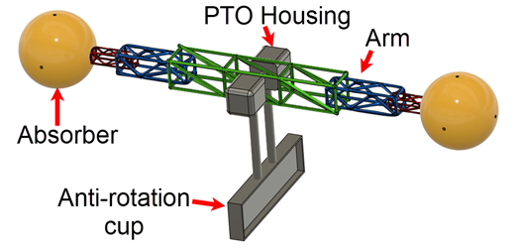

Figure . Floating seesaw WEC Concept.

|  |  |
| --- | --- |
|  |  |

Figure . (Left) Sea bed fixed seesaw WEC concept with two floats and (Right) Seabed fixed seesaw WEC with split back float.

The left-hand-side of Figure 2 shows the optimal float spacing (Equation 1) as:

|  |  |
| --- | --- |
|  | (1) |

where H is the wave height, and λ is the wave length.

The main goal of this project is to test the fundamental hypothesis that a seesaw WEC with float spacing placing one float at a trough and one at crest causes the floats to be out of phase with one another, and to numerically model the WEC using WEC-Sim to understand its power performance. LS and the WEC-Sim facility will test several models with different float spacings to characterize the WEC and understand whether changing float spacing converges to an optimal power output in different sea states. In addition, we will also test the hypothesis that in severe conditions, minimizing float spacing can mitigate stress on the WEC by lowering torque on the PTO. Time and budget allowed for modeling of the tri-float embodiment in the frequency-domain and an assessment of the hydrodynamic coefficients as aft-float spacing changes.

LS has conceptualized a base model design with float volumes of 9 cubic meters, and float spacing that ranges from 6 to 15 m between the float centers . The technical work will involve:

1. Test of static models with 4 different float spacings in a variety of regular wave conditions
2. Test of min vs mean float spacing in larger amplitude regular waves
3. Determine optimal spacing is found for each sea-state
4. Iterate on PTO size (damp coefficient) at optimal spacing at different sea-states
5. Analyze wake/shielding effects between the leading and trailing float

The following metrics of interest to be measured and reported to evaluate model performance:

* Device pitch response relative to wave slope i.e. kA
* PTO torque amplitude (torque x angular velocity will provide power)
* Ratio of excitation force between leading and trailing float

Time and budget allowed for modeling of the tri-float embodiment with optimal parameters found in the previous steps; serving as a basis for comparison for the next iterative design. The baseline WEC-Sim model developed as part of RFTS9 will allow LS to later perform a tradeoff study to judge whether the spacing adjustment feature is worth its increased costs, or whether the system LCOE would be lower using fixed spacing corresponding to the average wavelength of the region. LS is looking to identify a suitable go-to-market product out of our several concepts.

# 2 Roles and Responsibilities of Project Participants

## 2.1 Applicant Responsibilities and Tasks Performed

|  |  |
| --- | --- |
| Laminar Scientific Team Member | Responsibility |
| Narayan Iyer | LS manager and point of contact, distribute details of entire LS system (i.e. mass properties, CAD files, etc.), participate in bi-weekly meetings, provide feedback and make design decisions that are needed to move forward with modeling efforts. |

## 2.2 Network Facility Responsibilities and Tasks Performed

|  |  |
| --- | --- |
| NREL Team Member | Responsibility |
| Salman Husain | WEC-Sim Facility Lead, management of project, oversee and participate in the WEC-Sim numerical model development. |
| Sandia Team Member | Responsibility |
| Adam Keester | WEC-Sim Facility member, assist in numerical model development and performance evaluation. |

# 3 Project Objectives

The description of the tasks under this project are provided below:

**Task 1: Laminar Scientific (LS) will share device properties and existing CAD models of the seesaw wave energy converter (WEC) concept**

* LS shall complete the following:
  + Provide the geometric parameters, ideally CAD models, of the WEC
    - LS has requested that one additional float configuration (tri-float seesaw) be explored after completion of a preliminary study with bi-float seesaw, if time and budget permits.
    - The WEC-Sim facility has agreed to explore additional float configurations based on available budget and time after completing the first analysis of the two float seesaw configuration. This might only be through the work scope defined in Task 1 or a reduced Task 2 scope.
  + Share PTO information to determine if PTO-Sim needs to be used.
* WEC-Sim facility shall complete the following:
  + Review mass and buoyancy properties to ensure hydrostatic stability can be achieved.
  + Review CAD models to determine if they are sufficient for a hydrodynamic analysis. If not, provide feedback to LS on improvements to CAD models to be usable.
  + Verify desired PTO implementation and request additional details if a higher fidelity PTO model is necessary.

**Task 2: Develop Boundary Element Method (BEM) models of the LS seesaw WEC**

* LS shall complete the following:
  + LS shall meet with the WEC-Sim facility bi-weekly in order to receive regular updates and answer questions about WEC design and modeling decisions
  + LS has determined there to be four float separations to be analyzed in this study
    - Dynamic models that allow for real-time float adjustment will not be included in this work, thus a separate hydrodynamic model will need to be run for each specified distance.
* WEC-Sim facility shall complete the following:
  + Defeature the WEC geometry (if required)
  + Mesh the device geometry
  + Run the geometry in BEM solver(s), e.g. WAMIT, Capytaine
  + Iterate through 4 different monopile diameters (provided by LS) to assess the impact on the trailing float.
  + Compare BEM results across BEM solver(s)
  + Meet with LS bi-weekly regularly to provide updates on model development and ask clarifying questions to ensure project stays on schedule

**Task 3: Develop baseline WEC-Sim model of the LS seesaw device**

* LS shall complete the following:
  + LS shall verify final device parameters that will be used to develop the WEC-Sim model
    - Some design iterations may be required if the initial information packet provided in Task 1 results in an infeasible design.
  + ○ LS will define the wave conditions relevant for estimating the desired performance metrics (i.e. device motion, power performance, loads, etc. defined in Task 1)
* WEC-Sim facility shall complete the following:
  + Develop baseline WEC-Sim model of the LS seesaw WEC based on provided device parameters
  + Complete static water cases to verify hydrostatic stability
  + Complete free decay tests to verify the correct energy dissipation mechanisms are in place and the model is stable and estimate the natural pitch decay period.
    - Anticipate the pitch decay period will get longer with greater separation given the larger mass and hydrodynamic added moment of inertias.
  + Complete a response amplitude operator analysis by sending waves across a range of wave periods and two wave heights to verify model operation.
  + Run a final set of wave conditions that are defined by LS to evaluate the performance metrics defined in Task 1 by LS.
    - These wave conditions will be informed by previous simulations. LS and the WEC-Sim facility will have discussions to finalize these simulations. The expectation being that a down selected case with desired PTO properties would be run at other wave heights or periods that LS would use to estimate performance at a desired deployment location.
  + Share WEC-Sim model development with LS through private GitHub repository
  + Meet with LS bi-weekly regularly to provide updates on model development and ask clarifying questions to ensure project continues on schedule

**Task 4: Data analysis and post processing**

* LS shall complete the following:
  + LS shall provide feedback on the reported desired metrics, e.g. power output, motion response, foundation loads
  + LS will define if a different data format than Excel and .mat files are needed prior to final hand off
* WEC-Sim shall complete the following:
  + Post process WEC-Sim results based on LS provided metrics
  + Share data with LS through private GitHub repository
  + Meet with LS bi-weekly to provide updates on data analysis and receive confirmation from LS that results are being presented in a useful form.

**Task 5: Technology transfer and training**

* WEC-Sim shall complete the following:
  + Host technology transfer meeting(s) with LS, to review work completed during the TEAMER award, and answer any WEC-Sim questions
    - This will include a set of walkthrough slides on how LS can use the model to complete additional simulations or modify the model to suit their custom needs.
  + Provide the following to DOE Office of Scientific and Technical Information (OSTI)
    - An initial abstract suitable for public release at the time of the CRADA is executed.
    - A final report, within thirty (30) days upon completion or termination of the CRADA agreement, to include a list of Subject Inventions.
    - Other scientific and technical information in any format or medium that is produced as a restore of this CRADA.
* LS shall complete the following:
  + LS shall collaborate with the WEC-Sim facility on drafting the post access report, participate in technology transfer and training meetings, and upload WEC-Sim models with supporting data to the MHKDR.

# 4 Test Facility, Equipment, Software, and Technical Expertise

NREL and Sandia develop, validate, and distribute the open-source WEC-Sim software. The software is developed in MATLAB/Simulink using the multi-body dynamics solver Simscape Multibody. WEC-Sim simulates devices composed of bodies, joints, power take-off systems, and mooring systems. Simulations are performed in the time-domain by solving the governing wave energy converter equations of motion in six degrees of freedom. The software can be used to simulate wave energy converter (WEC) device dynamics and performance in operational and extreme waves, allowing for improvement of WEC performance during the design process. The WEC-Sim Facility team has the technical expertise, extensive experience, and the tools required to perform numerical simulations of wave energy converters. The WEC-Sim Facility team has many years of experience using hydrodynamic pre-processing BEM software (e.g. WAMIT, NEMOH, Capytaine, etc.) and WEC-Sim will be used for the proposed work.

# 5 Test or Analysis Article Description

The baseline seesaw WEC design consists of a bottom-fixed cylindrical support that houses a rotational PTO, shown in Figure 1. The PTO is connected to a truss section that extends in front and back of the pivot location that are rigidly connected to spherical floats. The truss system connecting the floats to the central pivot will be assumed to have minimal interaction with the water and will not be included in any hydrodynamic analysis. Furthermore, the truss system is allowed to extend or contract to adjust the spacing between the two spherical floats based on the wave slope. Initial work completed by LS has provided the mass and geometric parameters to define the base model as listed in Table 1.

|  |  |
| --- | --- |
|  |  |

Figure . Left: bottom fixed seesaw design with two spherical floats. Right: 15m spacing shown.

Table . Initial geometric and mass properties provided by LS

|  |  |  |
| --- | --- | --- |
| Variable | Value | Unit |
| Volume per float | 9 | m3 |
| Float draft | 1 | m |
| Mass per float | 2,000 | kg |
| Moment of Inertia about Hinge | 238,000 | kg*m2 |
| Water depth | 10 | m |
| Height of pivot above still water line | 0.29 | m |
| Float-to-float center spacing | 6 to 15 | m |

# 6 Work Plan

## 6.1 Numerical Model Description

WEC-Sim is a mid-fidelity numerical modeling tool based on linear potential flow theory. Hence, the wave field is assumed to be a linear superposition of incident, radiated and diffracted regular wave components. Boundary Element Method (BEM) software is used to compute hydrodynamic coefficients (e.g. added mass, damping, excitation force) for a range of discrete frequencies. Boundary Element Method Input Output (BEMIO) is then used to pre-process the hydrodynamic coefficients and save them to a *.h5 file that is read by WEC-Sim. WEC-Sim then uses these frequency-domain coefficients in time-domain formulations of the hydrodynamic forces. This conversion is required to model the WEC system in the time-domain, which is necessary to include non-linearities in the system, such as joints, PTOs, control systems, moorings etc. A complete description of the software’s theory is available on the WEC-Sim website:<https://wec-sim.github.io/WEC-Sim/main/theory.html> The accuracy of WEC-Sim has been verified in code-to-code comparisons and validated against experimental data. A full list of relevant publications is also available on PRIMRE: <https://openei.org/wiki/PRIMRE/Signature_Projects/WEC-Sim>.

A key input into WEC-Sim is the hydrodynamic radiation and diffraction coefficients that define the forces the WEC experiences when oscillating within the wave environment. These hydrodynamic coefficients are obtained from Boundary Element Method hydrodynamic solvers which assumes the fluid structure interaction can be adequately described by linear potential flow theory. Researchers in the offshore field commonly use BEM software such as WAMIT, NEMOH, Capytaine, and AQWA – all of which can be used as input into WEC-Sim. WAMIT is a commercial software, developed at the Massachusetts Institute of Technology (MIT). NEMOH and Capytaine are both free and open-source boundary element method software. Capytaine is used in this work as it is a robust, free and open-source software.

## 

## 6.2 Test and Analysis Matrix and Schedule

Table . Deliverables, Responsibilities and Estimated Completion Date. Project timeline and completions dates will be updated as the project progresses.

|  |  |  |  |  |
| --- | --- | --- | --- | --- |
| Task Number | Task Name | Duration (Months)  (Start) (Finish) | | Responsible Party |
| 1 | Provide seesaw WEC design details, existing CAD models, and other information relevant to building a WEC-Sim model to NREL/SANDIA. | On execution of the Agreement | | LS |
| 2 | Provide WAMIT (and/or Capytaine) support to understand the influence of the fore and aft floats. In addition estimate the impact of the central support column on hydrodynamics. | From execution of the Agreement | 2 months from execution of the Agreement | Sandia/NREL |
| 3 | Development of a WEC-Sim model of the Laminar Concept | 3 months from execution of the Agreement | 4 months from execution of the Agreement | Sandia/NREL |
| 4 | Data analytics and post processing | 4 months from execution of Agreement | 5 months from execution of the Agreement | Sandia/NREL |
| 5 | Reporting: Complete TEAMER Post Access Report | On completion of the technical work | | Sandia/NREL/  LS |

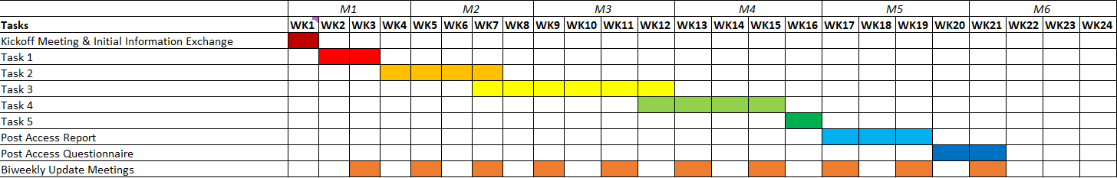

Figure . Project Proposed Schedule

The number of individual simulations to be run with Capytaine, is a function of the following parameters:

* 4 float spacings
* 3 monopile foundation diameters
* 1 float diameter

The first design iteration required 12 cases are completed to understand the hydrodynamic sensitivity of the 1) float spacing, 2) monopile diameter, and 3) float diameter. However, the number of simulations was reduced because the pylon diameter has a minimal influence on the results. A smaller float diameter leads to greater separation and a smaller characteristic diameter to wavelength which under linear hydrodynamic theory result in the fore and aft floats to have less interaction.

The number of individual simulations to be run within WEC-Sim is a function of the following parameters:

* Wave states
  + calm water,
  + free decay,
  + regular waves,
    - two wave heights
    - twelve wave periods ranging from 4-16 spaced at 1 s intervals
      * Waves longer than 16 s given the near shore are unlikely
* PTO control law
  + PTO damping,
    - eleven PTO damping values, 5 below and 5 above the optimum value for power absorption
      * The WEC design can be simplified to a one degree rotating system which should allow for the optimum damping to be derived analytically.
      * The need for additional damping values is to understand the influence on the other loading in the system such as force on the arms connect the floats and the monopile foundation.

For a single geometric design selected from the BEM results, the total number of simulations using WEC-Sim would be 192. These simulations are implemented using WEC-Sim’s Multiple Conditions Runs (MCR) which can automate the post processing for data collection and plotting. Since the models being developed will use the linear WEC-Sim model the computational time should run faster than real-time. The WEC-Sim facility does not expect any issues with time and budget for simulating up to 5 geometries (~960 individual simulations) but also expect that trends will be identified with 2-3 geometries to inform the direction towards an optimal geometry. LS and the WEC-Sim facility will have biweekly meetings to share results and make decisions on further simulations to run.

## 6.3 Safety

The project will not require any in-person or physical testing and analysis will be completed as a desktop study. Applicable office safety standards will be followed.

## 6.4 Contingency Plans

This work in this award will be completely numerical and Laminar has the initial WEC design details already available. Therefore, the WEC-Sim Facility team did not identify any project dependencies that could potentially delay the project or result in not delivering on the project milestones. However, the complexity of the models and analysis may exceed the WEC-Sim Facility’s initial estimates which could result in de-scoping some of the work such that the award can be completed on time and on budget.

## 6.4 Data Management, Processing, and Analysis

### 6.4.1 Data Management

WEC-Sim-generated data will be stored locally on the machine the software is run on and backed up using GitHub. The final dataset containing results from the numerical modelling campaign will be uploaded to MHKDR by LS.

### 6.4.2 Data Processing

WEC-Sim saves the data from each run as a *.mat file (binary), which can be read into memory with MATLAB or Python for post-processing. Meaningful directory and file names will be used for clarity and figures will be provided with accompanying post processing scripts attached for complete traceability and reproducibility.

### 6.4.3 Data Analysis

Data analysis will be completed either using Excel or MATLAB. For Task 2, the analysis will be focused on collecting and visualizing the radiation and diffraction coefficients for the various float shape and orientations. WEC-Sim’s BEMIO can plot the BEM solutions for single or multiple cases. The resulting images would result in a two-dimensional plot of wave angular frequency against the hydrodynamic coefficient of choice (added mass, wave damping, wave-excitation force) with individual lines associated with a different geometry configuration. If needed, a custom script could be developed to plot the coefficients in another format desired by LS. For Task 2 there is no dynamic analysis, and the results will be stored as vectors or arrays with radiation coefficients against oscillation frequency, float geometry, and support cylinder geometry. For Task 3, the WEC-Sim model allows for the dynamic simulation of the seesaw WEC under different sea conditions. Specifically for Task 4, the evaluation metrics, defined by LS, of interest that will be measured and reported during regular wave and custom wave simulations using the WEC-Sim model.

# 7 Project Outcomes

## 7.1 Results

**Task 1 – WEC Parameters**

The TSR provided the WEC-Sim facility with the following description of their device, which expands on Table 1. As shown in Figure 3, the spheres on the end of the WEC are referred to as floats. The truss structure connecting the floats to the rotational PTO are referred to as arms. The cylindrical support structures of the WEC are referred to as the pylons. The truss and floats are rigidly connected and do not move relative to each other, and therefore make up a single hydrodynamic body, referred to here as the seesaw. The pylons are rigid, unmoving, bottom-fixed, and surface piercing. Together, the pylons are treated as one fixed, hydrodynamic body.

The geometric properties of the WEC are listed in Table 3. The mass and moment of inertia properties of the WEC are listed in Table 4 and Table 5 respectively. The centers of gravity (CG) are referenced to the modeling origin, which is at the still water line.

Table . Geometric properties of the WEC

|  |  |  |
| --- | --- | --- |
| Variable | Value | Unit |
| Float, total volume | 9 | m3 |
| Float, radius | 1.29 | m |
| Float, draft | 1 | m |
| Float, center to center spacing | 6-15 | m |
| Pylon, diameter | 30-70 | cm |
| Pylon, center to center spacing | 1.6 | m |
| Pylon, height above the still waterline | 0.29 | m |
| Water depth | 10 | m |

Table . Mass properties of the WEC

|  |  |  |  |
| --- | --- | --- | --- |
| Variable | Seesaw | Pylons (15cm radius) | Unit |
| Submerged volume | 6.0 | 1.4 | m3 |
| Center of gravity (x, y, z) | (0, 0, 0.29) | (0, 0, -4.855) | m |
| Mass | 3939 | N/A (static body) | kg |
| Moment of inertia about the CG | See Table 5 | N/A (static body) | kg*m2 |

Table . Seesaw moments of inertia for each spacing case

|  |  |  |  |
| --- | --- | --- | --- |
|  | Float-to-float spacing | | |
| Moments of inertia | 15m | 12m | 9m |
| Ixx [kg·m2] | 1.066 × 105 | 6.115 × 104 | 3.113 × 104 |
| Iyy [kg·m2] | 1.380 × 103 | 1.380 × 103 | 1.380 × 103 |
| Izz [kg·m2] | 1.066 × 105 | 6.116 × 104 | 3.113 × 104 |

**Task 2 – Capytaine/BEM Hydrodynamic Analysis**

To perform the BEM hydrodynamic analysis, the software program Capytaine [1] was utilized. The pylons were modeled together as a single, rigid body. The seesaw’s submerged volume consists only of the two spherical floats. The two separated floats were modeled together as a single, rigid body. The truss was not submerged and therefore not represented in the BEM solution. Meshes for the bodies were constructed such that the spherical floats had 48 panels along a meridian, and the cylindrical pylons had 20 panels along the circumference and 40 panels along the height. These mesh resolutions were selected to reduce computational runtimes while maintaining hydrodynamic accuracy. See Figure A-1 in the appendix for details.

Iterative analyses were conducted to produce results for various float-to-float spacings, with main cases of interest being 6 m, 9 m, 12 m, and 15 m. Three pylon radii were examined for each float spacing case: 0.15 m, 0.25 m, and 0.35 m. Frequencies of interest for the analysis included values between approximately 0.4 and 1.6 rad·s−1, corresponding to wave periods between 4 and 16 s. The BEM analysis plots were calculated using WEC-Sim’s BEMIO functionality [2].

The normalized radiation damping in pitch motion for the seesaw device is shown in Figure 5, left. There are four float-to-float spacings shown, and for each spacing there are three pylon radii. The largest spacing has larger radiation damping values, and these values decrease as the spacing decreases. The three pylon radii for each spacing case have minimal effect on the radiation damping. For the wave frequencies of interest, marked by the gray area, the larger pylon radii have a larger radiation damping. However, this is a minimal effect compared to the float spacing.

The normalized radiation impulse response functions (IRFs) in pitch for the seesaw device are shown in Figure 5, right. There are four float-to-float spacings shown, and a single pylon radius for each. The varying pylon radii between 0.15 and 0.35 m for this case had minimal effect on the IRF results and are therefore not shown. In the normalized radiation IRF, the largest spacing has the largest initial result. All four cases reduce to oscillate about zero within 5 s, indicating stability in the hydrodynamic analysis.

|  |  |
| --- | --- |
|  |  |

Figure . Left: Normalized radiation damping in pitch for the seesaw device. Four float-to-float spacings and three pylon radii were used for 12 total configurations. Wave frequencies of interest are highlighted on the plot in gray. Right: Normalized radiation impulse response functions in pitch for the seesaw device. Four float-to-float spacings and one pylon radius were used.

The excitation force magnitude in pitch was normalized by half the float-to-float spacing for each case, shown in Figure 6. The four spacing cases are shown, and the varying pylon radii cases are excluded due to having minimal effect. Scaling the excitation force in pitch by the lever arm indicates how the vertical wave forces at the floats change, independent of the increasing lever arm increasing torque at the joint. At higher frequencies, the magnitude decreases, which is expected. A peak in excitation force occurs for the 15 m spacing case at approximately 1.3 rad·s−1, or a wave period of 4.8 s. For the smaller spacing cases, this peak in excitation force occurs at marginally higher frequencies, or smaller wave periods.

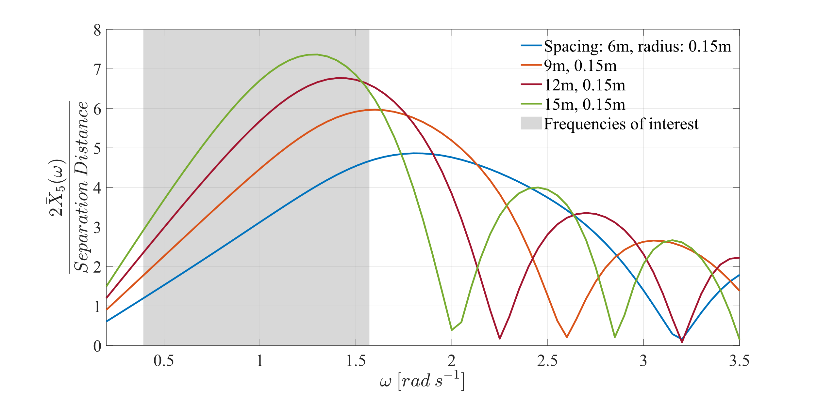

Figure . Normalized excitation force magnitude scaled by the seesaw device lever arm, defined as half the float-to-float spacing. Four float-to-float spacings were used. Wave frequencies or periods of interest are shaded in gray.

The added mass and excitation IRFs were examined for the 12 cases and appeared as expected—increase in magnitude with increasing float-to-float spacing (see Appendix A1).

The pylon radii examined for each spacing case had minimal effect on overall device hydrodynamics, as shown in the BEM analysis. For this reason, the following sections include only the 0.15 m pylon radius case to reduce the number of total simulations in the analysis. The frequencies of interest were changed to wave periods between 2 and 9 s (from between 4 and 16 s) to capture the largest device response. The 6 m float-to-float spacing case was also not considered for the WEC-Sim analyses by request from Laminar Scientific.

**Task 3 – Development of WEC-Sim Model**

To develop the WEC-Sim Simulink model of the seesaw device, the WEC-Sim OSWEC tutorial was used as reference [2]. The model consists of the seabed, fixed pylons, a rotational PTO, and the hydrodynamic body representing the seesaw. Model inputs included a fixed constraint location for the pylons at 0, 0, −10 m, where the coordinates correspond to x, y, and z directions. The PTO location was specified as 0, 0, 0.29 m in the Laminar Scientific design. The linear PTO model includes a damping coefficient applied to rotational motion.

Power matrices of the device were created by employing WEC-Sim’s batch run feature, referred to as Multiple Condition Run (MCR). Float spacings of 9, 12, and 15 m were used in this analysis. Each simulation recorded the average power produced by the PTO over a 3,000 s period, with a time-step of 0.05 s. The simulation runtime and time-step were chosen to ensure accuracy and convergence of average values [3]. The absolute value of power is averaged because the rotational PTO block generates power positively in only one direction. Joint North Sea Wave Project (JONSWAP) wave spectra were applied to each simulation, where significant wave heights and peak periods were modified for each iteration. Significant wave heights varied between 0.5 and 4 m in 0.5 m steps, and peak periods varied between 2 and 9 s in 1 s intervals. The MCR for each spacing created 64 simulations, for a total of 192 simulations.

For each iteration using the MCR, inputs included optimal PTO damping and hydrostatic stiffness. These were calculated for each simulation using Equation (1) (terms defined in Appendix A2):

|  |  |
| --- | --- |
| $$C_{opt}=B(ω)\sqrt{1+{\left(\frac{K_{H}-ω^{2}(M+A_{∞})}{ωB(ω)}\right)}^{2}}$$ | (1) [4] |

The power matrix results were used to determine the capture-width ratio (CWR) of the device. The CWR reflects the power produced by the device as a percentage of available wave power. Average available wave power is calculated by WEC-Sim during the simulation. Capture-width is calculated as the average power divided by the spherical float diameter (2.6 m). The wave conditions that correspond to breaking waves were identified on the power matrix and CWR plots by a red outline in Figures 7-9. Breaking waves were considered to occur when the wave steepness ($H/λ$) exceeded 7−1 [5]. Figures 7-9 show the average power (left) and CWR (right) of the 15 m, 12 m, and 9 m spaced seesaw respectively.

|  |  |
| --- | --- |
|  |  |

Figure . Left: Average power matrix of 15 m spaced seesaw device simulated in WEC-Sim using JONSWAP spectra waves, with optimized PTO damping for pitch motion. Significant wave heights range from 0.5 to 4 m, and peak periods range from 2 to 9 s. Red outline indicates breaking wave conditions. Right: CWR, or percent of average available wave power produced by 15m-spaced seesaw device.

|  |  |
| --- | --- |
|  |  |

Figure . Left: Average power matrix of 12 m spaced seesaw device simulated in WEC-Sim using JONSWAP spectra waves, with optimized PTO damping for pitch motion. Significant wave heights range from 0.5 to 4 m, and peak periods range from 2 to 9 s. Red outlines indicate breaking wave conditions. Right: CWR, or percent of average available wave power produced by 12m-spaced seesaw device.

|  |  |
| --- | --- |
|  |  |

Figure . Left: Average power matrix of 9 m spaced seesaw device simulated in WEC-Sim using JONSWAP spectra waves, with optimized PTO damping for pitch motion. Significant wave heights range from 0.5 to 4 m, and peak periods range from 2 to 9 s. Red outlines indicate breaking wave conditions. Right: CWR, or percent of average available wave power produced by 9m-spaced seesaw device.

**Task 4 – Data Processing**

Once the WEC-Sim model was developed and the power performance had been analyzed, two additional analyses were completed using the WEC-Sim model. The first examined the varied float-to-float spacing against wavelength in regular waves. The second utilized real-world wave field conditions (i.e. irregular waves) to simulate device performance.

The ratio of float-to-float spacing to wavelength was varied and simulated in regular waves to determine what effect the ratio has on average device power. Ratios were chosen between 0.2 and 2 in intervals of 0.1. The wave field was changed from JONSWAP spectra to regular waves, and the remaining simulation parameters were consistent. Because linearity was observed in the system, one wave height (0.5 m) was chosen for this analysis. Additionally, the wave height of 0.5 m would not induce wave breaking for the wave periods examined. Using the chosen wavelengths, wave periods were calculated from the dispersion relationship from linear wave theory (terms defined in Appendix A3):

$λ=\frac{gT^{2}}{2π}\tanh\left(\frac{2πd}{λ}\right) or T=\sqrt{\frac{2πλ}{g tanh\left(\frac{2πd}{λ}\right)}}$ (2) [6]

The ratio between the float-to-float spacing cases of the seesaw device and the regular waves’ wavelengths was iteratively evaluated for average power in Figure 10. The range of wave periods to determine the wavelength for each ratio varies from 8.4 to 2.2 s. The average power values peak at the 0.5 and 1.5 ratios. These local maxima indicate the required inherent antiphase behavior, where one float is at a wave crest while the other is at a wave trough, to produce maximum power from the device. Similarly, if the wavelength causes both floats to be collocated vertically, there is no power produced and the device will have minimal regular motion. The largest maximum occurs at a ratio of 0.5, or for the 15 m spacing case, a regular wave period of 4.5 s. While Figure 10 was produced using regular waves, this wave period associated with maximum antiphase behavior is similar to trends observed in Figures 6-8. As the spacing between floats decreases, the average power also decreases for all wave periods less than 6 s.

Examining the maximum power production case for the regular waves (wave period: 4.5 s, wave height: 0.5 m), the power decreases by approximately 66% on average for the three spacing cases when switching from regular to JONSWAP wave spectra, with all other simulation parameters held constant.

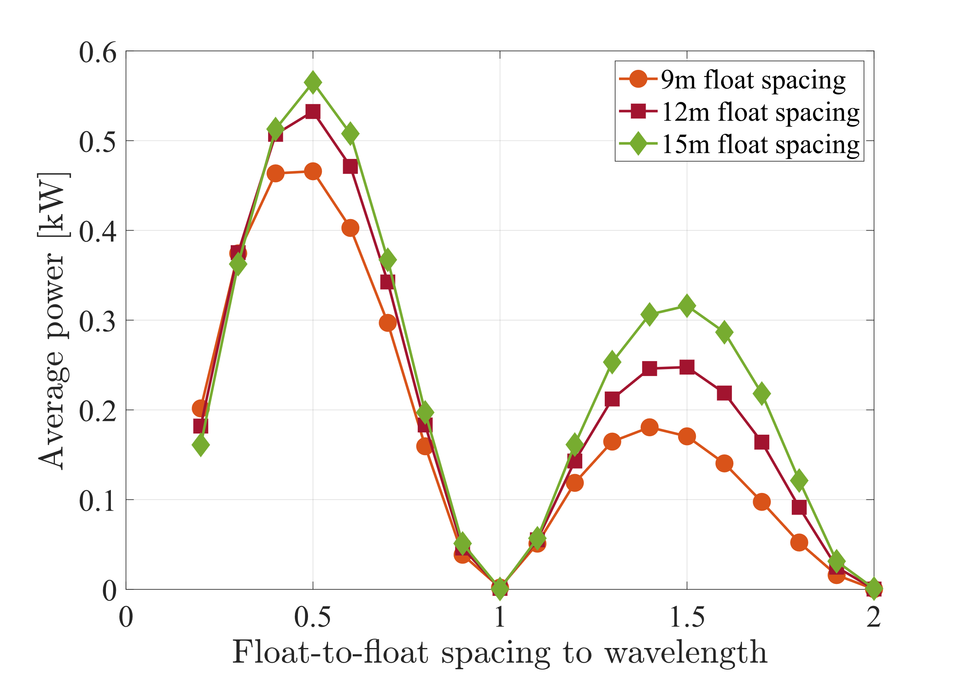

Figure . Average power of three float spacing cases in regular wave conditions. Wave height was 0.5 m, and periods were chosen to reflect a float-to-float spacing-to-wavelength ratio between 0.2 and 2 (8.4 to 2.2 s).

To estimate the annual power performance of the seesaw device with 15 m distance between floats, a coastal location was chosen in the United States with a wave energy period near 5 s, 10 m water depth, and relatively large significant wave height. The Marine Energy Atlas [7] and navigational chart 13237 from the National Oceanic and Atmospheric Administration (NOAA) [8] were used to make the location selection. South of Nantucket in Massachusetts, USA, met the criteria at coordinates 41.22N, −70.20W (see Figure A-5). The energy period, significant wave height, and omnidirectional wave power for the chosen location for monthly averages are included in Table 6. The annual average omnidirectional wave power at this location is 10.3 kW·m−1.

Table . Monthly average wave field parameters south of Nantucket, MA

|  |  |  |  |  |  |  |  |  |  |  |  |  |
| --- | --- | --- | --- | --- | --- | --- | --- | --- | --- | --- | --- | --- |
| Month | Jan | Feb | Mar | Apr | May | June | July | Aug | Sep | Oct | Nov | Dec |
| Energy period, Te [s] | 5.1 | 5.1 | 5.3 | 5.2 | 4.9 | 4.9 | 4.9 | 5.0 | 5.2 | 4.8 | 4.9 | 5.0 |
| Significant wave height, Hs [m] | 1.7 | 1.6 | 1.6 | 1.5 | 1.2 | 1.2 | 1.2 | 1.1 | 1.3 | 1.3 | 1.6 | 1.7 |
| Omni-directional wave power [kW·m−1] | 15.2 | 13.8 | 14.4 | 10.6 | 6.7 | 5.9 | 5.7 | 5.9 | 9.2 | 9.2 | 12.9 | 14.5 |

The method to convert energy period to peak wave period for JONSWAP spectra waves is included in Appendix A4. Using peak wave period and the significant wave height as simulation wave field parameters, WEC-Sim MCR produced 12 simulations. The simulation parameters remained the same as previous JONSWAP spectra analyses. Optimal PTO damping and hydrostatic stiffness were calculated for each case. The 12 average power values were averaged to create an indicator of yearly average power expected from the device at the study location.

The results of the seesaw device simulated near Nantucket, Massachusetts, are shown in Figure 11. The yearly average power for the seesaw device is 1.6 kW. The average power fluctuates throughout the year and is highest during the winter months. When compared to the wave conditions, there is a positive scaling effect between power produced and significant wave height. The CWR indicates that the device is utilizing approximately 11% of the available wave power throughout the year. This value inversely scales with peak wave period.

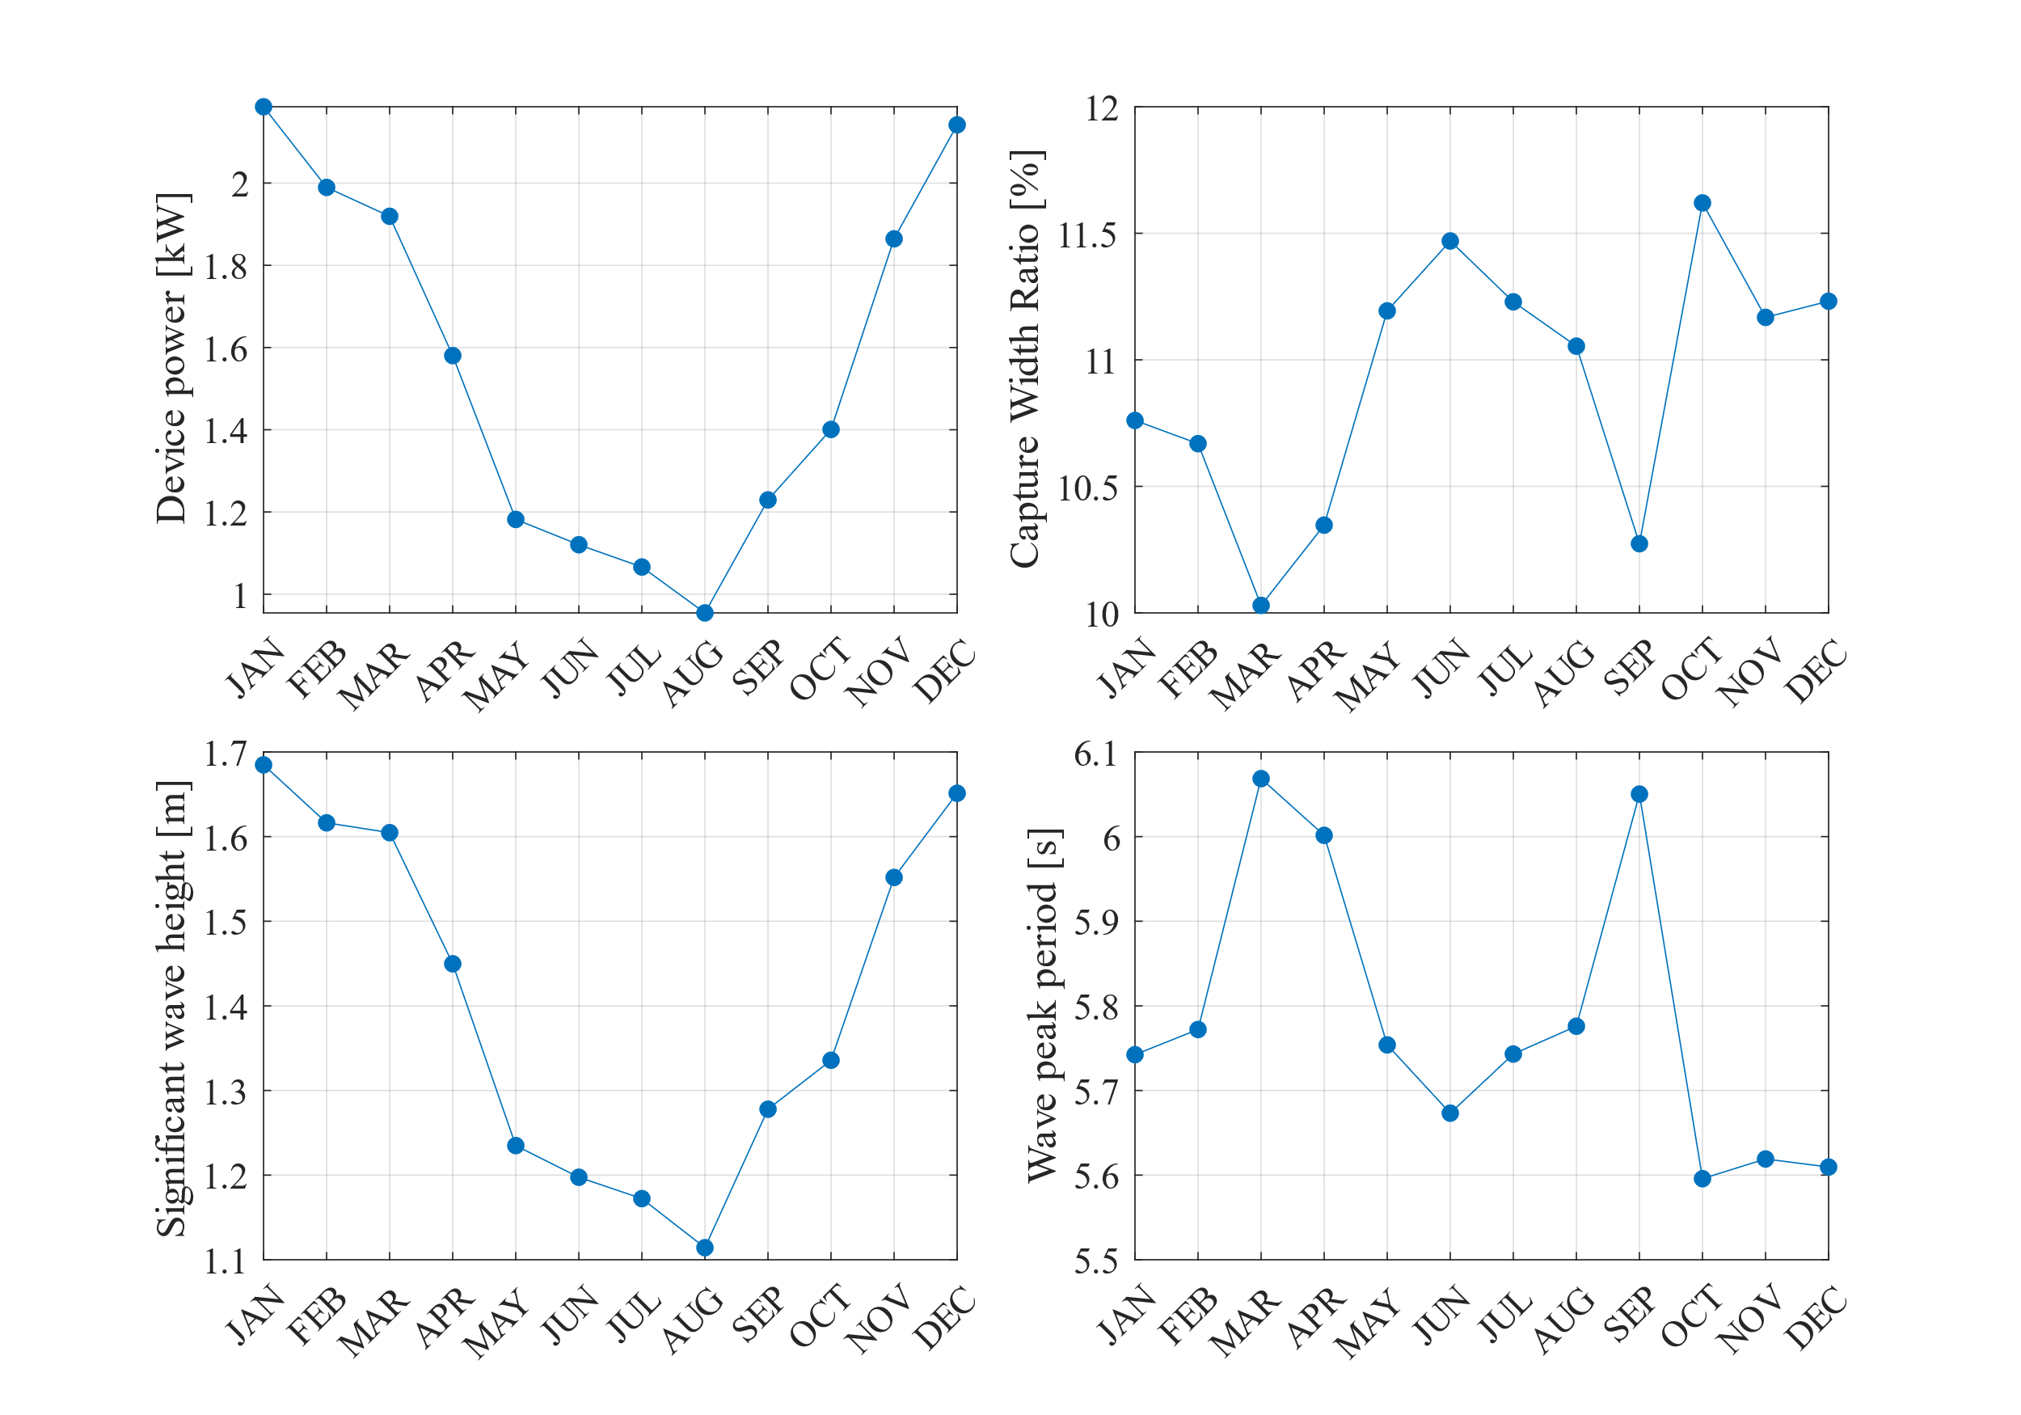

Figure . Monthly average values for the seesaw device performance at the case study location south of Nantucket, MA and corresponding wave conditions.

**Optional technical work**

As described in Section 3, an optional add-on to Task 1 was proposed. There was sufficient time and budget in the award to complete a BEM study of the tri-float configuration. The tri-float configuration was modeled with a center-to-center separation between the two aft floats of 3m, 6m, 9m, and 15m. 15 meter separation was found to be large enough that greater separations did not result in a significant change in hydrodynamics. At the natural frequency, the added mass and radiation damping decrease as aft float separation increases (Figures 12-13), while the excitation force changes very little with aft float separation (Figure 14). The pylons do not appear to shadow the aft float significantly. It is likely that the proximity of two aft floats is more significant in altering the radiation damping and added mass than shadowing by the pylon. The small change in hydrodynamics by using two aft floats should not result in significantly different power production but may increases costs by adding additional structure to the device.

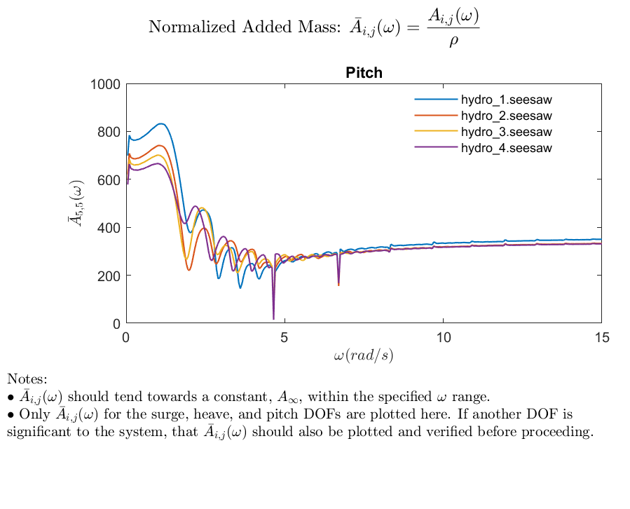

Figure . Normalized added mass in pitch for the tri-float seesaw device. Hydro_1, _2, _3, _4 correspond to aft float separations of 3m, 6m, 9m, 15m respectively.

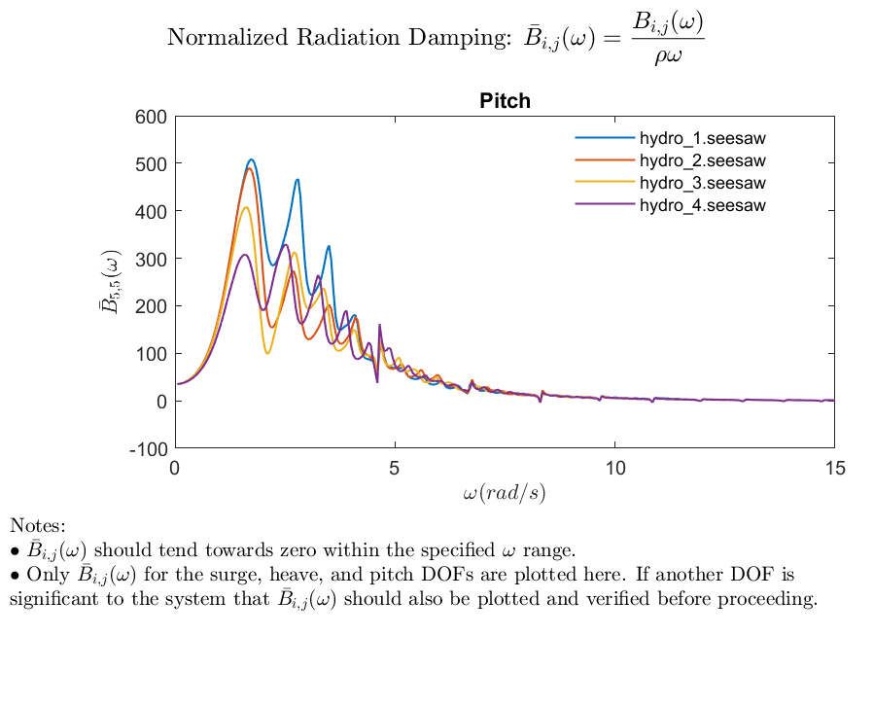

Figure . Normalized radiation damping in pitch for the tri-float seesaw device. Hydro_1, _2, _3, _4 correspond to aft float separations of 3m, 6m, 9m, 15m respectively.

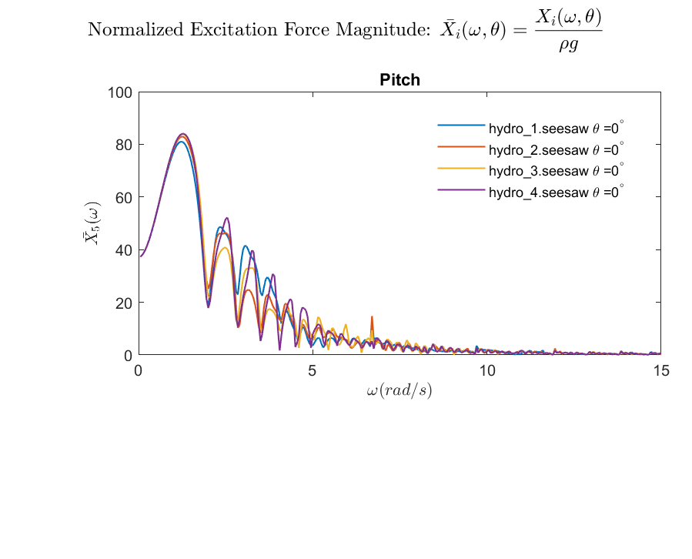

Figure . Normalized excitation force magnitude in pitch for the tri-float seesaw device. Hydro_1, _2, _3, _4 correspond to aft float separations of 3m, 6m, 9m, 15m respectively.

**Task 5 – Technology Transfer**

The WEC-Sim team met with personnel from Laminar Scientific June 4th, 2024, to complete the technology transfer. The work completed was reviewed, and the method and notes for running the models were discussed. Methods for LS to modify the models to suit custom needs were also indicated, and LS was given the opportunity to ask follow-up questions. All Capytaine and WEC-Sim inputs, models, output data, and post-processing scripts are available to Laminar Scientific and will be included in the project’s submission to MHKDR.

## 7.2 Lesson Learned and Test Plan Deviation

Technical work in this project proceeded smoothly and underbudget, allowing the facility to conduct the optional, time and budget-dependent technical work described in Sections 1 and 3. The WEC-Sim facility continues to develop robust workflows for a complete evaluation of a device from initial model creation to detailed evaluation. This experience continues to make WEC-Sim modeling awards fast and productive. In the WEC-Sim analyses, the 6 m float-to-float spacing case was not considered by request from Laminar Scientific.

Current literature heavily emphasizes the need to approach WEC design and modeling using the co-design approach instead of iterative methods. The device in this award evaluated the PTO based on a theoretically optimal linear damping. Realistic PTO models that can represent PTO dynamics in a realistic and complex way are necessary for truly accurate modeling and assessment of a given WEC architecture. While infeasible for all stages of device conceptualization, it is desirable that future modeling awards contain as much PTO detail as possible up front to allow for thorough evaluation and optimization.

# 8 CONCLUSIONS AND RECOMMENDATIONS

The BEM results indicate the hydrodynamic analysis matches the physical expectations for the device. Additionally, results showed that varying the pylon radius between 0.15 and 0.35 m had minimal effect on the hydrodynamics when compared with the varying float spacing. The power matrix results for the three spacing cases indicate that the best conditions for producing power occur at wave peak periods between 3 and 6 s depending upon the float spacing case, for JONSWAP wave spectra and with optimized PTO damping. The best conditions had the largest significant wave height while using a resonant peak period. The maximum average power produced by the 15 m spacing case was 14.1 kW and occurred during the 5 s peak period and 4 m significant wave height. The CWR plots for the three spacing cases indicate that the device performs linearly, and that performance relies upon a narrow range of peak wave periods.

The average power comparison with spacing-to-wavelength ratio further supports this deduction of a narrow-banded response for the device. In regular waves, peak production occurs when the two floats are exactly out of phase (i.e., when one float is at a wave crest while the other float is at a wave trough). Power production is maximized when the float spacing-to-wavelength ratio is 0.5. The increased power production in regular waves compared to the JONSWAP wave spectra cases demonstrates the dependence of the device upon regularity of antiphase behavior for maximizing power production.

A sample field location was selected to simulate the 15 m spacing case device. Because the device has both a low and narrow resonant frequency, geographically positioning the device to maximize power production is difficult. Yearly average wave conditions south of Nantucket, Massachusetts, include wave energy periods of 5.0 s and significant wave heights of 1.4 m, and the simulated device produced a yearly average power of 1.6 kW.

Finding a shallow deployment locations with large amplitude, unidirectional, regular waves at the device’s resonant frequency could drastically increase device power performance. However, the number and stringency of requirements on wave conditions for optimal power production will greatly limit deployment locations. Device design alterations could also increase power performance, such as allowing for two independently rotating lever arms about the pivot point instead of a single, rigid lever arm (similar to the Wave Star design). It is recommended that follow-on work assess the impact of decoupling the fore and aft floats or focus on robust site selection given the criteria for maximum power production above.

Each of the five project tasks were completed for this award. The WEC-Sim model of the LS device was developed and analyzed comprehensively, completing the project goals.

# 9 References

[1] M. Ancellin and F. Dias, "Capytaine: a Python-based linear potential flow solver," Journal of Open Source Software, pp. 4(36), 1341, 2019. https://joss.theoj.org/papers/10.21105/joss.01341.

[2] K. Ruehl, A. Keester, N. Tom, D. Forbush, J. Grasberger, S. Husain, D. Ogden and J. Leon, "WEC-Sim v6.0," 2023. https://doi.org/10.5281/zenodo.10023797.

[3] International Electrotechnical Commission, TS 62600-101:2015; Marine energy - Wave, tidal and other water current converters - Part 101: Wave energy resource assessment and characterization, Geneva, Switzerland: IEC, 2015. https://webstore.iec.ch/publication/22593.

[4] N. M. Tom, M. J. Lawson, Y. H. Yu and A. D. Wright, "Development of a nearshore oscillating surge wave energy converter with variable geometry," Renewable Energy, vol. 96 Part A, pp. 410-424, 2016. https://doi.org/10.1016/j.renene.2016.04.016.

[5] L. W. Schwartz and J. D. Fenton, "Strongly nonlinear waves," Annual Review of Fluid Mechanics, vol. 14, pp. 39-60, 1982. https://doi.org/10.1146/annurev.fl.14.010182.000351.

[6] R. G. Dean and R. A. Dalrymple, Water Wave Mechanics for Engineers and Scientists. Advanced Series on Ocean Engineering, 2, World Scientific Publishing Co, 1991.

[7] National Renewable Energy Laboratory; Sandia National Laboratories; Pacific Northwest National Laboratory, "Marine Energy Atlas," 2020b. [Online]. Available: https://maps.nrel.gov/marine-energy-atlas/.

[8] National Oceanic and Atmospheric Administration, "13237OG Nantucket Sound Nautical Chart".

[9] "The Specialist Committee on Waves Final Report and Recommendations to the 23rd ITTC," in 23rd International Towing Tank Conference, Venice, Italy, 2002.

[10] International Electrotechnical Commission, TS 62600-2:2019; Marine energy - Wave, tidal and other water current converters - Part 2: Marine energy systems - Design requirements, Geneva, Switzerland: IEC, 2019. https://webstore.iec.ch/publication/62399.

# 10 Acknowledgements

Sandia National Laboratories is a multimission laboratory managed and operated by National Technology & Engineering Solutions of Sandia, LLC, a wholly owned subsidiary of Honeywell International Inc., for the U.S. Department of Energy’s National Nuclear Security Administration under contract DE-NA0003525.

This work was authored in part by the National Renewable Energy Laboratory, operated by Alliance for Sustainable Energy, LLC, for the U.S. Department of Energy (DOE) under Contract No. DE-AC36-08GO28308. Funding provided by the U.S. Department of Energy Office of Energy Efficiency and Renewable Energy Water Power Technologies Office. The views expressed in the article do not necessarily represent the views of the DOE or the U.S. Government. The U.S. Government retains and the publisher, by accepting the article for publication, acknowledges that the U.S. Government retains a nonexclusive, paid-up, irrevocable, worldwide license to publish or reproduce the published form of this work, or allow others to do so, for U.S. Government purposes.

This project is funded under the Testing and Expertise for Marine Energy (TEAMER) program, administered by the Pacific Ocean Energy Trust, and funded by the U.S. Department of Energy Water Power Technologies Office.

# 11 Appendix A

## A1. Additional BEM results

Mesh resolution studies iterated through several resolutions for both the pylon and seesaw bodies. In the seesaw results below, resolutions 1-4 correspond respectively to 8, 16, 32, and 48 panels around a meridian. 48 panels were chosen as the ideal trade-off between accuracy and computational cost.

Figure A-1. Normalized added mass (top left), radiation damping (top right), and excitation force magnitude (bottom left) in pitch for the seesaw device. Several mesh resolutions in Capytaine compared to a high resolution WAMIT case.

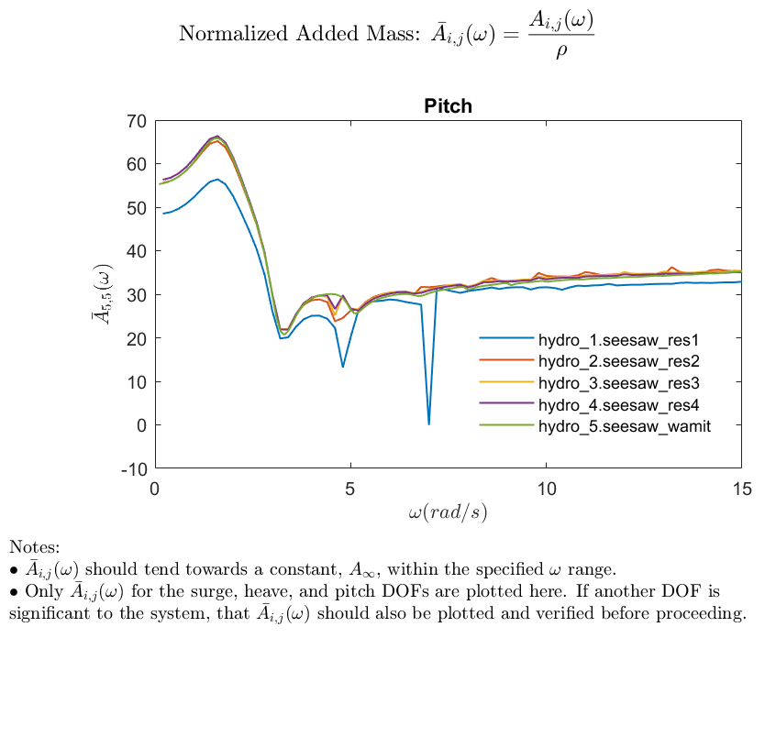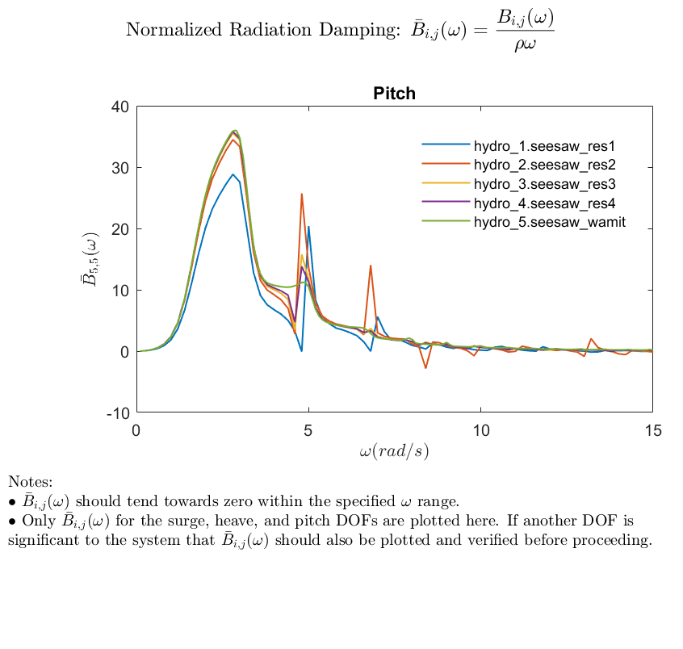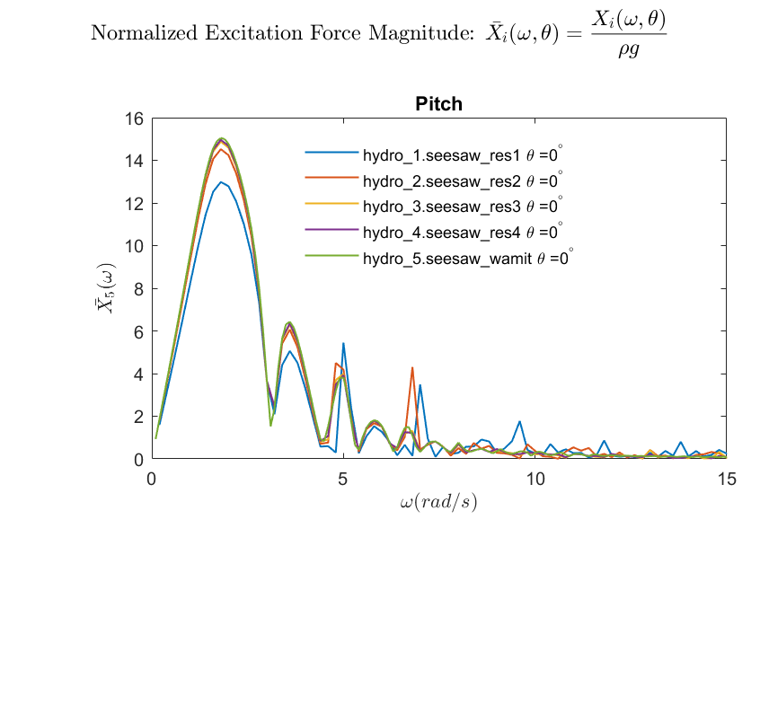

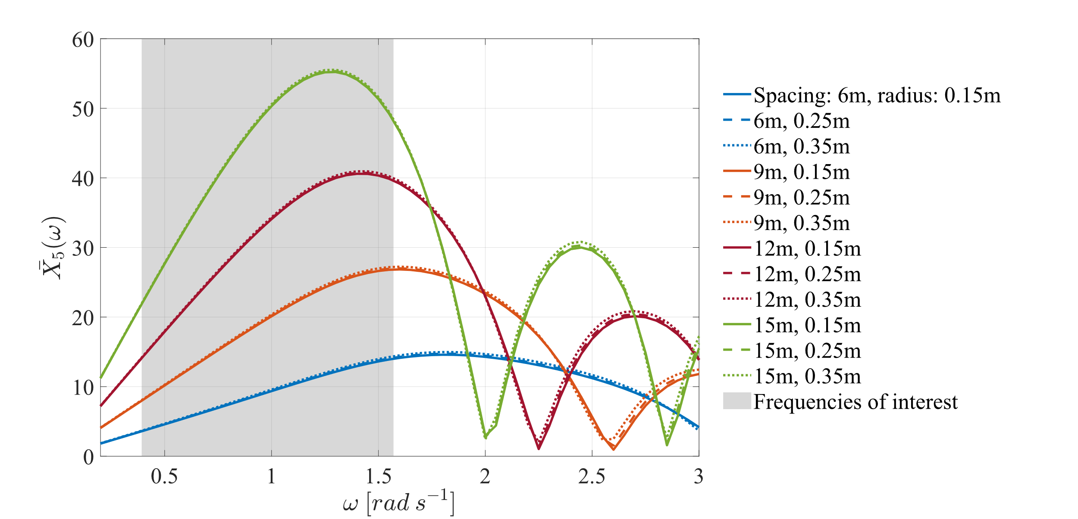

Figure A-2. Normalized excitation force magnitude in pitch for the seesaw device. Four float-to-float spacings and three pylon radii were used for a total of 12 configurations. Wave frequencies or periods of interest are shaded in gray.

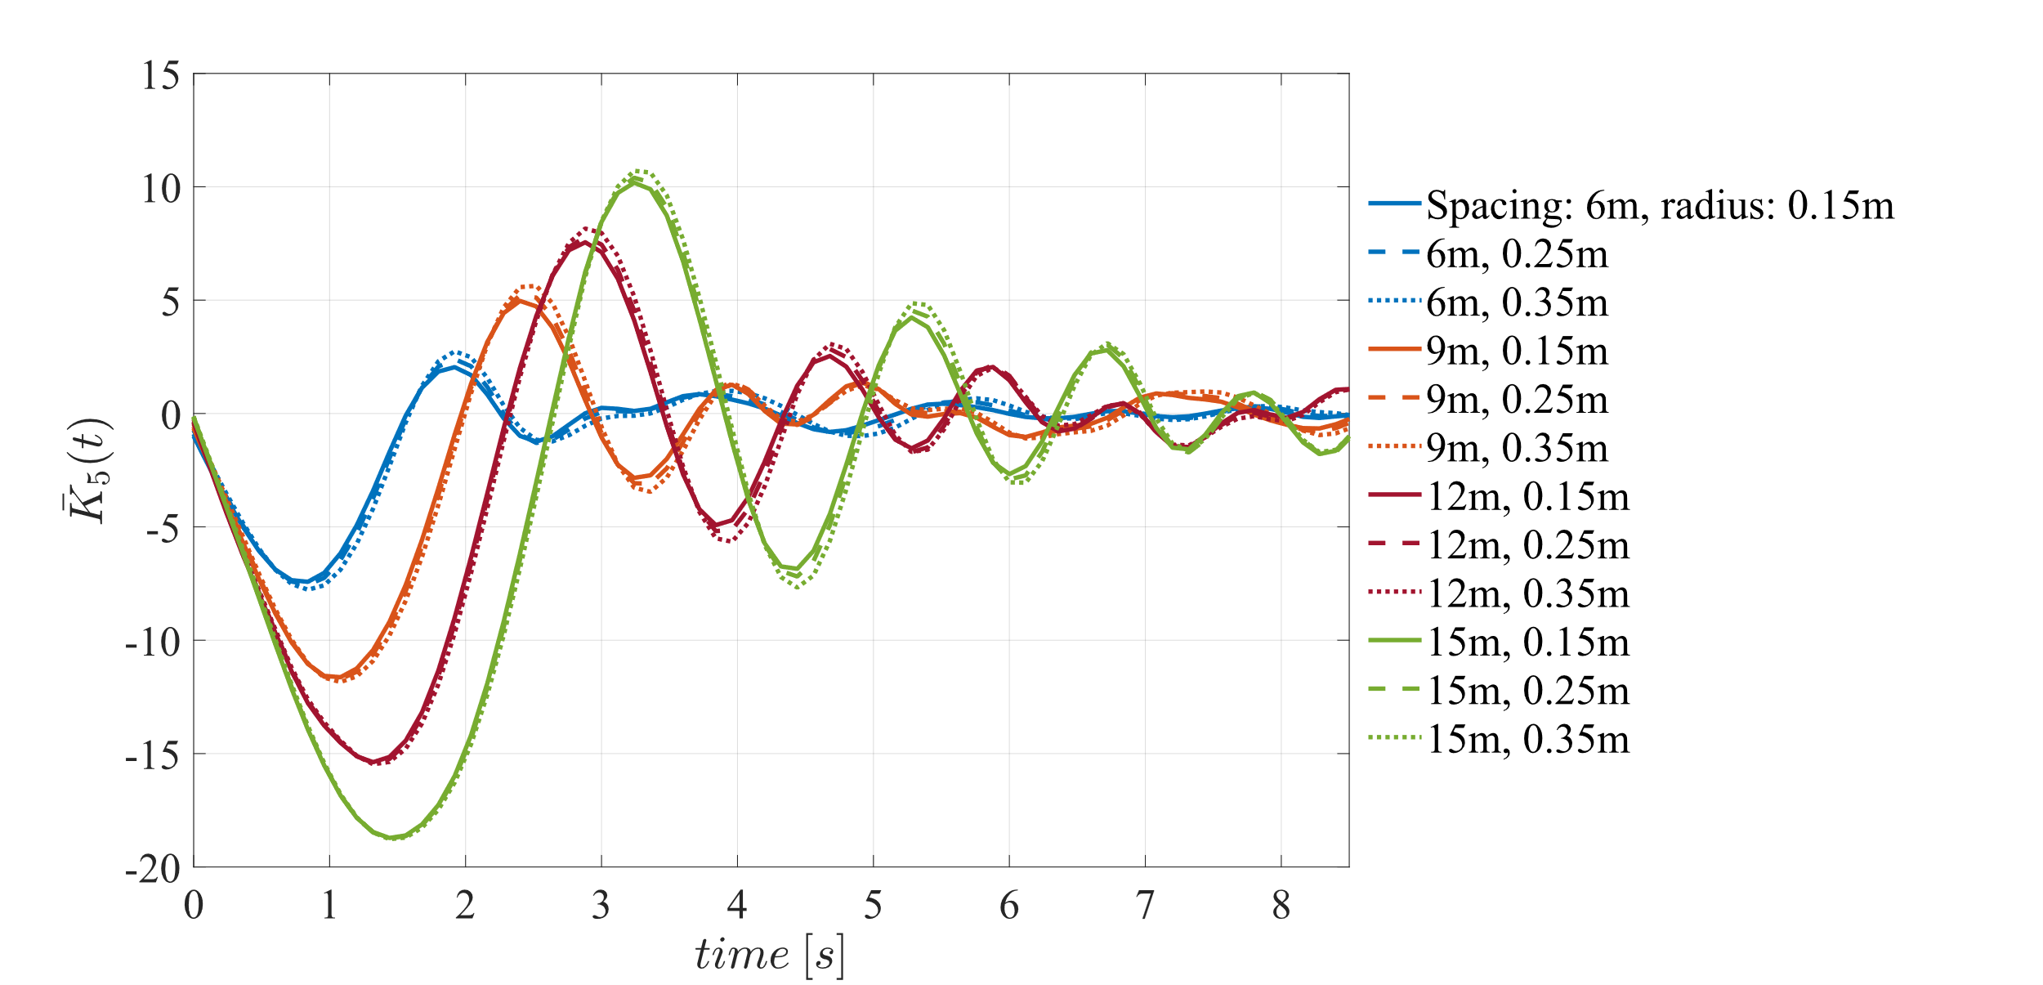

Figure A-3. Normalized excitation impulse response function in pitch for the seesaw device. Four float-to-float spacings and three pylon radii were used for a total of 12 configurations. All configurations reduce to oscillate about zero within 10 s, which is the e

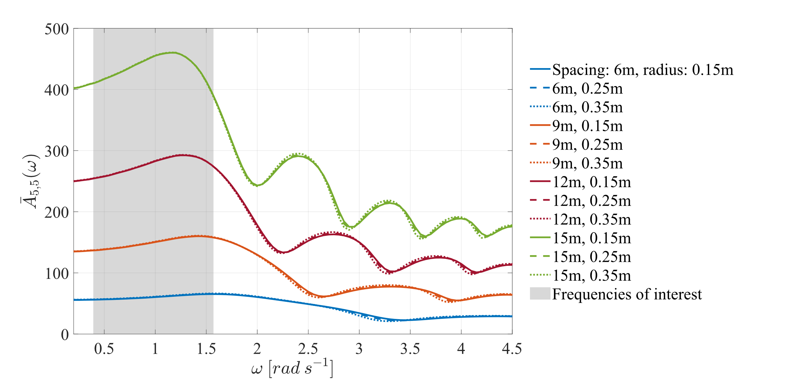

Figure A-4. Normalized added mass in pitch for the seesaw device. Four float-to-float spacings and three pylon radii were used for a total of 12 configurations. Wave frequencies or periods of interest are shaded in gray. The largest added mass occurred in the 15m spacing case, and peaked at a frequency of approximately 1.2 rad·s−1 or a wave period of 5.2 s. For each smaller float spacing case examined, the peak added mass occurred at slightly higher frequencies or smaller wave periods.

## A2. Optimal damping calculation

$C_{opt}=B(ω)\sqrt{1+{\left(\frac{K_{H}-ω^{2}(M+A_{∞})}{ωB(ω)}\right)}^{2}}$ (A-1) [4],

Table A-1. Variable definitions for optimal damping calculation

|  |  |  |
| --- | --- | --- |
| Variable | Description | Units |
| $$C_{opt}$$ | optimal damping coefficient | [N/(m/s)] |
| $$B(ω)$$ | seesaw radiation damping at a given radian frequency | [N/(m/s)] |
| $$K_{H}$$ | seesaw PTO stiffness (hydrostatic) | [N·rad/m] |
| $$ω$$ | wave radian frequency | [rad/s] |
| $$M$$ | seesaw pitch moment of inertia | [kg] |
| $$A_{∞}$$ | seesaw pitch added mass as radian frequency approaches infinity | [kg] |

Table A-2. Calculated optimal PTO damping values for 15m spacing case

|  |  |  |  |  |  |  |  |  |
| --- | --- | --- | --- | --- | --- | --- | --- | --- |
| Variable | Values | | | | | | | |
| Peak Period [s] | 2 | 3 | 4 | 5 | 6 | 7 | 8 | 9 |
| Optimal PTO damping  [(× 106) N/(m/s)] | 1.64 | 2.88 | 3.99 | 5.25 | 6.34 | 7.86 | 8.51 | 10.16 |

## A3. Dispersion relation from linear wave theory for calculating wavelength or wave period

## $λ=\frac{gT^{2}}{2π}\tanh\left(\frac{2πd}{λ}\right) or T=\sqrt{\frac{2πλ}{g tanh\left(\frac{2πd}{λ}\right)}}$ (A-2) [6]

Table A-3. Variable definitions for dispersion relation

|  |  |  |  |
| --- | --- | --- | --- |
| *Variable* | Description | Value | Units |
| $$λ$$ | = wavelength | = variable | [m] |
| $$g$$ | = gravitational acceleration | = 9.81 | [m s−2] |
|  | = wave period | = variable | [s] |
| $$d$$ | = water depth at device | = 10 | [m] |

## A4. Supplementary information for predicting device performance in the field

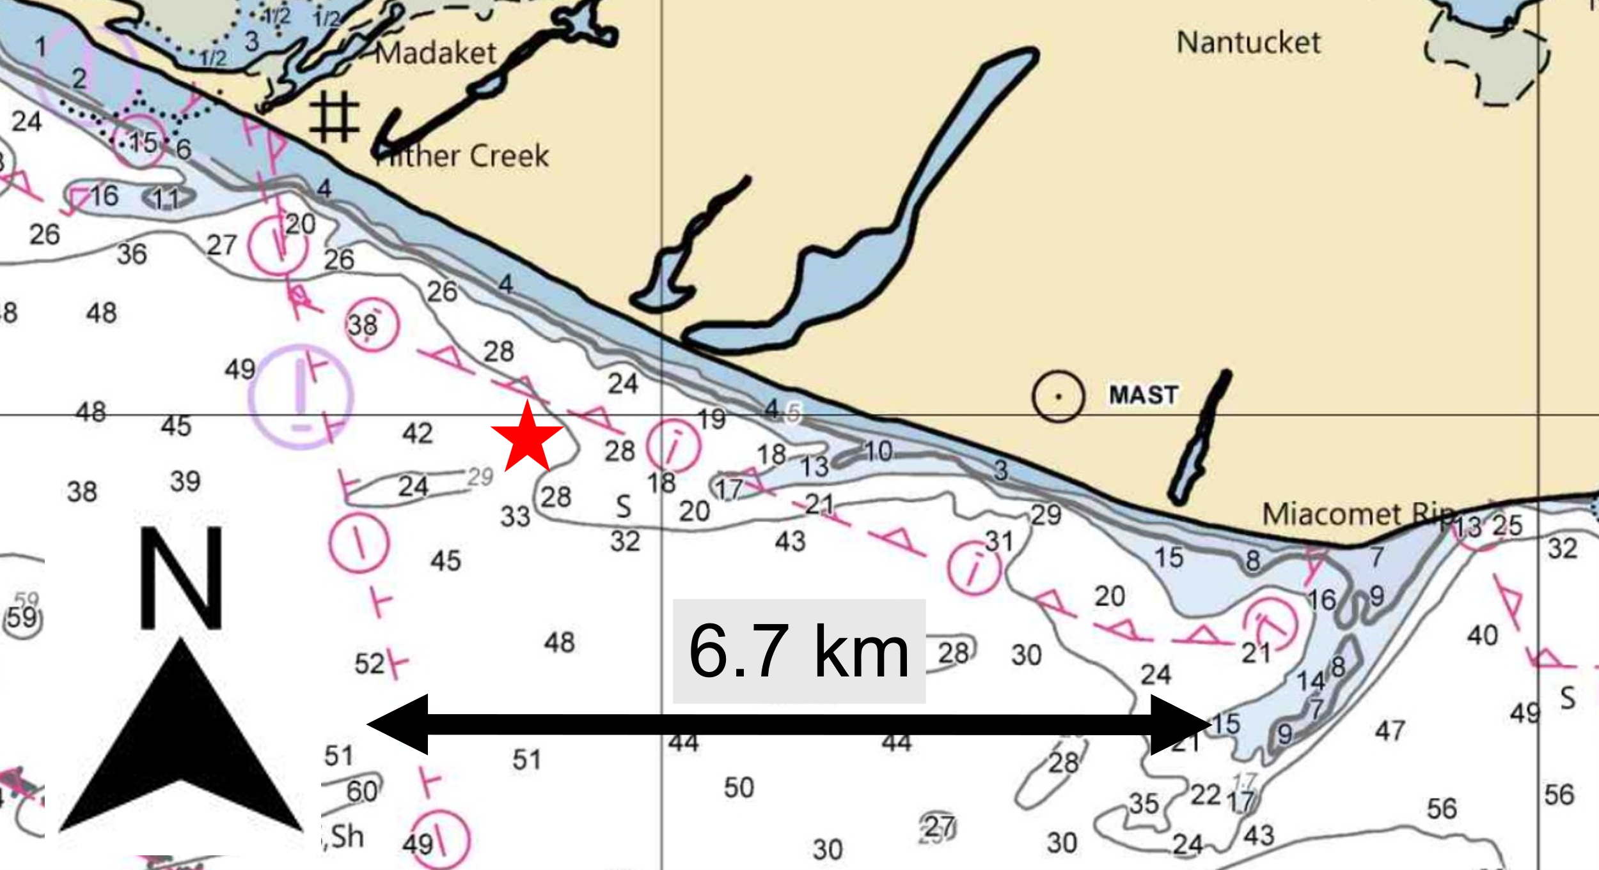

Figure A-5. Section of NOAA chart 13237 showing water depths (in feet) on the southern coast of Nantucket, MA. Red star indicates selected location for the seesaw device in the theoretical case study. Distances are approximate [8].

Conversion of wave energy period to peak wave period for JONSWAP spectra waves

$T_{p}=\frac{T_{e}}{f_{factor}}$ (A-3) [9],

Table A-4. Variable definitions for wave energy period to peak wave period calculation

|  |  |  |
| --- | --- | --- |
| Variable | Description | Units or equation |
| $$T_{p}$$ | wave peak period | [s] |
| $$T_{e}$$ | energy period | [s] |
| $$f_{factor}$$ | frequency factor | $$\left(0.8255+0.03852γ-0.005537γ^{2}+0.0003154γ^{3}\right) [9]$$ |
| $$γ$$ | peakedness for the single-peak JONSWAP wave model. | |

When:

$$\frac{T_{e}}{\sqrt{H_{s}}}≤3.6, γ=5,$$

$$\frac{T_{e}}{\sqrt{H_{s}}}>5, γ=1,$$

$3.6<\frac{T_{e}}{\sqrt{H_{s}}}≤5, γ=e^{\left(5.55-1.15\left(\frac{T_{e}}{\sqrt{H_{s}}}\right)\right)}$ (A-4) [10],

Where:

|  |  |  |
| --- | --- | --- |
| $$H_{s}$$ | = significant wave height | [m] |