**Test Plan**

A Tow Body Optical Camera System

Awardee: Igiugig Village Council

Awardee point of contact: AlexAnna Salmon

Facility: University of Washington, Applied Physics Laboratory

Facility point of contact: Cassandra Riel

Date: April 30, 2021

# Executive Summary

The Igiugig Village Council (IVC) has installed and is operating a hydrokinetic device in the Kvichak River in Igiugig, Alaska. A FERC license was issued on May 23, 2019. As required by the Project FERC license, a Fish Monitoring Plan (Plan) has been developed and implemented. The Plan outlines means and methods for collecting images from underwater cameras to assess the interaction of sockeye salmon with a cross-flow turbine. These cameras are on the turbine structure, and their field of view is in front of and directly behind one of the rotors. This system has not performed reliably over the year-long deployment, with multiple camera failures and issues with fiber optic communications occurring regularly.

IVC seeks to develop an alternative and independent camera monitoring approach working with University of Washington to develop a tow body for stabilized image acquisition that can be deployed over and adjacent to the turbine. The tow body will be maintained in place by an anchored vessel, which will also record the data streamed by the camera system where the images will be used in the Pacific Northwest National Laboratory (PNNL) developed EyeSea detection software. This TEAMER application focuses on providing specifications and basic design for a system that can obtain high resolution images for assessing fish interactions with a stationary and rotating turbine set. The ultimate goal, which extends beyond the scope of this application, is to deploy the system in the Kvichak River during two critical fish migration periods: a period when sockeye salmon smolt move downriver, and a period when adult sockeye salmon migrate upriver.

# Introduction to the project

Availability of hydrokinetic systems is a critical area of research. The system availability directly affects levelized cost of energy for a project. At present the hydrokinetic unit installed in the Kvichak River operates under a FERC license and an approved a Fish Monitoring Plan. For the system to operate during critical fish migration periods it is necessary that fish detection cameras be functional and that data be immediately available. With the present implementation this has proven to be difficult. Access to the system from October through May is impractical due to weather and river conditions. Cameras installed and operating in October may not last through the winter.

Expanding the available options for fish monitoring is critical for improving system availability, proving ability to continuously displace diesel generation, and demonstrating to regulatory agencies the interactions between hydrokinetic devices and the environment. This will allow de-risking of turbine technology. The Kvichak is uniquely suited to camera methodologies due to the clarity of the water in the river.

# Roles and Responsibilities of Project Participants

Ms. AlexAnna Salmon - President, Igiugig Village Council

Mr. Jarlath McEntee - ORPC, Inc. Senior Vice President & Chief Technology Officer

Ms. Kerry Strout Grantham - ORPC, Inc. Development Services Manager

Dr. Christopher Bassett - University of Washington, Applied Physics Laboratory

Dr. James Joslin - University of Washington, Applied Physics Laboratory

Mr. Paul Gibbs – University of Washington, Applied Physics Laboratory

Ms. Cassandra Riel - University of Washington, Applied Physics Laboratory

## Applicant Responsibilities and Tasks Performed

IVC and ORPC will support the University of Washington, Applied Physics Laboratory (UW-APL) staff in providing technical information about the current camera system design, available assets in Igiugig for tow body design, and technical review of the test plan.

## Network Facility Responsibilities and Tasks Performed

APL-UW will provide complete design specifications and documentation for an optical camera system deployable on a small tow body platform from an anchored, small vessel for monitoring the RivGen turbine. The deployment platform will be designed to ensure image stability with depth and orientation control for optimal field of view positioning. Additional considerations will be made for turbine protection, ease of deployment/recovery, maintenance in the Igiugig environment, and data transfer requirements. The specifications will include the optical cameras and lighting, the tow body platform, cabling, power supply, control computer, and data acquisition software. This complete specification will make the system stand-alone and deployable from any small vessel of opportunity, thus making its design applicable to a wide range of uses. UW-APL's expertise with complete marine system design from custom mechanical components, to software for real-time data acquisition and processing make them ideally suited for this task. Further assistance, once field testing is available, could include custom component fabrication, tank or vessel testing, deployment planning, and customization of real-time data processing software.

# Project Objectives

Availability of hydrokinetic systems is a critical area of research. The system availability directly affects levelized cost of energy for a project. For the system to operate during critical fish migration periods it is necessary that fish detection cameras be functional, and that data be immediately available. With the present implementation this has proven to be difficult. Access to the system from October through May is impractical due to weather and river conditions. Cameras installed and operating in October 2020 may not last through the winter.

Expanding the available options for fish monitoring is critical for improving system availability, proving ability to continuously displace diesel generation, and demonstrating to regulatory agencies the interactions between hydrokinetic devices and the environment. This will allow de-risking of turbine technology. The Kvichak is uniquely suited to camera methodologies due to the clarity of the water in the river.

IVC seeks technical support from experts to design an appropriate tow body to support the deployment of an optical camera system for imaging in the vicinity of the ORPC RivGen turbine. A camera system is installed in the Kvichak, but it has proven unreliable. Benchtop testing has not been able to reproduce the failures and the cameras have not been accessible since deployment.

To date IVC has worked with University of Alaska Fairbanks, Pacific Northwest National Laboratory, University of Washington, and ORPC to develop a protocol for fish monitoring:

* UAF has provided insight on what constitutes meaningful data in this context;
* MarineSitu, a University of Washington spinoff company has provided software for image collection from multiple cameras;
* PNNL has provided database and image processing tools to help identify interactions; and
* ORPC has provided technical and permitting support in implementing these systems.

The design team from the UW-APL will provide technical specifications suitable for the fabrication and deployment of the system. Optical and acoustic sensing packages have been developed by UW-APL for a variety of different deployments and applications. These results have been summarized in number of peer reviewed publications and conferences abstracts that summarize imaging capabilities and system endurance.

# Test Facility, Equipment, Software, and Technical Expertise

The Ocean Engineering department at UW-APL has considerable experience with various aspects of marine renewable energy research and the development of instrumentation packages. Multiple researchers have been previously involved with aspects of the project in Igiugig and are familiar with the challenges of operations at the site. UW-APL's expertise with complete marine system design makes them ideally suited for this work.

For the design of this tow-body camera system, UW-APL will leverage the experience of Dr. James Joslin and Paul Gibbs working with similar marine systems such as the machine vision camera system for the Adaptable Monitoring Package and tow bodies for sonar surveys. Specification of the camera system components, control computer, and data acquisition software will emphasize reliability and seek to minimize system cost and complexity while meeting the system requirements. To determine system stability during deployments, dynamic simulation software (ProteusDS) will be used to assess the tow-body’s hydrodynamics.

# Test or Analysis Article Description

This project is to design a tow body camera system to monitor for fish interactions with the Rivgen turbine. The design of this system will emphasize the ease of use and control of the camera field of view to capture the best image quality possible. While this system is being designed for the IVC Rivgen turbine, the design may be applied many other optical monitoring use cases. Optical monitoring of marine turbines is the best way to address regulatory concerns around animal interactions and advance the industry’s understanding of these risks. As is the case for the Rivgen turbine, performing this type of optical monitoring may be a requirement for turbine operation.

The camera system design will incorporate machine vision cameras and lights with a tow body platform that will be easily deployable from a small vessel. Figure 1 below shows an example of Allied Vision cameras along with a custom PVC underwater camera housing that would be suitable to this design. Paired with LED lights, this camera system will be connected to the vessel by a single power and Ethernet deployment cable. Onboard the vessel, a computer and power supply will be used to operate the camera system and control the image acquisition during the deployment.

|  |  |
| --- | --- |
|  |  |
| Figure - Allied Vision Manta machine vision cameras with a custom PVC underwater housing. | |

The tow-body will be designed to maintain stability and capture high quality images during deployments. Figure 2 shows an example tow body designed for similar deployments. The structure will include control surfaces to orient the system at the desired depth and standoff from the turbine structure. Adjustable mounting points will allow for the camera system to be oriented in different configurations depending on the deployment requirements.

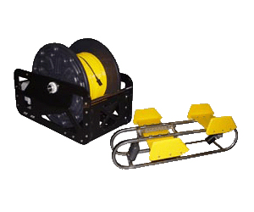

Figure - Example tow body designed for video camera systems.

# Work Plan

The goal of this project is to provide a complete design package for a tow body camera system that is deployable from a small vessel for monitoring fish interactions with a river turbine. All of this effort will be computer based, and will not involve any fabrication or testing of the equipment designed. The final deliverables will include design specifications and materials to enable rapid fabrication and use of the system given availability of funding. The design process will start with the development of a specifications document for the system requirements, then components will be selected for the available COTS products and the mechanical design of the custom components will begin; once a preliminary design is complete, it will be modelled in ProteusDS to ensure that the requirements have been achieved, and the design will be modified if necessary. Finally, the completed design will be used to develop the fabrication and assembly documents.

## Experimental Setup, Data Acquisition System, and Instrumentation

For the purposes of this test plan, the experimental setup described below outlines how the designed system is intended for use; however, this testing will not be completed as part of this effort.

During periods where optical monitoring of the Rivgen turbine is required for critical fish migrations, and the onboard cameras are not available, this camera system may act as a substitute. For deployment, a small vessel will anchor upstream of the turbine at a pre-determined location to allow the camera system to be properly positioned. Figure 3 below illustrates the proposed deployment configuration. The camera system will be powered from a small generator or battery bank on board the vessel, and controlled by a computer on board. The tow body will be lowered into the water by the user with a deployment cable to the desired depth and position relative to the turbine. Once in position, with the desired field of view confirmed by the operator, the acquisition software will be set to run for the duration of the deployment. Recovery of the system will involve hauling the tow body back aboard the vessel before returning to shore. Post processing of the acquired imagery may be performed to identify any fish/turbine interactions of interest.

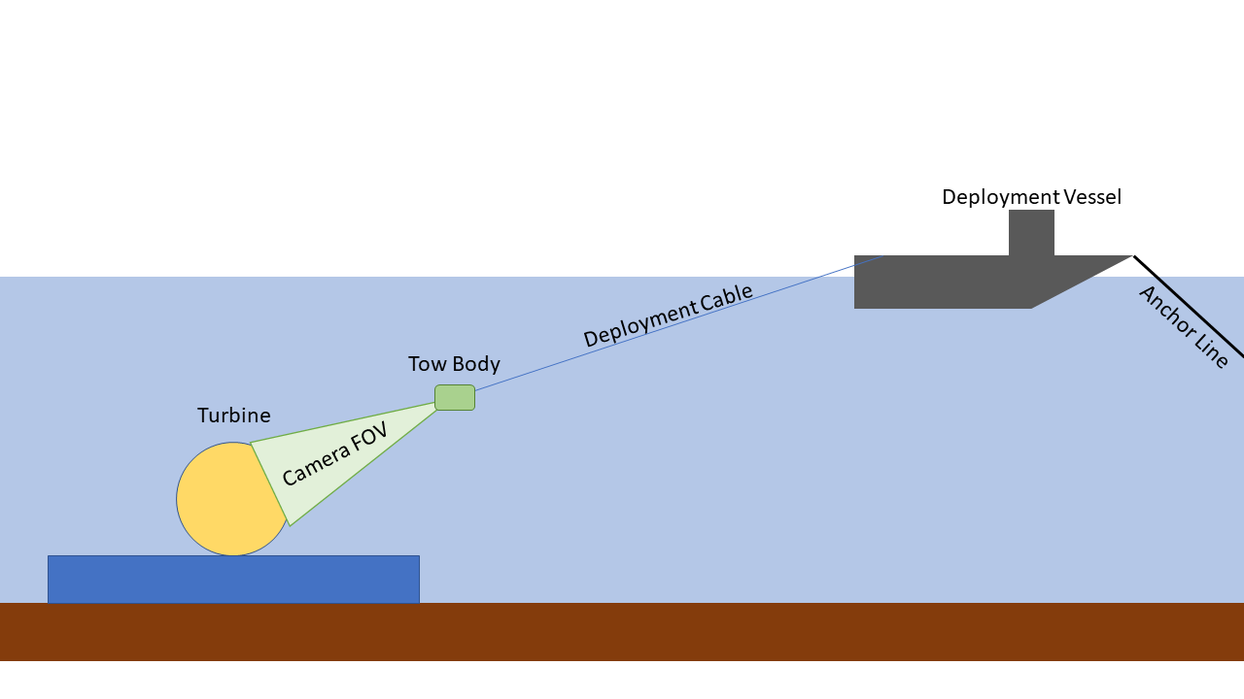

Figure - Deployment diagram showing turbine structure, tow body camera system, and deployment vessel.

## Numerical Model Description

A computer aided design (CAD) model of the tow body camera system will be completed in SolidWorks, and hydrodynamic stability of the system will be modelled in ProteusDS. SolidWorks models will include the cameras, lenses, lights, housings, camera fields of view, cabling, and tow body structure. Control surfaces on the tow body system will provide stability and may be adjusted to control the camera’s field of view of the turbine. Camera mounting points will also include options for changing the orientation on the tow body structure. These CAD models may be used for structural analysis of critical components if necessary, using finite element analysis. Custom component drawings, as well as assembly drawings, will be made from the CAD models.

Dynamic simulations of the tow body in the river flow will be performed in ProteusDS to determine system stability and placement of control surfaces. This modeling will capture the range of river currents and include the deployment cable and tow body structure as a rigid body.

## Test and Analysis Matrix and Schedule

The schedule shown below assumes that the design process will start in early January, if funds are available earlier, the schedule may be moved up to allow for an earlier completion date.

|  |  |  |  |  |  |  |  |  |  |  |  |  |  |
| --- | --- | --- | --- | --- | --- | --- | --- | --- | --- | --- | --- | --- | --- |
| **Design Task** | Month | January | | | | February | | | | March | | | |
|  | Week | 1 | 2 | 3 | 4 | 1 | 2 | 3 | 4 | 1 | 2 | 3 | 4 |
| Component Specification |  |  |  |  |  |  |  |  |  |  |  |  |  |
| CAD Modeling |  |  |  |  |  |  |  |  |  |  |  |  |  |
| Dynamic Simulation |  |  |  |  |  |  |  |  |  |  |  |  |  |
| Design Document Preparation |  |  |  |  |  |  |  |  |  |  |  |  |  |

## Safety

All efforts on this project will be computer-based and will not require safety protocols.

## Contingency Plans

As this is entirely a computer-based design effort, no contingency plans are needed.

## Data Management, Processing, and Analysis

### Data Management

The data products from this effort will be the design specifications document, bill of materials with component sources and costs, custom component machine drawings for fabrication, and assembly instructions. All of these documents will be considered deliverables from UW-APL to IVC at the end of the project.

### Data Processing

No data processing will be required for this project.

### Data Analysis

No data analysis will be required for this project.

# Project Outcomes

## Results

The tow body camera system designed for this project is shown in Figures 4 and 5 below. This system includes the stereo optical camera system with two lights and control bottle shown in Figure 6. The tow body design allows for mounting of the camera system in forward, rear, sideways, or angled orientations with adjustable tilt of the fields of view. This adjustability should allow this design to be used from any viewing location that is above the target. As indicated in Figure 4, the design includes adjustable elevators and multiple tow connection points to control the bodies orientation at different current speeds. The overall form of the tow body is designed to protect the camera system while leaving the field of view unobstructed. Flat panels connected by angle brackets make up the majority of the design to minimize production time and cost. In addition, the hydrodynamic profile does not change with different camera configurations, allowing the same body to be used for all mounting options. As a back up depth limiting option, a float may be attached to the tow rail on a short line that would guarantee that the system does not drop into the rotor swept area of the turbine.

The design package for the tow body includes the CAD model, mechanical drawings for fabrication of custom parts (as *.PDFs), and line drawings for laser cut or waterjet parts (as *.DXFs).

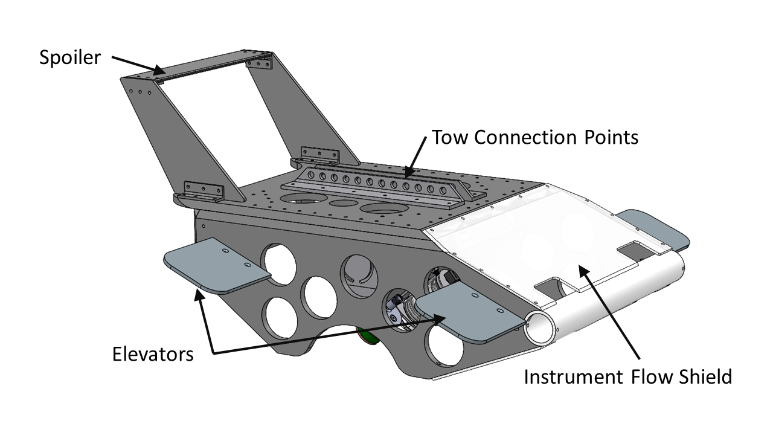

Figure - Tow body design with control features.

|  |  |
| --- | --- |
|  |  |
| Figure - Tow body with starboard side facing and back facing camera mounts. | |

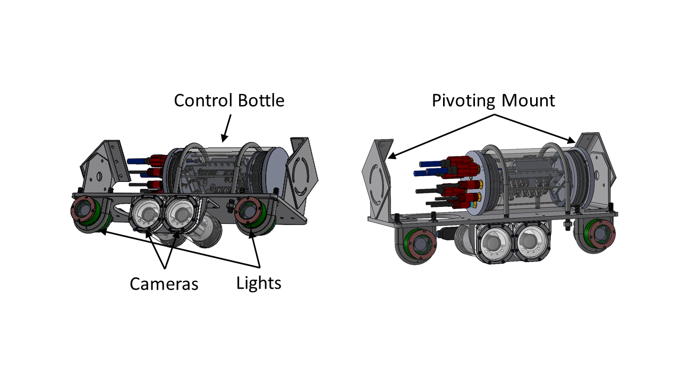

Figure - Camera system on tow body mount.

The camera system includes two machine vision cameras and two high power LED lights along with a control bottle. These components were specified as either an APL built option or using COTS components, details for all components are provided in the bill of materials included in the Appendix. The APL option would include custom housings and electronics for instrument control. Alternatively, the same structure will work with Sexton housings for the cameras, Deep Sea Power and Light LED SeaLites, and a BlueRobotics control housing with and Ethernet switch and relay control board. Custom data acquisition software (Stereo Vision) is available either through APL or TEAMER network facility partner MarineSitu if funding is available for system fabrication and testing.

Deck controls for this system include a portable computer, power supply, umbilical cable, and the deployment line on a DC winch. Potential low-cost options for these components are provided in the bill of materials although the selection will depend on the deployment vessel and parts that may already be available.

Table 1 below shows a summary of the bill of materials for the cost of the major components of the system and the remaining tasks as performed by APL. For more details, please see the full bill of materials in the Appendix or in the design package. The majority of the system cost is in the camera system, which could be reduced by limiting the system to one camera or switching the housings for lower cost BlueRobotics options. The tasks for fabrication and assembly, tank testing, and field testing as performed by APL include use of a saltwater test tank for camera calibration and a small vessel for towing and stability performance testing.

Table - Summary bill of materials.

|  |  |  |  |
| --- | --- | --- | --- |
| **TEAMER IVC/ORPC Camera Tow Body: Summary** | | | |
|  | **Cost** | |  |
|  | Option 1 | Option 2 | Notes |
| Camera System | $19,196 | $18,153 |  |
| Tow Body | $2,805 |  |  |
| Deck Controls | $1,927 |  | Does not include generator. |
| Fabrication and Assembly | $14,426 |  | Support for ordering parts, fabrication of custom parts, and system assembly |
| Tank Testing | $10,991 |  | In water testing to confirm operations and camera calibration |
| Field Testing | $7,246 |  | Vessel testing to confirm tow orientation |
|  |  |  |  |
| **Totals:** | **$56,591** | **$55,548** |  |

Per the award agreement, Technical Support Recipient (TSR) must:

## Lesson Learned and Test Plan Deviation

Design of this tow body camera system was completed as proposed with the exception of the completion date being delayed. This delay was due to personnel availability due to delays on previous unrelated projects.

# Conclusions and Recommendations

The tow body camera system designed for the IVC will allow for a wide range of viewing angles and deployment locations of the machine vision optical system for monitoring the RivGen turbine. This system can be deployed from a small vessel with minimal infrastructure or personnel requirements. When funding is available to build and test the system, APL-UW can perform all or part of the fabrication, assembly, and testing tasks. The cost of the system components, along with these tasks at APL is included in the bill of materials. Similarly, software support for data acquisition and processing is available through APL or TEAMER network facility partner MarineSitu. Due to long lead times on some of the system components (in particular the underwater cabling and connectors) it is recommended to allow approximately 4 months for system delivery.

# Appendix

## Bill of Materials:

|  |  |  |  |
| --- | --- | --- | --- |
| **TEAMER IVC/ORPC Camera Tow Body: Summary** | | | |
|  | **Cost** | |  |
|  | Option 1 | Option 2 | Notes |
| Camera System | $19,196 | $18,153 |  |
| Tow Body | $2,805 |  |  |
| Deck Controls | $1,927 |  | Does not include generator. |
| Fabrication and Assembly | $14,426 |  | Support for ordering parts, fabrication of custom parts, and system assembly |
| Tank Testing | $10,991 |  | In water testing to confirm operations and camera calibration |
| Field Testing | $7,246 |  | Vessel testing to confirm tow orientation |
|  |  |  |  |
| **Totals:** | **$56,591** | **$55,548** |  |

|  |  |  |  |  |  |  |  |
| --- | --- | --- | --- | --- | --- | --- | --- |
| **Camera System for Option 1: COTS Electronics Assembly** | | | | | | | |
|  |  |  |  |  |  | **Total:** | $19,196.00 |
| **Category** | **Part** | **Part Number** | **Manufacturer** | **Description** | **Cost** | **Quantity** | **Total Cost** |
| Cameras | Machine Vision Camera | BFS-PGE-50S5M-C | FLIR | Blackfly S GigE 5.0 MP, 22 FPS, Sony IMX264, Mono | $835.00 | 2 | $1,670.00 |
| Cameras | Lens | KOW-LM5JCM | Kowa | Model: BFS-PGE-50S5M-C: 5.0 MP, 22 FPS, Sony IMX264, Mono | $464.00 | 2 | $928.00 |
| Cameras | Camera I/O Cable | ACC-01-3009 | FLIR | Hirose HR10 (6 Pin) GPIO cable | $25.00 | 2 | $50.00 |
| Cameras | Camera Housing |  | APL Custom | PVC 4.5" housing with dome view port | $2,500.00 | 2 | $5,000.00 |
| Lights | Light |  | APL Custom | High Power LED Array in Custom Housing | $2,000.00 | 2 | $4,000.00 |
| Controller | Camera Control Housing |  | APL Custom | PVC 6" housing | $1,500.00 | 1 | $1,500.00 |
| Controller | Camera Controller |  | APL Custom | Custom Controller | $500.00 | 1 | $500.00 |
| Controller | Ethernet Switch |  | Netgear | 5 port Gigabit Ethernet Switch | $21.00 | 1 | $21.00 |
| Bulkhead | Umbilical Bulkhead | DBH13M | McCartney Subconn | 13 Contact Male Power and Ethernet | $207.00 | 1 | $207.00 |
| Bulkheads | Camera Bulkhead | DBH13F | McCartney Subconn | 13 Contact Female Power and Ethernet | $250.00 | 2 | $500.00 |
| Bulkheads | Light Bulkhead | MCBH6F | McCartney Subconn | 5 Contact Micro Circular | $110.00 | 2 | $220.00 |
| Cables | Camera to Controller |  | McCartney Subconn | DIL13F//DLSA-F//1m D/P cable//DLSA-M//DIL13M | $500.00 | 2 | $1,000.00 |
| Cables | Light to Controller |  | McCartney Subconn | MCIL6F to MCIL6M, 1 m | $300.00 | 2 | $600.00 |
| Cables | Surface Umbilical |  | McCartney Subconn | DIL13F//DLSA-F//30m D/P cable | $3,000.00 | 1 | $3,000.00 |

|  |  |  |  |  |  |  |  |
| --- | --- | --- | --- | --- | --- | --- | --- |
| **Camera System for Option 2: COTS Electronics Assembly** | | | | | | | |
|  |  |  |  |  |  | **Total:** | $18,153.00 |
| **Category** | **Part** | **Part Number** | **Manufacturer** | **Description** | **Cost** | **Quantity** | **Total Cost** |
| Cameras | Machine Vision Camera | BFS-PGE-50S5M-C | FLIR | Blackfly S GigE 5.0 MP, 22 FPS, Sony IMX264, Mono | $835.00 | 2 | $1,670.00 |
| Cameras | Lens | KOW-LM5JCM | Kowa | Model: BFS-PGE-50S5M-C: 5.0 MP, 22 FPS, Sony IMX264, Mono | $464.00 | 2 | $928.00 |
| Cameras | Camera I/O Cable | ACC-01-3009 | FLIR | Hirose HR10 (6 Pin) GPIO cable | $25.00 | 2 | $50.00 |
| Cameras | Camera Housing |  | Sexton or Similar | Aluminum Enclosure with 4.5" dome port | $2,375.00 | 2 | $4,750.00 |
| Lights | Light | LSL-2000 | Deep Sea Power and Light | LED SeaLite | $2,130.00 | 2 | $4,260.00 |
| Controller | Camera Control Housing |  | BlueRobotics | 6" Acrylic Enclosure | $317.00 | 1 | $317.00 |
| Controller | Camera Controller |  | NCD-IO | 4 channel solid state relay contoller | $630.00 | 1 | $630.00 |
| Controller | Ethernet Switch |  | Custom | 5 port Gigabit Ethernet Switch | $21.00 | 1 | $21.00 |
| Bulkhead | Umbilical Bulkhead | DBH13M | McCartney Subconn | 13 Contact Male Power and Ethernet | $207.00 | 1 | $207.00 |
| Bulkheads | Camera Bulkhead | DBH13F | McCartney Subconn | 13 Contact Female Power and Ethernet | $250.00 | 2 | $500.00 |
| Bulkheads | Light Bulkhead | MCBH5F | McCartney Subconn | 5 Contact Micro Circular | $110.00 | 2 | $220.00 |
| Cables | Camera to Controller |  | McCartney Subconn | DIL13F//DLSA-F//1m D/P cable//DLSA-M//DIL13M | $500.00 | 2 | $1,000.00 |
| Cables | Light to Controller |  | McCartney Subconn | MCILRA5F to MCIL 5M, 1 m | $300.00 | 2 | $600.00 |
| Cables | Surface Umbilical |  | McCartney Subconn | DIL13F//DLSA-F//30m D/P cable | $3,000.00 | 1 | $3,000.00 |

|  |  |  |  |  |  |  |  |
| --- | --- | --- | --- | --- | --- | --- | --- |
| **Tow Body** |  |  |  |  |  |  |  |
|  |  |  |  |  |  | **Total:** | $2,805.24 |
| **Category** | **Part** | **Part Number** | **Manufacturer** | **Description** | **Cost** | **Quantity** | **Total Cost** |
| Frame | Top Plate |  | Custom | Waterjet 3/4" HDPT top plate with routed edges | $120.00 | 1 | $120.00 |
| Frame | Side Plate |  | Custom | Waterjet 3/4" HDPT side plates with routed edges, drilled and tapped edge holes | $120.00 | 2 | $240.00 |
| Frame | Front/top Plate |  | Custom | Lasercut 1/4" Plexiglass with countersunk holes | $50.00 | 1 | $50.00 |
| Frame | Front/bottom Plate |  | Custom | Lasercut 1/4" Plexiglass with countersunk holes | $50.00 | 1 | $50.00 |
| Frame | Front Pipe |  | Custom | 3" PVD pipe cut to length and drilled mounting holes | $30.00 | 1 | $30.00 |
| Frame | Spoiler Riser |  | Custom | Lasercut 3/8" delrin with rounded edges | $50.00 | 2 | $100.00 |
| Frame | Spoiler |  | Custom | Lasercut 3/8" delrin with rounded edges | $50.00 | 1 | $50.00 |
| Frame | Elevator |  | Custom | Lasercut 3/8" delrin with rounded edges | $30.00 | 4 | $120.00 |
| Frame | Camera System Mounting Plate |  | Custom | Lasercut 3/8" aluminum | $50.00 | 1 | $50.00 |
| Frame | Camera Mount Angle 1 |  | Custom | Machined aluminum angle bracket | $150.00 | 1 | $150.00 |
| Frame | Camera Mount Angle 2 |  | Custom | Machined aluminum angle bracket | $100.00 | 2 | $200.00 |
| Frame | Camera Mount Angle 3 |  | Custom | Machined aluminum angle bracket | $100.00 | 2 | $200.00 |
| Frame | L bracket 1 |  | Custom | Machined aluminum L bracket | $50.00 | 4 | $200.00 |
| Frame | L bracket 2 |  | Custom | Machined aluminum L bracket | $50.00 | 2 | $100.00 |
| Frame | L bracket 3 |  | Custom | Machined aluminum L bracket | $50.00 | 2 | $100.00 |
| Frame | L bracket 4 |  | Custom | Machined aluminum L bracket | $50.00 | 2 | $100.00 |
| Frame | L bracket 5 |  | Custom | Machined aluminum L bracket | $50.00 | 4 | $200.00 |
| Frame | L bracket 6 |  | Custom | Machined aluminum L bracket | $50.00 | 2 | $100.00 |
| Frame | L bracket 7 |  | Custom | Machined aluminum L bracket | $50.00 | 2 | $100.00 |
| Hardware | U-Bolt | 8896T32 | McMaster | Control bottle u-bolt | $27.43 | 2 | $54.86 |
| Hardware | U-Bolt | 3176T71 | McMaster | Light u-bolt | $29.99 | 2 | $59.98 |
| Hardware | 5-16 Bolt 1.5" Buttonhead | 98164A276 | McMaster | 316 Stainless Steel Button Head Hex Drive Screw Super-Corrosion-Resistant, 5/16"-18 Thread Size, 1-1/2" Long | $9.17 | 18 | $165.06 |
| Hardware | 5-16 Bolt 1" Flathead | 90585A583 | McMaster | 316 Stainless Steel Hex Drive Flat Head Screw 82 Degree Countersink Angle, 5/16"-18 Thread Size, 1" Long | $4.10 | 14 | $57.40 |
| Hardware | 5-16 Bolt 5" Flathead | 90585A665 | McMaster | 316 Stainless Steel Hex Drive Flat Head Screw 5/16"-18 Thread Size, 5" Long | $3.09 | 2 | $6.18 |
| Hardware | 5-16 Hex Nut | 94804A030 | McMaster | Super-Corrosion-Resistant 316 Stainless Steel Hex Nut 5/16"-18 Thread Size | $5.42 | 3 | $16.26 |
| Hardware | 5-16 Flat Washer | 90107A030 | McMaster | 316 Stainless Steel Washer for 5/16" Screw Size, 0.344" ID, 0.75" OD | $9.15 | 2 | $18.30 |
| Hardware | 5-16 Lock Washer | 92147A030 | McMaster | 316 Stainless Steel Split Lock Washer for 5/16" Screw Size, 0.322" ID, 0.583" OD | $7.06 | 2 | $14.12 |
| Hardware | 3/4-16 Bolt | 92198A388 | McMaster | 18-8 Stainless Steel Hex Head Screw 3/4"-16 Thread Size, 3-1/2" Long | $3.86 | 2 | $7.72 |
| Hardware | 3/4-16 Hex Nuts | 91845A175 | McMaster | 18-8 Stainless Steel Hex Nut 3/4"-16 Thread Size | $3.80 | 1 | $3.80 |
| Hardware | 1/2 Shackle | 3555T49 | McMaster | Galvanized Steel Safety-Pin Shackle - for Lifting 7/16" Thick | $15.28 | 2 | $30.56 |
| Hardware | Cable strain relief grip | 69675K64 | McMaster | Cable Support Grip with One Loop, for 0.53" to 0.73" Cable OD, Corrosion-Resistant | $32.00 | 1 | $32.00 |
| Tow Line | 3/8" Spectra or similar |  | Amazon | 3/8" Amsteel blue or similar | $79.00 | 1 | $79.00 |

|  |  |  |  |  |  |  |  |
| --- | --- | --- | --- | --- | --- | --- | --- |
| **Deck Control Box** | | | |  |  |  |  |
|  |  |  |  |  |  | **Total:** | $1,926.98 |
| **Category** | **Part** | **Part Number** | **Manufacturer** | **Description** | **Cost** | **Quantity** | **Total Cost** |
| Computer | Laptop |  | Lenovo | ThinkPad | $1,700.00 | 1 | $1,700.00 |
| Power Supply | AC Generator |  |  | 2 kw portable generator | Not included | 1 | $0.00 |
| Power Supply | 48 VDC Converter |  |  | 480 w AC to DC Converter | $35.99 | 2 | $71.98 |
| Winch | 12 VDC Deployment Winch |  |  | Portable Winch | $155.00 | 1 | $155.00 |

## Design Package:

Please see attached PDF and DXF drawing packages along with the CAD model.