Post Access Report
Experimental Validation and Analysis of Deep Reinforcement Learning Control for Wave Energy Converters
Awardee: Michigan Technological University
Awardee point of contact: Shangyan Zou
Facility: Oregon State University, O.H. Hinsdale Wave Research Laboratory
Facility point of contact: Bryson Robertson and Bret Bosma
Date: 5/19/2025
Authors: Shangyan Zou, Abishek Subramanian, Bret Bosma, Junhui Lou, Courtney Beringer, Bryson Robertson, Pedro Lomonaco

Executive Summary
Deep Reinforcement Learning (DRL)-based controls demonstrate promising performance in maximizing the energy harvesting efficiency of Wave Energy Converters, especially for highly nonlinear and complex systems, as the control is model-free. Despite the strong performance shown in simulations and theoretical studies, the practical effectiveness of DRL-based control—and the challenges and limitations of its real-time implementation—remains insufficiently studied. Therefore, the objective of this study is to answer the following research questions: (1) What is the practical performance of DRL control? (2) What are the challenges and limitations of practically implementing DRL control?
To investigate the real-world performance of DRL-based control, the controller was trained and implemented on the Laboratory Upgrade Point Absorber (LUPA) device developed by the facility at OSU. A series of regular and irregular wave tests were conducted to evaluate the power harvested by the DRL control across different wave conditions, using various observation state selections, and incorporating a reward function that includes a penalty on the PTO force. Ample testing results were collected from this project, and the key findings are summarized below:
- The DRL control is trained using the MATLAB/Simulink Deep Learning Toolbox, which is found to integrate straightforwardly with the real-time system (SPEEDGOAT). This is because the same platform is used for both numerical simulations and the real-time implementation.
- The processing time of DRL control (which basically is to evaluate a deep neural network) in real time is found to be very small (around 0.008 ms) and is significantly smaller than the sampling rate (1 ms).
- The real challenge of the practical implementation of the DRL control is found to be the robustness of the control when subjected to various sources of randomness present in the actual environment. It is highly recommended to introduce significant randomness during training (such as nonlinear events, random initial conditions, nonlinear drivetrain losses, process noises, etc.) so that the control can remain robust under these uncertainties and nonlinearities.
- The performance of the control in terms of power production and robustness is significantly impacted by the selected observation states. The TSR has tested eight different selections based on the literature and found the control to be optimal and adaptive but slightly less robust when displacement and velocity are used as the observation state (so recommended for irregular waves). In contrast, the control was found to be strongly robust when displacement, velocity, significant wave height, period, and prior action were included in the observation state (so recommended for regular waves).
- Adding a penalty on the PTO force in the reward function, in addition to mechanical power, can effectively constrain the PTO force effort and therefore reduce losses in the drivetrain. More measurements are needed for further analysis to understand how this may benefit the electrical power output.
- The power harvested by the DRL control is nearly the same as that of the OFC control (when control is applied with the integral term) under regular wave conditions and is significantly better than the OFC control (when only damping applied) under both regular and irregular wave conditions.
The objectives of this project were successfully achieved during the test campaign, and the team was able to gather a substantial amount of valuable experimental data. The outcomes of this research contribute to advancing the current understanding of how DRL-based control performs in practice. This insight is particularly important for control developers like the TSR, as it helps ensure real-world control reliability and informs future advancements in control system design. Moreover, the demonstrated performance of the DRL control in this study enhances confidence in its practical deployment, highlighting its strong potential to improve power production efficiency and ultimately lower the cost of wave energy conversion technologies.

Introduction to the project
A major challenge in converting wave energy into useful electricity lies in developing highly efficient Power Take-Off (PTO) control algorithms. Conventional model-based controls, developed based on reduced-order models, show promising performance under idealized conditions but may be misleading in practice. Conversely, deriving a model-based control for a highly nonlinear/complex system, without neglecting necessary subsystems, is extremely cumbersome. Deep Reinforcement Learning (DRL) control might offer a new solution to this problem. Unlike traditional model-based controls, DRL control doesn’t require explicit knowledge of system dynamics; it learns optimality through direct interaction with the environment. Specifically, DRL control is model-free, adaptive, and robust, enabling Wave Energy Converters (WECs) to operate optimally amid highly complex systems, constantly changing sea conditions, and uncertainties and disturbances.
However, DRL control development for WECs is still in its early stages, and its practical performance remains unknown. Unaddressed questions include: (1) What is the practical performance of DRL control in terms of power production, power quality, adaptivity, robustness, computational speed, and losses? Advancing this understanding requires rich experimental data. (2) What are the challenges and limitations of practically implementing DRL control? Potential challenges include sensor noise and delays, actuator constraints, real-time control calculation, and software integration and compatibility. This knowledge is crucial for the practical viability of DRL control.
To address the problems, the specific objectives of this TEAMER project are: (1) To assess the practical performance of DRL control across various dimensions and compare it with state-of-the-art model-based controls; (2) To understand and identify the challenges and limitations of practically implementing DRL control.
To achieve the objectives, Michigan Technological University (MTU, applicant) and Oregon State University (OSU, facility) will collaborate to experimentally validate and analyze the practical performance of the developed DRL control for WECs through wave tank tests. The intended outcomes of this TEAMER project are an experimentally validated DRL control, and a journal publication and open-source data on the results of the practical performance, challenges, and limitations of the control. The performance of the DRL control will be compared with the state-of-the-art model-based controls and the metrics used include power production, load extrema, load cycling rate, power quality (e.g., coefficient of variance), adaptivity and robustness (e.g., power produced subject to varied sea states, model mismatch, etc.), computational speed, and losses (e.g., motor losses, inverter losses).

Roles and Responsibilities of Project Participants

Applicant Responsibilities and Tasks Performed
The applicant (Dr. Shangyan Zou) will play a significant role in preparing the control system for tank testing, which includes training the DRL control based on the Laboratory Upgrade Point Absorber (LUPA) numerical model and constraints, and providing the trained agent for practical implementation. During the implementation, tank testing, and data analysis tasks, the applicant will work closely with the facility to troubleshoot and modify the control system for successful implementation, provide metrics for data processing, and review the testing results. Finally, the applicant will collaborate with the facility in generating the final report and journal publication. More specific roles per task to be performed can be found in Section 2.3.

Network Facility Responsibilities and Tasks Performed
The facility (Dr. Bryson Robertson and Dr. Bret Bosma) will need to provide the numerical model of LUPA during the control preparation stage. Currently, a single-body heave-only WEC-Sim model for LUPA is ready to be shared. They will play a central role in the practical implementation, tank testing, and data processing tasks, which include demonstrating the control implementation, identifying and quantifying implementation challenges, conducting tank testing in different sea states, and collecting and processing data based on specified metrics. The facility will closely collaborate with the applicant to address control implementation issues, provide progress updates, and report and share results. Ultimately, the facility and applicant will collaborate on developing and submitting the final report and journal article. More specific roles per task to be performed can be found in Section 2.3.

Task Descriptions and Metrics
Task 0: Training of the DRL control according to the LUPA numerical model. Prior to tank testing, the DRL agent will be trained offline with the LUPA numerical model. Although the control can be trained online, it will be initialized to save some tank time.
Subtasks for OSU:
- Provide the WEC-Sim model of LUPA (An experimentally calibrated, single-body, heave-only model is ready to be shared from the facility).
- Provide hardware specifications (e.g., electronics communication bandwidth, sensor rate) and software interface method.
Subtasks for MTU:
- Modify the developed control subject to the hardware and software constraints (e.g., communication rate, available measurements, software platform, etc.).
- Train the DRL control according to the WEC-Sim model across varied sea states.
Metrics
- Control is adapted according to new hardware and software constraints and implemented in the proper platform.
- Energy harvesting performance demonstrated in numerical simulations.
Task 1: Physical implementation of the control in LUPA.
Subtasks for OSU:
- Implement the DRL control in LUPA.
- Demonstrate the sensor communications and motor control in dry test (without a load).
- Identify potential implementation challenges (e.g., signal noise and delay), and discuss with MTU for necessary changes to the control.
Subtasks for MTU:
- Provide trained DRL control and work with OSU closely in control implementation and troubleshooting.
- Re-train the DRL control if the performance is unexpected.
Metrics
- Controller can receive data from sensors and send commands to the motor drive; demonstrated for 5 mins.
- Practical implementation errors quantified and resolved.
Task 2: Tank testing (2 weeks access to the wave flume)
Subtasks for OSU:
- Perform tank tests across varied wave conditions including regular waves and irregular waves with different wave heights and periods.
- Collect and store rich experimental data from all the sensors for further analysis and share the raw and processed data with MTU via Box drive.
Metrics
- Data collected and experimental execution reported.
Task 3: Data analysis and postprocessing
Subtasks for OSU:
- Postprocess the data according to the metrics provided by MTU and share the processed data with MTU via Box drive.
Subtasks for MTU:
- Provide metrics for control assessment.
Metrics
- Required metrics evaluated such as power production, load extrema, load cycling rate, coefficient of variance, power produced across varied sea states, sensitivity to model mismatch and nonlinearities, control computational speed, motor and inverter losses, etc.
Task 4: Results dissemination. The tank testing data of the DRL control will be immediately accessible to the research community by the end of this project. Furthermore, the results will be published via a peer-reviewed journal article and reported to TEAMER.
Metrics
Final report and journal publication are developed and submitted by OSU and MTU.

Project Objectives
The specific objectives of this project are:
- Assess the practical performance of the DRL control – This project involves conducting tank testing experiments with LUPA to evaluate the effectiveness of a recently developed DRL control in a real-world setting. While numerical simulations have shown promising results for the DRL control [1,2], its practical performance remains unknown. To address this, the project will utilize existing expertise in design, implementation, and assessment of control performance for conducting comprehensive tank testing [3 - 9]. Rich experimental data will be generated to enhance the understanding of the DRL control's practical performance. Furthermore, the DRL control's performance will be compared with an impedance matching feedback control with critical performance metrics, leveraging recent works from the facility [3]. Additionally, the evaluation criteria (EC) used in the WEC control competition [10] will be applied to compare the proposed control with the state-of-the-art model-based controls like Model Predictive Control (MPC) and Linear Time-Invariant (LTI) control, which have undergone experimental validation. The results from these tests are anticipated to be both convincing and impactful.
- Understand and identify challenges and limitations of DRL control practical implementation – The experimental implementation of control systems, unlike numerical simulations, encounters challenges like sensor noise, actuator constraints, computational limits, and software integration. The variety of control methods [11 - 15] and limited experimental testing [4,9,10,16] lead to insufficient understanding of WEC control implementation. For example, a linear Proportional-Integral (PI) control, which requires only position and velocity measurements without wave prediction, is easy and robust to implement [16]. In contrast, MPC-based controllers require on-line optimization, which may be limited by computational power. MPC-based controls also typically need additional measurements for wave excitation force prediction, such as up-wave water surface elevation [10]. The specific challenges of implementing machine learning-based controls, such as DRL, are not well understood. For instance, the DRL control requires measurements of states, such as position and velocity, as well as power generation (e.g., DC link voltage and current). Understanding how these measurements can be effectively integrated and processed is crucial. This comprehension is essential for making DRL controls practically viable and will aid in future innovations of machine learning-based controls.

Test Facility, Equipment, Software, and Technical Expertise

Test Facility
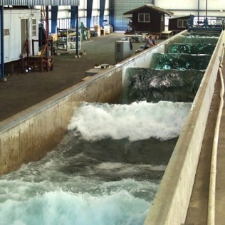
- O.H. Hinsdale - The O. H. Hinsdale Wave Research Laboratory features state-of-the-art wave facilities and personnel with extensive experience in testing wave energy devices. The Large Wave Flume (LWF, Figure 1) at OSU O.H. Hinsdale Wave Research Laboratory (HWRL) in Corvallis, Oregon is 104 m in length, 3.65 m wide, and 4.57 m high, with a maximum water depth of 4 m. The flume is equipped with two wave makers: 1) a hydraulically actuated piston type wave maker, capable of creating large-scale regular, irregular, Tsunami, and user-defined waves in the range of periods from 0.8 to 12 seconds at a maximum depth of 2.74 m, and 2) an electrically actuated removable elevated-hinge flap-type wave maker, capable of producing mid-scale regular, irregular, and user-defined waves in a typical range of periods from 0.5 to 4 seconds. The Large Wave Flume also includes a carriage for personnel access to instrumentation and an overhead gantry crane. Detailed information about the Large Wave Flume and the instrumentation available at HWRL can be found here: https://engineering.oregonstate.edu/facilities/wave-lab/facilities/large-wave-flume.
Figure 1: Wave flume in the Hinsdale Wave Research Laboratory.

Test Equipment
- Laboratory Upgrade Point Absorber – The LUPA WEC is a point absorber style WEC with three operational configurations: 1) A single float, heaving WEC; 2) A two-body, heaving WEC; and 3) A two-body, six degree-of-freedom WEC. It is important to note that the single float, heaving WEC configuration will utilize the full heave plate with buoyancy floats, which will simply be locked in place to limit movement. Additionally, in this project, only the single-float heaving WEC configuration will be utilized to obtain a meaningful dataset, considering the constraints of the limited tank time and budget.
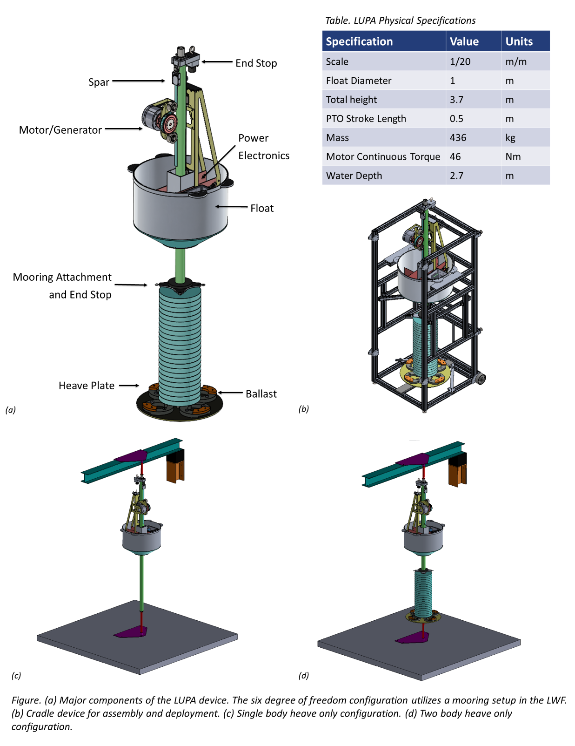
Figure 2: a) Major components of the LUPA device. The six degree of freedom configuration utilizes a mooring set-up in the LWF. (b) Cradle for LUPA assembly, deployment and recovery. (c) Single-body, heave-only configuration. (d) Two-body, heave-only configuration. Note the height in the Table is the total height of the device, and the noted water depth is the minimum operational depth.
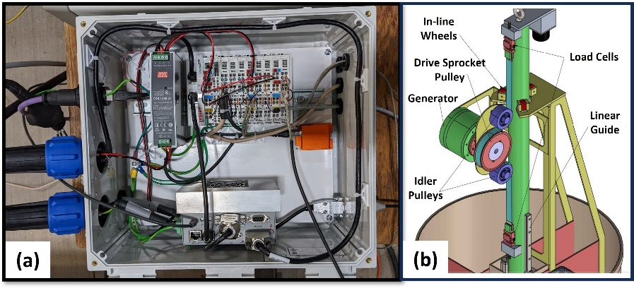
- The LUPA resource database comprises a physical scaled WEC model (nominally at a 1:20 scale, with details shown in Figure 2), a scaled numerical WEC model, and a full-scale numerical WEC model. These numerical WEC models are developed using WEC-Sim. The three operational configurations of LUPA, along with details on WEC parts and physical specifications, are detailed in Figure 2. LUPA consists of two hydrodynamically active rigid bodies: a surface-following float and a hydrodynamically stable heave plate. In the presence of incoming waves, the float is designed to be excited and 'follow' the water surface, while the heave plate, located at depth in calmer waters, remains more static. The PTO system captures the relative motion between the float and the heave plate to generate electrical power.
Figure 3: Electronics and PTO unit of LUPA.

- The power electronics of the LUPA are housed in a compartment (Figure 3) within the floating body, serving both data acquisition and control of the PTO unit, as shown in Figure 3(a). The PTO unit, depicted in Figure 3(b), translates the linear relative motion between the two bodies of LUPA into rotational motion through a pulley system, which then drives the generator/motor. This motor is controlled by a motor drive that applies the desired control force (calculated based on different control algorithms). The key equipment used in the PTO unit and the sensors are detailed in Table 1. The LUPA PTO generator specifications are summarized in Table 2.
Component | Brand | Part Number | Specification
Generator | Akribis | ADR220-B175-S/P-J/K-3.0-RA-26B-P25-Z75 | Continuous Torque: 50Nm
Encoder | Renishaw | L-9517-9448-05-B | Resolution: 26 bit
Drive | ElmoMC | G-OBOE 13A/230VAC ECTSW ENC SRC FIN+FAN | Peak Current: 26A
Load Cells | Futek | FSH00971 | Capacity: 4448N
VRU | Xsens | MTI-20-2A8G4 | Roll/Pitch: 0.5^{O}
Draw Wire | Micro-Epsilon | WDS-1000-P60-SR-SSI | Resolution: 0.012mm
Table 1: Major LUPA equipment.

Table 2: Generator specifications for LUPA PTO
Symbol | Quantity | Value | Unit
$$τ_{cn}$$ | Continuous Torque | 46 | N.m
$$τ_{pk}$$ | Peak Torque | 137.9 | N.m
$$K_{t}$$ | Torque Constant | 8.51 | N.m/Arms
$$Ω_{max}$$ | Max Speed | 150 | rpm

Technical Expertise
- Michigan Technological University – MTU boasts extensive experience in modeling, designing, controlling, and testing marine energy converters, utilizing its advanced wave tank facility, MTWave lab. The research team at MTU is committed to collaborating with industrial, academic, and national laboratory partners, focusing on enhancing the practical viability of marine renewables for various applications. The primary goal of this research is to investigate the potential of machine learning-based control in practical settings. MTU researchers' extensive expertise in developing machine learning-based controls will be leveraged in this research [1,2,17,18].
- Oregon State University – OSU is internationally recognized as a leader in water and energy research, development, and testing. The HWRL at OSU possesses significant expertise in constructing, modeling, monitoring, controlling, and actuating scaled systems, especially in wave-structure interactions. Hinsdale is actively utilized by wave energy technology developers for both private testing and OSU-collaborative research projects. Recently, OSU has developed the LUPA, a robust, highly modular, and open-source platform, ideal for control validations. The extensive experience in numerical modeling, wave tank testing, and control development at OSU will be leveraged in this project [19 - 22].

Test or Analysis Article Description
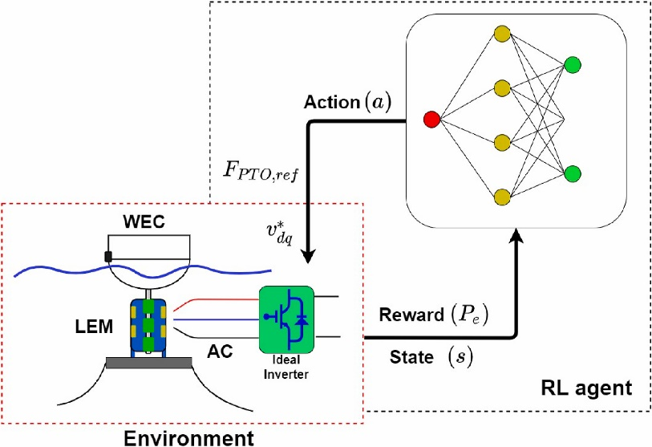
- Deep Reinforcement Learning Control – Unlike traditional model-based controls, the Reinforcement Learning (RL) technique does not require explicit knowledge of system dynamics. Instead, it optimizes system performance (defined in terms of rewards) through direct interaction with the environment. This model-free characteristic is well-suited for application in complex systems. Given the intricate dynamics of the WEC system (from wave to wire), deriving a model-based control is extremely challenging, if not impossible. Therefore, the application of Reinforcement Learning (RL) techniques could provide new perspectives on addressing this challenge, which will be tested in this project. Regarding the learning algorithm, the Deep Q-Network (DQN) was used in our previous study [1,2] (which will be tested in this project). The DQN is extended from the widely applied Q-learning technique, which leverages the advantages of deep learning (e.g., is able to learn more complex dynamics, more adaptive) [23].
- The details of the DQN control framework are illustrated in Figure 4. As depicted, the DRL agent gathers real-time rewards (such as electrical power production) and states (like displacement and velocity) to train the action-value function. It is noted that the drive train constraints will be considered in training the DRL control (e.g., adding penalties of the PTO peak force in the rewards function). The subsequent action is determined by maximizing the target, in this case, accumulated electrical power production. It's important to note that this action isn't the desired PTO control force directly, as conventional RL control requires discrete actions, while WEC control operates continuously. Hence, the actions are in fact variations of the proportional-derivative (PD) gains of a time-varying PD (TVPD) control law, which then determines the desired PTO control force. Additionally, to enhance convergence and learning speed, the experience replay technique is employed. It's also notable that two Deep Neural Networks (DNNs) are used, isolating target generation from the Q-learning update to improve stability.
Figure 4: DRL control framework.
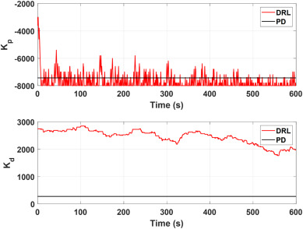
It is noted that the DRL control adopts a TVPD control law, which allows the control gain to be adjusted quickly (say every 0.1s). This approach is expected to be more suitable for highly nonlinear systems compared to conventional PD control, which has fixed gains. It is shown in our numerical studies that the resulting optimal gains of the trained DRL agent are significantly different compared to the impedance matching design as shown in Figure 8. Moreover, the gains of the DRL control can be initialized with any random guesses and do not depend on the design of impedance matching.
Figure 5: Trained DRL control gains versus conventional impedance matching.
- To implement the DRL control in the LUPA, the general framework outlined in Figure 4 will be utilized. Unlike in numerical simulations, the models represented by the red dashed box will be replaced with actual hardware. Additionally, the intelligence indicated in the black dashed box will be executed on a Speedgoat real-time machine, which will interact with sensors (like load cells and encoders) and the motor drive through EtherCAT connections. To physically apply the desired PTO force, the motor drive will be controlled to deliver the desired current. It's important to note that this framework is not limited to DRL controls; it is also applicable to model-based controls (e.g., impedance matching feedback control), which will be included in the tests for comparison purposes.
- Intended purpose – As shown in Figure 5, we have demonstrated that the DRL control (represented by the red line) outperforms the model-based controls in power production (average improvement ranging from 24% to 152%), power losses, operational efficiencies, and power qualities (Peak-to-Average Ratio improved from 23% up to 84%) in numerical simulations. These model-based controls include the Shape-Based (SB) control (black line), MPC (pink line), and the Proportional-Derivative (PD) control (blue line). Moreover, the DRL control (indicated by the red bar) has consistently achieved the highest power under various ocean conditions. However, the practical performance of DRL control remains unknown, which we aim to validate and demonstrate in this TEAMER project. It is noted that given the limited budget and timeline of this project, we are not able to compare the DRL control with all the model-based controls as we did in the numerical simulations. However, we will compare the DRL control with the impedance matching feedback control, which is referred to as 'PD' in Figure 5.
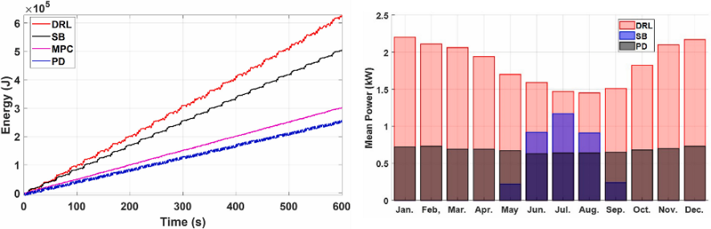
Figure 6: Performance of the DRL control compared to the model-based controls [1] subject to complex/nonlinear dynamics (left), and the monthly mean power generation comparison (right).
- Advance marine energy technologies – In this project, a recently developed DRL control will be experimentally tested to assess its performance in practice. This project will lead to (1) an improved understanding of the practical performance, challenges, and limitations of DRL controls, which not only fills a gap in the literature but also benefits future development; (2) unique and expansive experimental datasets for the validation of the control, increasing confidence in the developed DRL control and leading to more advanced algorithms in the future; (3) enabling WECs to operate in an optimal, robust, and adaptive manner in the face of highly dynamic and complex ocean environments, which ultimately leads to long-duration, low-cost, autonomous, and scalable wave energy harvesting.

Work Plan

Experimental Setup, Data Acquisition System, and Instrumentation
- Experimental Setup - All testing will be conducted in the Large Wave Flume at OSU HWRL in Corvallis, Oregon. The water depth for the experiments is set at 2.74 meters. Wave conditions chosen for the DRL control validation are based on the operational conditions of the LUPA at the PacWave test site, located off the coast of Newport, Oregon, USA, and will be scaled down using Froude scaling. The LUPA has three modes of operation, as shown in Figure 2. For this project, only the first configuration (single-body, heave-only) will be utilized to validate the control performance. An initial setup of the LUPA is presented in Figure 6. The DRL control will be implemented in real-time using MATLAB Simulink and a Speedgoat machine. Data is processed in real-time and displayed for the user to monitor the WEC response, as well as mechanical power production. Additional data analyses will be completed after testing to reduce the influence of noise and produce higher quality results.
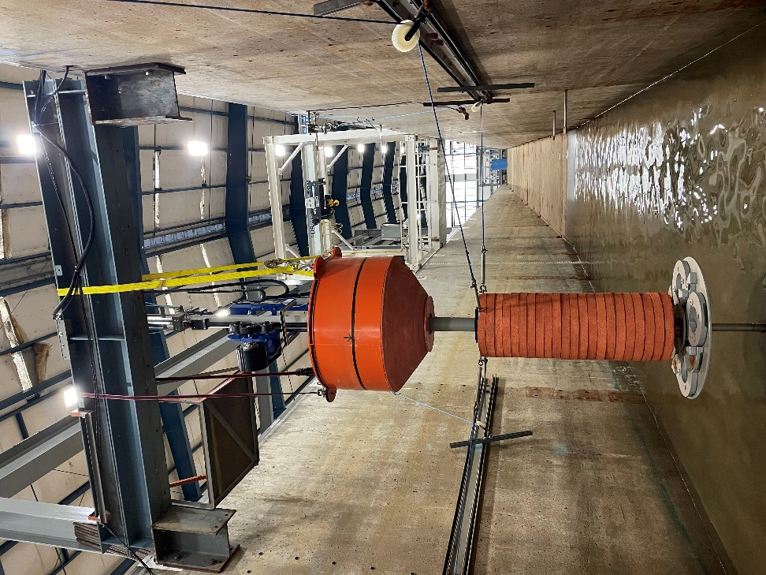
Figure 7: The LUPA in the Large Wave Flume set up for mode 1 and 2 of testing. The black line around the float represents the still water line when the flume is filled at operating depth.
- Data Acquisition – There are two data acquisition systems (DAQs) that are time synchronized: the Hinsdale DAQ and the onboard LUPA DAQ. The flow of power and data, as well as the sensors used onboard LUPA (available for the controls), can be visualized in Figure 7. See Appendix A for a list of sensors and associated details.
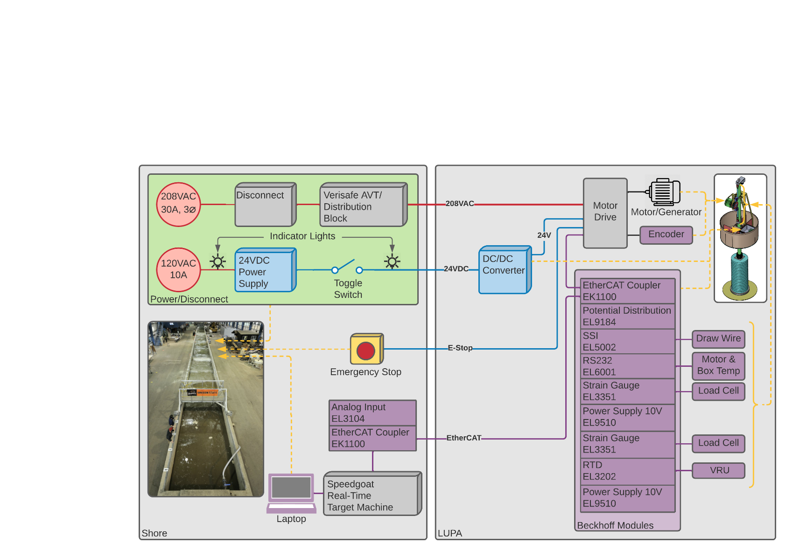
Figure 8: Experimental setup for power and data

Numerical Model Description
- Simulation tool – A WEC-Sim model of LUPA has been developed by the facility recently, with experimental campaigns conducted to calibrate this model. In the initial phase (Task 0) of this project, the experimentally calibrated numerical model will be used to train the DRL control offline, aiming to significantly reduce tank testing time. Additionally, the control will be numerically tested across various sea conditions planned for the experimental campaign. This comprehensive numerical rehearsal is crucial for error detection, ensuring safety (such as peak force and power limits), and troubleshooting. Furthermore, this model will also be utilized to design the gains of the impedance matching feedback control, which will also be tested for comparison.

Test and Analysis Matrix and Schedule
The testing campaign for the proposed objectives is outlined below. The first configuration (single-body, heave-only) of LUPA will be utilized in the tank testing. Testing is scheduled from late 2024 or early 2025 for two weeks. It is noted that the instruments at Hinsdale and on LUPA will be calibrated by Hinsdale staff before tests to guarantee accurate and high-quality data collection.
- Control implementation in dry test without a load – Before conducting wave tank tests, the control implementation will initially be demonstrated in a dedicated manner. The DRL control will be implemented with LUPA, and the sensor communication and motor control will be demonstrated in dry test under a no-load condition. To be more specific, the PTO unit will be unhooked from the LUPA, and WEC motion will be simulated through manual actuations. Sensor measurements (e.g., draw wire, motor encoder, etc.) will be collected and verified. Regarding constraint violation, this setup cannot test when a constraint will be violated, but can assess the control response (e.g., significantly lower/negative reward) to a constraint violation, which will be intentionally introduced during manual actuation. Any implementation errors, such as signal noise and delay, will be identified and resolved (e.g., by incorporating estimators) through discussions between the facility and the applicant in this phase, ensuring the success of the subsequent wave tank tests. Furthermore, re-training of the DRL control will also be conducted if necessary (e.g., due to significant drive train model mismatch, etc.) to avoid the risks associated with re-training during the tank testing phase. Previous work by the facility regarding motor parameter identification will be leveraged in this project [19,21]. It is noted that the drive train constraints will be considered in training the DRL control (e.g., adding penalties of the PTO peak force in the cost function).
- DRL control test – The operational range for the LUPA in regular waves at the prototype scale is approximately H = 1 – 5 m, T = 7.5 – 25 s. For irregular waves (Pierson-Moskowitz spectrum), Hs = 1- 5.2 m, Tp = 7.4 – 15.5 s. Consequently, in the tank testing, the wave conditions are scaled down and selected for the DRL control tests, as summarized in Tables 3 and 4. In this, the regular wave tests are mainly used to quantify the frequency domain characteristics such as power and motion response. Irregular wave conditions will also be tested across a wide range to ensure a comprehensive evaluation of the practical performance of the DRL control, which includes its robustness and adaptivity in different ocean environments. For regular waves, each sea state will be run for at least 100 seconds, and for each irregular wave condition, the test duration will be 360 seconds. It is also important to note that each wave condition will be repeated three (3) times to minimize the impacts of noise and uncertainties.
Table 3: Regular wave conditions
Wave Period (s) | H = 0.1 m | H = 0.15 m | H = 0.20 m
1.5 | R1A | R1B | R1C
1.75 | R2A | R2B | R2C
2.0 | R3A | R3B | R3C
2.25 | R4A | R4B | R4C
2.5 | R5A | R5B | R5C

Table 4: Irregular wave conditions, Pierson-Moskowitz
Peak Wave Period (s) | H_{m0} = 0.04 m | H_{m0} = 0.07 m | H_{m0} = 0.13 m | H_{m0} = 0.21 m
1.48 | P1A | P1B | P1C | P1D
1.90 | P2A | P2B | P2C | P2D
2.35 | P3A | P3B | P3C | P3D
3.09 | P4A | P4B | P4C | P4D

- Impedance matching test – The feedback gains of this control will be designed based on the experimentally calibrated numerical model of the LUPA. Similarly, this control will be tested for each sea state three times to mitigate the impacts of noise and uncertainty. It is noted that the impedance matching control will only be tested with irregular waves since the purpose of this test is to establish a performance baseline. This baseline will be compared with the proposed DRL control across various dimensions, including optimality (such as power generation), robustness, adaptivity, and the evaluation criteria. The facility's extensive experience in the design and testing of this control will be significantly leveraged in this test.

Safety
The applicant and OSU facility staff will follow all relevant safety procedures and protocols outlined in the HWRL Safety Plan 2021. This document describes the comprehensive and proactive safety plan in use at the HWRL at OSU. The plan is built upon the principles of involvement, identification, rules, and training. The plan applies to anyone and everyone conducting work at the facility, including but not limited to faculty, instructors, post-docs, researchers, staff, and students, whether University employees or visitors.
The facility adheres to the University safety policy as described below. The policy requires everyone to follow safe working practices and procedures. It applies to all Oregon State University employees, students, and any other individuals conducting business on OSU property. The policy states the following:
Effective management of health and safety at Oregon State University is fundamental to delivering excellence in research and teaching. Health and safety should be a concern to everyone since our mutual efforts and vigilance are necessary to eliminate incidents that result in personal injury and loss of property. The majority of injuries and property loss are costly and preventable. Through the dedicated efforts of everyone involved, we can maintain a safe and healthy environment while accomplishing the mission of the University. Oregon State University will make reasonable efforts to provide a safe and healthful working environment for all employees, students and others who may utilize the University's facilities and grounds. All University departments/units will develop and implement safety policies and procedures that promote an injury free environment. Anyone engaged in University related activities must exercise personal responsibility and care to prevent injury and illness to themselves and others who may be affected by their acts or omissions. No person shall intentionally interfere with or misuse anything provided by the University in the interests of health and safety. Individuals are required to have the proper training for the safe operation and use of university facilities, equipment and supplies as well as animal handling. Faculty and staff administrators will be held accountable for fulfilling their safety responsibilities. Flagrant disregard of the University safety policies and procedures may result in disciplinary action. Priority should be given to safe working conditions and job safety practices in the planning, budgeting, direction and implementation of University activities. The OSU Health and Safety Policy should be read in conjunction with SAF 103: OSU Safety Program and other safety policies contained in the OSU Safety (SAF) Policy and Procedure Manual.
All visitors, researchers and clients performing an activity within HWRL will undergo a specific and documented Safety Training, reviewing general safety procedures, rules and hazards. Temporary visitors will use yellow safety vests for best identification and awareness, and should use safety shoes at all times while working on the laboratory floor. Other safety protocols will be reviewed with the client during the Safety Training. Safety Briefings will be performed at the beginning of the project and every time a safety hazard or activity is identified. HWRL staff and visitors are required to attend each and every briefing.

Contingency Plans
For the DRL control test, there are limited risks or need for significant contingency plans. Two possible risks are outlined in this section. (1) Significant violation of physical constraints. Before tank testing, the DRL control will be extensively rehearsed in the numerical environment to ensure the satisfaction of the constraints (which will be incorporated into the reward function). During the tank testing, minor violation of the constraints will be allowed; however, an emergency stop will be triggered if a significant violation is observed. (2) Lack of access to the O.H. Hinsdale Wave Research Laboratory. This risk will be managed through direct and constant communication with Dr. Pedro Lomonaco (Hinsdale Director).

Data Management, Processing, and Analysis

Data Management
- Data is to be stored locally at OSU and on hard drive backup. Raw and processed data will additionally be compressed and zipped onto Box, with access shared with the MTU. A ReadMe file for the data describing the data will be included with all data files. Processing of data will be conducted at OSU the day following a drain calibration of wave gauges.
- OSU has a server that will house the data on their end. They also will have a hard drive backup. At the end of the project, they will lock the directory and archive it (read only). Raw data file and raw data in engineering units will be transferred to MHK DR and then processed on site the following day.
- Raw data path:
- Recorded locally on each individual DAQ hardware component (PXI system). All filenames include a timestamp off a PTP (IEEE-1588) synchronized clock, so there’s no possibility of accidental overwrites. After each trial is completed, every data file is pushed on to step (2).
- Recorded locally on the DAQprocessor (Mac mini). This is continuously backed up to an external drive (macOS Time Machine). It’s not running any services other than accepting inbound connections from the PXI systems to dump data. When each file arrives, it is evaluated and then placed on depot (step (3)) in the correct project, experiment, and trial. Data is put in the DAQprocessor trash after each project is completed, and then erased a month later. The backups persist for years.
- Stored on the depot file server. This is also where the path for everything BUT raw data (intermediate data, code, photos, videos) forks in. Depot has an hourly snapshot backup system, so if something is deleted by accident it can be recovered immediately. More here:https://it.engineering.oregonstate.edu/restore-using-snapshots
- Archived on attic. This is not backed up by snapshots. Instead, it’s backed up by multiple hard drives, spread in different locations around the lab and around Corvallis at a radius on the scale of miles.
Table 5: Data planned to be submitted.
Data to be submitted | Data types
motion capture data | ASCII logs and plots
video data | video files
power production data and drive train data | ASCII logs and plots
wave data | ASCII logs and plots

Data Processing
Data will be processed using MATLAB code at OSU by the facility in between tests to enable quality assurance in the event of signal errors.
Data will be translated from analog voltages to engineering units following the last data collection or calibration event needed for the dataset. OSU Hinsdale staff is responsible for developing and updating the calibrations for both Hinsdale equipment and LUPA instrumentation.
Uncertainties in measurements, such as power absorption, PTO force, coefficient of variance of the power, and wave-to-wire efficiency, will be quantified using both analytical and numerical methods, as documented in references [24] and [25], respectively. The facility's prior experience in investigating uncertainties in wave tank testing will be leveraged.

Data Analysis
Sensitivity analysis will be conducted for both the DRL and impedance matching control subject to modeling errors such as damping, inertia, and excitation, as documented in reference [26]. It should be noted that the system identification of the linear model of LUPA, as well as the identification of nonlinearities, has already been carried out by the facility and will be utilized in this sensitivity analysis. Additionally, key performance metrics such as power production, load extrema, load cycling rate, wave-to-wire efficiency, and power quality will be analyzed and compared for both controls across all sea states. Potential transient performance that may result from the online adjustment of the DRL control will be identified. Uncertainty in these performance metrics will also be estimated using the methods referenced in [24] and [25]. The guidance in [27] will be employed for data quality assurance and integrated in the uncertainty analysis. Finally, the evaluation criteria proposed in [10] will be assessed for both controls and compared with the performance of state-of-the-art model-based controls published in the same reference.

Project Outcomes

Results
The proposed research aims to answer the following questions: (1) What is the performance of DRL control in practice? and (2) What are the challenges and limitations of the practical implementation of DRL control? The following content is divided into three sections, each corresponding to the proposed tasks, to provide results addressing these research questions.
7.1.1 TASK 0 – Training of the DRL control according to the LUPA numerical model
This section focuses on the training of the DRL control based on the LUPA numerical model and addresses both research questions. A numerical model is essential for training the DRL control, and the more accurately the model represents the real environment, the better the control is likely to perform when deployed in practice. On the other hand, a numerical model can never fully capture real-world conditions. The practical behavior of the WEC may still involve nonlinearities and uncertainties that cannot be represented, even by an experimentally identified model (which is already costly to obtain). Would this model mismatch significantly degrade the performance of the control? If so, would a highly detailed nonlinear model be required to support effective control performance—thus representing a potential limitation of machine learning–based methods? The results presented in this section and the tank testing section can help us better understand these issues.
Thanks to the support provided by OSU on this project, the facility provided the TSR with the experimentally calibrated, single-body, heave-only LUPA model, which is shown in Fig. 9, and the specifications of LUPA are presented in the same figure. In addition, a hardware table (associated with LUPA) is also provided by the facility to help the TSR understand the available measurements and the physical constraints that the TSR should consider (shown in Table 6).
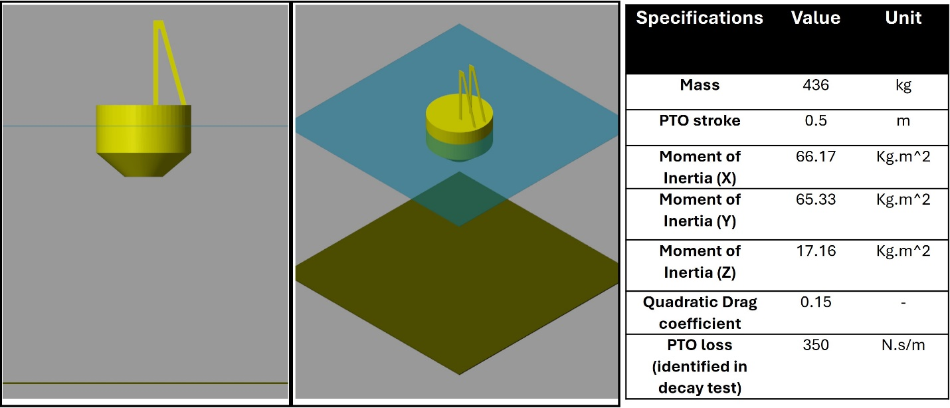
Figure 9: LUPA WECSim model and the key device parameters.
Table 5: Available sensors for LUPA
Sensors | Quantity of interest | Range | Sensor Location | Manufacturer
Motor Encoder | Rotory position of motor | 0 to 2pi | Integrated into the end of the motor | Renishaw
Motor Drive | Current, torque | R2B | Inside the electrical box in the float | Elmo Motion Control
Draw Wire | Relative distance between float and spar | 1000mm | On top of the PTO bracket | Micro-Epsilon
Load Cell | Force in the PTO | 2000lb | Top of the spar/Halfway down the spar | Futek
Inertial Measurement Unit | Hull angle of rotation, angular velocity, and translational accelerations | Gyroscope: ±450degpersec  Accelerometer: ±20g | Inside the electrical box in the float | Xsens
Wave Gage | Water surface elevation | +/-1.2m | Wave flume wall | OSU Hinsdale
String Pot | Relative distance between spar and ground in two body heave only mode | 40 in - 1.016 m | I-Beam across flume | UniMeasure, Inc.
Load Cell | Mooring line forces in two body heave only and two body 6 DOF modes | 2000 lbf - 8896.44 N | Wave flume wall | tecsis

According to the information of LUPA provided by the facility, we are able to understand that the available measurements include the motor angle, current, and torque; heave motion of the float; PTO force; rotation of LUPA (in 6DOF mode); wave elevation; relative motion between the float and spar (in two-body heave mode); and mooring line forces. Given that the proposed experiment is in single-body heave-only mode, the measurements such as LUPA rotation, relative motion, and mooring line forces are not used in this project. In addition, the PTO stroke is an important parameter to be considered when training the DRL control (the magnitude of the displacement shall not exceed 0.25 m). Given all this useful information, the TSR is able to develop a model to train the DRL control for LUPA. More specifically, the measurements collected by the controller are the displacement and velocity.
 | $$s=\left[z,v\right]$$ | (1)
And the reward collected is the instantaneous mechanical power:
 | $$P_{m}=-F_{PTO}v$$ | (2)
The proposed DRL control implements the PTO control in a time-varying proportional integral (PI) manner:
 | $$F_{PTO}^{*}=-K_{p}(t)v-K_{i}(t)z$$ | (3)
where the time-varying PI gains $K_{p}(t)$ and $K_{i}(t)$ will be updated by the DRL control at every RL step (user-defined, say 0.1s) such that the accumulated reward is maximized.
 | $$K_{p}\left(t+t_{RL}\right)=K_{p}\left(t\right)+δK_{p}$$
 | $$K_{i}\left(t+t_{RL}\right)=K_{i}\left(t\right)+δK_{i}$$ | (5)
Moreover, the constraints for the motion and the PI gains (e.g., $0<K_{p}<1e4$ and $-8e3<K_{i}<0$) are also considered in the training. It is noted that the integral gain shall be negative for LUPA in order to maximize energy harvesting for most of the wave conditions (except when the wave period equals 1.25 s, given that the natural period of LUPA is slightly less than 1.5 s); however, it cannot be lower than −8000 N/m, as this would lead to unstable behavior of LUPA. More details of the DRL theory and training can be found in [1].
The training is conducted across the following wave conditions:

Table 6: Regular wave conditions used in DRL pretraining
Wave Period (s) | H = 0.15 m | H = 0.20 m
1.25 | R1A | R1B
1.75 | R2A | R2B
2.25 | R3A | R3B
2.5 | R4A | R4B
2.75 | R5A | R5B

Table 7: Irregular wave conditions used in DRL pretraining
Wave Conditions | H_{m0} = 0.1 m  T_{p} = 1.9s | H_{m0} = 0.1 m  T_{p} = 2.35s | H_{m0} = 0.13 m  T_{p} = 2.35s | H_{m0} = 0.21 m  T_{p} = 3.09s
 | P1A | P1B | P1C | P1D

It is noted that the wave conditions were downselected from the planned wave conditions (as presented in Tables 3 and 4). This is because, after a thorough discussion with the facility and according to the facility’s recent work, it was found that a significant tank/LUPA resonance effect occurs when the wave period is 1.5 s, which causes a substantial disturbance in the ocean wave generated by the flume. It is therefore suggested to remove this wave condition from testing. In addition, with respect to the irregular wave conditions, four representative wave conditions from the PacWave South WEC test site are used to provide a more realistic assessment of control performance and to make this research more impactful. Finally, the overall number of tests planned to be conducted is reduced to 14, given the recommendation to run regular wave tests for 600 seconds and irregular wave tests for 800 seconds. This duration ensures a sufficient number of waves pass through LUPA, enabling a rigorous assessment of control performance in terms of power production and robustness. In addition, this setup allows more time for the team to conduct retraining if necessary.
The performance of the trained DRL control is presented in the following figures. Figures 10 and 11 show a comparison of the power produced by the Impedance Matching (IM) control and the DRL control across all regular wave conditions. It is noted that the IM control uses constant proportional and integral gains, which are computed as:
 | $$K_{p}=B\left(ω\right)$$
 | $$K_{i}=\left(m_{r}+A\left(ω\right)\right)ω^{2}-K_{s}$$ | (5)
where $B\left(ω\right)$ and $A\left(ω\right)$ represent the frequency-dependent radiation damping and added mass, respectively, and $K_{s}$ is the hydrostatic coefficient. In addition, $m_{r}$ denotes the rigid body mass of LUPA.
The figures show that the proposed DRL control can achieve strong energy harvesting performance, approaching the theoretical maximum represented by the IM control.
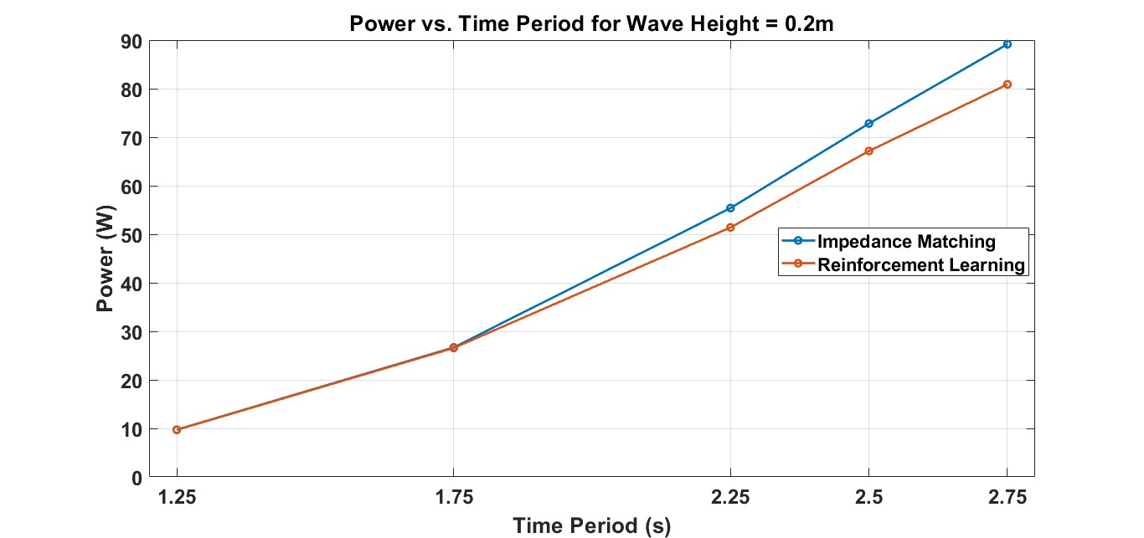
Figure 10: Comparison between the DRL control and IM control in terms of power production under regular wave conditions with a height of 0.15m.
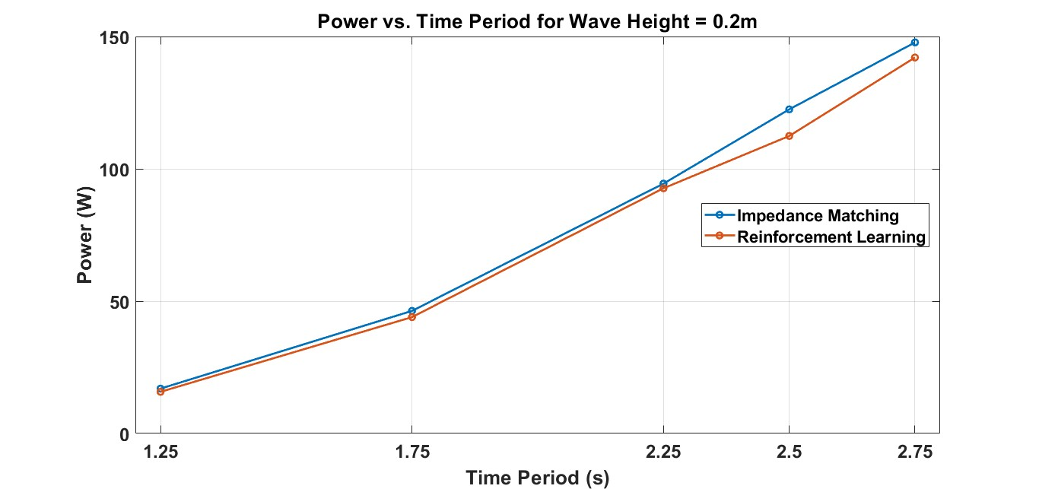
Figure 11: Comparison between the DRL control and IM control in terms of power production under regular wave conditions with a height of 0.2m.
Figure 12 presents the energy harvesting performance of the DRL control (red bars) and the IM control (blue bars) under four irregular wave conditions. From this figure, we can observe that in some of the irregular wave conditions, the DRL control outperforms the IM control, as the simple IM control algorithm described in Eq. (5) is no longer the theoretical maximum for irregular waves. In addition, under the most energetic wave condition, the IM control significantly outperforms the DRL control. This is because the IM control is unconstrained (unlike the DRL control, which accounts for constraints) resulting in motions that exceed the allowable PTO stroke.
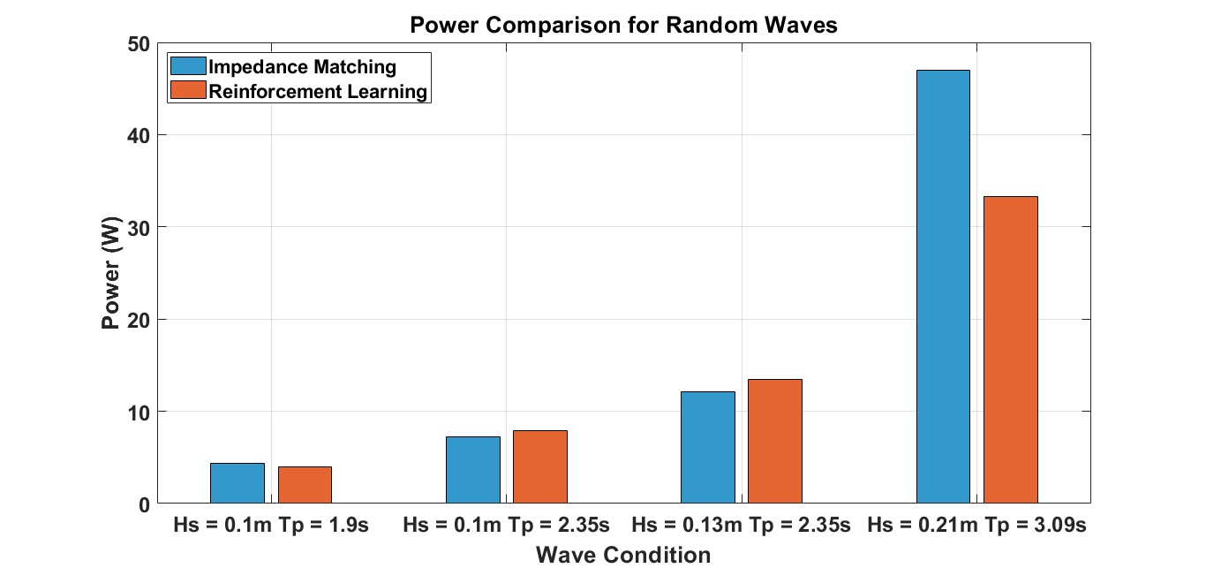
Figure 12: Comparison between the DRL control and IM control in terms of power production under irregular wave conditions.
The detailed performance of the DRL control under a specific wave condition (wave height of 0.2 m and period of 2.25 s) is presented in the following figures. Figure 13 shows the power harvested by the DRL control, with an average value of 92.66 W. In addition, Figure 14 presents the optimal time-varying PI gains identified by the control, where $K_{i}(t)$ reaches a steady-state value of −4100 N/m, and $K_{p}(t)$ oscillates around 441 N.s/m. It is noted that the optimal PI gains identified by the IM control are −4315N/m and 231N.s/m, respectively, which are close to the values identified by the DRL control. Regarding the motion of LUPA, it is clearly visible in the figure that the device's motion remains within the PTO stroke limits. It is noted that the power identified in the pretraining is significantly higher than the actual power harvested during the tank testing [21]. One major reason is the significant losses in the PTO drivetrain (which were later observed during the tank testing and also vary depending on different operational conditions) that are not accurately described in the current model. This will be discussed in more details in later sections.
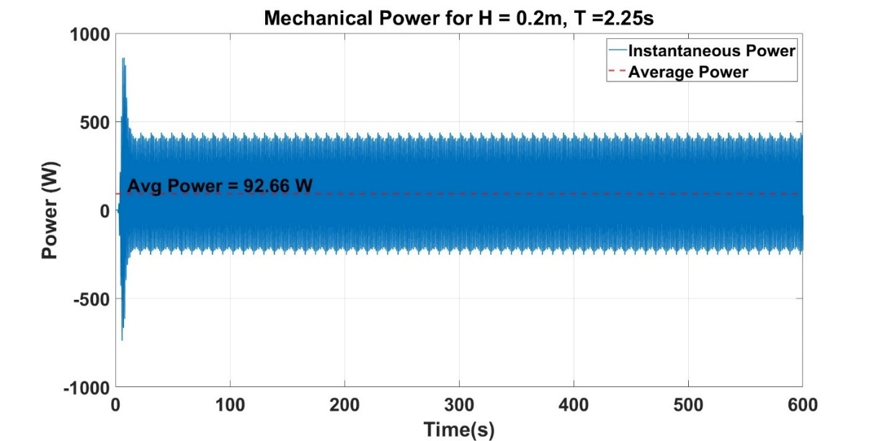
Figure 13: Power produced by the DRL control

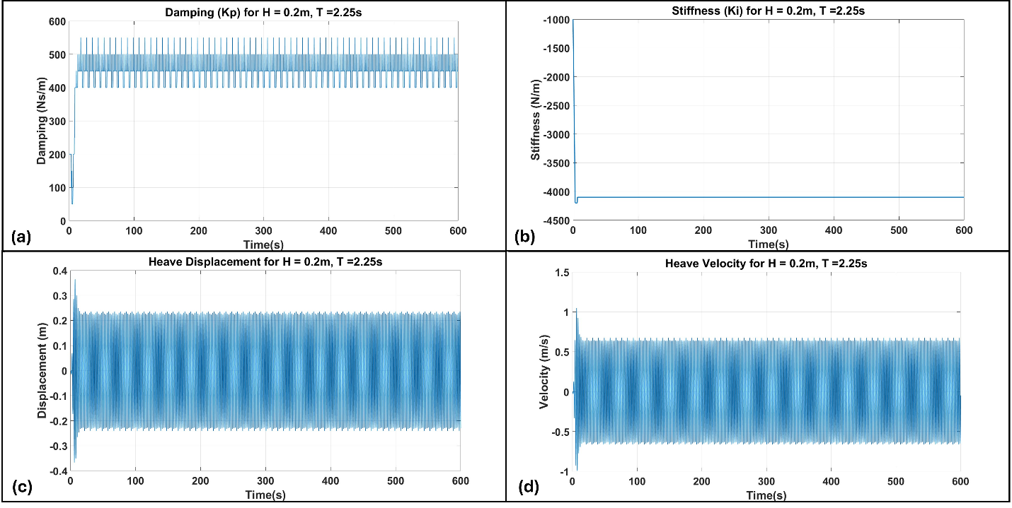
Figure 14: (a) PTO damping coefficient, (b) PTO stiffness coefficient; and the displacement (c) and velocity (d) of LUPA.

7.1.2 TASK 1 – Physical implementation of the control in LUPA.
In this task, we focus on implementing the trained DRL control in real time, which primarily addresses the research question regarding the challenges and limitations of the practical implementation of DRL control. LUPA uses EtherCAT connections to communicate with various types of sensors and the motor power electronics drive via a SpeedGoat machine. The real-time control is embedded in this machine through a MATLAB/SIMULINK-based user interface. More details of the real-time control setup can be found in [19, 21].
Next, we need to deploy the trained DRL agents in the real-time machine. Since both the training of the DRL agents and the real-time control are performed on the same platform (SIMULINK), the deployment of the trained agent becomes straightforward with the support of the existing MATLAB toolbox. A SIMULINK block named “generatePolicyBlock” can be applied to deploy the trained agents (which takes the trained weights of the neural network as the block parameter). This block takes the observations (in other words, the measurements) in real time and outputs the action calculated according to the trained agent.
This policy generation block (parameterized by the trained agent) is then implemented in the complete SIMULINK model for LUPA and tested in real-time. The results show that the control is able to perform in real time with a very small computation time of 0.008ms, which is significantly smaller than LUPA's sampling time of 1 ms.
Moreover, key measurements are also validated (as presented in Fig. 15) which includes the displacement velocity, motor current, and wave elevation, and it is clearly visible from these figures that the signals are clean and there is no need to implement a filter to denoise them.
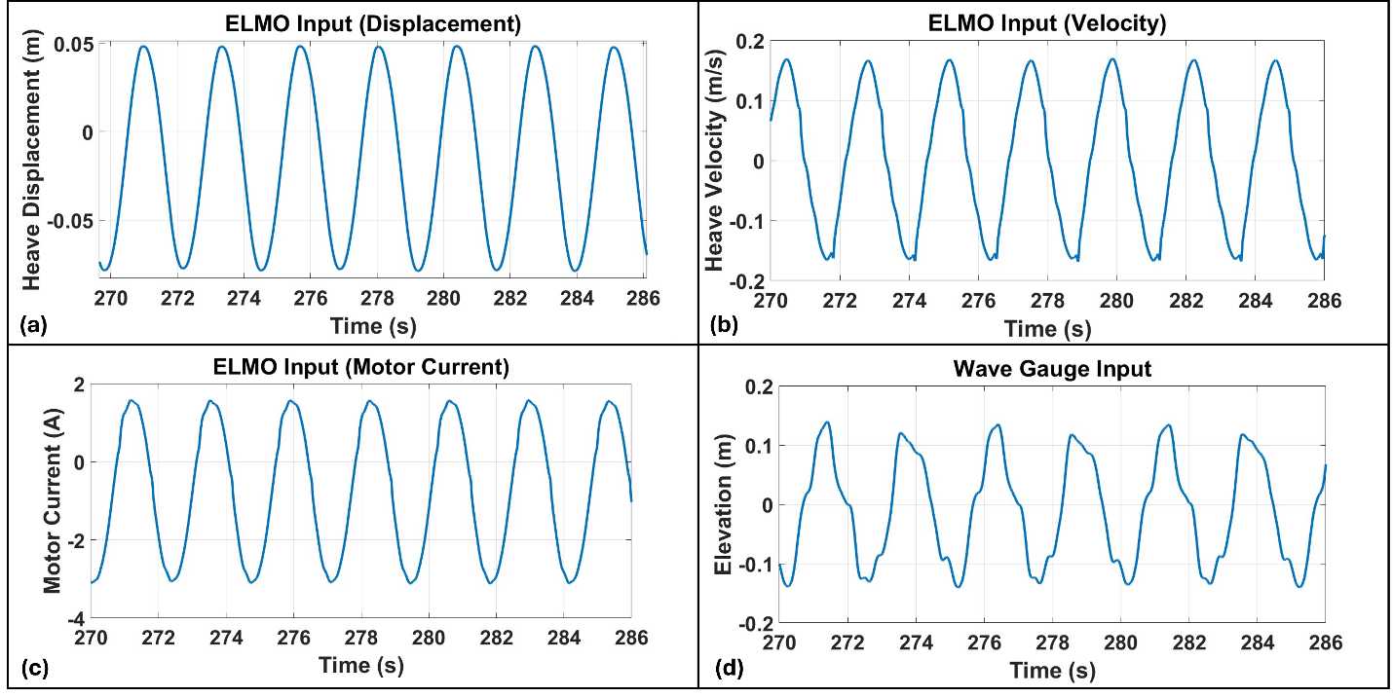
Figure 15: Measurement of displacement (a), velocity (b), motor current (c), and wave elevation (d).
Overall, this project found that the integration of DRL control in real time does not present significant challenges, especially when the control is designed using MATLAB/SIMULINK built-in functions. Since the real-time machine (SPEEDGOAT) also uses SIMULINK to interface with the sensors and motor drive, it offers the unique benefit of straightforward control deployment.

7.1.3 TASK 2 – Tank testing.
Tank testing of the DRL control with LUPA was performed between 2/17 and 3/7 at the O.H. Hinsdale Wave Research Laboratory. Thanks to the support of the facility team, the installation of the LUPA model was completed on 2/19. LUPA was configured as a single-body, heave-only system, and the final setup is presented in Fig. 16 and Fig. 17.
This section focuses on presenting the tank testing results to help address both research questions. It is further divided into four subsections: (1) DRL retraining for enhanced practical performance, (2) regular wave condition results, (3) irregular wave condition results, and (4) loss-informed reward design.
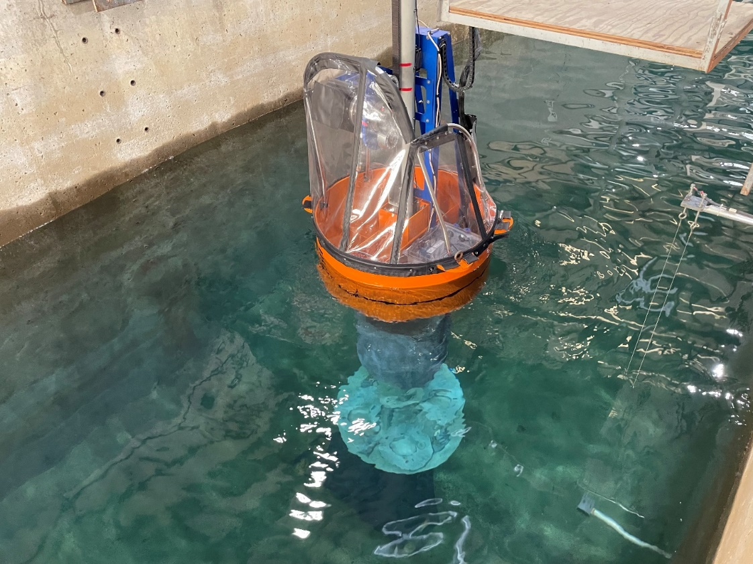
Figure 16: Experimental setup of LUPA
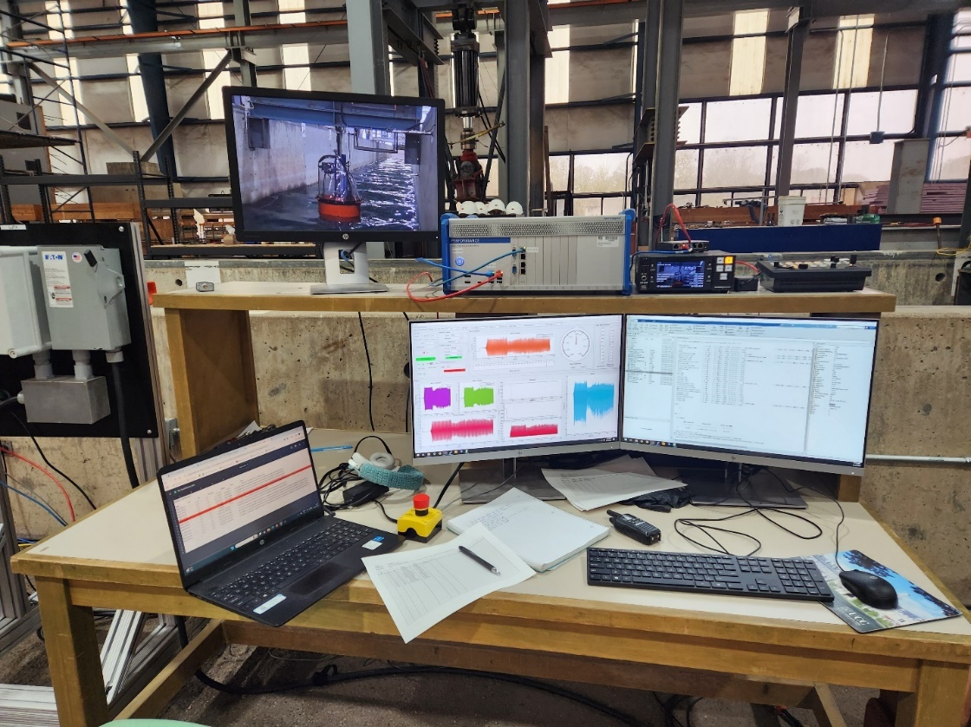
Figure 17: Control station in the tank testing.

(1) DRL retraining for enhanced practical performance
During 2/19 to 2/21, the TSR team tested the pre-trained DRL agents in the wave flume. However, in most cases, the pre-trained DRL control did not work. Figures 18 presents the detailed DRL control performance in contrast to the optimal feedback control (OFC) under six wave conditions, with only one working case for the pre-trained DRL control. It is worth noting that, instead of using the IM control as the benchmark for comparison with the numerical studies, the OFC is applied as the benchmark for experimental testing. The reason is that the IM control, calculated using Eq. (5), is a very theoretical setup, which may not be the optimal solution in practice (especially since we have observed significant losses in the drivetrain). The facility has conducted prior work on identifying the control in a more practical way. The control applies a feedback formula (PI-based for moderate and small wave conditions, and damping-based for large wave conditions to avoid hitting the end stop), and the optimal feedback gains are identified directly by sweeping a range of values in the wave tank [21]. This control (denoted as OFC in this study) is used as the benchmark.
Further, the wave conditions were downselected. Given that the proposed DRL control can provide a spring effect (in contrast to pure damping), which will excite the motion of the device, the two most energetic wave conditions, with a wave height of 0.2 m and periods of 2.5 s and 2.75 s, were removed from the test matrix to prevent the device from hitting the end stop. Moreover, it was also found that the commanded wave in the flume became very chaotic for wave conditions with a period of 1.25 s, and the extracted wave power was very low (below 1 W), making it subject to significant measurement error. Therefore, these two wave conditions (with heights of 0.15 m and 0.2 m and a period of 1.25 s) were also eliminated from Table 6 to allow the team to focus on addressing the practical implementation issues of the DRL control.
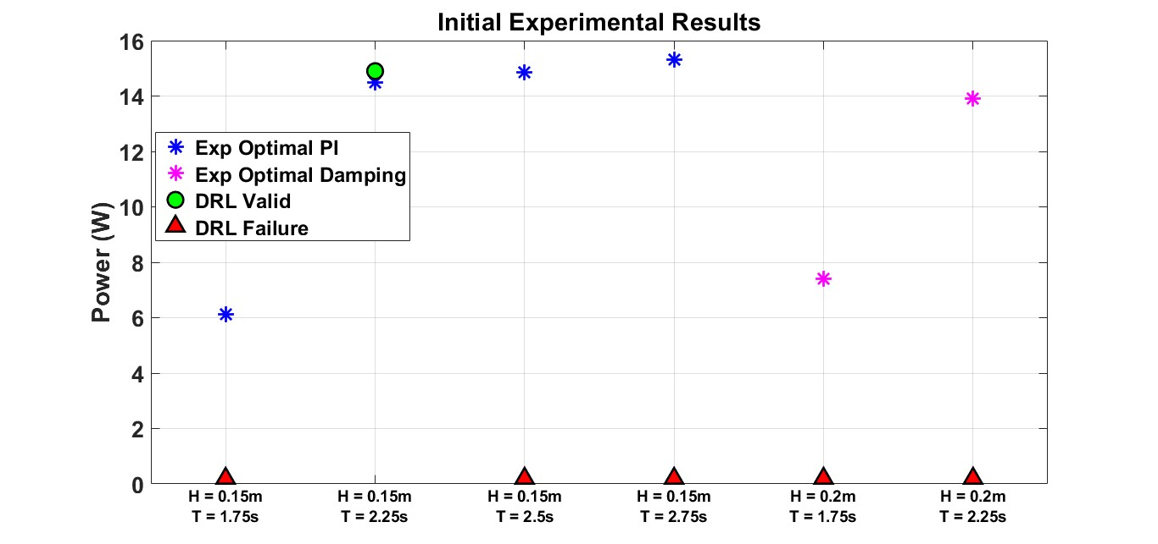
Figure 18: Comparison between the DRL control and OFC in terms of power produced under regular wave conditions in tank testing.
There are several issues that need to be addressed to make the DRL control practically feasible. It was found during the tank testing that different sources of randomness introduced in the testing environment have a significant impact on control performance (in some cases, a random event can even easily drive the control to become unstable). This is because the DRL control is trained in a relatively deterministic environment. Therefore, the control is unable to make the correct decision when an “unseen” operational condition (which is inevitable) occurs in practice. Accordingly, it is important to account for different sources of randomness during the training process of the DRL control to ensure the control is robust in practice. The team spent significant effort resolving these issues and enhancing the performance of the DRL control. These improvements will be thoroughly discussed in this section, as they are directly related to the objectives of this research (understanding the practical performance of DRL control) and are highly valuable to the community of interest (up to the best of the TSR’s knowledge, this has not been discussed in the literature).
Nonlinearities and Uncertainties in the Environment
(a) Varying PTO loss
The first issue identified that contributes to the significant performance degradation of the DRL control is the model mismatch. More specifically, significant PTO drivetrain loss (especially on the mechanical side) was observed during testing, and this loss varies under different testing conditions. However, it is not yet well modeled in the numerical simulation.
Figures 19 and 20 present an example of this model mismatch. It is clearly visible in these figures that the displacement predicted by the numerical model is significantly larger than the experimental measurements. In addition, we can see that this loss differs between the controlled (Figure 19) and uncontrolled (Figure 20) conditions.
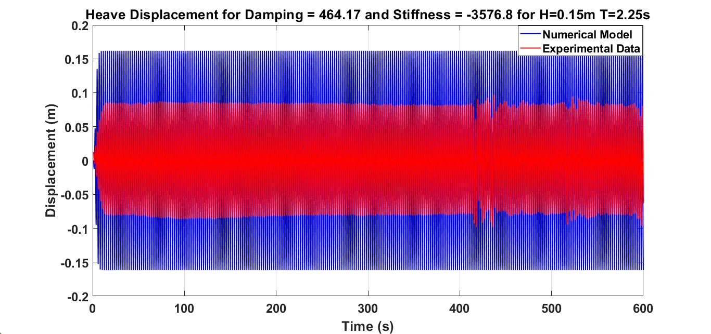
Figure 19: Comparison between the numerical prediction and experimental measurements in terms of the displacement under controlled condition.
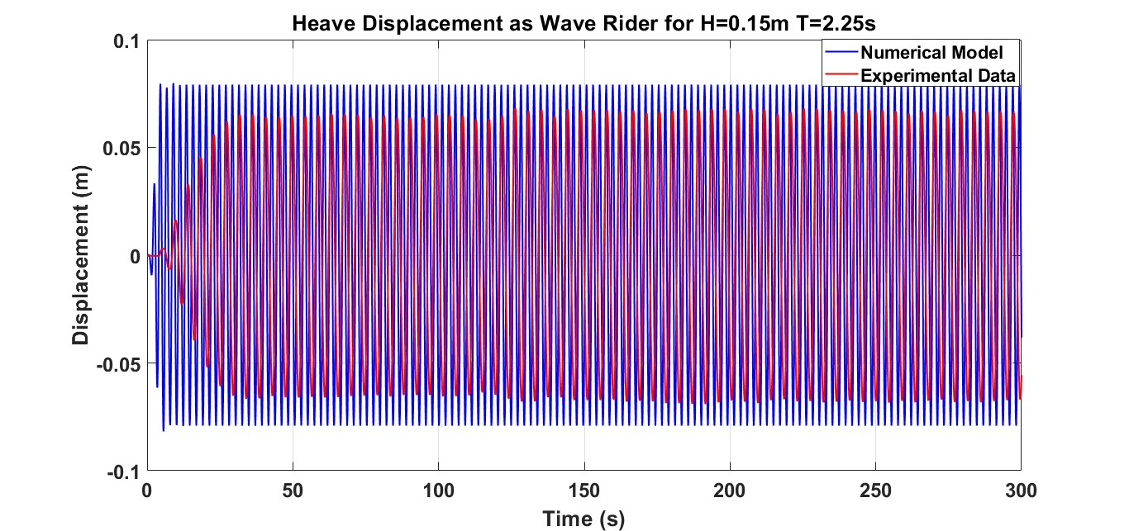
Figure 20: Comparison between the numerical prediction and experimental measurements in terms of the displacement under uncontrolled condition.
To address this issue, additional PTO loss is now added into the model in the form of linear damping, where the linear damping coefficient varies within a range depending on different operational conditions. This range is defined based on a centered constant (say, $c_{pto}$) that is identified by matching the system response under appropriate modes. For instance, for small and moderate wave conditions (e.g., height of 0.15 m), the wave rider mode is applied to identify this damping constant, given that the WEC under DRL control is likely to exhibit motion within a similar range. In contrast, for large wave conditions (height of 0.2 m), the system response under the optimal damping control case is applied instead, since under these energetic wave conditions, it is expected that the motion of the WEC needs to be significantly constrained to remain within the motion stroke of LUPA, which is closer to the damping case. The resulting centered damping constant are presented in Table. 8.
Table 8: Damping constant that is identified by matching the system responses.
Wave Conditions | H = 0.15 m  T = 1.75s | H = 0.15 m  T = 2.25s | H = 0.15 m  T = 2.5s | H = 0.15 m  T = 2.75s | H = 0.2m  T = 1.75s | H = 0.2m  T = 2.25s
$c_{pto}$ (N.s/m) | 500 | 700 | 800 | 900 | 1200 | 800

The displacement of the WEC predicted by the numerical model, after adding this damping constant under the wave rider mode, now shows good agreement with the experimental data (as shown in Fig. 21).

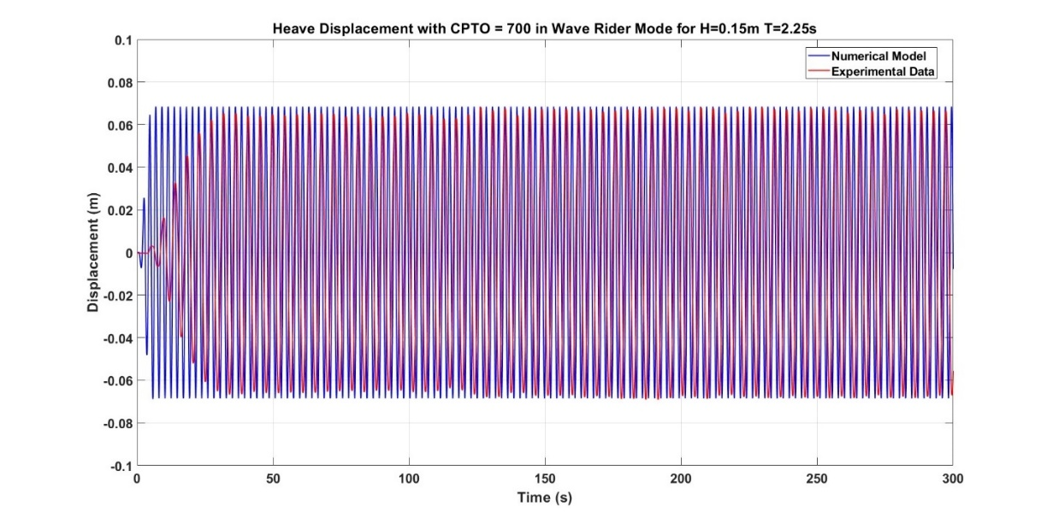
Figure 21: Comparison between the numerical model and experimental data in terms of displacement after fixing the PTO loss.
Next, we need to determine the range of the PTO loss under varied operational conditions subject to the identified centered damping constant. For small and moderate wave conditions, it was found that the damping coefficient needed to match the system response under optimal PI control (motion significantly excited, expected to have larger damping) is in general 100 N.s/m higher than the value identified under wave rider conditions (Fig. 22 shows the agreement of the system response after fixing this loss). Therefore, $c_{pto}+100$ is assumed to be the upper bound of the range (applies for all wave conditions). To account for any possible damping values that are lower than $c_{pto}$, $c_{pto}-300$ is selected as the lower bound for the range.
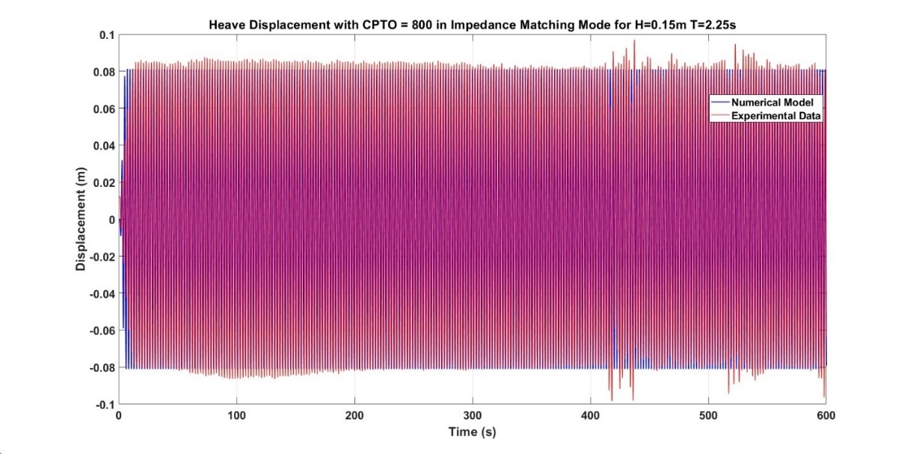
Figure 22. Comparison between the numerical model and experimental data in terms of displacement after fixing the PTO loss under optimal PI control.
Based on the prior discussion, this PTO loss is clearly a nonlinear loss term that may depend on the motion of the device. The TSR recognizes that the most accurate way to account for this nonlinear loss is to identify a model. However, due to the limited tank access time, an ad hoc approach was developed to account for this varying PTO loss. More specifically, the loss is assumed to be a random value selected from a range as discussed before without a clear function relates to the operational conditions:
 | $$PTO_{loss}∈\left[c_{pto}-300, c_{pto}+100\right]$$ | (6)
Actually, the control works well with this ad hoc setup for nonlinear PTO loss. This is because the machine-learning-based control is model-free. Accordingly, it is more important to let the control "see" an operational condition (in terms of value or pattern in system responses) during training rather than rely on an explicit and accurate model (which would be better but is optional and typically requires significant cost). This is, in fact, another advantage of machine-learning-based control. Finally, this PTO loss value is randomized in every episode during the training of the DRL control.
(b) Random initial conditions
Unlike in numerical simulations, where the initial conditions of the DRL control's observations (e.g., displacement and velocity) are always set to zero, the initial conditions in practice depend on the control enable time due to the wave tank testing setup. More specifically, the WEC control can only be enabled after several waves have passed LUPA, allowing the device to enter wave rider mode. Enabling the control before LUPA has any motion may introduce large transients, potentially causing damage. Additionally, the DRL control is enabled manually by the user, resulting in random initial conditions for the control. This randomness has a significant impact on control performance, as shown in the following figures.
Figures 23–25 show that the control becomes unstable quickly (within 7 seconds) due to the “unseen” initial conditions and transients. Although the initial displacement at the time the control is enabled is fairly close to zero, the initial velocity is not. It is noted that, in this context, instability means that the PI gains of the control reach their boundary limits (in this case, the proportional gain drops to zero, which is the lower bound). These boundaries are implemented to prevent the control from becoming truly unstable and potentially damaging the hardware.
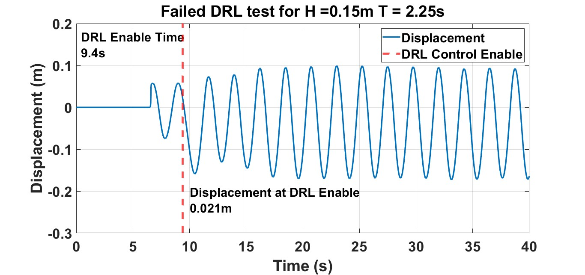
Figure 23: Displacement of the WEC with DRL control that has an unstable performance.
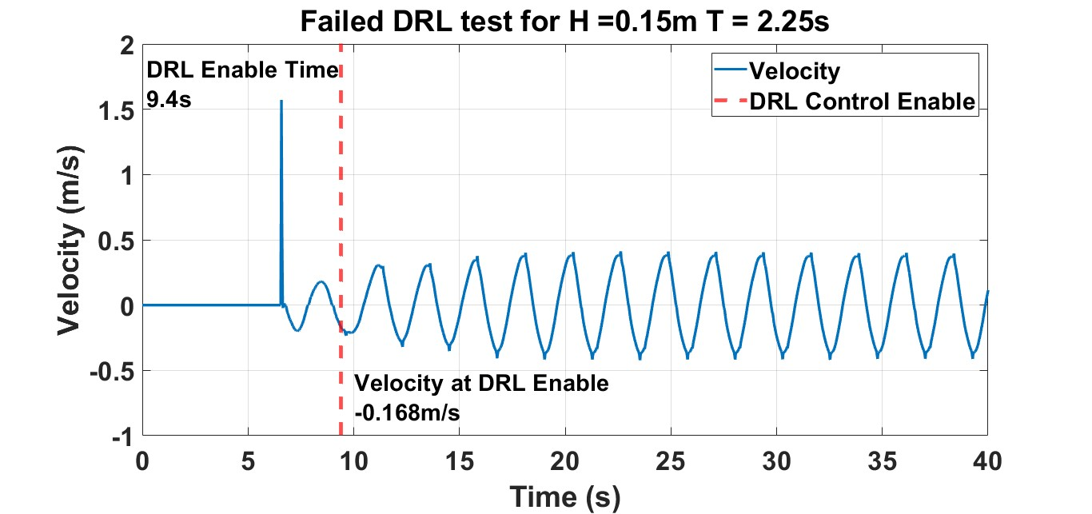
Figure 24: Velocity of the WEC with DRL control that has an unstable performance.
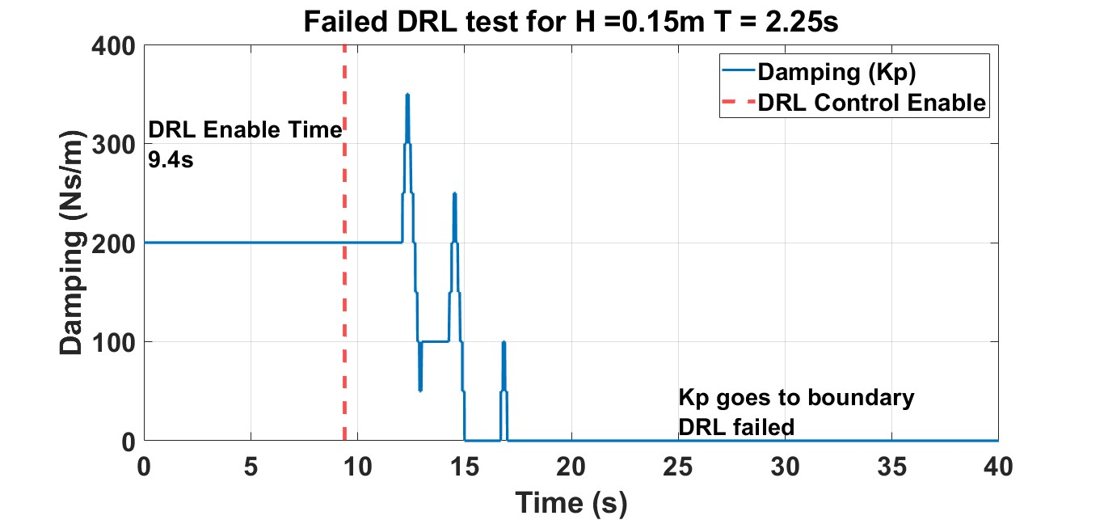
Figure 25: Proportional gain of the DRL control goes to the lower boundary at this initial condition.
In contrast, Figures 26–28 present the DRL control performance under the same wave condition (wave height of 0.15 m and period of 2.25 s), but with a different control enable time (since the control is manually enabled). It is clearly visible from the figures that the DRL control is working properly in this case—the control gains exhibit a time-varying pattern without reaching the boundary. The initial conditions of the observations in this case are –0.046 m and –0.068 m/s for displacement and velocity, respectively, which are close to zero. It is important to note that the only difference between this case and the previous one is the control enable time, indicating that the DRL control is highly sensitive to initial conditions.

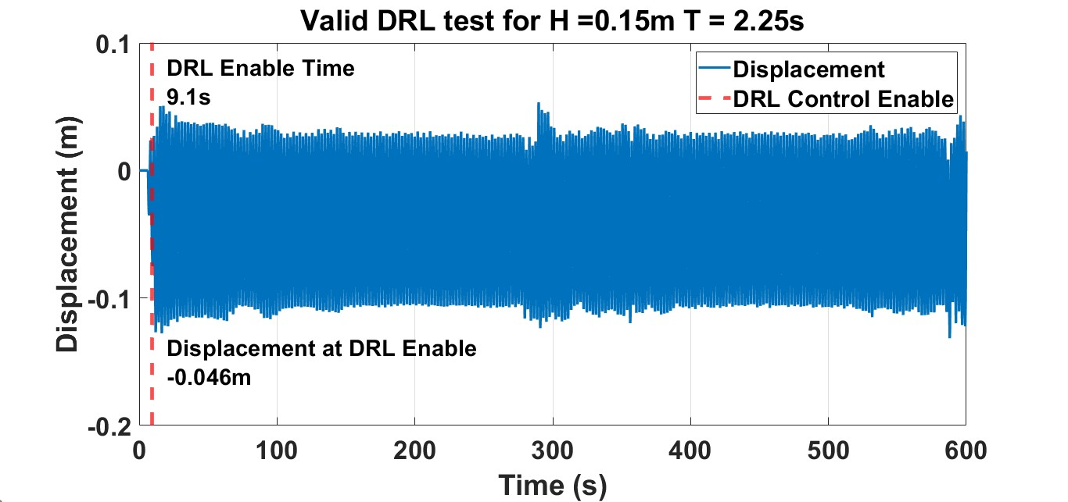
Figure 26: Displacement of the WEC with DRL control that has an stable performance.
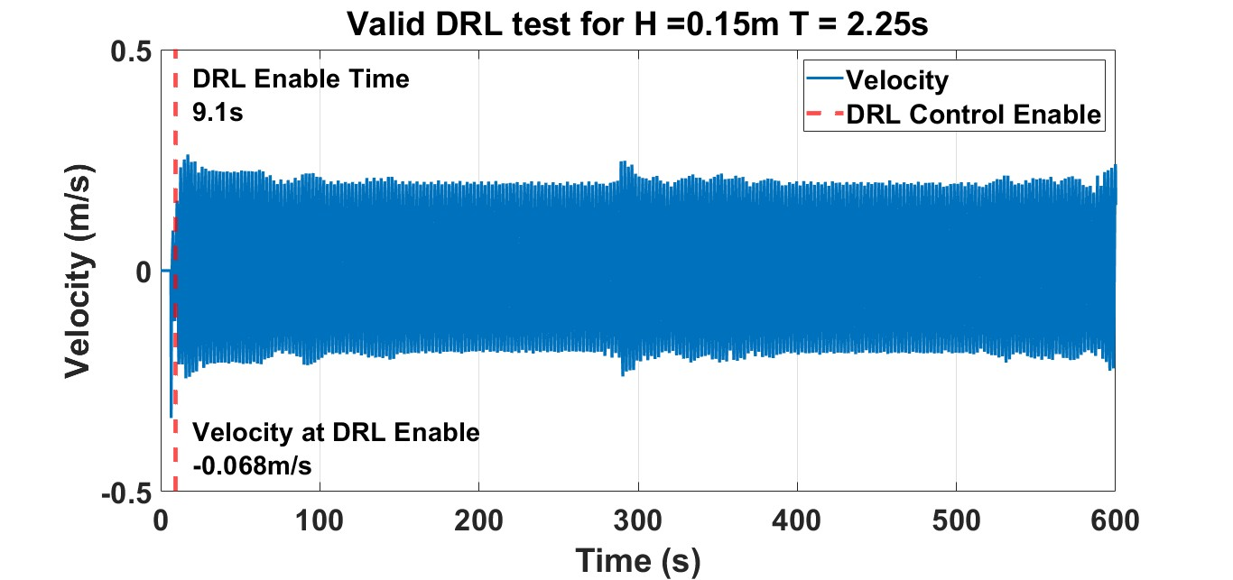
Figure 27: Velocity of the WEC with DRL control that has an stable performance.
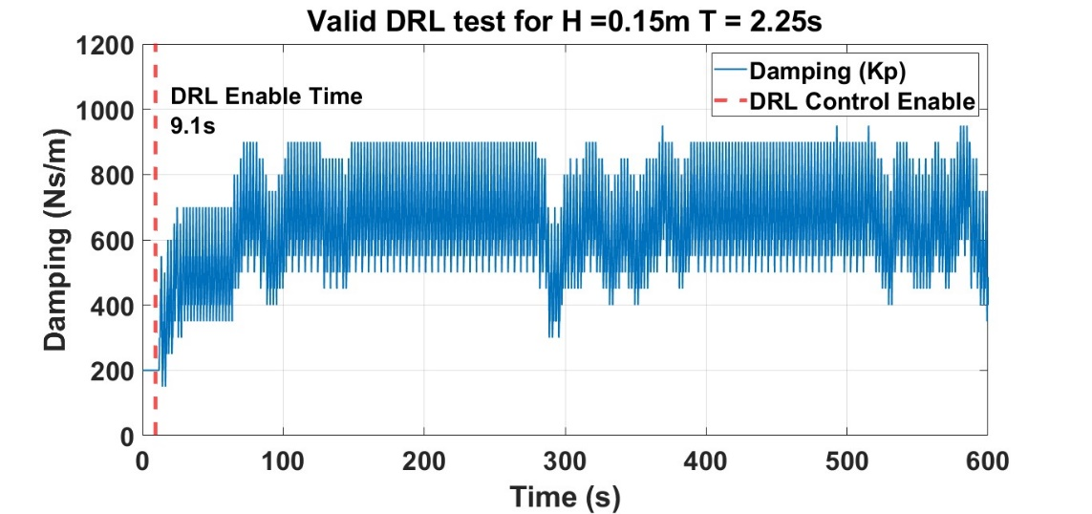
Figure 28: Proportional gain of the DRL control presents a time-varying pattern.
(c) Nonlinear events
It was also found that nonlinear events occurring in the system responses can significantly impact control performance. More specifically, these events are characterized by unexpected positive or negative impulses in motion amplitude, which can easily disrupt and degrade the control’s effectiveness. Physically, such nonlinear events may be caused by nonlinear wave behavior or other sources, such as nonlinearities in the mechanical drivetrain or in the interaction between the device and the wave.
Figures 29 and 30 show an example of nonlinear events caused by nonlinear wave behavior. As presented in Figure 29, the wave events occurred twice during the testing period, at approximately 260 s and 530 s. It is clearly visible that the wave magnitude during these events is significantly larger than the typical magnitude—which should remain relatively consistent in a regular wave test—with the largest deviation reaching up to 54%. These events had a substantial impact on the system responses, as shown in Figure 30, where the displacement exhibits sharp impulses at those times, with the largest change in magnitude reaching up to 138%.
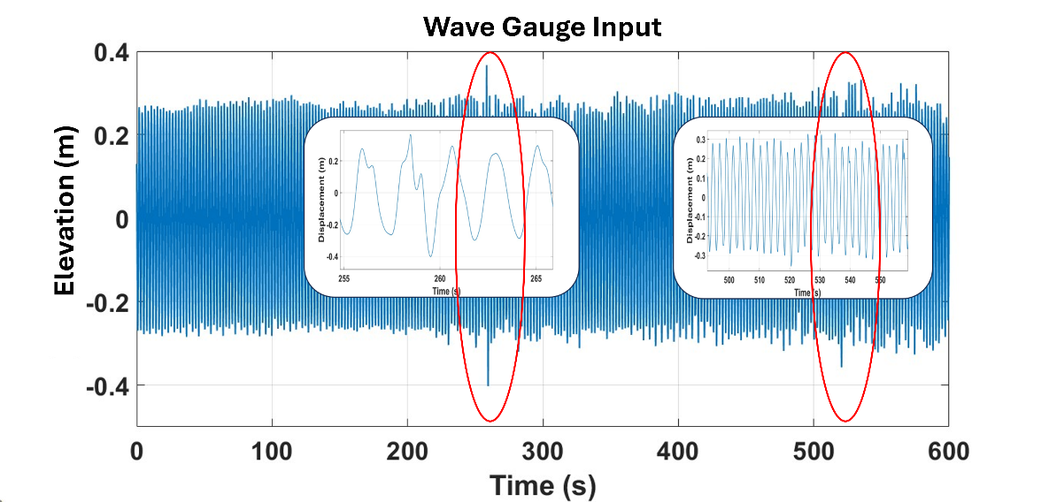
Figure 29: Nonlinear wave events happened during the testing.
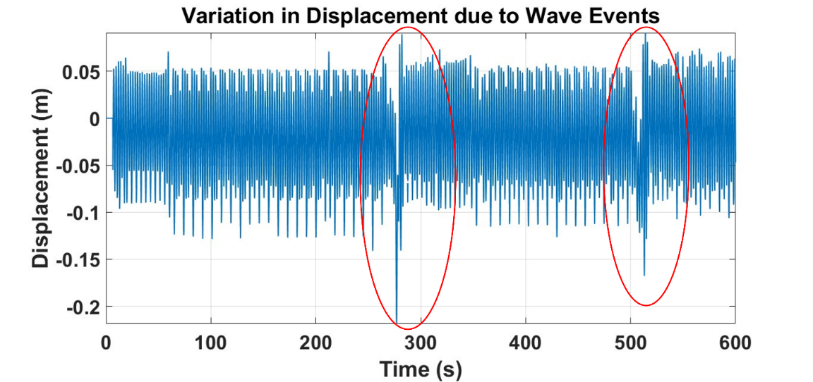
Figure 30: Significant impulses of the system response due to the nonlinear wave events.
Actually, even aside from these large events, a nonlinear event that introduces a magnitude change of just 21.38% is sufficient to degrade or destroy control performance. This is evidenced by the following figures. Figure 31 and 32 present the time profile of the integral control gain and the displacement of the WEC, respectively. It is evident from these figures that the control gain goes to unstable around 325s and the system response also has a dramatic change correspondingly. Now if we take a closer look at these two figures, this instability is caused by a nonlinear event in the system response that occurred at approximately the same time (slightly earlier than control changes), as clearly shown in Figure 33. A significantly lower peak appears around 323 s (highlighted in the figure), and the control immediately drives the integral gain to its lower boundary after encountering this value. It is noted that this nonlinear event in the system response may not have been caused by the wave itself, since there is no apparent impulse is observed in the wave gauge data presented in Fig. 34.
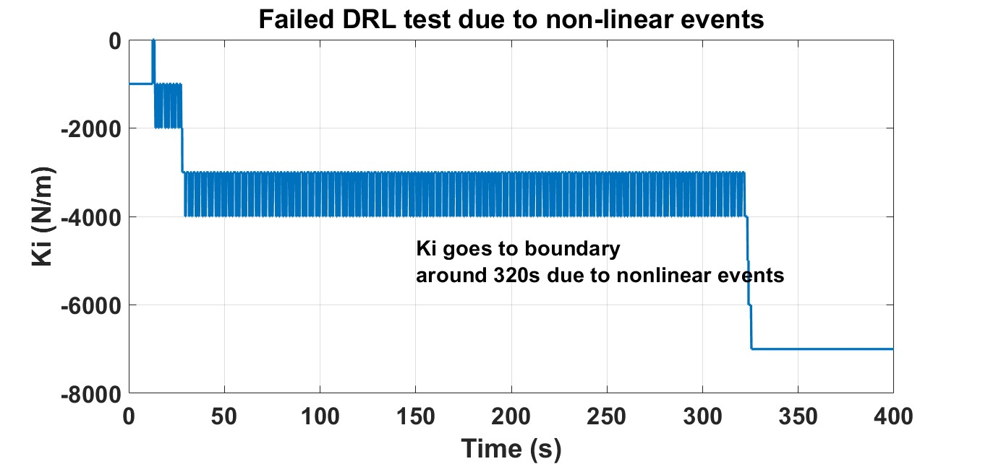
Figure 31: Integral gain of the DRL control goes to the boundary at around 320s.
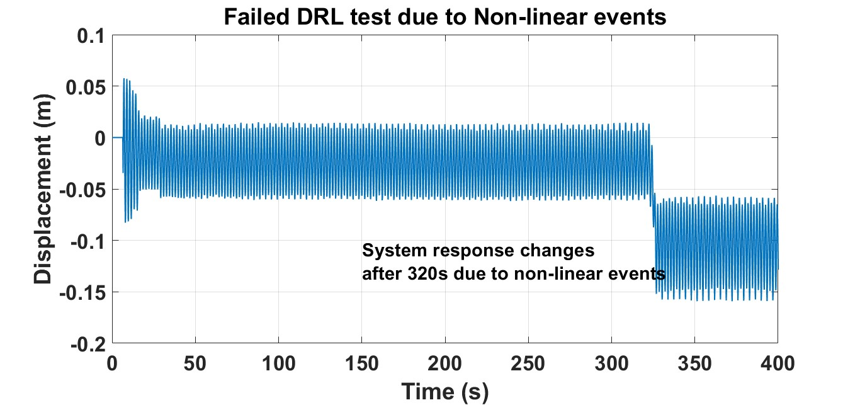
Figure 32: Significant change in the displacement is also observed at around 320s.
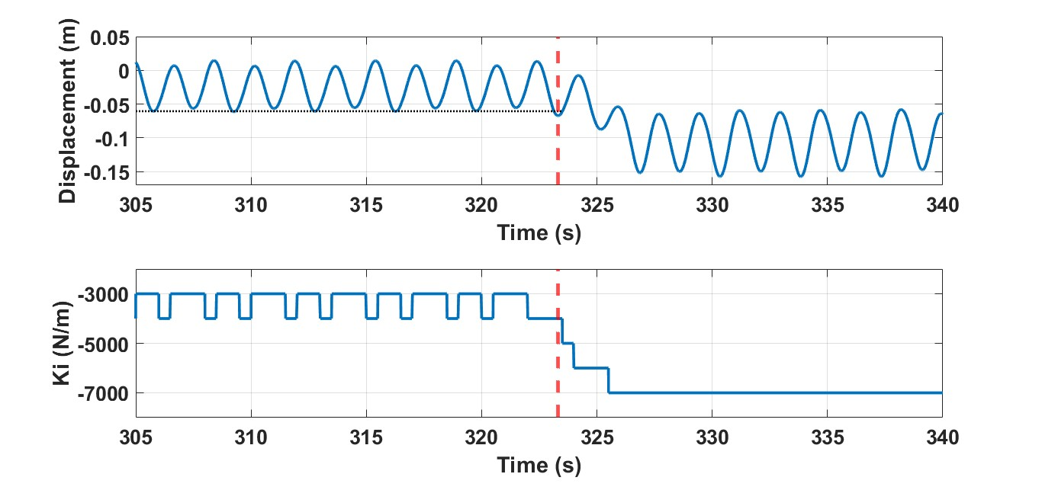
Figure 33: Integral gain of the DRL control goes to the boundary due to a significant low peak happened in the displacement.
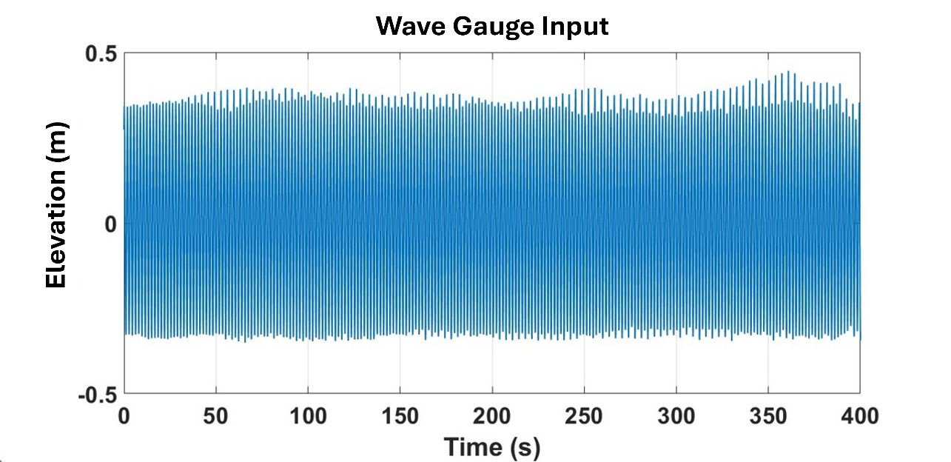
Figure 34: No apparent wave events were observed during this test.
(d) Process Noise
Process noise was also observed during the test. Figure 35 and 36 show the system responses under a regular wave condition with a height of 0.2 m and a period of 1.75 s using OFC control (with constant control gains). It is clearly visible in the figure that the system responses exhibit varying magnitudes throughout the testing period, although the variation is not as significant as that caused by the nonlinear events. Physically, this variation may result from several factors, such as fluctuations in incoming wave height, uncertainties, and unmodeled nonlinearities in the drivetrain and in the wave–buoy interaction. Although this process noise has a smaller impact on the system responses compared to the nonlinear events, it may still affect control performance. Therefore, it is also important to take this noise into consideration in the DRL training.

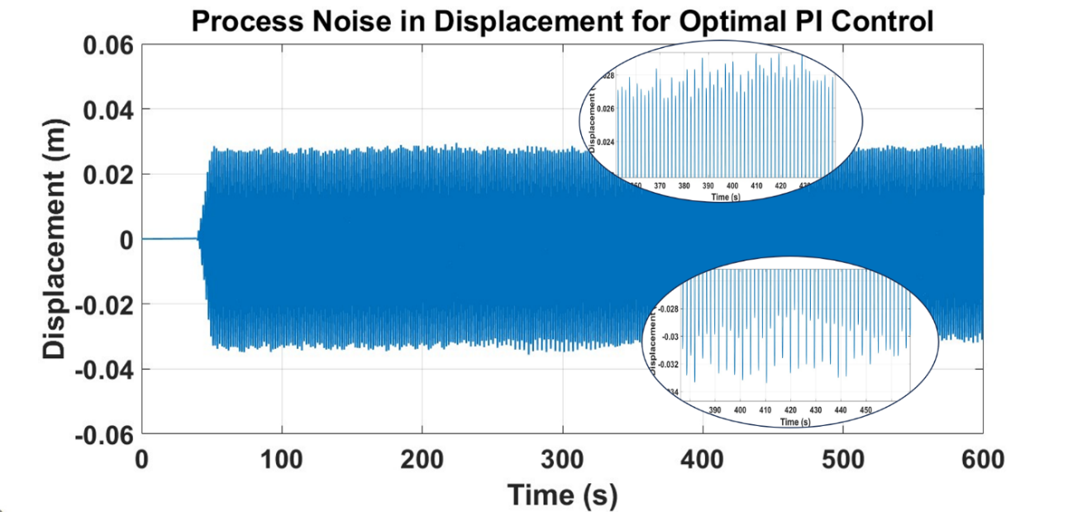
Figure 35: Displacement of the WEC presents a noise in the pattern.

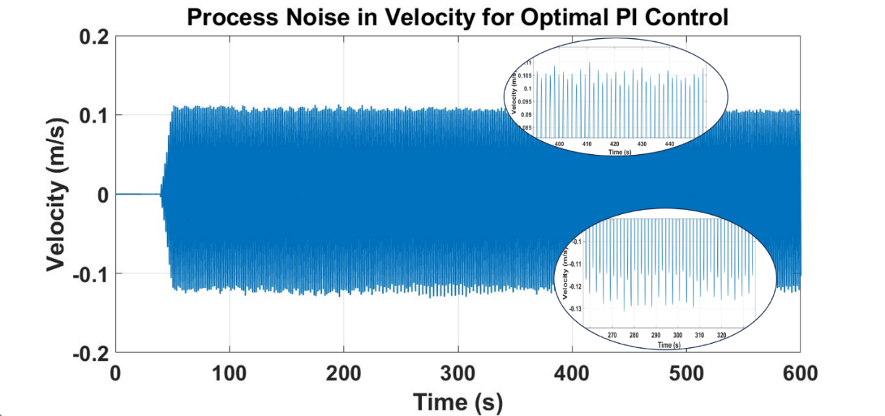
Figure 36: Velocity of the WEC also presents a noise in the pattern.

Improvements for practical implementation
(a) Incorporate uncertainties and nonlinearities in the environment
The above-mentioned uncertainties and nonlinearities are then incorporated into the DRL training process, which significantly improves control performance in practice in terms of both energy harvesting and robustness. More specifically, the overall updated training framework is presented in Figure 37.
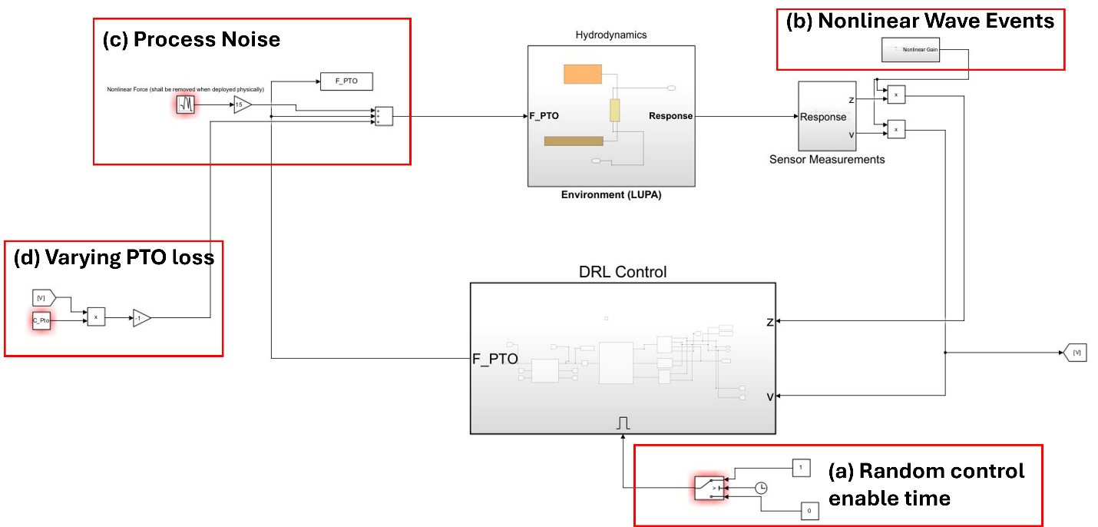
Figure 37: New training environment that incorporates different sources of randomness.
In this figure, part (a) introduces random control enable time, resulting in random initial conditions for the DRL control. Part (b) incorporates the impact of nonlinear events by directly modifying the amplitude of displacement and velocity (from 70% to 130%) within a random time window. Moreover, part (c) adds normally distributed white noise to the model to represent process noise. Lastly, part (d) accounts for varying PTO loss through a linear damping term, with the damping coefficient randomly selected from a range defined according to Eq. (6).
After applying these changes, the trained DRL control demonstrated good performance in the tank testing. Figure 38 presents the detailed performance of the DRL control under a regular wave with a wave height of 0.15 m and a period of 2.25 s. More specifically, Figure 38(a) shows the wave elevation measured at the wave gauge placed near the wavemaker (approximately 28.7 m away from the buoy). We can see from this figure that two notable wave events occurred (highlighted by the red and yellow boxes). It is noted that the first wave event led to a significant change in the system responses (around 276 s), as shown in Figures 38(b) and 38(c). The control was able to remain robust to this strong nonlinear event. As shown in Figures 38(d) and 38(e), although the control gains initially deviated from the optimal values due to the event, they recovered to the optimal values around 348 s after the system response returned to a normal pattern. The second nonlinear event occurred at around 506 s, where a significant change in the system responses can be observed (highlighted by the green boxes in Figures 38(b) and 38(c)). There is no direct wave event observed that caused this response. The control responded similarly to the previous event—deviating from the optimal value and recovering after a certain period.
It is also worth noting that a third nonlinear event occurred, as highlighted by the yellow box in Figure 38(a) (a wave event), but this event did not cause any noticeable change in the system responses. This may be because the device was operating close to wave rider mode at that moment (with control gains close to zero), and therefore did not strongly respond to the wave event.

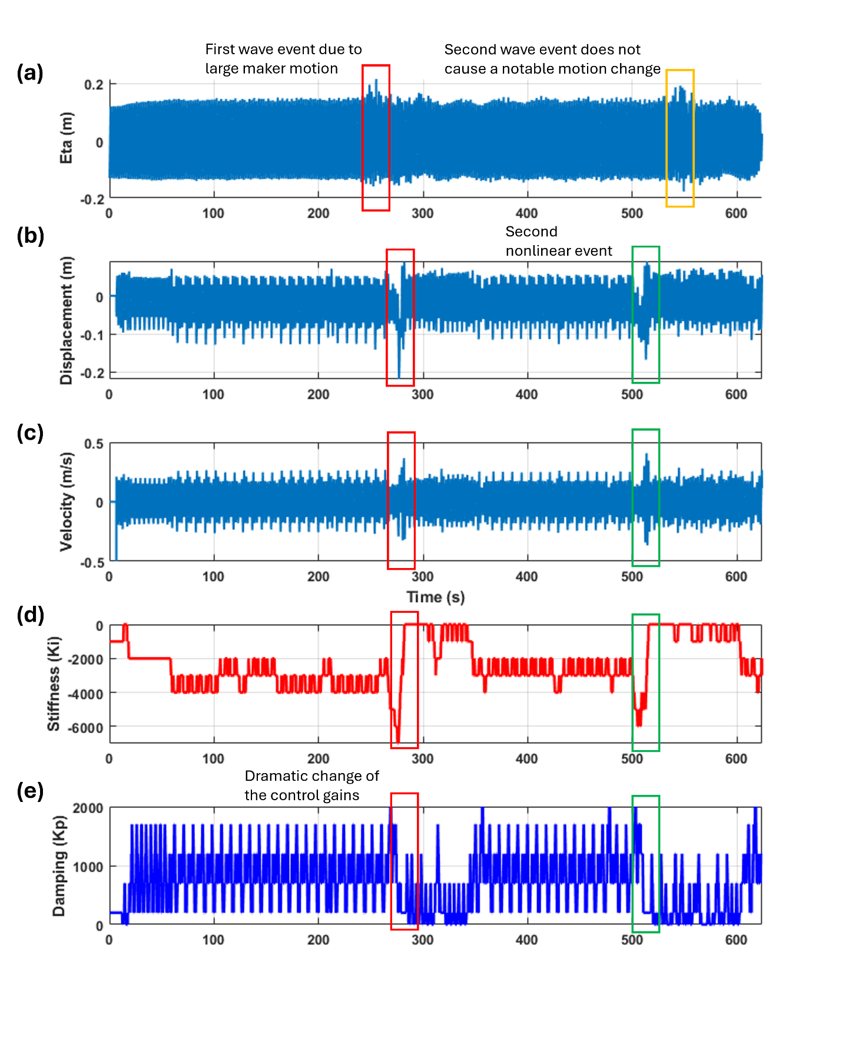
Figure 38: Detailed performance of DRL control under a regular wave with height of 0.15m and period of 2.25s.

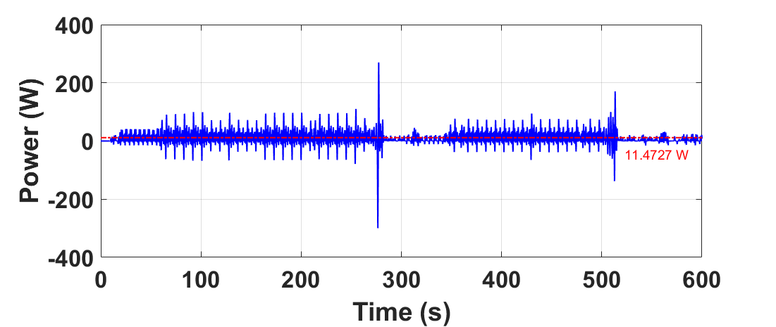
Figure 39: Power produced by the DRL control.
Finally, the power produced by the DRL control under this wave condition is plotted in Fig. 39, and the average power produced is around 11.47W.
(b) Observation states
Another important variable that significantly impacts control performance is the selection of observation states. To further improve DRL control performance, the TSR selected representative observation states from the literature [1,17,18,28] and tested them with LUPA to identify the optimal state selection.
Table 9: Performance of the DRL control with different observation states
Observations | Expression | Power Performance  (H = 0.15m, T=1.75s)
S1: Displacement and Velocity | $$s= (z,v)$$ | 4W
S2: Displacement, Velocity, Wave Height and Wave Period | $$s=(z,v,H_{s},T_{p})$$ | Unstable, no Power
S3: Displacement, Velocity and PTO Force | $s=(z,v,F_{PTO}$) | Unstable, no Power
S4: Displacement, Velocity and Mechanical Power (inst) | $$s=(z,v,P_{PTO})$$ | Unstable, no Power
S5: Displacement, Velocity, Mechanical Power (inst), Wave Height, Wave Period and Previous Action | s$=(z,v,P_{PTO},H_{s},T_{p},a_{t-1}$) | 2.5W
S6: Displacement, Velocity, Wave Height, Wave Period and Previous Action | $$s=(z,v,H_{s},T_{p},a_{t-1})$$ | 4W
S7: Displacement, Velocity and Mechanical Power (moving average) | $$s=(z,v,\frac{ΣP_{PTO}}{N})$$ | 2.7W
S8: Displacement, Velocity, Wave Height, Wave Period and Mechanical Power (moving average) | $$s=(z,v,H_{s},T_{p},\frac{ΣP_{PTO}}{N})$$ | Unstable, no Power
Table 9 presents the testing results of the DRL control using different selections of observation states under the same wave condition. From this table, we can see that S1 and S6 are the best-performing observation sets out of the eight possible selections (the others are either unstable or suboptimal). We have already discussed the detailed performance of the control using S1 as the observation. Next, we will discuss the control performance when S6 is used as the observation state.
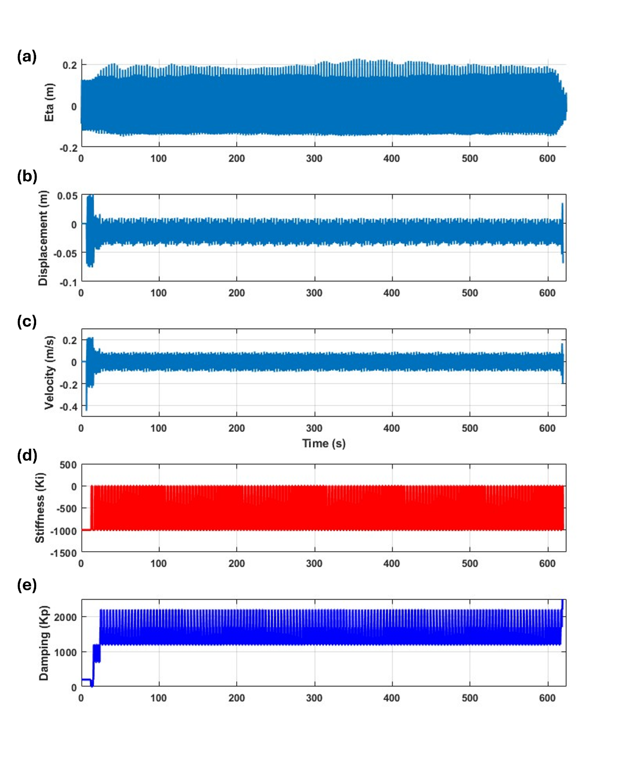
Figure 40: Detailed performance of DRL control under a regular wave with height of 0.15m and period of 1.75s with S6 selected as the observation state.
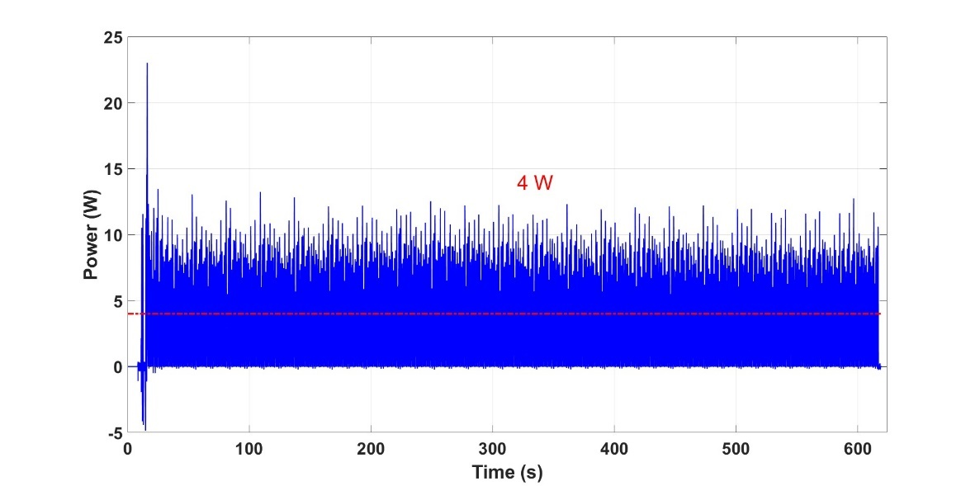
Figure 41: Power produced by the DRL control.
Figure 40 presents the detailed control performance using S6 under the wave condition with a height of 0.15 m and a period of 1.75 s. As shown in Figures 40(a), (b), and (c), no clear nonlinear events are observed during the entire testing period. Figures 40(d) and 40(e) show that the PI gains of the DRL control remain robust throughout the test, exhibiting a steady-state time-varying pattern—specifically, the integral gain oscillates around -625N/m, and the proportional gain oscillates around 1450N.s/m. Regarding power production, the average power output is approximately 4 W, as shown in Figure 41.
Figure 42 presents the detailed control performance using S6 as the observation state under a wave condition with strong wave events (wave height of 0.2 m and period of 1.75 s). As shown in Figures 42(a), (b), and (c), two significant wave events occur at approximately 171 and 283 seconds, leading to notable changes in the motion of the device. However, the control gains demonstrate robust performance in response to these events, maintaining the PI gains with only slight disturbances—effectively riding through the events.
This performance differs significantly from that shown in Figure 38, where the observation state included only displacement and velocity. In that case, while the DRL control was adaptive to the nonlinear events, it deviated considerably from the optimal values and required a significant amount of time to recover. In contrast, when S6 is used as the observation state, the control behaves more robustly than with S1—showing minimal reaction to wave events—but is less adaptive. This could make it too stiff for irregular wave conditions (a point that will be discussed later), though it is well suited for regular wave conditions. Finally, the power produced under this wave condition is around 12.3W as presented in Fig. 43.

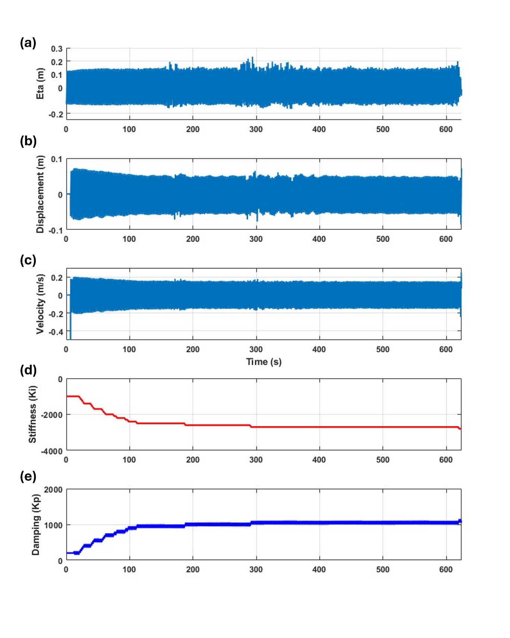
Figure 42: Detailed performance of DRL control under a regular wave with height of 0.2m and period of 1.75s with S6 selected as the observation state.

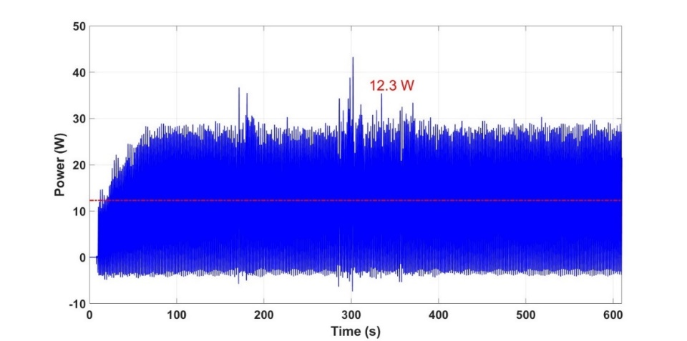
Figure 43: Power produced by the DRL control.
(2) Regular wave results
Given that S6 provides better performance in terms of energy harvesting, this observation state is selected for all regular wave conditions. The performance of the DRL control across various regular wave conditions is presented in Figure 44. In this figure, blue stars represent the power produced by the OFC control (with optimal gains identified through the sweep study discussed earlier), and the green dot represents the power produced by the DRL control. It is also worth noting that for wave height of 0.2m, OFC only applies an optimal damping control to avoid excessive motion of LUPA.
It is noted that for each wave condition presented, the DRL control was executed three times. The green dot and red bars indicate the average power production and the maximum/minimum power production from the three tests, respectively. It is clearly visible in the figure that the power produced by the proposed control is close to that of the OFC control for most wave conditions. Notably, under a wave height of 0.2 m and period of 2.25 s, the power produced by the DRL control is significantly higher (by approximately 56.8%). This is because, under this wave condition, the OFC applies only a damping control, while the DRL control includes a spring term.
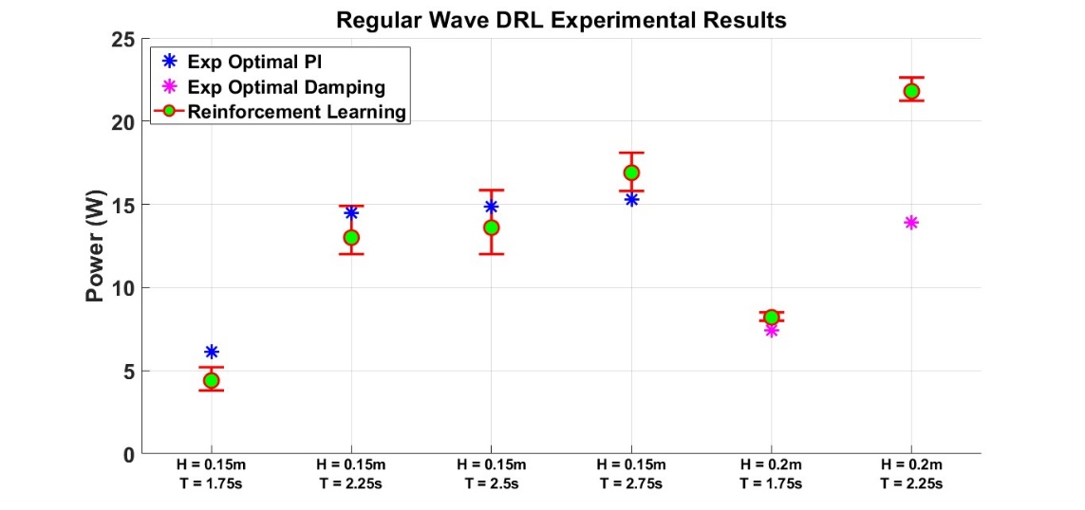
Figure 44: Comparison between DRL control and OFC control in terms of power production across varied regular wave conditions.
(3) Irregular wave results
The control performance is further validated under irregular wave conditions. As described in Table 7, four representative sea states from PacWave South were proposed for testing. However, during the tests, it was found that the power produced under three of these wave conditions (P1A, P1B, and P1C) was very low, which could not produce high-quality power data. Therefore, only the final wave condition (with a significant wave height of 0.21 m and a period of 3.09 s) was tested in this project.
Given that the DRL control with S6 as the observation state showed the best performance under regular wave conditions, this configuration was initially applied to the irregular wave condition as well. However, it was observed during testing that the PI gains were always adjusted subject to the peak system responses rather than adapting to the irregular nature of the wave profile. As a result, the PI gains always converged to their boundary values, leading to suboptimal energy production.
Based on these findings, S1 was reselected for use in irregular wave applications, as previous observations indicated that this state provided more adaptive control performance. Moreover, the TSR also conducted a test on the window size selection for the DRL control, which is used in the moving average mechanical power calculation (as the reward). Two different window sizes were tested—500 samples and 1500 samples—and it was found that 500 samples was the optimal choice, as it resulted in more power being harvested (13.7 W compared to 12.8 W) and required less computational expense. It is noted that this number is 200 samples for all regular wave conditions.
Figures 45, 46, and 47 present the performance of the DRL control under irregular wave conditions with different random seeds. The integral gain of the control consistently converges to the boundary value of -6000 N/m, as the wave peak period in this case is relatively large (3.09 s). This requires a larger negative control stiffness to shift the system's natural frequency closer to the wave frequency. The proportional gain of the PI control, on the other hand, demonstrates strong adaptability in response to the randomness of the system responses.
In fact, the time-varying pattern of the proportional gain in the DRL control closely follows the pattern of the system responses. As shown in Figures 45(b) and 45(c), the proportional gain decreases when the motion of the WEC is small (highlighted by the red boxes) and increases when the motion becomes larger (highlighted by the green boxes). This trend is consistent across all random seed scenarios.
Finally, the power harvested by the DRL control is 11.6 W, 14 W, and 15.5 W, respectively, for the three different random seeds, which is significantly higher than the power harvested by the optimal damping control at 5.4 W.

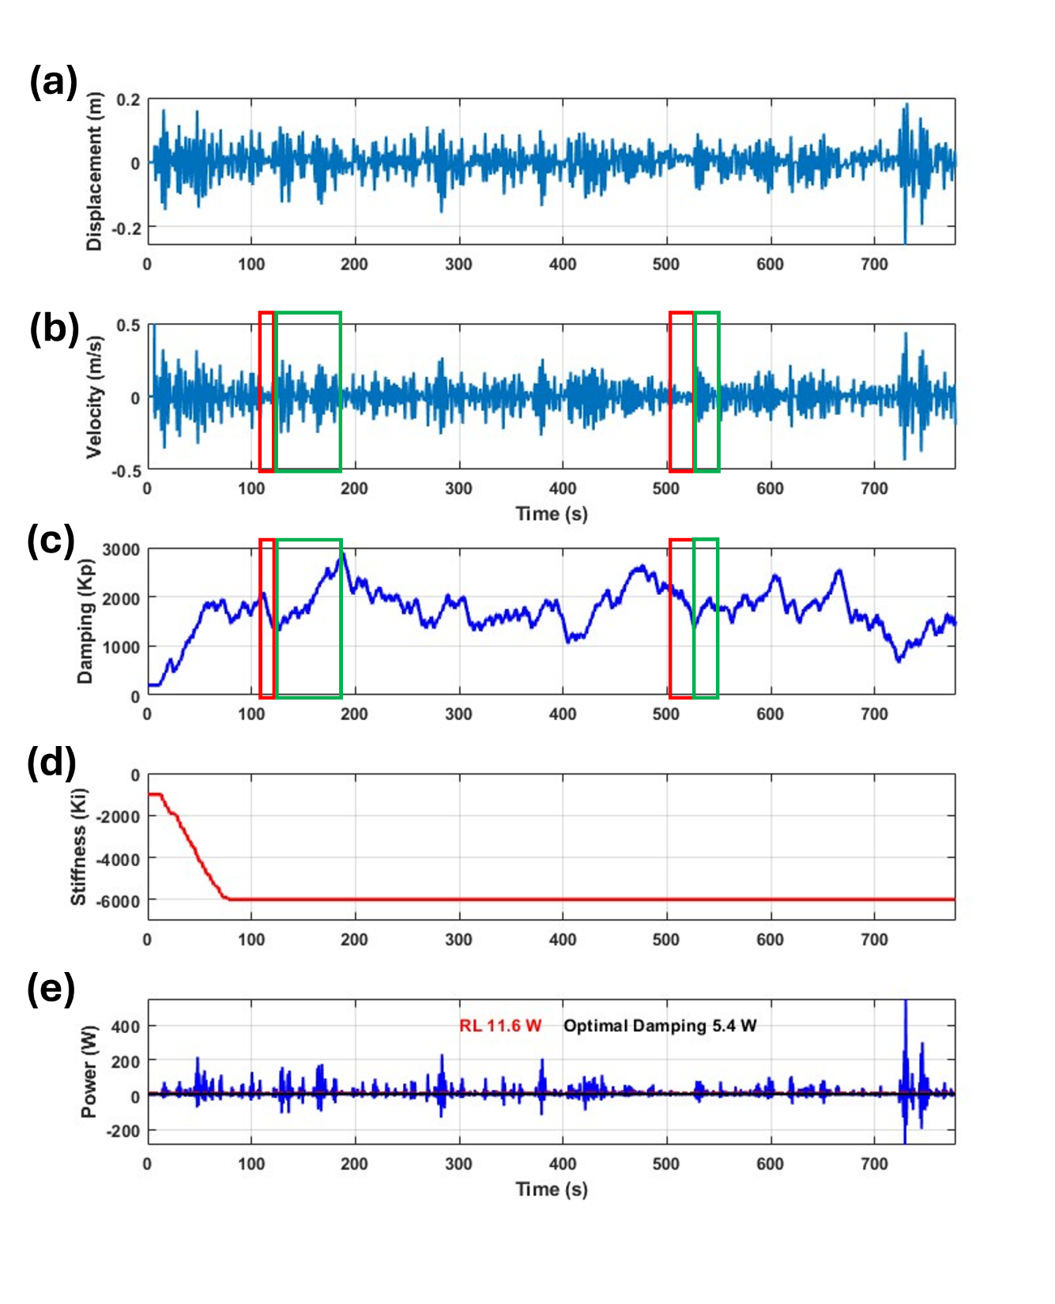
Figure 45: Detailed performance of the DRL control under the irregular wave which has a significant height of 0.21m and a peak period of 3.09s with the first random seed.

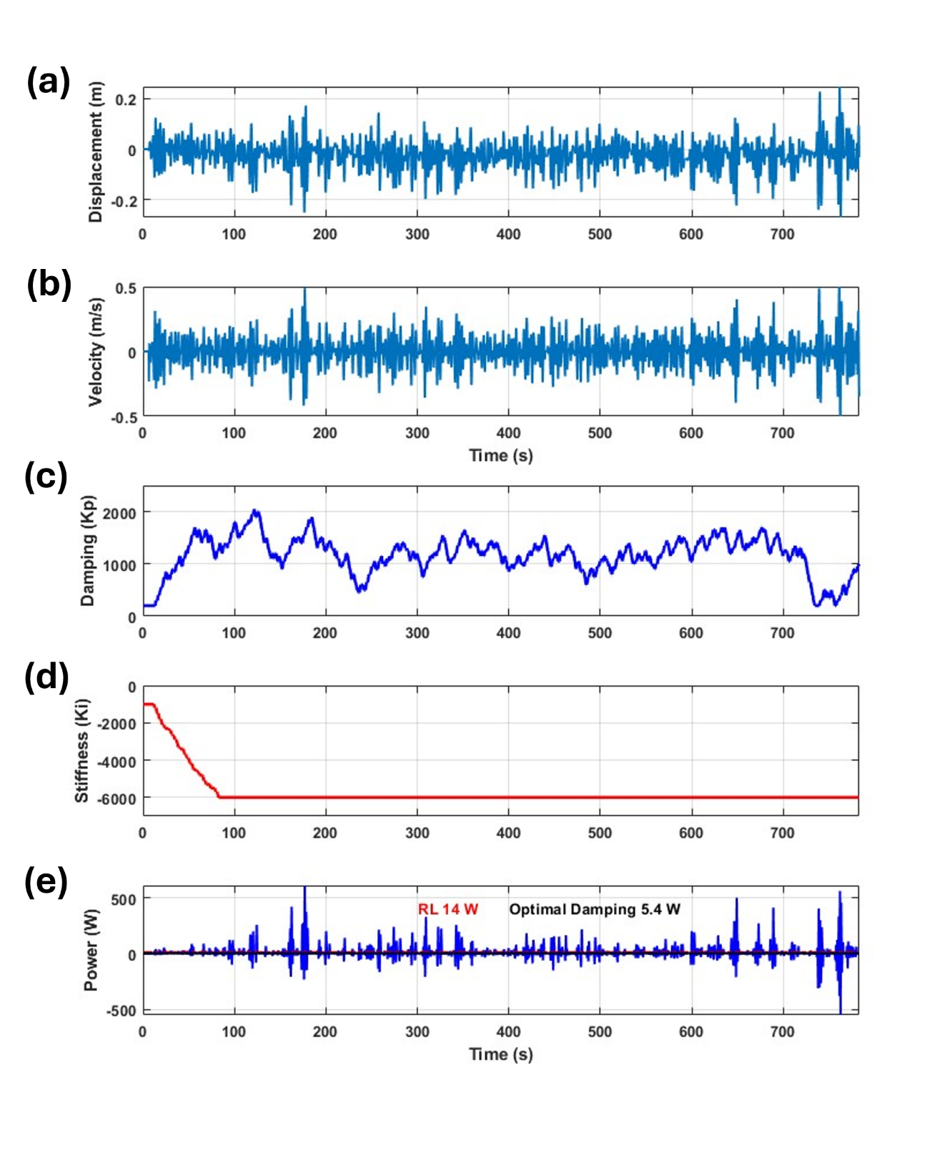
Figure 46: Detailed performance of the DRL control under the irregular wave which has a significant height of 0.21m and a peak period of 3.09s with the second random seed.
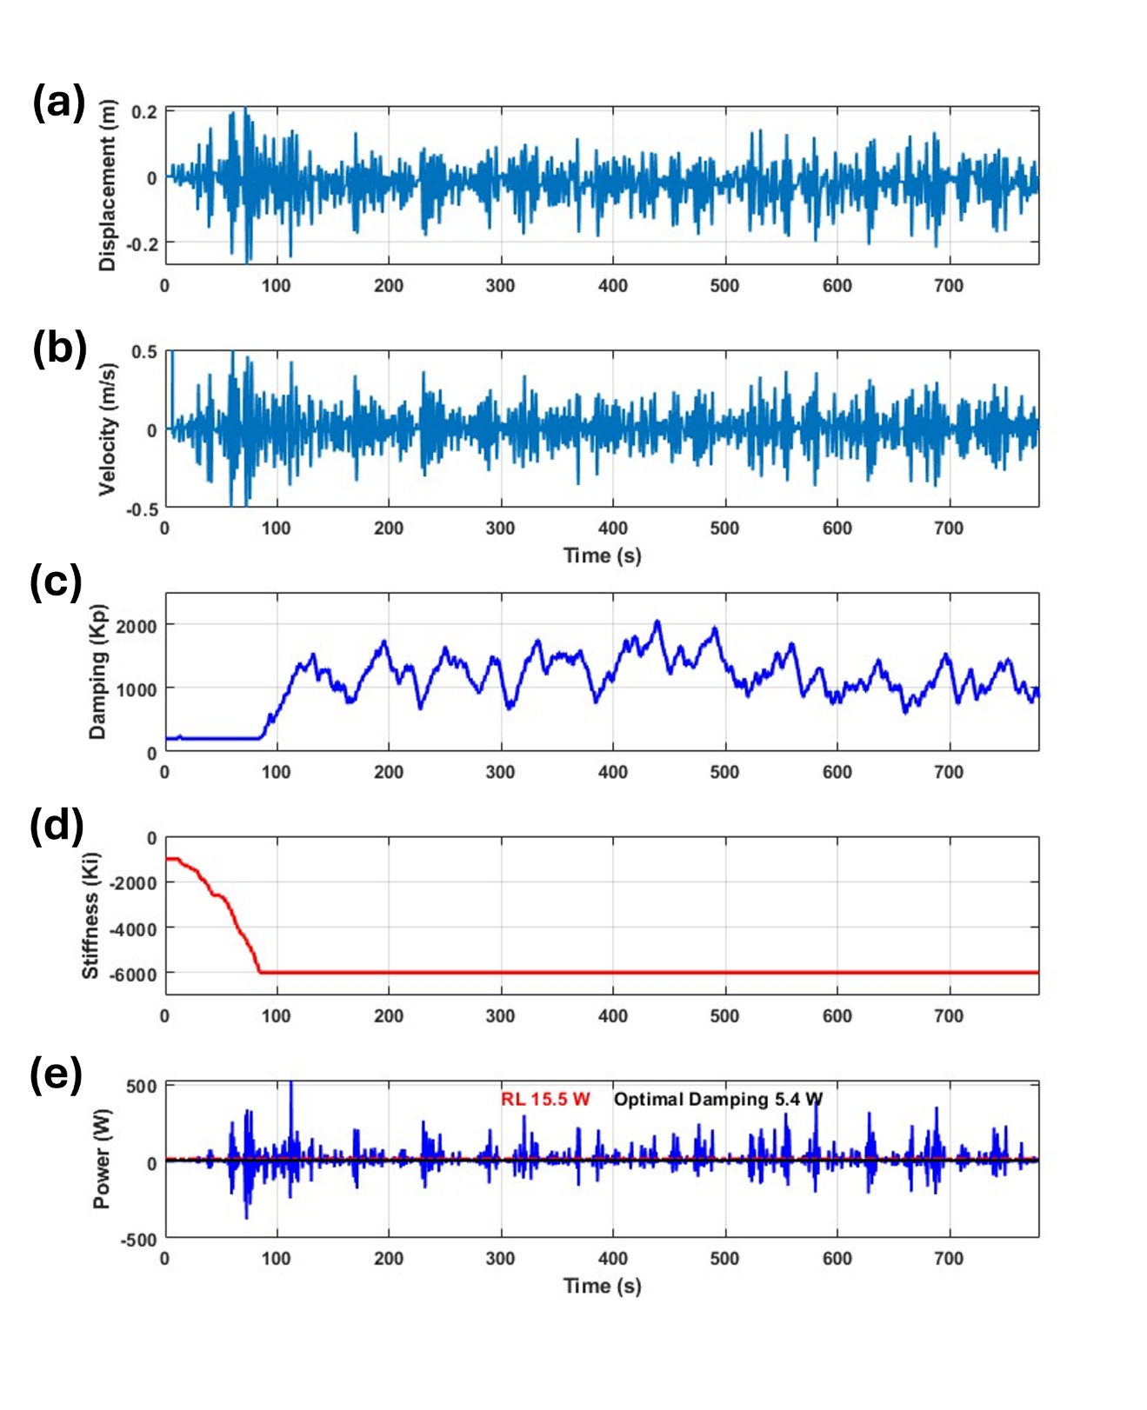
Figure 47: Detailed performance of the DRL control under the irregular wave which has a significant height of 0.21m and a peak period of 3.09s with the third random seed.

(4) Reward design to account for PTO losses
In the TSR’s prior work, the DRL control was designed to directly optimize electrical power output, which is one of the significant benefits of this approach given that it is model-free. However, in this project, the reward collected from the environment is based on mechanical power instead, primarily due to two reasons: (1) the current limitations of the experimental setup, as there is no dedicated power analyzer available to measure the AC and DC power output; and (2) the lack of an accurate PTO model that can calculate the electrical power output of LUPA for training the DRL control.
However, designing the control solely based on mechanical power may not lead to optimal electrical power output, especially when considering losses in the PTO drivetrain. Therefore, to assess the electrical power output under the current limitations of the testing environment, a reward function that accounts for the losses is introduced [28]:
$$r=-\frac{\sum{F_{PTO}v}}{N}-αF_{PTO}^{2}$$
In this equation, the first term represents the mechanical power harvested (calculated in a moving average manner which is the reward applied in prior tests), while the second term introduces a penalty on the PTO force. Unlike a reward function based solely on mechanical power, this new loss-informed reward accounts for both energy production and associated losses, making it more representative of optimizing electrical power output. It is noted that the $α$ is a tuning parameter represents the weight of the penalty.
Figure 48 presents the details of the DRL control performance using the new reward setup under the wave condition with a height of 0.2 m and a period of 1.75 s, with α selected as 0.00005 in this case. From Figures 48(a) and 48(b), it is clearly observed that the motor torque and current are reduced when the PTO force is penalized—by 13.2% and 17.6%, respectively, compared to the unpenalized case. As a result, the displacement and velocity of LUPA are also smaller than in the unpenalized scenario, as shown in Figures 48(c) and 48(d).
The harvested mechanical power is presented in Figure 49. The unpenalized case yields 12.3 W, while the penalized case produces 9.76 W, representing a decrease of 20.65%. In terms of electrical power, since motor copper loss is proportional to the square of the current, a current reduction of 17.6% results in a loss reduction of approximately 32%. Given that the reduction in loss is greater than the reduction in harvested mechanical power, this suggests a potential improvement in electrical power output.
Figure 50 presents a second case study using the penalized reward, with α selected as 0.0002. With a stronger penalty, it is clearly visible in Figures 50(a) and 50(b) that the motor torque and current are significantly smaller than in the unpenalized case, reduced by 35 percent and 35.3 percent respectively. Similarly, the displacement and velocity of LUPA are also reduced, as shown in Figures 50(c) and 50(d).
The harvested mechanical power is presented in Figure 51. In this case, the mechanical power produced with the penalized reward is reduced by 35.8%. However, the associated loss is reduced by 58.1%, which is a greater reduction than that of the mechanical power. This again suggests a potential improvement in electrical power output.
However, the actual improvement in electrical power output also depends on the specific amounts of loss and mechanical power, as well as other types of losses such as inverter loss. More rigorous evidence and dedicated studies, including direct measurement of electrical power, are needed to confirm this improvement.
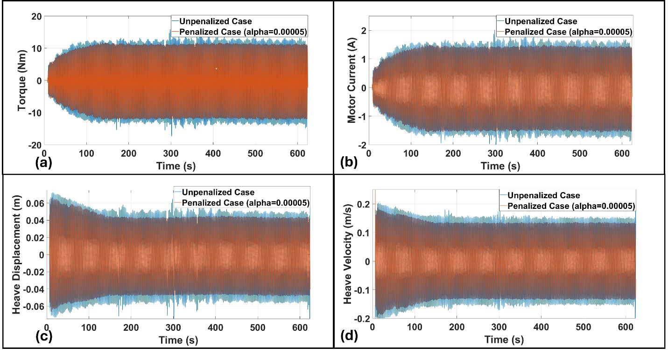
Figure 48: Detailed performance of the DRL control with penalty term in the reward function compared with unpenalized case.
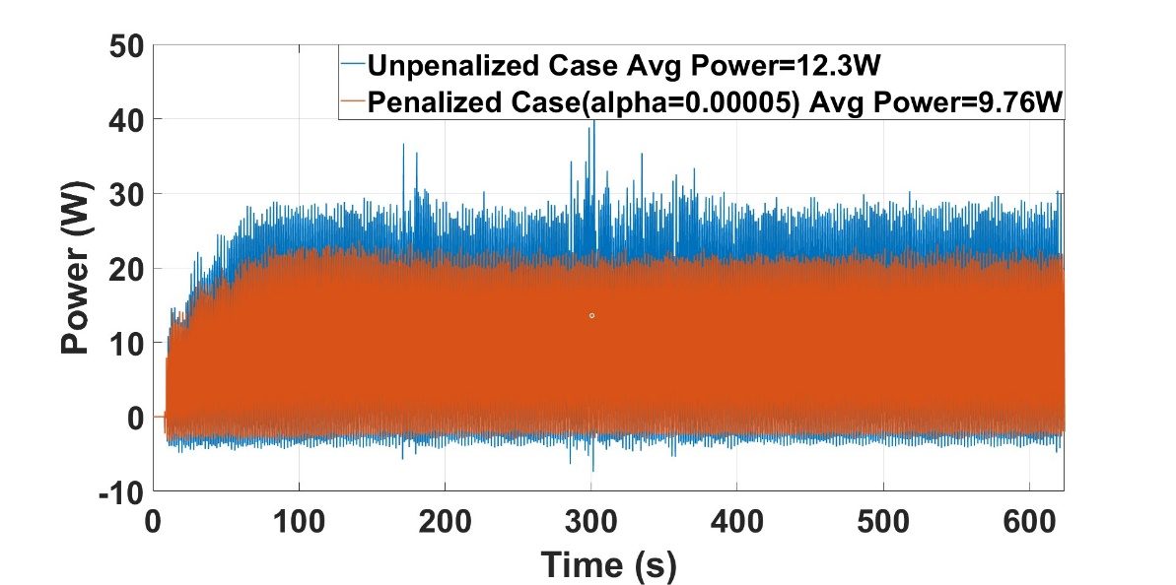
Figure 49: Power harvested by the DRL control with penalty in the reward function compared with unpenalized case.

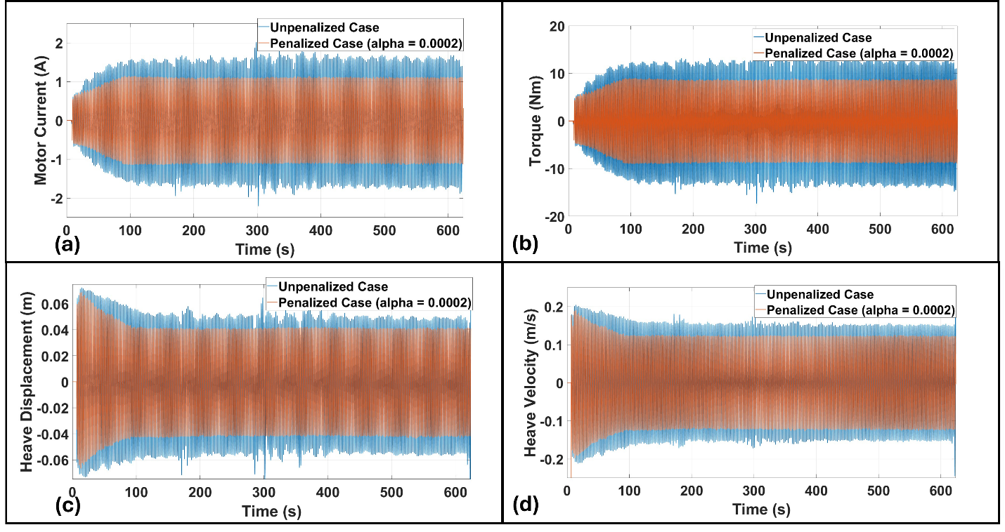
Figure 50: Detailed performance of the DRL control with stronger penalty term in the reward function compared with unpenalized case.
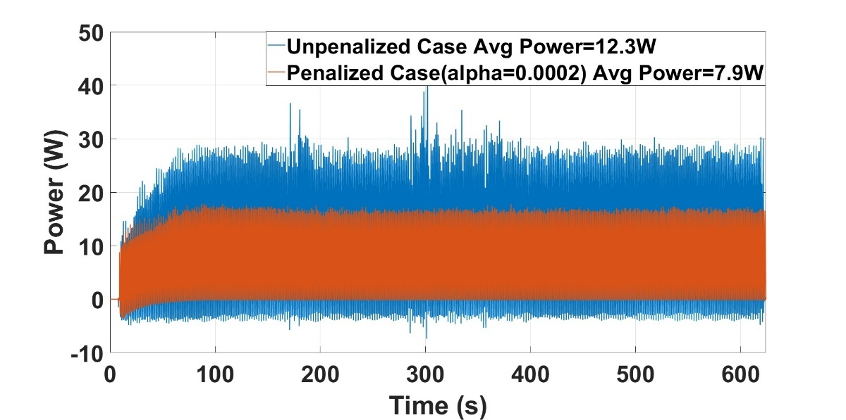
Figure 51: Power harvested by the DRL control with stronger penalty in the reward function compared with unpenalized case.
A special finding
Actually, when we analyze the first penalized case, more findings are obtained. Fig. 52 and 53 present the PI gains compared between the penalized and unpenalized cases. It is clearly visible in this figure that the PI gains between these two cases are actually very close in terms of the average value, which is around 1100 N·s/m and -2700 N/m for the proportional and integral gains, respectively.
This brings an interesting question: under the same wave condition (height of 0.2 m and period of 1.75 s) with nearly the same control, how come the power produced is significantly different (unpenalized 12.3 W and penalized 9.76 W)? This is actually due to the oscillation presented in the control gains. The DRL control is formulated as:
$$F_{PTO}= -K_{i}\left(t\right)z-K_{p}\left(t\right)v$$
As presented in Fig. 53, we can see that for the unpenalized case, the proportional gain exhibits significant oscillation. This oscillation further leads to a control force with an oscillating magnitude (Fig. 54), which in turn results in system responses with oscillating magnitudes (or significant nonlinear responses, as shown in Fig. 55). In contrast, for the penalized case, the integral gain also displays an oscillating pattern. However, it is noted that in this specific case, the proportional control term is more dominant than the integral control term. Therefore, the control force in the penalized case does not exhibit a strong nonlinear pattern (Fig. 54), and as a result, the system responses also display a more linear behavior (Fig. 55).
More importantly, it is evidenced in Fig. 51 that this nonlinear response is actually beneficial for wave power harvesting—improving the power produced by 26%—by exciting the motion of the buoy through added oscillation in the control gains. To rule out the factor of measurement error, this specific case was repeated three times, and the observation remained consistent across the repeated tests. The TSR believes that this nonlinear behavior warrants further investigation in the future to enhance the power harvesting performance of WECs.
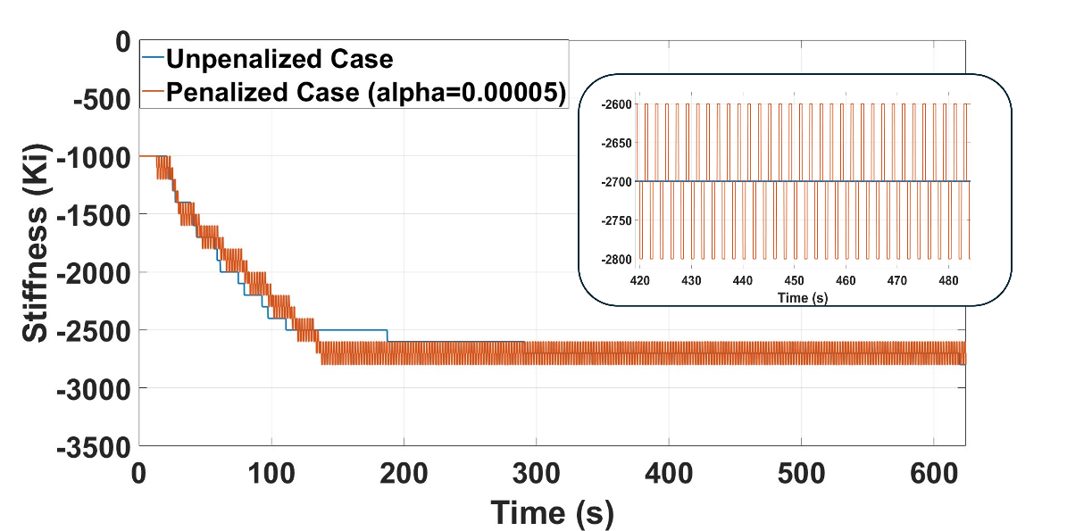
Figure 52: Comparison of the integral gain of the DRL control between penalized and unpenalized cases.
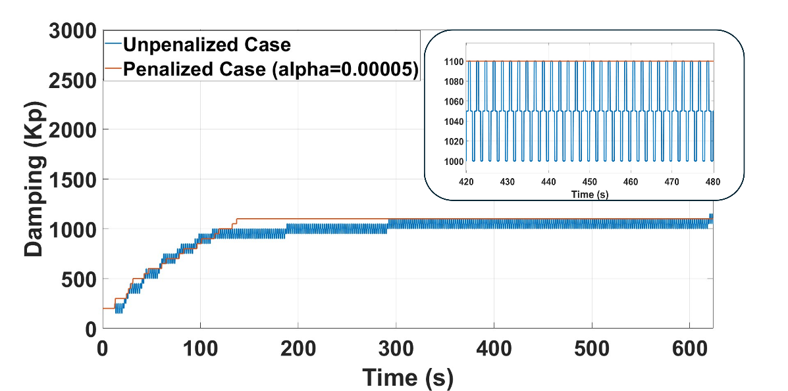
Figure 53: Comparison of the proportional gain of the DRL control between penalized and unpenalized cases.
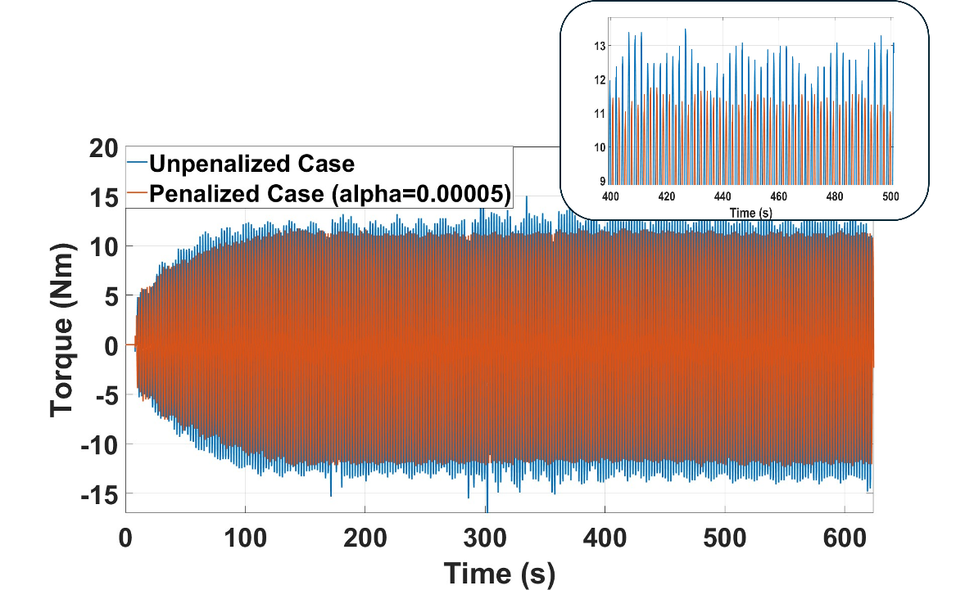
Figure 54: Comparison of the actually applied control torque between penalized and unpenalized cases.
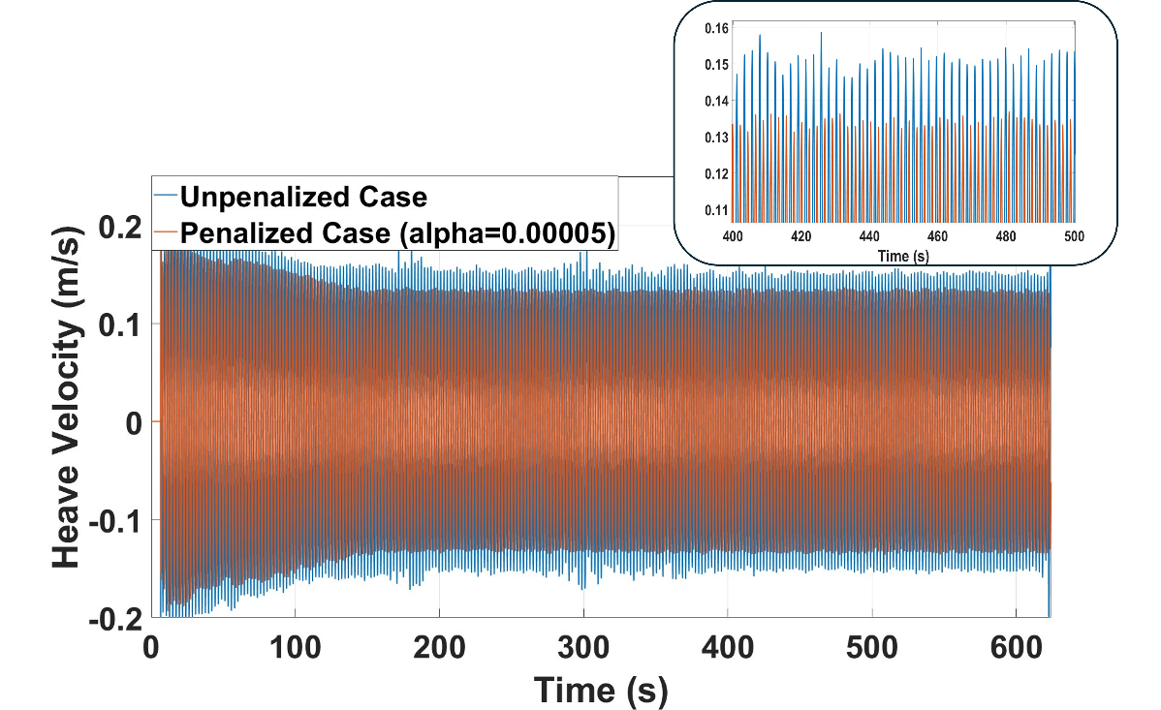
Figure 55: Comparison of the velocity of the WEC under the DRL control with penalized and unpenalized rewards.

Lesson Learned and Test Plan Deviation

General Lessons Learned
In testing the DRL control with LUPA, it is found that the end stop system in LUPA plays an important role in designing the test plan, especially under controlled conditions. Although the purpose of having an end stop system is to protect LUPA from excessive motions, in general, it is not preferred to reach the end stop during the tests (or even hit the end stop a few times during one test) to protect LUPA from damage. In this scenario, some wave conditions are too strong for LUPA, especially when active control is applied. For instance, the motion of LUPA is large under wave conditions with a height of 0.2 m and has a high potential to hit the end stop if the motion is fully excited (e.g., using an impedance matching control). Therefore, unless the control is able to take the constraints into consideration (and is expected to be respected in practice), it would be very risky to test an unconstrained active control under this wave height.
Considering the irregular wave conditions, despite the fact that on average irregular waves contain less power than regular waves under the same wave height (theoretically, one can test with a higher wave height), it is still risky to test with a large wave height. The reason is that although the wave may introduce less motion in an average sense, it may introduce some significant wave events due to the irregular nature of the wave. In summary, it is important to know these limitations prior to designing the test matrix, especially for control studies. For controls that are able to consider constraints, it may also be valuable to rehearse the control with the random seed that can be provided by the facility.
Significant PTO mechanical loss is found during the test, which is also dependent on the operating conditions. An ad-hoc way of implementing this nonlinear PTO loss is developed in this test campaign, which applies a linear damping formula with the damping coefficient being a random number within a certain range (identified according to test data). This works fine for the proposed DRL control since it is model-free. However, a more dedicated model would be useful in the future, especially when testing model-based controls.
A number of drive downtime events also occurred during the testing period (also documented in the testing log). When there is a drive down (meaning control is calculated but could not be sent to the motor drive), the device will apply no control and the test is considered failed for that run. The tester then has to wait the same amount of time (as between normal tests) for the tank to return to a quiet state, which is very time-consuming. In this test campaign, thanks to the suggestions provided by the facility, the general way to address this problem is to clean up all the saved files in SPEEDGOAT every other test (which is quite effective) and restart the whole system if necessary.
Thanks to the support provided by the facility, the TSR is aware of the tank resonant period prior to conducting tests (around 1.5s). This wave condition is avoided.
Nonlinear wave events are observed for some wave conditions (especially height 0.15 m and period 2.25 s, and height 0.2 m and period 1.75 s). This may actually be a good opportunity to challenge the control. In this test campaign, these conditions were tested earlier according to the plan, which gave the team sufficient time to address these events. This may be a good practice for testing other controls as well.

Deviations from the Test Plan
The wave conditions were downselected from the original test plan for several reasons. First of all, wave conditions that cause significant tank resonance effects (such as periods at or below 1.5 s, which result in highly chaotic commanded waves) were removed from the testing matrix. Wave conditions with very small heights, which fail to induce meaningful LUPA motion and produce only minimal power output (making the data highly susceptible to measurement errors), were also excluded. On the other hand, overly energetic wave conditions that pose a high risk of LUPA hitting the end stops were similarly removed. Finally, seven different wave conditions were tested, including six regular wave conditions (Table 8) and one irregular wave condition.
However, it is noted that despite the downselection of wave conditions from the original plan, more meaningful tests were conducted in other dimensions to support a dedicated study of DRL control performance. For instance, the control was tested under a specific wave condition across eight different observation state setups to examine the impact of observation states on control performance in terms of power harvesting, robustness, and adaptability. The optimal observation state was then selected and used for testing across all regular wave conditions.
In addition, two different penalty setups for the reward function were tested under a specific regular wave condition to evaluate control performance in terms of energy harvesting and losses. Two different setups for the window size were also tested to identify the optimal window size for irregular wave conditions.
In summary all these tests support the objective of this research: to understand the practical challenges and limitations of implementing DRL control and to evaluate its performance in real-world scenarios.

Conclusions and Recommendations
The objective of this study is to understand the practical limitations and challenges of real-time implementation of DRL control, as well as to evaluate its performance in practice. A series of tests under varied regular and irregular wave conditions were conducted in this project to generate meaningful data in support of this objective. The key findings of this project are summarized below:
- The DRL control is trained using the MATLAB/Simulink Deep Learning Toolbox, which is found to integrate straightforwardly with the real-time system (SPEEDGOAT). This is because the same platform is used for both numerical simulations and the real-time implementation.
- The processing time of DRL control (which basically is to evaluate a deep neural network) in real time is found to be very small (around 0.008 ms) and is significantly smaller than the sampling rate (1 ms).
- The real challenge of the practical implementation of the DRL control is found to be the robustness of the control when subjected to various sources of randomness present in the actual environment. It is highly recommended to introduce significant randomness during training (such as nonlinear events, random initial conditions, nonlinear drivetrain losses, process noises, etc.) so that the control can remain robust under these uncertainties and nonlinearities.
- The performance of the control in terms of power production and robustness is significantly impacted by the selected observation states. The TSR has tested eight different selections based on the literature and found the control to be optimal and adaptive but slightly less robust when displacement and velocity are used as the observation state (so recommended for irregular waves). In contrast, the control was found to be strongly robust when displacement, velocity, significant wave height, period, and prior action were included in the observation state (so recommended for regular waves).
- Adding a penalty on the PTO force in the reward function, in addition to mechanical power, can effectively constrain the PTO force effort and therefore reduce losses in the drivetrain. More measurements are needed for further analysis to understand how this may benefit the electrical power output.
- The power harvested by the DRL control is nearly the same as that of the OFC control (when control is applied with the integral term) under regular wave conditions and is significantly better than the OFC control (when only damping applied) under both regular and irregular wave conditions.
The project objectives were successfully met in this test campaign, and the team was able to collect a very ample amount of testing results. The findings from this research advance the understanding of the practical implementation and performance of reinforcement learning-based control, which is currently insufficiently studied and discussed in the literature. This knowledge is vital for control developers such as the TSR to ensure the practical performance of the control and will benefit the development of more advanced control strategies in the future. Based on the demonstrated control performance, this research also increases confidence in the practical application of reinforcement learning-based control, which has strong potential to improve the efficiency of power production and, consequently, reduce the cost of wave energy conversion technologies.

References
[1] Zou, S., Zhou, X., Khan, I., Weaver, W.W. and Rahman, S., 2022. Optimization of the electricity generation of a wave energy converter using deep reinforcement learning. Ocean Engineering, 244, p.110363.
[2] Zou, S., Zhou, X., Weaver, W. and Abdelkhalik, O., 2022. Deep Reinforcement Learning Control of Wave Energy Converters. IFAC-PapersOnLine, 55(27), pp.305-310.
[3] Forbush, D.D., Bacelli, G., Spencer, S.J., Coe, R.G., Bosma, B. and Lomonaco, P., 2022. Design and testing of a free floating dual flap wave energy converter. Energy, 240, p.122485.
[4] Bacelli, G., Spencer, S.J., Patterson, D.C. and Coe, R.G., 2019. Wave tank and bench-top control testing of a wave energy converter. Applied Ocean Research, 86, pp.351-366.
[5] Cho, H., Bacelli, G. and Coe, R.G., 2019. Model predictive control tuning by inverse matching for a wave energy converter. Energies, 12(21), p.4158.
[6] Bacelli, G., Nevarez, V., Coe, R.G. and Wilson, D.G., 2019. Feedback resonating control for a wave energy converter. IEEE Transactions on Industry Applications, 56(2), pp.1862-1868.
[7] Wilson, D.G., Robinett III, R.D., Bacelli, G., Abdelkhalik, O. and Coe, R.G., 2020. Extending complex conjugate control to nonlinear wave energy converters. Journal of Marine Science and Engineering, 8(2), p.84.
[8] Bacelli, G. and Coe, R.G., 2020. Comments on control of wave energy converters. IEEE Transactions on Control Systems Technology, 29(1), pp.478-481.
[9] Coe, R.G., Bacelli, G. and Forbush, D., 2021. A practical approach to wave energy modeling and control. Renewable and Sustainable Energy Reviews, 142, p.110791.
[10] Ringwood, J.V., Tom, N., Ferri, F., Yu, Y.H., Coe, R.G., Ruehl, K., Bacelli, G., Shi, S., Patton, R.J., Tona, P. and Sabiron, G., 2023. The wave energy converter control competition (WECCCOMP): Wave energy control algorithms compared in both simulation and tank testing. Applied Ocean Research, 138, p.103653.
[11] Zou, S., Abdelkhalik, O., Robinett, R., Bacelli, G. and Wilson, D., 2017. Optimal control of wave energy converters. Renewable energy, 103, pp.217-225.
[12] Bacelli, G. and Ringwood, J.V., 2014. Numerical optimal control of wave energy converters. IEEE Transactions on Sustainable Energy, 6(2), pp.294-302.
[13] Zou, S., Abdelkhalik, O., Robinett, R., Korde, U., Bacelli, G., Wilson, D. and Coe, R., 2017. Model Predictive Control of parametric excited pitch-surge modes in wave energy converters. International journal of marine energy, 19, pp.32-46.
[14] Li, G. and Belmont, M.R., 2014. Model predictive control of sea wave energy converters–Part I: A convex approach for the case of a single device. Renewable Energy, 69, pp.453-463.
[15] Haider, A.S., Brekken, T.K. and McCall, A., 2021. Application of real‐time nonlinear model predictive control for wave energy conversion. IET Renewable Power Generation, 15(14), pp.3331-3340.
[16] Coe, R.G., Bacelli, G., Spencer, S.J. and Cho, H., 2018. Initial results from wave tank test of closed-loop WEC control (No. SAND-2018-12858). Sandia National Lab.(SNL-NM), Albuquerque, NM (United States).
[17] Anderlini, E., Husain, S., Parker, G.G., Abusara, M. and Thomas, G., 2020. Towards real-time reinforcement learning control of a wave energy converter. Journal of Marine Science and Engineering, 8(11), p.845.
[18] Anderlini, E., Parker, G.G. and Thomas, G., 2019. Docking control of an autonomous underwater vehicle using reinforcement learning. Applied Sciences, 9(17), p.3456.
[19] Beringer, C., Bosma, B. and Robertson, B., 2023, September. Degrees of Freedom Effects on a Laboratory Scale WEC Point Absorber. In Proceedings of the European Wave and Tidal Energy Conference (Vol. 15).
[20] Strofer, C.M., Coe, R., Gaebele, D., Beringer, C., Bosma, B., Robertson, B., Bacelli, G. and Devin, M., 2023, September. Control co-design and uncertainty analysis of the LUPA’s PTO using WecOptTool. In Proceedings of the European Wave and Tidal Energy Conference (Vol. 15).
[21] Bosma, B., Beringer, C. and Robertson, B., 2023, September. Experimental passive and reactive control of a Laboratory Scale WEC Point Absorber. In Proceedings of the European Wave and Tidal Energy Conference (Vol. 15).
[22] Robertson, B., Bosma, B. and Beringer, C., 2022. National Marine Renewable Energy Center Upgrades-LUPA (No. 480). Marine and Hydrokinetic Data Repository (MHKDR); Oregon State Univ., Corvallis, OR (United States).
[23] Mnih, V., Kavukcuoglu, K., Silver, D., Graves, A., Antonoglou, I., Wierstra, D. and Riedmiller, M., 2013. Playing atari with deep reinforcement learning. arXiv preprint arXiv:1312.5602.
[24] Fornies-Marquina, J.M., Letosa, J., Garcia-Gracia, M. and Artacho, J.M., 1997. Error propagation for the transformation of time domain into frequency domain. IEEE Transactions on Magnetics, 33(2), pp.1456-1459.
[25] Orphin, J.J., Penesis, I. and Nader, J.R., 2018. Uncertainty analysis for a wave energy converter: the Monte Carlo method. AWTEC 2018 Proceedings, p.444.
[26] Ringwood, J.V., Mérigaud, A., Faedo, N. and Fusco, F., 2019. An analytical and numerical sensitivity and robustness analysis of wave energy control systems. IEEE Transactions on Control Systems Technology, 28(4), pp.1337-1348.
[27] Ingram, D.M., 2011. Protocols for the equitable assessment of marine energy converters. Lulu. com.
[28] Chen, K., Huang, X., Lin, Z., Han, Y. and Xiao, X., 2024. Design and Tank Testing of Reinforcement Learning Control for Wave Energy Converters. IEEE Transactions on Sustainable Energy.

Acknowledgements
Thanks to Dr. Gordon Parker for all the meaningful discussions and his willingness to share the high-performance computing resources, which enabled the TSR to conduct retraining on time. Thanks to Dr. Tim Maddux for all the meaningful discussions and the support provided on site. Also, thanks to him for providing the processing code for the wave gauge data.

Appendix

Appendix A – Additional Data Acquisition
Additional details on the measurements can be found in Table 6.
Table 6: Data Acquisition Channels and Sensors
Sensor Name | Quantity | DAQ System | Physical Quantity | Units
Load cell | 4 | Hinsdale | Mooring line tension | Newtons
Wave gage | 4 | Hinsdale | Free surface elevation | Meters
String pot | 1 | Hinsdale | Relative motion of spar to tank | Meters
Draw wire | 1 | Onboard LUPA | Relative motion of spar and float | Meters
Load cell | 2 | Onboard LUPA | Force in PTO | Newtons
Vertical Reference Unit | 1 | Onboard LUPA | Accelerations, angular position, angular velocity | Meters per seconds squared, radians, radians per second
Temperature Sensor | 1 | Onboard LUPA | Motor temperature | Degrees Celsius
Encoder | 1 | Onboard LUPA | Motor position | Radians
Motor Drive | 1 | Onboard LUPA | Motor torque, motor current | Newton-meters, amps

