Post Access Report
Field Demonstration of MarineSitu’s Marine Energy Monitoring Tools
Awardee: MarineSitu, Inc.
Awardee point of contact: James Joslin
Facility: Pacific Northwest National Laboratory
Facility point of contact: Nichole Sather
Facility project lead: Theodore Nowak
Date: August 23, 2026

Executive Summary
From 07/01/2024 through 10/28/2024, Pacific Northwest National Laboratory (PNNL) supported the first long-term deployment and demonstration of MarineSitu’s Adaptable Monitoring Package (AMP). In addition to evaluating the open water suitability of MarineSitu’s system, throughout the course of the effort, PNNL data scientists worked with MarineSitu staff to test and improve MarineSitu’s data management and analysis software. Approximately 9 TB of data from MarineSitu’s multi-camera and sonar-equipped system were captured during the deployment. MarineSitu trained and deployed real-time object detection algorithms and, to evaluate MarineSitu’s API and data quality, PNNL tested experimental objection detection, tracking, and 3D object detection algorithms in post-processing. The interfaces to MarineSitu’s system - both software and human - were evaluated both by marine biologists and data scientists at PNNL. In totality, MarineSitu’s AMP operated nearly every day of the 4-month deployment period, numerous software bugs and improvements were identified and corrected, novel AI approaches were demonstrated and evaluated using their data, and feedback was provided to improve the AMP and its utility as an environmental monitoring platform for both researchers and regulators.

Introduction to the project
Environmental monitoring of marine energy devices is often prohibitively expensive and complicated for project developers. For this reason, DOE issued an SBIR topic area for the development of “low-cost and user-friendly environmental monitoring tools for marine energy” and subsequently awarded MarineSitu with both Phase I and II grants to develop a modular camera system. This system costs approximately 50% or less than comparable tools on the market and offers unique capabilities, especially in automated data processing. This TEAMER deployment was the first opportunity to test this system in a tidal channel with currents suitable for marine energy testing, and the first opportunity to put the system in the hands of researchers for evaluation and feedback.
MarineSitu’s underwater monitoring tools were originally developed by the Pacific Marine Energy Center at the University of Washington (UW) as part of the Adaptable Monitoring Package (AMP), an integrated instrumentation system designed for environmental monitoring at marine energy sites. The DOE SBIR related to this project has funded the technology transfer from UW to MarineSitu, where these instruments have been further refined and commercialized as products. The instruments include a modular underwater camera system with machine vision cameras, lights, and a camera system controller, an instrument integration hub, and a new prototype of a camera system with integrated lights, rotator, and antifouling brush. In addition to the hardware products, the software for data acquisition and processing was initially developed by UW in LabVIEW (National Instruments) and has been rewritten by MarineSitu in an executable format with modules for AI models and a cloud interface.
This project allowed MarineSitu to deploy these tools on a tripod bottom lander near the PNNL pier in the Sequim Bay channel with support from PNNL divers and staff. The instrumentation platform was cabled back to the pier and connected to a 48 VDC power supply and control computer. During the deployment, PNNL staff assessed the system software and provided feedback on usability, features, and performance. Specifically, PNNL staff assessed the ease of deploying the software to collect data in its standard configuration and of integrating custom modules to control data acquisition. This feedback has informed future software development by the MarineSitu team.
The goals of this deployment were to demonstrate the survivability of MarineSitu’s hardware and help to advance the system to TRL9. In addition, PNNL evaluated the technical capabilities and usability of MarineSitu’s tools and MarineSitu evaluated object detection model development strategies applicable to marine energy sites. All of these outcomes have helped to demonstrate and refine MarineSitu’s tools for marine energy monitoring.

Roles and Responsibilities of Project Participants

Applicant Responsibilities and Tasks Performed
The applicant (MarineSitu) provided the following equipment:
- Tripod instrumentation platform fully assembled and ready to deploy. This system included the following components:
  - MarineSitu’s modular camera system with two machine vision cameras (C1), two high power LED lights (L1), and camera controller (CC1)
  - MarineSitu’s new low-cost integrated camera system with rotator (IC1)
  - Tritech Gemini 1200ik sonar
  - Antifouling system (BC1) with wipers and UV lights
  - Instrument integration hub (H1)
- Subsea cable for power/communication
- Data acquisition computer and required equipment for communications with the AMP
After AMP deployment, MarineSitu:
- Handled day-to-day operation of the system, including adjusting instrument settings and controlling data acquisition
- Uploaded data to cloud storage and provided API and web interfaces for interacting with the data products
- Trained ML models for data acquisition control during deployment
- Iterated on ML models using new annotated data collected during the deployment on a biweekly basis
- Provided model performance assessments for each model iteration

Network Facility Responsibilities and Tasks Performed
The facility (PNNL) provided the following:
- Environmental permitting/authorizations for deployment
- Divers and vessel support for system deployment and cable routing
- Screw anchors to anchor system and cabling to seabed
- Facility space, power, network connection, and routing for PNNL and MarineSitu to access data acquisition computer remotely
The facility conducted the following operations:
- Deployment of MarineSitu’s system
- Recovery of MarineSitu’s system
During AMP deployment, the facility (PNNL):
- Provided MarineSitu with remote network access to the system throughout the duration of the deployment
- Coordinated with MarineSitu to monitor and maintain system health
- Tested control and data acquisition software from startup to shutdown and provided feedback on usability
- Provided any needed shore-side support after deployment (e.g., reboot computer after power outage)
- Evaluated MarineSitu’s user interface and reported its utility
- Evaluated MarineSitu’s software API and data storage and reported their utility
- Accessed data products through MarineSitu APIs and reported on their utility
- Developed unique data visualizations and data analytics approaches to demonstrate novel system capability and evaluated the system’s utility for automated detection research
- Documented and shared system utility evaluations, software, analytics, and data

Project Objectives
The objective of this test was to demonstrate and assess the performance and usability of MarineSitu’s environmental monitoring tools. This objective was achieved by conducting a medium-term deployment of the system in a high-energy tidal channel, by testing real-time monitoring software tools during the deployment, and by evaluating the efficacy of these tools through usability surveys and data analysis tasks. The objective of MarineSitu’s machine learning component of this work was to evaluate the iterative model development methodology and its applicability to marine energy monitoring, not to achieve production-ready model performance. Model accuracy was tracked as a metric for evaluating the methodology, but absolute performance levels were expected to be limited by the size and temporal coverage of the training dataset during a single deployment. While MarineSitu provided the system and support and refined their existing machine learning (ML) methods during deployment, PNNL researchers performed the expert assessment of the newly developed system and software and developed their own data analytics during deployment to vet the system.

To evaluate performance towards these objectives, the following metrics were used to analyze performance both during and after deployment:
Bi-weekly tests and metrics conducted during deployment:
- ML model retraining and fine-tuning
- Precision of ML models for target detection in both optical and imaging sonar data
- Recall of ML models for target detection in both optical and imaging sonar data
- False positive rate of ML models for target detection in both optical and imaging sonar data
Post deployment:
- Manual data review time requirements (average hours per week)
- Change in stereo calibration over the course of deployment (pre-deployment to post-deployment)
- Qualitative evaluation of biological fouling on system at recovery
- System up-time and causes of any outages
- Recorded data volume
- PNNL utility evaluations and tests

This demonstration was intended to advance MarineSitu’s tools to a higher technology readiness level and help to make them available to the larger marine energy industry. Ultimately, the adoption of these monitoring tools is intended to help advance the marine energy industry by improving the data collection during field deployments and simultaneously lowering the associated costs of monitoring.

Test Facility, Equipment, Software, and Technical Expertise

PNNL Facilities, Vessels, and Dive Team
Testing was conducted at PNNL’s Marine and Coastal Research Lab (MCRL) in Sequim, Washington. The MCRL facility is located on the western shoreline of the mouth of Sequim Bay which experiences peak tidal current velocities exceeding 2.5 m/s (Branch et al. 2022) suitable for small-scale tidal energy testing (Cavagnaro et al. 2019). MarineSitu’s system was deployed alongside MCRL’s pier, which is outside of the strongest tidal currents. The power/data cable was routed along the pier to a network-connected building on site (MSL3).
The system was deployed using PNNL’s vessel R/V Strait Science (Figure 1), which maneuvered the system into place and secured it. The subsea cable was routed from the system to the shore by PNNL’s scientific dive team.
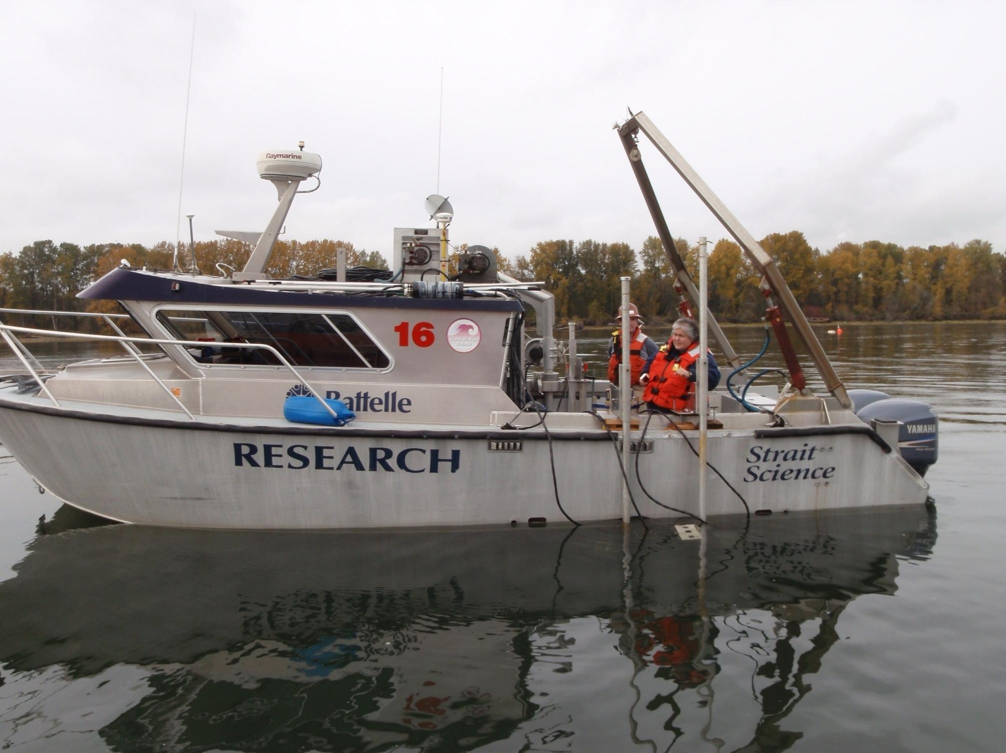
Figure 1: PNNL’s R/V Strait Science.
PNNL routinely deploys and operates sensor systems in and around Sequim Bay. Deployment and recovery operations were standard operations for vessel operators, crew, and divers, and cable routing was similar to previous tests of the Adaptable Monitoring Package (AMP) at the site by the University of Washington and MarineSitu with PNNL support.
The AMP’s data acquisition computer was connected to PNNL’s network to facilitate live, remote monitoring of the system. Access and exfiltration of data in this manner was previously demonstrated during the TEAMER project titled: “Support for environmental monitoring and data analysis around a field-deployed tidal energy converter in Sequim Bay, WA.” Actual system control and data acquisition were handled by MarineSitu software that is commercialized with the system.

PNNL Technical Expertise
The PNNL staff that participated in this effort came from both the Coastal Sciences and AI and Data Analytics divisions at PNNL. Together, they have extensive experience working in the marine energy and collision risk space as well as the sensing, robotics, and AI domains. This work was similar to both ongoing and prior projects that these staff have led, including: machine learning on LiDAR and 3D mesh scenes, real-time object tracking in a high-resolution multi-camera video sensor, and tracking of marine life in imaging sonar data for collision risk around marine energy devices. As such, the staff were well poised to compare MarineSitu’s hardware and software to other systems that they have worked with and to develop additional visualizations and analytics for enhanced awareness using this unique, multi-sensor data.

Test or Analysis Article Description
The MarineSitu instruments were mounted to a Teledyne Ocean Sciences Sea Spider tripod for the deployment. Figure 2 shows the MarineSitu modular camera system and integration hub during a prior short-term deployment in Lake Union as well as the Sea Spider platform and the new low-cost camera system with an imaging sonar. The imaging sonar deployed was a Tritech Gemini 1200ik dual frequency shallow water system.

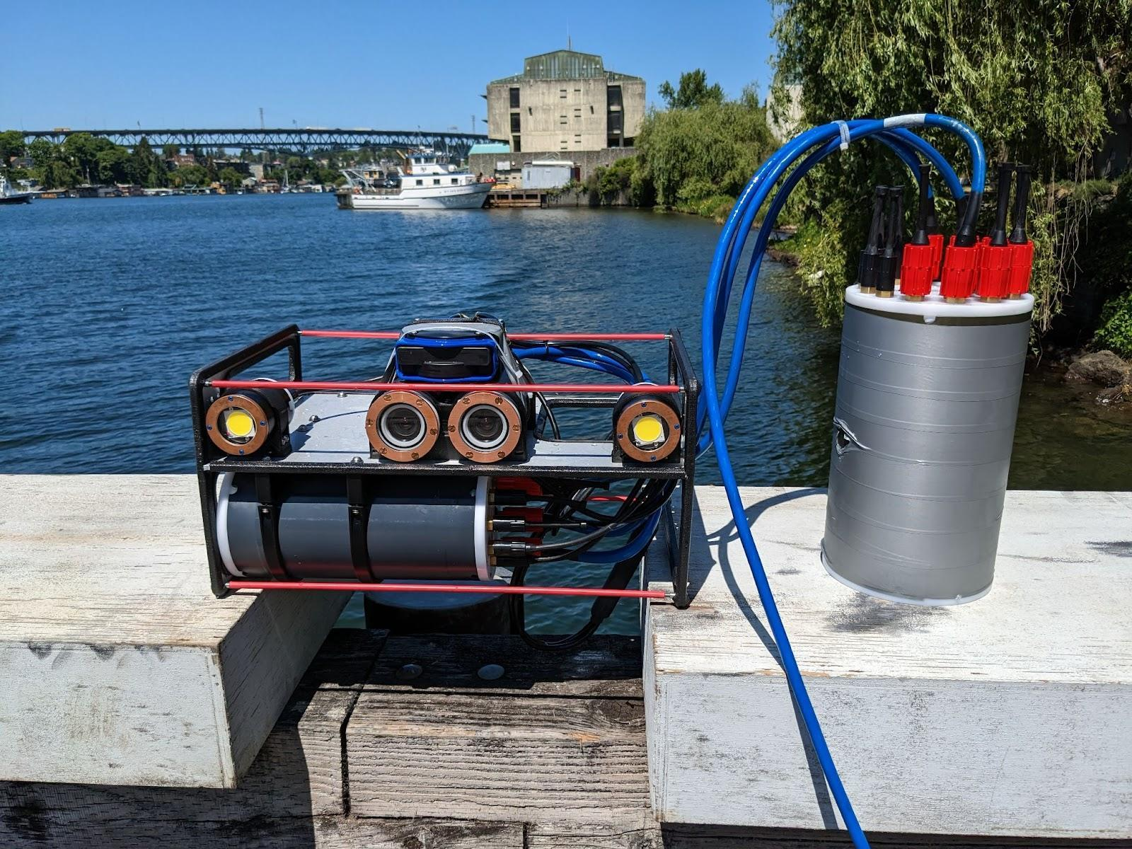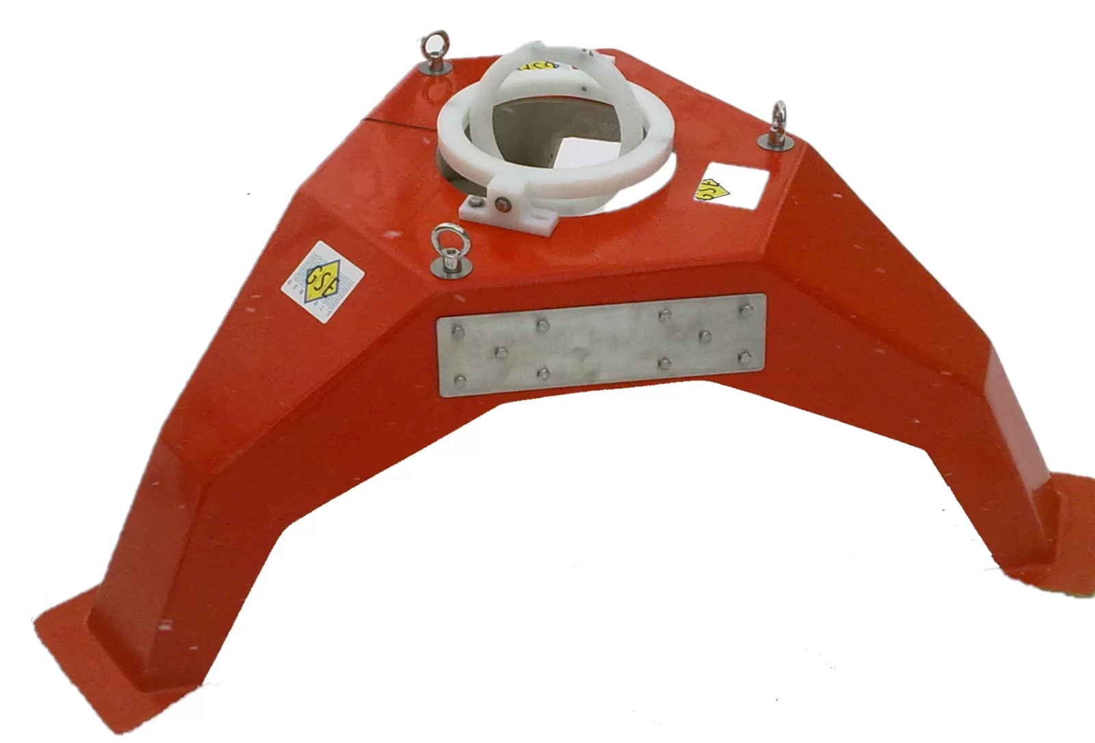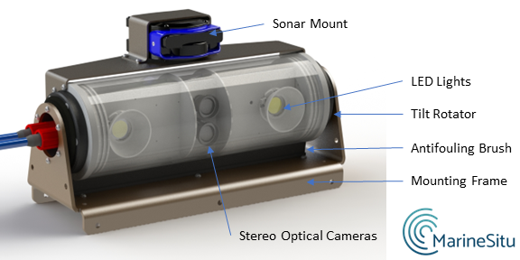
Figure 2: Prototype system during deployment at Lake Washington (top left), Sea Spider (top right), and MarineSitu IC1 Integrated Camera system (bottom).
MarineSitu integrated this equipment onto the Sea Spider platform for the deployment with the two camera systems positioned on top of one another such that they had overlapping fields of view. The Sea Spider is a tripod platform approximately 1.5 m on a side and 0.5 m tall with lead ballast on the feet. Fully assembled the system was estimated to weigh approximately 460 lbs including ballast and the instrumentation system. The cameras and sonar were mounted to the top of the tripod and oriented to look out horizontally across the seabed. The rotator on the new camera system was intended to allow for the field of view of that camera system and the sonar to be adjusted throughout the deployment. The integration hub and control bottles were mounted to the legs of the tripod. The whole platform was cabled back to PNNL-Sequim via a single 48 VDC power and Ethernet connection with bandwidth up to 10 Gigabit per second. The system was controlled by a desktop computer and switchable power supply. PNNL provided space for the control computer and power supply along with a standard 120 VAC outlet and internet connection.

In addition to data acquisition and instrument control, the shoreside computer handled machine learning target detection, data upload to the cloud, and data upload to a remote PNNL workstation. Data was recorded on a regularly scheduled duty-cycle as well as when objects were detected in the field of view by the real-time machine learning algorithms.

Data streams for both optical and imaging sonar data were dispatched to a machine learning algorithm which was trained to detect any objects in the imagery and save prediction information if objects exist. The data rates for the camera systems were primarily limited by the 1 Gbps Ethernet connections between the camera control hubs and the integration hub. The integration hub routes all data via fiber optic or ethernet cables with up to 10 gigabit total bandwidth. Given these constraints and instruments deployed, the bandwidth required for this deployment ranged from approximately 0.5 – 1.5 Gbps depending on instrument configuration (e.g., camera resolution, frame rate). All archived data was moved to cloud storage before being deleted from the shoreside computer.

Work Plan

Experimental Setup, Data Acquisition System, and Instrumentation
The experimental setup of the MarineSitu instrumentation system was informed by several instrumentation deployments at the MCRL site, including, most recently, the deployment of a University of Washington Adaptable Monitoring Package instrumentation system from fall 2023 to spring 2024 (TEAMER project title: “Support for environmental monitoring and data analysis around a field-deployed tidal energy converter in Sequim Bay, WA”).

Test Setup
The test location was adjacent to the MCRL research pier and cables were routed back to PNNL facilities along the pier (Figure 3). The approximate instrumentation system location and routing are shown below. The instrumentation system was mounted to a Sea Spider platform with 300 lbs of ballast and a screw anchor on each leg. The platform was lowered to the seabed using the A-frame on PNNL’s R/V Strait Science (Figure 1). After deployment from the vessel, PNNL’s dive team routed and secure the system’s cable along the seafloor using screw anchors. The cable was routed up a piling of the research pier and into MSL3 where the data acquisition computer was housed and network-connected.
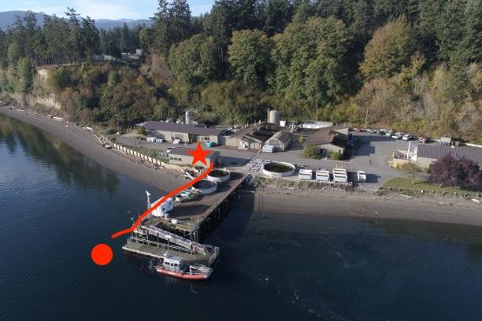
Figure 3: Approximate deployment and cable routing.
Instruments were oriented to face towards the center of the channel, where currents are strongest and the likelihood of marine life in view the greatest. The intent behind deploying as such was to provide as much activity in the instrument fields-of-view (FoV) as possible.

Recovery operations were conducted similarly. First, the dive team disconnected cabling and secured the lift lines to the system. Then, the system was lifted to the surface using the R/V Strait Science A-frame. Upon recovery, the system was inspected for biofouling and any signs of corrosion.

Instrumentation
The deployed instrumentation included the MarineSitu Modular Camera System (which consisted of two C1 cameras in a calibrated stereo configuration, two 14,000 lumen L1 LED lights, and a CC1 camera control bottle), the new IC1 Integrated Camera System (which consisted of an OAK-D S2 PoE camera, two LED lights, a rotator, and an antifouling brush), one Tritech Gemini 1200ik dual frequency imaging sonar, a BC1 antifouling system with wipers and UVC lights, and an H1 Integration Hub (Table 1). The integration hub was cabled back to a shore computer via a 10 Gb ethernet connection, and the shore computer was connected to the internet through the PNNL firewall. This internet connection allowed for remote access by the MarineSitu team and for data to be uploaded to remote cloud storage for future evaluation and sharing.
The visual range of the camera systems varied with water clarity and illumination and was typically between 3 and 10 meters. The imaging sonar, which can operate without ambient light, had a maximum range of approximately 40 m.

Table 1: Instrumentation System Details.
Instrument | Measurement | Frame Rate | Frequency Range | Range | Calibration Date
MarineSitu Modular Stereo Camera System (2x Allied Vision G-317B Cameras) | 2 x 3.2 Megapixel black and white images with correspondences; camera calibration matrices; pixel depth beyond 0.1 m, maximum range limited by turbidity | up to 18 FPS when operating both cameras at full resolution; >30 FPS with pixel binning | visible spectrum | 3 to 10 m | July 1, 2024
MarineSitu IC1 Integrated Camera System (1x OAK-D S2 PoE Camera) | 2 x 1 Megapixel black and white images + 1 x 12 Megapixel color images;  pixel depth beyond 0.2 m, maximum range limited by turbidity | black and white up to 120 FPS;  color up to 30 FPS at 4K, 60 FPS at 1080p | visible spectrum | 3 to 10 m | Same as above
Tritech Gemini 1200ik dual frequency imaging sonar | Imaging sonar imagery | 5-65 Hz (mode and range dependent) | 720 kHz or 1200 kHz | 0.1-120 m (720 kHz)  0.1-50 m (1200 kHz) | N/A

Data Acquisition
Following the deployment of the instrument system, MarineSitu built object detection models from acquired optical and imaging sonar data. This model development utilized an iterative data curation process, where data acquisition and annotation rates varied throughout the deployment. Initially, data was collected on a duty cycle recording at five frames per second for one minute every ten minutes. Previous deployments and observations at this site suggested that acquisition at this data rate would allow for ample quantities of data for machine learning model training without producing an overbearing amount of data. Shortly after deployment, duty cycle acquisition was disabled and instruments were configured to acquire continuously at 1 Hz while activating momentary full sample rate collection in response to object detections. Continuous low sample rate acquisition proved to be a more reliable method of capturing data from rare animal observations than high sample rate duty cycle acquisition.

MarineSitu’s edge software managed the collection of data from the edge device and the transfer of data to MarineSitu’s cloud platform. An overview of these setups is shown in Figure 4.
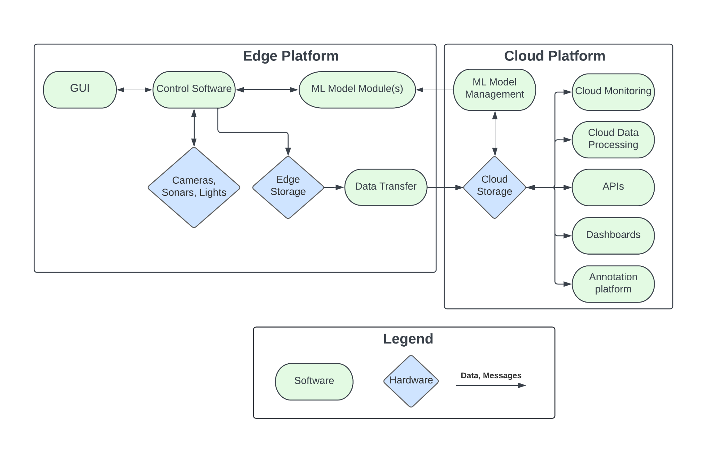
Figure 4: MarineSitu’s edge and cloud platforms.

Once on the cloud, data was ingested by MarineSitu’s cloud platform for data access and analysis. Data was also synced with an external annotation platform, allowing for data review and annotation. To accelerate this process, MarineSitu used a model-in-the-loop approach, whereby a generalized model helped identify candidate objects in the collected imagery before being presented to a manual reviewer. MarineSitu led this data annotation task.

After sufficient data had been collected and annotated, site-specific models based on YOLO v8 (a deep learning object detection model) were trained for detection of objects in both optical cameras and imaging sonars and were deployed to the system. Once successfully deployed, data were recorded 1) continuously at 1 Hz and 2) at full sample rate (5-10 Hz) when the deployed model detected a target of interest. A subset of collected data was then reviewed by MarineSitu staff and new models were developed and deployed. Models were updated on an approximately 1-month cadence and their efficacy was tracked over time.

Test and Analysis Matrix and Schedule
The deployment was originally planned for 6/28/24, but was delayed until 7/1/24 due to technical issues with the AMP hardware on the deployment date. System recovery occurred on 10/28/24 resulting in a total deployment duration of just under 4 months (119 days). The predicted project timeline of four months (3-month deployment) is presented in Table 2.
Table 2: Project Timeline.
 | M1 |  |  |  | M2 |  |  |  | M3 |  |  |  | M4 |  |  |  | M5
Task | 1 | 2 | 3 | 4 | 5 | 6 | 7 | 8 | 9 | 10 | 11 | 12 | 13 | 14 | 15 | 16 | 17 | 18 | 19 | 20
Planning, Setup, Permitting
Deployment of System
Data Collection & Analysis
Recovery of System
Post Access Report
Post Access Questionnaire

Safety
PNNL divers and vessel operators were able to complete the deployment and recovery work without delay, consequence, or contingency days. During manipulation and deployment, the system was powered off via its control interface to mitigate any possible electrical risk. To the best of our knowledge no marine life was impacted by this deployment.
All operations were conducted around slack tide to avoid unsafe operating conditions due to strong currents. This procedure was routine for the PNNL dive/vessel crew and had been performed safely many times in the past.
Operations followed PNNL’s safety procedures, including:
- For all vessel operations, any member of the team was encouraged to call an “all stop” if they observed an imminent safety risk or were unsure of next steps.
- Vessel operations would not commence if weather conditions present unsafe working conditions due to wind/waves, air temperature, or precipitation.
- All work scopes and funding were authorized by one or more responsible managers, depending on the type of work being performed, and all work activities conducted in laboratory or operations spaces were conducted under a project management office director approved electronic prep and risk (EPR) profile and appropriate work planning and controls.
- Hazards and risks associated with the work followed the requirements in hazard-specific work controls and were reviewed with assistance from the PNNL Safety and Health representative, and/or PNNL subject matter experts (SMEs).
Standard controls to mitigate hazards were conducted in the following order:
- Elimination or substitution of hazards
- Enaction of engineered controls
- Performance of specified work practices and administrative controls
- Use of personal protective equipment
Determination of appropriate work controls relevant to the work performed were found in a PNNL Lab Assist document. A Lab Assist activity is a central document that includes work controls, applicable training, associated hazards, and approved lab spaces that all workers must review and acknowledge before performing work. All workers performing activities on this task were required to review hazards, mitigations, and engineering controls listed within the Lab Assist activity and to complete trainings as appropriate prior to the onset of lab work.

Contingency Plans
The following contingency plans were in place for this test. Except for the deployment delay from 6/28/24 to 7/01/24, no contingency plans were pursued.

Deployment Delays
Successful deployment required satisfactory weather and tides. If no satisfactory weather window occurred during the target deployment timeline, project deployment was to be delayed until deployment was possible. The deployment timeline was prepared such that delays during either the deployment or recovery could still result in sufficient in-water time for evaluation.

Hardware or Software Failure
MarineSitu’s system could experience hardware or software failures during the deployment. If a problem occurred which could be solved on-site (e.g., controller chip malfunction, cable communication issues, etc.) the system would be recovered as soon as possible, and a shore-side resolution would be attempted. If successful, the system would be re-deployed, and the evaluation would continue. Funding for one extra deployment/recovery operation was budgeted into the project.

Total System Failure or Loss
If an unrepairable problem arose (such as total system failure or loss of hardware), the evaluation would stop and a failure analysis would be conducted and reported.

Data Management, Processing, and Analysis

Data Management
Data from the cameras, sonar, integration hub inertial measurement unit (IMU), and central computer health monitor were recorded throughout this deployment. Additionally, machine learning detection outputs from processing camera and sonar data were also recorded. Camera and sonar data were collected through continuous, low-rate acquisition, duty cycle acquisition, and detection initiated acquisition. IMU and health logs were recorded continuously.
Data were stored temporarily on a local machine before being uploaded to MarineSitu’s cloud platform for analysis. After upload, temporary data were maintained on the local machine for 24-72 hours before being deleted, though storage of these data for longer periods was possible in the event of network outages or other disruptions. Local to cloud data transfer was handled by the MarineSitu edge and cloud platforms.
As substantial quantities of data were collected in this project, much of it without objects of interest, data archived to MHKDR were limited to imagery with confirmed or suspected objects of interest present (e.g., birds, fish, etc.). Object detection model weights, model validation data, and scripts used to validate model accuracy were also archived. Because the complete imagery and prediction archives constitute proprietary training data assets during the company's active commercialization phase, project data have been deposited across two MHKDR repositories. A public repository contains a representative subset of imagery and object detection predictions along with all model weights, validation data, and analysis scripts. The complete imagery and prediction archives are deposited in a private repository subject to a data use moratorium of up to 5 years from the start of the project period. Descriptions of archived data products and their repository assignments are presented in Table 3.
Table 3: Data and data products archived to MHKDR.
Type | Description | Repository
Gemini images | Images (.jpg) containing confirmed or suspected targets of interest | Public (representative subset);  Private (complete archive)
Optical camera images | Images (.jpg) containing confirmed or suspected targets of interest | Public (representative subset);  Private (complete archive)
Object detections | Prediction files (.json) containing instances of detected objects | Public (representative subset);  Private (complete archive)
Data review script | A python script used to view data and object detections to aid users with data review | Public
Model weights | Files containing pytorch model weights and biases (.pt) for each model developed during the deployment | Public
Model validation data | Annotation files (.txt) containing manually labeled instances of targets of interest | Public
Model validation script | A python script used with the model weights and validation data to evaluate model accuracy | Public
False positive analysis data | Deployment detection data (.csv) used to evaluate in-situ false positive rates. | Public
False positive analysis script | A python script used with the deployment detection data to calculate false positive rates during deployment. | Public

Data Processing
Data review began after data were uploaded to MarineSitu’s cloud platform. Data collected from the first phase of the deployment, during which only duty cycle imagery was available, were analyzed and annotated manually by MarineSitu staff. These data were used to train initial optical and sonar models which were then utilized alongside low-sample rate continuous acquisition to acquire more images for review, annotation, and model refinement. A detailed visualization of this data flow is presented in Figure 5.
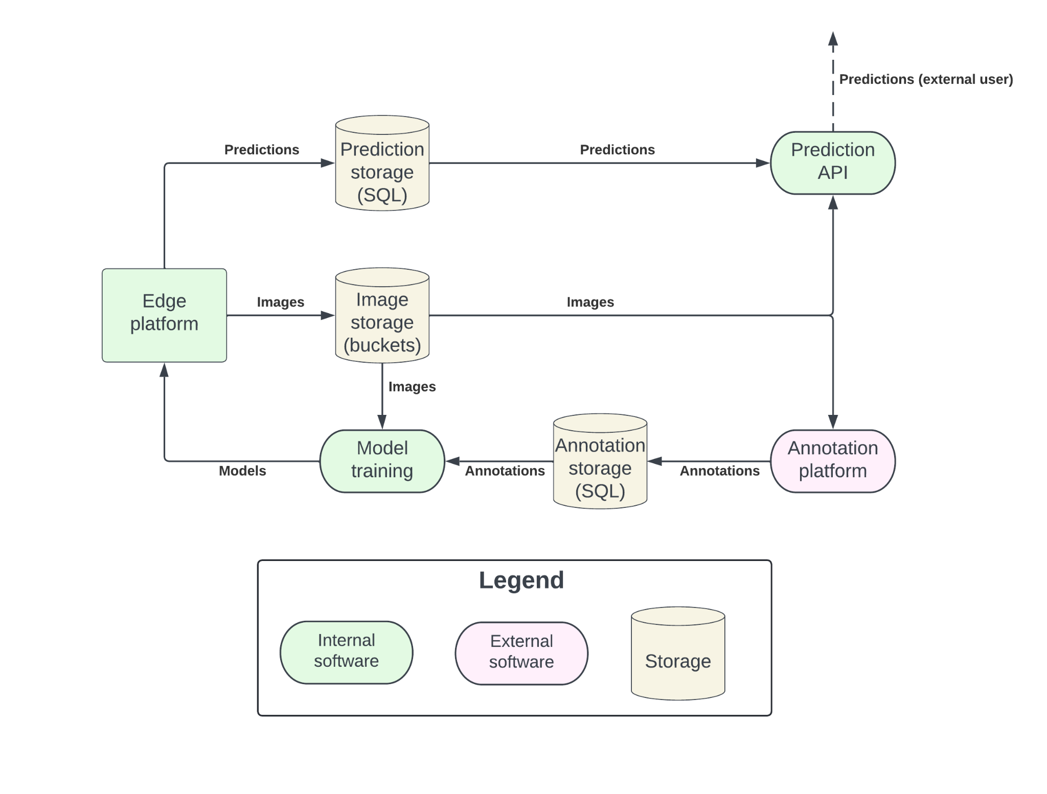 Figure 5: Detailed overview of prediction, annotation, and model development.

Data Analysis
Model performance analysis
MarineSitu measured the accuracy and performance of both the optical and imaging sonar models using four metrics over the deployment timeline. The first two of these metrics reference “Intersection over Union” (IoU) which defines an overlap level between the predicted polygon surrounding a detected object and ground truth (human annotations). We evaluated models using an IoU value of 50% in all cases.

The four metrics used were as follows:
- Precision and recall measured at a 50% confidence interval and 50% IoU threshold.
Precision (which measures the ratio of true positives to total positives) and recall (which measures the ratio of true positives to the total number of objects present in the database) are
two metrics which help explain the performance of a machine learning model. They indicate, respectively, the likelihood a predicted object is correctly classified and the likelihood that an object of interest would be captured. A model with both high precision and high recall indicates a model is successful at finding most objects in a dataset while also keeping false positives low. These metrics are often inversely correlated, as retrieving a larger portion of objects in a dataset typically leads to an increased rate of false positives as well.
In this type of deployment – where the capture of rare occurring events is of primary concern – we typically regard recall as the most important metric, as it helps to quantify how likely you are to identify these rare events. As the capture of rare events is the primary motivation for model deployment, we also often operate using lower than standard confidence levels such as 50% to increase the likelihood of object capture. But it is also important to keep the data archive sufficiently small enough that observers can review data without being overburdened.
- Mean Average Precision (mAP) measured at a 50% IOU threshold (mAP50). mAP is a standard evaluation metric in the evaluation of machine learning models. It represents the tradeoff between precision and recall as described above. This metric leverages the “precision-recall” curve which shows the tradeoff between precision and recall over varying confidence intervals (not just fixed at 50% as we proposed to do above) for each object class under consideration. “Average Precision” is calculated for each class as the area under this curve, and mean average precision is the mean of all individual average precisions. An example Precision-Recall curve and associated mAP50 scores from a previous deployment at MCRL is presented in Figure 6.In many cases, mAP has become the de facto metric for machine learning model analysis such as what is proposed here. However, a straight recall metric is often more valuable, as recall is the most important metric at quantifying how often objects of interest are detected. Still, mAP provides a more holistic view of model performance and is a valuable metric for evaluating performance changes over model iterations.
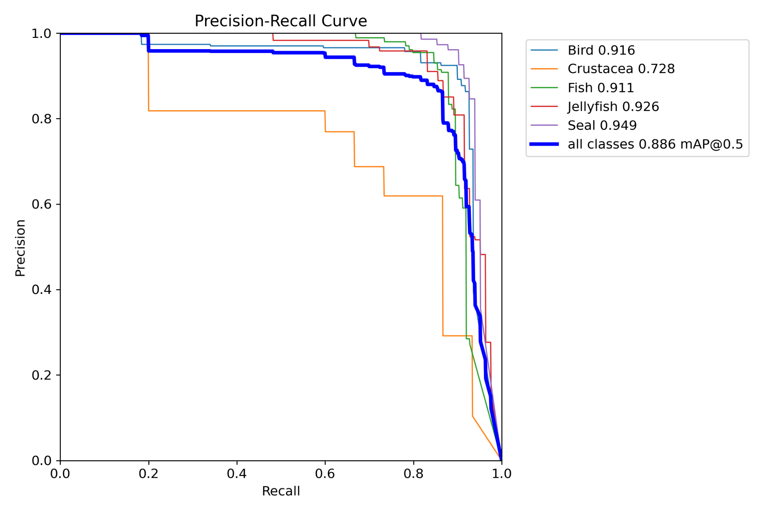
Figure 6. Precision-Recall curve and associated mAP50 score (in legend) for five species found at a previous MCRL deployment in optical camera imagery. First, each species’ individual P-R curve is calculated by evaluating the precision and recall at varying confidence intervals. Second, the mean of these curves is calculated and drawn on the plot. Finally, mAP is calculated as the area under the mean curve.

- False positive rate as a function of data reviewed
Maintaining a low false positives low rate is important in deployments such as this to ensure reviewers are not being overburdened. To evaluate false positives produced by the deployed models, we evaluated the number of false positives counted during data evaluation relative to the total number of reviewed images. We expected to the quantity of false positives to fall as each new model iteration included additional site-specific data.

- Model latency
Finally, model latency (i.e., how long the model takes to process a single image) for a particular model was tracked as new models were deployed. To accurately characterize animal behavior, data acquisition must take place at high frame rates (e.g., >15 frames per second), and machine learning models must therefore process data at an equivalent rate to avoid backlog and trigger data acquisition and illumination in real time.

Model performance metrics were evaluated against the same validation data to avoid biasing. For example, the evaluation of mAP score of a model trained on week two and of a model trained on week four utilized the same evaluation data. This required recalculating the precision, recall, and mAP50 metrics for all models every time a new dataset iteration occurred to track performance changes over time. Reevaluation of metric 3 was not possible in this manner but monitoring this value over time was sufficient as its value is evaluated against live data and not a curated database.

For model accuracy evaluation metrics (metrics 1-3 above), we were interested in understanding 1) how long it takes for models to converge to acceptable levels of performance which we define as recall > 80%, precision > 80%, and false positive rates < 30%, and; 2) how long it takes for the model iteration to hit levels of diminishing returns. We anticipated that model performance metrics would approach their best-case values asymptotically and we considered the deployment successful if it contributed to our understanding of the iterative model development process even if the final model performance results were lower than what might be required for production deployments. This learning was intended to inform the required deployment duration at a new marine energy site before which machine learning models become effective at detecting objects of interest.

Finally, model latency (i.e., how long the model takes to process one image) is one of the critical aspects which impacts data capture frame rate as it can be a bottleneck on maximum achievable frame rates. As image acquisition must occur at rates of at least 15 frames per second over the duration of the deployment to support species identification and behavior analysis, model latency must remain low enough to support data acquisition at this frequency. Although acquisition rates of 15 frames per second is a minimum requirement, higher rates would ultimately make species classification and animal behavior assessment tasks easier. Therefore, we tracked model latency throughout the deployment and compared against other model efficacy metrics.

Usability Study of MarineSitu’s System
PNNL assessed the utility of MarineSitu’s system through the lens of a representative operator (customer) seeking to manually control the system to configure instruments and acquire data, and of a researcher seeking to pull and process data generated by the system. While doing so, PNNL staff documented the tests they attempted to conduct and rated their experience according to the scoring system in presented in Table 4. While the raw data generated by this study was conveyed privately to MarineSitu, the general conclusions have been shared.

Table 4: Usability Study Scoring System.
1 | 2 | 3 | 4 | 5 | Failure
Trivial to complete without referencing a manual | Able to complete without referencing a manual, but needed to spend less than 5 minutes figuring the controls out | Able to complete after referencing a manual | Unable to complete without assistance, but text-based support clarified the issue | Unable to complete the task without assistance, text-based support was not helpful. MarineSitu engineers had to diagnose the problem over voice or video call | PNNL unable to complete the task, MarineSitu engineers were unable to help

Expert Testing of MarineSitu’s System
PNNL operational testing assessed the system’s user interface, ease of use, and general readiness as a human-in-the-loop data acquisition device.
First, PNNL research staff with a marine biology background operated MarineSitu’s data acquisition and instrument control software to complete a series of tasks prescribed by MarineSitu. These tasks included:
- powering on the system.
- changing camera and sonar operation settings (e.g., frame rate, range, etc.)
- changing data acquisition settings (e.g., duty cycle frequency)
- accessing recorded data,
- and powering down the system.
The ease of completing each task was assessed following the 1-5 scale above, and any additional notes or recommendations for ease of use were documented.
PNNL researchers also evaluated the ease of using recorded data to assess the marine environment. They assessed the usability of MarineSitu API for downloading recorded data from the cloud, data and model prediction formats, and calibration information. PNNL accessed MarineSitu model-generated label predictions (i.e., detected marine fauna) and system calibrations and use this information to determine the 3D-position of targets (i.e., range and elevation relative to camera system). This was representative of how the data might be used for environmental monitoring of animal behavior at a marine energy site. PNNL documented the process and provided suggestions on how to improve data access and usability or methods for advanced data visualization.
Finally, PNNL tested the ability to integrate user-developed machine learning-based detection and tracking algorithms with MarineSitu software. Using data annotated by MarineSitu, PNNL developed custom animal detection and tracking algorithms. While standard camera system users would likely use MarineSitu-developed algorithms, researchers would likely want to design custom processing and data acquisition pipelines for specific research applications. These tests assessed the utility of MarineSitu’s system as a research tool, served as a comparison for MarineSitu’s automated processing software, and investigated novel approaches to automated target detection for marine energy applications.

Project Outcomes

Results

Deployment
PNNL’s vessel the R/V Strait Science, along with PNNL and MarineSitu staff, deployed the Sea Spider off the Southern edge of PNNL’s dock on July 1, 2024 at around 1500PT. Divers oriented the system to be as level as possible - facing roughly north looking into the channel - and a calibration board was used to capture video with which to perform camera calibration (Figure 7). Divers secured the array’s cable to the seabed using screw anchors, and the platform remained in this state until it was recovered.
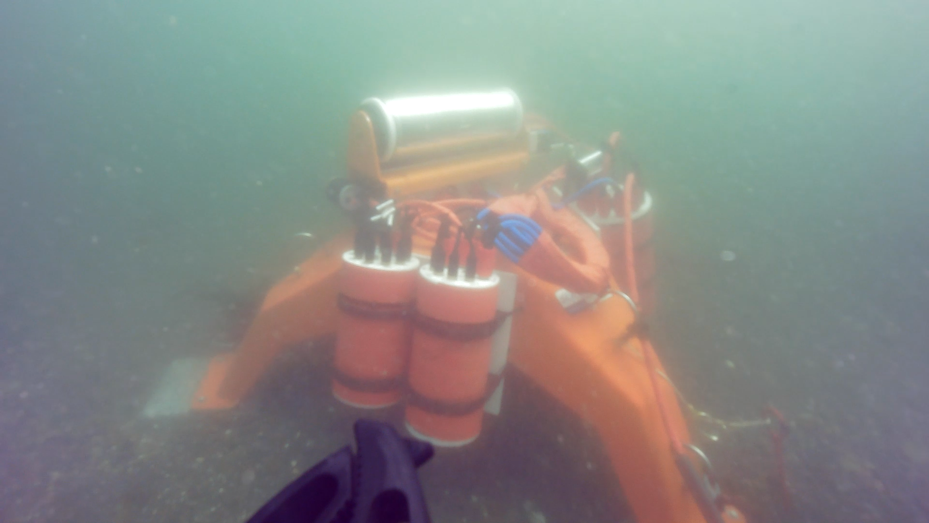 | 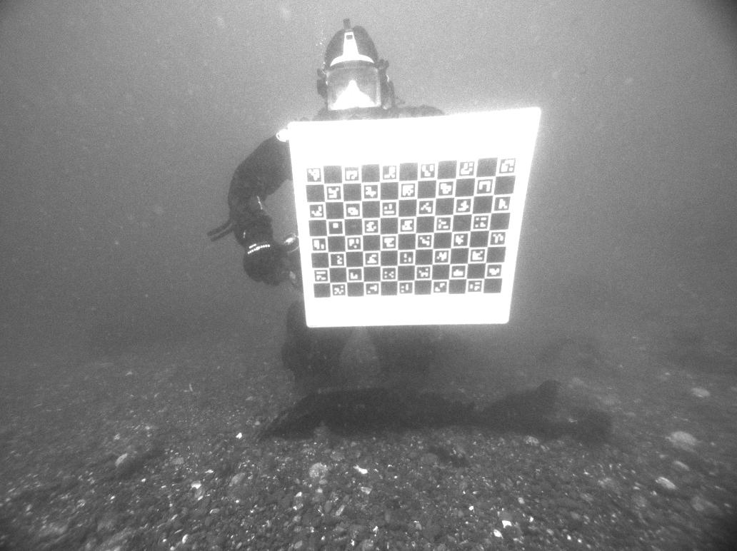
Figure 7: View of the deployed sea spider and AMP captured with the video camera onboard an ROV on 07/05/2024, four days after the deployment (left) and PNNL scientific scuba diver performing camera calibration underwater after deploying the AMP (right).

Recovery
PNNL and MarineSitu recovered the AMP array on October 28, 2024at 1430PT (Figure 8). The recovery was performed similarly to the reverse of the deployment: the power and data cabling was disconnected; divers removed the screw anchors that secured the cabling; and the A-frame of the R/V Strait Science was used to remove the Sea Spider.
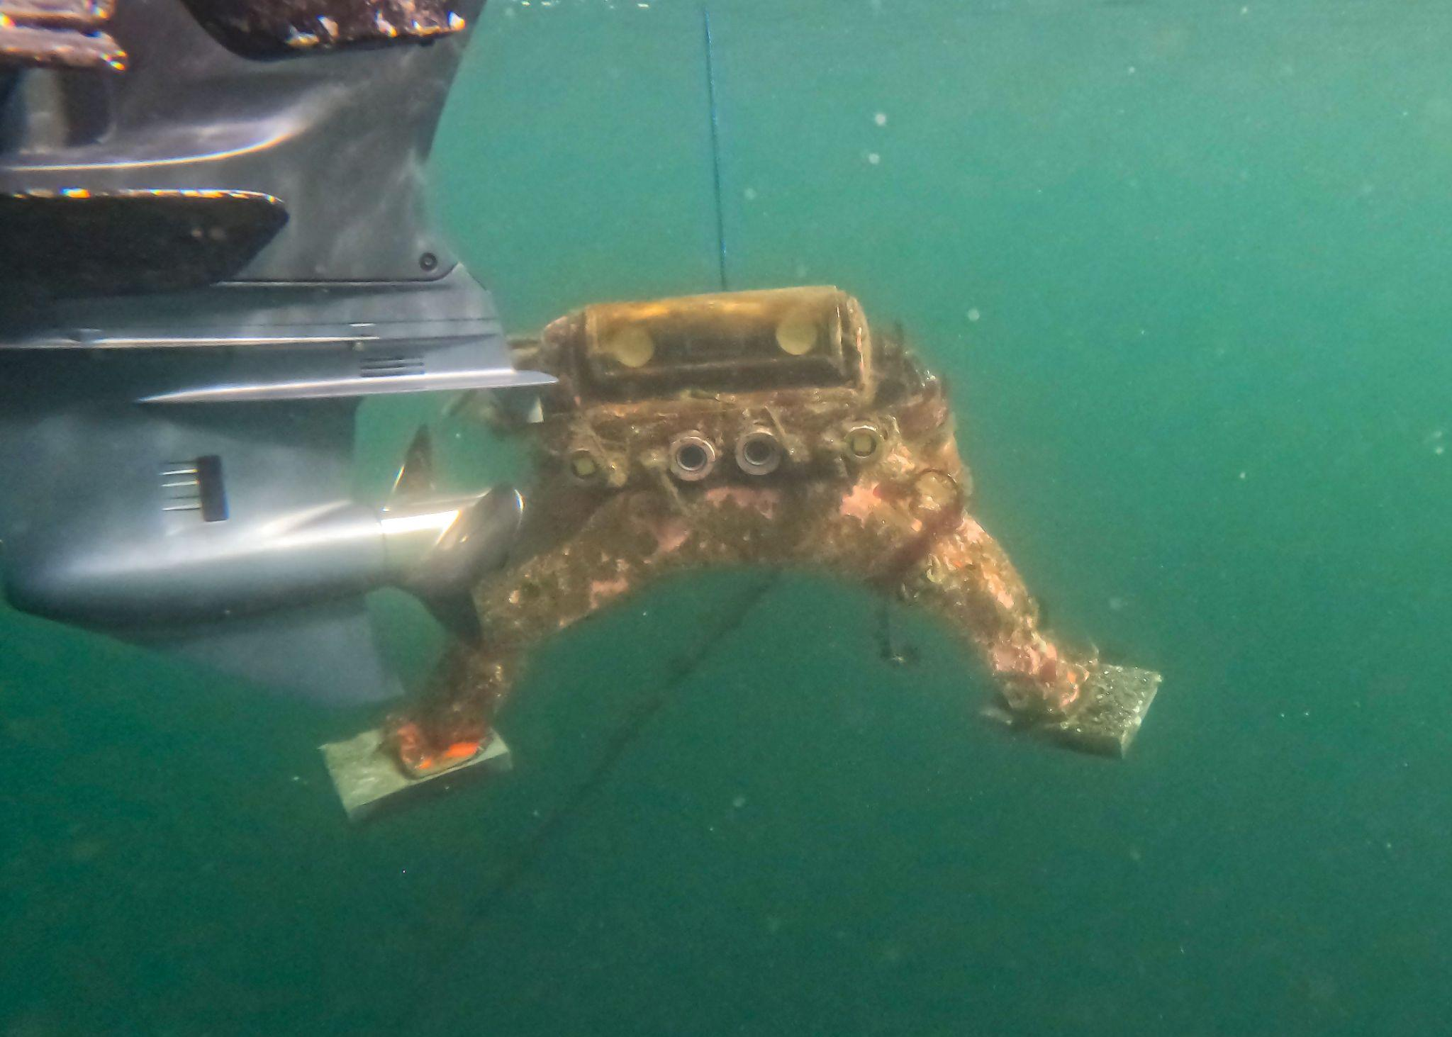 | 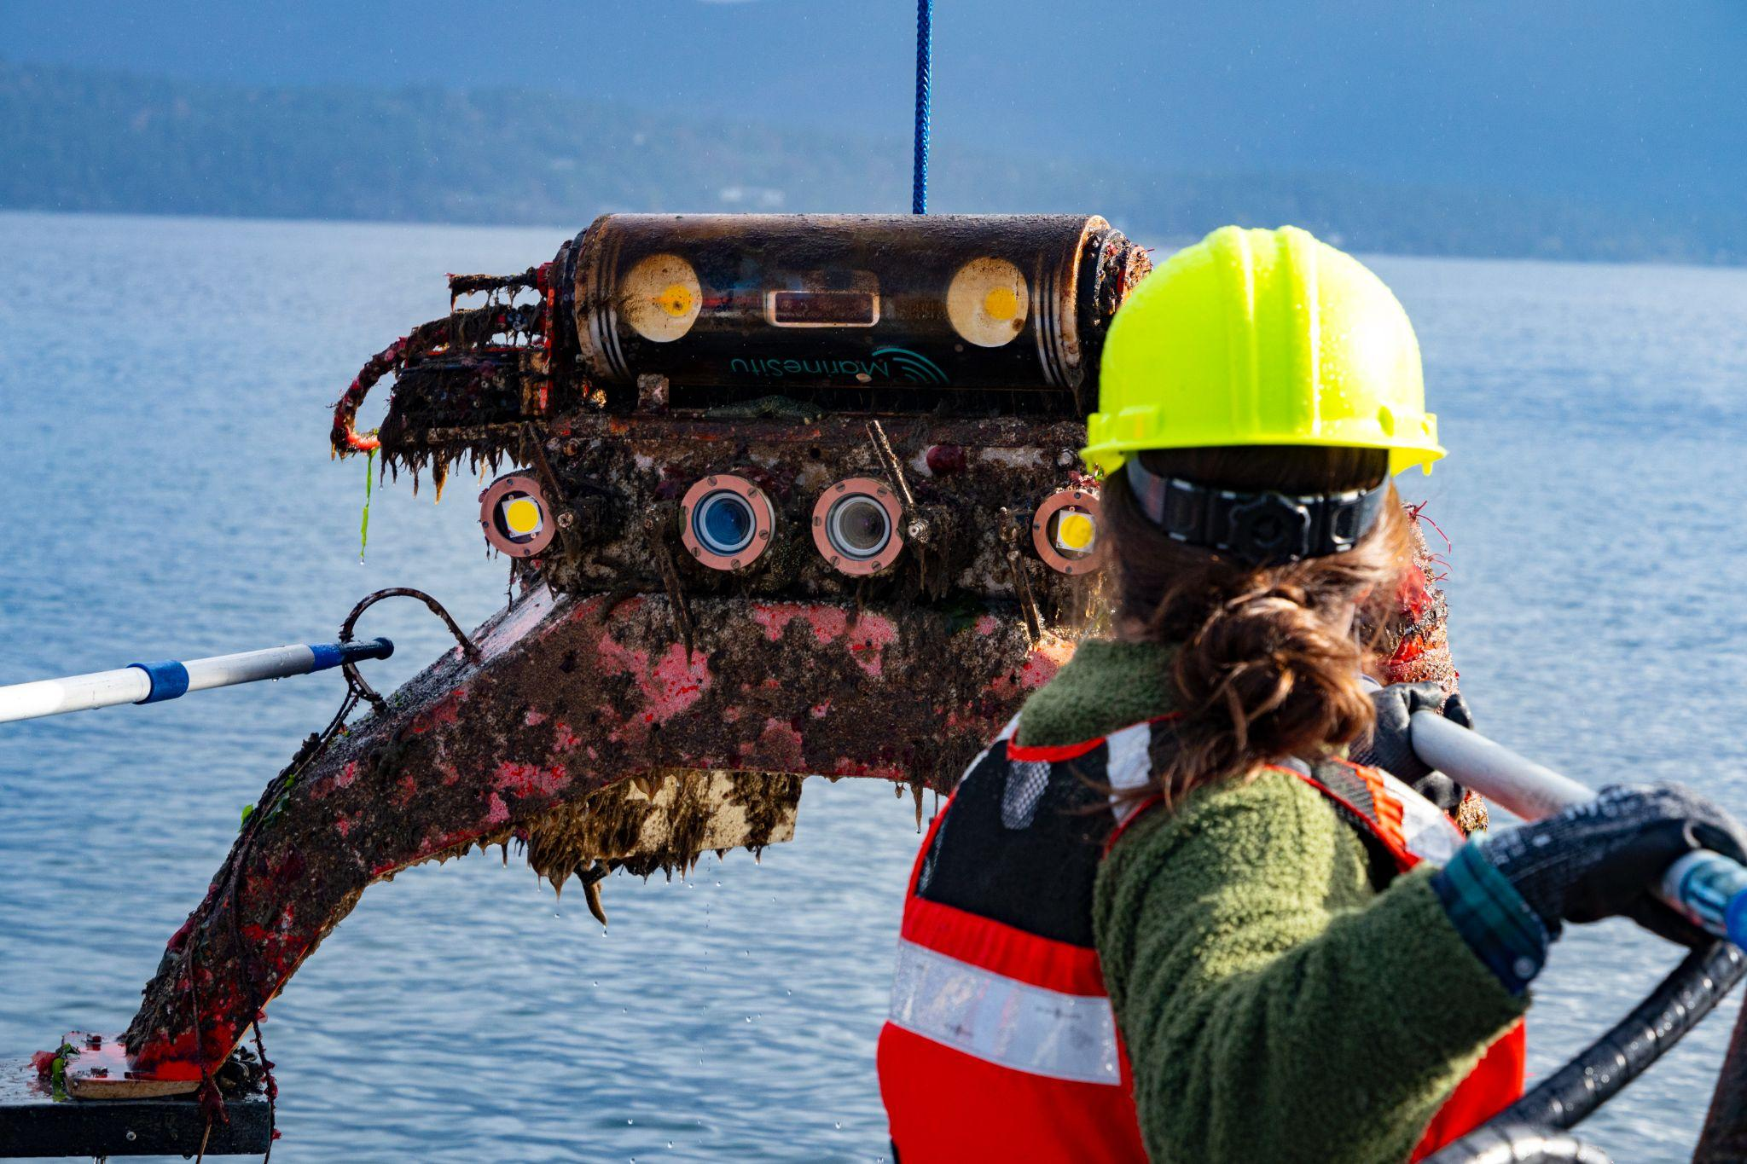
Figure 8: The AMP suspended below the R/V Strait Science mid-hoist (left) and PNNL and MarineSitu staff guiding the AMP aboard the R/V Strait Science (right, photo credit: Shanon Dell).
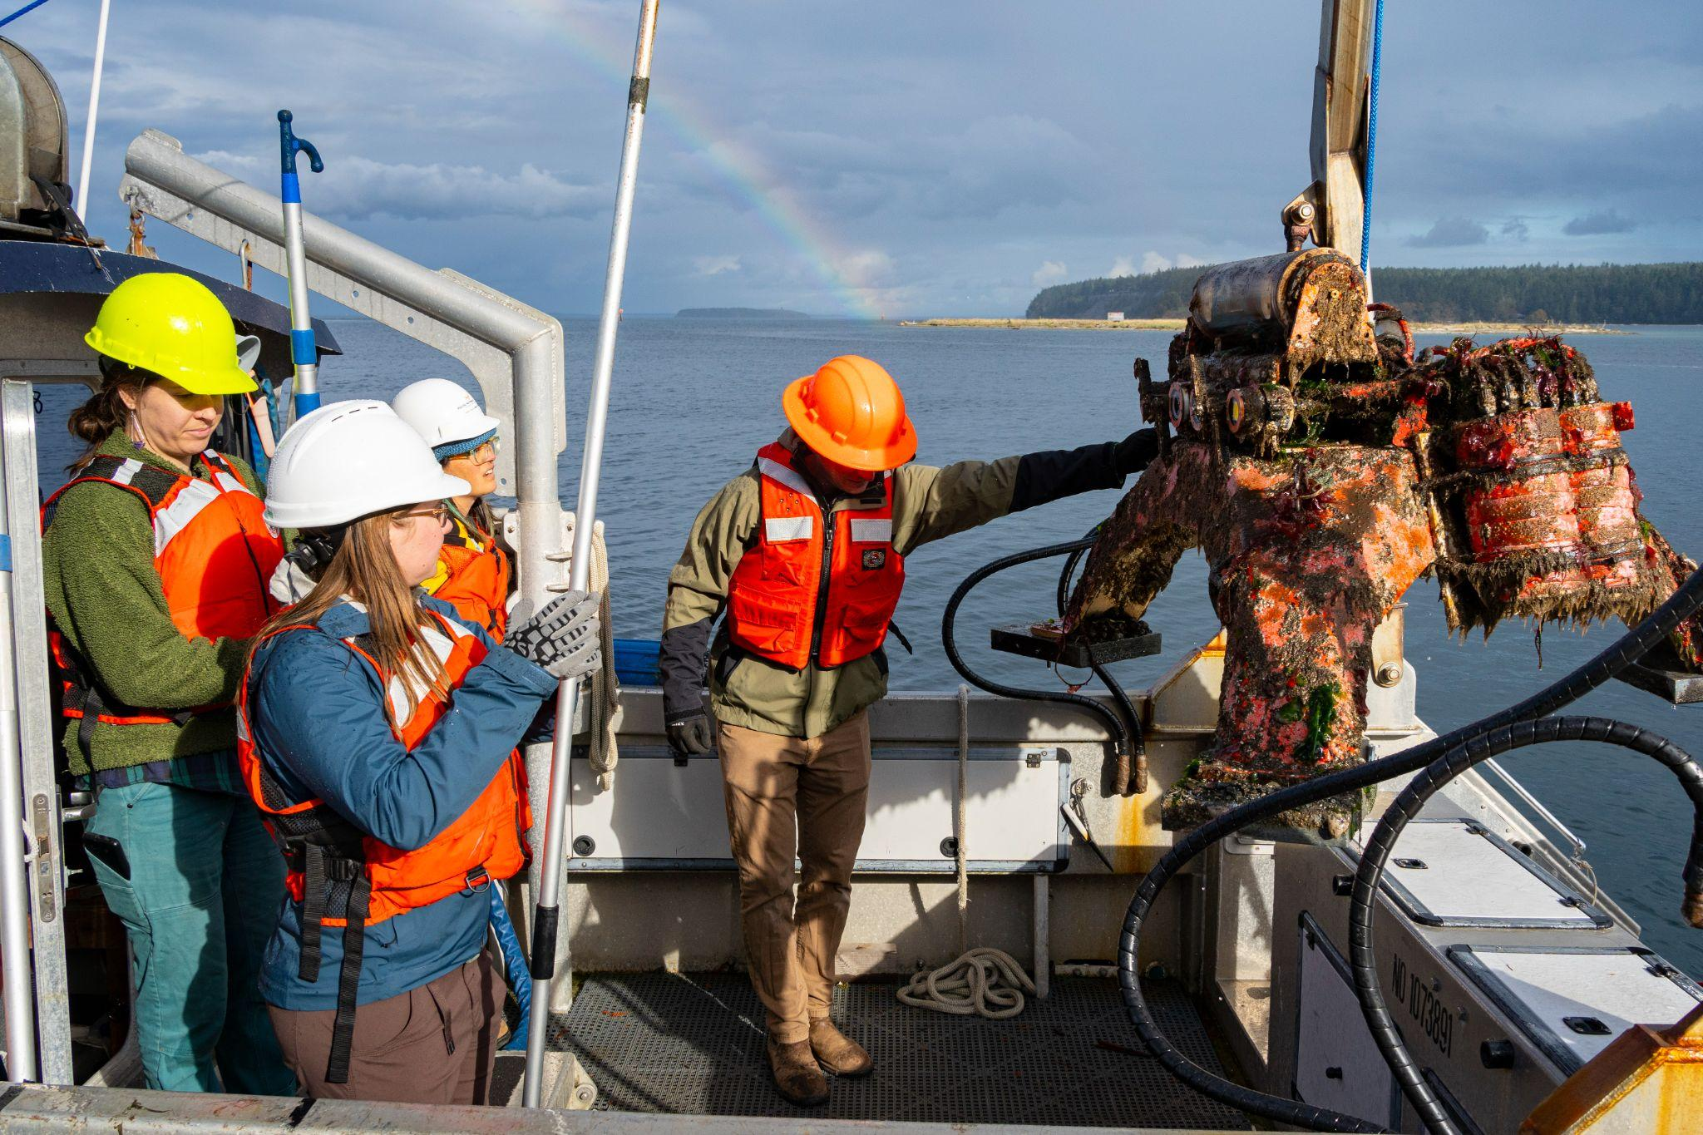
Figure 9: PNNL and MarineSitu staff guiding the AMP aboard the R/V Strait Science (photo credit: Shanon Dell).
Although there was significant biofouling on the system upon recovery (Figure 9), the anti-biofouling system effectively prevented all fouling on the faces of the modular stereo camera system. The prototype UVC light also prevented fouling in the covered area up to a range of approximately 0.25 m and reduced fouling up to a range of approximately 0.50 m. Because the rotator on the integrated camera system​​ was not functional, biofouling accumulated on the subsystem throughout the deployment and was routinely removed by PNNL divers.
Corrosion was observed on the aluminum screws fastening the front copper rings of the modular camera system’s lights to their aluminum housings. The design of the lights has been updated to use PEEK fasteners, rather than the stainless steel fasteners used during this deployment, to address this issue. Except for the sacrificial zinc anode on the Gemini 1200ik, no other corrosion was observed.

Instrumentation
Out of the array of instruments only one, the experimental barrel rotator component of the IC1, did not function as intended. Because of this malfunction, biofouling accumulated on the IC1’s transparent housing and inhibited efforts to perform 3D object detection. PNNL divers were able to intermittently clean the stereo camera, but this was not sufficient for persistent optical clarity.

Data Acquisition
The system ran for four months until its recovery on October 28, 2024, at 1430 PT. Throughout the deployment, the optical cameras sampled at 10 Hz during duty cycle and detection acquisition events and at 1 Hz during periods of continuous acquisition. Similarly, the imaging sonar operated at 5-10 Hz during duty cycle and detection acquisition events and at 1 Hz during periods of continuous acquisition.
Three days of system outages occurred throughout the deployment. These were on 07/06/2024, 09/03/2024, and 09/04/2024. For two additional days, the Tritech Gemini stopped recording: 07/15/2024 and 08/22/2024. Outages were caused by a combination of facility power loss, planned outages for software or hardware maintenance, or software errors or misconfiguration.

Data Management
Approximately 9 TB of data were collected in total over the duration of the deployment. Data acquired by the AMP were automatically pushed to MarineSitu’s cloud platform. PNNL scientists found that data retrieval of data from MarineSitu’s cloud platform was impractically slow, with requests for a few seconds of data taking minutes to complete. In coordination with MarineSitu, PNNL scientists created automated scripts to regularly copy data from MarineSitu’s acquisition computer to a PNNL workstation to better support development.
Data were synced to the local PNNL machine within 10 minutes of the data having been acquired from the instruments. PNNL performed all subsequent work on this locally-stored data. Data acquired by MarineSitu’s AMP were stored in the format shown in Figure 10. Raw imagery in .jpg format for each instrument were stored in “images” directories while .json files containing object detector predictions were stored under “predictions” directories.

AMP Data File Structure
├── 2024_08_17_00_40_00
│ ├── Camera1
│ │ ├── images
│ │ └── predictions
│ ├── Camera2
│ │ ├── images
│ │ └── predictions
│ │ ├── mcrl-pier-AVCamera
│ │ └── v2
│ ├── Gemini1Cartesian
│ │ ├── images
│ │ └── predictions
│ ├── Gemini1Polar
│ │ ├── images
│ │ └── predictions
│ ├── Oak1Center
│ │ ├── images
│ │ └── predictions
│ ├── Oak1Left
│ │ ├── images
│ │ └── predictions
│ └── Oak1Right
│ ├── images
│ └── predictions
Figure 10: File structure of MarineSitu data acquired by the AMP. Below “images” directories are .jpg files, and below “predictions” directories are .json files containing MarineSitu’s object detector predictions.

Data Processing

MarineSitu Object Detection, Tracking, and Filtering Pipelines
MarineSitu’s software utilizes a modular and configurable “pipeline” architecture to organize on-edge data processing. Any number of independent pipelines can be configured to conduct various tasks (within the limits of available CPU, GPU, and memory resources). Instruments can be configured to pass their data, sequentially, through a selection of pipelines. For this deployment, only instances of the “DetectionTracking” pipeline were used. As the name implies, “DetectionTracking” pipelines include an object detection stage and a tracking stage, as well as a filtering stage. In the object detection stage, images are processed by either an object detection or image segmentation model to produce bounding boxes or polygons around detected objects. The resulting bounding boxes or polygons are then passed to a tracking stage wherein bounding boxes or polygons are associated from frame to frame to produce “tracks”. Tracks are enumerated to distinguish them from one another. Finally, detections and tracks are processed by optional and independently configurable filters. The objective of the filtering stage is to determine whether the detections or tracks should produce an “event”, which are used to automate other system actions, such as data acquisition or light activation. For example, a filter may check if a tracked object enters or exits a monitored region.
For this deployment, three “DetectionTracking” pipelines were configured - one for the modular camera system, one for the integrated camera system, and one for the imaging sonar. By using three “DetectionTracking” pipelines, each instrument type was paired with an object detection model tailored to its specific training data (e.g., optical camera data for the optical cameras, sonar data for the sonar) and with tracking stages independent of one another. The object detection stages utilized YOLOv8 models and the tracking stages utilized intersection-over-union (IoU) based trackers, which associate detected objects based on the degree of overlap between their bounding boxes or polygons in successive frames. Because the detection and acquisition of rare events was prioritized for this deployment, the filtering stage was highly permissive, generating data acquisition events for all detected objects of track length 2 (i.e., tracks with a least 2 successive detections) or greater. In addition, acquisition events were configured to save high sample rate data up to +/- 1 second around each detection/tracking event, thereby improving the likelihood that relevant images were acquired even if detections were not produced for all images containing an object of interest.

MarineSitu’s Cloud Platform
Prior to this deployment, MarineSitu developed a cloud platform and database that allowed for automated upload and ingestion of data and for queries of optical or sonar data via REST APIs. For this deployment, the delivery of synced data from multiple instruments was particularly important for analysis. To support this need, database schemas and processing codebases were updated to allow for the query of synced, multi-source data.

Data Analysis
The model performance results presented below reflect the constraints of a single four-month deployment with limited training data. As noted in the project objectives, the goal of this component of the work was to evaluate the iterative model development methodology rather than to achieve production-level accuracy. In that regard, the deployment was successful: model performance improved across iterations, the methodology for in-situ model development was validated, and key limitations, including class imbalance, annotation consistency, and the divergence between validation and deployment performance, were identified and documented for future deployments.
Early in the deployment, MarineSitu deployed two models for both optical cameras and sonars. These models were intended to assist in initial data collection and were trained from prior data collected at other locations. Throughout the deployment, MarineSitu annotated and deployed three new models for both optical and sonar detection based on data from the site. Model performance is discussed for both modalities below. We present model performance metrics evaluated against validation data instead of test data as there was insufficient data in our annotated dataset to create a sufficiently large training dataset while maintaining both test and validation datasets. A test dataset was initially created for optical model v1, but was not maintained for subsequent models to maximize training data quantity. For consistency, optical model v1 accuracy metrics were calculated using the validation dataset. Maintaining and evaluating against a test dataset is preferable to a validation dataset when reporting results, as the validation dataset is used during model development to guide training decisions, which can introduce optimistic bias in reported metrics.

Optical Data
Object detection models were trained for the mono-color cameras (i.e., C1 cameras of the modular camera system and left/right sensors of the OAK-D S2 PoE on the IC1 camera system). Three new models were trained over the course of this deployment, each utilizing new data captured from the site. Breakdowns of training data composition for each optical model is shown in Table 5 for the three models trained in this project.
Table 5: Breakdown of training data for each of the three optical models. Start and end dates describe the UTC dates of the first and last images utilized in each dataset.
  Optical v1
  Class | Annotations
  binary_object | 261
  Total | 261
  Start Date | 7/3/24
  End Date | 7/11/24
  Optical v2
  Class | Annotations
  Crab | 22
  Fish | 648
  Seal | 87
  Fish School | 23
  Total | 780
  Start Date | 7/3/24
  End Date | 8/3/24
  Optical v3
  Class | Annotations
  Crab | 33
  Fish | 1010
  Seal | 39
  Fish School | 93
  Total | 1175
  Start Date | 7/3/24
  End Date | 8/29/24

Optical model performance metrics are shown in Table 6. Models were either binary (i.e., only trained to detect one class) or multiclass (trained to detect multiple different classes). Reported metrics include precision, recall, mean average precision at 50% Intersection of Union (mAP50), and false positive rate evaluated against the v3 validation data, and model latency for on-edge inference results. All developed models were bounding box level models (in contrast to polygon level models).

Table 6: Validation results for deployed optical models. Precision, recall, and mAP50 are evaluated against the validation data for v3. False positive rate and inference latency are reported from deployment performance.
Deployment Date | Model | Binary or Multiclass | Mean Precision | Mean Recall | mAP50 | False Positive Rate | Inference Latency (ms per image)
7/25/24 | v1 | Binary | 0.8203 | 0.5421 | 0.6321 | 0.3916 | 4.3
8/9/24 | v2 | Multiclass | 0.8991 | 0.7443 | 0.8395 | 0.2067 | 4.7
10/22/24 | v3 | Multiclass | 0.9507 | 0.8400 | 0.9402 | 0.1263 | 4.8

Overall validation performance increased through additional model iterations, with precision, recall, and mAP50 all increasing by model revision. This improvement is attributable to two factors: (1) additional data was captured and annotated throughout the deployment, expanding the training dataset, and (2) the v3 validation data utilized for evaluation had more overlap with the training data of models v2 and v3 than with model v1. Although false positive rates evaluated against validation data decreased with each model iteration, false positive rates measured in deployment did not follow the same trend, as models v2 and v3 produced more erroneous predictions in-situ than model v1. This divergence between validation and deployment performance highlights the limitations of validation-only evaluation. In addition, seasonal variation in animal presence and natural illumination alter the in-situ data composition and can degrade in-situ model performance (an effect known as “model drift”). Finally, the multiclass models had difficulty distinguishing debris and seaweed from biological targets, a challenge not well represented in the validation dataset.
A breakdown of model v3 performance evaluated against the v3 validation dataset can be seen in Table 7. There is a clear class imbalance, with fish as the dominating class (337 of 411 images). Despite this, fish exhibited the worst recall performance (0.577), which is attributable to inconsistent annotation boundaries between the “fish” and “fish school” categories. During annotation, there was insufficient specificity around when individual fish detections should be classified as fish schools, leading to labeling inconsistencies that degraded model performance for both classes. To improve model performance in future deployments, two actions are recommended: (1) expand the in-situ training dataset with additional annotated images collected across a broader temporal range to improve model robustness to environmental variations, and (2) establish quantitative criteria for distinguishing “fish” from “fish school” during annotation to eliminate boundary ambiguity and ensure consistent training labels.

Table 7: Optical model v3 performance by class.
Class | Images | Precision | Recall | mAP50
Fish | 337 | 0.9826 | 0.5765 | 0.8500
Seal | 48 | 1 | 0.8944 | 0.9714
Crab | 9 | 0.9028 | 1 | 0.9950
Fish School | 17 | 0.9174 | 0.8889 | 0.9445
Total | 411 | 0.9507 | 0.8400 | 0.9402

Precision-Recall curves for each of the three optical models, evaluated against v3 validation data are presented in Figures 11 – 13.
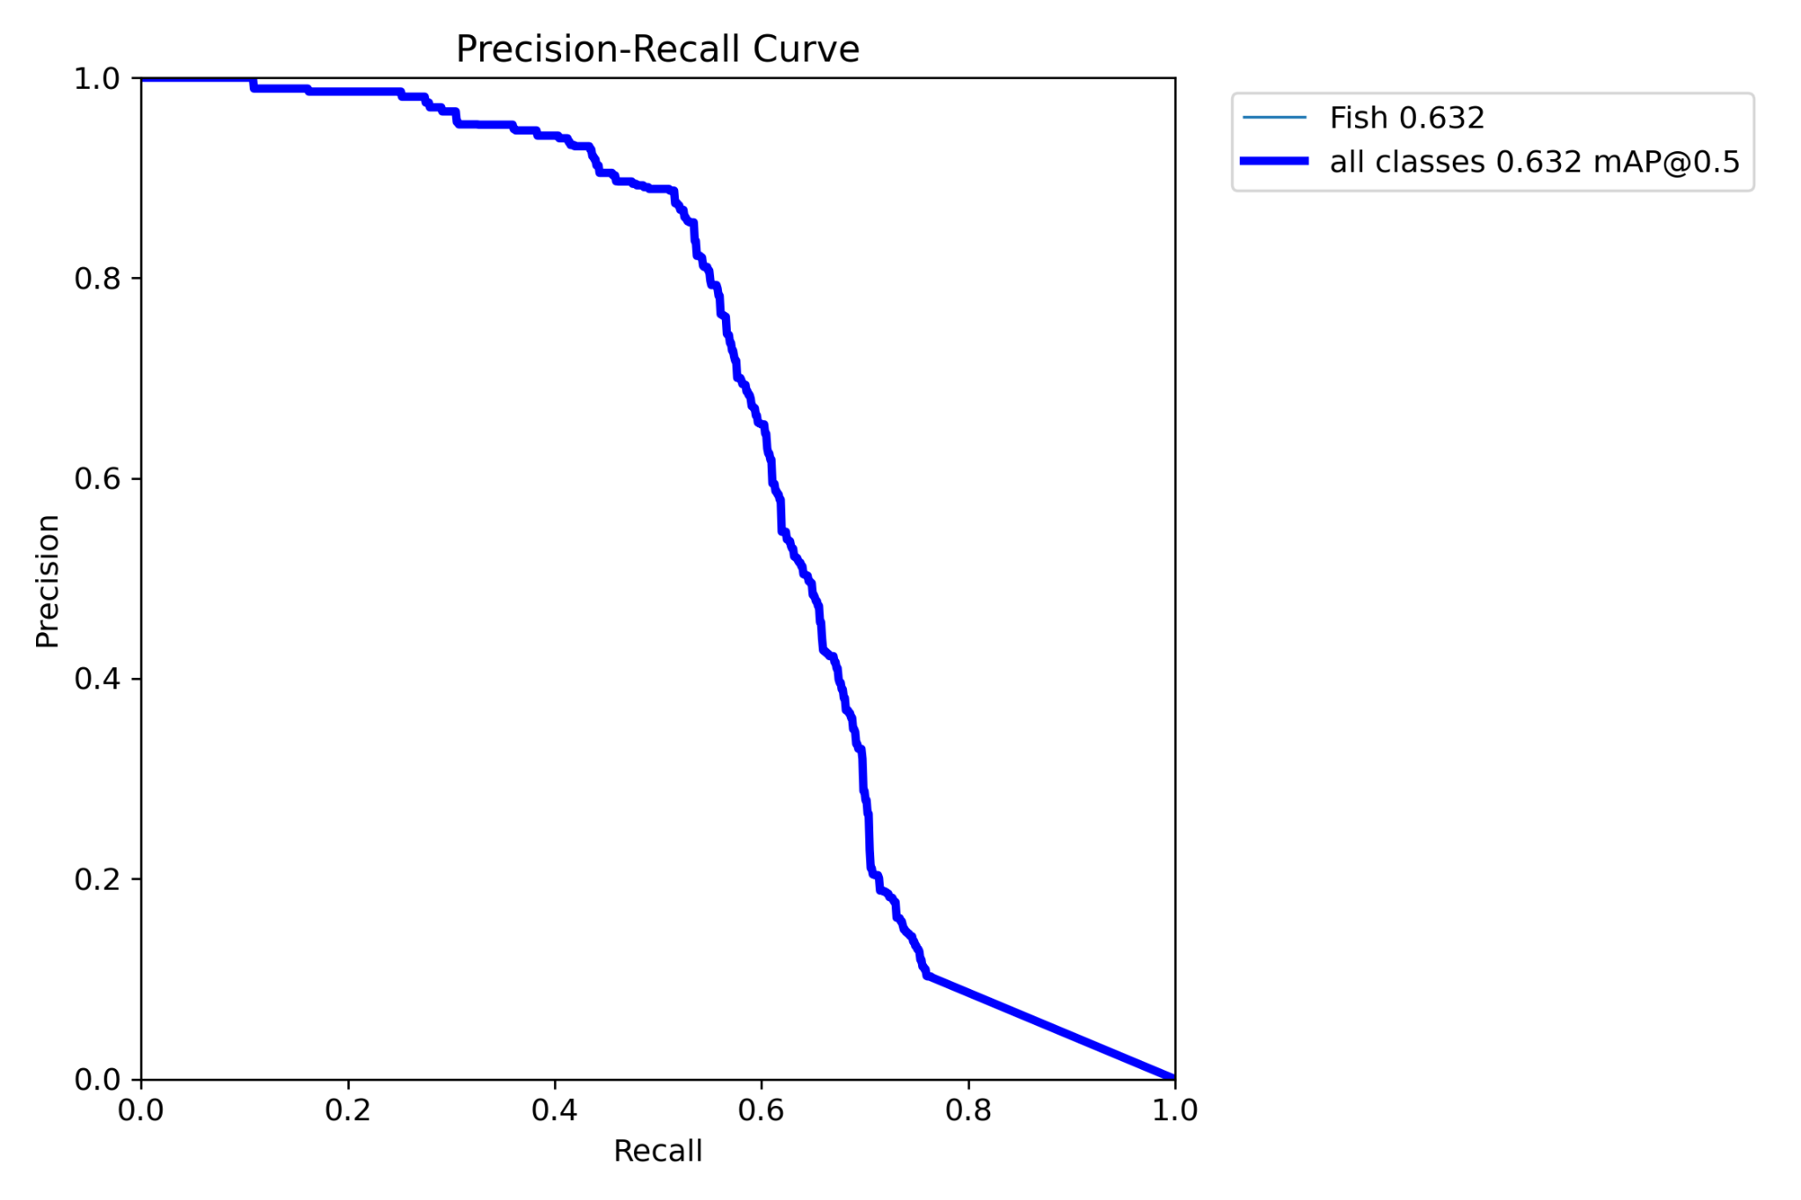
Figure 11: Precision recall curve for optical model v1. NOTE: The class name of “Fish” was due to how the annotated data was trained. In deployment, it detected binary objects, not only “Fish”.
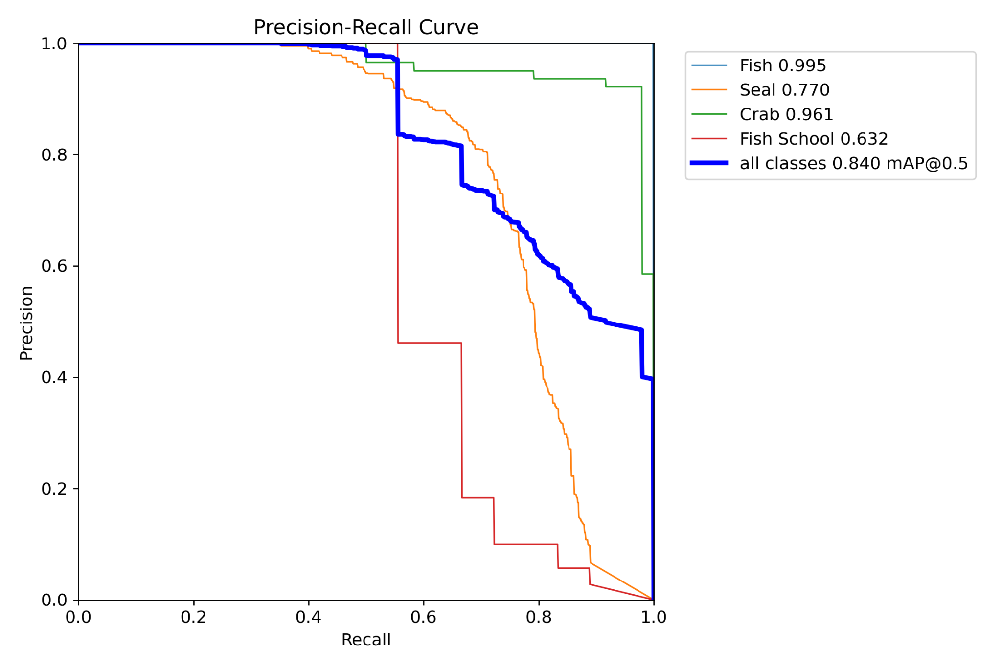
Figure 12: Precision-Recall curve for optical model v2.

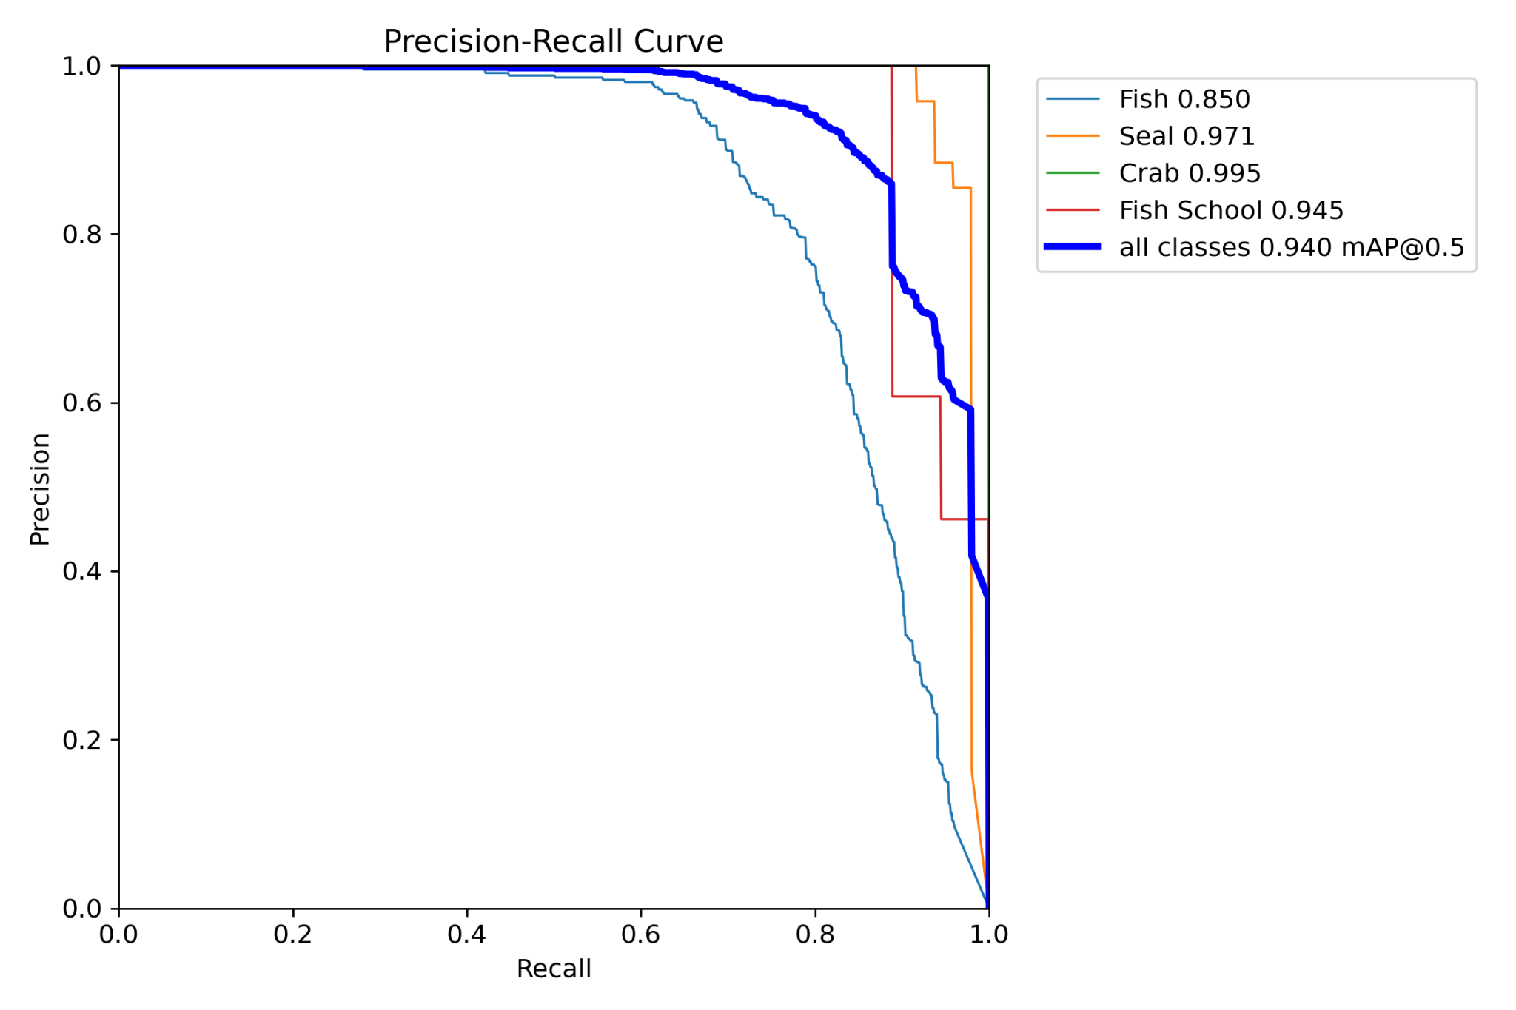
Figure 13: Precision-Recall curve for optical model v3.

Imaging Sonar Data
The breakdowns of training data for the imaging sonar models are shown in Table 8 for the three models trained in this project. The dataset size dropped between v2 and v3 as classifications were consolidated during model training preparation. Note that this shows the number of images utilized per class. For model v2, there were instances where both fish school and seals were present in an annotation file, so the total number of images is not equal to the sum of the individual components.
Table 8: Breakdown of images utilized per trained class for each of the three imaging sonar models. Start and end dates describe the UTC time of the first and last image utilized in this dataset.
  Imaging Sonar v1
  Class | Annotations
  binary_object | 89
  Total | 89
  Start Date | 2024-07-05
  End Date | 2024-07-18
  Imaging Sonar v2
  Class | Annotations
  Fish School | 66
  Seal | 615
  Total | 663
  Start Date | 2024-07-03
  End Date | 2024-08-03
  Imaging Sonar v3
  Class | Annotations
  binary_object | 623
  Total | 623
  Start Date | 2024-07-03
  End Date | 2024-08-29

Sonar model performance metrics evaluated against the “v3” validation data, are presented in Table 9. Note that since v3 is a binary model, the metrics here reflect binary performance as well. As with optical data, three different models were trained for sonar detection, focusing on seal and fish school classes. The first model deployed, “v1”, was binary and the results were relatively poor, only detecting about 67% of all targets. The false positive rate for v1 was notably elevated (0.747) when evaluated against v3 validation data, driven by the limited quantity and substantially different distributions of the v1 training data relative to v3. The second iteration, “v2”, was improved marginally, detecting approximately 75% of targets correctly, but yielded an ~29% false positive rate. Model “v2” performance was likely impacted by the switch from a binary to a multiclass model. The final model, “v3”, was reverted to a binary model and showed a small increase in model performance and small decrease in false positive rate.

Table 9: Results of model training for deployed sonar models.
Deployment Date | Model | Binary or Multiclass | Precision | Recall | mAP50 | False Positive Rate | Inference Latency (per image)
07/30/2024 | v1 | Binary | 0.2433 | 0.4912 | 0.1818 | 0.7469 | 3.5 ms
08/09/2024 | v2 | Multiclass | 0.7559 | 0.7087 | 0.7515 | 0.2878 | 3.9 ms
10/10/2024 | v3 | Binary | 0.8593 | 0.8661 | 0.8855 | 0.1679 | 3.4 ms

Precision-Recall curves evaluated against v3 validation data for each of the three imaging sonar models are presented in Figures 14 – 16.

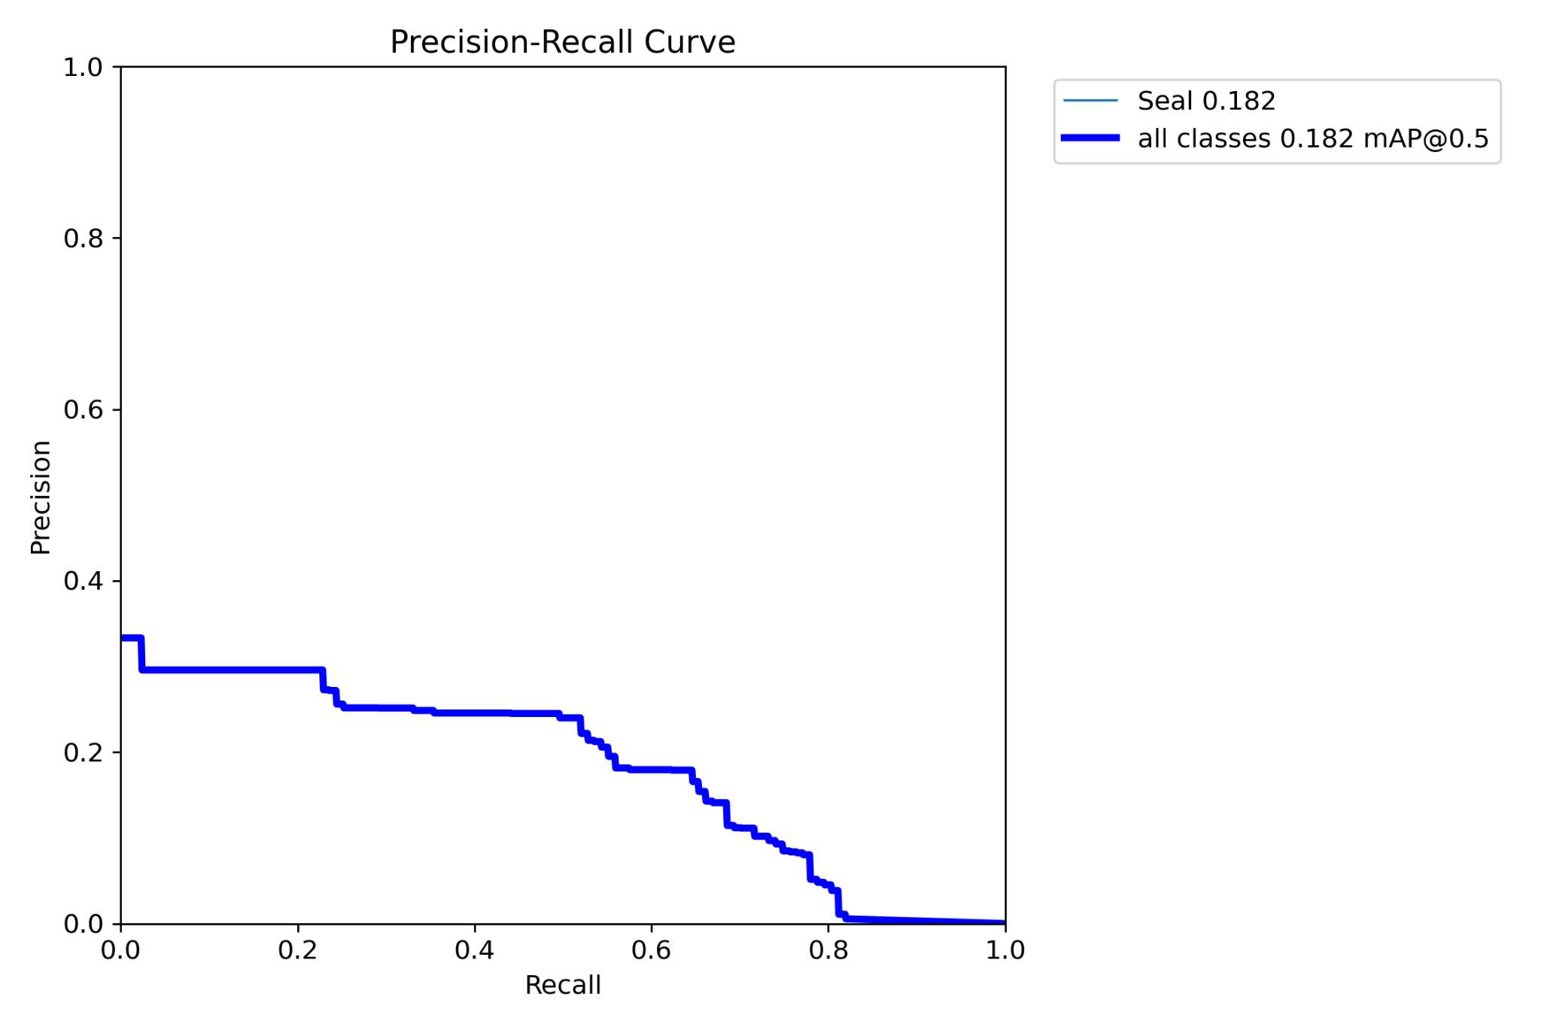
Figure 14: Precision-Recall curve for model v1. NOTE The class name, “seal”, is an artifact of the training data. In deployment, the model detected binary objects, not only seals.

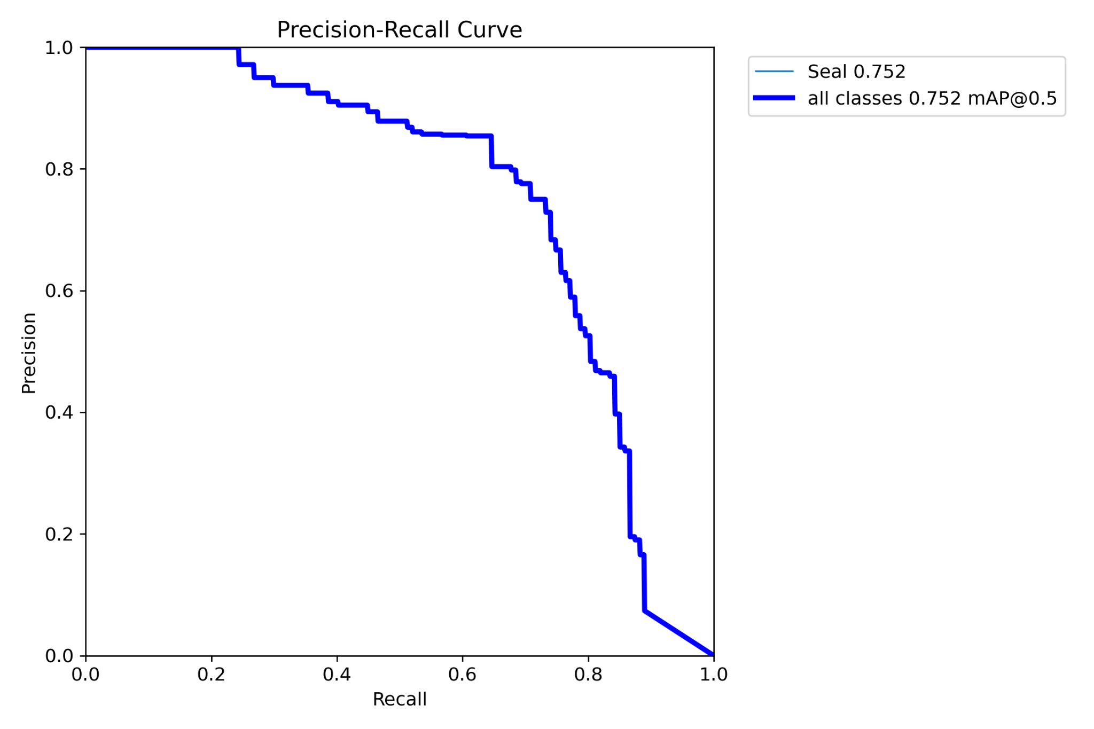
Figure 15: Precision-Recall curve for imaging sonar model v2. NOTE: Although model v2 was a multiclass model, it was evaluated as a binary model to maintain a consistent validation across all models. The class name, “seal”, is an artifact of the training data. In deployment, the model detected multiple objects, not only seals.

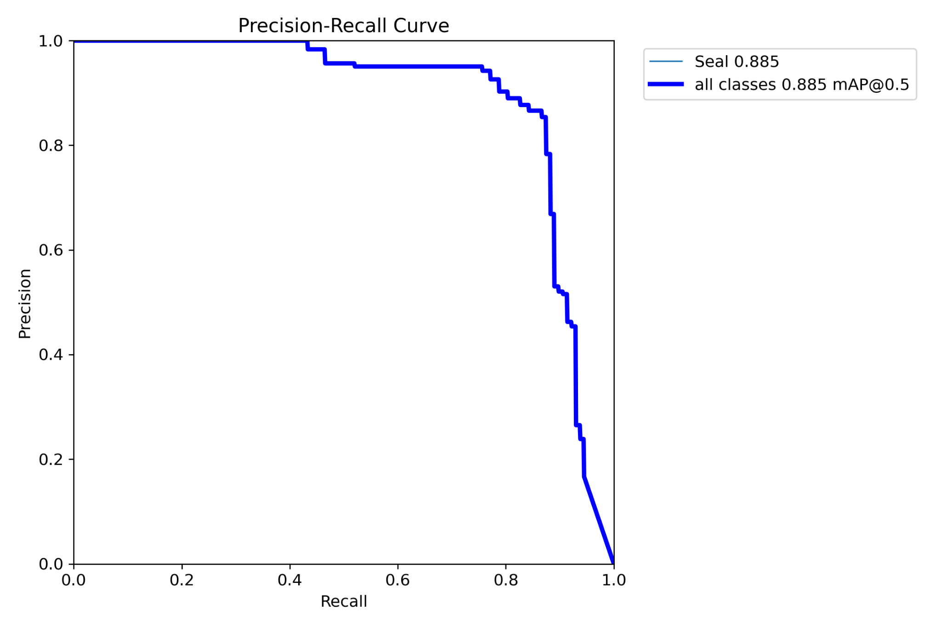
Figure 16: Precision-Recall curve for imaging sonar model v3. NOTE: The class name, “seal”, is an artifact of the training data. In deployment, the model detected binary objects, not only seals.

Evaluating false positive rate on the deployed system
To assess the false positive rate of deployed models, a large quantity of optical detections produced by the system in-situ was analyzed. These data were captured between July 30, 2024, and August 9, 2024. In total, 51,838 images containing detections were reviewed and 33,498 of them were found to contain an object of interest while the other 18,340 were not, resulting in an aggregate false positive rate over the studied periods of approximately 35%. This is higher than the false positive rates presented in the validation results but is unsurprising given the dynamic nature of the environment and the relatively limited amount of training data included in each model. For example, debris, such as seaweed and other drifting material, were among the most frequently observed and varied objects observed. Inclusion of all debris observed in the models would have significantly biased the models towards debris, degrading accuracy. In addition, temporal changes in the environment (diurnal light variations, seasonal variations) alter the distribution and presentation of each class, such that the accuracy of models trained on a temporally limited set of prior data will steadily decrease over time. In general, this problem can be addressed through inclusion of data with a broad temporal distribution to address all periodic variations. A lack of temporal variation in the training data likely degraded accuracy, but likely to a much smaller degree than the limited size of the training dataset.

Usability Study of MarineSitu’s System
One Marine Ecologist and two Data Scientists evaluated their ability to work with MarineSitu’s system. The study aimed to assess the system from two distinct perspectives: that of an operator performing standard monitoring, and that of a researcher seeking to integrate custom code and algorithms. Detailed evaluation logs were documented and shared privately with MarineSitu to inform future development. A summary of findings is presented below.

Operational Feedback (Marine Ecologist)
PNNL’s Marine Ecologist interfaced with the system primarily through the user interface (UI). Feedback highlighted that while the system provided comprehensive controls for instrument configuration and health monitoring, the learning curve was steep. The primary recommendation was the development of a comprehensive user manual and in-application tooltips to aid users in configuring the system without requiring direct support from MarineSitu staff.

Research and Integration Feedback (Data Scientists)
PNNL Data Scientists evaluated the system’s architecture for supporting advanced research tasks, such as real-time custom algorithm development. The evaluation highlighted a distinction between the system’s design for operational monitoring and the needs of active research:
- Data Access: The system’s architecture effectively centralized data via MarineSitu’s cloud platform to streamline remote monitoring and standard data product access. However, for research workflows requiring immediate interaction with high-volume raw data, the study identified a need for local data access methods to supplement the cloud connectivity.
- Software Integration: While the existing software supported data capture and cloud synchronization, researchers noted that a dedicated local API would significantly enhance the ability to integrate third-party software and custom machine learning models in real-time. Such an API would consist of REST API endpoints for configuring and retrieving system settings, commanding system actions (e.g., activate recording, activate strobes, etc.), retrieving other system information (e.g., health data) and video streaming endpoints for retrieving higher bandwidth data for real-time streaming and processing.

System Hardware
In addition to the UI, the scientist assessed the hardware of the AMP. The hardware endured a 4-month deployment during a high-biofouling period in the energetic inlet of Sequim Bay. All hardware that functioned on the day of deployment continued to function until recovery. Wipers and strobes enabled sensor clarity throughout the deployment despite the failure of barrel rotator on the IC1. The barrel rotator failure was attributed to a design flaw. The rotator’s DC motor, located inside the barrel, was magnetically coupled to the barrel’s mounting bracket. The maximum torque supported by the coupling was lower than what was necessary to rotate the barrel, causing the coupling to slip when the rotator was driven. Although the coupling was semi-functional in a laboratory setting (both in-air and in fresh water at room temperature), the coupling slipped nearly 100% of the time during deployment. It is thought that the temperature differences between the laboratory and Sequim Bay contributed to an increase in friction in the system, requiring higher torques to overcome. That said, design refinement is clearly necessary to achieve high reliability across a range of deployment settings.
The sonar and greyscale monocular cameras were appropriate for the deployment, and the OAK-D would have been except for high distortion due to its cylindrical housing as well as biofouling from the missing wiper. The SeaSpider, ballasting, and screw anchors held the array stable throughout the entire deployment. Apart from the IC1’s highly-refractive cylindrical housing and inoperable rotator, the only other critique of the hardware was that no 3D model of sensor locations was provided (which would have allowed for sensor fusion between instruments and ultimately 3D reconstruction using both camera and sonar).

Usability Study Conclusions
Overall, the PNNL team confirmed the robust sensor and hardware capabilities of the AMP. The system required little to no intervention throughout the deployment and the sensors captured high-quality data valuable for downstream analysis.
Regarding software, the study clarified that while the current cloud-centric architecture is well-suited for operational monitoring and centralized data management, specific features are required to optimize the system for research-intensive applications. PNNL recommended that future development focus on.
      - Enhancing user documentation and UI guidance to support independent operation.
      - Expanding local software capabilities—specifically via a local API—to facilitate high-bandwidth data transfer and real-time integration with third-party research tools.

Analytics using MarineSitu’s System
A pipeline to query MarineSitu’s API to identify periods of time with high activity, a text-prompted object detector, and a 3D reconstruction algorithm were developed by PNNL scientists. In doing so, PNNL was forced to utilize and examine the technical nuances of MarineSitu’s AMP and evaluate ways in which the AMP supported, or didn’t, various research applications.

Identifying and Visualizing Periods of High-Activity
PNNL first sought to leverage the detections and other meta-data that MarineSitu’s algorithms produced and exposed through their cloud API. At the outset, PNNL had hoped to solely use this API to interface with the AMP and all its data, as MarineSitu had intended. Ultimately, this API was used solely to access meta-data, while sensor data and imagery were loaded locally.
As an example, PNNL decided to build a pipeline which iteratively queried MarineSitu’s cloud API to identify periods of time during the deployment with the most marine life activity. This “high-activity pipeline” used MarineSitu’s “counts” cloud API endpoint to identify the minute period in a month of time with the most activity as determined by MarineSitu’s object detection algorithm. Figure 17 shows a plot of the maximal minute during the month of August generated using this pipeline.
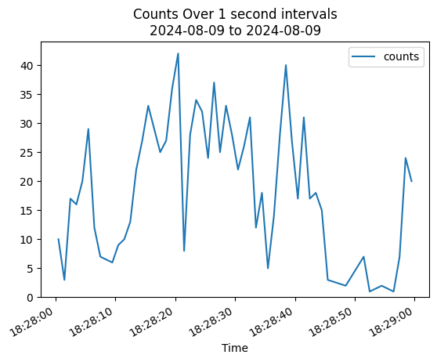
Figure 17: The number of object detections over time during one of the most active minutes in August as reported by MarineSitu’s “counts” endpoint in their cloud-based API.

Performing Enhanced Object Detection During Periods of High Activity
PNNL sought to demonstrate ways that the AMP and its data could be used by downstream AI algorithms. To do so, PNNL implemented a modern, text-prompt-based AI object detector called Grounding DINO and used it to identify fish in image frames. Using the high-activity pipeline above, PNNL identified periods of time with significant fish activity, fetched local imagery corresponding to that time, and then ran their object detector to detect all the fish in the scene. Figure 18 shows the results of their detector alongside the fish detected by MarineSitu’s detector. While MarineSitu’s object detector runs in real-time during deployment, the deployed models were developed and iterated in pursuit of methodological learning, not in pursuit of maximizing model performance. As expected, the post-processing detector produced more exhaustive detections on individual frames, though at a significantly lower throughput. Cascading MarineSitu’s algorithms with additional analytics could be a way to further refine detections or generate additional downstream analytics.

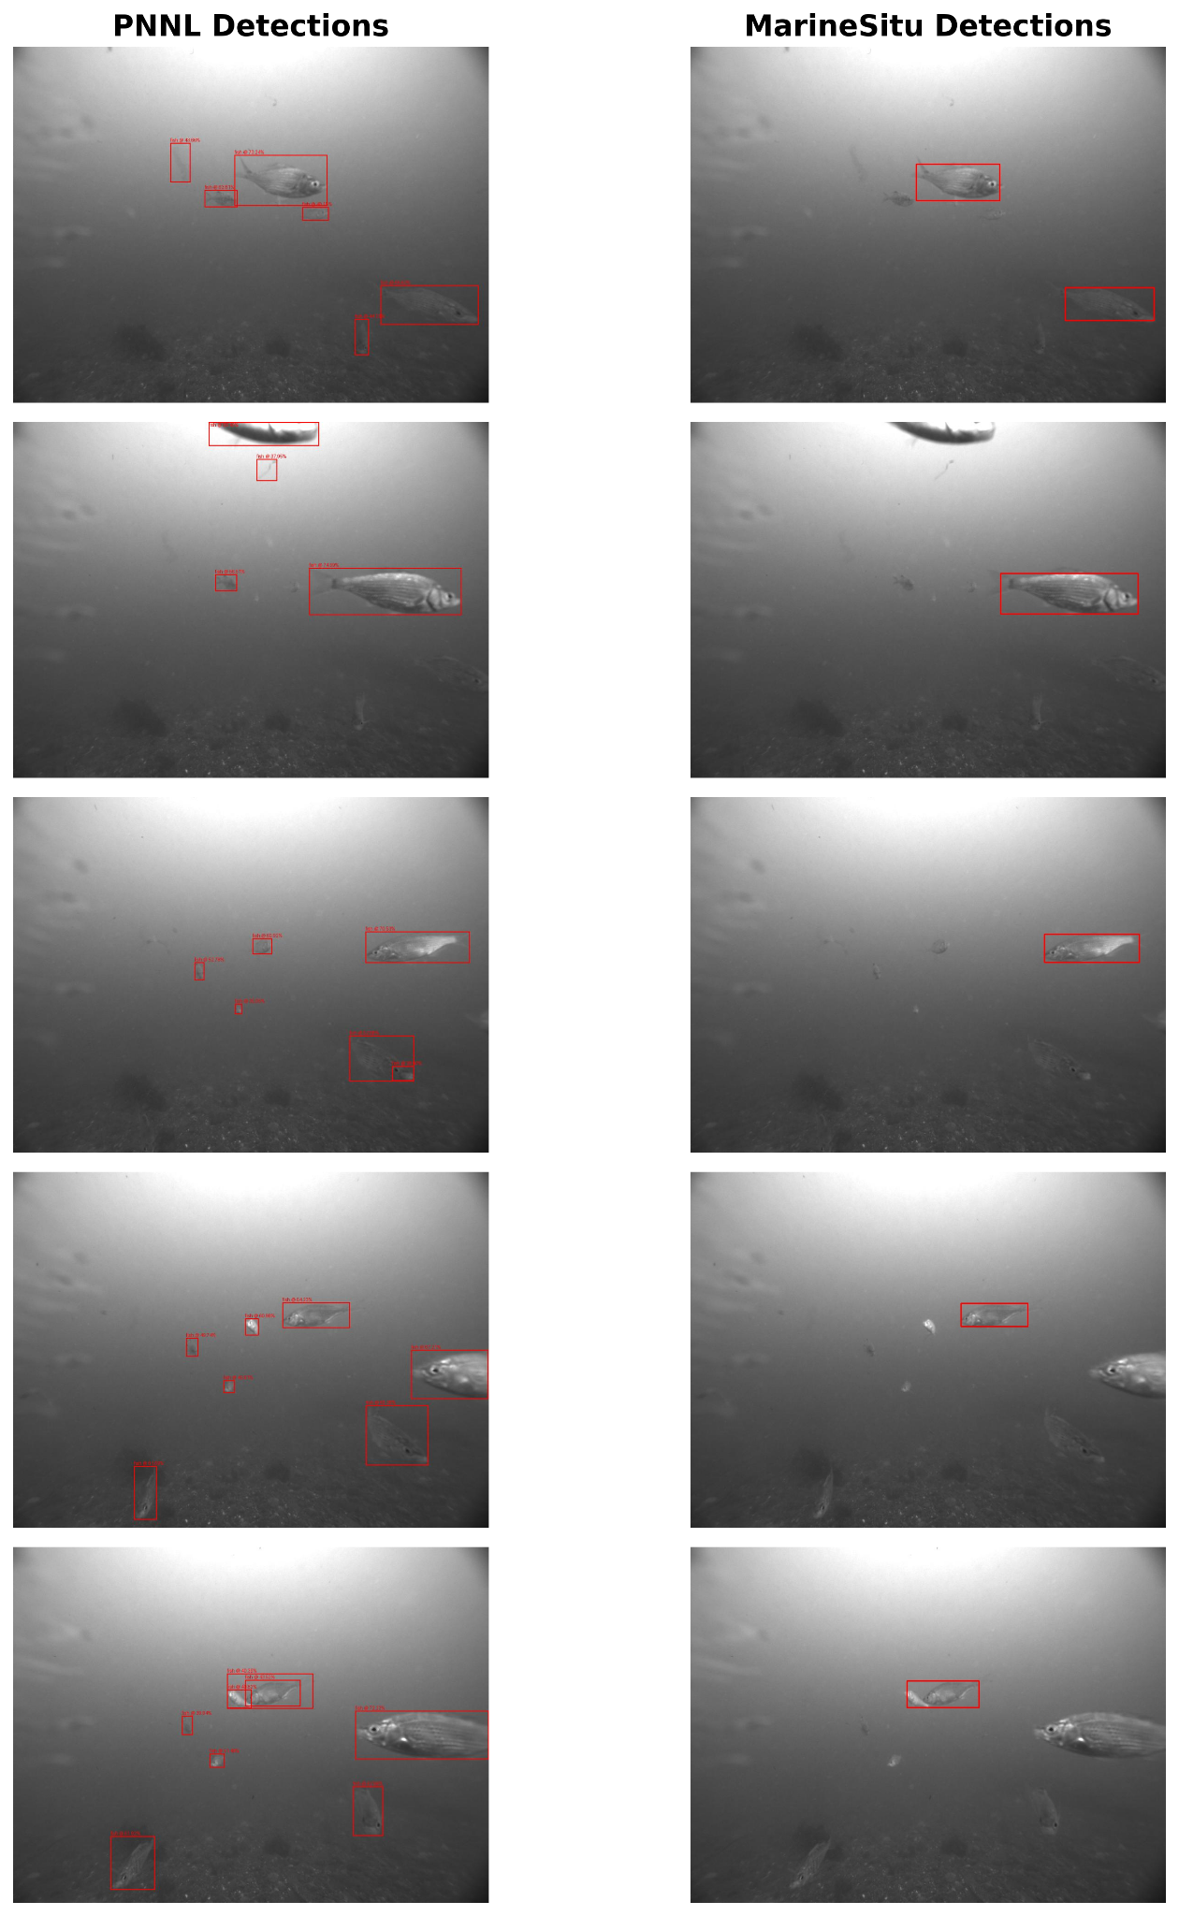 | 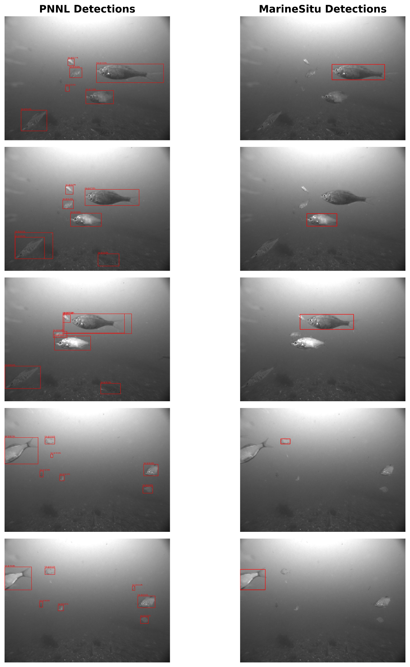
Figure 18: PNNL implemented a prompt-based, off-the-shelf object detector called Grounding DINO to automatically detect all “fish” in view. This often resulted in more exhaustive detections than MarineSitu’s real-time detector, but inference time was approximately 3 Hz compared to MarineSitu’s approximately 10 Hz (note: MarineSitu’s model inference capability can achieve throughput as high as 200 Hz; the 10 Hz rate reflects the camera acquisition frame rate during this deployment, not the model’s maximum throughput). Leveraging MarineSitu’s fast detector and then refining detections using a stronger, but slower detector, could be one way in which end-users synergistically leverage the AMP with their own algorithms.

3D Reconstruction and Object Detection using AMP Data
The IC1 includes an OAK-D S2 PoE camera and during deployment, PNNL’s dive team “danced” (underwater) with a camera calibration board to capture data with which to perform calibration and thus enable 3D depth estimation. PNNL scientists developed a 3D calibration and estimation pipeline along with an implementation of the Segment Anything 2 AI algorithm in order to illustrate how with 3D object detections, one could more precisely determine whether marine life collided with a marine energy device.
However, when seeking to apply this approach outside of the calibration period, they found that the stereo camera imagery was inconsistently synchronized (left and right images were not captured at the same moment in time) and that there was significant biofouling on the stereo camera housing due to the failed wiper brush. As such, a complete 3D object detection demo could not be used to estimate the 3D position of marine life. Nonetheless, this section details this effort, the flaws that undermined it, and the next steps that could be taken to estimate depth or improve results in future deployments.
The first step in 3D stereo reconstruction is camera calibration, in which the intrinsic and extrinsic camera matrices are calculated which describe per-camera distortion effects and camera to camera offsets respectively. The calibration data captured during deployment was fed into a pipeline which detected the calibration checkerboard and verified that images at the exact same moment in time existed for both the left and right OAK-D cameras. 873 images over a 11-minute period were thus identified and used to calibrate the stereo array. Solving the calibration optimization on these 873 image pairs took around an hour (as it is not parallelized). With the resulting camera calibration information, the raw images were undistorted to remove lens warping and rectified to align their epipolar lines; disparity estimation could then be performed using block matching. Block matching identified common features along the axis of translation between a horizontally or vertically aligned camera pair and results in a disparity map which defines the offset of these features between cameras. Using these disparities, the camera focal information and the baseline between the cameras, one can then determine an estimated depth for each feature. To improve the quality of the feature matching, objects of interest were segmented using background subtraction as well as the Segment Anything 2 AI segmentation network. The results of this 3D reconstruction pipeline are shown in Figure 19.

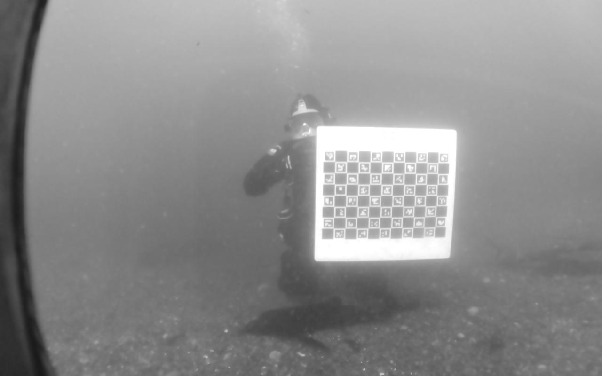 | 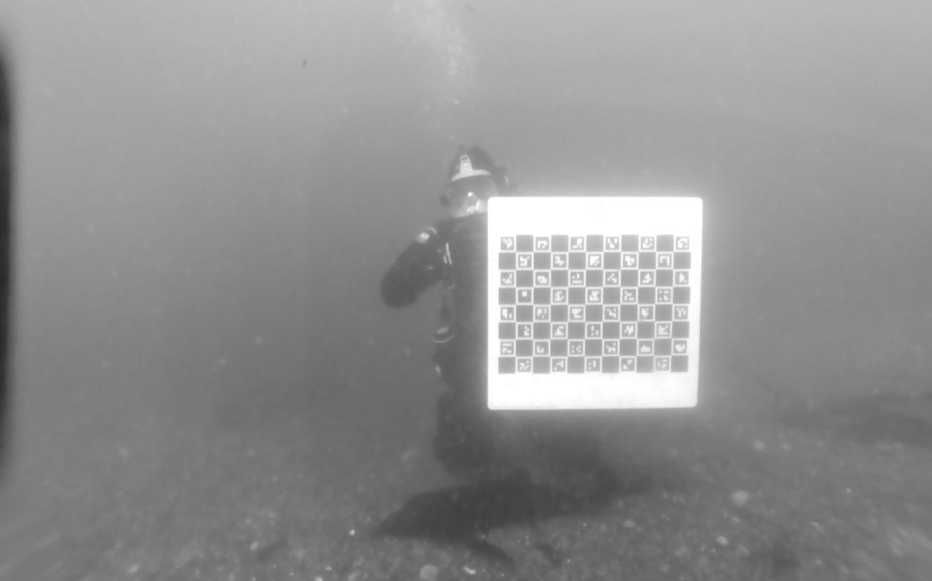
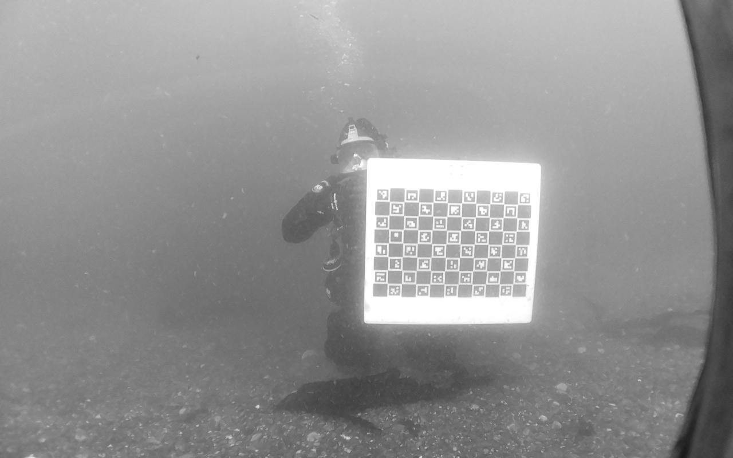 | 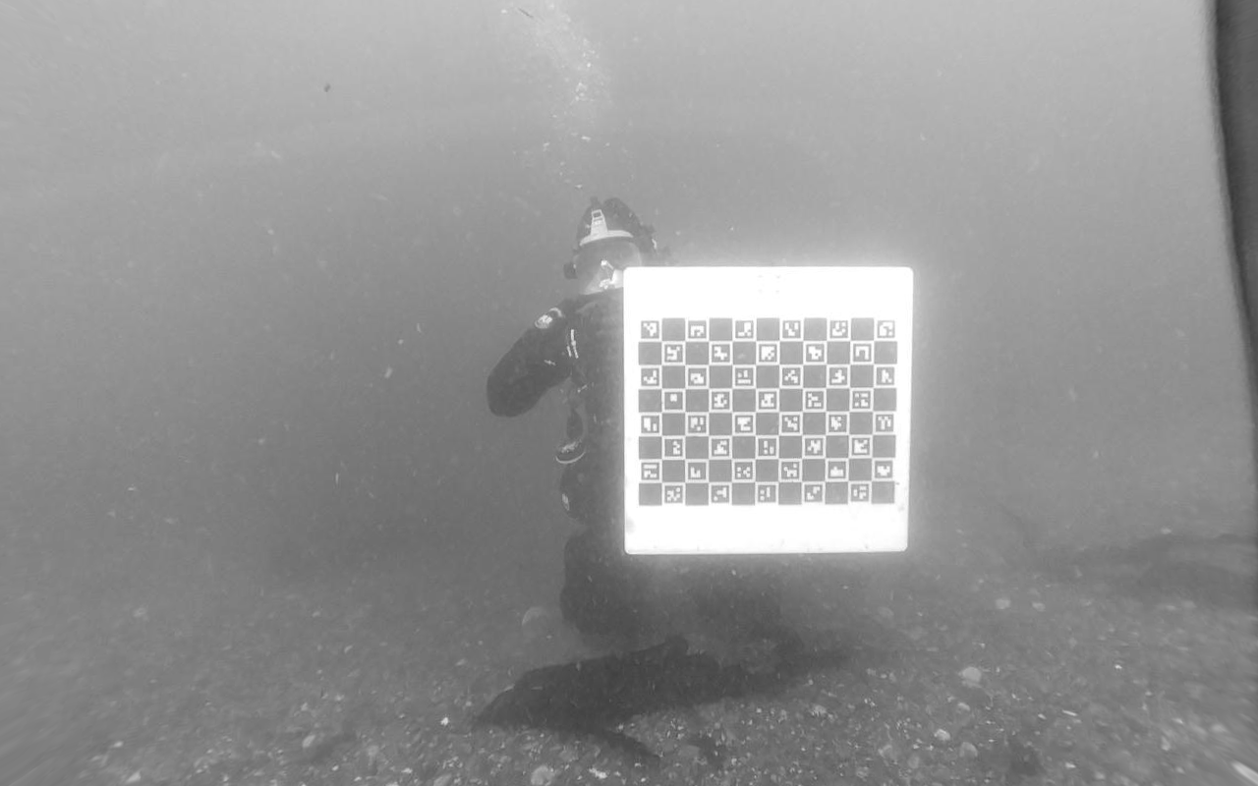
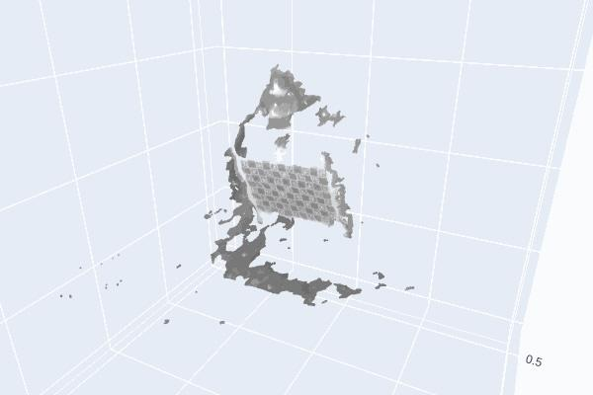
Figure 19: Top Left - A raw image from the OAK-D’s left camera; Top right - corrected left camera image; Middle Left - corresponding raw right image; Middle right - corrected right camera image; Bottom - 3D reconstruction of diver during calibration using background subtraction (from a different frame).
While camera calibration and 3D reconstruction were able to be performed on data captured during the AMP’s deployment, shortly after deployment the OAK-D sensors began to become intermittently desynchronized. This issue was attributed to a software error in the configuration of the OAK-D sensors synchronization pipeline that was eventually corrected, but not until late in the deployment. Without two images captured at the same instant, 3D reconstruction is not possible as features move between frames which compromises triangulation. While this desynchronization was intermittent, biofouling also affected the optical quality of the OAK-D (due to the failed rotator) which further inhibited efforts to identify salient periods of time on which to demonstrate the 3D reconstruction pipeline with marine life in view. Figure 20 shows the state of the OAK camera during the fish activity period used for the detection demo above.
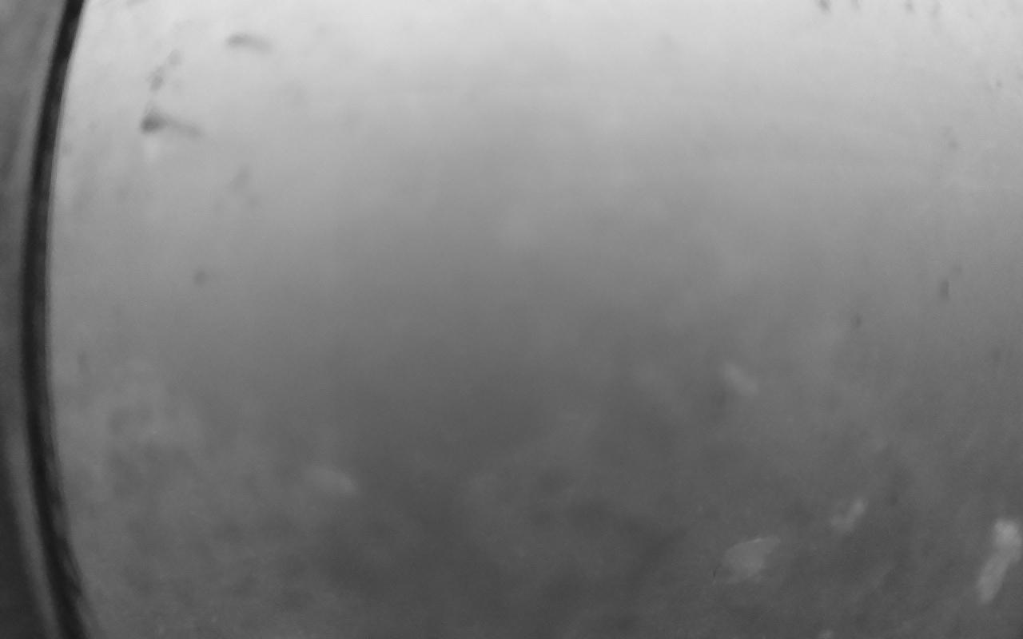 | 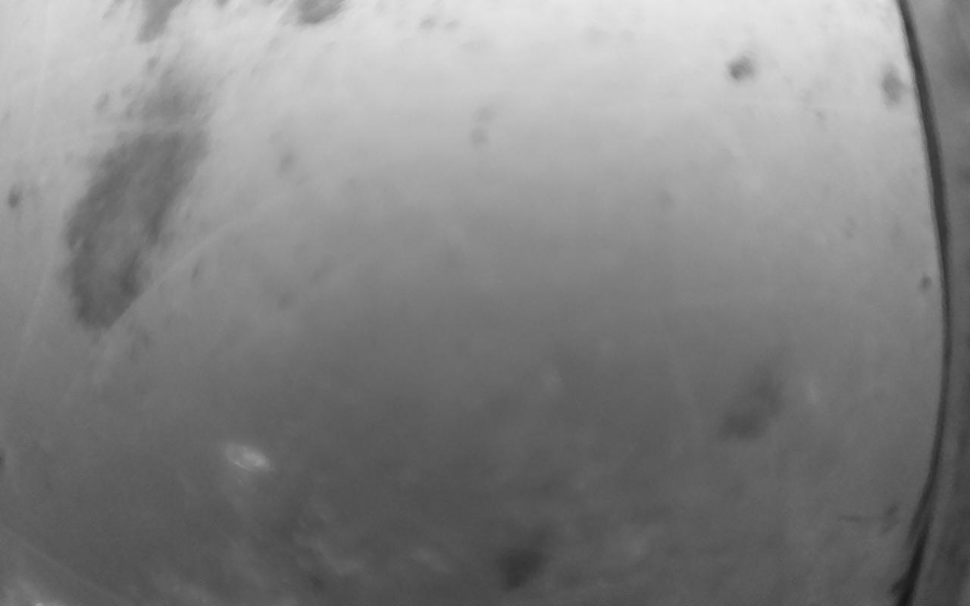
Figure 20: Biofouling on the OAK-D left and right cameras during the high-activity period used in the object detection demo above.
With more time and a more robust hardware setup, 3D object detection via a stereo camera array could prove to be a valuable method for more accurately assessing the risk of collision around marine energy devices during these deployments. Conversely, stereo has its drawbacks. Namely its complexity, sensitivity to parameter tuning, fragility due to background subtraction and object segmentation quality, as well as sensor cost. Modern AI approaches offer a possible alternative via monocular depth estimation, and if time and funds allowed, would have provided for an interesting investigation in this work.

Technology Maturity
Because the hardware components of the AMP are modular it is appropriate to evaluate their technology readiness levels independently (Table 10).
Table 10: Technology Readiness Level Evaluation.
Component | TRL | Evidence | Remaining Gaps to Advance TRL
H1 Integration Hub | 9 | Updated design met performance expectations in operational environment; component has been deployed for commercial project. | N/A
CC1 Camera Hub | 9 | Updated design met performance expectations in operational environment; component has been deployed for commercial project. | N/A
C1 Modular Camera | 9 | Updated design met performance expectations in operational environment; component has been deployed for commercial project. | N/A
L1 Modular Light | 9 | Updated design met performance expectations in operational environment; component has been deployed for commercial project. | N/A
BC1 Anti-Biofouling Hub | 9 | Updated design met performance expectations in operational environment; component has been deployed for commercial project. | N/A
IC1 Integrated Camera System | 5 | Prototype design fielded but rotator subsystem failed during operation. | Rotator must be redesigned and validated in development setting to advance to TRL 6.
UVC1 UV-C Anti-Biofouling Light | 7 | Prototype design met performance expectations in operational field trial. | Final production-intent design must be completed and qualified to advance to TRL 8.

Lesson Learned and Test Plan Deviation
This long-term deployment in a challenging tidal environment provided critical data and operational feedback for the continued development of the AMP system. The collaboration with PNNL experts was instrumental in identifying the system's operational strengths and areas for improvement.
Lessons Learned
- Hardware Robustness: The modular camera system demonstrated excellent durability over the four-month deployment. The anti-biofouling wipers on these cameras were highly effective at preventing biofouling accumulation and maintaining optical clarity. Conversely, the failure of the prototype rotator-wiper mechanism on the integrated stereo camera resulted in significant biofouling and required periodic cleaning by divers. This failure, coupled with periods of intermittent data desynchronization from the OAK-D camera, prevented planned 3D analysis. This finding prompted a post-deployment software review that resolved the synchronization problem.
- Data Access Architecture and Use-Case Suitability: The deployment highlighted a key distinction in data access requirements. While the cloud API was well-suited for certain “operationalized” remote monitoring tasks, such as accessing data products of limited size, PNNL found that the APIs were not adequate for research applications requiring immediate access to the complete raw dataset. Their experience necessitated a local data transfer workaround and underscores the need for a high-performance local API to support more demanding scientific and real-time analysis tasks. Since the deployment, MarineSitu has further developed the cloud platform to support additional use-cases, such as on-platform data review. MarineSitu has also made substantial progress towards developing a local API to provide additional capabilities to advanced users and system integrators.
- Software Usability and Development Prioritization: The usability study effectively distinguished between immediate operational bugs and a broader set of feature requests and UI improvements identified by PNNL. While numerous high-priority bugs affecting the AMP’s core operations were addressed during the deployment, the feedback from PNNL contributes to the development roadmap for future software revisions to improve usability in research applications. The study also reaffirmed that comprehensive user documentation is an essential requirement.
- Machine Learning Model Optimization: The in-situ model training workflow was effective and yielded improved precision, recall, and mAP50 metrics over several model iterations, but also resulted, generally, in increased rates of false positives. The deployment demonstrated a clear trade-off between model complexity and false positive rates. This was evident in the sonar model development, where the higher false positive rate of a multiclass model (v2) informed the decision to revert to a binary model (v3), which achieved comparable precision and recall with a significantly lower false positive rate.
Test Plan Deviations
- Deployment Schedule: The initial deployment was delayed from June 28th to July 1st, 2024, to resolve minor networking issues. This had no significant impact on the project's objectives. The deployment lasted for nearly 4 months – on the upper end of the 2-4 months initially planned.
- Model updates were initially planned to occur every 2 weeks. In practice, models were updated on a schedule closer to once ever 4-5 weeks. The relative rarity of seals to fish resulted in a significant imbalance in the training data composition. As a result, the availability of new seal observations was a limiting factor in the advancement of model performance. Models could have been trained and deployed earlier but would have yielded minimal performance improvements. Despite the rarity of some class observations, it is believed that additional model review and annotation efforts would have yielded performant models over somewhat shorter timeframes. As a result, MarineSitu has adjusted future project planning to include support for additional data review effort and has created a Data Manager position to assist in coordination and QA/QC of data production across the company’s projects. In addition, further development of on-platform data review and annotation tools have improved model development timelines in more recent projects.
- 3D Reconstruction Analysis: 3D analysis was explored but not completed due to the failure of the prototype rotator-wiper mechanism, resulting in significant biofouling and occlusion in the camera images, and intermittent data desynchronization from the integrated stereo camera.
- Camera Calibration: The first in-situ calibration was performed by a diver post-deployment on July 1st and served as the primary stereo camera calibration for the project. The planned mid-deployment check was deprioritized because the failure of the integrated camera system wiper resulted in poor optical clarity that would have significantly complicated results. Lacking the second in-situ calibration, an analysis of calibration stability over the four-month period was not performed.
- Data Availability: The original test plan described archiving imagery, annotations, and predictions to MHKDR. The scope of archived data products was expanded beyond the original plan to include model weights, validation datasets, and analysis scripts sufficient to reproduce the analyses presented in this report. However, the complete imagery and prediction archives have been deposited in a private MHKDR repository subject to a data use moratorium of up to 5 years from the start of the project period, rather than being made immediately publicly available. A representative subset of imagery and predictions, along with all model weights, validation data, and analysis scripts, has been deposited in a public MHKDR repository for immediate access. This approach was adopted to protect proprietary training data assets during the company's active commercialization phase. The public repository provides sufficient data to reproduce and verify the analyses presented in this report.

Conclusions and Recommendations
This four-month field demonstration successfully met its primary objectives. The project demonstrated the long-term survivability and operational reliability of the AMP hardware in a high-energy tidal environment, advancing the system's Technology Readiness Level. The core instrumentation, particularly the modular camera system with its effective anti-fouling technology, performed reliably throughout the deployment.
The project successfully implemented a real-time, on-edge machine learning pipeline that was updated with in-situ data. The collaboration with PNNL provided essential expert feedback that has produced an actionable roadmap for improving the system. While the core hardware proved durable, the project identified specific software usability gaps, data accessibility limitations, and necessary refinements for prototype hardware. Ultimately, the project validated the AMP's utility as a robust data collection platform for AI-driven environmental monitoring.

MarineSitu Recommendations
Based on the outcomes and lessons learned from this project, MarineSitu recommends the following actions:
- Prioritize Software and Data Access Development: The most critical next step is to address the software and API limitations identified by PNNL. We recommend:
  - Developing a robust, high-performance local API on the shoreside computer to enable real-time data streaming and efficient bulk data transfer.
  - Migrating the user interface from the current desktop application to a web-based application to simplify remote operations.
  - Creating comprehensive user documentation and implementing in-UI features such as configuration management.
- Redesign and Validate Hardware Subsystems: The prototype components require further engineering and validation before they are suitable for commercial use. We recommend:
  - A full redesign of the integrated stereo camera's rotator-wiper mechanism to ensure operational reliability.

PNNL Recommendations
To summarize PNNL’s recommendations to improve the AMP for research applications:
- System documentation, example integration code, and in-UI tooltip descriptions for each button and setting
- Migration from an application-based UI to a web-based UI to support multiple users; playback of historical sensor data and predictions in UI; completion of UI-based settings configuration saving, loading, and management
- Local API as well as a cloud API for integrating third-party local data storage, local software, or local analytics
- Hardware CAD models with 3D pose and offsets; stereo array with a wider baseline for better far-field depth estimation; stereo array housing with better optical quality; wiper system improvements for the stereo array housing

References
Branch, R., Cavagnaro, R.J., Turpin, A., McVey, J., Wickett, M., Wickett, M., Boult, W. and Hindley, S., 2022, October. Vortex Induced Vibration Test of the WITT Device in a Tidal Channel. In OCEANS 2022, Hampton Roads (pp. 1-7). IEEE.
Cavagnaro, Robert J., et al. 2019, "Survey and Numerical Model Analysis for Siting Kilowatt-Scale Tidal Turbines." Proceedings of the 13th European Wave and Tidal Energy Conference (EWTEC 2019), Napoli, Italy. Vol. 31.

Acknowledgements
The authors would like to thank Emma Cotter for project management advice and support, Nori Kono for initial investigations into API integration and 3D reconstruction methods, Lenaig Hemery for assessing the usability of the AMP, and all members of the PNNL marine operations team at Sequim without whom this work would not have been possible.

Data Availability
Project data have been deposited in two MHKDR repositories. A representative dataset, including sample imagery, object detection predictions, and all model weights, validation data, and analysis scripts, is publicly available at https://mhkdr.openei.org/submissions/709. The complete imagery and prediction archives are deposited in a private MHKDR repository at https://mhkdr.openei.org/submissions/689, subject to a data use moratorium of 5 years from the start of the project period. Upon expiration of the moratorium, the complete dataset will be made publicly available.

The confidence interval is an output of the machine learning model that indicates how “sure” the model is that a prediction is accurate. If in practice a 50% confidence interval results in too many false positives, we may increase this value and adjust these metrics to reflect that.

